Supporting Information

Retro-Inversion Imparts Antimycobacterial Specificity to Host Defense Peptides

Hugh D. Glossop, Gebremichal Gebretsadik, Sabiha Sultana, Nathan A. Schacht, Neela H. Yennawar, Diptomit Biswas, Anthony D. Baughn, Scott H. Medina

Content Page Number

Supplementary Table S1. Tabulated peptide mass and purity S3

Supplementary Table S2. MAD1-RI activity towards clinical Mtb isolates S4

Supplementary Fig. S1. Structure of MAD1 and MAD1-RI with trehalose dimycolate S5
Supplementary Fig. S2. CD spectra of MAD1-RI at 70 – 95°C temperatures S6

Supplementary Fig. S3. Checkboard results for MAD1-RI and antibiotic combinations S7

Supplementary Fig. S4. Antibiotic kill kinetics in proliferating Mtb cultures S8

Supplementary Fig. S5. Antibiotic kill kinetics in dormant Mtb cultures S9

Supplementary Fig. S6. MAD1 and MAD1-RI kill kinetics in hypoxic Mtb cultures S10

Supplementary Fig. S7. RNA sequencing principal components analysis S11

Table S1: Sequence identity, analytical properties, and synthetic purity.
No. | Peptide ID | Sequence​ª | Mass  (Da)​ | Calculated MS Ion Peaks  (M+5, M+4, M+3, M+2)​ | Observed MS Ion Peaks  (M+5, M+4, M+3, M+2)​ | Purity​
1 | MAD 1 | KRWHWWRRHWVVW | 2017.4​ | 404.5, 505.3, 673.4, 1009.6 | 405, 505, 673,1009 | 93.5%
2 | MAD1-R | WVVWHRRWWHWRK | 2017.4​​ | 404.5, 505.3, 673.4, 1009.6 | 405, 506, 674, 1010 | 91.6%
3 | MAD1-I | krwhwwrrhwvvw | 2017.4​​ | 404.5, 505.3, 673.4, 1009.6 | 405, 505, 674, 1009 | 95.6%
4 | MAD1-RI | wvvwhrrwwhwrk | 2017.4​​ | 404.5, 505.3, 673.4, 1009.6 | 404, 505, 673, 1009 | 95.9%
5 | MAD2.2 | RRWRWWKVHWHEW | 2047.3 | 410.5, 512.8, 683.5, 1024.7 | 411, 513, 683, 1025 | 92.9%
6 | MAD2.2-RI | wehwhvkwwrwrr | 2047.3 | 410.5, 512.8, 683.5, 1024.7 | 410, 513, 683, 1024 | 98.9%
7 | MAD5.1 | RLRKFRRRFRKEG | 1804.2​ | 361.8, 452, 602.4, 903 | 362, 452, 603, 903 | 97.8%
8 | MAD5.1-RI | Gekrfrrrfkrlr | 1804.2​ | 361.8, 452, 602.4, 903 | 362, 452, 602, 903 | 98.2%
9 | Latarcin 3a | SWKSMAKKLKEYMEKLKQRA | 2483.0​ | 497.6, 621.8, 828.7, 1242.5 | 498, 622, 829, 1242 | 98.2%
10 | Latarcin 3a-RI | arqklkemyeklkkamskws | 2483.0​​ | 497.6, 621.8, 828.7, 1242.5 | 498, 622, 829 | 95.5%
11 | Euminitin F | LNLKGLFKKVASLLT | 1644.1 | 329.8, 412.0, 549.0, 823.0 | 412, 549, 823 | 99.0%
12 | Euminitin F-RI | tllsavkkflGklnl | 1644.1 | 329.8, 412.0, 549.0, 823.0 | 412, 549, 823 | 98.5%
13 | Pinipesin F | VAEARQGSFSY | 1213.3 | 152.3, 304.3, 405.3, 607.5 | 608 | 97.1%
14 | Pinipesin F-RI | ysfsGqraeav | 1213.3 | 152.3, 304.3, 405.3, 607.5 | 608 | 92.7%
ªAll sequences prepared with amidated C-terminus

Table S1: Activity of MAD1-RI and Isoniazid (drug control) against the indicated Mtb clinical isolate, as determined by visual inspection and optical density measurements (OD₅₇₀).
Mtb clinical isolate | MIC
Mtb clinical isolate | Visual Inspection |  | OD₅₇₀
Mtb clinical isolate | MAD1RI (µM) | Isoniazid (µg/ml) | MAD1RI (µM) | Isoniazid (µg/ml)
N0004 | 20 | 1.25 | 20 | 1.25
N0052 | 40 | 1.25 | 40 | 1.25
N0072 | 10 | 1.25 | 20 | 2.5
N0091 | 20 | 1.25 | 40 | 1.25
N0136 | 20 | 1.25 | 20 | 1.25
N0145 | 20 | 0.625 | 20 | 0.625
N0155 | 20 | 1.25 | 20 | 1.25
N1063 | 40 | >10 | 40 | >10
N1177 | 20 | 1.25 | 20 | 1.25
N1272 | 20 | 1.25 | 40 | 1.25
N1274 | 20 | 0.625 | 20 | 0.625
N1283 | 20 | 1.25 | 20 | 1.25

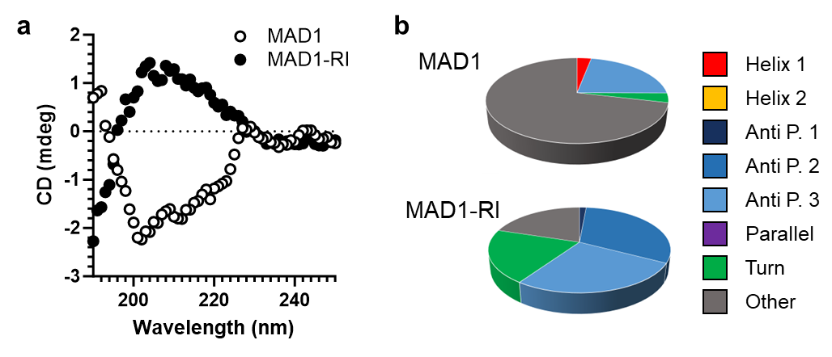

Figure S1: (a,b) CD spectra (a) and BeStSeL structural classification of MAD1 and MAD1-RI in the presence of the mycobacterial outer membrane glycolipid, trehalose dimycolate.

Figure S2: CD spectra of MAD1-RI in physiologic buffer at 70 – 95°C temperatures.

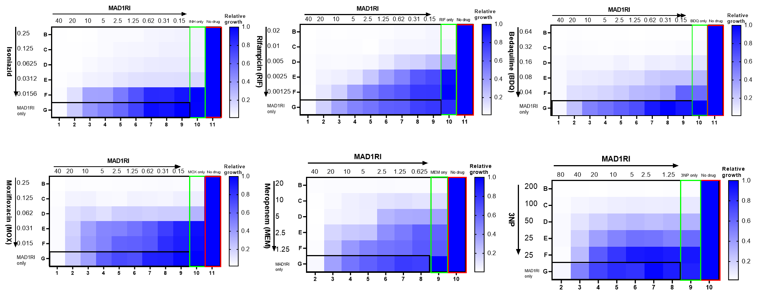Figure S3: Representative checkboard results for antibiotics that displayed additive or synergistic activity with MAD1-RI.

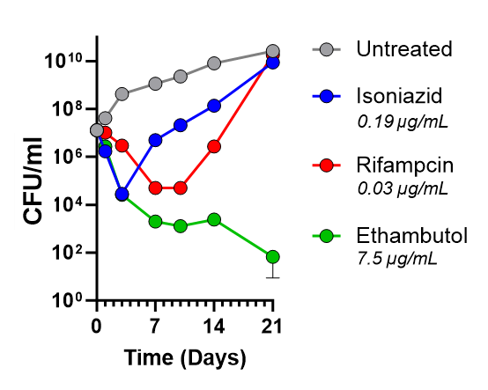

Figure S4: Time-dependent kill kinetics of Isoniazid, Rifampicin and Ethambutol in proliferating Mtb (H37Rv) cultures at the indicated concentration.

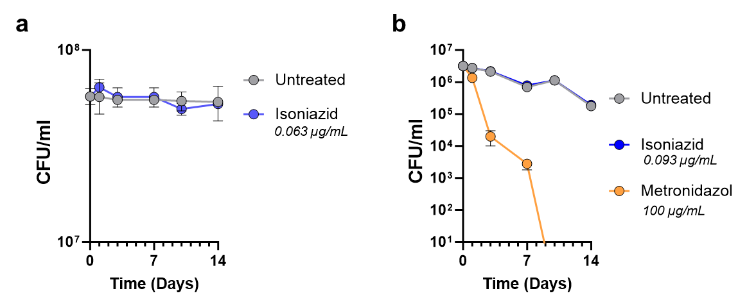

Figure S5: Time-dependent kill kinetics of the indicated antibiotic in (a) H37Rv cultures under nutrient starvation conditions, or (b) H37Ra cultures under hypoxic conditions. Untreated controls in a and b are the same as in Figure 4e and Figure 4f, respectively.

Figure S6: Time-dependent kill kinetics of MAD1 and MAD1-RI in hypoxic H37Ra cultures. Untreated control is the same as Figure 4f.

Figure S7: Principal components analysis of RNA sequencing samples prepared from untreated (black) or MAD1-RI exposed (red) Mtb H37Rv cultures.

