Supplementary Information
Electrosynthesis of NH₃ from low-concentration NO on cascade dual-site catalysts in neutral media
Xiaoxi Guo,^{1,‡} Tongwei Wu,^{3,‡} Hengfeng Li,² Yanning Zhang,³ Chao Ma,⁴ Hongmei Li,¹ Liyuan Chai,⁵ Haitao Zhao⁶ and Min Liu^{1,5*}
¹Hunan Joint International Research Center for Carbon Dioxide Resource Utilization, State Key Laboratory of Powder Metallurgy, School of Physics, Central South University, Changsha, 410083, China.
²School of Materials Science and Engineering, Central South University, Changsha, 410083, China.
³Institute of Fundamental and Frontier Sciences, University of Electronic Science and Technology of China, Chengdu 610054, Sichuan, China.
⁴College of Materials Science and Engineering, Hunan University, Changsha 410082, China.
⁵School of Metallurgy and Environment, Central South University, Changsha 410083, China
⁶Department of Electrical and Electronic Engineering, The Hong Kong Polytechnic University, Hong Kong, China
‡X. Guo and T. Wu contributed equally to this work.
*Correspondence and requests for materials should be addressed to M.L. (email: minliu@csu.edu.cn)

Experimental Section:
Material characterizations
XRD patterns were collected by a LabX XRD-6100 X-ray diffractometer with Cu Kα radiation (40 kV, 30 mA) of wavelength 0.154 nm (SHIMADZU, Japan). TEM images were acquired on a Hitachi H-8100 electron microscopy (HITACHI, Japan), equipped with EDS mapping. XPS measurements were conducted on an ESCALABMK II X-ray photoelectron spectrometer using Mg as the exciting source. In situ electrochemical ATR-FTIR spectra were obtained by using a Thermo iS50. The XAS spectra were performed at the BL11B beamline of Shanghai Synchrotron Radiation Facility (SSRF). The incident photons were monochromatized by a Si (111) double-crystal monochromator. The absorbance data of spectrophotometer were measured on SHIMADZU UV-1800 ultraviolet-visible (UV-Vis) spectrophotometer.

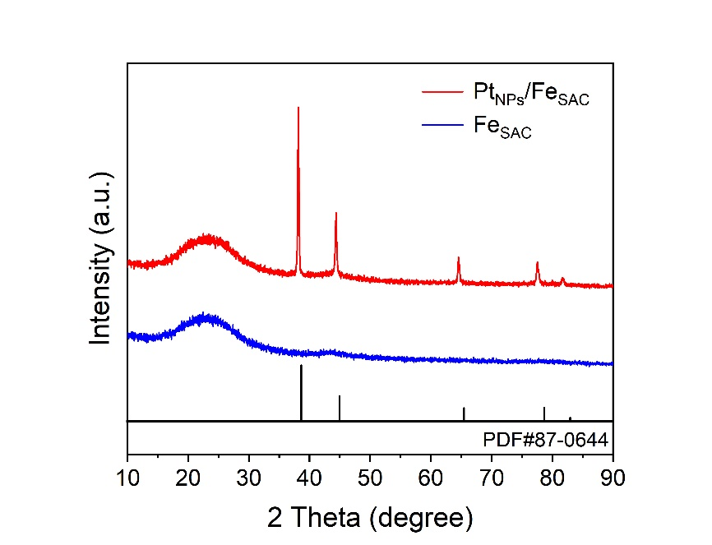
Supplementary Fig. 1 | XRD patterns for Pt_{NPs}/Fe_{SAC} and Fe_{SAC}.

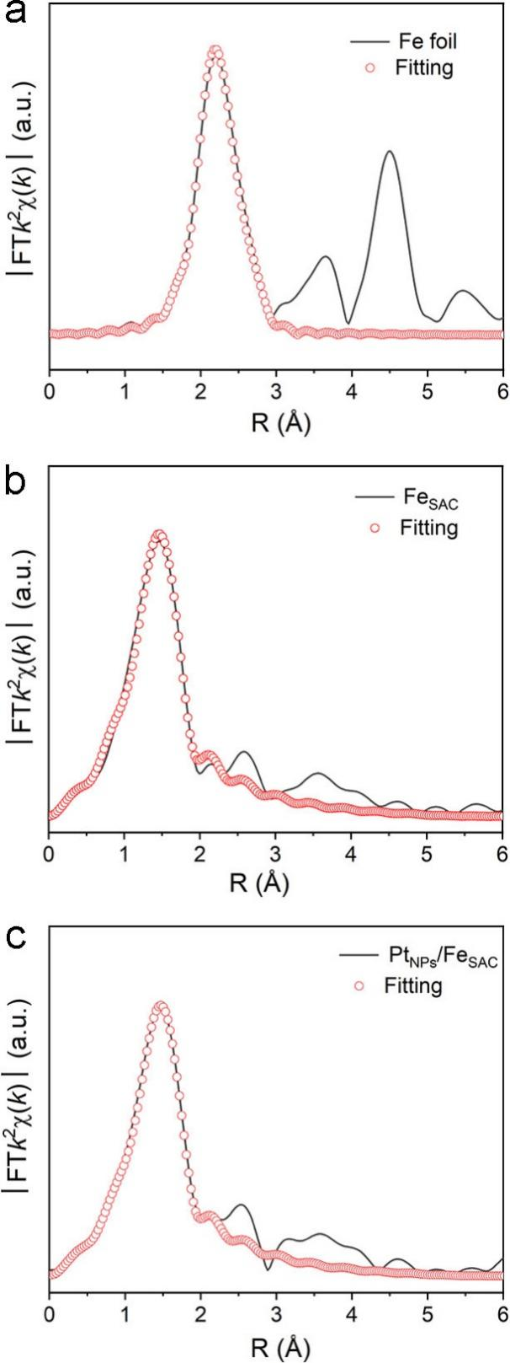
Supplementary Fig. 2 | FT-EXAFS fitting curves of Fe foil, Fe_{SAC} and Pt_{NPs}/Fe_{SAC}.

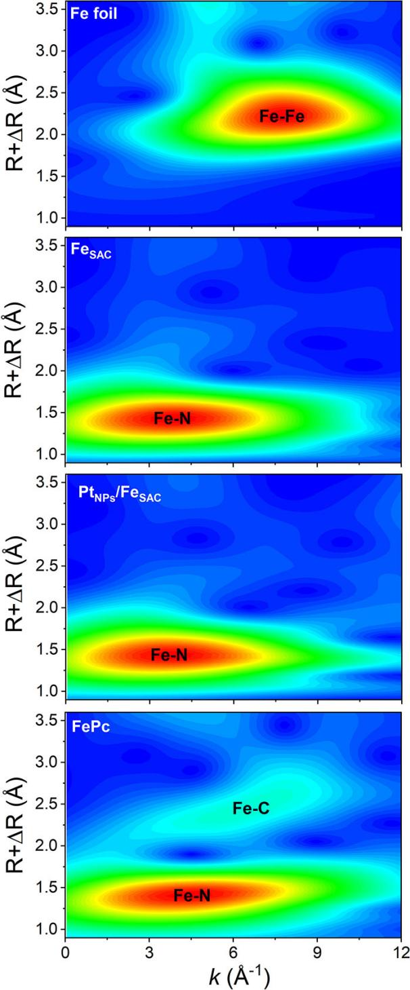
Supplementary Fig. 3 | WT contour spectra of Fe atom in Fe_{SAC}, Pt_{NPs}/Fe_{SAC} and reference samples.

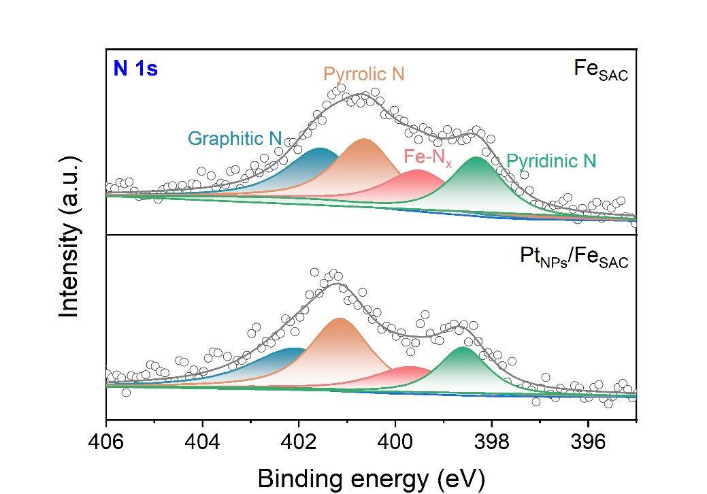
Supplementary Fig. 4 | XPS spectra of Pt_{NPs}/Fe_{SAC} and Fe_{SAC} in N 1s region

Supplementary Fig. 5 | The DMPO-involved EPR spectra of Pt_{NPs}/Fe_{SAC} and Fe_{SAC} collected after 10 min electrolysis at -0.6 V and -0.7 V, respectively, under Ar atmosphere.

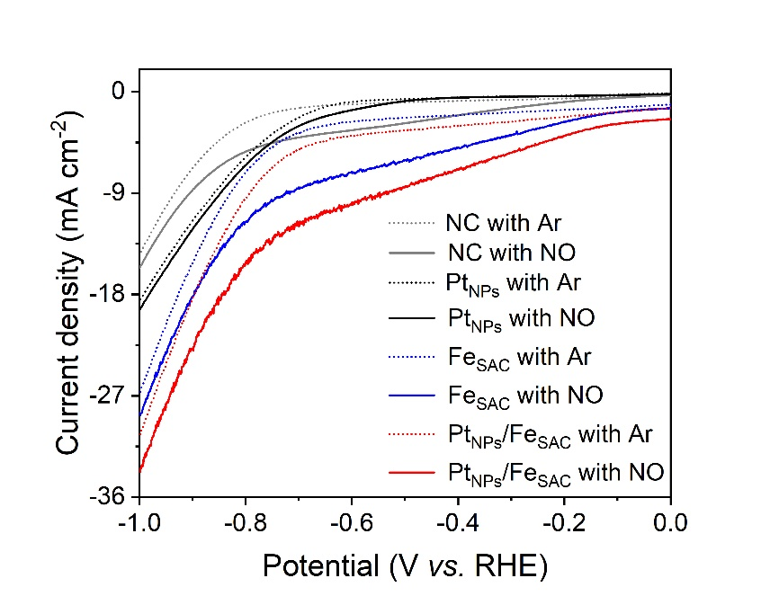
Supplementary Fig. 6 | LSV curves of NC, Pt_{NPs}, Fe_{SAC} and Pt_{NPs}/Fe_{SAC} in Ar- and 1 vol% NO-saturated 0.5 M K₂SO₄ electrolyte.

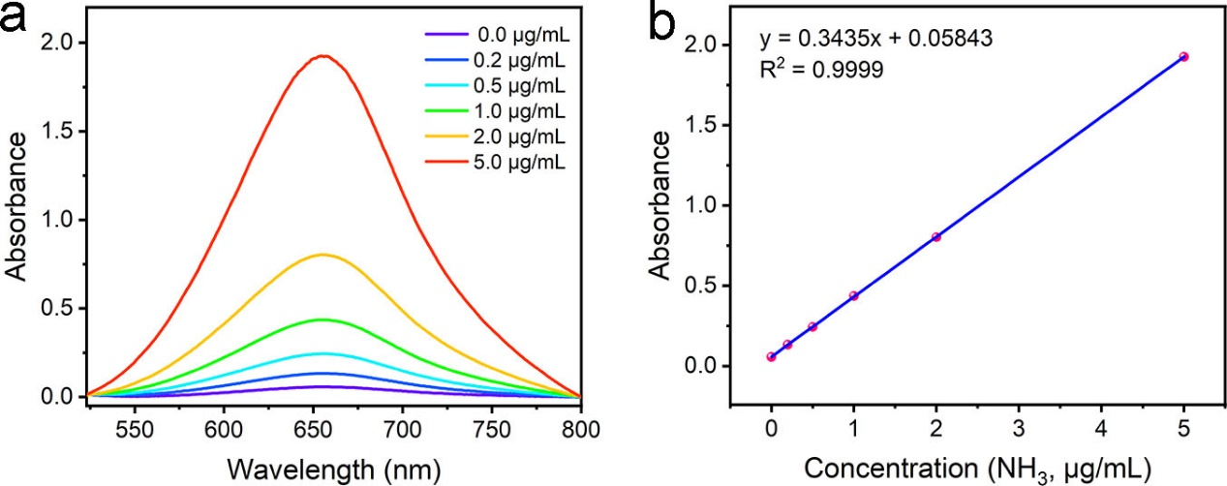
Supplementary Fig. 7 | UV-Vis absorption spectra of indophenol assays with NH₃ after incubated for 2 h at room temperature. (b) Calibration curve used for assessment of NH₃ concentrations.

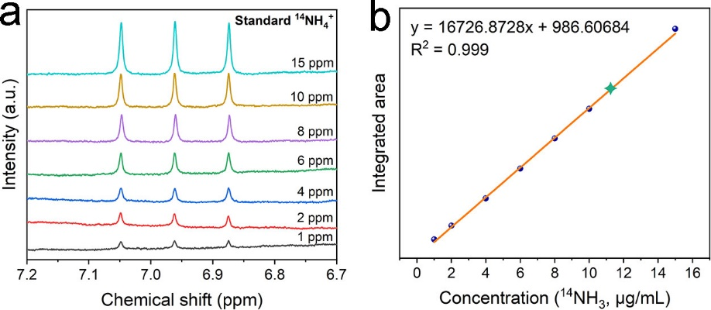
Supplementary Fig. 8 | (a) ¹H NMR spectra of standard NH₃ solution. (b) The standard curve of NMR integral area against NH₃ concentration.
Before ¹H NMR measurements, the electrolyte after electrolysis was diluted 2 times with 1 M HCl to adjust the Ph to acidic. Then, 100 mL DMSO-d6 was added in 500 μL acidified electrolyte.

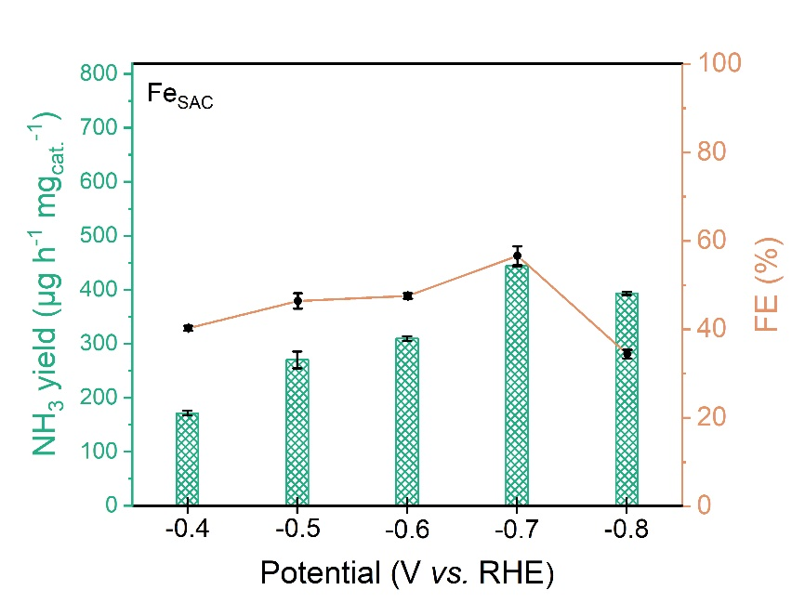
Supplementary Fig. 9 | NH₃ yield and FE of Fe_{SAC}.

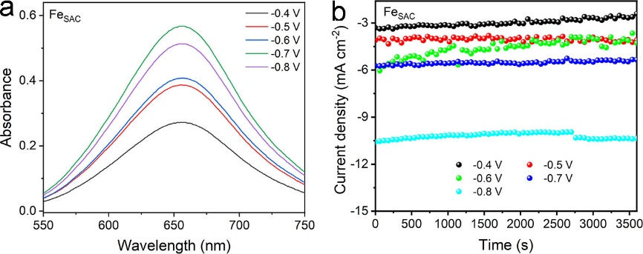
Supplementary Fig. 10 | Electrochemical NORR measurements over Fe_{SAC}. (a) UV-Vis absorption spectra at various potentials after dilute 10 times. (b) I-t curves at various potentials for 1 h.

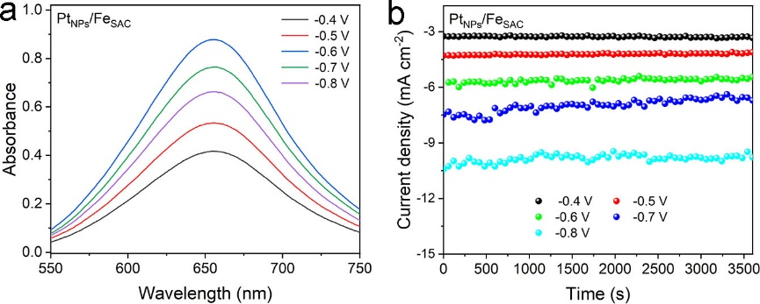
Supplementary Fig. 11 | Electrochemical NORR measurements over Pt_{NPs}/Fe_{SAC}. (a) UV-Vis absorption spectra at various potentials after dilute 10 times. (b) I-t curves at various potentials for 1 h.

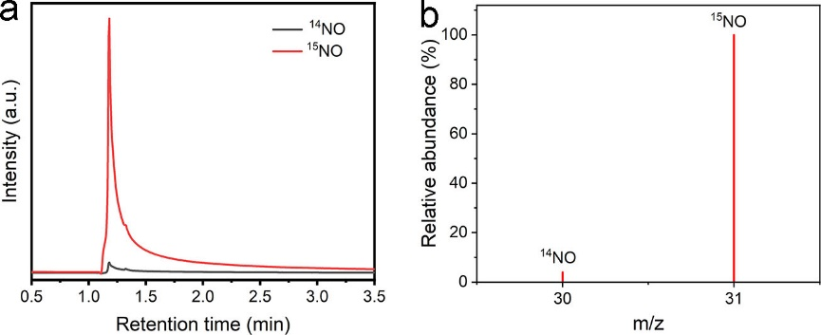
Supplementary Fig. 12 | The prepared 1% vol NO gas characterization. (a) Gas chromatograms. (b) Mass spectrum.
According to the following equation, the laboratory-prepared ¹⁵NO was collected in a gas sample bag and confirmed by GC-Mass analysis. As shown in Figure S12, a single intense peak at m/z=31 was observed in the profile.
3 Na¹⁵NO₂+H₂SO₄→2 ¹⁵NO↑+Na¹⁵NO₃+Na₂SO₄+H₂O

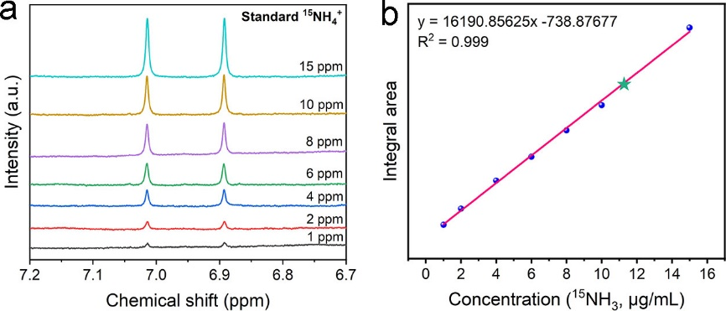
Supplementary Fig. 13 | (a) ¹H NMR spectra of standard NH₃ solution. (b) The standard curve of NMR integral area against NH₃ concentration.

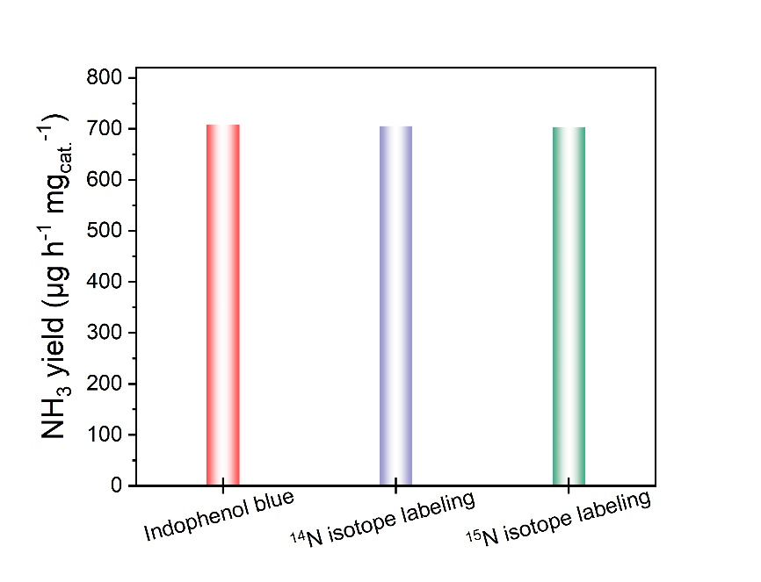
Supplementary Fig. 14 | The comparison between indophenol blue method and NMR method on NH₃ yield.

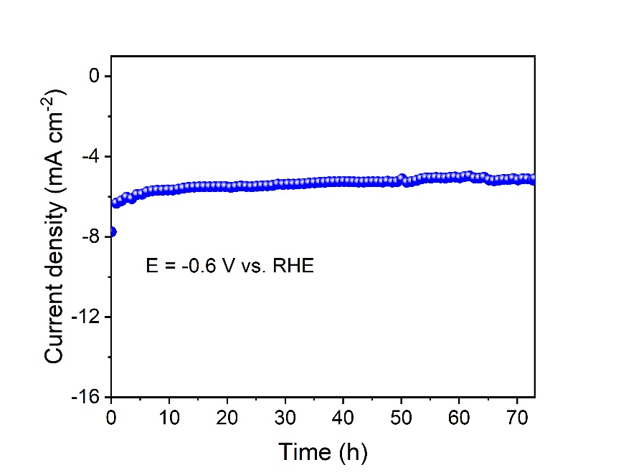
Supplementary Fig. 15 | Long-term stability test of Pt_{NPs}/Fe_{SAC} at -0.6 V.

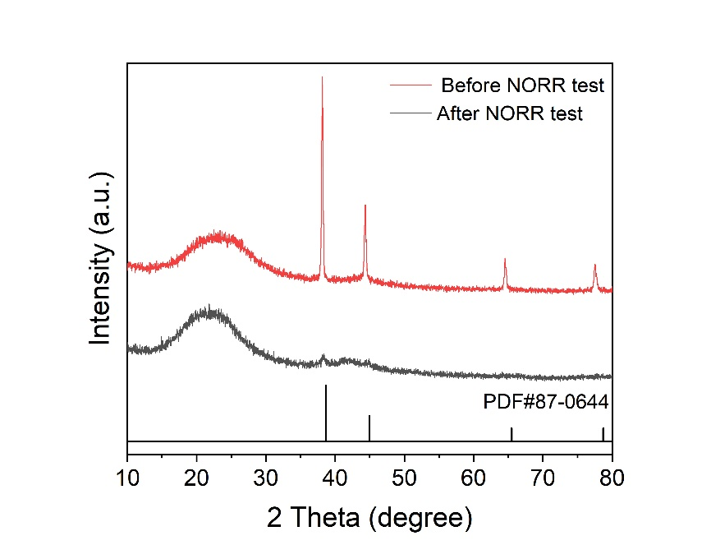
Supplementary Fig. 16 | XRD patterns of Pt_{NPs}/Fe_{SAC} before and after NORR test.

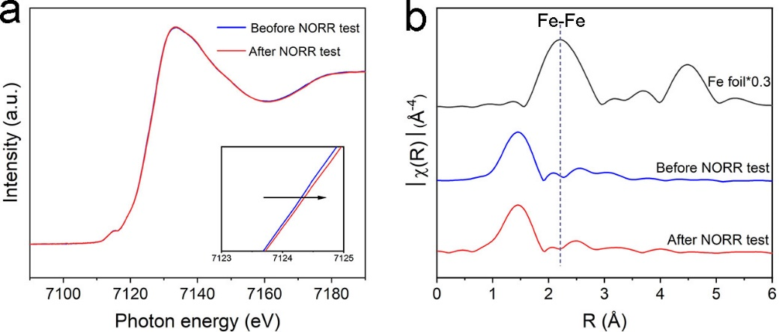
Supplementary Fig. 17 | (a) Fe K-edge XANES spectra of Pt_{NPs}/Fe_{SAC} before and after NORR test. (b) FT-EXAFS spectra at Fe K-edge.

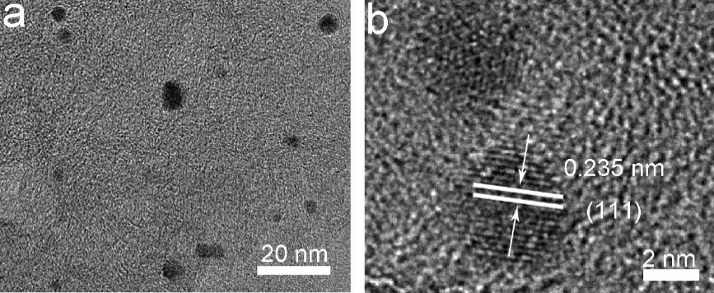
Supplementary Fig. 18 | (a) TEM and (b) HRTEM of Au_{NPs}/Fe_{SAC}.

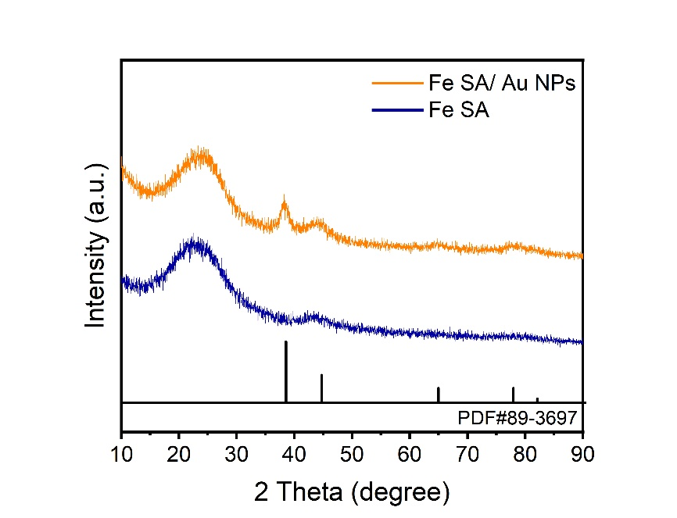
Supplementary Fig. 19 | XRD patterns for Au_{NPs}/Fe_{SAC} and Fe_{SAC}.

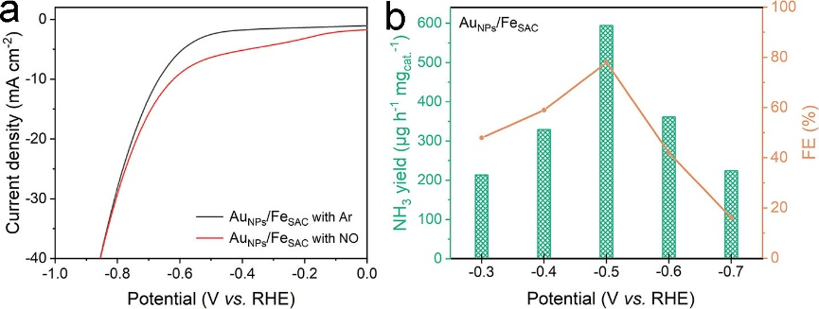
Supplementary Fig. 20 | (a) LSV curves of Au_{NPs}/Fe_{SAC} in Ar- and 1 vol% NO-saturated 0.5 M K₂SO₄. (b) NH₃ yield and FE with 1 vol% NO over Au_{NPs}/Fe_{SAC} at each given potential.

Supplementary Table 1. Fe and Pt content of Fe_{SAC} and Pt_{NPs}/Fe_{SAC} catalysts determined by ICP-OES.
Catalyst | Fe (wt%) | Pt (wt%)
Fe_{SAC} | 0.66 | ND
Pt_{NPs}/Fe_{SAC} | 0.62 | 0.84

Supplementary Table 2. EXAFS fitting parameters at the Fe K-edge.
Sample | Shell | CNª | R(Å)^{b} | σ²(Å²)^{c} | ΔE₀ (eV)^{d} | R factor
Fe foil | Fe-Fe | 8* | 2.47±0.01 | 0.0051 | 6.6±1.0 | 0.0037
Fe foil | Fe-Fe | 6* | 2.85±0.01 | 0.0064 | 6.6±1.0 | 0.0037
Fe_{SAC} | Fe-N | 4.4±0.3 | 1.96±0.01 | 0.0085 | -5.6±2.0 | 0.0086
Pt_{NPs}/Fe_{SAC} | Fe-N | 4.2±0.2 | 1.97±0.01 | 0.0091 | -4.9±1.5 | 0.0051

Supplementary Table 3 The Fe and Pt content after long-term stability test of Fe_{SAC} and Pt_{NPs}/Fe_{SAC} catalysts determined by ICP-OES.
Electrolyte | Fe (mg/L) | Pt (mg/L)
Fe_{SAC} after NORR test | 0.15 | ND
Pt _{NPs}/Fe_{SAC} after NORR test | 0.04 | 0.19
Before NORR test | ND | ND

Table S4. Comparison of NORR performance of Pt _{NPs}/Fe_{SAC} with other reported catalysts.
Catalyst | Electrolyte | c_{NO} | Potential (V) | Performance | Ref.
Pt _{NPs}/Fe_{SAC} | 0.5 M K₂SO₄ + 50 mM SB | 1 vol% | -0.6 | Y=709.7 μg h⁻¹mg⁻¹  FE=90.3% | This work
Pt _{NPs}/Fe_{SAC} | / | 1 vol% | 1.6 V vs. cell voltage | Y=3123.8 μg h⁻¹ mg⁻¹  FE=94.5% | This work
Ni@NC | 0.1 M HCl | 99.9 vol% | 0.16 | Y= 1233.2 μg mg⁻¹ h⁻¹  FE=92.5% | Adv. Sci. 2022, 9, 2201410
TiO_{2-x} | 0.2 M PBS | 10 vol% | -0.4 | Y=588.2 μg mg⁻¹ h⁻¹  FE=72.3% | Small 2023, 19, 2300291
MoS₂/GF | 0.1 M HCl +0.5 mM Fe^{II}SB | 10 vol% | -0.7 | Y=281.1 μg mg⁻¹ h⁻¹  FE=76.6% | Angew. Chem. Int. Ed. 2021, 60, 25263–25268
Cu@Co | 0.1 M Na₂SO₄ | 1 vol% | -0.5 | Y=78.4 μg mg⁻¹ h⁻¹  FE=76.54% | Adv. Mater. 2024, 36, 2309470
FeOCl-V_{Cl} | 0.1 M HCl+50 mM SB | 1.0 vol% | -0.5 | Y=455.4 μg mg⁻¹ h⁻¹  FE=91.06% | Angew. Chem. Int. Ed. 2024, 63, e202318792
Ru_{0.05}Cu_{0.95} | 0.5 M Na₂SO₄ | 25 vol% | -1.1 | Y=300.6 μg mg⁻¹ h⁻¹  FE=64.9% | Sci. China Chem. 2021, 64, 1493–1497
CuFe DS/NC | 0.1 M Na₂SO₄ | 99.9 vol% | -0.6 | Y=3188.1 μg mg⁻¹ h⁻¹  FE=90% | Adv. Mater. 2024, 36, 2309470
Ru-LCN | 0.5 M Na₂SO₄ | 1 vol% | -0.2 | Y=765.3 μg mg⁻¹ h⁻¹  FE=65.96% | ACS Energy Lett. 2022, 7, 1187−1194
MnO_{2-x} NA/TM | 0.2 M Na₂SO₄ | 10 vol% | -0.7 | Y=153.0 μg mg⁻¹ h⁻¹  FE=82.8% | Mater. Today Phys. 2022, 22, 100586.
Bi@C | 0.1 M Na₂SO₄ | 10 vol% | -0.4 | Y= 1592.5 μg mg⁻¹ h⁻¹  FE=93% | Nano Res. 2022, 15, 5032-5037
Ni₂P/CP | 0.1 M HCl | 10 vol% | 0.16 | Y= 406.4 μg mg⁻¹ h⁻¹  FE=76.9% | J. Mater. Chem. A 2021, 9, 24268- 24275
NiFe-LDH/NSA | 0.25 M Li₂SO₄ | 99.9 vol% | -0.7 | Y=1904.0 μg mg⁻¹ h⁻¹  FE=82.0% | Chem. Commun. 2022, 58, 8097-8100
Au-BNC | 0.1 M HCl | 99.9 vol% | -0.6 | Y=1877.4 μg mg⁻¹ h⁻¹  FE= 94.7% | Nano Res. 2024, 17. 1151–1164

