Supplementary Information
Schottky engineering of GDYO@Pt to boost piezoelectric and oxidative stress modulation for accelerated cranial regeneration
Authors
Kang Song^{1,2,4,5,6}, Xuezheng Geng^{1,2}, Huan Yin^{1,2}, Yanzhu Shi^{1,2}, Jiawei Wang^{1,2}, Jiayu Yu^{1,2}, Mateng Bai^{1,2}, Lizhen Wang^{1,2*}, Yurui Xue^{3*}, Chunli Song^{4,5,6*}, Yubo Fan^{1,2*}

Affiliations
¹Medical Engineering &Engineering Medicine Innovation Center, Hangzhou International Innovation Institute, Beihang University, Hangzhou 311115, China.
²Key Laboratory of Biomechanics and Mechanobiology (Beihang University), Ministry of Education, Beijing Advanced Innovation Center for Biomedical Engineering, School of Biological and Medical Engineering, Beihang University, Beijing 100191, China.
³State Key Laboratory of Supramolecular Structure and Materials, College of Chemistry, Jilin University, Changchun 130012, China.
⁴Department of Orthopedics, Peking University Third Hospital, Beijing 100083, China.
⁵Beijing Key Laboratory of Spinal Diseases, Beijing 100083, China.
⁶Engineering Research Center of Bone and Joint Precision Medicine, Beijing 100083, China.
*Corresponding authors:
Email: lizhenwang@buaa.edu.cn (L.W.);
yrxue@jlu.edu.cn (Y.X.);
schl@bjmu.edu.cn (C.S);
yubofan@buaa.edu.cn (Y.F.)

Supplementary Note 1 DFT theoretical calculations
To analyze the interaction, the density functional theory (DFT) calculations were performed using the CASTEP module in Materials Studio 2020. The electron exchange-correlation function was treated using a generalized gradient approximation (GGA) in the form proposed by Perdew, Burke, and Ernzerhof (PBE)⁵⁸. The energy cutoff of the plane waves was set to 500 eV. All presented geometry optimizations are obtained until the maximum displacement below 0.005 Å, energy tolerance below 1×10⁻⁵ eV, and the maximum forces lower than 0.02 eV Å⁻¹. The lattice constants larger than 15 Å along the x- and y-directions and vacuum region of about 20 Å along the z-direction was adopted. A k-point grid of 3 × 3 × 1 was selected for geometry optimizations, DFT-D3 was used for van der Waals correction. For the electron self-consistent field calculations, the convergence criterion was set to 1×10⁻⁵ Ha. The isosurface values for the charge density difference is 0.005 eV Å⁻³. The green and yellow regions correspond to electron accumulation and depletion, respectively. The adsorption energy (E_{ads}) between substrate and adsorbed molecule was defined by the following formula:
E_{ads}=E_{tot}–E_{GDYO@Pt}–E_{H2O}
Where E_{tot}, E_{GDYO@Pt}, and E_{H2O} are the total energy of the GDYO@Pt adsorbed H₂O molecule, GDYO@Pt and H₂O molecule, respectively.

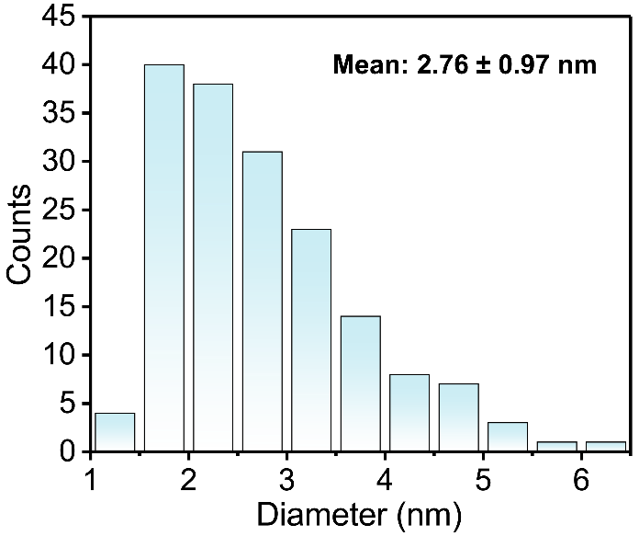

Supplementary Fig. 1 The size distribution of Pt nanoparticles in GDYO@Pt.

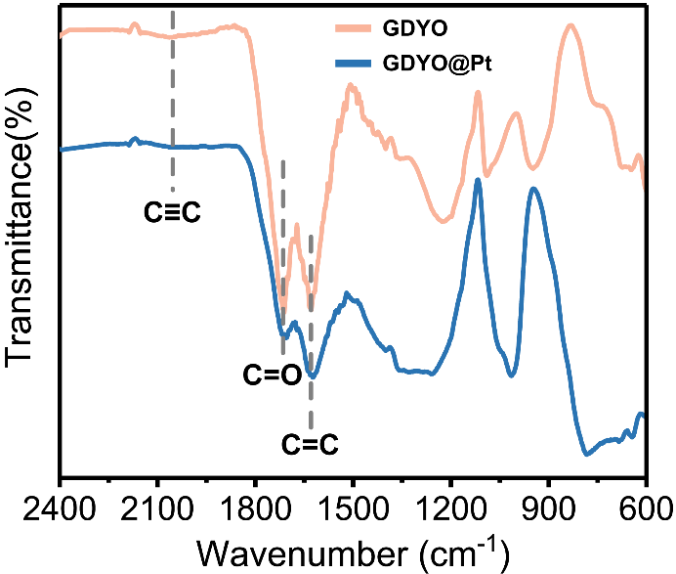

Supplementary Fig. 2 The infrared spectra of GDYO and GDYO@Pt.

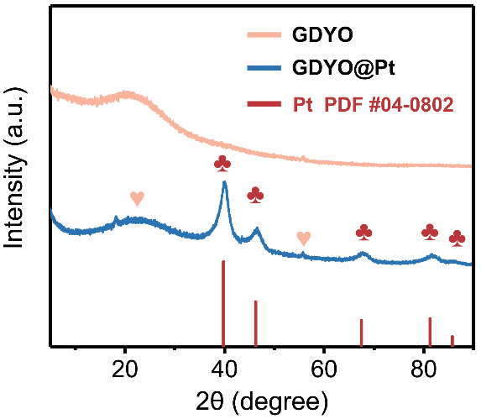

Supplementary Fig. 3 XRD patterns of GDYO and GDYO@Pt.

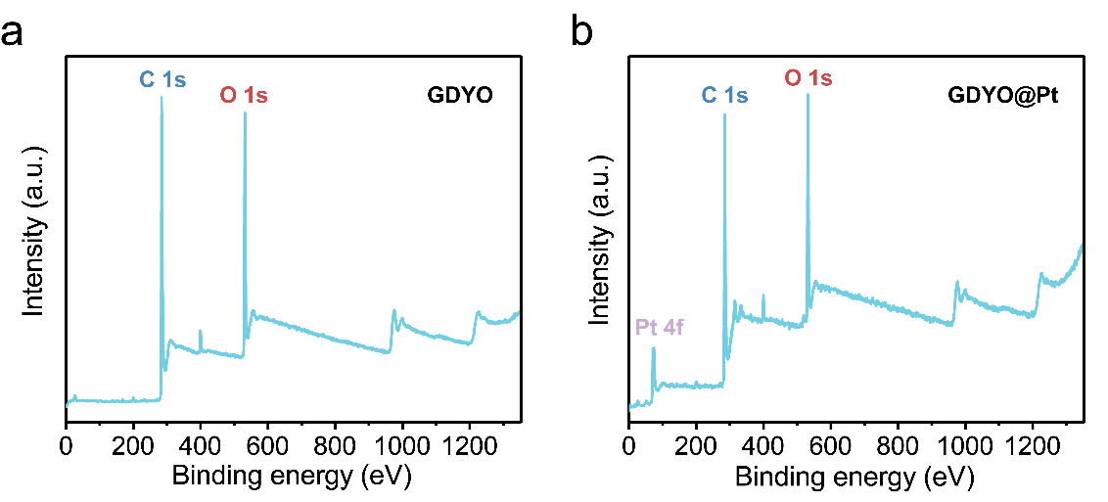

Supplementary Fig. 4 XPS survey spectra. The XPS survey spectra of (a) GDYO and (b) GDYO@Pt.

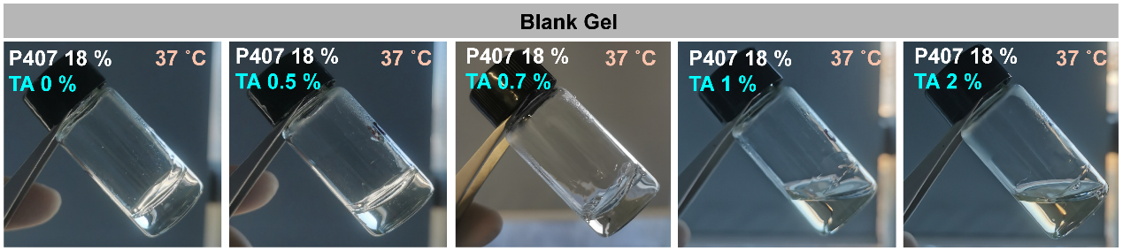

Supplementary Fig. 5 The digital photographs of gels of different prescriptions at 37°C.

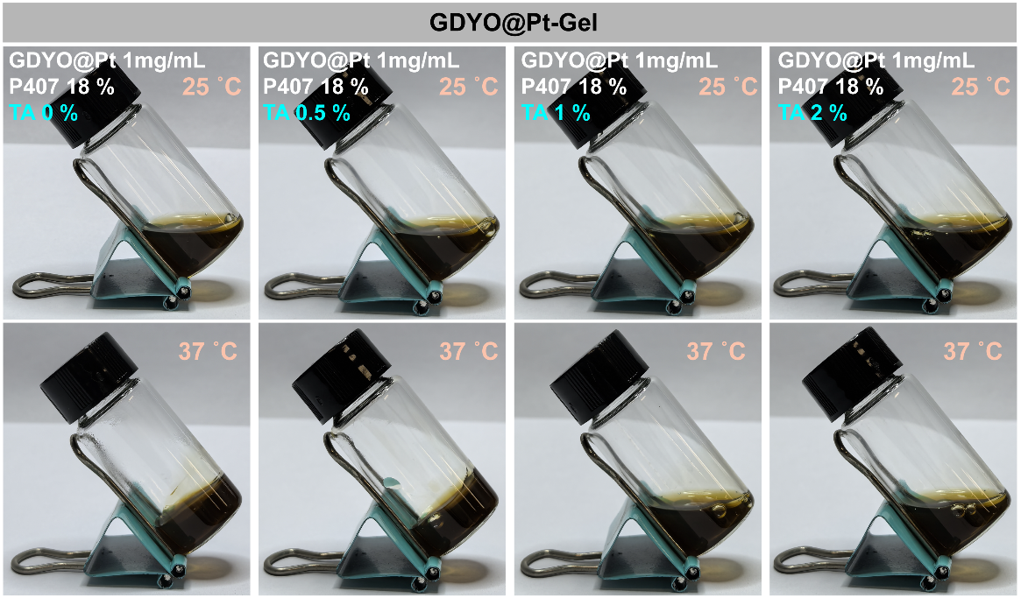

Supplementary Fig. 6 The digital photographs of different prescriptions of GDYO@Pt gel at 37°C.

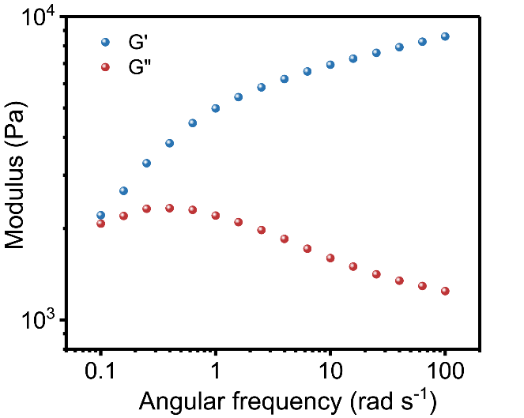

Supplementary Fig. 7 The oscillatory frequency scanning of GDYO@Pt gel.

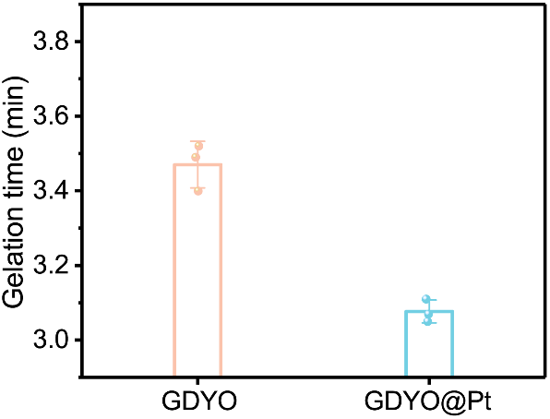
Supplementary Fig. 8 The gelation time of GDYO and GDYO@Pt.

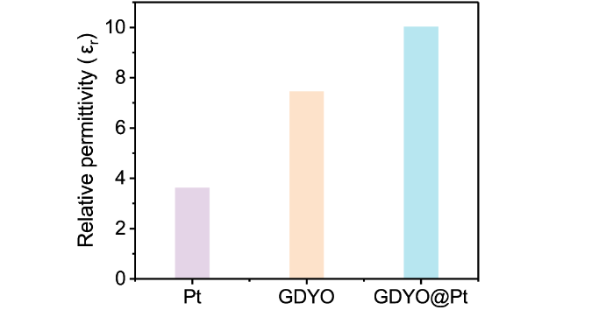
Supplementary Fig. 9 The relative permittivity of Pt, GDYO and GDYO@Pt.

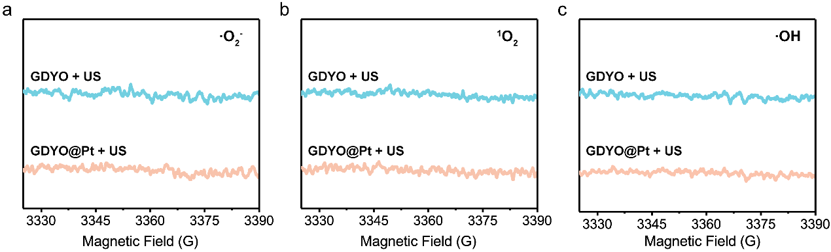
Supplementary Fig. 10 The production of ROS ((a) ·O₂⁻, (b) ¹O₂ and (c) ·OH) in GDYO and GDYO@Pt under ultrasonic irradiation was monitored via ESR spectral analysis.

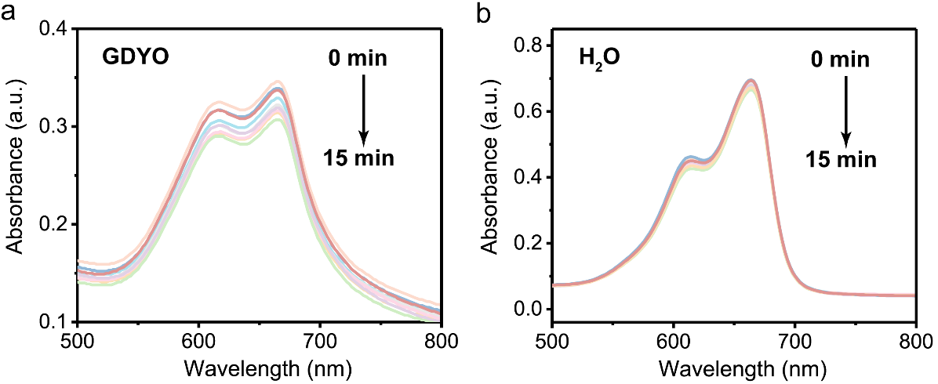
Supplementary Fig. 11 Time-dependent MB consumption by (a) GDYO solution and (b) H₂O under US irradiation.

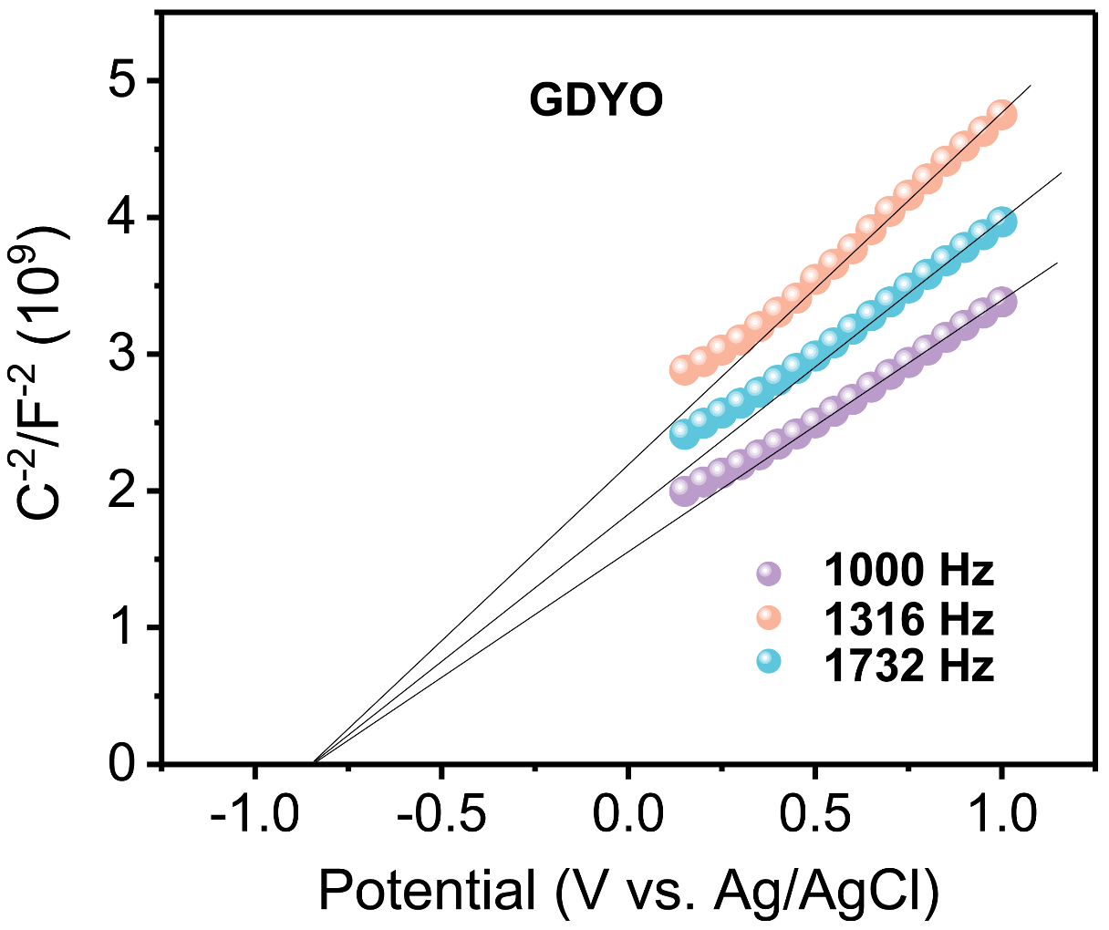
Supplementary Fig. 12 Mott-Schottky curves of GDYO nanosheets.

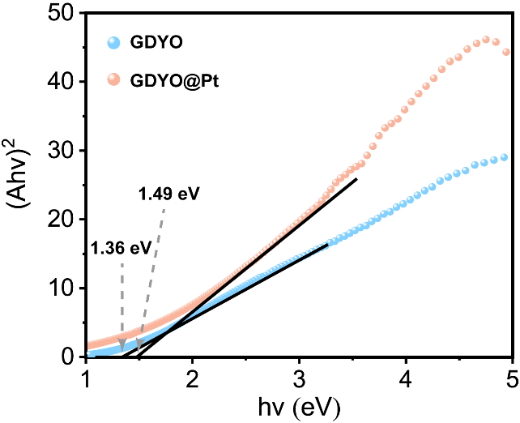
Supplementary Fig. 13 Energy bandgap of GDYO and GDYO@Pt.

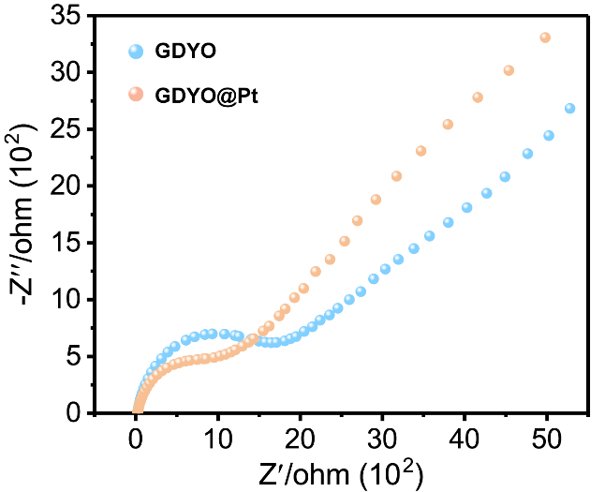
Supplementary Fig. 14 Electrochemical impedance spectra of GDYO and GDYO@Pt.

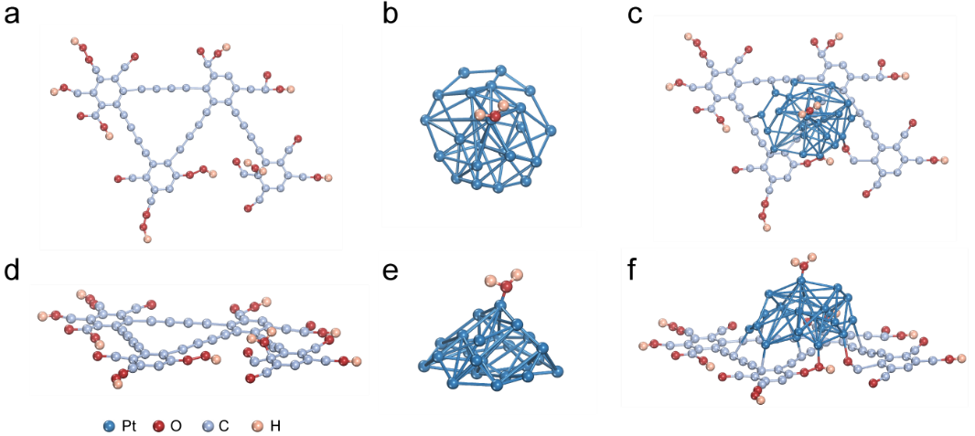
Supplementary Fig. 15 Top and side views of the water adsorption structure model corresponding to (a, d) GDYO, (b, e) Pt and (c, f) GDYO@Pt.

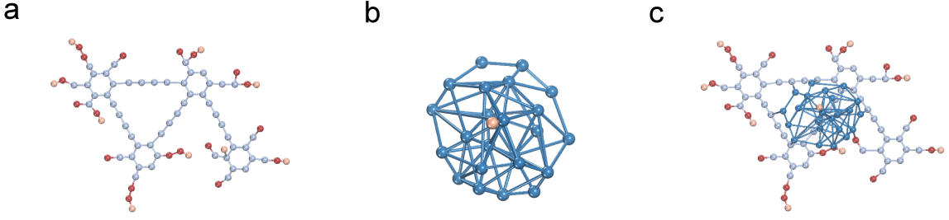
Supplementary Fig. 16 Top views of (a) GDYO, (b) Pt and (c) GDYO@Pt for corresponding adsorbed H atomic structural models.

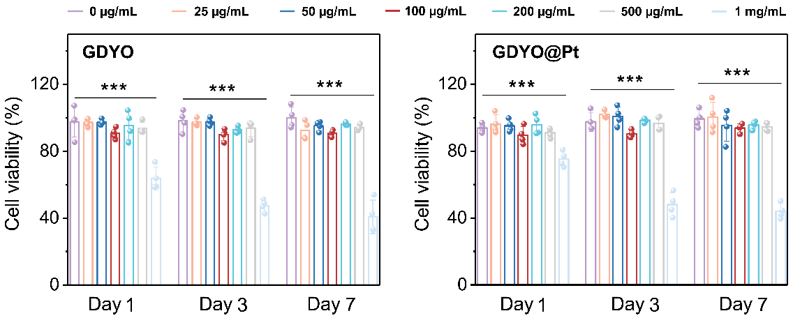
Supplementary Fig. 17 Toxicity of GDYO and GDYO@Pt with different concentrations on BMSCs after incubation for 1 d, 3 d and 7 d. Statistical differences were calculated using independent samples T-test (***P < 0.001, **P < 0.01 and *P < 0.05).

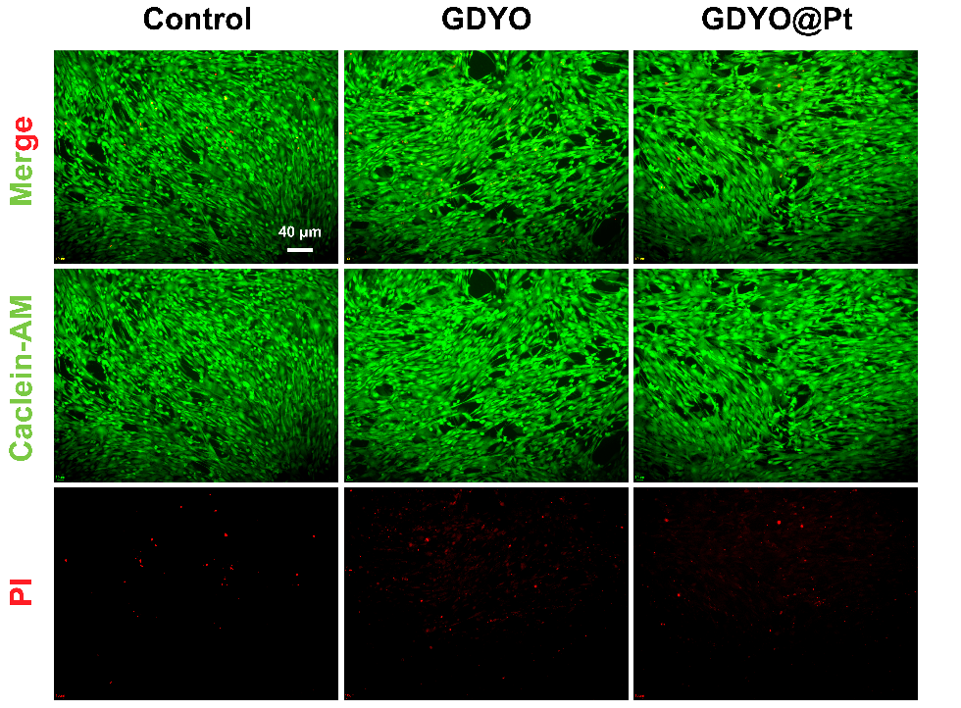
Supplementary Fig. 18 Fluorescence images of BMSCs stained with Calcein-AM/PI after 5-day incubation with PBS, GDYO, and GDYO@Pt (200 ug/mL).

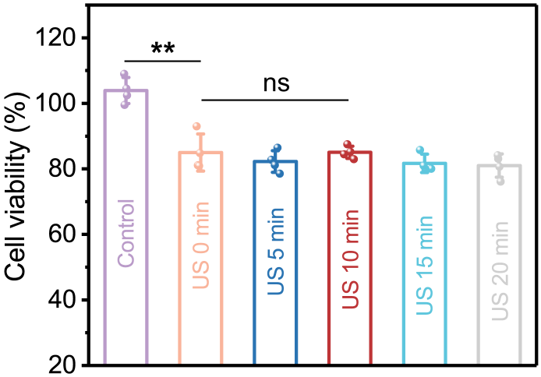
Supplementary Fig. 19 The cell viability of BMSCs after 3-day culture with different ultrasound treatment times. Statistical differences were calculated using independent samples T-test (***P < 0.001, **P < 0.01 and *P < 0.05).

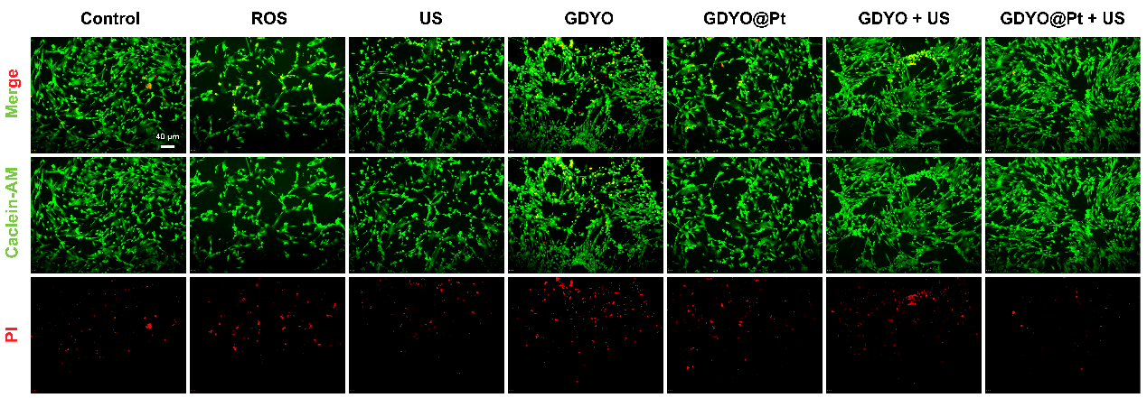
Supplementary Fig. 20 The fluorescence imaging of BMSCs treated with Calcein-AM (green, live cells) and PI (red, dead cells) post-different therapeutic exposures.

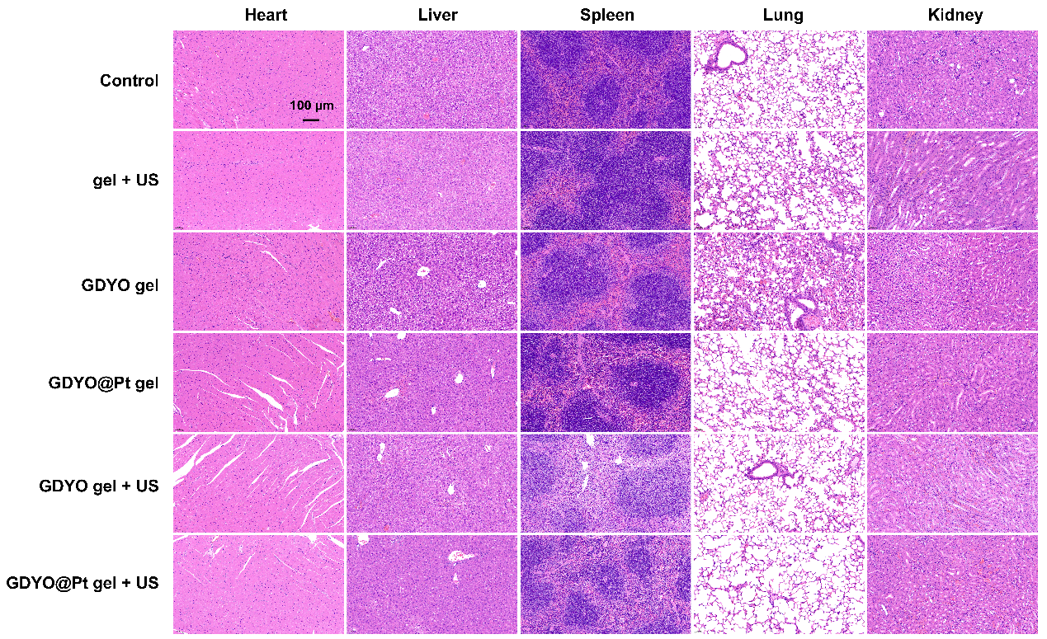
Supplementary Fig. 21 H&E-stained tissue sections of major organs (heart, liver, spleen, lungs, and kidneys) from different mouse groups post-treatment.

Supplementary Table 1 Primer sequences of genes. (species, mouse).
