Supplementary Information:

MTBAN: An enhanced variant effect predictor based on a deep generative model
Ha Young Kim¹, Woosung Jeon¹ and Dongsup Kim^{1,*}

¹Department of Bio and Brain Engineering, Korea Advanced Institute of Science and Technology, Daejeon 34141, Republic of Korea
*Corresponding author (kds@kaist.ac.kr)

Supplementary Table S1. Performances of MTBAN and other predictors on the HumVar dataset from Grimm et al. consisting of total 772 deleterious and 772 benign variants.
Predictor | ROC AUC | PR AUC | Accuracy | MCC | Precision | Specificity | Sensitivity | F-score | NPV
MTBAN | 0.882 | 0.871 | 0.794 | 0.597 | 0.75 | 0.706 | 0.882 | 0.811 | 0.857
SIFT | 0.858 | 0.859 | 0.789 | 0.583 | 0.76 | 0.729 | 0.849 | 0.802 | 0.827
PolyPhen-2 | 0.852 | 0.847 | 0.782 | 0.574 | 0.735 | 0.699 | 0.868 | 0.796 | 0.846
MutationAssessor | 0.861 | 0.857 | 0.768 | 0.539 | 0.745 | 0.731 | 0.806 | 0.774 | 0.795
fathmm-MKL | 0.867 | 0.831 | 0.781 | 0.585 | 0.72 | 0.636 | 0.924 | 0.809 | 0.891
MPC | 0.851 | 0.875
DANN | 0.85 | 0.814
phyloP | 0.85 | 0.843
phastCons | 0.809 | 0.842
GenoCanyon | 0.799 | 0.799
GERP++ | 0.804 | 0.766
**ROC-AUC, Receiver Operating Characteristic Area Under Curve; PR-AUC, Precision-Recall Area Under Curve; MCC, Matthews Correlation Coefficient; NPV, Negative Predictive Value

Supplementary Table S2. Performances of MTBAN and other predictors on the UniFun, BRCA1-DMS, and TP53-TA datasets from Mahmood et al. consisting of total 472 deleterious and 472 benign variants.
Predictor | ROC AUC | PR AUC | Accuracy | MCC | Precision | Specificity | Sensitivity | F-score | NPV
MTBAN | 0.872 | 0.87 | 0.771 | 0.56 | 0.718 | 0.648 | 0.894 | 0.796 | 0.86
SIFT | 0.876 | 0.886 | 0.728 | 0.496 | 0.663 | 0.53 | 0.926 | 0.773 | 0.877
PolyPhen-2 | 0.861 | 0.868 | 0.733 | 0.506 | 0.667 | 0.535 | 0.93 | 0.777 | 0.884
MutationAssessor | 0.864 | 0.847 | 0.755 | 0.536 | 0.694 | 0.598 | 0.91 | 0.788 | 0.87
fathmm-MKL | 0.824 | 0.816 | 0.658 | 0.37 | 0.604 | 0.396 | 0.919 | 0.729 | 0.831
MPC | 0.637 | 0.62
DANN | 0.746 | 0.678
phyloP | 0.82 | 0.836
phastCons | 0.755 | 0.81
GenoCanyon | 0.687 | 0.672
GERP++ | 0.728 | 0.65
**ROC-AUC, Receiver Operating Characteristic Area Under Curve; PR-AUC, Precision-Recall Area Under Curve; MCC, Matthews Correlation Coefficient; NPV, Negative Predictive Value

Supplementary Figure S1. Distribution of MTBAN predictions (z-scores) for 1221 disease and 1221 neutral protein variants obtained from the Humsavar database (release 03/2020). From this z-score distribution, we divided the distribution into equal-length z-score intervals, calculated the proportion of pathogenic variants in each z-score interval, and use this information to predict the probability of pathogenicity for a given variant. Also, from the same z-score intervals, we classify a variant as disease-causing or neutral based on a z-score threshold (0.647) that maximizes the classification accuracy.
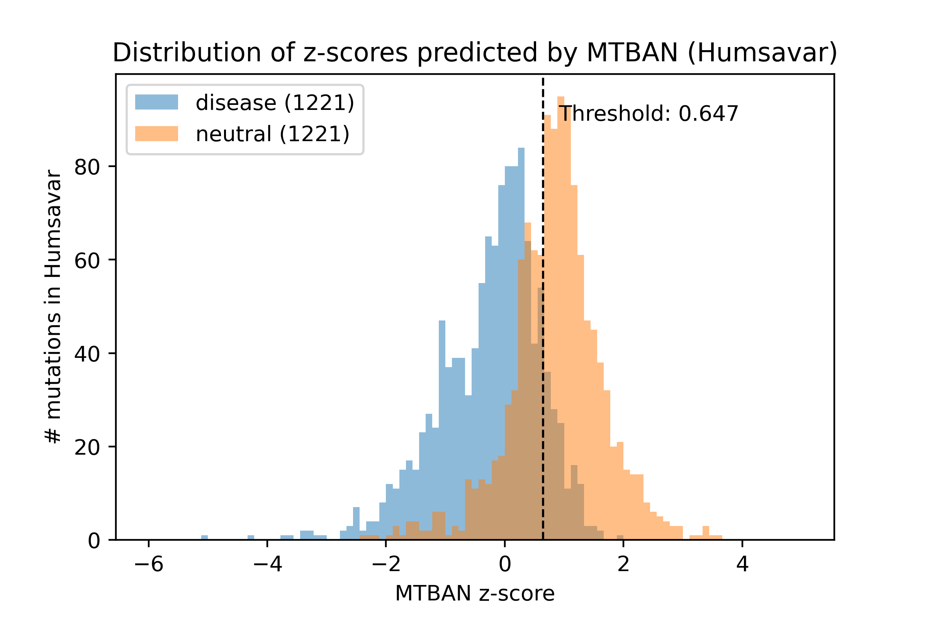

Supplementary Figure S2. MTBAN web server workflow. The web server takes in protein UniProt accession and a set of amino acid variants as input. First, it checks if pre-computed predictions exist and can be returned immediately to the user. If predictions do not exist, it checks if a sequence alignment of the target protein sequence is present in the database. If an alignment is present, it uses the alignment to train model; if not, it builds an alignment first. Subsequently, sequence weights are calculated, and the prediction model is trained. After model training, the predictions are returned to the user.
