Supplementary and Optional Figures
Figure 1 (alt.). Graphical summary of the oyster shell-based antifouling process (cover suggestion or visual abstract).
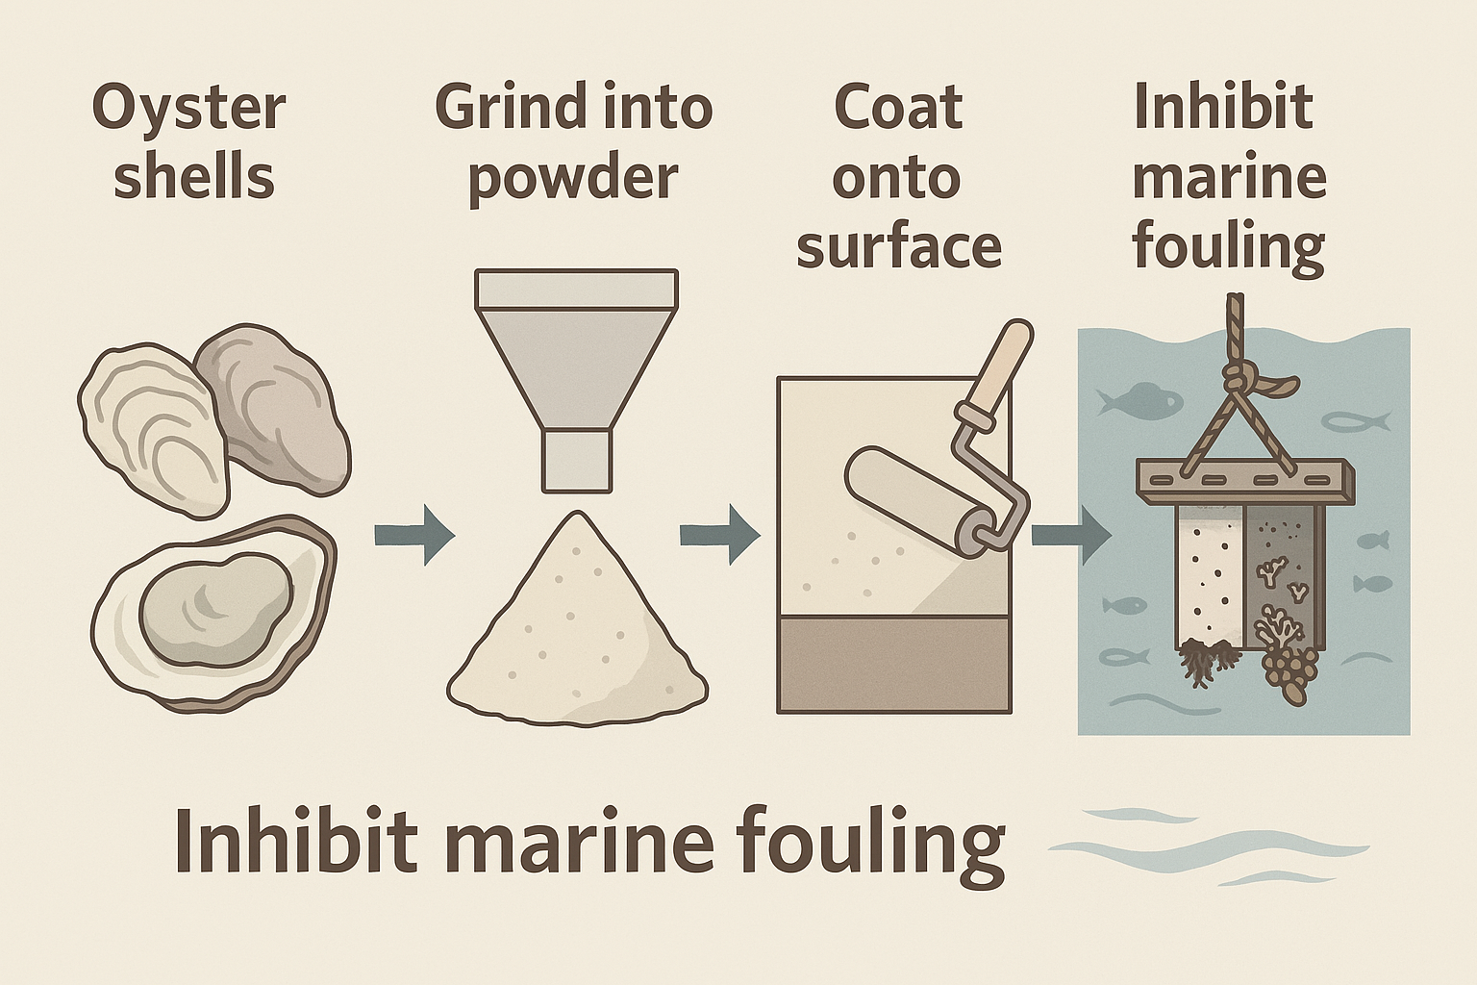
Figure S1. Combined comparison of contact angle, attachment rate, and biofouling image results across coatings.
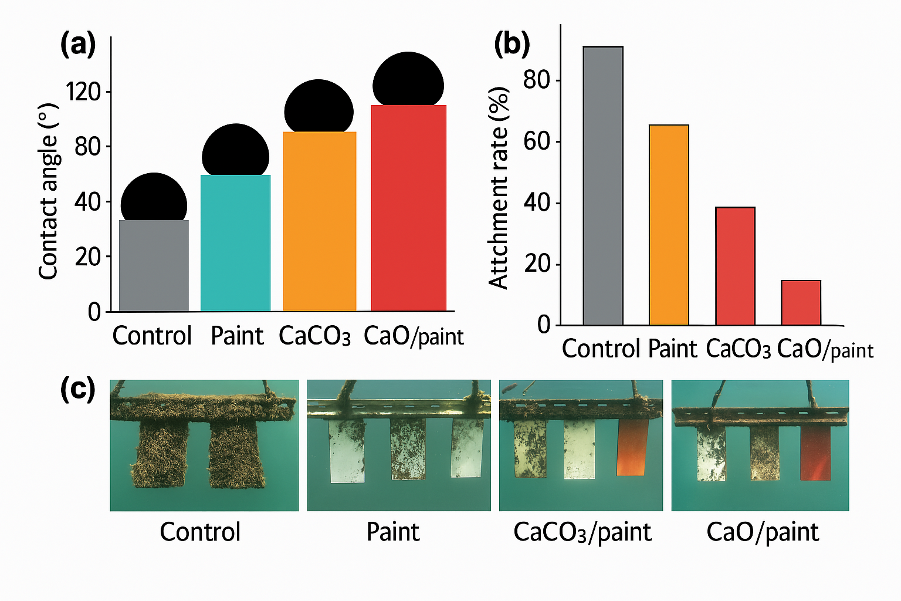

Supplementary Figure S2.
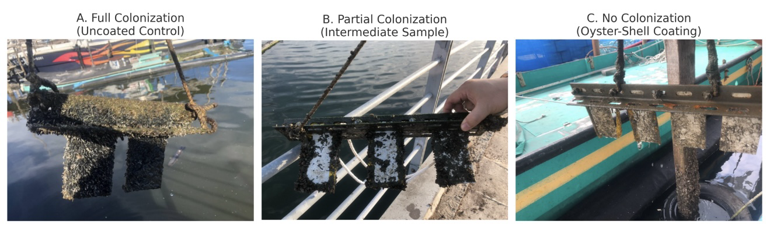
Field Comparison of Biofouling Behavior at Anping Harbor
A. Full Colonization: Uncoated control panels exhibit extensive algal and invertebrate biofouling after prolonged immersion.
B. Partial Colonization: Intermediate-performance coatings show moderate fouling resistance under identical exposure conditions.
C. No Colonization: Panels treated with oyster-shell-based antifouling coating demonstrate excellent resistance, with minimal surface attachment observed after 12 months.

Supplementary Figure S1
Field comparison of fouling resistance (left) and contact angle measurements (right) for uncoated and coated panels. The oyster-shell-based coating demonstrates significantly reduced biofouling and enhanced surface hydrophobicity, with contact angle increasing from ~70° (uncoated) to ~145° (coated).
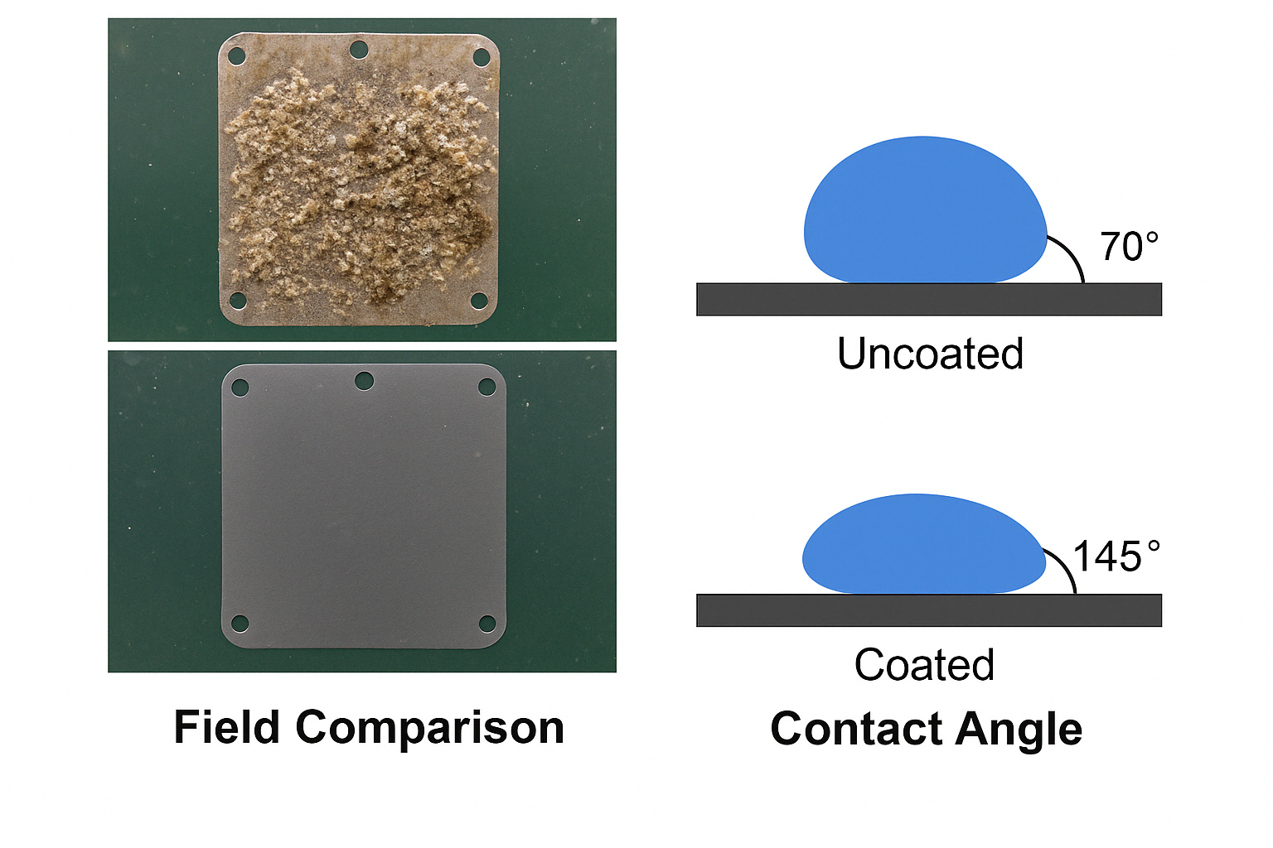
Supplementary Figure S1 further visualizes the coating's dual functionality in suppressing biofouling and enhancing hydrophobicity through side-by-side comparisons.

