Supplementary materials

Seasonal Influenza Dynamics in Korea Before and After COVID-19: Parameter Estimation using the Ensemble Kalman Filter Method
Wasim Abbas^{1,¶}, Yeonsu Lee^{2,¶}, Sangil Kim^{3,4}, Hyojung Lee^{2,*}
¹Nonlinear Dynamics and Mathematical Application Center, Kyungpook National University, Daegu 41566, Republic of Korea
²Department of Statistics, Kyungpook National University, Daegu, 41566, Republic of Korea
³Department of Mathematics, Pusan National University, Pusan, 46241, Republic of Korea
⁴Institute for Future Earth, Pusan National University, Busan, 46241, Republic of Korea

Ensemble Kalman Filter (EnKF) Algorithm
The Ensemble Kalman Filter (EnKF) was implemented to assimilate observed influenza incidence data into the SEIR model over discrete time steps $t=2,3,…,T$, where $T$ is the total number of measurements. The algorithm iteratively performs forecast and update steps for an ensemble of n members, estimating the augmented state vector $x=[ x_{state},pram]^{⊤}$, where $x_{state}=[S,E,I,R]^{⊤}$ are the SEIR states and $pram=[R0_{min},R0_{max},σ,γ,θ,,E_{0}]^{⊤}$are the parameters. The observation is the incidence $z_{t}=σE_{t}$.
Initialization
- Ensemble Size: $n=200.$
- Initial Ensemble: For $i=1,2,⋯,n$,
$x_{0|i}={\left[x_{state,0}, param_{0}\right]}^{⊤}$, $x_{state,0}=[S_{0},E_{0},I_{0},R_{0}]^{⊤}$, $param_{0}$ is the column vector of estimated parameters (using 1st approach),
- Iterative Steps (for $t = 2, 3, ⋯, T$)
- Forecast Step
- State Propagation: For each ensemble member $i = 1, 2, ⋯, n$,
$$x_{t|i}^{f}​=f\left(x_{t-1∣i}​,param_{t-1∣i}​,q(t)\right)+w_{t|i}​,$$
where, $f\left(⋅\right)$ is the SEIR model solution over $\left[t-1, t\right]$, $q(t)$ is the interpolated absolute humidity, and $w_{t|i}\sim N(0,Q_{t}​)$ is the process noise with covariance $Q_{t}$.
- Update Step
- Observation Forecast: For each $i=1,2,⋯,n$,
$y_{t|i}^{f}​=h\left(x_{t|i}^{f}, {param}_{t|i}^{f}\right)=σ_{t|i}E_{t|i}^{f}​$,
where $h\left(⋅\right)$ is the observation operator, and
- Forecast Mean: ${\hat{x}}_{t}^{f}​=\sum_{i=1}^{n}{x_{t∣i}^{f}}​​$, ${\hat{y}}_{t}^{f}​=\sum_{i=1}^{n}{y_{t∣i}^{f}}​​$.
- Ensemble Deviation:
$$E_{t}^{f}=\left[x_{t|1}^{f}-{\hat{x}}_{t}^{f},⋯,x_{t|n}^{f}-{\hat{x}}_{t}^{f}\right],E_{y,t}^{f}=\left[y_{t|1}^{f}-{\hat{y}}_{t}^{f},⋯,y_{t|n}^{f}-{\hat{y}}_{t}^{f}\right]$$
- Covariance Matrices
$$P_{xy,t}​=\frac{1}{n-1}​E_{t}^{f}​(E_{y,t}^{f})^{⊤},P_{yy,t}​​=\frac{1}{n-1}E_{y,t}^{f}​(E_{y,t}^{f}​)^{⊤}.$$
- Observation Noise: $v_{t∣i​}∼N(0,R_{t}​),$ where $R_{t}$ the input observation noise covariance is at the time $t$ and $R_{e,t}=\frac{1}{n-1}V_{t}V_{t}^{⊤}$with $V_{t} =\left[v_{t|i},⋯, v_{t|n}\right]$.
- Kalman Gain:
$K_{t}=P_{xy,t}{\left(P_{yy,t}+R_{e,t}\right)}^{⊤}$.
- State Update: For each $i=1,2,⋯,n$
$x_{t|i}=x_{t|i}^{f}+K_{t}\left(z_{t}+v_{t|i}-y_{t|i}^{f}\right)$,
- Posterior Mean: ${\hat{x}}_{t}​=\sum_{i=1}^{n}{x_{t|i}}​​$, ${\hat{y}}_{t}​=\sum_{i=1}^{n}{y_{t|i}}$.
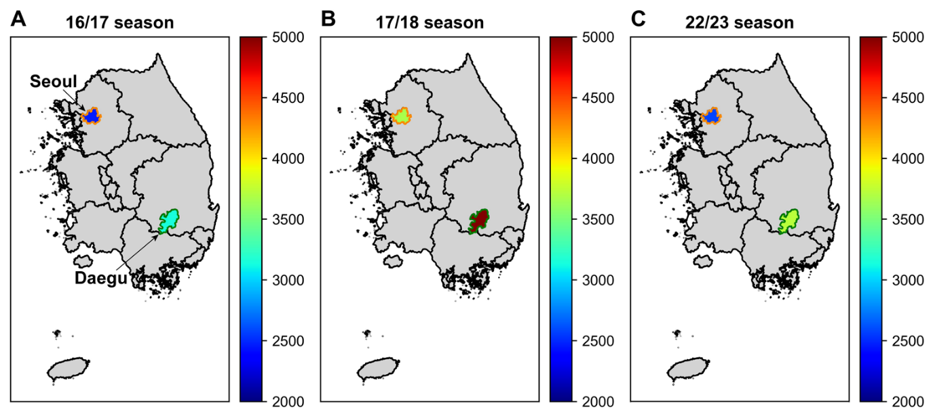Figure S1. Cumulative influenza cases per 100,000 in Seoul and Daegu by season. Cumulative influenza cases per 100,000 in A the 16/17 season, B the 17/18 season, and C the 22/23 season. The orange line represents Seoul, and the green line represents Daegu.
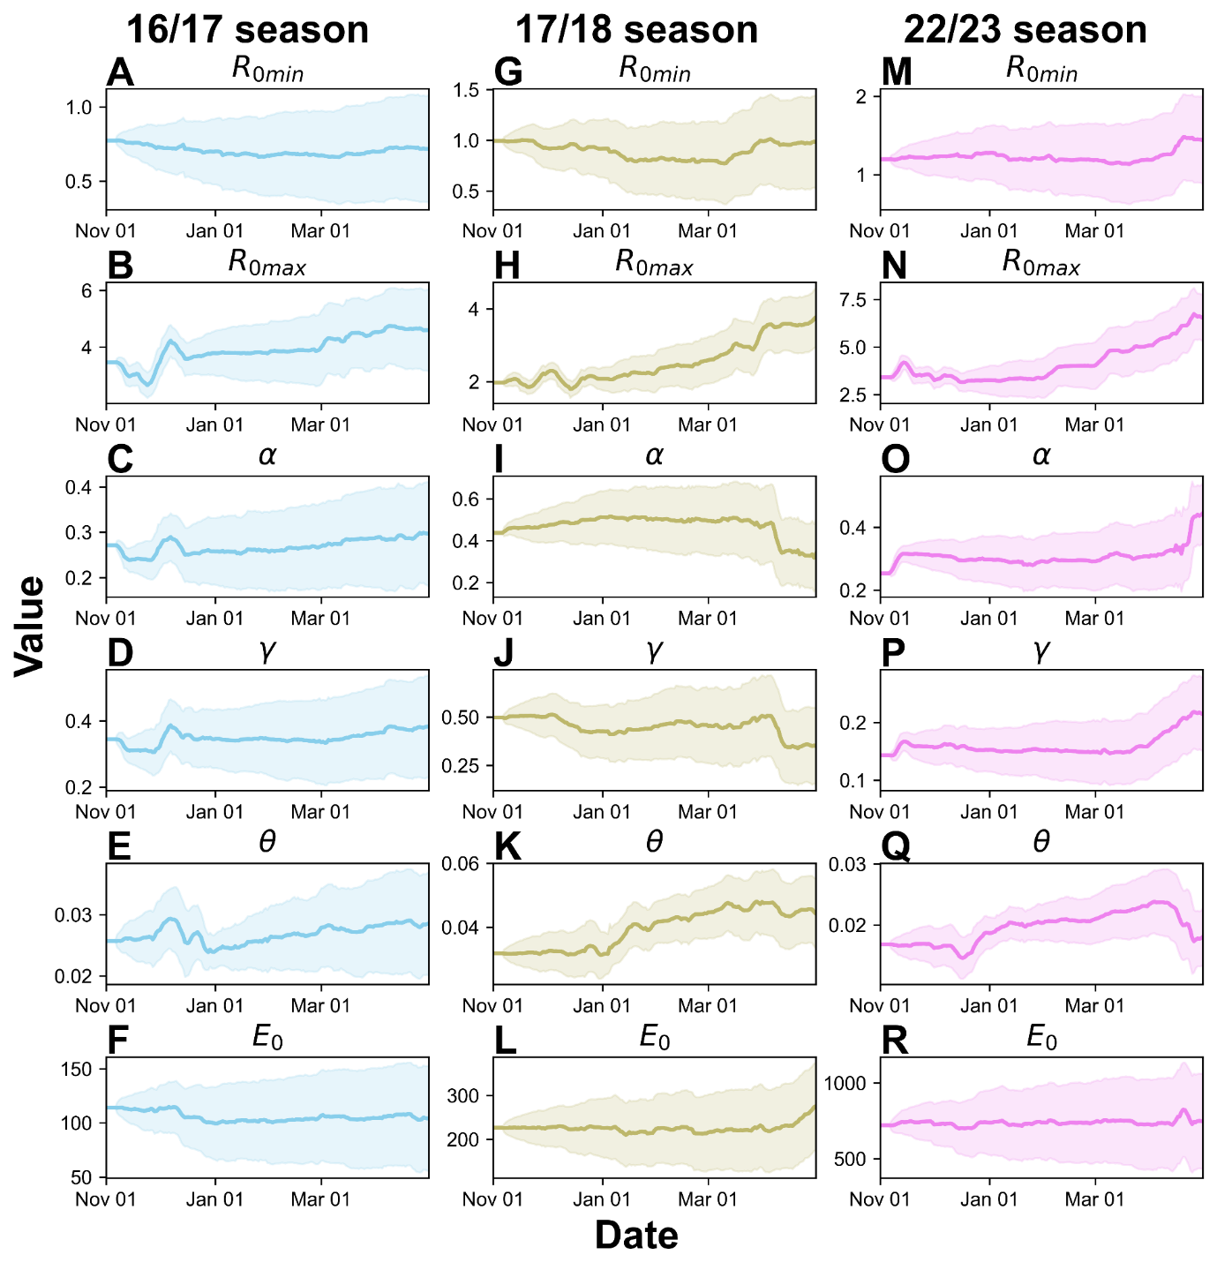
Figure S2. Time-dependent estimated parameter values via EnKF in Seoul.
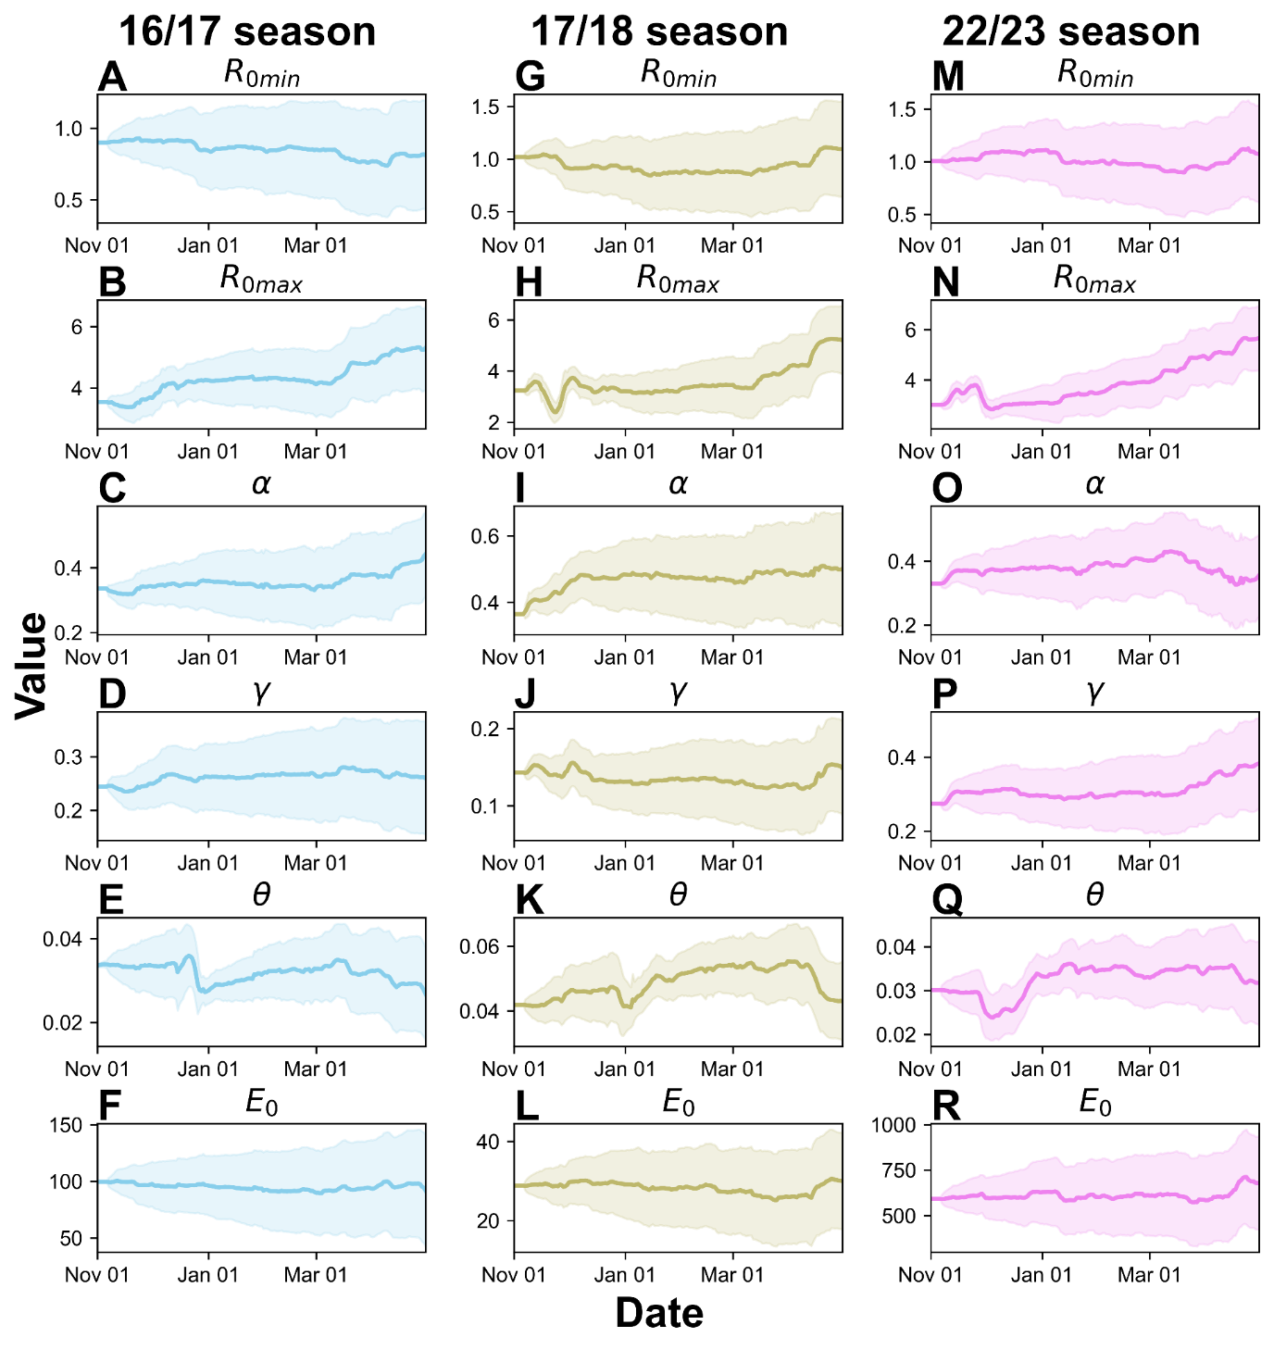
Figure S3. Time-dependent estimated parameter values via EnKF in Daegu.
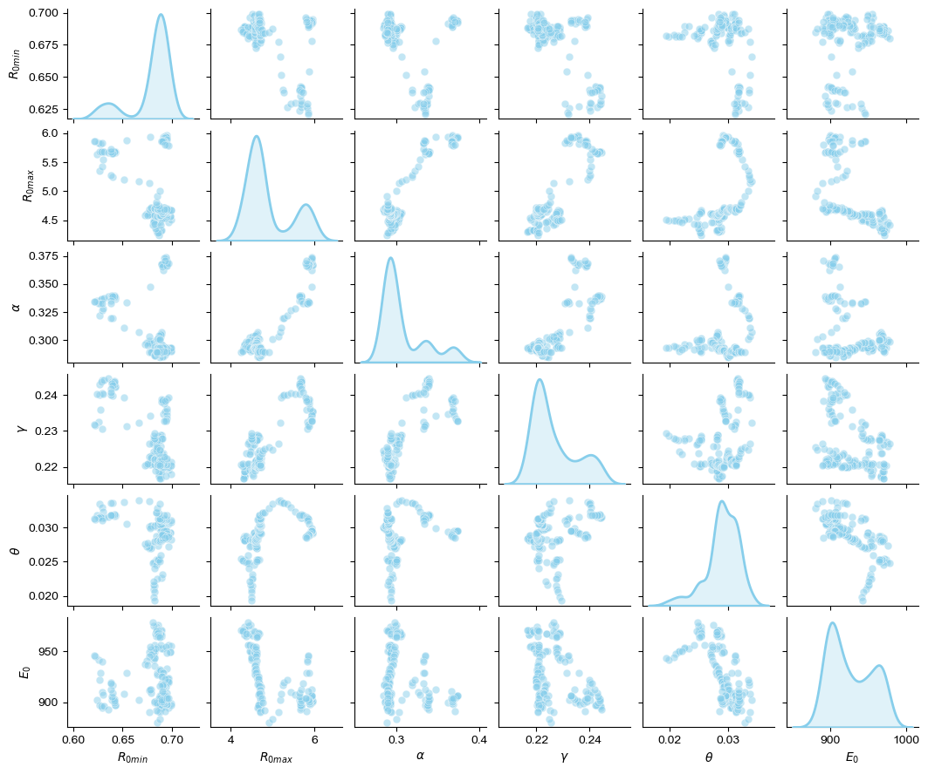
Figure S3. Analysis of Parameter Relationships in Korea (16/17 Season)
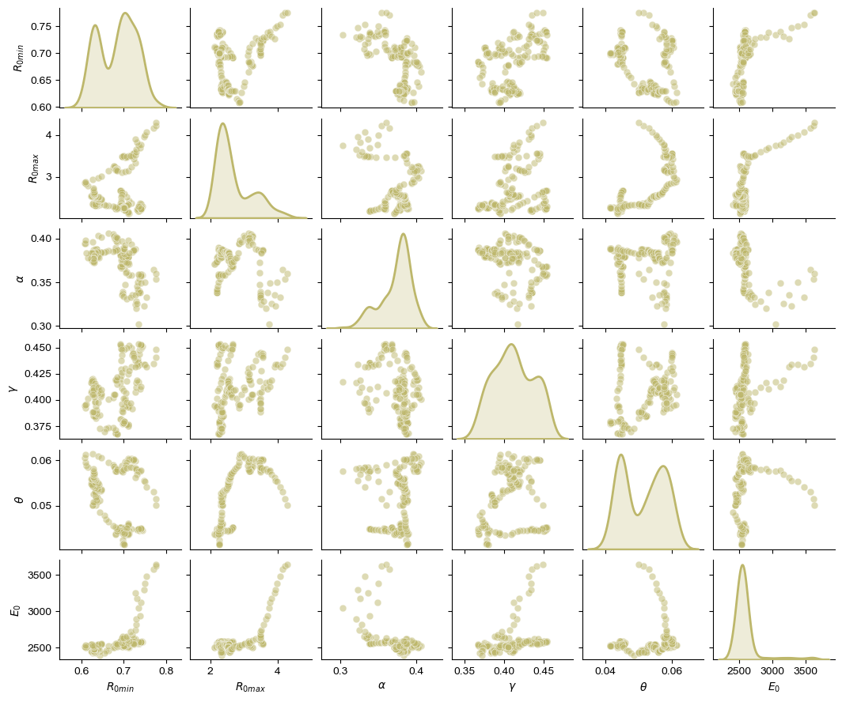
Figure S4. Analysis of Parameter Relationships in Korea (17/18 Season)
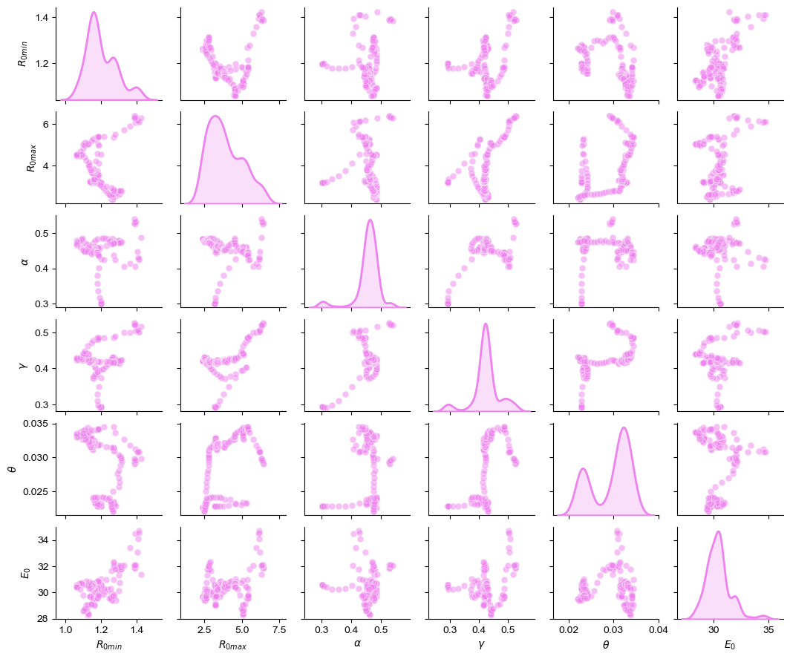
Figure S5. Analysis of Parameter Relationships in Korea (22/23 Season)
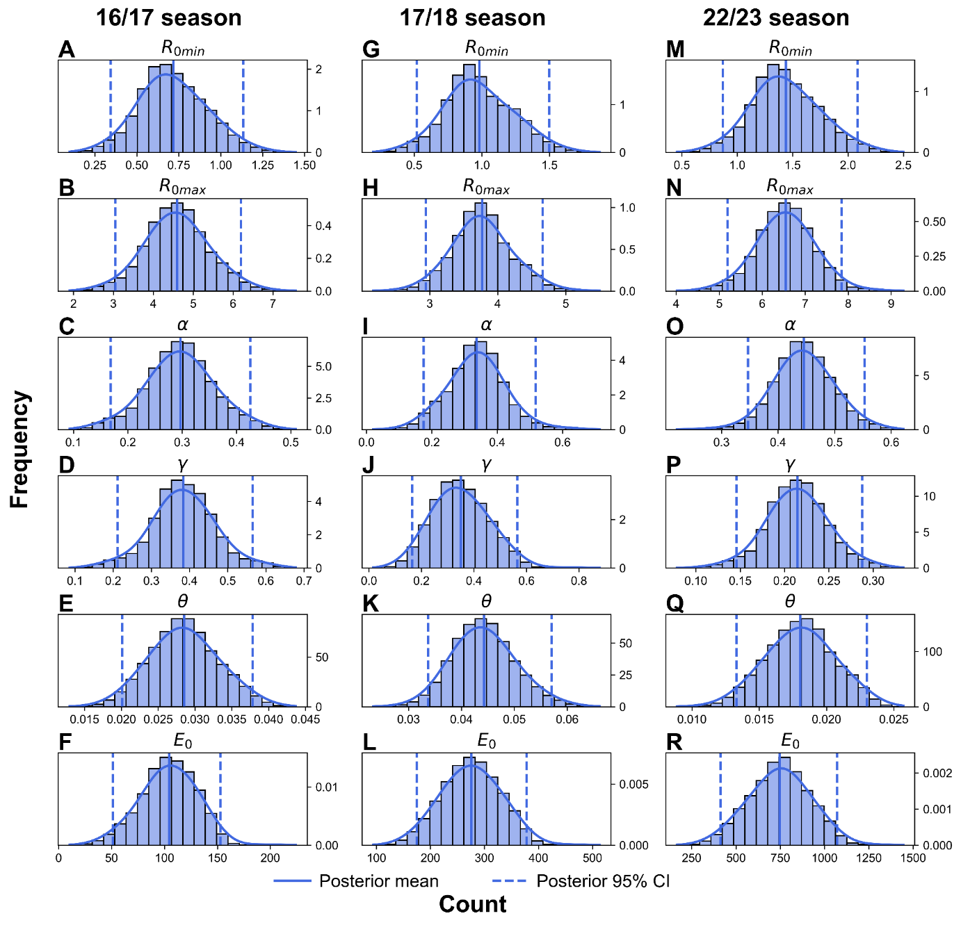Figure S7. Posterior distributions of parameters estimated via EnKF in Seoul.
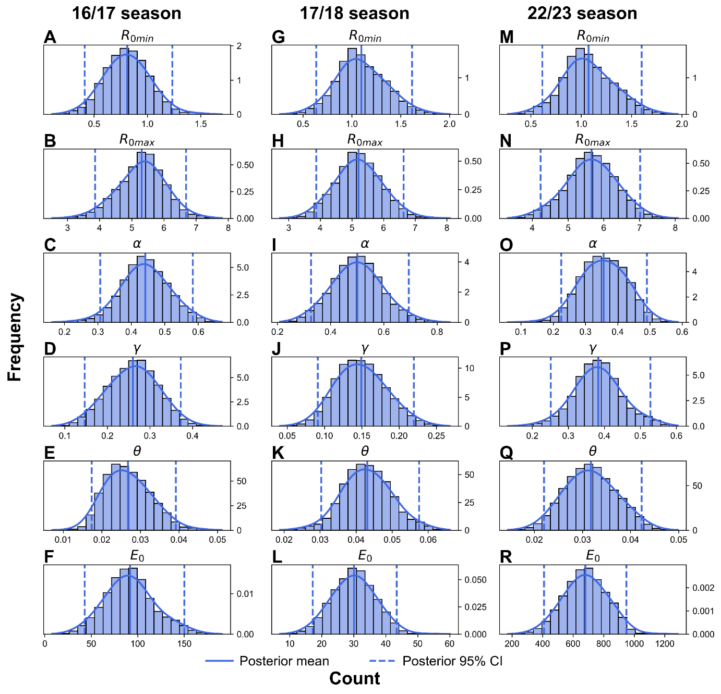
Figure S8. Posterior distributions of parameters estimated via EnKF in Daegu.

