Supplementary information
Fig S1 shows the outcomes of the model compared with observed data for pigs infected at 4 weeks of age with 100, 5,000 and 20,000 eggs. Please note that the confidence intervals are confidence intervals for the regression coefficient and not prediction intervals.
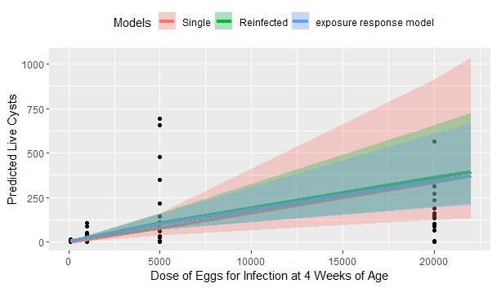
In Fig S2, data and predictions from our experiment are compared with data from an earlier systematic review of infection experiments used to feed into a model of the likelihood of infection for different doses (Andrade-Mogrovejo et al., 2022). There is reasonable agreement between our model and prior data. In the prior model, pigs infected with 100 eggs were estimated to have a [62-100%] probability of developing cysts, while in our dataset 11 out of 14 pigs (79%) receiving a first or single infective dose of 100 eggs developed cysts.
