Table S1. The effect of Water/LB permeability test on multi-substrates layer composition.

Multi-substrates composition | Various thicknesses of multi-substrates layer film
Multi-substrates composition | 0.8 mm |  |  | 1.0 mm |  |  |  | 1.2 mm
Multi-substrates composition | Different time intervals
Multi-substrates composition | 8 h | 6h | 24h |  | 8h | 16h | 24h |  | 8h | 16h | 24h
Alginate 2.5% + Gelatin 2.5% | - | - | - |  | - | - | - |  | - | - | -
Cornstarch 4% + Gelatin 2.5% | - | - | - |  | - | - | - |  | - | - | -
Starch 3% + Gelatin 3% | - | - | - |  | - | - | - |  | - | - | -
Lactose 6% + Gelatin 3% | - | - | - |  | - | - | - |  | - | - | -
Glycine 6% + Gelatin 3% | - | - | - |  | - | - | - |  | - | - | -
(+) Passed, (-) Not Passed

Fig S1. Different bacterial strains sensitivity to multi-substrates based biosensor system with various concentrations (A)-B. subtilis, (B)-S. marcescens (C)-S.aureus, (D)-B. licheniformis and (E)- S.aureus (****p<0.0001, ***p<0.0005, ** p=0.008, *p<0.05, and n.s.- not significant by ANOVA).
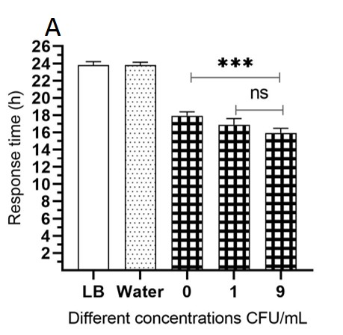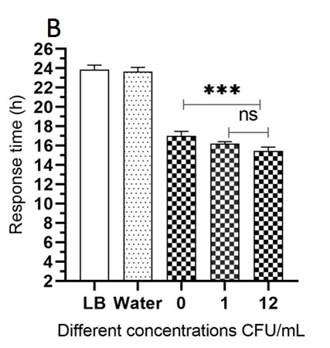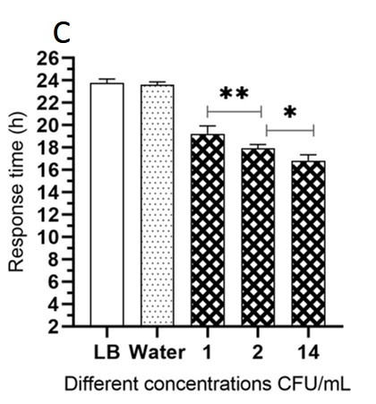

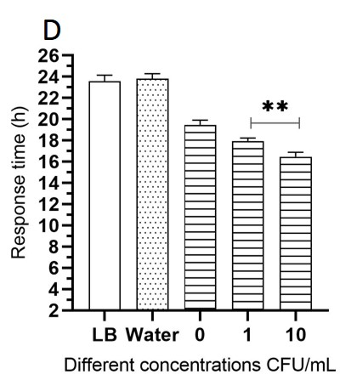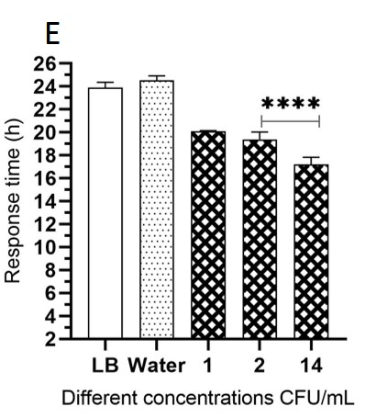

Fig. S2. Specificity of different bacterial strains detection on Multi-substrates layer system (A) B.subtilis detection on Alginate 2.5%+Gelatin2.5%, B) S.marcescens detection on Cornstarch 4%+Gelatin 2.5%, (C) S. aureus detection on Starch 3%+Gelatin 3%, (D) B.licheniformis detection on Lactose 6%+Gelatin 3% and (E) S. aureus detection on Glycine 6%+Gelatin 3%
