Table S1
Composition of waste rubber used in the experiment
Ingredients | Mass fraction /%
Rubber | 56.6
Carbon black | 27.9
Inorganic fillers | 8.1
Volatile components | 7.5

Table S2
Formulation for vulcanized rubber compound.
Ingredients | phr (parts per hundred parts rubber)
Waste tire rubber | 100
Stearic acid | 0.33
ZnO | 2.5
Accelerator (N-cyclohexylbenzothiazyl sulfenamide) | 0.8
Sulfur | 1.5

Table S3
Surface atomic composition of untreated and plasma-treated waste rubber particles.
Treatment condition | Atomic composition (%) |  |  | O/C ratio | S/C ratio
Treatment condition | C | O | S | O/C ratio | S/C ratio
Untreated | 90.99 | 8.35 | 0.66 | 0.092 | 0.0073
Plasma-treated | 89.77 | 9.63 | 0.60 | 0.107 | 0.0067

Text S1 Lissajous method for calculating discharge power
An equivalent capacitor (100 nF) is connected in series at the grounding terminal of the reaction circuit. The voltage U_{m}​ across this capacitor is then measured. By utilizing the relationship between the discharge output charge and the current in the discharge circuit, the circuit current I can be calculated as follows:$\begin{aligned}I=\frac{dQ}{dt}=\frac{d(C_{m}U_{m})}{dt}=C_{m}\frac{dU_{m}}{dt}\#\left(S1\right)\end{aligned}$
where $C_{m}$ represents the equivalent capacitance, and $U_{m}$ denotes the equivalent voltage across the equivalent capacitor.
Under alternating current excitation discharge, each discharge cycle contributes an equivalent amount of energy to the system. Therefore, to determine the power P, it is necessary to integrate the energy over the entire discharge process and then divide by the total number of cycles. The formula for calculating the power is as follows:$\begin{aligned}P=\frac{1}{T}\int_{0}^{T}{UI}dt=\frac{C_{m}}{T}\int_{0}^{T}{ }dU_{m}/dt=fC_{m}ϕUdU_{m}\#\left(S2\right)\end{aligned}$
Text S2 Characterization methods of rubber powder samples

Contact angle
A contact angle meter (Kino SL250, manufactured in the USA) was used to assess the surface hydrophilicity of rubber particles. To facilitate the measurement of the water contact angle, the rubber particles were compressed into a tablet form prior to the test. A single drop of distilled water was dispensed onto the surface of the tablet sample. Once the water droplet had stabilized, an image was captured. The contact angle was determined as the angle between the solid-liquid interface and the tangent to the gas-liquid interface at the point where the droplet touched the surface. For each tablet sample, three replicate tests were conducted to minimize random errors and ensure data reliability.
Scanning electron microscopy (SEM)
The surface morphology of both neat (untreated) and plasma-treated samples was studied using a scanning electron microscope (JEOL JSM-7900F, manufactured in Japan), operating at an accelerating voltage of 30 kV. Prior to each experiment, the samples were sputter-coated with gold to enhance their conductivity and improve image quality.
Energy dispersive X-ray mapping (EDX)
EDX analysis was also performed on the surfaces of both untreated and plasma-treated waste tire rubber vulcanizates using an Oxford EDX system coupled to a scanning electron microscope (JEOL JSM-7900F, manufactured in Japan).
Attenuated total reflection Fourier infrared spectroscopy (ATR-FTIR)
Untreated and plasma-treated rubber samples were analyzed using ATR-FTIR spectroscopy within the wavenumber range of 4000–400 cm⁻¹, employing an infrared spectrophotometer (Bruker VERTEX 70, Germany). The spectra were acquired at a resolution of 4 cm⁻¹ using a zinc selenide (ZnSe) crystal, with an average of 120 scans reported for each spectrum to ensure data accuracy and reproducibility.
X-ray photoelectron spectroscopy (XPS)
XPS was utilized for quantitative surface chemical analysis of rubber particles. This study measured both the atomic composition and chemical bond changes on the surface of waste tire rubber particles before and after cold plasma treatment. The measurements were conducted using an XPS spectrometer (ThermoFisher ESCALAB 250Xi, USA), which featured a monochromatic Al Kα (1486.6 eV) X-ray source and was equipped with an advanced electron energy analyzer. The peak positions were calibrated with respect to the C1s peak at 284.8 eV to ensure accuracy. Furthermore, the spectrometer's software was employed to analyze the high-resolution spectra of C1s, O1s, and S2p through Gaussian and Lorentzian non-linear curve fitting and deconvolution techniques.

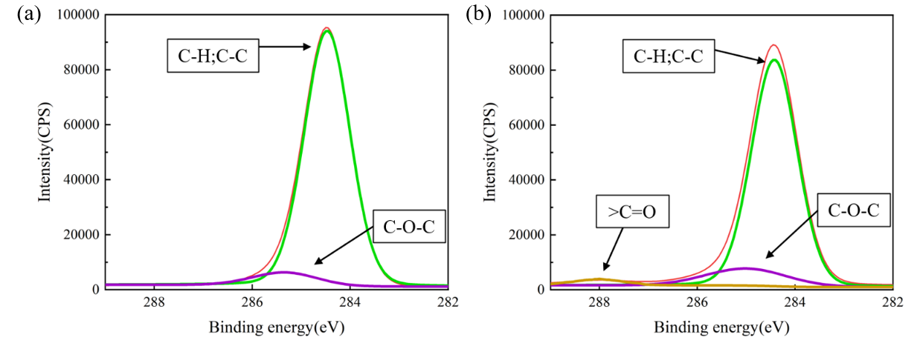
Figure S1 High-resolution XPS spectra of C 1s orbitals for waste rubber powders: (a) untreated, (b) plasma-treated at 18 kV for 30 minutes

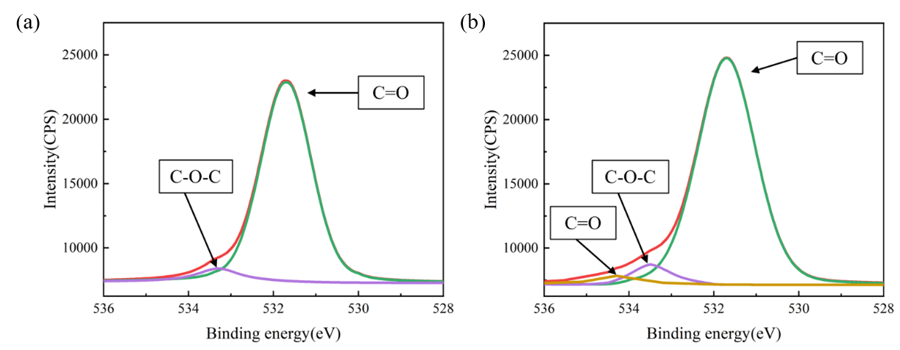
Figure S2 High-resolution XPS spectra of O 1s orbitals for waste rubber powders: (a) untreated, (b) plasma-treated at 18 kV for 30 minutes

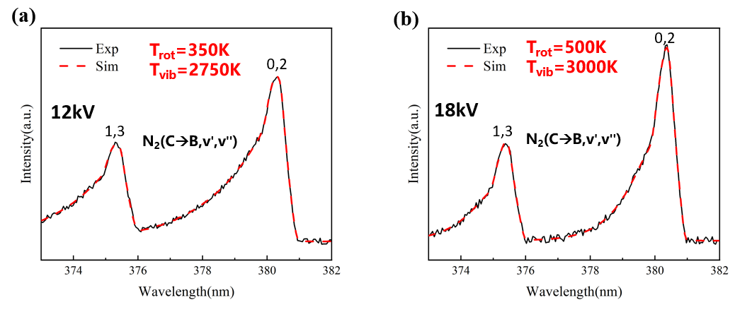
Figure S3 Determination of T_{rot} and T_{vib} through curve fitting of the nitrogen second positive system at different discharge voltages: (a) 12 kV and (b) 18 kV

