Table 1. Descriptive statistics and Pearson’s correlations for the research variables
 | 1 | 2 | 3 | 4 | 5 | 6 | 7 | 8 | 9 | 10 | 11 | 12 | 13 | 14 | 15 | 16 | 17 | 18 | 19 | 20
- Gender (male)
- Age | 0.025
- Years living in Haifa | -.035 | .675**
- Religiosity | .013 | -.381** | -.265**
- Kids under 18 years old | -.044 | -.245** | -.278** | .202**
- Marriage/Living with a partner | .027 | .153** | .031 | .079 | .344**
- Education | -.023 | .184** | .129** | -.102* | .019 | .093*
- Income | .143** | .242** | .209** | -.215** | .065 | .231** | .229**
- Frequency of encounters with wild animals | .022 | -.016 | .052 | -.129** | .020 | -.006 | .021 | .087*
- Perceived harm caused by human-animal interactions | -.054 | .011 | .049 | .212** | .050 | .057 | .010 | .012 | .326**
- Political support in incumbent mayor | -.018 | -.046 | -.076 | -.040 | .119* | .101* | .026 | .047 | -.041 | -.066
- Political Ideology (left) | -.054 | .236** | .118** | -.372** | -.163** | .016 | .128** | .061 | .075 | -.124** | .060
- Political Participation | .140** | .109* | .173** | .045 | .047 | .102* | .022 | .240** | .119** | .126** | -.005 | .027
- Satisfaction with local services | -.064 | -.024 | -.081 | -.004 | -.068 | -.067 | -.131** | .008 | -.075 | -.184** | .137** | .067 | -.070
- Trust in local leadership | -.012 | -.133** | -.147** | .125** | -.067 | -.046 | -.071 | -.066 | -.097* | -.057 | .144** | .015 | -.019 | .658**
- Good local governance | .110* | -.071 | -.102* | .133** | .020 | -.012 | -.111* | -.043 | -.069 | -.072 | .135** | -.039 | .061 | .582** | .660**
- Fear (vs. empathy) | -.141** | .063 | .082 | .220** | .090* | .049 | -.065 | -.069 | .025 | .579** | -.067 | -.161** | .004 | -.151** | -.074 | -.076
- Indifference (vs. curiosity) | .035 | -.023 | .032 | .080 | .051 | .048 | -.020 | -.002 | .072 | .220** | .038 | -.078 | -.087* | -.081 | -.008 | -.008 | .251**
- Urban Reactive Behavior: Immediate spatial response | -.211** | -.028 | .009 | .124** | .088* | .099* | .033 | .038 | -.012 | .395** | .009 | -.159** | .042 | -.105* | -.007 | -.017 | .525** | .159**
- Urban Reactive Behavior: Civic reporting response | .024 | .127** | .042 | .258** | .043 | .116** | -.091* | -.086 | -.272** | .219** | -.065 | -.095* | .125** | .026 | .064 | .151** | .408** | -.020 | .207**
Mean | .42 | 44.94 | 30.76 | 3.65 | .39 | .68 | 14.72 | 2.64 | 2.70 | 3.24 | .56 | 3.46 | 3.58 | 2.66 | 2.22 | 2.74 | 1.86 | .71 | 1.44 | .01
SD | .49 | 16.61 | .42 | 3.12 | .49 | .47 | 3.48 | 1.25 | 1.02 | 1.10 | .50 | 1.57 | 1.61 | .77 | .81 | .57 | 2.25 | 2.14 | 2.37 | 2.91
Range |  |  |  | 1-10 |  |  |  | 1-5 | 1-4 | 1-5 | 0-1 | 1-7 | 1-10 | 1-5 | 1-5 | 1-5 | (-4)-4 | (-4)-4 | (-4)-4 | (-4)-4
Cronbach's alpha |  |  |  |  |  |  |  |  |  | .82 |  |  | .80 | .91 | .89 | .72 | .96 | .95 | .96 | .97
N=522; *p < .05, **p < .01

Table 2. Conditional model (PROCESS Model #21 & #7) examining (i) mediating effect of fear on the relationship between the perceived harm and urban reactive behaviors: immediate spatial response and civic reporting response; (ii) the moderating effect of indifference; (iii) the moderating effect of good governance
 |  | Model #21: Dependent Variable = Urban reactive behaviors: Immediate spatial response  R²=.340; F=13.085*** |  |  |  |  |  |  |  |  |  |  |  | Model #7: Dependent Variable = Urban reactive behaviors: Civic reporting response  R²=.319; F=12.735***
 | Predictor |  |  | β |  |  |  | T |  |  |  | β |  |  |  |  | T
 | Constant |  |  | -.111 |  |  |  | -.124 |  |  |  | -2.655 |  |  |  |  | -2.422*
 | Perceived harm caused by wild boars |  |  | .305 |  |  |  | 2.602** |  |  |  | .234 |  |  |  |  | 1.585
 | Fear (vs. empathy) |  |  | .733 |  |  |  | 3.923*** |  |  |  | .414 |  |  |  |  | 5.915***
 | Good governance |  |  | .369 |  |  |  | 1.399 |  |  |  | .895 |  |  |  |  | 2.896**
 | Fear * Good governance |  |  | -.106 |  |  |  | -1.685*
 | Frequency of encounters with wild animals |  |  | -.138 |  |  |  | -1.335 |  |  |  | -.822 |  |  |  |  | -6.246***
 | Gender (male) |  |  | -.840 |  |  |  | -4.182*** |  |  |  | .403 |  |  |  |  | 1.581***
 | Age |  |  | -.013 |  |  |  | -1.886* |  |  |  | .030 |  |  |  |  | 3.265**
 | Religiosity |  |  | -.038 |  |  |  | -.958 |  |  |  | .130 |  |  |  |  | 2.605**
 | Kids under 18 years old |  |  | -.097 |  |  |  | -.437 |  |  |  | .116 |  |  |  |  | .409
 | Marriage/Living with a partner |  |  | .154 |  |  |  | .658 |  |  |  | .415 |  |  |  |  | 1.397
 | Education |  |  | .035 |  |  |  | 1.193 |  |  |  | -.043 |  |  |  |  | -1.175
 | Income |  |  | .153 |  |  |  | 1.783* |  |  |  | -.110 |  |  |  |  | -1.010
 | Satisfaction with local services |  |  | -.251 |  |  |  | -1.400 |  |  |  | .146 |  |  |  |  | .646
 | Trust in local leadership |  |  | .133 |  |  |  | .730 |  |  |  | -.293 |  |  |  |  | -1.269
 | Political support for Kalish |  |  | .152 |  |  |  | .777 |  |  |  | -.347 |  |  |  |  | -1.393
 | Political Ideology (left) |  |  | -.131 |  |  |  | -1.923* |  |  |  | .008 |  |  |  |  | .093
 |  |  |  | Conditional indirect effect of  perceived harm caused by wild boars on fear  with simple slopes for indifference level |  |  |  |  |  |  |  | Conditional indirect effect of  perceived harm caused by wild boars on fear  with simple slopes for indifference level
 | Indifference levels |  |  | Effect |  |  |  | LLCI ULCI |  |  |  | Effect |  |  |  |  | LLCI ULCI
 | -1.500 Low Indifference (high curiosity) |  |  | 1.318*** |  |  |  | 1.146 1.490 |  |  |  | .543*** |  |  |  |  | .373 .733
 | .563 Medium Indifference (medium curiosity) |  |  | 1.096*** |  |  |  | .954 1.238 |  |  |  | .453*** |  |  |  |  | .314 .608
 | 3.625 High Indifference (low curiosity) |  |  | .766*** |  |  |  | .537 .995 |  |  |  | .320*** |  |  |  |  | .183 .475
 |  |  |  | Conditional indirect effect of fear on immediate spatial response with simple slopes for good governance level
 | Good governance levels |  |  | Effect |  |  |  | LLCI ULCI
 | 2.229 Low good governance |  |  | .497*** |  |  |  | .387 .608
 | 2.635 Medium good governance |  |  | .545*** |  |  |  | .361 .547
 | 3.208 High good governance |  |  | .394*** |  |  |  | .295 .492
 |  |  | Index for moderated mediation for  Immediate spatial response |  |  |  |  |  |  |  | Index for moderated mediation for  Civic reporting response
 |  |  |  |  | Index β |  | LLCI |  |  | ULCI | Index β |  |  |  |  | LLCI |  |  | ULCI
 |  |  |  |  | -.054 – -.042*** | -.088 – -.072 |  |  | -.020 – -.015 |  |  |  | -.043*** |  | -.079 |  |  | -.014
 | N=522; *p < .05, **p < .01, ***p < .001

Table 3: Fisher's Z transformation testing significant difference between Pearson correlations between emotions and urban reactive behaviors to Photo stimuli
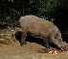 | 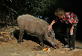 | 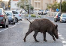 | 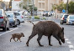 |  |  | 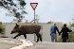  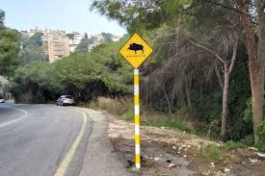  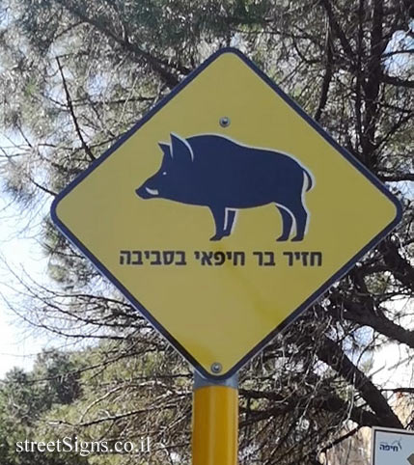  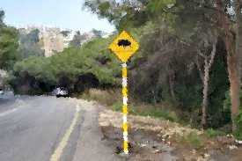 |  | 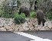 | 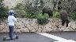 | 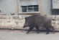 | 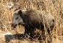 | 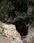 | 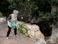
8B | 8A | 7B | 7A | 6B | 6A | 5B | 5A | 4B | 4A | 3B | 3A | 2B | 2A | 1B | 1A¹
 |  |  |  |  |  |  |  |  |  |  |  |  |  | fear→isr | FEAR²→³ISR⁴ >⁵
INDIFF→CRR⁴ | indiff→crr < ⁶ |  |  | indiff→isr | INDIFF→ISR> | indiff→isr | INDIFF→ISR> | indiff→isr | INDIFF→ISR> | indiff→isr | INDIFF→ISR> |  |  | indiff→isr | INDIFF²→ISR >
N=522
- For example, 1A, 1B, 2A… refer to various photo stimuli (see below full descriptions). 1A was compared to 1B, 2A to 2B etc'.
- Fear = A higher score reflects frightening, while a lower score reflects empathy. INDIFF = A higher score reflects indifference, while a lower score reflects curiosity.
- → reflects a Pearson correlation between an emotion to an urban reactive behavior.
- ISR = Urban Reactive Behavior: Immediate spatial response; CRR = Urban Reactive Behavior: Civic reporting response.
- > reflects significant stronger Pearson correlation in 1A compared with 1B, according to Fisher's Z transformation.
- < reflects significant weaker Pearson correlation in 8A compared with 8B, according to Fisher's Z transformation.

