Appendix A: Additional Figures
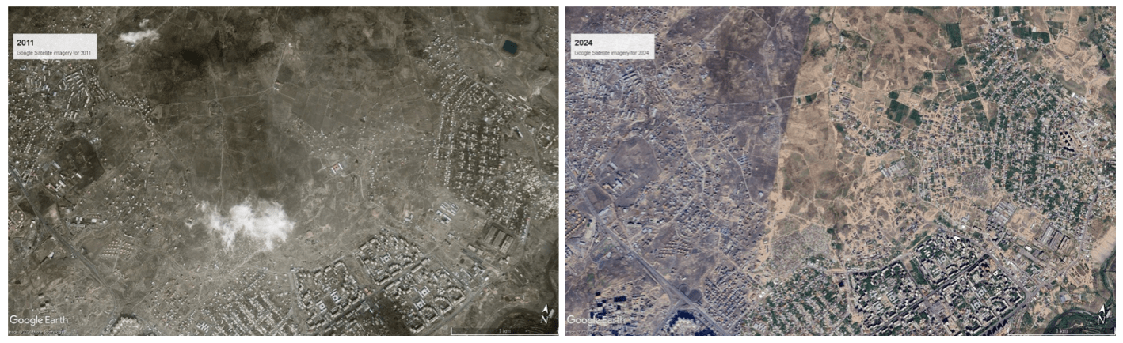
Figure A.1: Change in population distribution in an area between 2011 and 2024

Appendix B: Field and Offline Maps
To take advantage of the boundaries and other spatial information, the survey conductor can create field maps of selected pre-EAs for enumerators to feed their navigation when they collect the survey. Even in the presence of the field maps, it could be still challenging for enumerators to navigate themselves in the selected pre-EA especially, when the enumerators are not familiar with the area and cannot eyeball the boundaries from the information provided in the physical maps, like street address and some information about church and schools. A potential solution to this problem could be offline maps, which inform the enumerators of their location live and signal if they overstep outside the selected pre-EAs. In many developing countries like Armenia, access to the internet is a substantial challenge, especially in rural and remote areas, so enumerators can benefit from the offline maps that operate well with the minimum requirement of only access to satellite. So, enumerators should be able to navigate smoothly and avoid the risk of going beyond the boundaries of selected PSUs unless they are, for example, under the tunnel or in between narrow alleys in the mountain. In total, 400 field paper maps and 400 georeferenced offline maps were created using QGIS software.
Multiple settled areas are probably present in various pre-EAs. Map definitions of these settled areas may be helpful for ground navigation. Several actions have been taken to display the settled region on the field maps. Administrative boundaries with incorporated urban and rural areas were intersected with settlement boundaries. Zonal Statistic Polygons in QGIS were then used to determine the population sum for the resultant intersected polygons based on the gridded population data. A point layer was created from the output. Additionally, the settlement locations’ maximum population values inside each pre-EA were extracted. The settlement with the highest population numbers is shown by the black circle surrounding settlement sites on the field map. This can help the enumerator to find the most densely populated area as a starting point. The X and Y coordinates were calculated for all the settlement points and were shown on the field map (Figures B.1 and B.2).

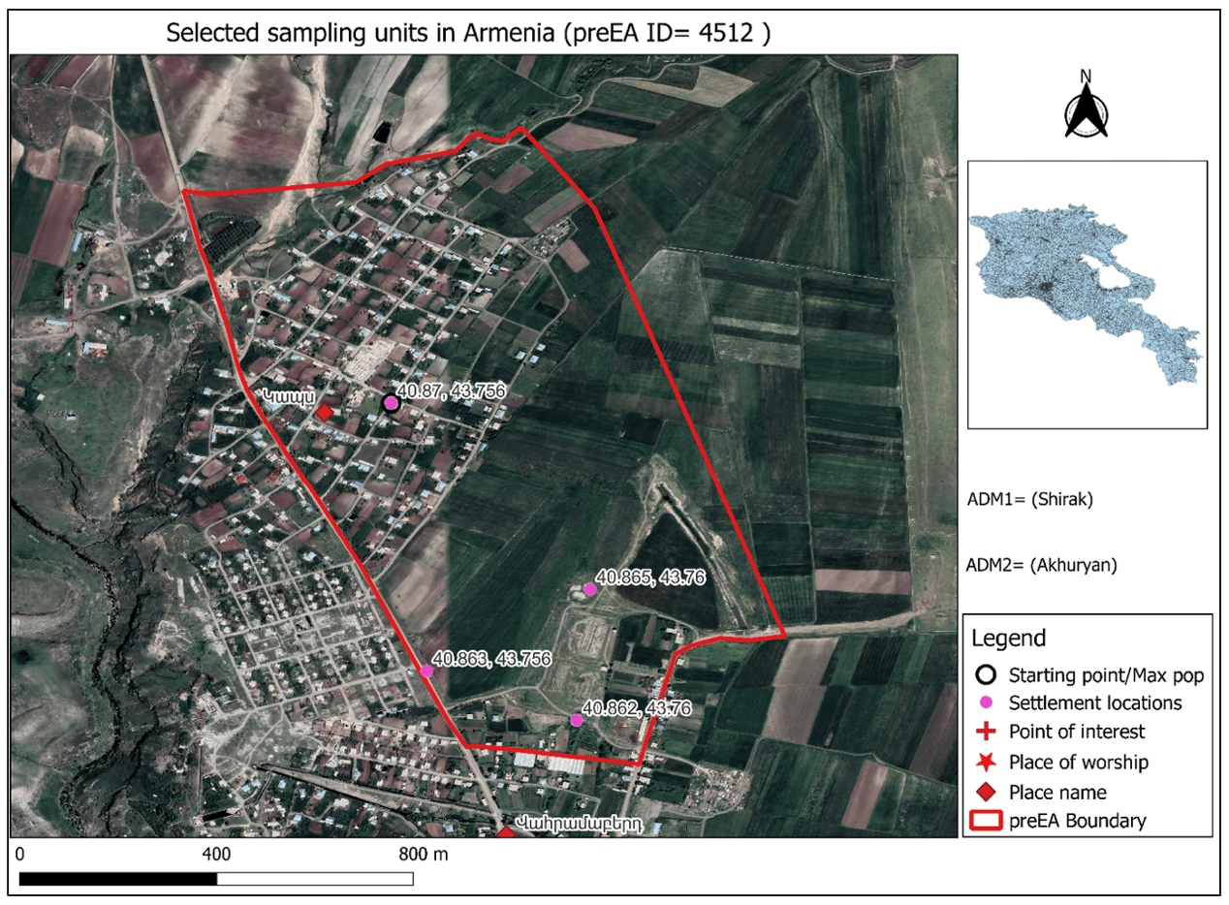
Figure B.1: An example of a detailed field paper map in rural areas
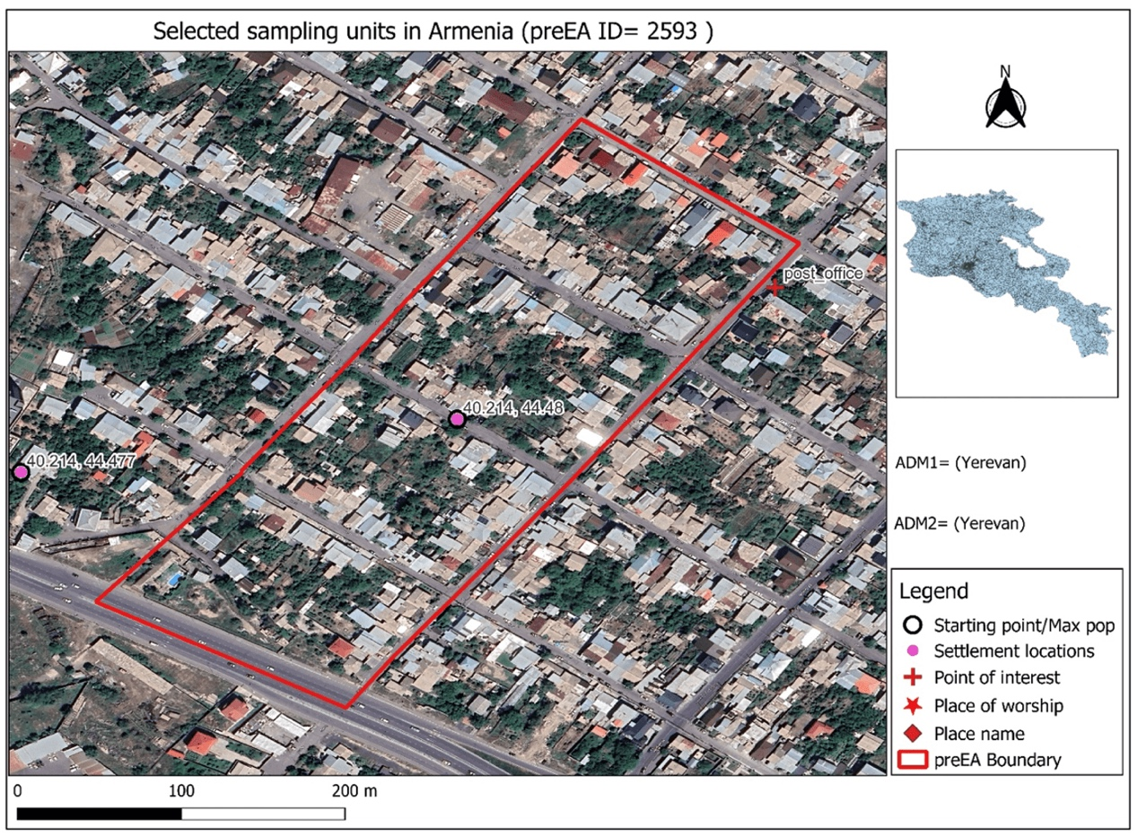
Figure B.2: An example of a detailed field paper map in urban areas

Appendix C: Survey Weights
Sampling weights account for the fact that different members of the population have different probabilities of being selected for interviews, represent various numbers of people in the overall population, and are necessary when computing the representative statistics at the level of the domain. If required, sampling weights are also adjusted to account for non-responsive rates given the survey design.
The dataset will have two sets of weights, including household and individual weights. The household weights are the inverse probability of selection of households and are calculated from the following two components in our two-stage sampling design. The first component is the sampling weight (inverse probability of selection) of PSU within the stratum, and the second component is the sampling weight of selection of households within the PSU. For calculating individual weights, the third component, sampling weights of individuals within the household, is added to compute the household weights. Each of the components is calculated as follows:
Component 1: The inverse probability of selection of PSU within the stratum by using PPS (Probability Proportional to Size) is calculated as:
$$W_{psu}=\frac{1}{P_{psu}}=\frac{N_{stratum}}{n_{psu}×N_{psu}},$$
where $W_{psu}$ is the sampling weight of PSU within the stratum, $P_{psu}$ is the probability of selection of PSU within the stratum, $n_{psu}$ is the number of selected PSUs within the stratum, $N_{psu}$ is the size of selected PSU, and $N_{stratum}$ is the population of the stratum. The size measure can be the population, the number of households, the number of electors, or the school attendance, while the number of households would be the preferred option in most household surveys.
Component 2: The inverse probability of selection of household within PSU is calculated as:
$$W_{hh_{psu}}=\frac{1}{P_{hh_{psu}}}=\frac{N_{hh_{psu}}}{n_{hh_{psu}}},$$
where $W_{hh_{psu}}$ is the sampling weight of household within PSU, $P_{hh_{psu}}$ is the probability of selection of household within PSU, $n_{hh_{psu}}$ is the number of sampled (interviewed) households within PSU, and $N_{hh_{psu}}$ is the total number of households within PSU.
Component 3: The inverse probability of selection of individual within the household is calculated by:
$$W_{ind_{hh}}=\frac{1}{P_{ind_{hh}}}=\frac{N_{ind_{hh}}}{n_{ind_{hh}}}=\frac{N_{ind_{hh}}}{1},$$
where $W_{ind_{hh}}$ is the sampling weight of individual within the household, $P_{ind_{hh}}$ is the probability of selection of individual within the household, $n_{ind_{hh}}$ is the number of sampled (interviewed) individuals within the household, equal to 1, as only one individual was allowed to be interviewed from each household, and $N_{ind_{hh}}$ is the size of the household surveyed (asked and recorded during the interview).
Based on these components, household and individual weights are calculated as:
$$W_{hh}=W_{psu}×W_{hh_{psu}},$$
$$W_{ind}=W_{hh}×W_{ind_{hh}}.$$

