Supplementary figure 1. Validation of I-TASSER Model for Neuraminidase Structure. (A) Ribbon Diagram of Neuraminidase Crystal Structure (2hu4). (B) I-TASSER Modeled Structure. (C) Superimposition of I-TASSER Model with 2hu4

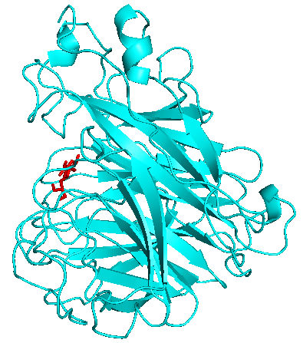a | 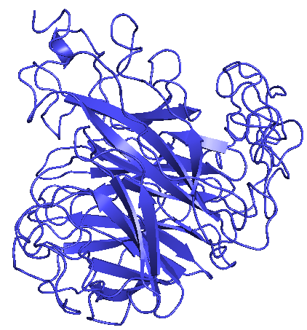b
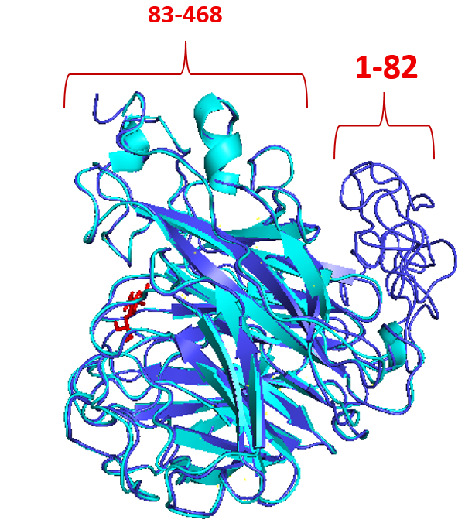

c

