Appendix S1. Information of cigarettes per day (CPD) from UK Biobank.
CPD was defined as the average number of cigarettes smoked per day by participants who were either current or past smokers and the data from UKBB fields 2887 (number of cigarettes previously smoked daily), 3456 (number of cigarettes currently smoked daily), and 6183 (number of cigarettes previously smoked daily (current cigar/pipe smokers) were combined [1]. We recoded values<1to 0 and constrained extreme values>60to 60; otherwise, we kept the original values as reported in UKBB. The final analysis included 142,752 participants aged 40−72, including 74,061 males and 68,691 females who had genetic data available in UKBB.

Figure S1. Genome-wide Manhattan plot and the genomic region of interest for cigarettes per day (CPD). Genome-wide analysis was performed to evaluate the associations between SNPs and CPD. The inclusion criteria, including minor allele frequency (MAF) > 0.01,Hardy-Weinberg equilibrium (HWE) > 0.001, missingness per marker (GENO) > 0.05, and missingness per individual (MIND) > 0.02, were used for filtering data in GWAS. We identified a region with extraordinarily strong association in chromosome 15 (circled in the Manhattan plot). In the zoom plot of chromosome 15, we see that the SNPs colored in light blue have extremely high−log10(p-value) between 78,700,000 and 79,230,000 bp. Therefore, we further explored the potential causal variants of the 1733 SNPs within this region and CPD via Dense-LD and compared the selection performance with that of other fine-mapping methods.
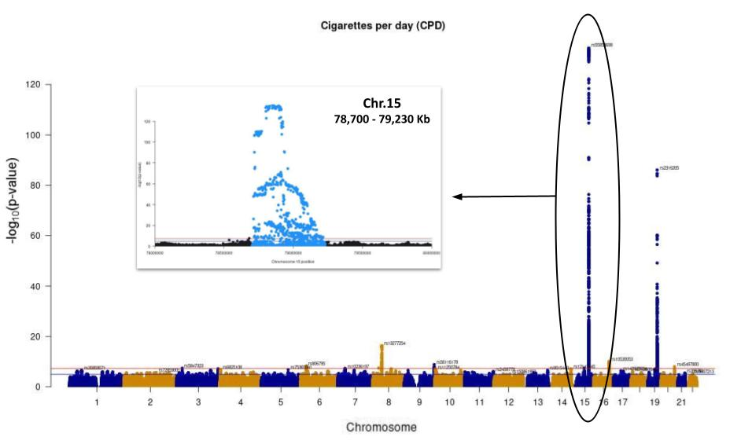

Figure S2. Comparison of the existing LD block detection method and corresponding fine-mapping results. We compared our dense LD block detection method with the cutting-edge LD block detection method. The LD matrix in the figure shows the blocks detected by Big-LD [26]. Clearly, the eight Big-LD detected blocks are much wider and sparse than the dense blocks from Dense-LD. Applying the Big-LD blocks to fused-LASSO, we selected almost all SNPs regardless of the effect sizes, which may be misleading. The non-selected SNPs are colored in gray, and the selected SNPs are highlighted with corresponding genes (i.e., IREB2, CHRNA3, CHRNA5, CHRNB4, HYKK, and PSMA4).
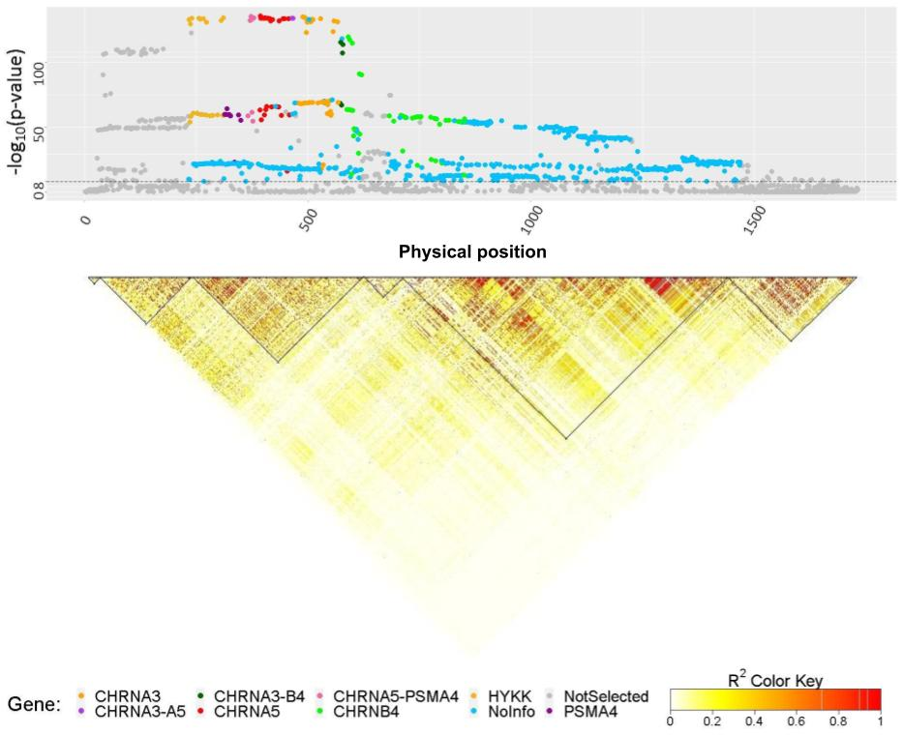

Figure S3. Heatmap of the haplotype blocks detected by ldetect algorithm. We perform block detection using the ldetect algorithm [55]. This algorithm identified 1515 of 1733 SNPs extracted from CPD data and detected 30 haplotype blocks.
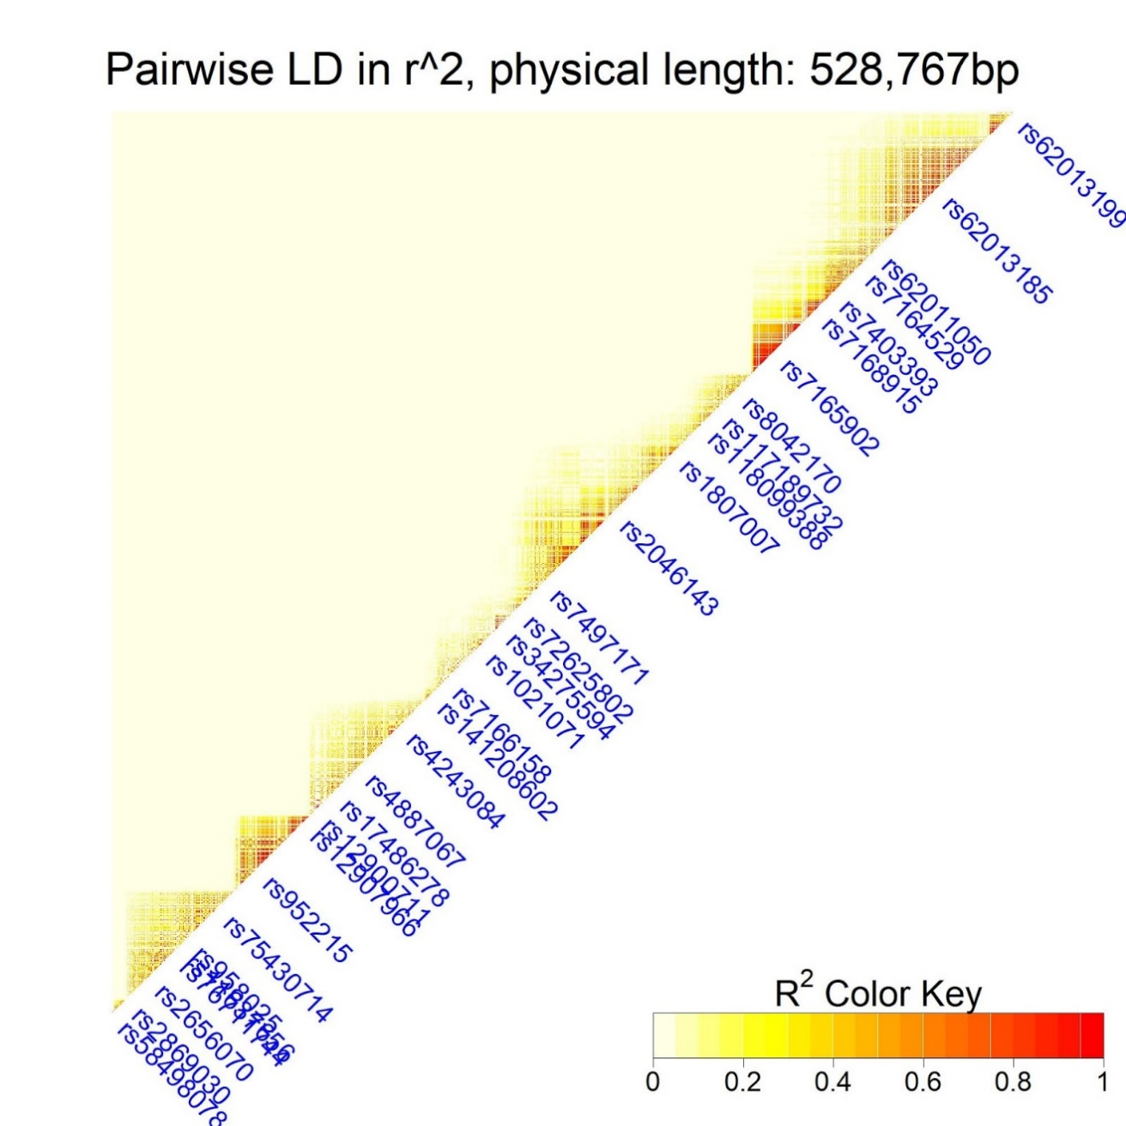

Table S1. Descriptive statistics of LD scores (r2) inside and outside LD blocks detected by different methods. The table provides summary statistics of LD scores of SNPs inside and outside LD blocks identified by different detection methods. Dense-LD detected blocks with highly correlated SNPs(i.e., dense structure). Big-LD [26] and ldetect [55] algorithm provides LD blocks based on haplotypes. The results evidently demonstrated that the blocks from Dense-LD had remarkably larger mean and median than other methods, indicating much denser structure and revealing significant latent network information among SNPs
 |  | Mean (SE) | Median
DenseLD | Inside | 0.8326 (0.0008) | 0.8887
 | Outside | 0.0726 (0.0001) | 0.0184
BigLD | Inside | 0.1032 (0.0003) | 0.0212
 | Outside | 0.0999 (0.0002) | 0.0195
ldetect | Inside | 0.3291 (0.0017) | 0.1644
 | Outside | 0.0901 (0.0002) | 0.0187

Figure S4. Manhattan plots and heatmaps before and after LD pattern detection via Dense-LD for the genomic region on chromosome 19. In addition to chromosome 15, we detected LD patterns via Dense-LD for the genomic region in chromosome 19. This region contained 438 SNPs that were highly associated with CPD. (A) shows the Manhattan plot and heatmap of the SNPs in the region ordered according to their natural physical positions. (B) shows the Manhattan plot and heatmap of the same SNPs ordered according to dense block detected using Dense-LD. The dots represent the SNPs and are colored according to their LD block number (i.e., SNPs in the same block have the same color). The SNPs in the same block are highly correlated (i.e., dense correlation matrix). Among these SNPs, most have similar trait associations (see (B), indicating that the−log10(p-value) is more consistent in dense blocks compared to SNPs in the other blocks.
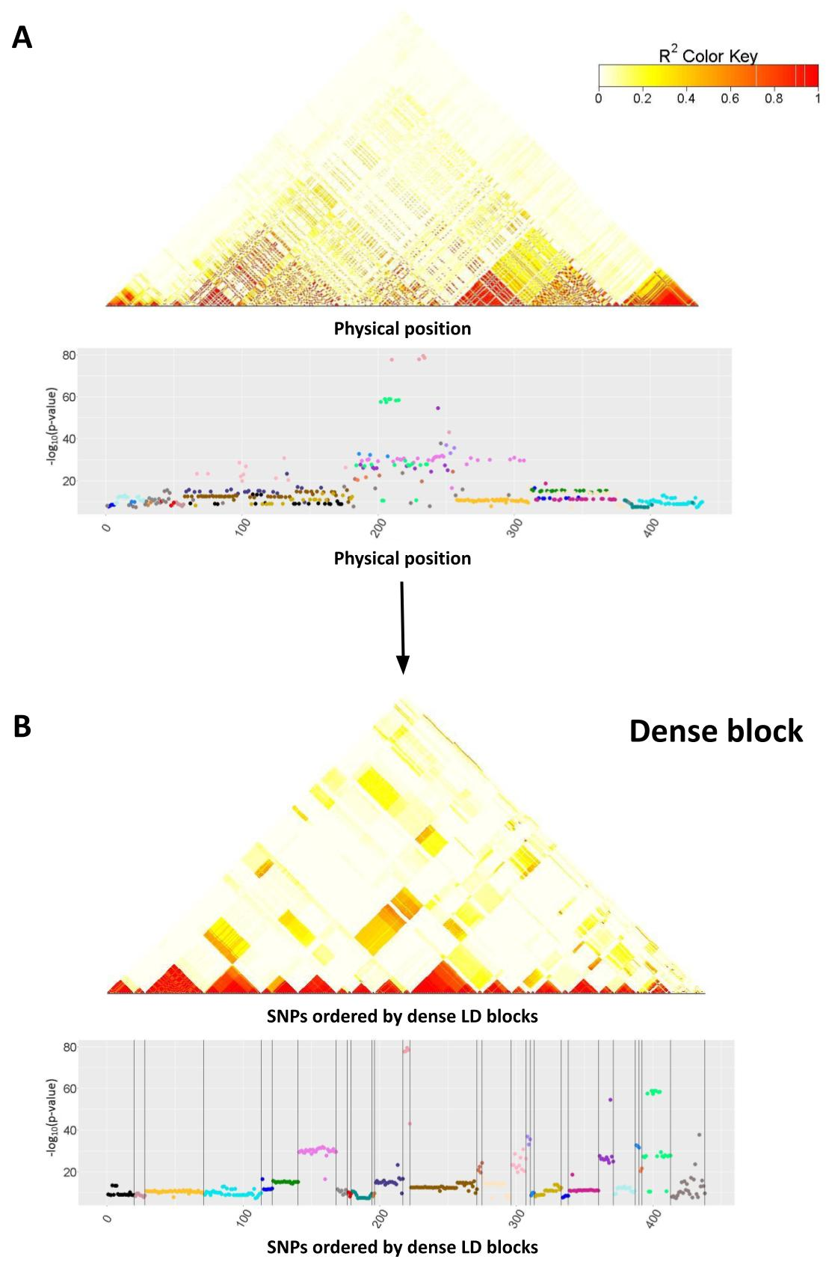
Figure S5. Selected SNPs for CPD via LASSO and ENET. The Manhattan plots show the SNPs excluded in gray and highlight the selected SNPs in other colors. A and B reveal the results of LASSO and ENET, respectively. SNPs are aligned in the following order in Dense-LD. The horizontal dashed line (at −log₁₀(p-value) = 8) corresponds to the genome-wide significance level (p-value = 5×10−8).
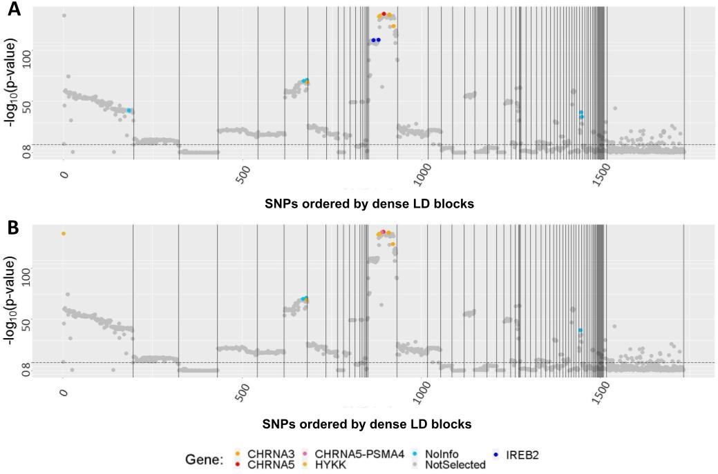

Figure S6. The ROC in the simulation. The ROC curves represent the means of sensitivity and specificity obtained by varied regularization parameters across 100 repeated simulations using different fine-mapping methods.
