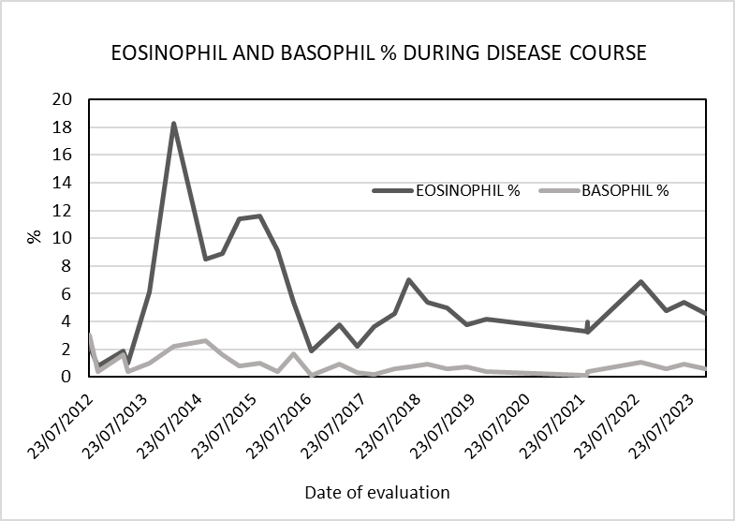
Fig.1 a) Trend analysis of Eosinophil and Basophil percentage during the course of the disease
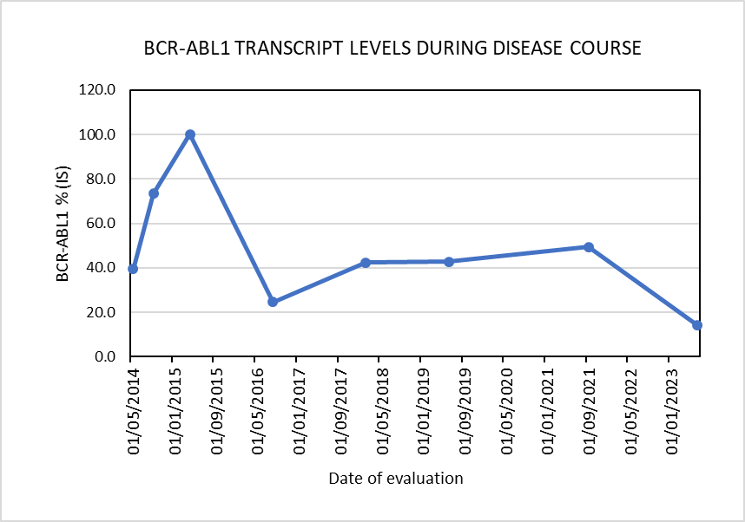
b) BCR-ABL1 transcript levels as determined on International Scale (IS) by Real Time PCR.

