Supplementary Material
Nutrient resorption strategies of three oak tree species in response to interannual climate variability

Baoming Du¹, Huawei Ji¹, Shirong Liu², Hongzhang Kang³, Shan Yin^{1,4,5*}, Chunjiang Liu^{1,4,5*}
School of Agriculture and Biology, Shanghai Jiao Tong University, Shanghai 200240, China
Key Laboratory of Forest Ecology and Environment, China's State Forestry Administration, Research Institute of Forest Ecology, Environment and Protection, Chinese Academy of Forestry, Beijing 100091, China
School of Design, Shanghai Jiao Tong University, Shanghai 200240, China
Shanghai Yangtze River Delta Eco-environmental Change and Management Observation and Research Station, Ministry of Science and Technology, Shanghai 200240, China
Shanghai Urban Forest Ecosystem Research Station, State Forestry Administration, Shanghai 200240, China
*Correspondence: yinshan@sjtu.edu.cn; chjliu@sjtu.edu.cn
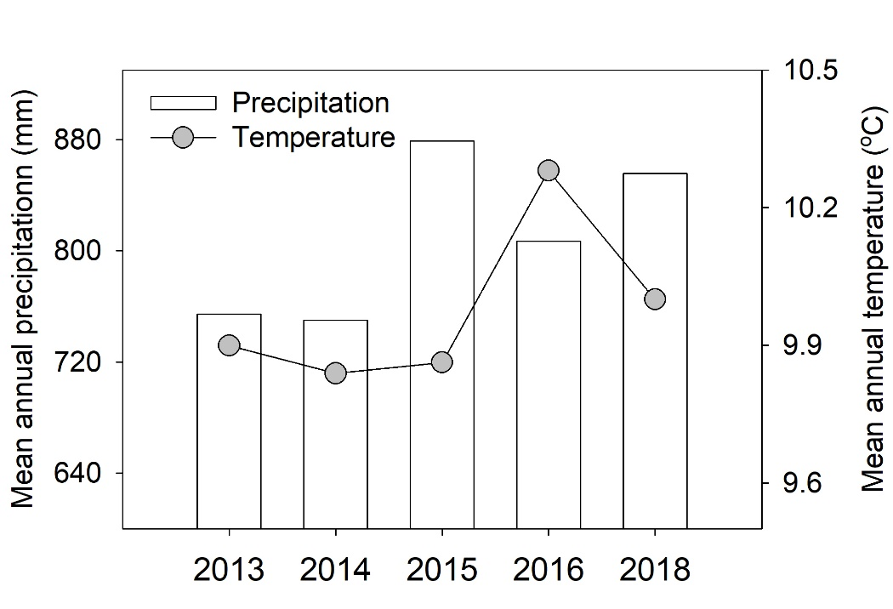
Fig. S1 Mean annual temperature (MAT) and mean annual precipitation (MAP) spanning 2013 to 2016, and 2018. In 2017, MAT was 10.0℃, MAP was 1239mm. Climatic data was obtained from the Neixiang Meteorological Bureau and Baotianman Forest Ecological Research Station.
Table S1 Site and vegetation conditions of the three study Quercus stands at the Baotianman Natural Reserve.
Stands | Longitude  (ºC) | Latitude  (ºC) | Altitude (m) | Tree height (m) | DBH  (cm)
Q. aliena var. acuteserrata | 111.933 | 33.497 | 1423 | 19.1±1.7 | 31.3± 4.8
Q. glandulifera | 111.930 | 33.496 | 1416 | 19.4±1.6 | 28.1±0.7
Q. variabilis | 111.926 | 33.494 | 1320 | 21.7±0.5 | 34.1±5.8
Diameter at breast height (DBH) of trees was measured at 1.3 m. Tree height was estimated by an ultrasonic altimeter.
Table S2 Wilks' Lambda test in canonical discriminant analyses for elements throughout the year.
Test of Function(s) | Wilks' Lambda (λ) | Chi-square | df | Sig.
1 through 4 | 0.000 | 369.73 | 56 | <0.001
2 through 4 | 0.001 | 247.48 | 39 | <0.001
3 through 4 | 0.017 | 140.53 | 24 | <0.001
4 | 0.216 | 52.89 | 11 | <0.001

Table S3 Wilks' Lambda test in canonical discriminant analyses for elements of all three oak species.
Test of Function(s) | Wilks' Lambda (λ) | Chi-square | df | Sig.
1 through 2 | 0.322 | 40.23 | 28 | 0.063
2 | 0.863 | 5.23 | 13 | 0.970

Table S4 Fraction of variance (%) accounted for climatic factors, and leaf and soil nutrients in nutrient resorption efficiencies for three oak tree species.
Nutrient resorption | Tree  species | Full model (r²) | MAT | MAP | Leaf element | Soil  element
C | 1 | 86.13 | 7.29 | 17.67* | 50.29* | 24.75*
 | 2 | 48.15 | 11.01 | 14.09 | 46.72* | 28.18
 | 3 | 71.88 | 18.05 | 34.56* | 26.80 | 20.58
N | 1 | 76.98 | 47.46* | 1.35 | 44.81* | 6.38
 | 2 | 72.18 | 46.96* | 3.48 | 48.04* | 1.52
 | 3 | 72.19 | 32.01* | 3.20 | 54.05* | 10.74
P | 1 | 81.86 | 66.87* | 7.95 | 19.78* | 5.40
 | 2 | 90.21 | 25.71* | 12.73 | 59.54* | 2.02
 | 3 | 96.04 | 5.49 | 7.44 | 85.28* | 1.80
S | 1 | 74.20 | 11.20 | 13.65* | 72.16* | 3.03
 | 2 | 82.35 | 59.31* | 24.55* | 4.51 | 11.62
 | 3 | 19.38 | 72.74 | 8.38 | 9.57 | 9.32
K | 1 | 47.07 | 46.97* | 5.87 | 42.84 | 4.32
 | 2 | 35.26 | 40.08 | 27.13 | 11.54 | 21.25
 | 3 | 18.13 | 2.69 | 19.81 | 21.37 | 56.13
Na | 1 | 29.96 | 21.77 | 25.82 | 37.37 | 15.03
 | 2 | 32.83 | 22.54 | 15.91 | 8.93 | 52.61
 | 3 | 34.10 | 0.12 | 19.75 | 12.62 | 67.51
Ca | 1 | 59.11 | 0.45 | 13.01 | 84.60* | 1.93
 | 2 | 88.43 | 60.79* | 1.53 | 24.12* | 13.56
 | 3 | 86.06 | 49.36* | 6.58 | 33.16* | 10.89
Mg | 1 | 69.14 | 1.79 | 5.80 | 82.93* | 9.48
 | 2 | 73.39 | 57.73* | 19.12 | 12.24 | 10.91
 | 3 | 82.47 | 37.26* | 15.26 | 41.49* | 5.99
Al | 1 | 48.99 | 9.19 | 6.14 | 81.82* | 2.85
 | 2 | 30.87 | 70.76 | 3.56 | 13.75 | 11.92
 | 3 | 32.93 | 49.01 | 19.50 | 23.31 | 8.19
Fe | 1 | 87.09 | 1.71 | 15.62* | 82.30* | 0.37
 | 2 | 42.06 | 19.19 | 5.88 | 71.99* | 2.95
 | 3 | 57.21 | 24.38 | 28.44 | 41.49* | 5.69
Mn | 1 | 70.94 | 0.94 | 5.25 | 93.03* | 0.78
 | 2 | 80.72 | 14.86* | 4.71 | 66.51* | 13.93
 | 3 | 88.08 | 23.69* | 1.63 | 72.43* | 2.25
Zn | 1 | 81.91 | 7.24 | 9.87 | 68.14* | 14.75
 | 2 | 41.80 | 12.34 | 66.04* | 11.44 | 10.18
 | 3 | 62.32 | 20.43 | 21.07 | 20.87 | 37.64*
Cu | 1 | 43.08 | 4.57 | 78.68* | 6.57 | 10.18
 | 2 | 74.40 | 11.48 | 48.83* | 27.38 | 12.32
 | 3 | 72.88 | 16.75 | 60.25* | 13.06 | 9.94
Ba | 1 | 89.97 | 5.31 | 18.87* | 66.92* | 8.91
 | 2 | 84.30 | 14.25* | 2.50 | 62.72* | 20.52
 | 3 | 82.59 | 32.79* | 14.60 | 40.27* | 12.35
Asterisks indicate significant differences at p< 0.05.Numbers represent the three oak species: Q. aliena var. acuteserrata (1), Q. glandulifera (2), and Q. variabilis (3).

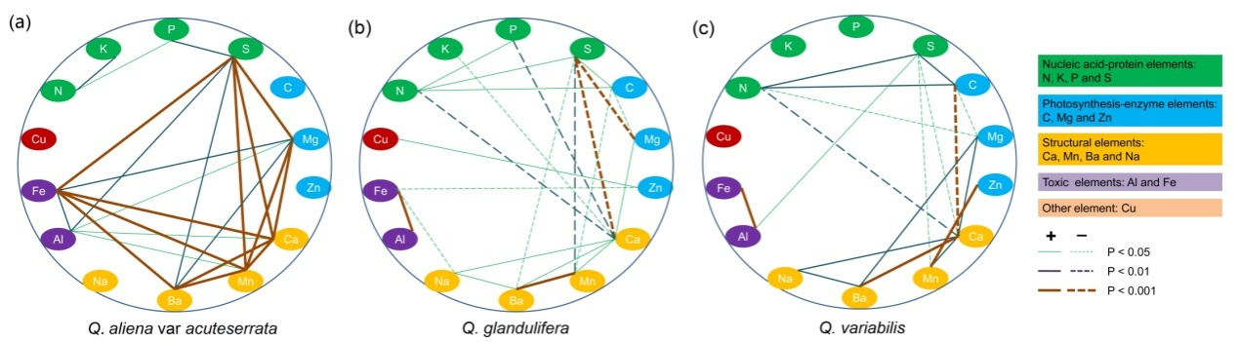
Fig. S2 Correlations of resorption efficiencies between different elements by species, Q. aliena var. acuteserrata (a), Q. glandulifera (b), and Q. variabilis (c). Different colors indicate different elemental groups by cluster analysis in Fig. 3.

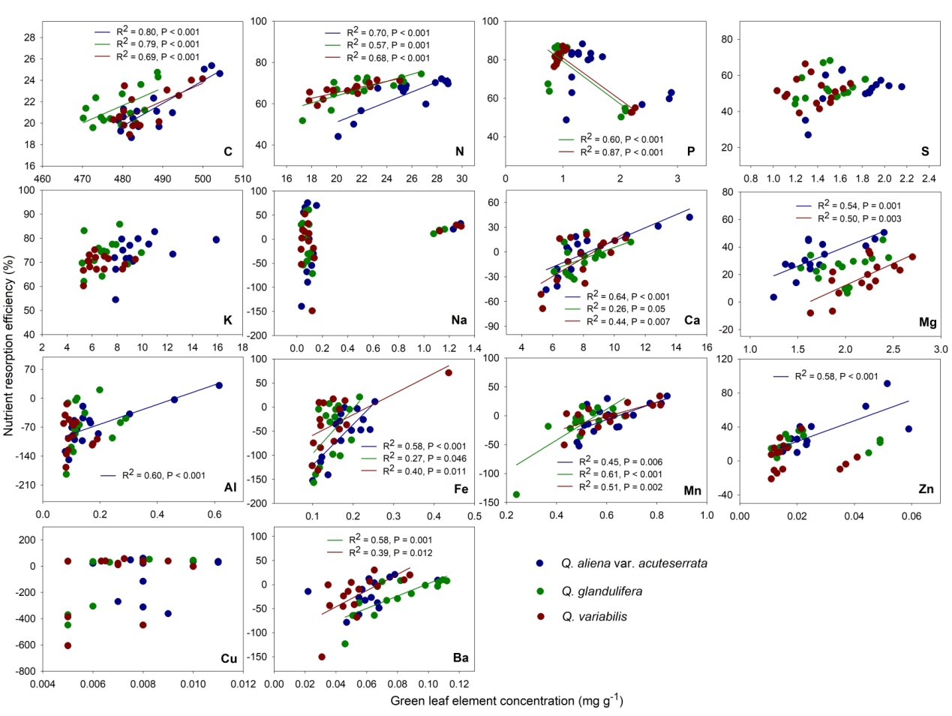
Fig. S3 Relationships between element resorption efficiencies and leaf element concentrations.

Table S5 Summary statistics of nutrient resorption efficiencies of Na, Ca, and Mn in the three oak species across five years.
Element | Tree Species | Mean (%) | SD | CV(%)
Na | 1 | -4.10 | 48.52 | -1182.48
 | 2 | -0.10 | 34.53 | -34183.17
 | 3 | -5.15 | 39.85 | -774.52
Ca | 1 | -1.09 | 25.59 | -2345.83
 | 2 | -8.20 | 16.45 | -200.52
 | 3 | -8.25 | 27.38 | -331.89
Mn | 1 | -3.94 | 24.33 | -617.69
 | 2 | -13.37 | 27.30 | -204.23
 | 3 | 0.03 | 18.31 | 58305.73
Note: The numbers represent the three oak species, Q. aliena var. acuteserrata (1), Q. glandulifera (2), and Q. variabilis (3).
Table S6 A multiple linear regression analysis of element resorption against mean annual temperature (MAT) and mean annual precipitation (MAP). These models can be used to predict changes in nutrient resorption over the next twenty years.
Equation | R² | Pvalue | Current  RE(%)ª | Prediction RE (%)^{b} | Variation extent (%)
CRE_1 = 64.00-2.42×MAT-0.023×MAP | 0.41 | 0.04 | 21.25 | 19.22 | ↓2.03
CRE_2 = n.d.
CRE_3 = 87.01-5.04×MAT-0.019×MAP | 0.6 | 0.002 | 21.36 | 16.94 | ↓4.41
NRE_1 = 492.15-41.91×MAT-0.012×MAP | 0.74 | <0.001 | 64.33 | 26.69 | ↓37.64
NRE_2 = 350.25-28.53×MAT+0.002×MAP | 0.59 | 0.005 | 67.25 | 41.56 | ↓25.69
NRE_3 = 221.96-14.95×MAT-0.008×MAP | 0.54 | 0.01 | 66.34 | 52.94 | ↓13.40
PRE-1 = 664.24-53.49×MAT-0.070×MAP | 0.66 | 0.001 | 73.97 | 26.27 | ↓47.69
PRE_2 = 523.77-36.14×MAT-0.108×MAP | 0.41 | 0.04 | 75.84 | 44.00 | ↓31.84
PRE_3 = n.d.
Note: Numbers represent the three oak species, Q. aliena var. acuteserrata (1), Q. gladlulifera (2), and Q. variabilis (3).
a Current resorption efficiency (RE) was calculated by the mean of the five year MAT and MAP.
b Twenty years downstream, MAT increases by 0.9ºC and MAP decreases by 6.4 mm in this region, as reported by Zhao et al. (2012), MAT and MAP will be 10.88, and 802.8mm, respectively.

