Sodium Alginate/Sodium Lignosulfonate Composite Gel Beads for Controlled Release of (+)-Pinoresinol: Synthesis, Characterization, and Applications
Yuhao Cheng, Junjie Zhang, Xun Li, Chaoqun You, Fei Wang, Yu Zhang*
Jiangsu Co-Innovation Center of Efficient Processing and Utilization of Forest Resources, Jiangsu Provincial Key Lab for the Chemistry and Utilization of Agro Forest Biomass, College of Chemical Engineering, Nanjing Forestry University, Nanjing 210037, PR China

*Corresponding author：Yu Zhang
Tel: +86-25-85427635. Fax: +86-25-85418873. E-mail: yuzhang@njfu.edu.cn
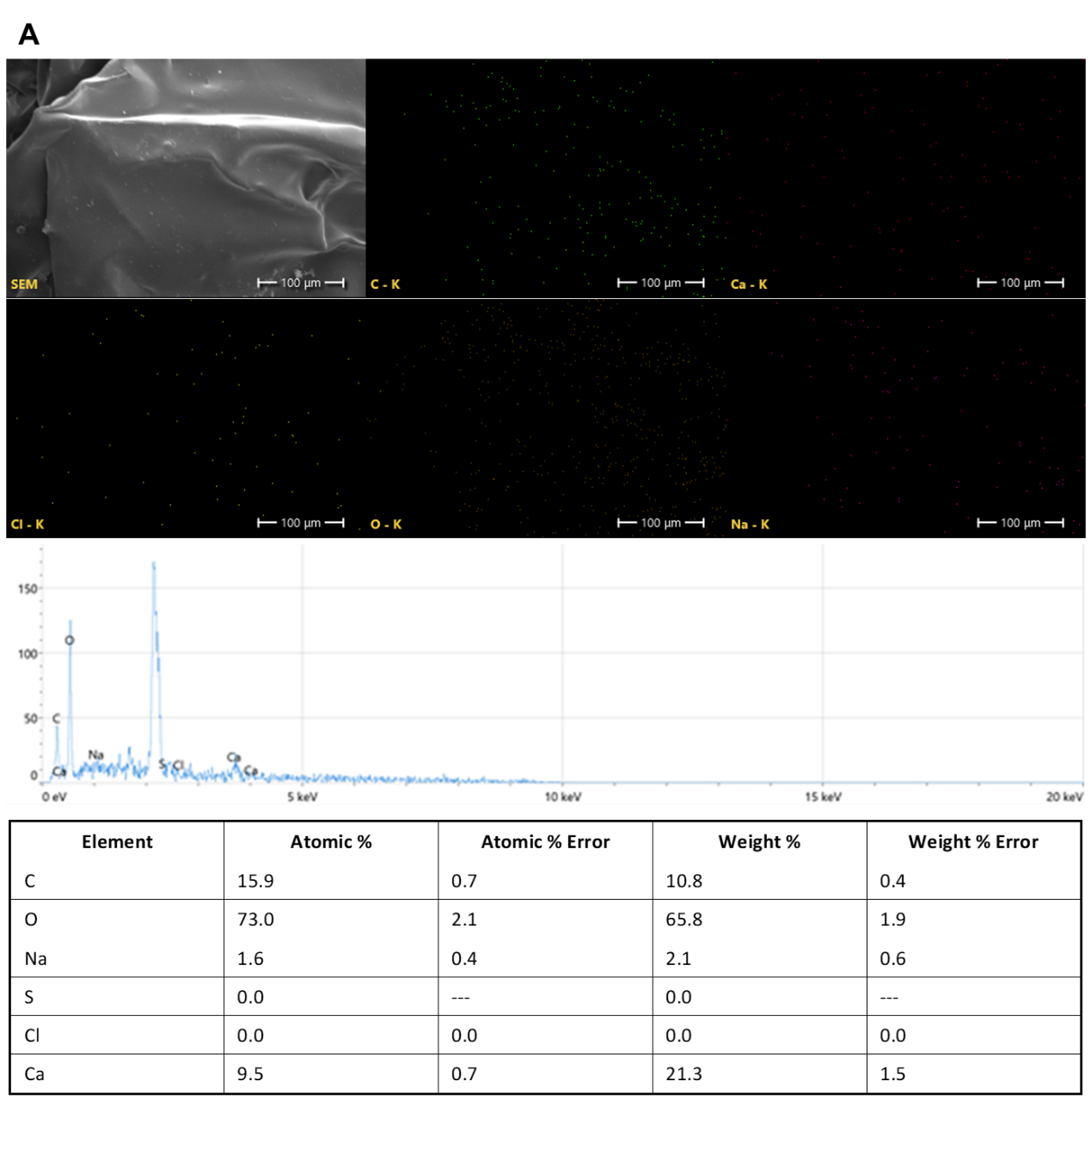
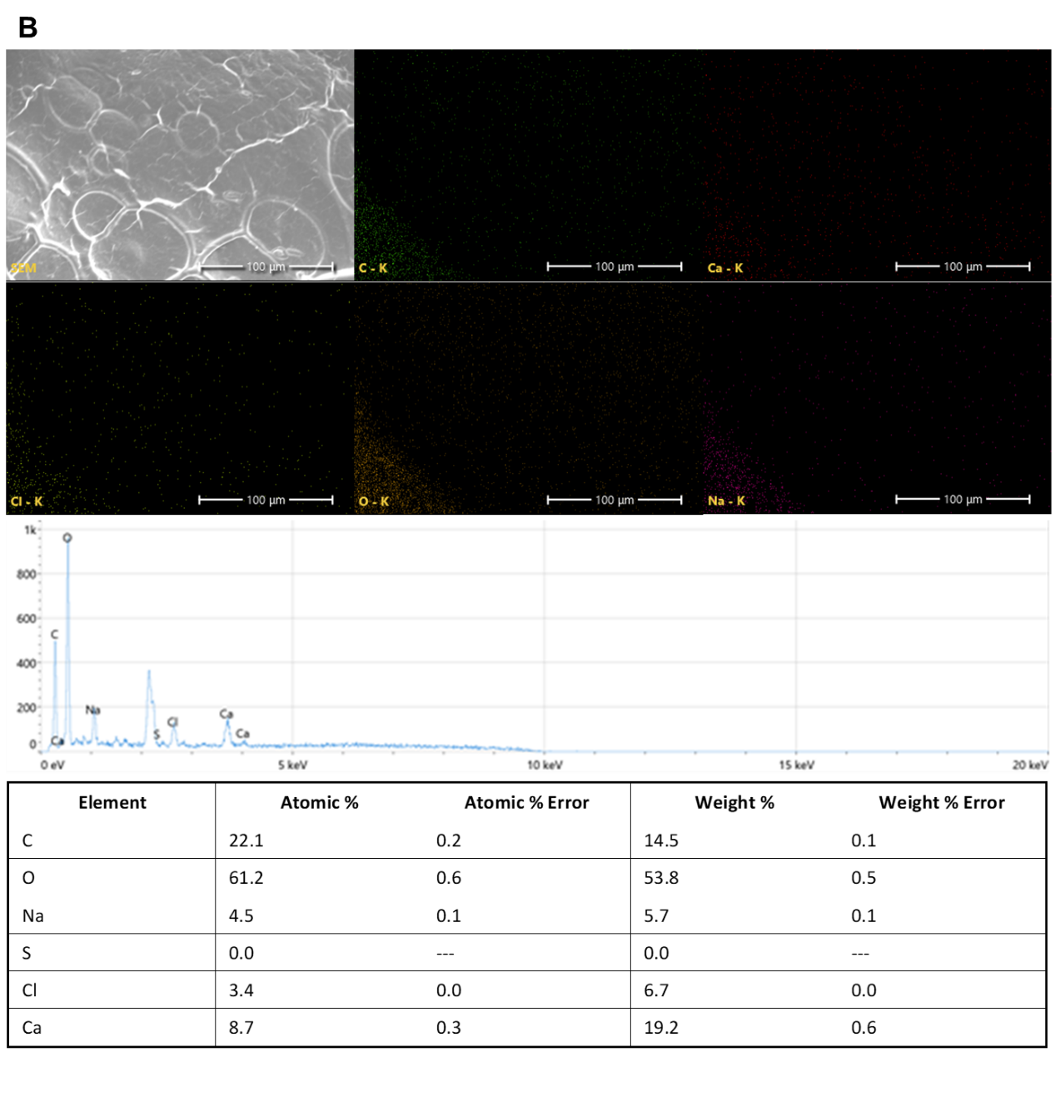
Fig. S1. Gel Bead Surface Elemental Distribution (EDS). A. SA/LS@PIN, B. LS@PIN.
Tab. S1. SA/LS@PIN drug-carrying capacity
Formulations | Drug loading(%) | Encapsulation efficiency (%)
1% LS | 0.53 | 53.1
2% LS | 0.61 | 61.1
3% LS | 0.86 | 85.5

Tab. S2. Mechanical properties of SA/LS@PIN gel beads
Sample | Mechanical properties
Sample | break force（g） | Break strain（%）
SA@PIN | 193.63 ± 3.01 | 56.01 ± 0.41
SA/LS@PIN | 248.33 ± 6.26 | 67.67 ± 1.15

