Supplementary materials
Title: Variation in local communities of insect pollinators in different land-use types in Northeastern Thailand
Kornkanok Wongwila¹, Thotsapol Chaianunporn¹, Nakorn Pradit², Wangworn Sankamethawee^{1*}
¹ Department of Environmental Science, Faculty of Science, KhonKaen University, Khon Kaen, 40002, Thailand
² Walai Rukhavej Botanical Research Institute, Mahasarakham University, Maha Sarakham, 44150, Thailand
*corresponding author: wangsa@kku.ac.th

Table S1. Details of nine environmental variables measured from all transects: sum flower score of ground flora (GFL), species richness of ground flora (GFsp), species richness of tree (Tsp), number of individual trees (Tden), sum of flower score of tree (TFL), % canopy cover (CC), air temperature (Temp), air humidity (HD), and light intensity (LG). Transect numbers indicate AB abandoned land, AG agricultural land, FO forest patch, and UR urban area.
Transect number | Biotic variables |  |  |  |  | Abiotic variables
Transect number | GFL | GFsp | Tsp | Tden | TFL | %CC | Temp (°C) | HD (%) | LG (Lux)
AB1 | 13 | 7 | 2 | 39 | 2 | 0 | 35.44 | 47.24 | 59713.33
AB2 | 26 | 10 | 0 | 0 | 0 | 0 | 35.56 | 47.09 | 71888.89
AB3 | 30 | 10 | 0 | 0 | 0 | 0 | 35.33 | 55.54 | 81937.44
AB4 | 24 | 9 | 0 | 0 | 0 | 0 | 34.11 | 56.44 | 43565.44
AB5 | 23 | 10 | 0 | 0 | 0 | 0 | 34.61 | 52.89 | 45068.89
AB6 | 24 | 13 | 0 | 0 | 0 | 0 | 32.94 | 53.20 | 56831.11
AB7 | 20 | 7 | 0 | 0 | 0 | 0 | 33.94 | 51.48 | 65688.89
AB8 | 24 | 10 | 5 | 15 | 0 | 0 | 34.56 | 47.16 | 67655.56
AB9 | 27 | 14 | 0 | 0 | 0 | 0 | 34.28 | 50.38 | 60102.22
AB10 | 31 | 9 | 0 | 0 | 0 | 0 | 33.94 | 94.71 | 62664.44
AB11 | 36 | 21 | 1 | 3 | 2 | 0 | 34.50 | 54.46 | 62601.11
AB12 | 35 | 15 | 0 | 0 | 0 | 0 | 34.06 | 53.28 | 52237.78
AB13 | 26 | 15 | 0 | 0 | 0 | 0 | 33.33 | 56.62 | 42924.11
AB14 | 6 | 5 | 2 | 18 | 0 | 0 | 34.00 | 56.94 | 49686.67
AB15 | 15 | 7 | 1 | 3 | 0 | 0 | 36.00 | 47.27 | 68648.89
AB16 | 26 | 12 | 0 | 0 | 0 | 0 | 32.89 | 54.37 | 50650.00
AB17 | 11 | 6 | 0 | 0 | 0 | 0 | 34.44 | 50.32 | 56770.13
AB18 | 37 | 15 | 0 | 0 | 0 | 0 | 35.00 | 107.80 | 67578.89
AB19 | 12 | 5 | 2 | 6 | 0 | 0 | 34.67 | 48.76 | 68684.44
AB20 | 19 | 10 | 2 | 9 | 0 | 0 | 33.44 | 54.11 | 56625.56
AB21 | 23 | 14 | 2 | 12 | 0 | 0 | 32.83 | 57.41 | 66791.11
AB22 | 10 | 8 | 2 | 6 | 0 | 0 | 34.13 | 49.58 | 71218.89
AB23 | 19 | 12 | 1 | 6 | 0 | 0 | 34.28 | 50.60 | 66112.22
AB24 | 15 | 8 | 1 | 3 | 0 | 0 | 34.00 | 56.74 | 72105.56
AB25 | 13 | 9 | 0 | 0 | 0 | 0 | 33.17 | 56.07 | 41507.78
AB26 | 15 | 9 | 1 | 6 | 2 | 0 | 33.89 | 53.29 | 47725.00
AB27 | 14 | 6 | 3 | 6 | 0 | 0 | 35.78 | 47.57 | 55776.67
AB28 | 31 | 12 | 0 | 0 | 0 | 0 | 34.67 | 51.60 | 52687.78
AB29 | 27 | 14 | 1 | 9 | 2 | 0 | 31.72 | 59.60 | 35354.67
AB30 | 25 | 11 | 0 | 0 | 0 | 0 | 31.33 | 57.43 | 46541.78
AG1 | 30 | 15 | 2 | 9 | 1 | 0 | 35.17 | 45.12 | 65254.44
AG2 | 27 | 12 | 1 | 9 | 0 | 0 | 34.11 | 55.02 | 98620.33
AG3 | 28 | 16 | 0 | 0 | 0 | 0 | 32.44 | 66.24 | 38178.33
AG4 | 20 | 10 | 2 | 12 | 1 | 0 | 34.39 | 52.92 | 32668.22
AG5 | 20 | 11 | 0 | 0 | 0 | 0 | 32.56 | 57.66 | 60182.22
AG6 | 32 | 19 | 0 | 0 | 0 | 0 | 34.00 | 48.98 | 32570.47
AG7 | 30 | 12 | 0 | 0 | 0 | 0 | 33.11 | 54.01 | 65103.33
AG8 | 8 | 6 | 0 | 0 | 0 | 0 | 34.56 | 49.47 | 44571.11
AG9 | 32 | 17 | 0 | 0 | 0 | 0 | 35.50 | 50.96 | 56399.78
AG10 | 38 | 20 | 1 | 3 | 0 | 0 | 34.50 | 55.81 | 56743.44
AG11 | 38 | 15 | 0 | 0 | 0 | 0 | 34.72 | 55.19 | 48542.44
AG12 | 22 | 19 | 1 | 15 | 0 | 28.34 | 33.00 | 58.37 | 68791.00
AG13 | 25 | 11 | 1 | 36 | 0 | 0 | 34.22 | 51.92 | 59448.89
AG14 | 26 | 12 | 0 | 0 | 0 | 0 | 34.67 | 50.44 | 68463.33
AG15 | 24 | 13 | 1 | 3 | 0 | 0 | 32.17 | 60.52 | 44057.22
AG16 | 28 | 14 | 2 | 9 | 0 | 0 | 35.61 | 48.54 | 52531.11
AG17 | 25 | 11 | 0 | 0 | 0 | 0 | 32.33 | 56.52 | 50571.25
AG18 | 21 | 8 | 0 | 0 | 0 | 0 | 33.06 | 53.71 | 46490.00
AG19 | 18 | 9 | 1 | 3 | 0 | 0 | 32.22 | 57.97 | 53095.56
AG20 | 23 | 14 | 0 | 0 | 0 | 0 | 33.67 | 54.49 | 54171.92
AG21 | 24 | 17 | 1 | 6 | 1 | 0 | 33.44 | 60.52 | 63625.56
AG22 | 10 | 8 | 2 | 6 | 0 | 0 | 34.58 | 56.22 | 72001.67
AG23 | 22 | 12 | 0 | 0 | 0 | 0 | 33.83 | 54.59 | 61067.78
AG24 | 28 | 13 | 0 | 0 | 0 | 0 | 35.00 | 52.04 | 64847.78
AG25 | 22 | 13 | 0 | 0 | 0 | 0 | 35.50 | 52.94 | 56166.67
AG26 | 14 | 8 | 0 | 0 | 0 | 0 | 33.78 | 58.92 | 34049.33
AG27 | 39 | 20 | 2 | 4 | 0 | 0 | 34.50 | 51.89 | 53407.50
AG28 | 18 | 6 | 0 | 0 | 0 | 0 | 34.11 | 52.76 | 42984.44
AG29 | 20 | 12 | 3 | 9 | 0 | 0 | 33.67 | 52.51 | 72703.22
AG30 | 22 | 12 | 0 | 0 | 0 | 0 | 33.28 | 55.12 | 74503.22
FO1 | 19 | 14 | 22 | 213 | 5 | 68.19 | 31.48 | 70.97 | 12563.67
FO2 | 16 | 7 | 13 | 189 | 8 | 57.24 | 30.54 | 75.38 | 10610.67
FO3 | 5 | 4 | 18 | 237 | 1 | 69.91 | 33.40 | 65.18 | 10129.78
FO4 | 15 | 11 | 11 | 198 | 4 | 51.26 | 33.97 | 63.68 | 23795.00
FO5 | 8 | 6 | 18 | 213 | 4 | 61.43 | 33.43 | 144.79 | 18525.67
FO6 | 8 | 5 | 18 | 237 | 3 | 55.26 | 34.28 | 63.26 | 16127.78
FO7 | 3 | 3 | 21 | 192 | 7 | 64.28 | 35.09 | 65.04 | 10798.56
FO8 | 18 | 9 | 15 | 279 | 6 | 55.77 | 31.72 | 72.21 | 26841.56
FO9 | 17 | 15 | 11 | 234 | 4 | 53.14 | 32.39 | 121.13 | 34594.00
FO10 | 8 | 7 | 11 | 174 | 4 | 65.47 | 33.39 | 65.57 | 21358.89
FO11 | 7 | 7 | 17 | 141 | 1 | 64.84 | 33.06 | 64.80 | 28842.67
FO12 | 28 | 13 | 17 | 141 | 2 | 51.01 | 33.72 | 65.50 | 21758.11
FO13 | 10 | 6 | 21 | 195 | 3 | 44.82 | 33.11 | 67.02 | 16651.67
FO14 | 9 | 7 | 16 | 153 | 4 | 63.88 | 32.78 | 67.93 | 18551.56
FO15 | 9 | 5 | 18 | 171 | 5 | 49.88 | 33.64 | 65.57 | 24763.56
FO16 | 10 | 8 | 11 | 123 | 2 | 42.31 | 30.24 | 71.19 | 25952.44
FO17 | 8 | 6 | 7 | 54 | 2 | 59.14 | 30.36 | 73.62 | 5522.67
FO18 | 10 | 8 | 9 | 78 | 2 | 49.25 | 28.10 | 75.72 | 5539.22
FO19 | 16 | 12 | 6 | 27 | 2 | 49.10 | 30.27 | 69.31 | 11767.11
FO20 | 16 | 10 | 9 | 57 | 2 | 50.20 | 32.77 | 63.02 | 27621.56
FO21 | 13 | 10 | 7 | 72 | 1 | 61.95 | 31.37 | 62.76 | 35314.11
FO22 | 19 | 17 | 14 | 120 | 4 | 48.84 | 32.32 | 62.17 | 22649.22
FO23 | 25 | 19 | 13 | 138 | 2 | 60.50 | 31.74 | 60.92 | 11759.54
FO24 | 18 | 15 | 14 | 129 | 5 | 67.94 | 31.22 | 65.13 | 23074.64
FO25 | 19 | 15 | 15 | 93 | 3 | 56.56 | 31.63 | 66.38 | 18951.44
FO26 | 9 | 8 | 13 | 111 | 2 | 49.57 | 30.48 | 70.33 | 11871.22
FO27 | 21 | 14 | 20 | 129 | 1 | 45.79 | 32.52 | 67.38 | 13537.11
FO28 | 18 | 14 | 15 | 159 | 2 | 60.42 | 31.71 | 70.97 | 7093.67
FO29 | 17 | 12 | 22 | 180 | 2 | 62.26 | 32.26 | 69.11 | 8729.44
FO30 | 15 | 12 | 15 | 93 | 6 | 58.20 | 32.82 | 70.17 | 9485.11
UR1 | 28 | 9 | 2 | 15 | 0 | 22.77 | 33.17 | 51.13 | 130243.56
UR2 | 7 | 4 | 0 | 0 | 0 | 0 | 33.67 | 52.56 | 52924.29
UR3 | 24 | 8 | 6 | 54 | 4 | 64.48 | 32.28 | 54.60 | 30193.00
UR4 | 9 | 5 | 4 | 42 | 0 | 78.55 | 31.89 | 53.48 | 10827.00
UR5 | 14 | 8 | 4 | 15 | 1 | 60.11 | 33.44 | 48.99 | 33846.22
UR6 | 14 | 11 | 5 | 48 | 5 | 41.87 | 32.72 | 53.79 | 37479.22
UR7 | 10 | 5 | 6 | 24 | 1 | 44.91 | 33.61 | 52.61 | 39084.67
UR8 | 21 | 9 | 0 | 0 | 0 | 0 | 29.56 | 63.70 | 43995.78
UR9 | 4 | 3 | 3 | 15 | 0 | 0 | 30.17 | 60.06 | 53825.56
UR10 | 9 | 3 | 3 | 9 | 0 | 0 | 31.17 | 60.48 | 53283.78
UR11 | 12 | 9 | 0 | 0 | 0 | 0 | 30.28 | 62.24 | 50196.67
UR12 | 27 | 12 | 1 | 3 | 0 | 0 | 29.67 | 64.16 | 41795.56
UR13 | 26 | 14 | 0 | 0 | 0 | 0 | 29.89 | 60.79 | 41765.67
UR14 | 17 | 11 | 0 | 0 | 0 | 0 | 32.22 | 56.37 | 51098.89
UR15 | 17 | 12 | 1 | 9 | 0 | 0 | 31.11 | 58.07 | 54269.56
UR16 | 8 | 2 | 3 | 45 | 9 | 16.19 | 33.39 | 55.38 | 67996.67
UR17 | 8 | 6 | 1 | 30 | 2 | 62.47 | 32.50 | 54.59 | 53369.11
UR18 | 9 | 4 | 4 | 18 | 6 | 41.78 | 34.89 | 50.71 | 64544.11
UR19 | 4 | 2 | 4 | 27 | 4 | 38.07 | 35.22 | 50.68 | 56644.44
UR20 | 8 | 4 | 4 | 12 | 1 | 0 | 33.72 | 50.04 | 44507.00
UR21 | 17 | 7 | 2 | 9 | 0 | 36.15 | 31.33 | 57.64 | 40021.44
UR22 | 16 | 9 | 2 | 24 | 0 | 16.13 | 30.56 | 60.88 | 22607.00
UR23 | 32 | 18 | 0 | 0 | 0 | 0 | 32.22 | 57.46 | 53733.33
UR24 | 21 | 14 | 0 | 0 | 0 | 0 | 30.28 | 65.12 | 30716.78
UR25 | 17 | 10 | 1 | 3 | 0 | 0 | 31.33 | 58.03 | 65832.00
UR26 | 3 | 3 | 3 | 60 | 3 | 46.89 | 31.28 | 60.51 | 50094.11
UR27 | 13 | 10 | 0 | 0 | 0 | 0 | 32.11 | 59.92 | 59867.78
UR28 | 10 | 6 | 0 | 0 | 0 | 0 | 33.78 | 119.77 | 75741.00
UR29 | 11 | 10 | 0 | 0 | 0 | 9.72 | 31.83 | 59.60 | 70127.44
UR30 | 21 | 13 | 0 | 0 | 0 | 11.06 | 33.22 | 55.68 | 52457.78

Table S2. Species list with the number of individuals of observed pollinating insects: Coleoptera, Diptera, Hymenoptera, and Lepidoptera (CDHL) in four land-use types pooled over three seasons, in Khon Kaen Province, Northeastern Thailand. AB Abandoned land, AG Agricultural land, FO Forest patch, UR Urban area.
Order | Insect species | Land-use type
Order | Insect species | AB | AG | FO | UR
Coleoptera | Aulacophora indica | 5 | 47 | 0 | 16
Coleoptera | Cheilomenes sexmaculata | 0 | 0 | 0 | 1
Coleoptera | Chrysochus pulcher | 80 | 23 | 0 | 15
Coleoptera | Coccinella transversalis | 23 | 39 | 0 | 4
Coleoptera | Epilachna sp. | 0 | 1 | 0 | 5
Coleoptera | Henosepilachna sp. | 0 | 0 | 0 | 3
Coleoptera | Hypomeces squamosus | 0 | 0 | 0 | 7
Coleoptera | Micraspis discolor | 114 | 215 | 4 | 23
Coleoptera | Monolepta signata | 2 | 4 | 0 | 2
Coleoptera | Sternocera aequisignata | 1 | 0 | 0 | 1
Shannon H’ index |  | 1.096 | 1.066 | 0 | 1.889
Diptera | Asarkina sp. | 3 | 2 | 0 | 0
Diptera | Dolichopus spp. | 0 | 1 | 0 | 0
Diptera | Eristalinus sp. | 3 | 1 | 1 | 0
Diptera | Mesembrius sp. | 19 | 36 | 8 | 4
Diptera | Musca domestica | 2 | 4 | 15 | 11
Diptera | Family Asilidae sp.1 | 31 | 38 | 18 | 1
Diptera | Family Asilidae sp.2 | 7 | 4 | 31 | 0
Diptera | Family Syrphidae sp. 1 | 18 | 11 | 5 | 5
Shannon H’ index |  | 1.575 | 1.419 | 1.488 | 1.141
Hymenoptera | Amegilla sp. | 1 | 3 | 4 | 1
Hymenoptera | Apis cerana | 2 | 6 | 0 | 28
Hymenoptera | Apis dorsata | 40 | 8 | 13 | 38
Hymenoptera | Apis florea | 222 | 107 | 36 | 294
Hymenoptera | Campsomeris sp. | 0 | 6 | 1 | 1
Hymenoptera | Delta esuriens | 25 | 21 | 6 | 11
Hymenoptera | Megachile sp. | 13 | 34 | 18 | 8
Hymenoptera | Ropalidia sp. | 90 | 78 | 11 | 112
Hymenoptera | Sceliphron sp.1 | 3 | 4 | 0 | 3
Hymenoptera | Sceliphron sp.2 | 2 | 6 | 6 | 1
Hymenoptera | Scolia sp.1 | 26 | 7 | 12 | 6
Hymenoptera | Scolia sp.2 | 5 | 2 | 12 | 0
Hymenoptera | Sphex lucae | 0 | 3 | 1 | 3
Hymenoptera | Trigona sp. | 0 | 30 | 54 | 4
Hymenoptera | Triscolia sp. | 0 | 0 | 0 | 4
Hymenoptera | Vespa tropica | 60 | 59 | 5 | 6
Hymenoptera | Xylocopa aestuans | 42 | 44 | 6 | 42
Hymenoptera | Xylocopa latipes | 18 | 3 | 11 | 14
Shannon H’ index |  | 1.901 | 2.213 | 2.278 | 1.656
Lepidoptera | Acraea terpsicore | 318 | 112 | 5 | 56
Lepidoptera | Acropteris sp. | 0 | 0 | 5 | 0
Lepidoptera | Amata sp. | 77 | 74 | 4 | 49
Lepidoptera | Amata sperbius | 41 | 79 | 0 | 78
Lepidoptera | Amblypodia anita | 0 | 0 | 1 | 0
Lepidoptera | Ancema blanka | 0 | 0 | 1 | 0
Lepidoptera | Appias olferna | 95 | 113 | 10 | 87
Lepidoptera | Ariadne ariadne | 10 | 7 | 4 | 9
Lepidoptera | Castalius rosimon | 40 | 5 | 34 | 9
Lepidoptera | Catopsilia pomona | 683 | 398 | 445 | 420
Lepidoptera | Catopsilia pyranthe | 7 | 9 | 2 | 2
Lepidoptera | Cepora nerissa | 6 | 0 | 3 | 0
Lepidoptera | Cethosia cyane | 12 | 6 | 25 | 8
Lepidoptera | Chilades putli | 0 | 0 | 0 | 1
Lepidoptera | Chilasa clytia | 5 | 6 | 11 | 0
Lepidoptera | Coladenia indrani | 0 | 0 | 9 | 0
Lepidoptera | Cupha erymanthis | 0 | 0 | 12 | 0
Lepidoptera | Danaus chrysippus | 153 | 76 | 8 | 75
Lepidoptera | Danaus genutia | 14 | 11 | 16 | 24
Lepidoptera | Delias hyparete | 1 | 0 | 0 | 1
Lepidoptera | Elymnias hypermnestra | 0 | 0 | 0 | 1
Lepidoptera | Euploea algea | 1 | 0 | 3 | 0
Lepidoptera | Euploea core | 46 | 42 | 32 | 34
Lepidoptera | Euploea spp. | 14 | 0 | 164 | 0
Lepidoptera | Eurema hecabe | 323 | 323 | 303 | 246
Lepidoptera | Euthalia aconthea | 0 | 0 | 2 | 0
Lepidoptera | Euthalia evelina | 0 | 0 | 2 | 0
Lepidoptera | Gerosis bhagava | 0 | 0 | 8 | 0
Lepidoptera | Graphium doson | 1 | 0 | 14 | 0
Lepidoptera | Hebomoia glaucippe | 2 | 1 | 0 | 1
Lepidoptera | Hypolimnas bolina | 2 | 3 | 5 | 23
Lepidoptera | Hypolimnas misippus | 16 | 11 | 1 | 29
Lepidoptera | Ixias pyrene | 29 | 12 | 12 | 15
Lepidoptera | Junonia almana | 79 | 104 | 31 | 17
Lepidoptera | Junonia atlites | 1 | 0 | 4 | 10
Lepidoptera | Junonia lemonias | 16 | 20 | 15 | 33
Lepidoptera | Leptosia nina | 0 | 1 | 17 | 19
Lepidoptera | Lestranicus transpectus | 0 | 0 | 0 | 1
Lepidoptera | Lethe confusa | 0 | 0 | 1 | 0
Lepidoptera | Loxura atymnus | 0 | 0 | 50 | 0
Lepidoptera | Macroglossum sp. | 0 | 0 | 1 | 0
Lepidoptera | Melanitis leda | 0 | 17 | 32 | 2
Lepidoptera | Moduza procris | 0 | 0 | 140 | 0
Lepidoptera | Mycalesis spp. | 1 | 4 | 1 | 0
Lepidoptera | Neochera dominia | 0 | 0 | 23 | 0
Lepidoptera | Neptis hylas | 0 | 1 | 109 | 6
Lepidoptera | Neptis miah | 0 | 0 | 2 | 0
Lepidoptera | Pachliopta aristolochiae | 181 | 123 | 117 | 72
Lepidoptera | Papilio demoleus | 35 | 22 | 31 | 19
Lepidoptera | Papilio memnon | 0 | 1 | 35 | 0
Lepidoptera | Papilio nephelus | 0 | 0 | 2 | 0
Lepidoptera | Papilio polytes | 2 | 3 | 74 | 5
Lepidoptera | Parantica aglea | 0 | 0 | 5 | 0
Lepidoptera | Pareronia anais | 0 | 0 | 2 | 0
Lepidoptera | Parthenos sylla | 0 | 0 | 3 | 0
Lepidoptera | Peridrome orbicularis | 0 | 0 | 45 | 2
Lepidoptera | Phalanta alcippe | 0 | 1 | 36 | 0
Lepidoptera | Phalanta phalantha | 2 | 2 | 12 | 0
Lepidoptera | Rapala iarbus | 0 | 0 | 1 | 0
Lepidoptera | Rapala scintilla | 0 | 0 | 3 | 0
Lepidoptera | Spindasis lohita | 0 | 0 | 3 | 0
Lepidoptera | Suastus gremius | 0 | 0 | 0 | 1
Lepidoptera | Tanaecia julii | 0 | 1 | 0 | 0
Lepidoptera | Telicota ohara | 0 | 1 | 0 | 0
Lepidoptera | Tirumala septentrionis | 3 | 2 | 15 | 1
Lepidoptera | Troides aeacus | 28 | 19 | 25 | 20
Lepidoptera | Utetheisa pulchella | 57 | 69 | 0 | 38
Lepidoptera | Ypthima baldus | 0 | 0 | 0 | 6
Lepidoptera | Ypthima huebneri | 1 | 0 | 7 | 4
Lepidoptera | Zizula hylax | 189 | 101 | 22 | 230
Lepidoptera | Family Hesperiidae | 20 | 23 | 42 | 2
Lepidoptera | Family Lycaenidae | 153 | 84 | 122 | 31
Shannon H’ index |  | 2.603 | 2.704 | 3.04 | 2.674
Table S3. Summary of ground flora families with the number of species in flower observed from four land-use types pooled over three seasons. The numbers in the land-use columns indicate the sum of flower scores of each family from each land-use type pooled over three seasons.
Ground flora family | #Species | Land-use type
Ground flora family | #Species | Abandoned | Agricultural | Forest | Urban
Acanthaceae | 3 | 6 | 2 | 2 | 21
Aizoaceae | 1 | 1 | 1 | 0 | 0
Amaranthaceae | 5 | 60 | 59 | 0 | 50
Apocynaceae | 3 | 0 | 2 | 13 | 0
Asclepiadaceae | 2 | 2 | 0 | 14 | 0
Asteraceae | 13 | 161 | 262 | 89 | 126
Boraginaceae | 1 | 1 | 15 | 0 | 3
Celastraceae | 1 | 0 | 1 | 0 | 0
Cleomaceae | 2 | 5 | 18 | 0 | 18
Colchicaceae | 1 | 0 | 0 | 1 | 0
Commelinaceae | 5 | 8 | 24 | 23 | 1
Convolvulaceae | 9 | 35 | 32 | 10 | 49
Costaceae | 1 | 0 | 0 | 1 | 0
Cucurbitaceae | 4 | 5 | 17 | 1 | 8
Dioscoreaceae | 1 | 0 | 0 | 3 | 0
Erythroxylaceae | 1 | 0 | 0 | 9 | 0
Euphorbiaceae | 7 | 9 | 17 | 2 | 6
Fabaceae | 25 | 139 | 115 | 17 | 73
Lamiaceae | 1 | 44 | 6 | 3 | 5
Lauraceae | 1 | 0 | 0 | 1 | 0
Linderniaceae | 6 | 3 | 17 | 13 | 3
Malvaceae | 15 | 120 | 63 | 63 | 12
Onagraceae | 2 | 0 | 5 | 0 | 0
Orchidaceae | 1 | 0 | 0 | 11 | 0
Passifloraceae | 1 | 17 | 6 | 0 | 6
Phyllanthaceae | 2 | 1 | 13 | 4 | 0
Plantaginaceae | 1 | 0 | 2 | 0 | 0
Pontederiaceae | 1 | 0 | 1 | 0 | 0
Portulacaceae | 2 | 0 | 2 | 0 | 1
Rhamnaceae | 1 | 0 | 0 | 3 | 0
Rubiaceae | 9 | 34 | 32 | 29 | 38
Rutaceae | 2 | 0 | 0 | 23 | 0
Sapindaceae | 1 | 0 | 1 | 0 | 0
Solanaceae | 1 | 0 | 0 | 0 | 4
Sphenocleaceae | 1 | 0 | 5 | 0 | 0
Verbenaceae | 2 | 1 | 17 | 0 | 6
Vitaceae | 2 | 0 | 0 | 18 | 0
Zingiberaceae | 5 | 0 | 2 | 61 | 0
Zygophyllaceae | 1 | 11 | 0 | 0 | 6

Table S4. Summary of tree families ant the number of flowering species observed from four land-use types pooled over three seasons. The numbers in the land-use columns represent the total flower scores for each family within each land-use type.
Tree families | #Species | Land-use type
Tree families | #Species | Abandoned | Agricultural | Forest | Urban
Apocynaceae | 1 | 0 | 0 | 0 | 13
Bignoniaceae | 2 | 0 | 0 | 0 | 9
Cochlospermaceae | 1 | 0 | 0 | 0 | 1
Connaraceae | 1 | 0 | 0 | 44 | 0
Dipterocarpaceae | 2 | 0 | 0 | 1 | 4
Euphorbiaceae | 1 | 0 | 0 | 1 | 0
Fabaceae | 9 | 4 | 0 | 18 | 9
Fagaceae | 1 | 0 | 0 | 1 | 0
Lecythidaceae | 1 | 0 | 0 | 3 | 0
Lythraceae | 1 | 0 | 0 | 1 | 0
Rhamnaceae | 1 | 3 | 0 | 0 | 0
Total | 21

Table S5. Summary of least squares linear regression models assessing the relationships between environmental variables and abundance of CDHL insects, combining all land-use types over three seasons. Each model includes the coefficient ± standard error (SE), 95% confidence interval (CI) for the coefficient (lower and upper bounds), r value indicating the direction and strength of the relationship, and associated p value, * indicates statistical significance.
Predicting variables |  | coefficient ± SE | 95% CI | r | p
Biotic variables | GFL | 2.167 ± 0.411 | 1.44, 2.86 | 0.43686 | <0.001**
 | GFsp | 3.358 ± 0.869 | 1.84, 4.88 | 0.33521 | <0.001**
 | Tsp | -1.135 ± 0.607 | -2.13, 0.01 | -0.16966 | 0.064
 | Tden | -0.104 ± 0.055 | -0.18, -0.004 | -0.17176 | 0.061
 | TFL | -2.666 ± 1.987 | -5.77, 0.96 | -0.12258 | 0.182
Abiotic variables | %CC | -0.43 ± 0.143 | -0.67, -0.186 | -0.26517 | 0.003**
 | Temp | 3.738 ± 2.448 | -0.61, 8.211 | 0.13920 | 0.129
 | HD | -0.250 ± 0.275 | -0.68, 0.30 | -0.08353 | 0.364
 | LG | 39.004 ± 13.585 | 16.18, 61.93 | 0.25552 | 0.005**

Table S6. Summary of least squares linear regression models assessing the relationships between each of nine environmental variables and abundance of CDHL insects, in each land-use type. Each model includes the coefficient ± standard error (SE), 95% confidence interval (CI) for the coefficient (lower and upper bounds), r value indicating the direction and strength of the relationship, and associated p value, * indicates statistical significance.
Predicting variables |  | Land-use type | coefficient ± SE | 95% CI | r | p
Biotic variables | GFL | Abandoned | 3.139 ± 1.062 | 1.70, 4.52 | 0.48772 | 0.006**
 |  | Agricultural | 2.426 ± 0.907 | 0.60, 3.86 | 0.45115 | 0.012*
 |  | Forest | 2.674 ± 0.852 | 0.40, 4.10 | 0.51026 | 0.004**
 |  | Urban | 0.530 ± 0.838 | -1.07, 2.23 | 0.11860 | 0.532
 | GFsp | Abandoned | 7.149 ± 2.398 | 1.93, 11.05 | 0.49089 | 0.006**
 |  | Agricultural | 3.723 ± 1.796 | 0.37, 7.39 | 0.36473 | 0.047*
 |  | Forest | 3.711 ± 1.232 | 0.85, 6.22 | 0.49482 | 0.005**
 |  | Urban | -0.045 ± 1.584 | -3.09, 2.58 | -0.00534 | 0.978
 | Tsp | Abandoned | -9.563 ± 8.148 | -20.13, 10.98 | -0.21653 | 0.250
 |  | Agricultural | 3.853 ± 8.430 | -14.40, 19.43 | 0.08606 | 0.651
 |  | Forest | 0.341 ± 1.309 | -2.35, 2.75 | 0.04919 | 0.796
 |  | Urban | -5.163 ± 3.133 | -11.43, -0.23 | -0.29732 | 0.110
 | Tden | Abandoned | -1.908 ± 1.172 | -4.76, -0.24 | -0.29399 | 0.115
 |  | Agricultural | 0.233 ± 1.009 | -2.28, 2.78 | 0.04368 | 0.819
 |  | Forest | -0.013 ± 0.096 | -0.19, 0.17 | -0.02526 | 0.895
 |  | Urban | -0.578 ± 0.337 | -1.36, 0.04 | -0.30807 | 0.098
 | TFL | Abandoned | -0.067 ± 14.433 | -28.96, 33.48 | -0.00088 | 0.996
 |  | Agricultural | -15.333 ± 24.343 | -58.98, 44.30 | -0.11820 | 0.534
 |  | Forest | 0.148 ± 3.187 | -6.44, 5.69 | 0.00881 | 0.963
 |  | Urban | 1.795 ± 3.042 | -2.18, 11.00 | 0.11079 | 0.560
Abiotic variables | %CC | Abandoned | - | - | - | -
 |  | Agricultural | 0.032 ± 1.446 | -0.49, 0.54 | 0.00413 | 0.983
 |  | Forest | -1.035 ± 0.758 | -2.62, 0.86 | -0.24993 | 0.183
 |  | Urban | -0.441 ± 0.247 | -1.02, 0.06 | -0.32018 | 0.084
 | Temp | Abandoned | -7.670 ± 9.114 | -26.17, 14.70 | -0.15707 | 0.407
 |  | Agricultural | 4.672 ± 7.397 | -10.41, 18.67 | 0.11852 | 0.533
 |  | Forest | -0.860 ± 3.987 | -7.12, 5.98 | -0.04075 | 0.831
 |  | Urban | -1.809 ± 4.218 | -10.97, 6.31 | -0.08079 | 0.671
 | HD | Abandoned | 0.733 ± 0.760 | -4.87, 1.30 | 0.17942 | 0.343
 |  | Agricultural | -1.326 ± 1.754 | -4.35, 2.76 | -0.14147 | 0.456
 |  | Forest | -0.101 ± 0.341 | -0.34, 2.90 | -0.05595 | 0.769
 |  | Urban | -0.414 ± 0.520 | -3.60, 0.97 | -0.14862 | 0.433
 | LG | Abandoned | 47.343 ± 144.340 | -215.31, 292.27 | 0.07801 | 0.682
 |  | Agricultural | 40.550 ± 66.288 | -76.21, 185.34 | 0.11484 | 0.546
 |  | Forest | 32.842 ± 25.789 | -12.64, 80.92 | 0.23399 | 0.213
 |  | Urban | 34.606 ± 36.437 | -57.90, 141.50 | 0.17666 | 0.350

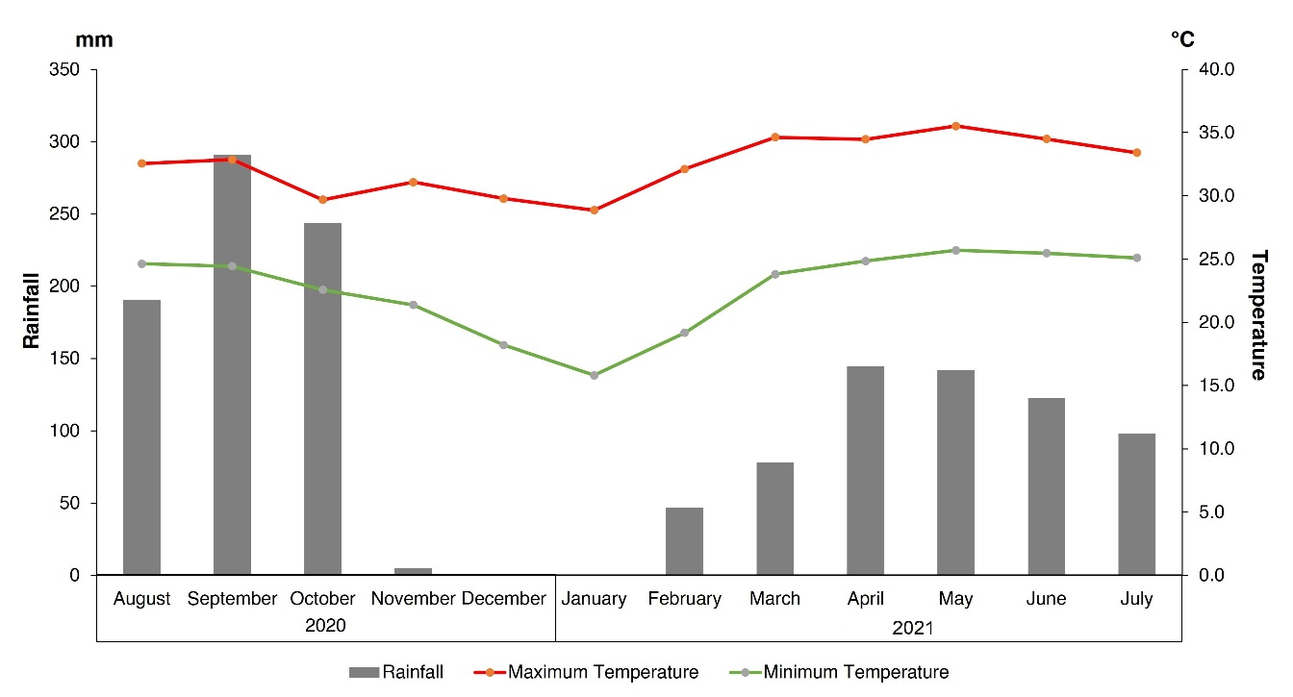
Figure S1 Monthly rainfall and temperature data recorded at Khon Kaen Station during the study period. The data were provided by the Thai Meteorological Department.
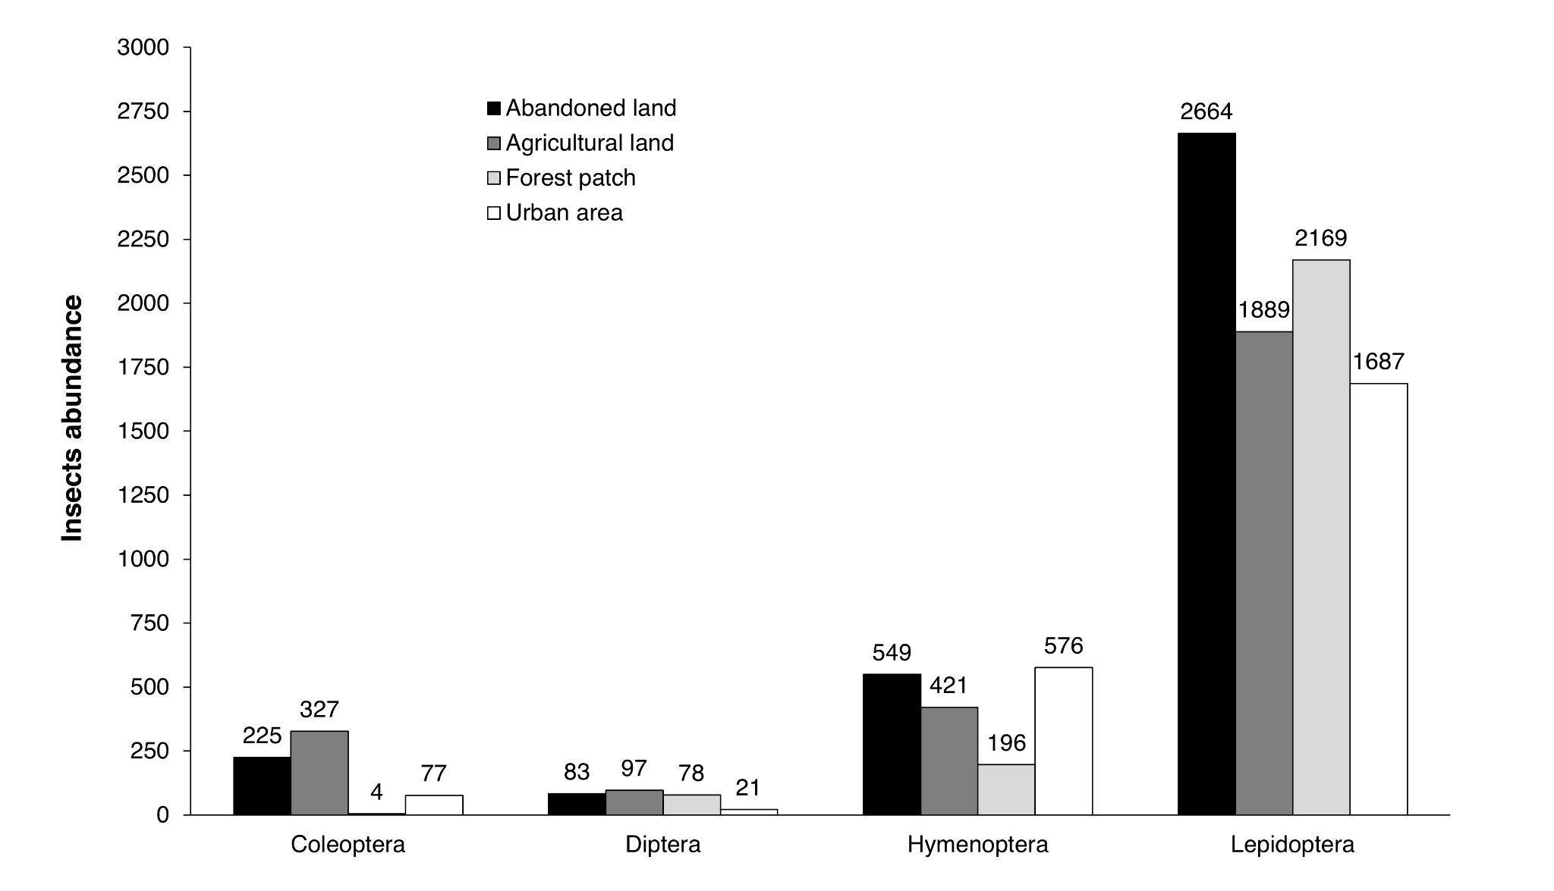Figure S2 Summary of absolute counts of CDHL insects observed from four land-use types across three seasons.

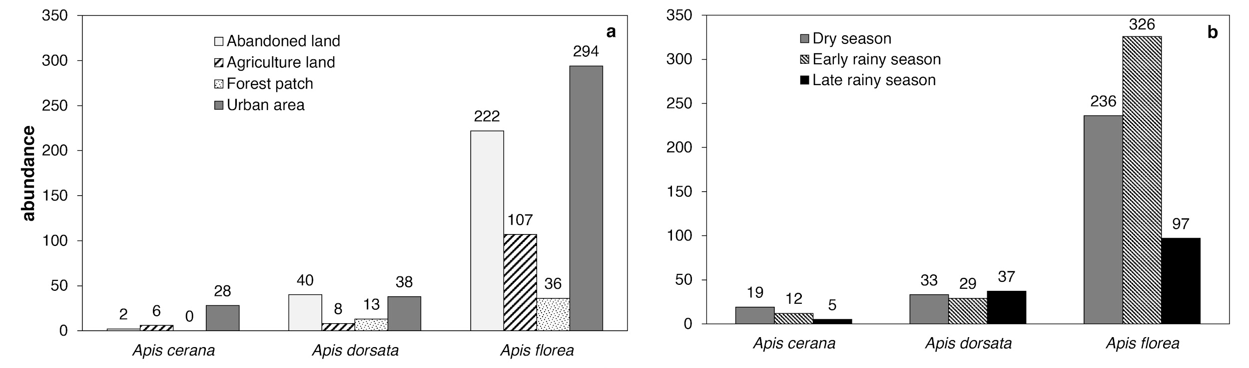
Figure S3 Combined data of Apis bees from three seasons in four land-use types (a), and seasonal variation from landscape scale combined from four land-use types (b): dry season (January-March), early rainy season (May-June), and late rainy season (August-October).

