BAI1 (Figure 2B) Repeat 1, 2
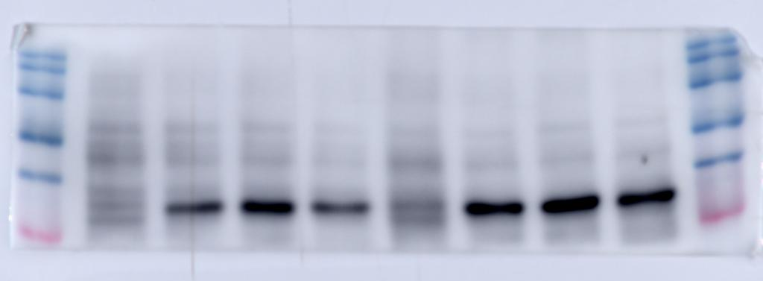
Vinculin (Figure 2B)
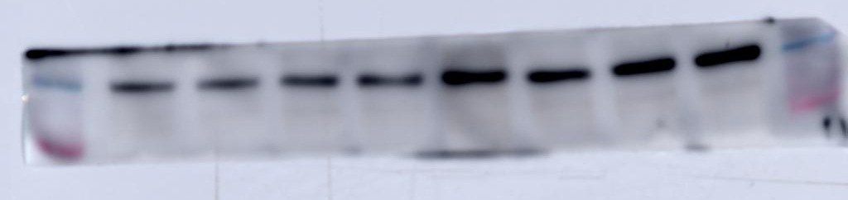

BAI1 (Figure 2B) Repeat 3, 4
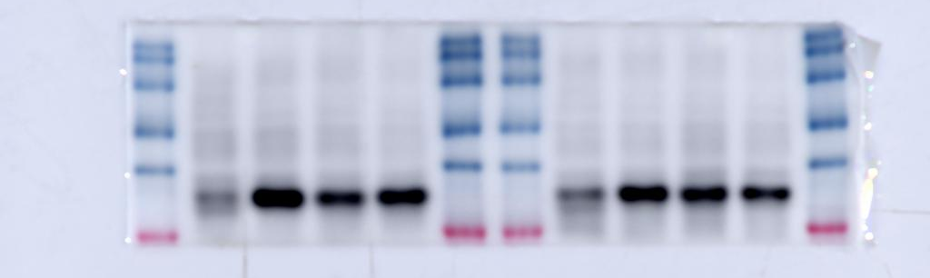
Vinculin (Figure 2B)
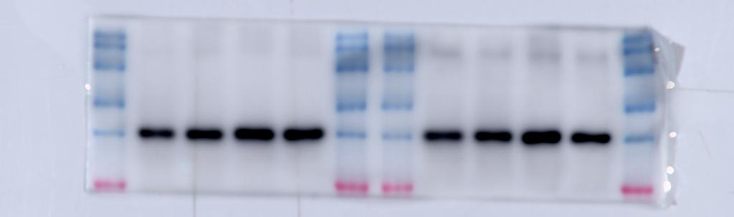

BAI1 (Figure 2A) Repeat 1
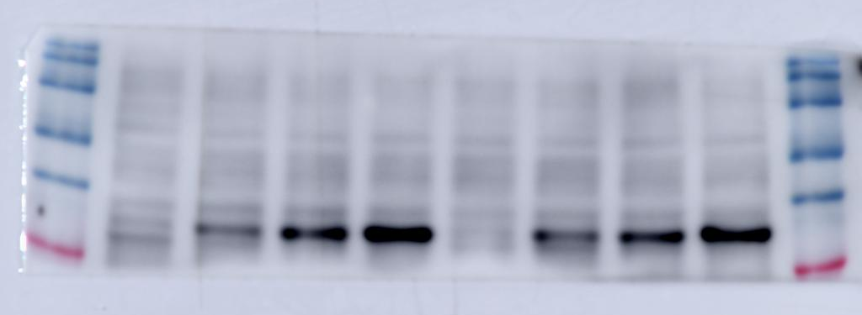
Vinculin (Figure 2A)
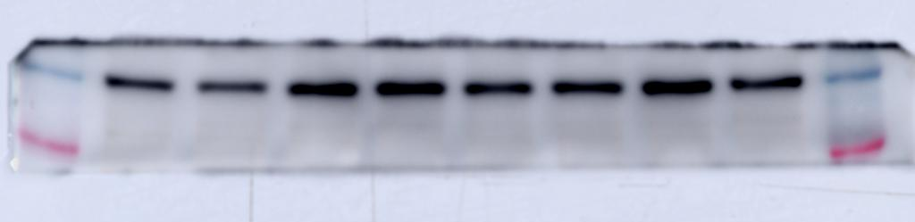

BAI1 (Figure 2A) Repeat 2, 3
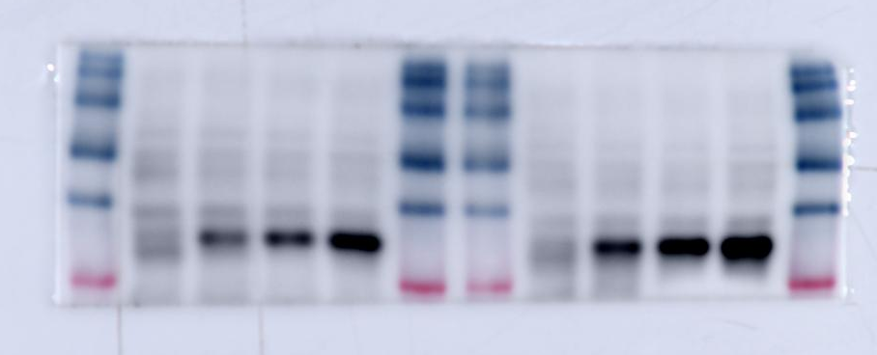
Vinculin (Figure 2A)
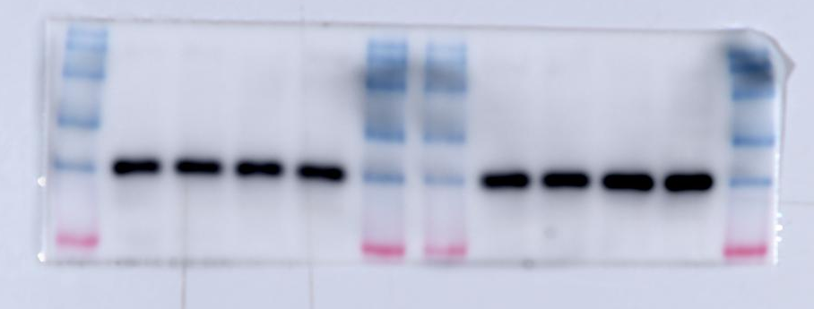

Cell lysate BAI1 (Figure 1A) Repeat 1
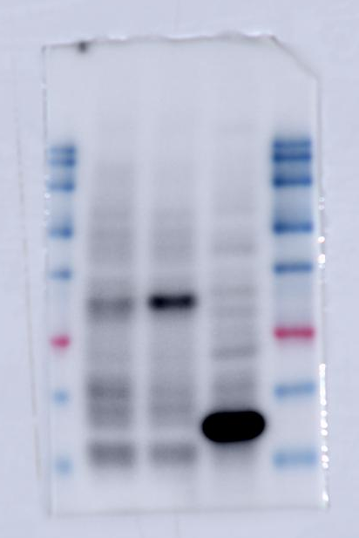
Cell lysate vinculin (Figure 1A) Repeat 1
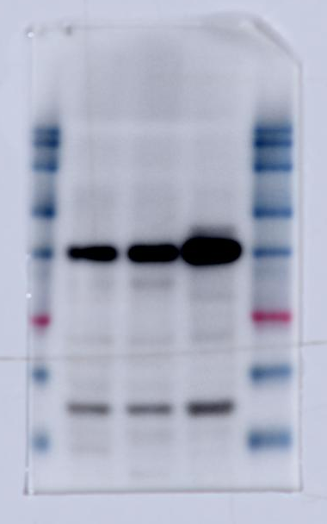

tissue lysate BAI1 (Figure 1A) Repeat 1
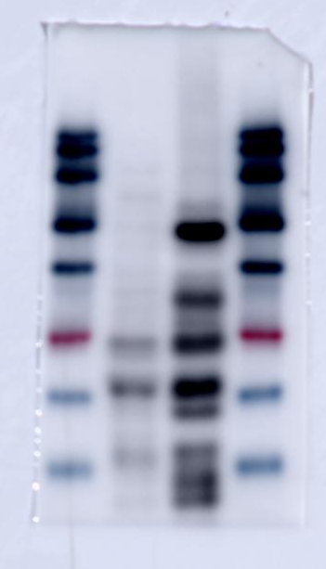
tissue lysate vinculin (Figure 1A) Repeat 1
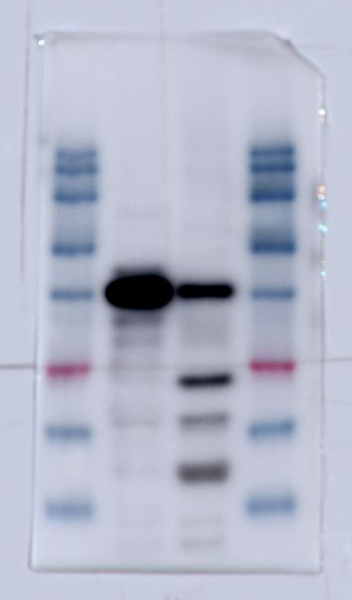

Cell lysate BAI1 (Figure 1A) Repeat 2
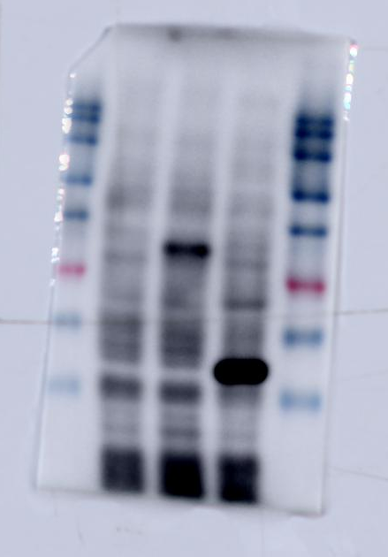
Cell lysate vinculin (Figure 1A) Repeat 2
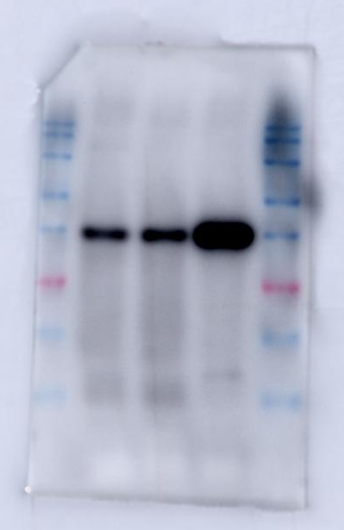

tissue lysate BAI1 (Figure 1A) Repeat 2
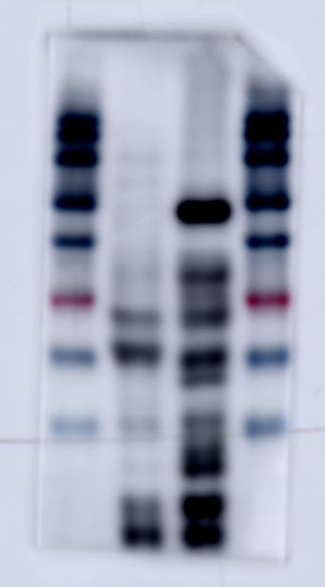
tissue lysate vinculin (Figure 1A) Repeat 2
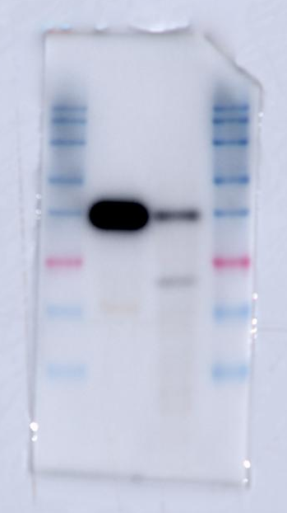

Cell lysate BAI1 (Figure 1A) Repeat 3
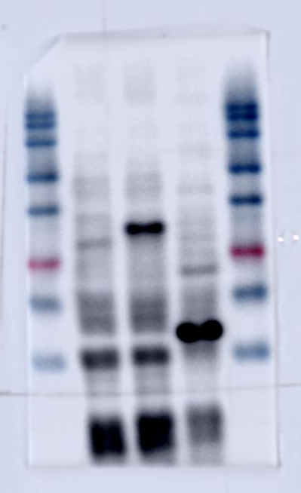
Cell lysate vinculin (Figure 1A) Repeat 3
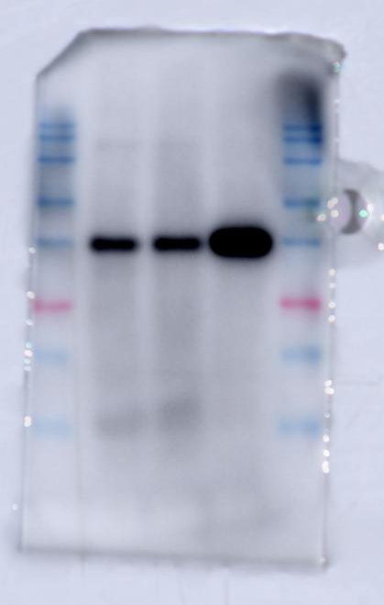

tissue lysate BAI1 (Figure 1A) Repeat 3
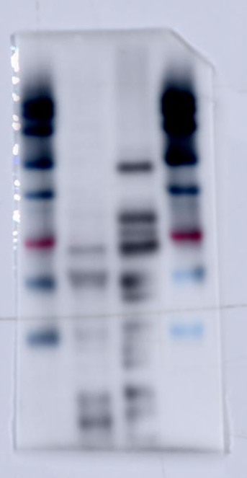
tissue lysate vinculin (Figure 1A) Repeat 3
