Application of remodeled water quality indices and multivariate statistical methods for the appraisal of water quality in a Himalayan lake

Mozim Shafi ª, Chander Prakash ª, Khalid Muzamil Gani^{b*}

ª Department of Civil Engineering, National Institute of Technology, Hamirpur, Himachal Pradesh, India
^{b} Department of Civil Engineering, National Institute of Technology , Srinagar, Jammu and Kashmir India-190001

*Corresponding author: - khalidmzml@gmail.com

Supplementary information

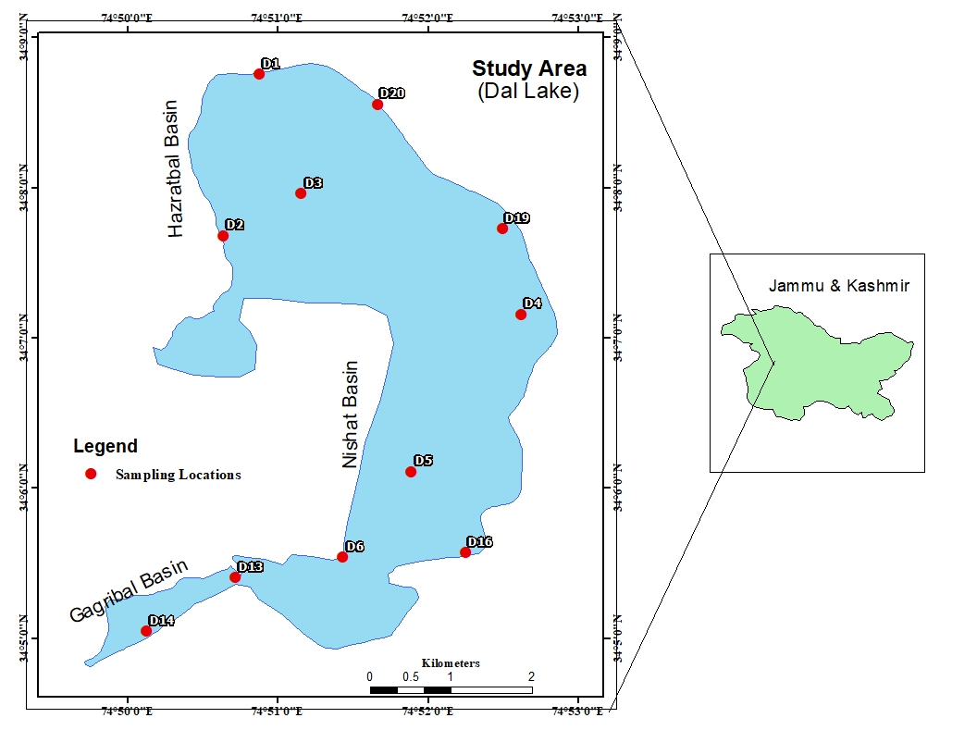
Figure S1 Location of the sampling sites in each basin of the Dal Lake.

Table S1 Geographic coordinates and site description of each sampling site of the 3 Basins in Dal Lake

S.No | Site | Basin | Description | Co- ordinates
1 | D1 | Hazratbal | Inside lake near entry of Telbal Nallah | 34.1459 N , 74.8480 E
2 | D2 | Hazratbal | Dhobi Ghat Area | 34.128 N , 74.844 E
3 | D3 | Hazratbal | Central site near Ropelank | 34.1326 N , 74.8526 E
4 | D20 | Hazratbal | Near Shalimar channel bridge | 34.1425 N , 74.8611 E
5 | D4 | Nishat | Nishat pipeline bund | 34.1193 N , 74.8771 E
6 | D5 | Nishat | Central site near charchinari | 34.1018 N , 74.8649 E
7 | D6 | Nishat | Near Kabootar Khana | 34.0923 N , 74.8573 E
8 | D16 | Nishat | Dole dumb towards NPL bund | 34.0928 N , 74.8709 E
9 | D19 | Nishat | New shikara ghat near Nishat garden | 34.1287 N , 74.8750 E
10 | D13 | Gagribal | Opposite hotel nun kun | 34.0900 N , 74.8453 E
11 | D14 | Gagribal | Opposite hotel welcome | 34.0841 N , 74.8355 E

Table S2: Methodology and equipment’s used in the Laboratory of Research and Monitoring Division of Lakes and Waterways Development Authority
S.No | Parameters | Methods | Equipment
1 | Water Temperature | Manual | Thermometer (Digital/Mercury)
2 | Ph | Calibration on 7,9 and 4 buffer solutions | pH meter
3 | EC | Direct Reading | Conductivity meter
4 | Dissolved oxygen | Azide Modification Method | Burette for Titration
5 | Chlorides | Argentometric Method | Burette for Titration
6 | Calcium | Titration Method | Burette for Titration
7 | Magnesium | Titration Method | Burette for Titration
8 | Sulphate | Automated methyl thymol Method | HACH DR-5000/460nm
9 | Iron | Bromine Method | HACH DR-5000/420nm
10 | COD | Closed reflux Method | HACH DR-5000/600nm
11 | Nitrate Nitrogen | Brucine sulphate Method | HACH DR-5000/410nm
12 | Ammonical nitrogen | Nesslerization Method | HACH DR-5000/450nm
13 | Ortho-Phosphate | Staneous chloride Method | HACH DR-5000/690nm
14 | Total Phosphorous | Staneous chloride Method | HACH DR-5000/690nm
15 | Turbidity | Direct Reading | Turbidity meter

