Supplementary material for: Balloon atrial septostomy in d-Transposition of the Great Arteries - predictive discriminators for intervention

Authors: ¹Sinead Burke (first), ¹Siobhan Coughlan, ²Martina Healy, ^{3,6}Jennifer J Brady, ¹Kevin Walsh, ¹Damien Kenny, ¹Paul Oslizlok, ⁴Jonathan McGuinness, ⁵Afif El Khuffash, ¹Terence Prendiville (last and corresponding)
Institution: ¹Department of paediatric cardiology, Children’s Health Ireland at Crumlin, Dublin, Ireland; ²Department of intensive care, Children’s Health Ireland at Crumlin, Dublin, Ireland; ³Biochemistry Department, Children’s Health Ireland at Crumlin, Dublin, Ireland; ⁴Department of cardiothoracic surgery, Children’s Health Ireland at Crumlin, Dublin, Ireland; ⁵Department of neonatology. Rotunda Hospital, Parnell Sq. E. Dublin, ⁶ School of Medicine, University College Dublin.
Corresponding author: Dr. Terence Prendiville; terence.prendiville@cuh.ie
Supplementary material.

Supplemental Figure S1. Gender, birth weight and gestation of infants with d-Transposition of the Great Arteries (dTGA) undergoing Balloon A trial Septostomy (BAS).

Supplemental Figure S2. A comparison of peri-operative course in neonates with d-Transposition of the Great Arteries between those undergoing a Balloon Atrial Septostomy or not.
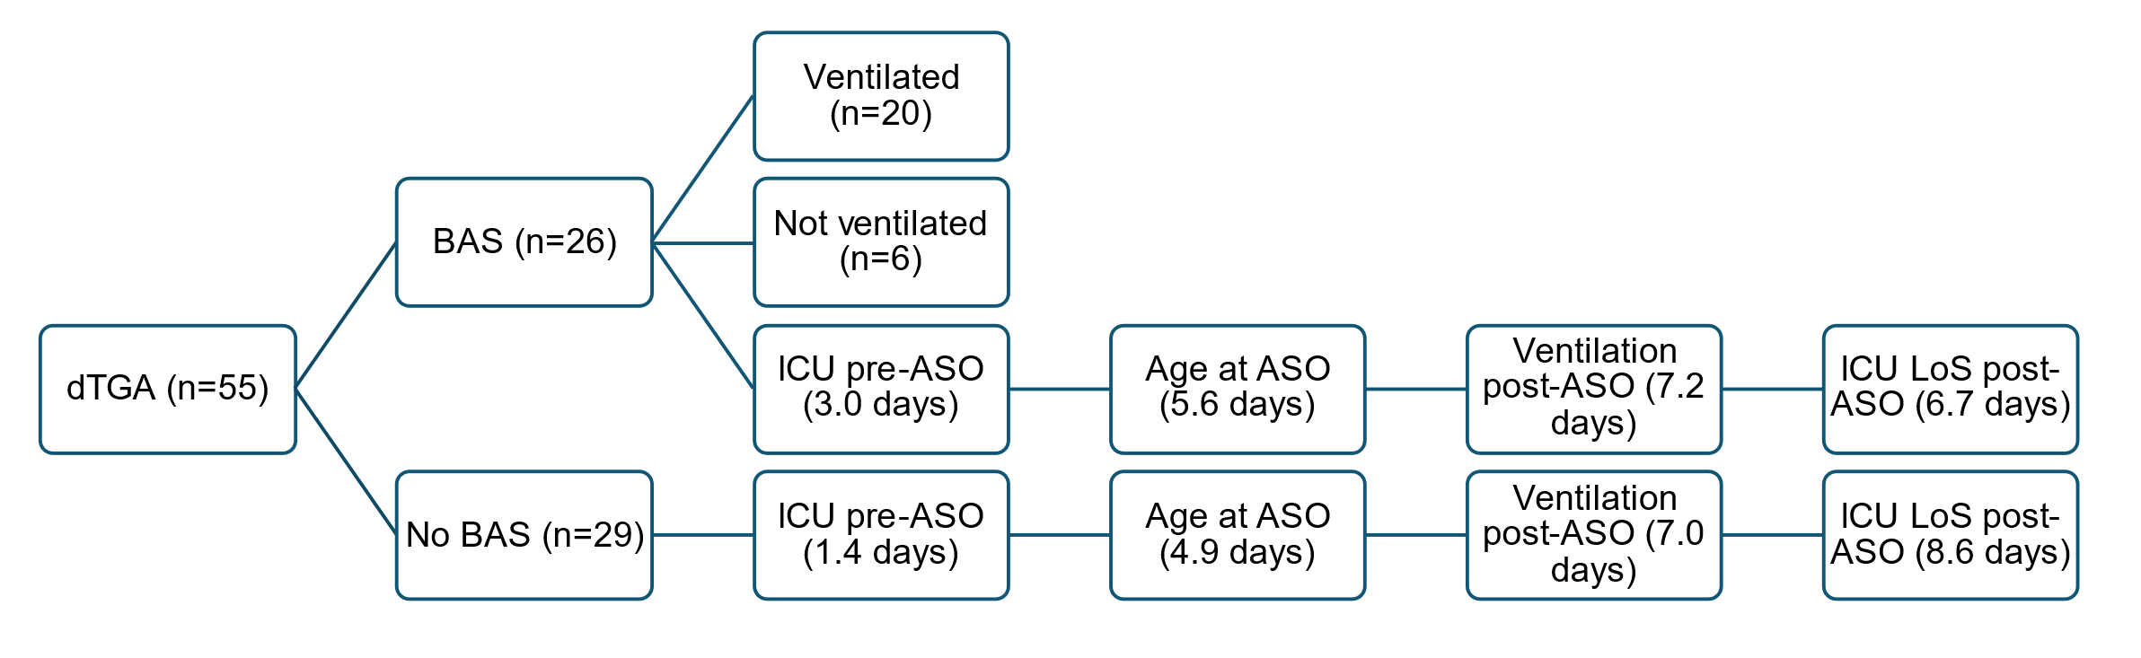

Supplemental Figure S3. Atrial septal defect size by echocardiography in infants with d-Transposition of the Great Arteries (dTGA) pre- and post-Balloon Atrial Septostomy (BAS).

Supplemental Figure S4. Intensive Care Unit (ICU) course in neonates with d-Transposition of the Great Arteries (dTGA) - Comparing those requiring Balloon Atrial Septostomy (BAS) versus to those that did not prior to the Arterial Switch Operation (ASO).

