Aggregation Organic Molecule as a Nanocluster in Mixture Solvents

Farid Taherkhani^{1,2*}

¹Departments of Thermodynamics and Thermal Process Engineering Brandenburg University of Technology, Cottbus, 03046 Germany
² Universität Bremen, Energiespeicher-und Energiewandlersysteme, Bibliotechkstraße 1, Bremen, 28359, Germany
*Corresponding Author:

taherkha@b-tu.de, faridtaherkhani@gmail.com

Part.A

Fig.S1
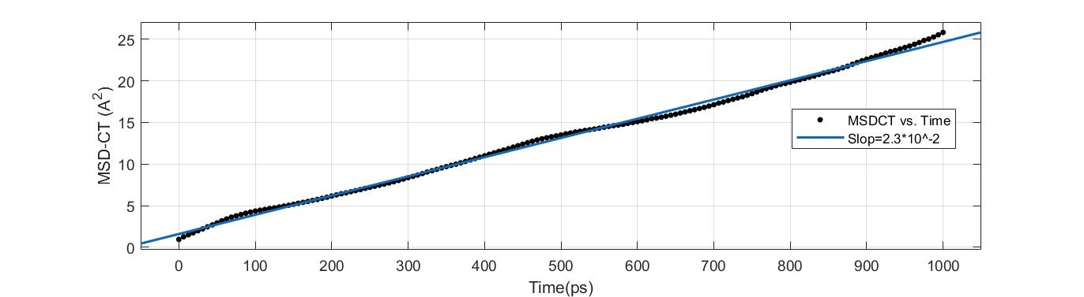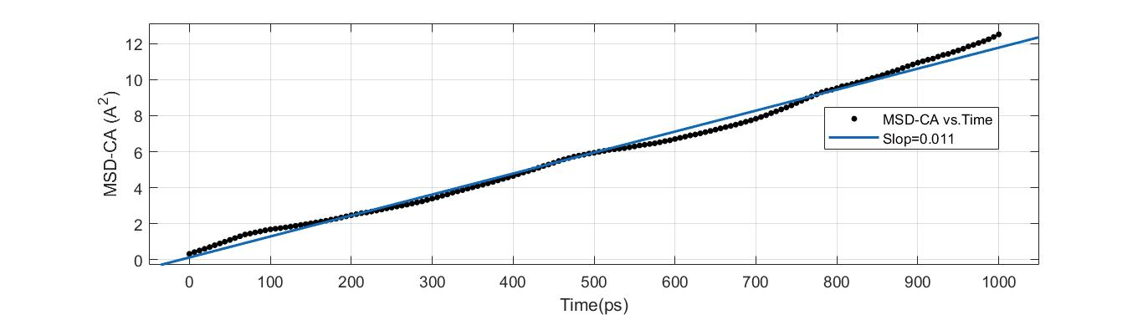
(1) (2)
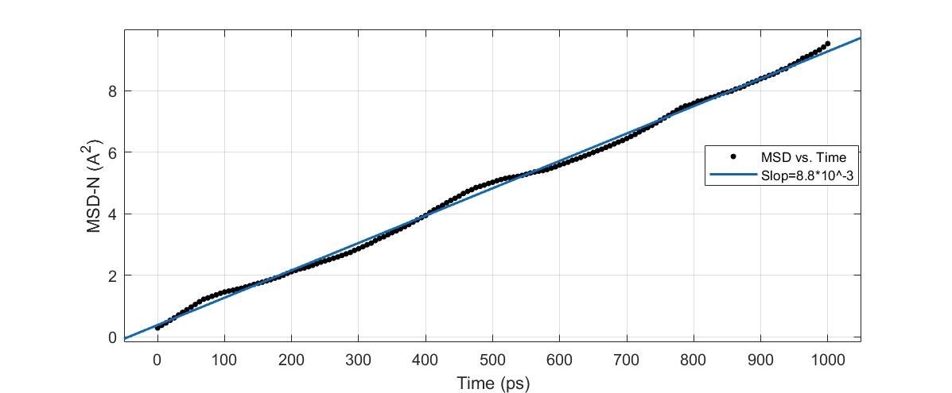
(3)

FigS1.Results of the MSD fitting with one-line shapes for 1) CT , 2) CA , 3) N are presented Fig.S1

Fig.S2.

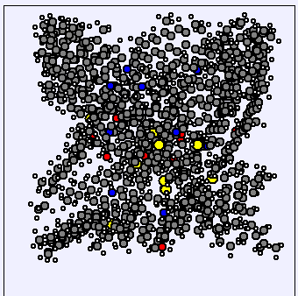

FigS2.Schematic representation of a 10 Asphaltene cluster

Fig.S3.

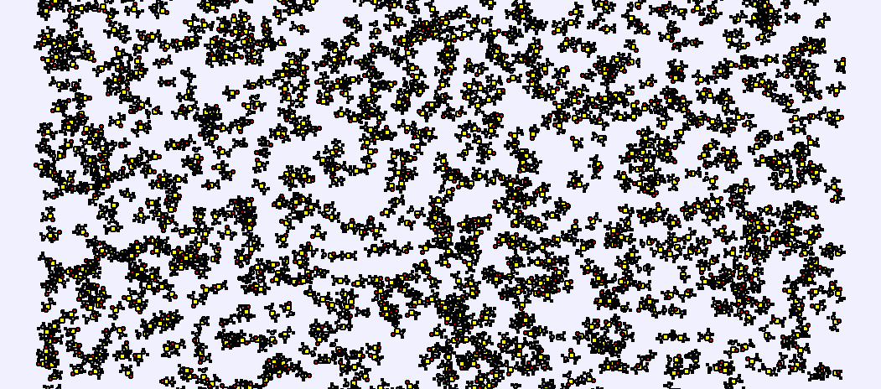

Fig.S3.schematic representation of 530 molecules of dimethyl sulfoxide (DMSO) solvent

Fig.S4.

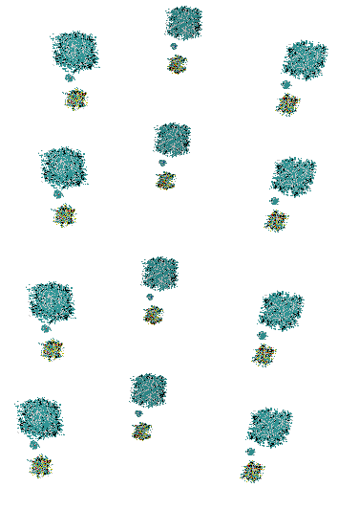

Fig.S4.MD simulation setup with Initial Cell Size (1172*1172*1758 A³)
Weight (5%Asphalt, 20 %DMSO, 75%Toluen)

Fig.S5
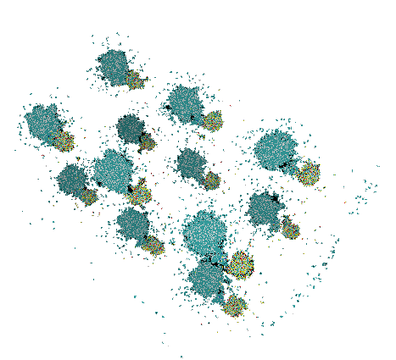

Fig.S5. MD Snapshot with Cell size (1026*1026*1540) A³
Weight (5%Asphalt, 20 %DMSO, 75%Toluen)

Fig.S6
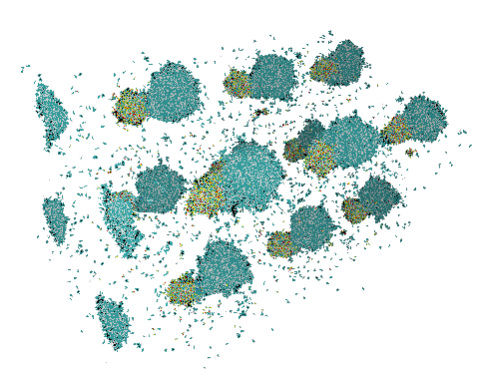

Fig.S6.MD snapshot with (470*470*705)A³
Weight (5%Asphalt, 20 %DMSO, 75%Toluen)

Fig.S7

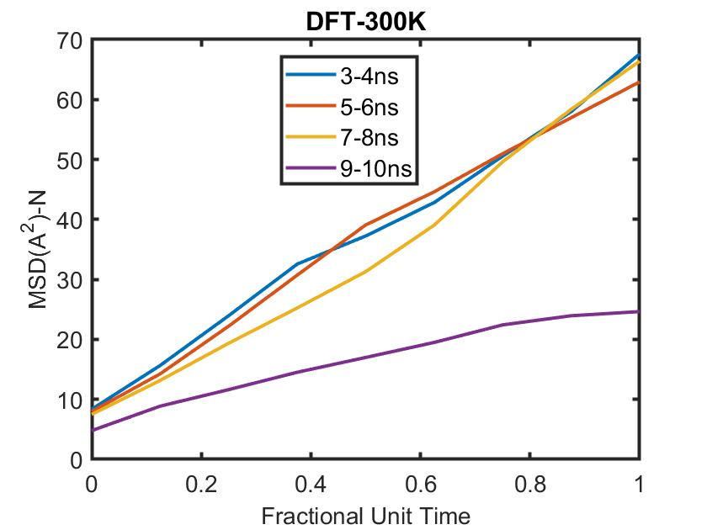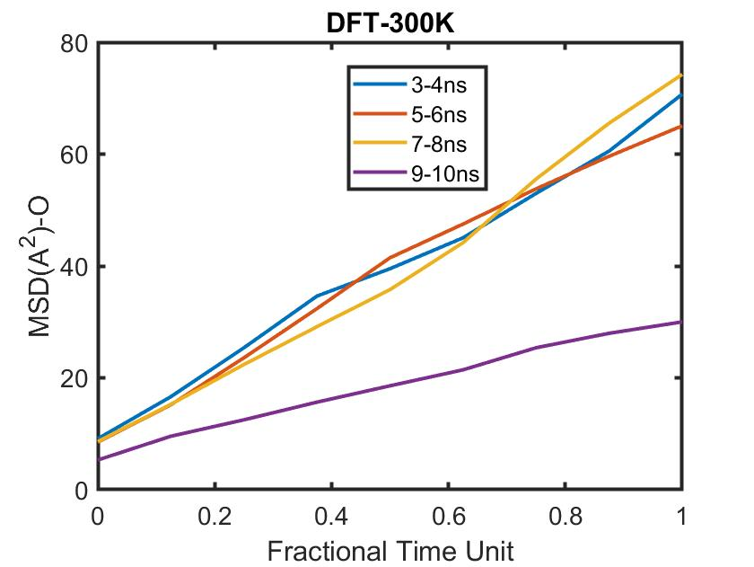

(1) (2)

Fig.S.7.1.Result of MSD for N atom in Asphaltene in during aggregation time based n DFT
FigS7.2.Result of MSD for O atom in Asphaltene in during aggregation time based on DFT

Fig.S8
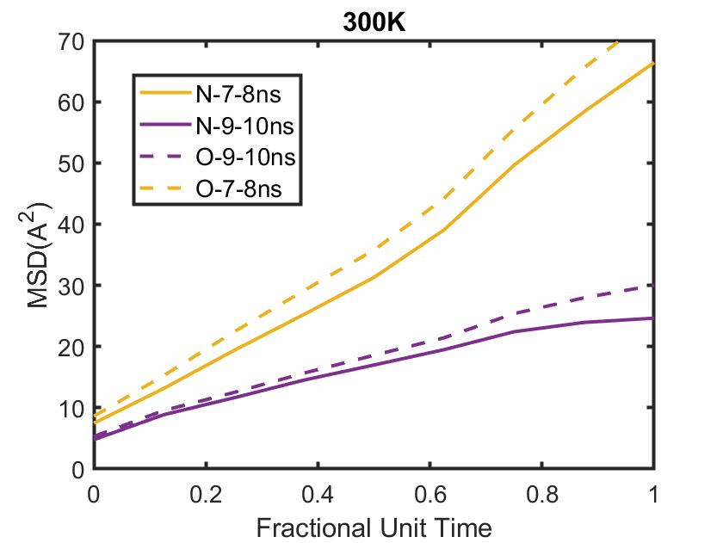

Fig.S8. Comparison MSD for N and O atoms in core parts of Asphalten

Fig.S9

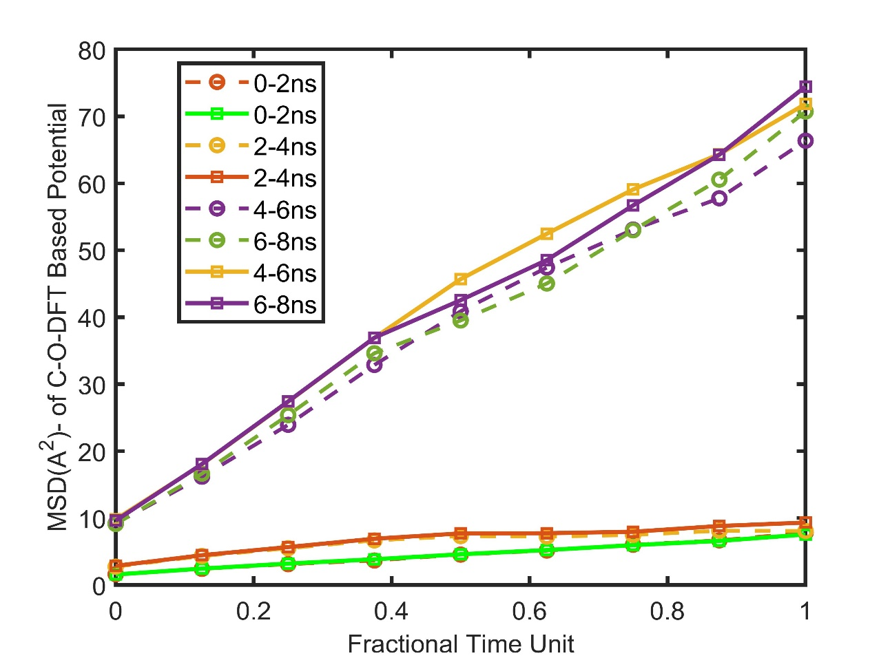

Fig.S9. Comparison MSD value for O and C in aromatic core

Fig.S10

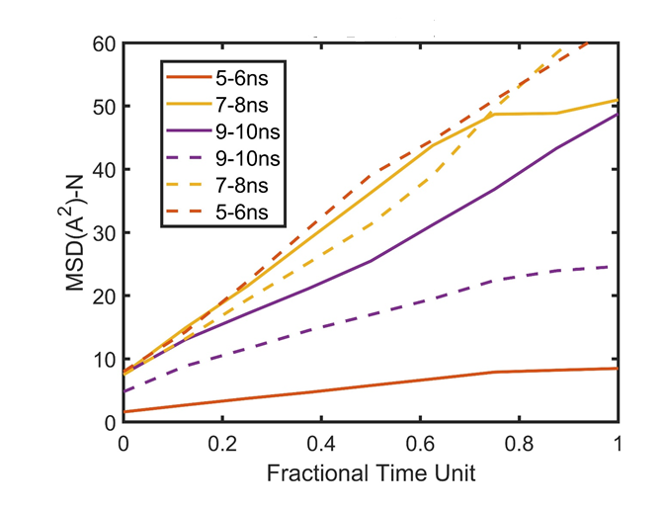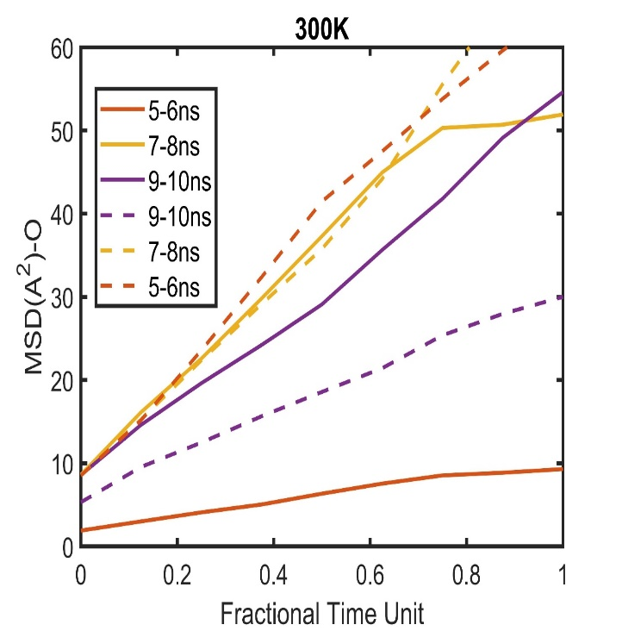

- (2)

Fig.S10.1.MSD result for nitrogen atom by using DFT potential parametrization and OPLS force field
Fig.S10.2. MSD result for O atom in core part of Asphaltene by application DFT potential parametrization and OPLS force field

Part B

Fig.S1.B

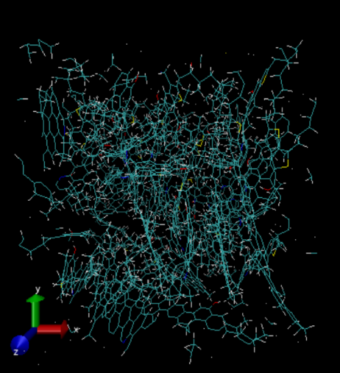
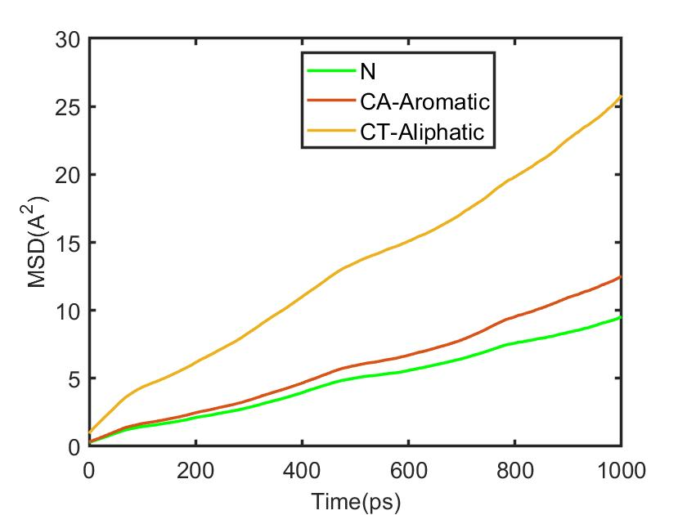

- (2)

Fig.S1B.1.Shematics presentation of optimized Asphaltene after 1 nanosecond via OPLS force field

Fig.S1B.2. MSD result by application of OPLS force field for aliphatic and aromatic carbon and N atom in Asphaltene core as a function of time

Fig.S2.B
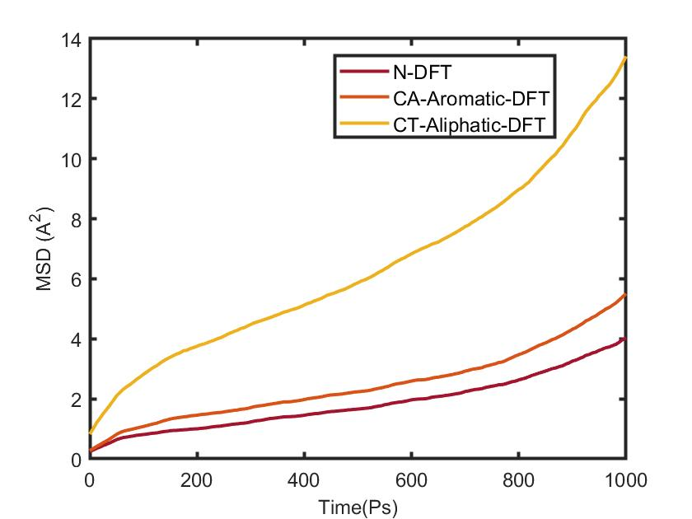

FigS2B. Result of MSD via Molecular dynamics simulation based on DFT potential parametrization, for nitrogen and carbon in core structure and aliphatic carbon in tail structure for Asphaltene liquid

Fig.S3.B
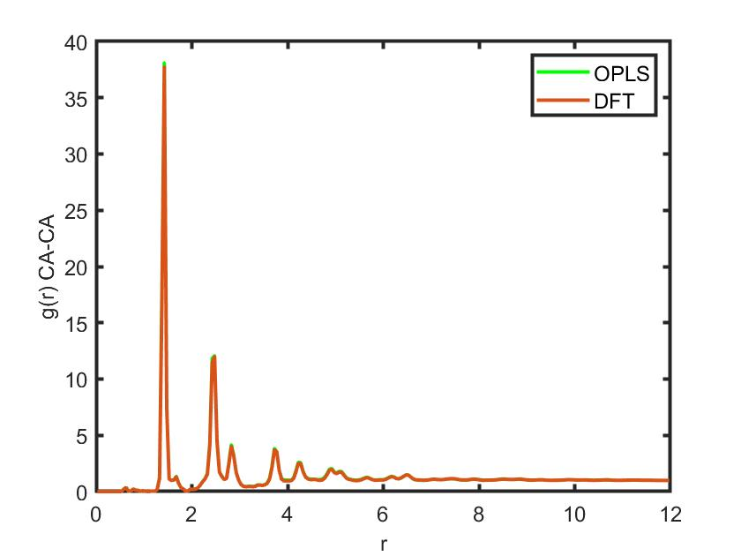

Fig.S3B. MD result for radial distribution function for Asphaltene liquid with OPLS force field and DFT potential parametrization

Fig.S4.B

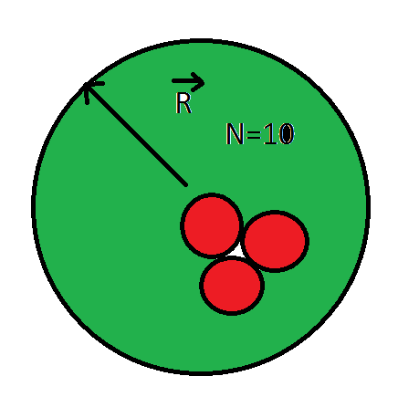

Fig.S4.B. 10 Asphaltene molecule is included for formation of Asphaltene cluster with 3 nm size

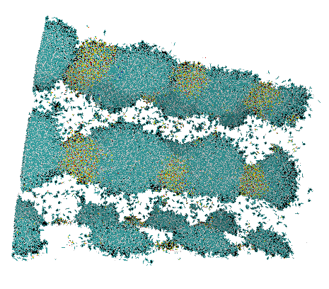
Fig.S5.B

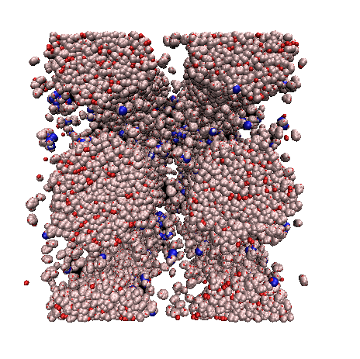

- (2)

Cell size (324*324*407)A³ Weight (5%Asphalt, 20 %DMSO, 75%Toluen)

Fig.S5B.1 . Combining Asphaltene , DMSO and Toluene in near the mixture with line presentation
Fig.S5B.2 Combining Asphaltene, DMSO and Toluene in near the mixture spherical presentation molecular model

Fig.S6.B

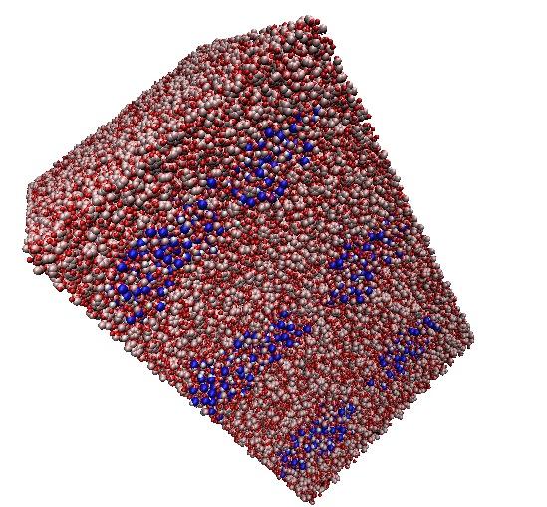

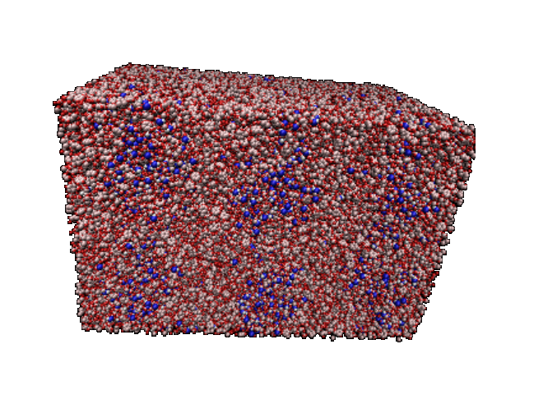
- (2)

Fig.S6.B.1. Cell size ( 144.45 * 144.45 * 216.68 A³) Weight (5%Asphalt, 20 %DMSO, 75%Toluen), Snapshot, cell size of mixture of Asphaltene with Toluene and DMSO with DFT potential parametrization at 0.8 ns
Fig.S6.B.2. Cell Size (143.62*143.62*215.43 A³)Weight (5%Asphalt, 20 %DMSO, 75%Toluen) Snapshot of Asphaltene mixture in DMSO and Toluene at 1 ns

Fig.S7.B

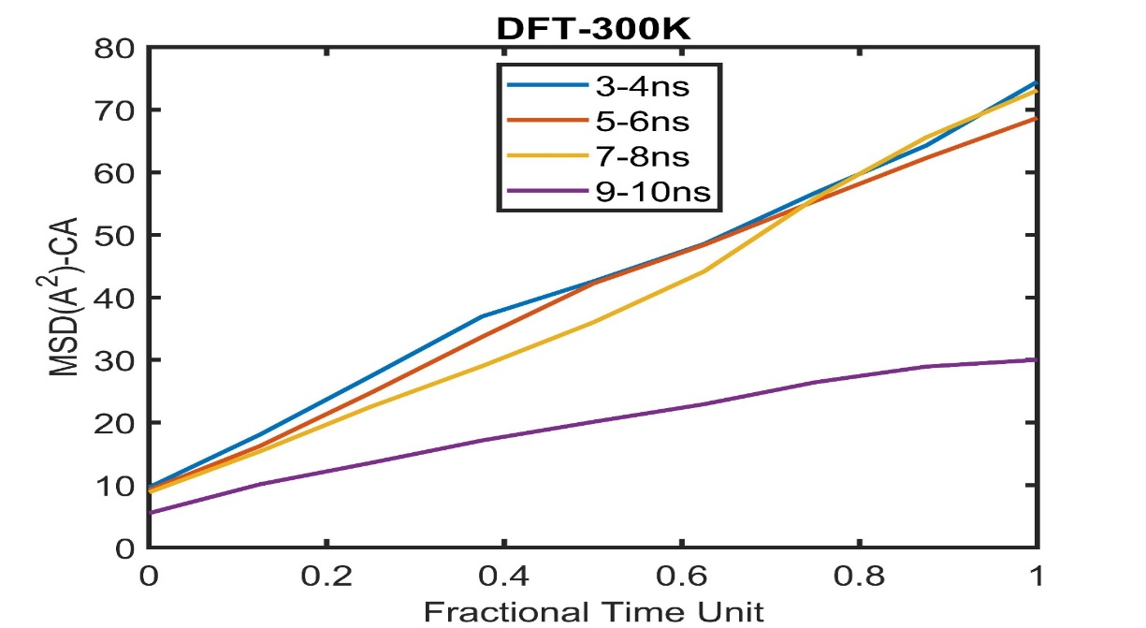
Fig.S7.B. MSD result for Asphaltene core from 3-10 nanosecond in different time interval versus fractional time unit based on DFT potential Parametrization

Fig.S8.B
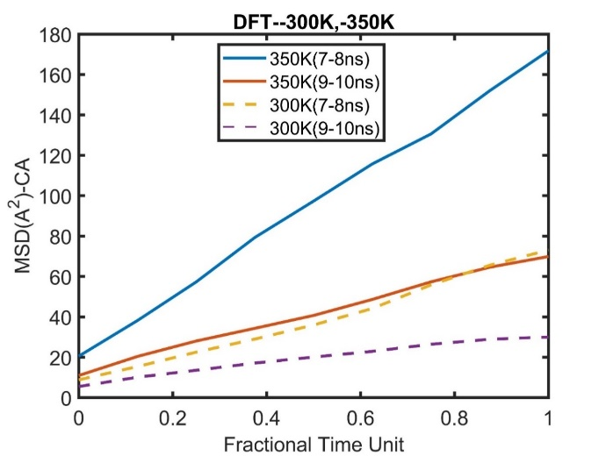
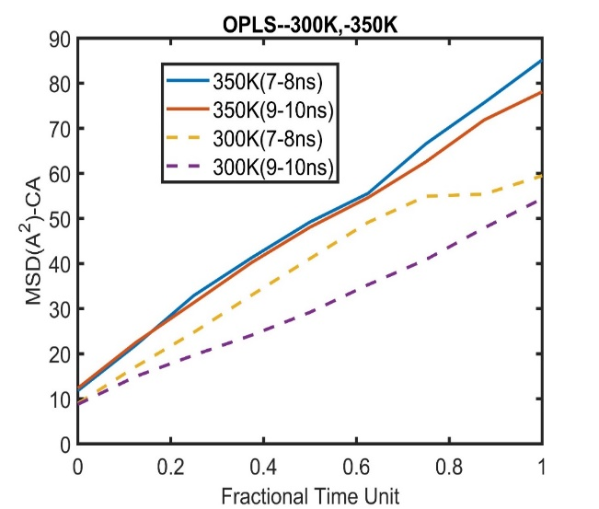
(1) (2)

Fig.S8.B.1. MD result regarding temperature effect on MSD value by using DFT potential parametrization

Fig.S8.B.2.MSD value for Asphalten core by application OPLS force field at different temperature and time

Fig.S9.B

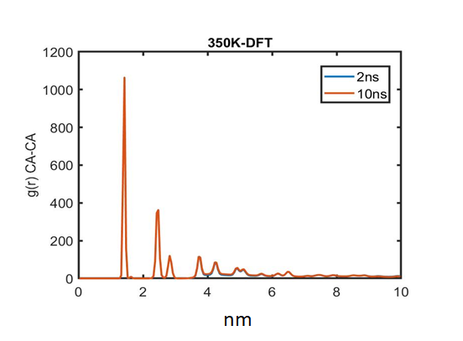

Fig.S9.B. Molecular dynamics result about radial distribution function based on DFT potential parametrization for carbon-carbon in core Asphaltene at 350K

Fig.S10.B

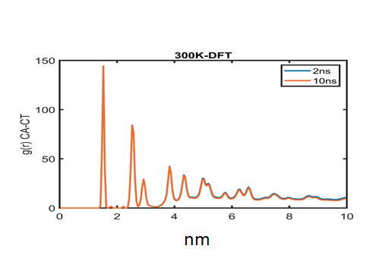

Fig.S10.B.Result of radial distribution function between carbon in aromatic core and aliphatic chain at two different simulation time 2, 10 ns

Part.C.

Chemical Symbol for Asphalten Structure

CA 12.0115000000000
CA 12.0115000000000
CA 12.0115000000000
CA 12.0115000000000
CA 12.0115000000000
CA 12.0115000000000
CA 12.0115000000000
CA 12.0115000000000
CA 12.0115000000000
HA 1.00797000000000
NB 14.0067000000000
CA 12.0115000000000
CA 12.0115000000000
CA 12.0115000000000
CA 12.0115000000000
CT 12.0115000000000
CT 12.0115000000000
CA 12.0115000000000
CA 12.0115000000000
HC 1.00797000000000
CT 12.0115000000000
HC 1.00797000000000
HC 1.00797000000000
CA 12.0115000000000
CA 12.0115000000000
CA 12.0115000000000
C56A 12.0115000000000
C56B 12.0115000000000
CA 12.0115000000000
OHP 15.9994000000000
HO 1.00797000000000
SA 32.0610000000000
C5A 12.0115000000000
C5B 12.0115000000000
HC 1.00797000000000
CT 12.0115000000000
HC 1.00797000000000
HC 1.00797000000000
CT 12.0115000000000
CT 12.0115000000000
HC 1.00797000000000
HC 1.00797000000000
CT 12.0115000000000
HC 1.00797000000000
HC 1.00797000000000
CT 12.0115000000000
HC 1.00797000000000
HC 1.00797000000000
HC 1.00797000000000
CT 12.0115000000000
CT 12.0115000000000
HC 1.00797000000000
HC 1.00797000000000
CT 12.0115000000000
HC 1.00797000000000
HC 1.00797000000000
CT 12.0115000000000
HC 1.00797000000000
HC 1.00797000000000
HC 1.00797000000000
HC 1.00797000000000
CT 12.0115000000000
CT 12.0115000000000
HC 1.00797000000000
HC 1.00797000000000
CT 12.0115000000000
HC 1.00797000000000
HC 1.00797000000000
HC 1.00797000000000
HC 1.00797000000000
HC 1.00797000000000
CT 12.0115000000000
HC 1.00797000000000
HC 1.00797000000000
HC 1.00797000000000
CA 12.0115000000000
CA 12.0115000000000
CA 12.0115000000000
CA 12.0115000000000
CA 12.0115000000000
CA 12.0115000000000
CA 12.0115000000000
CT 12.0115000000000
CA 12.0115000000000
CA 12.0115000000000
CA 12.0115000000000
CA 12.0115000000000
CA 12.0115000000000
CA 12.0115000000000
CA 12.0115000000000
CA 12.0115000000000
CT 12.0115000000000
HC 1.007970000000
HC 1.00797000000000
HC 1.00797000000000
CT 12.0115000000000
CT 12.0115000000000
CA 12.0115000000000
CA 12.0115000000000
CA 12.0115000000000
CA 12.0115000000000
CA 12.0115000000000
CA 12.0115000000000
CA 12.0115000000000
CT 12.0115000000000
CT 12.0115000000000
CT 12.0115000000000
CA 12.0115000000000
CA 12.0115000000000
CT 12.0115000000000
CT 12.0115000000000
CT 12.0115000000000
CT 12.0115000000000
CT 12.0115000000000
HC 1.00797000000000
HC 1.00797000000000
HC 1.00797000000000
HA 1.00797000000000
HC 1.00797000000000
HC 1.00797000000000
HC 1.00797000000000
HC 1.00797000000000
HC 1.00797000000000
HC 1.00797000000000
HC 1.00797000000000
HC 1.00797000000000
HC 1.00797000000000
HC 1.00797000000000
HC 1.00797000000000
HC 1.00797000000000
HC 1.00797000000000
HC 1.00797000000000
HA 1.00797000000000
HA 1.00797000000000
HC 1.00797000000000
HA 1.00797000000000
HC 1.00797000000000
HC 1.00797000000000
HC 1.00797000000000
HA 1.00797000000000
HC 1.00797000000000
HC 1.00797000000000
HC 1.00797000000000
HA 1.00797000000000
HA 1.00797000000000
CA , CT , HA, HC are aromatic carbon, aliphatic carbon, hydrogen which bonded aliphatic, hydrogen is bonded to aromatic in Asphalten respectively.
OHP, SA, NA, C56A, C56B, C5A, C5B, HO are oxygen atom, sulfur atom, nitrogen atom, carbon near the oxygen, carbon near the nitrogen, hydrogen bonded to oxygen in Asphalten respectively.

Lenard Jones Parameters in simulation, Energy UNITS kcal (epsilon) , sigma unit is Angstrom.
VDW 210
CA CA lj 0.0700 3.5500
HA CA lj 0.0458 2.9310
NB CA lj 0.1091 3.3967
CT CA lj 0.0680 3.5249
HC CA lj 0.0458 2.9791
C56A CA lj 0.0700 3.5500
C56B CA lj 0.0700 3.5500
OHP CA lj 0.1091 3.3013
HO CA lj 0.0458 1.3323
SA CA lj 0.1663 3.5550
C5A CA lj 0.0700 3.5500
C5B CA lj 0.0700 3.5500
HA HA lj 0.0300 2.4200
NB HA lj 0.0714 2.8045
CT HA lj 0.0445 2.9103
HC HA lj 0.0300 2.4597
C56A HA lj 0.0458 2.9310
C56B HA lj 0.0458 2.9310
OHP HA lj 0.0714 2.7257
HO HA lj 0.0300 1.1000
SA HA lj 0.1089 2.9352
C5A HA lj 0.0458 2.9310
C5B HA lj 0.0458 2.9310
NB NB lj 0.1700 3.2500
CT NB lj 0.1059 3.3727
HC NB lj 0.0714 2.8504
C56A NB lj 0.1091 3.3967
C56B NB lj 0.1091 3.3967
OHP NB lj 0.1700 3.1587
HO NB lj 0.0714 1.2748
SA NB lj 0.2591 3.4015
C5A NB lj 0.1091 3.3967
C5B NB lj 0.1091 3.3967
CT CT lj 0.0660 3.5000
HC CT lj 0.0445 2.9580
C56A CT lj 0.0680 3.5249
C56B CT lj 0.0680 3.5249
OHP CT lj 0.1059 3.2780
HO CT lj 0.0445 1.3229
SA CT lj 0.1615 3.5299
C5A CT lj 0.0680 3.5249
C5B CT lj 0.0680 3.5249
HC HC lj 0.0300 2.5000
C56A HC lj 0.0458 2.9791
C56B HC lj 0.0458 2.9791
OHP HC lj 0.0714 2.7704
HO HC lj 0.0300 1.1180
SA HC lj 0.1089 2.9833
C5A HC lj 0.0458 2.9791
C5B HC lj 0.0458 2.9791
C56A C56A lj 0.0700 3.5500
C56B C56A lj 0.0700 3.5500
OHP C56A lj 0.1091 3.3013
HO C56A lj 0.0458 1.3323
SA C56A lj 0.1663 3.5550
C5A C56A lj 0.0700 3.5500
C5B C56A lj 0.0700 3.5500
C56B C56B lj 0.0700 3.5500
OHP C56B lj 0.1091 3.3013
HO C56B lj 0.0458 1.3323
SA C56B lj 0.1663 3.5550
C5A C56B lj 0.0700 3.5500
C5B C56B lj 0.0700 3.5500
OHP OHP lj 0.1700 3.0700
HO OHP lj 0.0714 1.2390
SA OHP lj 0.2591 3.3059
C5A OHP lj 0.1091 3.3013
C5B OHP lj 0.1091 3.3013
HO HO lj 0.0300 0.5000
SA HO lj 0.1089 1.3342
C5A HO lj 0.0458 1.3323
C5B HO lj 0.0458 1.3323
SA SA lj 0.3950 3.5600
C5A SA lj 0.1663 3.5550
C5B SA lj 0.1663 3.5550
C5A C5A lj 0.0700 3.5500
C5B C5A lj 0.0700 3.5500
C5B C5B lj 0.0700 3.5500
CA SZds lj 0.166282 3.5500
CA OZds lj 0.14 3.120
CA CTds lj 0.06797 3.52
CA HCds lj 0.04582 3.02
HA SZds lj 0.1088 2.99
HA OZds lj 0.09165 2.55
HA CTds lj 0.044497 2.96
HA HCds lj 0.03 2.46
NB SZds lj 0.2591 3.405
NB OZds lj 0.2181 2.975
NB CTds lj 0.1059 3.375
NB HCds lj 0.07141 2.875
CT SZds lj 0.16146 3.53
CT OZds lj 0.1359 3.10
CT CTds lj 0.066 3.50
CT HCds lj 0.04449 3.00
HC SZds lj 0.1088 3.03
HC OZds lj 0.09165 2.60
HC CTds lj 0.04449 3.0
HC HCds lj 0.03 2.5
C56A SZds lj 0.1662 3.555
C56A OZds lj 0.14 3.125
C56A CTds lj 0.06797 3.525
C56A HCds lj 0.04582 3.025
C56B SZds lj 0.1662 3.555
C56B OZds lj 0.14 3.125
C56B CTds lj 0.067970 3.525
C56B HCds lj 0.04582 3.025
OHP SZds lj 0.25913 3.315
OHP OZds lj 0.21817 2.885
OHP CTds lj 0.10592 3.285
OHP HCds lj 0.071414 2.785
HO SZds lj 0.10885 2.03
HO OZds lj 0.09165 1.60
HO CTds lj 0.04449 2.0
HO HCds lj 0.0300 1.5
SA SZds lj 0.395 3.56
SA OZds lj 0.3325 3.13
SA CTds lj 0.1614 3.53
SA HCds lj 0.1088 3.03
C5A SZds lj 0.16628 3.555
C5A OZds lj 0.14 3.125
C5A CTds lj 0.06797 3.525
C5A HCds lj 0.04582 3.025
C5B SZds lj 0.16628 3.555
C5B OZds lj 0.14 3.125
C5B CTds lj 0.06797 3.525
C5B HCds lj 0.04582 3.025
SZds SZds lj 0.3950 3.5600
OZds SZds lj 0.3326 3.1003
CTds SZds lj 0.1615 3.5299
HCds SZds lj 0.1089 2.9833
OZds OZds lj 0.2800 2.7000
CTds OZds lj 0.1359 3.0741
HCds OZds lj 0.0917 2.5981
CTds CTds lj 0.0660 3.5000
HCds CTds lj 0.0445 2.9580
HCds HCds lj 0.0300 2.5000
CA CAts lj 0.07 3.55
CA HAts lj 0.04582 2.985
CA CTts lj 0.06797 3.525
CA HCts lj 0.045825 3.025
HA CAts lj 0.045825 2.985
HA HAts lj 0.03 2.42
HA CTts lj 0.04449 2.96
HA HCts lj 0.03 2.46
NB CAts lj 0.1090 3.4
NB HAts lj 0.07141 2.835
NB CTts lj 0.10592 3.375
NB HCts lj 0.07141 2.875
CT CAts lj 0.06797 3.525
CT HAts lj 0.04449 2.96
CT CTts lj 0.066 3.5
CT HCts lj 0.04449 3.00
HC CAts lj 0.04582 3.025
HC HAts lj 0.03 2.46
HC CTts lj 0.04449 3.00
HC HCts lj 0.03 2.5
C56A CAts lj 0.07 3.55
C56A HAts lj 0.04582 2.985
C56A CTts lj 0.06797 3.525
C56A HCts lj 0.04582 3.025
C56B CAts lj 0.07 3.55
C56B HAts lj 0.04582 2.985
C56B CTts lj 0.06797 3.525
C56B HCts lj 0.04582 3.025
OHP CAts lj 0.1090 3.54
OHP HAts lj 0.07141 2.745
OHP CTts lj 0.1059 3.285
OHP HCts lj 0.07141 2.785
HO CAts lj 0.04582 2.025
HO HAts lj 0.03 1.46
HO CTts lj 0.04449 2
HO HCts lj 0.03 1.5
SA CAts lj 0.16628 3.555
SA HAts lj 0.10885 2.99
SA CTts lj 0.16146 3.53
SA HCts lj 0.10885 3.03
C5A CAts lj 0.07 3.55
C5A HAts lj 0.04582 2.985
C5A CTts lj 0.06797 3.525
C5A HCts lj 0.04582 3.025
C5B CAts lj 0.07 3.55
C5B HAts lj 0.04582 2.985
C5B CTts lj 0.06797 3.525
C5B HCts lj 0.04582 3.025
CAts SZds lj 0.1662 3.555
CAts OZds lj 0.14 3.125
CAts CTds lj 0.06797 3.525
CAts HCds lj 0.04582 3.025
HAts SZds lj 0.10885 2.99
HAts OZds lj 0.09165 2.56
HAts CTds lj 0.04449 2.96
HAts HCds lj 0.03 2.46
CTts SZds lj 0.1614 3.53
CTts OZds lj 0.1359 3.10
CTts CTds lj 0.066 3.5
CTts HCds lj 0.04449 3.00
HCts SZds lj 0.10885 3.03
HCts OZds lj 0.09165 2.60
HCts CTds lj 0.04449 3.00
HCts HCds lj 0.03 2.50
CAts CAts lj 0.0700 3.5500
HAts CAts lj 0.0458 2.9310
CTts CAts lj 0.0680 3.5249
HCts CAts lj 0.0458 2.9791
HAts HAts lj 0.0300 2.4200
CTts HAts lj 0.0445 2.9103
HCts HAts lj 0.0300 2.4597
CTts CTts lj 0.0660 3.5000
HCts CTts lj 0.0445 2.9580
HCts HCts lj 0.0300 2.5000
There are 210 types of Lenard’s jones for Asphalten which is solved in Toluene and DMSO solvents. ts symbols has been used to represent atoms of toluene solvent (ts) molecule. “ds” symbols presents for DMSO solvent atoms.

Part.D. Diffusion Regime

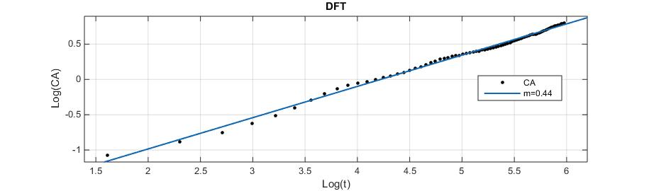
Fig.S1.D

Fig.S2.D

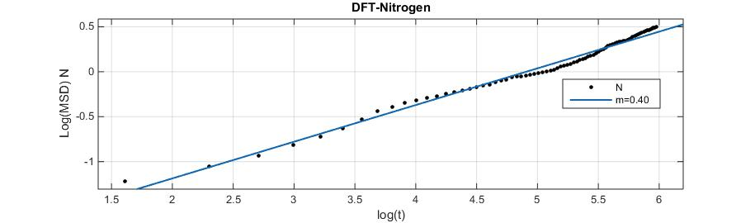

Fig.S3.D
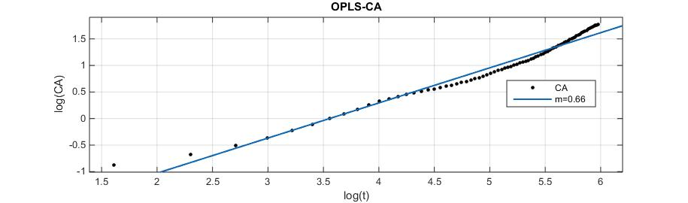

Fig.S4.D
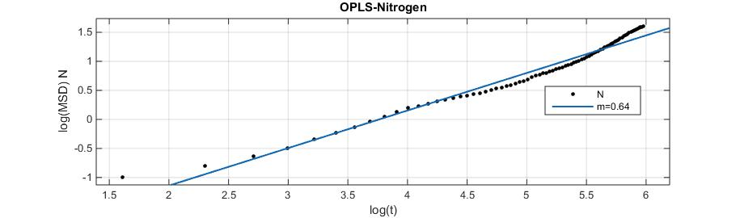

Fig.S5.D

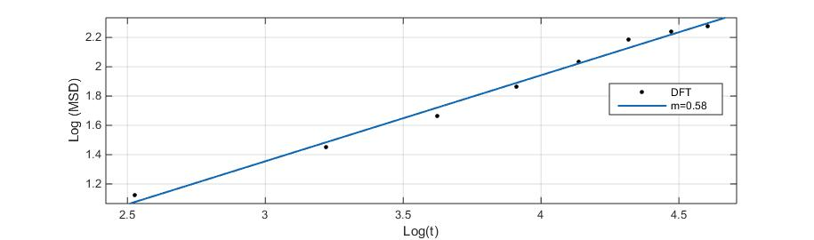
Asphalten Core

5-6 ns

Fig.S6.D
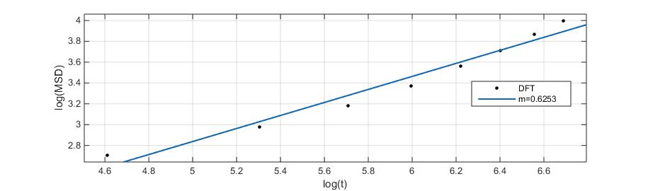

9-10ns

Fig.S7.D

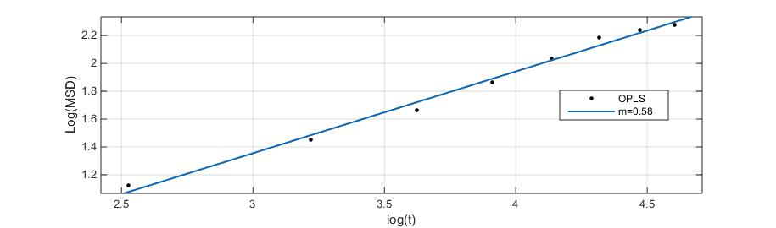

5-6 ns

Fig.S8.D
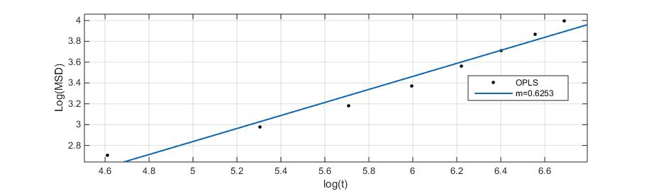

9-10ns

