Supporting Information
Exploring the impact of S/N co-doping on NiO nanoparticles towards improving energy bandgaps, photocatalytic efficiency, and antibacterial Performance.
Tariku Tamesgen ¹, Michael Asfaw Ameya ¹, Getu Sisay ¹, Lu Yuanqi ², Zhu Kai ², Tamene Tadesse Beyene*^{, 1}
¹Department of Chemistry, College of Natural Sciences, Jimma University, P.O.Box 378, Jimma, Ethiopia
²College of Materials Science and Chemical Engineering, Harbin Engineering University, Harbin 150001, China
* Corresponding Author
(E-Mail: tamene.tadesse@ju.edu.et)
- MATERIALS AND METHODS
A bare Nickel oxide nanoparticle was synthesized using co-precipitation method to examine the impact of incorporating S/N co-doping into NiO-NPs. In this method, an aqueous solution of a soluble nickel salt (Ni (NO₃)₂.6H₂O)) was reacted with a base such as sodium hydroxide. The base causes the formation of nickel hydroxide, which is then calcined to form NiO nanoparticles. This method is straightforward and allows for large-scale production of nanoparticles. A prepared NiO nanoparticle was mixed with a suitable amount of S/N co-doped and calcined to obtain the S/N co-doped NiO nanoparticles.
1.1. Chemicals and Reagents
Standard reagent grade chemicals were entirely utilized in this study. For the synthesis and characterizations of S/N co-doped NiO nanoparticles, the following analytical grade chemicals were used: Nickel nitrate-hexahydrate (Ni (NO₃)₂·6H₂O ≥ 98%) (Loba Chemie Pvt. Ltd), Hydrochloric acid (HCl; 37%, Labserv Pronalys, Australia), Sodium hydroxide (NaOH) ≥ 99% Blulux Laboratories Ltd-121,005), Ethanol (CH₃CH₂OH 99% Shree Renuk Sugars Ltd.India), Sodium thiosulphate (Na₂S₂O₃, 99%), Urea (NH₂CONH₂) , DMSO (≥ 99.99%, Xilong Scientific Co, Ltd), methylene blue (≥99%; Sigma-Aldrich) and distilled water (DW) were used in this work.

1.2. Apparatus and instruments
Different laboratory tools were utilized including beakers, measuring cylinders, magnetic stirrers, electronic balances, muffle furnaces, crystallizing dishes, burettes, funnels, Whatman filter 1& (size 10-500mm)pH meters, spoons, sample bottles, and pipettes. Advanced analytical instruments such as XRD (Drywell XRD-7000, Cu Kα (λ =1.54178 Å) radiation), UV-Vis (specord 200 plus - 223E1128F), and FT-IR (PerkinElmer Spectrum 2, wavenumber range 8300-350 cm⁻¹), and SEM (JSM-IT210, Scanning Electron Microscope) were used in this research.
1.3. Methods
1.3.1. Optimization of different parameters
The parameters like time, pH, temperature, and concentration of precursors were optimized for the rapid and maximum synthesis of NiO-NPs, S-doped NiO-NPs, N-doped NiO-NPs and S/N co-doped NiO-NPs. The pH was maintained by using HCl and NaOH. The reaction time was, although monitored at different time intervals, the synthesis of NiO-NPs, S-doped NiO-NPs, N-doped NiO-NPs and S/N co-doped NiO-NPs were monitored at various temperatures, and the concentration​s of precursors were maintained. Generally, during the optimization process, it was common to perform multiple experiments, systematically varying one parameter at a time while keeping the others constant. This helps in understanding the individual effects of each parameter and finding the optimal combination for rapid and maximum synthesis of NiO-NPs, S-doped NiO-NPs, N-doped NiO-NPs and S/N co-doped NiO-NPs. It was important to note that the specific optimal conditions for synthesis may vary depending on the experimental setup, precursor materials, and desired nanoparticle properties.

Synthesis of NiO Nanoparticles
NiO-NPs was synthesized using the some modifications as in a previously published paper ¹. High-purity substances including sodium hydroxide (NaOH) and Ni (NO₃)₂·6H₂O were utilized as precursors in this common chemical production of NiO NPs. 100 mL of DW was used to fully dissolve 2.91 g Ni (NO₃)₂.6H₂O. Then 8g of NaOH pellet was dissolved in 100 mL of distilled water (DW), and added drop wise to the aqueous solution of nickel nitrate up to pH of 10 was set. The mixture was then agitated for 3 h at 60 °C. Slowly, a green precipitate formed, which was washed three times using ethanol and DW. Then the precipitate was dried in oven at 120 °C. The resulting NiO-NPs were annealed at 400 ºC and NiO-powder was obtained.

. Synthesis of S-doped NiO nanoparticles
With a few modifications, S-doped NiO was produced as described in previous literature ². <sup>3</sup><sup>3</sup><sup>3</sup>S-doped NiO -NPs was synthesized by adding 1 g of undoped NiO to 10mL of Ethanol & 0.03, 0.04, and 0.05 g of Na₂S₂O₃ dissolved in 10 mL of DW. Then the solutions were mixed and stirred for 3 h separately. Then the resulting mixture was filtered, washed three times with ethanol and DW, and air-dried overnight. The resulting S-doped NiO-NPs were calcined at 400 ºC and S-doped NiO-NPs was obtained.
  - Synthesis of N-doped NiO Nanoparticles
For synthesis of N-doped NiO-NPs 0.05, 0.06 and 0.07g of urea were dissolved in 25 mL of DW at room temperature, in order to determine the ideal N-concentration in N-doped NiO-NPs. Then to create a homogenous solution, each urea concentrations were added to a 0.1 M Ni (NO₃)₂·6H₂O solution that had already been made and agitated for 10 min. Then 8 g of NaOH was dissolved in 100 mL of DW to create 2 M NaOH solution. Following that, the previously solutions of urea and Ni (NO₃)₂·6H₂O stirred while adding 2 M NaOH dropwise till pH 10 and a precipitate formed. After that the liquid was heated to 60 °C while stirring constantly for 3 h. Then the solution was filtered by Whatman filter paper, and oven-dried at 120°C. Then calcined in muffle furnaces at 400 °C for 2 h and N-doped NiO-NPs obtained ³.
  - Synthesis of S/N co-doped NiO Nanoparticles
A modified version of the previously published paper was used to manufacture S/N co-doped NiO-NPs ³. In order to create S/N co-doped NiO-NPs chemically, 0.1M precursor salt (90%) of Ni (NO₃)₂.6H₂O was added to 100 mL of DW and 4% of Na₂S₂O₃ and 6% of urea were dissolved in 25mL of DW separately. Then the two solutions were mixed. After adding 2M NaOH to the solution in drops and adjusting the pH to 10, the solution was agitated for 3hr. During this time, a change in the solution's color was seen. Following the reaction, the solution was filtered, dried in an oven at 60 °C, ground in an agate mortar, and then annealed at 400 °C for 2 h to create an S/N co-doped NiO-NPs powder.
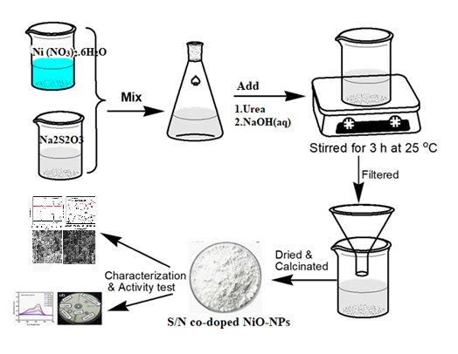
Figure S1. Schematic representation of synthesis of S/N co-doped NiO-NPs

Photocatalytic Activity Test
As a stock solution, 1000 mg/L of MB dye solution was first made. 100 mL of DW water was mixed with 10 mg/L of this stock solution. In a beaker, 100 mL of 10 mg/L MB solution was mixed with 40 mg of S/N co-doped NiO catalysts ⁴. A magnetic stirrer was used to stir the sample suspension mixture while it remained in the dark for 30 min in order to achieve an adsorption-desorption equilibrium between MB and the photo-catalyst surface. Subsequently, the sample suspensions were exposed to sunlight at 10-min intervals. 5 mL of the resulting sample suspensions were then removed and centrifuged for 10 min, and the UV-Vis spectrophotometer was used to measure the absorbance of methyl blue in the resulting solution at wavelengths between 400 and 800 nm ⁵. Then distilled water was used as reference. The photo degradation efficiency was calculated using equation-1.

% Degradation = $\left(\frac{Ao-At}{A_{0}}\right)x100$……………………………………………………………1
Where A₀ and A_{t} represent the dye absorbance at irradiation time of t = 0 and t = t, respectively.

Antibacterial Activity Test
The Agar disc diffusion method was used in the Jimma University Microbiology Laboratory to screen the synthesized sample for in vitro antibacterial activity against bacterial strains (Salmonella, Bacillus cereus, Escherichia coli, and Staphylococcus aurous). At 4 ºC, the bacterial stock cultures were kept on nutrient agar slants. The 6 mm-diameter disc was made using Whatman filter paper that had been dry heated for 2 h at 121 ºC ⁶. Synthesized nanoparticles were dissolved in DMSO to create the various concentrations of the synthesized sample (25, 50, 75, and 100g/ mL). After that, 6 mm filter paper discs were sterilized and immersed in a solution of S/N co-doped NiO nanoparticles. To prevent zones of growth inhibition from overlapping, the discs impregnated with the test solutions were positioned equally apart on a cultured glass plate ⁷. Following a 24 h incubation period at 37 °C, the expansion of the inhibitory zone was measured by using ruler and compared to the standard medication, Gentamicin. Gentamicin (10 g/mL) was employed as a conventional medication, while 1% DMSO served as a negative control. After three iterations of the aforementioned process, the mean standard deviation of a zone of inhibition was calculated.
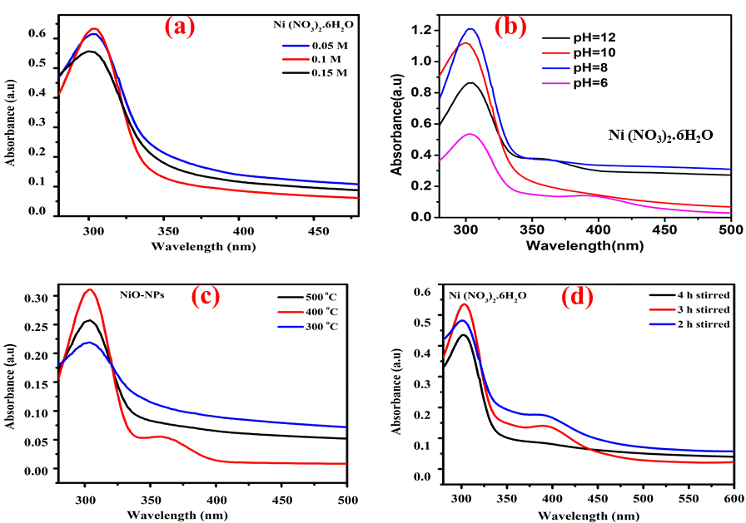
Figure S2. Effects of (a) Precursors concentration (b) precursors pH (c) Calcination temperature and (d) stirring time on synthesis of NiO-Nanoparticles
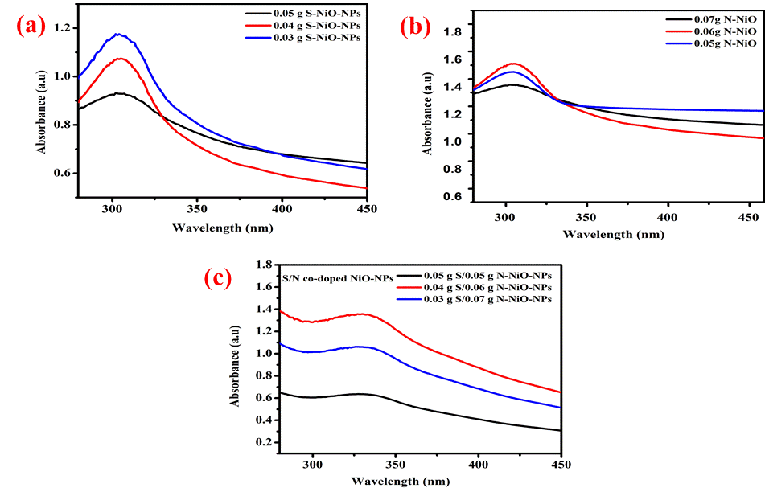
Figure S3. Effects of concentration on synthesis of (a) S-doped NiO-NPs (b) N-doped NiO-NPs and (c) S/N co-doped NiO-NPs
References
(1) El Ghmari, B.; Farah, H.; Ech-Chahad, A. Biosynthesis, Characterization of Nickel (II) Oxide Nanoparticles NiO and Their High-Efficient Photocatalytic Application. Int J Nanosci Nanotechnol 2023, 19 (3), 135–147. https://doi.org/10.22034/ijnn.2023.560608.2262.
(2) Aga, K. W.; Efa, M. T.; Beyene, T. T. Effects of Sulfur Doping and Temperature on the Energy Bandgap of ZnO Nanoparticles and Their Antibacterial Activities. ACS Omega 2022, 7 (12), 10796–10803. https://doi.org/10.1021/acsomega.2c00647.
(3) Yadesa, D.; Guyasa, J. N.; Beyene, T. T. Effect of Codoping Zinc Oxide Nanoparticles with Sulfur and Nitrogen on Its Energy Bandgap, Antioxidant Properties, and Antibacterial Activity. Adv Mater Sci Eng 2024, 2024, 16–18. https://doi.org/10.1155/2024/4275035.
(4) Zaib, M.; Akhtar, A.; Maqsood, F.; Shahzadi, T. Green Synthesis of Carbon Dots and Their Application as Photocatalyst in Dye Degradation Studies. Arab J Sci Eng 2021, 46 (1), 437–446. https://doi.org/10.1007/s13369-020-04904-w.
(5) Zhou, Y.; Zahran, E. M.; Quiroga, B. A.; Perez, J.; Mintz, K. J.; Peng, Z.; Liyanage, P. Y.; Pandey, R. R.; Chusuei, C. C.; Leblanc, R. M. Size-Dependent Photocatalytic Activity of Carbon Dots with Surface-State Determined Photoluminescence. Appl Catal B Environ 2019, 248 (February), 157–166. https://doi.org/10.1016/j.apcatb.2019.02.019.
(6) Primadona, I.; Hardian, A.; Dara, F.; Endah, E. S. Green Synthesis of Silver @ Carbon Dots Nanocomposites for Enhancing the Antimicrobial Activity Green Synthesis of Silver @ Carbon Dots Nanocomposites for Enhancing the Antimicrobial Activity. 2021, 040002 (August).
(7) Cheng, Y.; Wang, M.; Fang, C.; Wei, Y.; Chen, J.; Zhang, J. Variability and Improvement of Optical and Antimicrobial Performances for CQDs/Mesoporous SiO2/Ag NPs Composites via in Situ Synthesis. Green Process Synth 2021, 10 (1), 403–411. https://doi.org/10.1515/gps-2021-0035.

