Supplementary Materials for

Agency Modulation of Hippocampal Activity During Spatial Navigation

Yi-Chuang Lin, Ya-Ting Chang, Charlotte Maschke, Wan-Rue Lin, Yu-Shiang Su, Joshua O. S. Goh

Corresponding author: joshuagoh@ntu.edu.tw

The PDF file includes:

Supplementary Text
Supplementary Figs. 1 to 2
Supplementary Tables 1 to 6

Other Supplementary Materials for this manuscript include the following:

Data S1 to S3

Supplementary Text
Direction and Distance Judgement
In both familiarization and the formal retrieval trial, participants were also instructed to make direction and distance judgments (Supplementary Fig. 1). During direction judgment, participants rotated at their current location through 16 street view orientations (in steps of 22.5°) to the one perceived as having the closest heading to the landmark. During the distance judgment, participants selected path distances between their location and the landmark, using a scale of 0 to 10 steps for familiarization and 0 to 25 steps for the formal experiment.
Correspondingly, we compared landmark finding direction and distance errors for mazes learned under Free vs. Tour conditions. The error rate of direction judgment, or termed direction misestimation, was

;

the error rate of distance judgment, or termed distance misestimation, was

;

and the absolute error rate of distance judgment, or termed absolute distance estimation, was

.

For trials in which participants successfully navigated landmarks, we compared differences in time taken to make direction and distance judgments under Free vs. Tour learning conditions. Paired-sample t-tests were then applied to evaluate the effect of learning conditions on navigation retrieval errors and time taken.
During map retrieval, there were trends for participants to make more accurate judgments in direction (t(20) = 1.709, p = 0.052) and distance (t(20) = 1.660, p = 0.056) under Free than Tour conditions, as expected, albeit not significant (fig. S2). The time spent for direction (t(20) = -0.087, p = 0.535) and distance judgments (t(20) = -0.396, p = 0.348) did not differ under Free than Tour conditions.

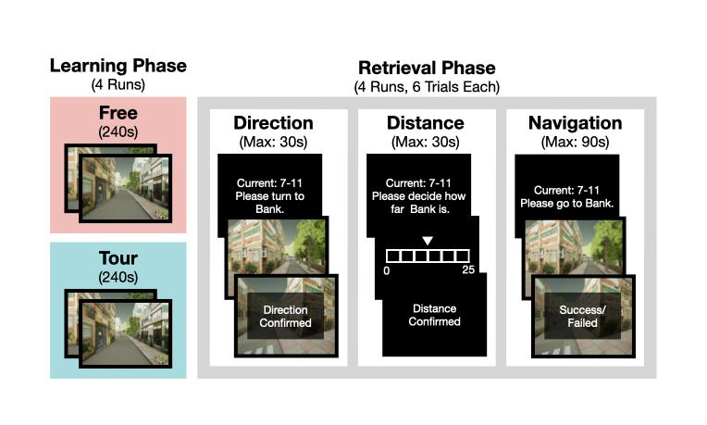

Supplementary Fig. 1. Expanded schematic of the learning and retrieval phases of the familiarization. Participants learned two different environments under Free or Tour conditions, respectively. Following one learning trial, participants’ maze knowledge was tested in one retrieval trial, where they made direction and distance judgments, and then navigated from various start positions to one target landmark. The retrieval phase would be repeated until participants were familiar with the motion control and experimental design.

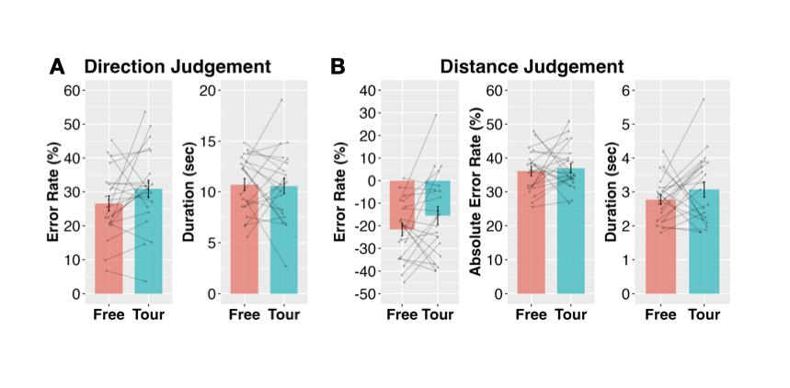

Supplementary Fig. 2. Navigational agency enhanced spatial maze acquisition. A. Retrieval spatial navigation performances showed participants had fewer navigation errors (left) and spent similar time (right) in determining target landmarks’ directions from their starting locations for the Free (pink) than the Tour (cyan) condition. B. Participants tended to underestimate distance (left), made similar distance estimation errors (middle) and spent similar time (right) in determining target landmarks’ distances from their starting locations for the Free (pink) than the Tour (cyan) condition. Gray dots and lines denote one participant’s navigation performances across Free and Tour conditions. N = 21. Error bars show standard errors.

Effect | Df | F | p
Condition | 1, 1606 | 14.3 | < 0.001
Gradient | 1, 1606 | 43.8 | < 0.001
State | 2, 1606 | 8.26 | < 0.001
Condition x Gradient | 1, 1606 | 24.8 | < 0.001
Condition x State | 2, 1606 | 0.611 | 0.543
Gradient x State | 2, 1606 | 3.89 | 0.021
Condition x Gradient x State | 2, 1606 | 0.226 | 0.797

Supplementary Table 1. Analysis of Variance (ANOVA) table of effects for the linear mixed-model of HC responses in Supplementary Table 2. Model fixed effects were navigation Condition (Free, Tour), HC longitudinal Gradient slice (y coordinates), and maze position State (Junction, Landmark, Traversal), with participants as the random effect.

Fixed Effect | 𝛽 | SE | Df | t | p
Intercept: T, Free, anterior most y | -0.708 | 0.209 | 1, 1606 | -3.395 | < 0.001
Condition: Tour | 0.901 | 0.238 | 1, 1606 | 3.780 | < 0.001
Gradient: y position | 0.103 | 0.016 | 1, 1606 | 6.619 | < 0.001
State: J | -0.323 | 0.086 | 2, 1606 | -3.767 | < 0.001
Sate: L | -0.048 | 0.086 | 2, 1606 | -0.560 | 0.576
Condition: Tour x Gradient | -0.060 | 0.012 | 1, 1606 | -4.982 | < 0.001
Condition: Tour x State: J | -0.134 | 0.121 | 2, 1606 | -1.102 | 0.270
Condition: Tour x State: L | -0.075 | 0.121 | 2, 1606 | -0.620 | 0.535
Gradient x State: J | 0.032 | 0.012 | 2, 1606 | 2.651 | 0.008
Gradient x State: L | 0.007 | 0.012 | 2, 1606 | 0.571 | 0.568
Condition: Tour x Gradient x State: J | -0.011 | 0.017 | 2, 1606 | -0.614 | 0.539
Condition: Tour x Gradient x State: L | -0.001 | 0.017 | 2, 1606 | -0.069 | 0.945

Supplementary Table 2. Details of coefficients from the linear mixed-model of HC ROI responses. The regression model included navigation Condition (Free, Tour), HC longitudinal Gradient slice (y position; see Methods), and maze position State (J: Junction, L: Landmark, T: Traversal) as fixed effects, and participants as random effects. The model used the mean response for T states during the Free condition at the HC anterior most y position as the baseline intercept. Planned comparisons were based on t-contrasts of the specific effect level differences. See Supplementary Table 1 for accompanying ANOVA table. HC: Hippocampal, ANOVA: Analysis of Variance.

Contrast | Effect | Df | F | p
J - T | Condition | 1, 522 | 5.12 | 0.024
J - T | Gradient | 1, 522 | 29.6 | < 0.001
J - T | Condition x Gradient | 1, 522 | 1.59 | 0.208
L - T | Condition | 1, 522 | 1.59 | 0.208
L - T | Gradient | 1, 522 | 1.35 | 0.247
L - T | Condition x Gradient | 1, 522 | 0.020 | 0.888

Supplementary Table 3. Analysis of Variance (ANOVA) table of effects for the linear mixed-model of HC state response contrasts in Supplementary Table 4. Model fixed effects were navigation Condition (Free, Tour) and HC longitudinal Gradient slice (y coordinates), with participants as the random effect.

Contrast | Fixed Effect | 𝛽 | SE | Df | t | p
J - T | Intercept: Free, anterior most y | -0.323 | 0.059 | 1, 522 | -5.475 | < 0.001
J - T | Condition: Tour | -0.134 | 0.060 | 1, 522 | -2.262 | 0.024
J - T | Gradient (y position) | 0.032 | 0.006 | 1, 522 | 5.440 | < 0.001
J - T | Condition: Tour x Gradient | -0.011 | 0.008 | 1, 522 | -1.260 | 0.208
L - T | Intercept: Free, anterior most y | -0.048 | 0.058 | 1, 522 | -0.830 | 0.407
L - T | Condition: Tour | -0.075 | 0.060 | 1, 522 | -1.260 | 0.208
L - T | Gradient (y position) | 0.007 | 0.006 | 1, 522 | 1.160 | 0.246
L - T | Condition: Tour x Gradient | -0.001 | 0.008 | 1, 522 | -0.141 | 0.888

Supplementary Table 4. Details of coefficients from the linear mixed-model of HC ROI J - T and L - T contrasts, separately, adjusting for condition session baseline differences. The regression models included navigation Condition (Free, Tour) and HC longitudinal Gradient slice (y position) as fixed effects, and participants as random effects. The model used the mean contrast during the Free condition at the HC anterior most y position as the baseline intercept. Planned comparisons were based on t-contrasts of the specific effect level differences (see Supplementary Table 3 for ANOVA table). HC: Hippocampal, ANOVA: Analysis of Variance.

Autocorrelation | Effect | Df | F | p
Temporal | Condition | 1, 522 | 182 | < 0.001
Temporal | Gradient | 1, 522 | 21.9 | < 0.001
Temporal | Condition x Gradient | 1, 522 | 0.95 | 0.330
Spatial | Condition | 1, 522 | 44.1 | < 0.001
Spatial | Gradient | 1, 522 | 15.2 | < 0.001
Spatial | Condition x Gradient | 1, 522 | 0.940 | 0.333

Supplementary Table 5. Analysis of Variance (ANOVA) table of effects for the linear mixed-model of autocorrelation of HC responses in Supplementary Table 6. Model fixed effects were navigation Condition (Free, Tour) and HC longitudinal Gradient slice (y coordinates), with participants as the random effect.

Autocorrelation | Fixed Effect | 𝛽 | SE | Df | t | p
Temporal | Intercept: Free, anterior most y | 0.861 | 0.003 | 1, 522 | 306 | < 0.001
Temporal | Condition: Tour | 0.016 | 0.002 | 1, 522 | 7.23 | < 0.001
Temporal | Gradient (y position) | -0.0005 | 0.0002 | 1, 522 | -2.62 | 0.009
Temporal | Condition: Tour x Gradient | -0.0003 | 0.0003 | 1, 522 | -0.975 | 0.330
Spatial | Intercept: Free, anterior most y | 0.016 | 0.002 | 1, 522 | 8.55 | < 0.001
Spatial | Condition: Tour | 0.004 | 0.001 | 1, 522 | 3.99 | < 0.001
Spatial | Gradient (y position) | 0.0003 | 0.0001 | 1, 522 | 3.44 | < 0.001
Spatial | Condition: Tour x Gradient | -0.0001 | 0.0001 | 1, 522 | -0.969 | 0.328

Supplementary Table 6. Details of coefficients from the linear mixed-model of temporal and spatial autocorrelation of HC responses. The regression models included navigation Condition (Free, Tour) and HC longitudinal Gradient slice (y position) as fixed effects, and participants as random effects. The model used the mean autocorrelation during the Free condition at the HC anterior most y position as the baseline intercept. Planned comparisons were based on t-contrasts of the specific effect level differences (see Supplementary Table 5 for ANOVA table).

Data S1. (separate file)
Spreadsheet of the 21 participants’ navigation behavioral performances including (a) number of times participants passed landmarks, (b) retrieval navigation trial success/failure labels, (c) retrieval navigation successful trial durations.

Data S2. (separate file)
Spreadsheet of hippocampal 13 section ROI response estimates for Junctions, Landmarks, and Traversal states during Free and Tour conditions for each of the 21 participants.

Data S3. (separate file)
Spreadsheet of 17 non-hippocampal ROI responses estimates for Junctions, Landmarks, and Traversal states during Free and Tour conditions for each of the 21 participants.

