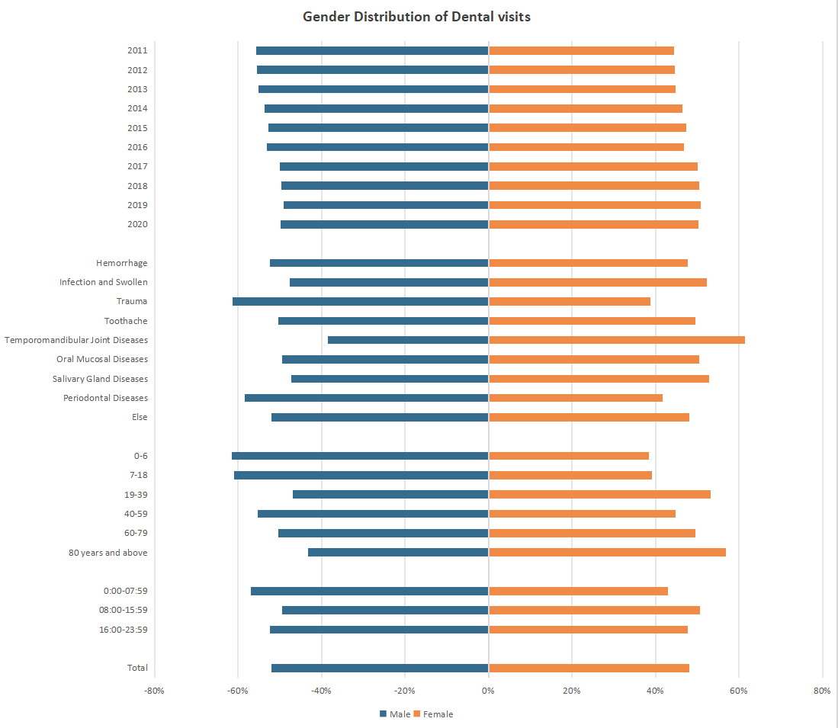
Figure 1 Gender Distribution of Dental Visits. The horizontal bar chart displays the percentage distribution of male (blue) and female (orange) patients within various demographic groups, visit times, and disease types over the study period (2011–2020). Gender proportions were relatively balanced across years, with notable differences in disease types and age groups. Females were more frequently affected by temporomandibular joint diseases and periodontal diseases, while males had a higher prevalence of trauma and hemorrhage. Visit times also varied, with males slightly more represented during late-night hours (00:00–07:59). Age-specific trends indicated a male predominance in younger age groups (0–6 and 7–18 years) and a more balanced distribution in older age categories.

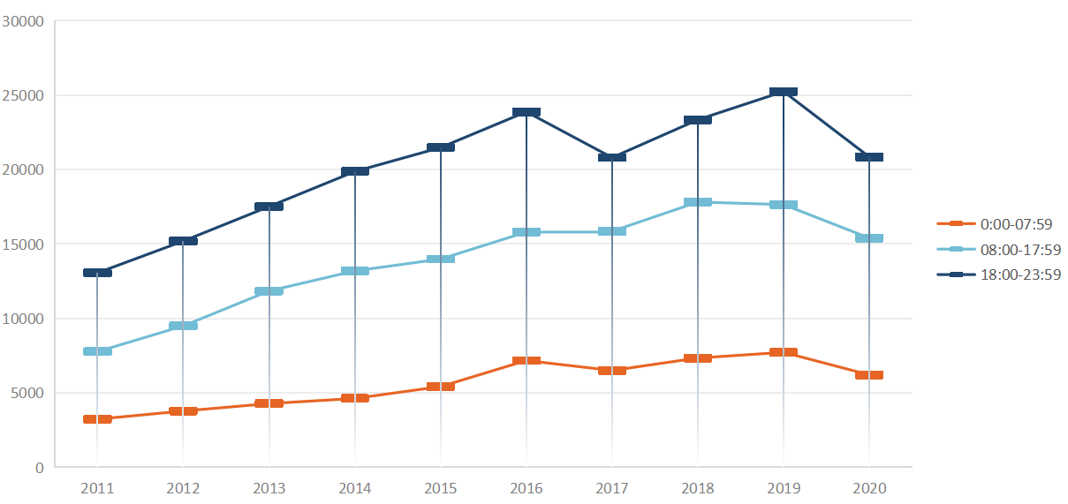
Figure 2 The Time of the Visit during ten years. The line chart shows the distribution of dental emergency visits across three time intervals: early morning (00:00–07:59, orange), daytime (08:00–17:59, light blue), and evening (18:00–23:59, dark blue) over a ten-year span. Visits during the evening consistently accounted for the largest share, peaking in 2019, followed by daytime visits, which exhibited a steady increase before a slight decline in 2020. Early morning visits remained the least frequent and relatively stable throughout the decade, with a small decrease observed in 2020. The trends suggest a persistent preference for evening visits, potentially due to patient work schedules or clinic availability.

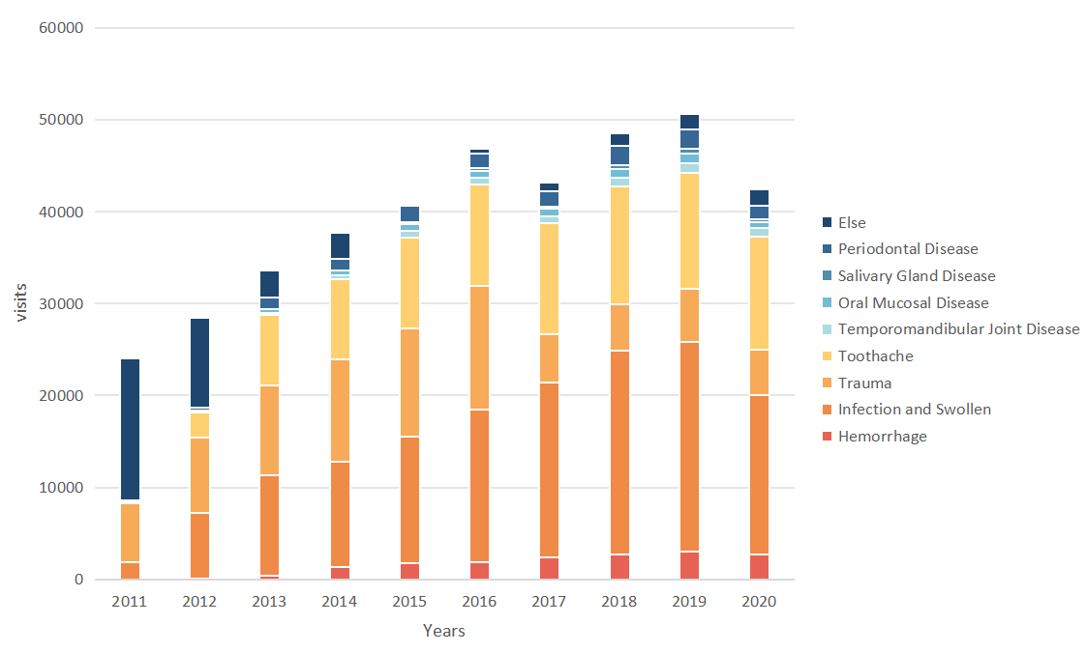
Figure 3 Disease Composition of Visit during ten years. The stacked bar chart represents the annual number of dental emergency visits categorized by disease types, including hemorrhage (red), infection and swelling (orange), trauma (yellow), toothache (light orange), temporomandibular joint diseases (light blue), oral mucosal diseases (teal), salivary gland diseases (light cyan), periodontal diseases (dark blue), and other conditions (dark navy). Across the ten years, infection and swelling, toothache, and trauma were the most common reasons for visits, while less frequent visits were attributed to salivary gland diseases and periodontal diseases. The overall number of visits showed an increasing trend from 2011, peaking in 2019, followed by a notable decline in 2020.

