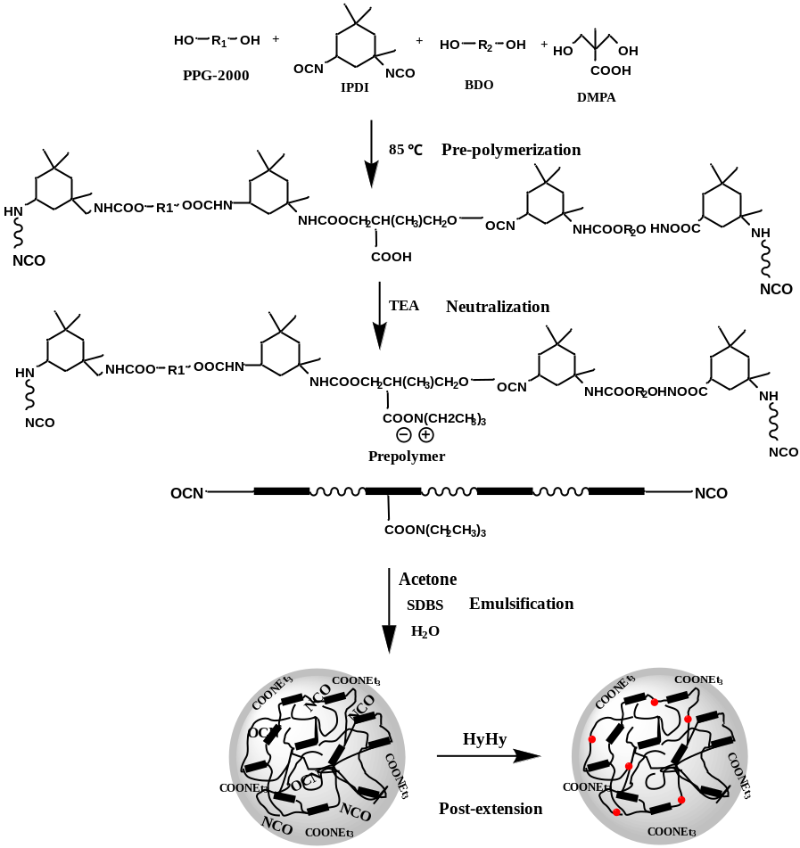
Scheme 1. Elementary steps for the preparation of WPU dispersion.

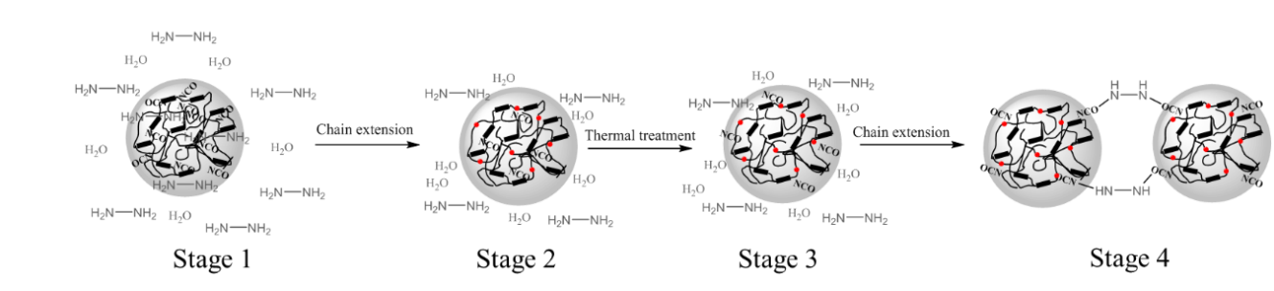
Scheme 2. Schematic illustration for thermal-storage instability of WPUs due to cage effect.

