Supplementary Information

Field-modulated quantum dot solids enable exceptional gain–bandwidth product of infrared photodetector

Seo Young Lee^{1†}, Min-Jae Si^{1†}, Dongeon Kim^{1†}, Benjamin Rehl², Minjung Yang¹, Seungin Jee¹, Seoryeon Jeong¹, Taeho Han¹, Jaewoo Jeong¹, In-ho Bae³, Yoon Jang Chung¹, Sjoerd Hoogland², Yujin Jung^{4,*}, and Se-Woong Baek^{1,*}

¹Department of Chemical and Biological Engineering, Korea University, Seoul, 02841 Republic of Korea
²Department of Electrical and Computer Engineering, University of Toronto; Toronto, M5S 3G4, Canada.
³Division of Physical Metrology, Korea Research Institute of Standards and Science, Daejeon, 34113 Republic of Korea
⁴Department of Chemical Engineering, Yeongnam University, Gyeongsan, 38541 Republic of Korea

*All correspondence should be addressed to S.-W. B. (email: sewoongbaek@korea.ac.kr) and Y. J. (email: yj_jung@yu.ac.kr)
†S.Y.L., M.J.S. and D.K. equally contributed to this work.

Keywords: Colloidal quantum dot (CQD), Photodetector, Shortwave Infrared, Solution-processed, Electric-field modulation

Supplementary Note 1 | Determination of effective detection range of devices in time-of-flight LIDAR system using signal-return intensity calculations
The effective detection range of the photodetector device was determined by calculating the reflected optical power and comparing it to the sensitivity of the device, which was characterized by the NEP of the device¹.
The transmitted light experienced attenuation as the photons travelled through the atmosphere, diffused, and were scattered after reflecting off targets. The intensity of the returned optical signal was related to several factors, including the efficiency of the optical system (η, %), diffuse reflectivity (ρ, %), transmitted laser power (P_{t}, W), receive aperture area (A, m²), attenuation coefficient (γ, m⁻¹), and target range (R).
By assuming that the laser beam size was smaller than the target and that atmospheric attenuation was characterized by γ, the power reaching the target (P_{reached}) could be given by²:
$P_{reached}=P_{t}\exp\left(-γR\right) (W)$ (1)
The target was assumed to be a Lambertian reflector with a ρ. The optical power reflected on the target (P_{reflected}) was calculated using Equation (2)³.
$P_{reflected}=ρP_{reached} (W)$ (2)
The optical power of the reflected light at an angle θ with respect to the incident laser was calculated using Equation (10), where the transmitted light was assumed to be incident normally on the surface of the target (θ = 0°)⁴:
$P_{reflected, θ}=\left(\frac{P_{reflected}}{π}\right)\cos{Θ}=ρP_{reached}\left(\frac{\cos{Θ}}{π} \right)=\frac{{ρP}_{t}\exp\left(-γR\right)}{π}$ (normal incidence) (3)
The reflected light only reached the receive aperture when the light fell within the solid angle subtended by the receive aperture ($Ω_{rx}=\frac{A}{R^{2}}$). The intensity of the reflected light was further reduced due to scattering and absorption by atmospheric molecules and aerosols (γ), and the efficiency of the optical system (η) had to be considered. The optical power reflected by the target and delivered to the receive aperture (P_{r}) was calculated using Equation (4)^{1,5}:
$P_{r}=η{(P}_{reflected,θ}){(Ω}_{rx})\left(\exp\left(-γR\right)\right)=P_{t}η\frac{A}{πR^{2}}ρ\exp\left(-2γR\right)]$ (4)

Supplementary Note 2 | TCAD ATLAS device simulation
To simulate the device physics, we used the ATLAS device simulator from Silvaco. The Shockley–Read–Hall recombination model was employed for carrier recombination, and Selberherr’s model was used for impact ionization⁶. Selberherr’s model is widely recommended for simulating impact ionization⁷.

Supplementary Note 3 | Determining gain and k value from measured excess noise
To estimate the gain resulting from avalanche multiplication, we determined the gain from excess noise. The following equations from McIntyre’s model were used to calculate the gain and k value from the excess noise⁸.
$F\left(m\right)=km+\left(1-k\right)\left(2-\frac{1}{m}\right)(m:gain, k:impact ionization coefficient)$ (5)
$S_{m}={2qI_{u}\left(m_{n}m_{pt}\right)}^{2}F\left(m_{n}m_{pt}\right)R(ω)$ (6)
(F(m): excess noise factor at gain m, m_{n}: relative gain at a given operating voltage compared to the gain at punch-through voltage, m_{pt}: estimated gain at punch-through voltage, R(ω): frequency dependent impedance of the device and circuit, I_{u}: unity photocurrent)
By calculating the ratio of the excess noise factor at the operating voltage (F(m_{n}m_{pt})) to the excess noise factor at the punch-through voltage (F(m_{pt})), we estimated the parameter k, m_{pt}, and m_{n} through fitting the following equation.
$\frac{S_{n}}{S_{pt}}\frac{1}{{m_{n}}^{2}m_{pt}I_{u}}=\frac{F(m_{n}m_{pt})}{F(m_{pt})}=\frac{k\left(m_{n}\right)\left(m_{pt}\right)+(1-k)(2-\frac{1}{m_{n}m_{pt}})}{k\left(m_{pt}\right)+(1-k)(2-\frac{1}{m_{pt}})}$ (7)
The known value of m_{n} and estimated m_{pt} from the equation (6) were then multiplied to calculate the accurate gain of the devices (Supplementary Fig. 18).

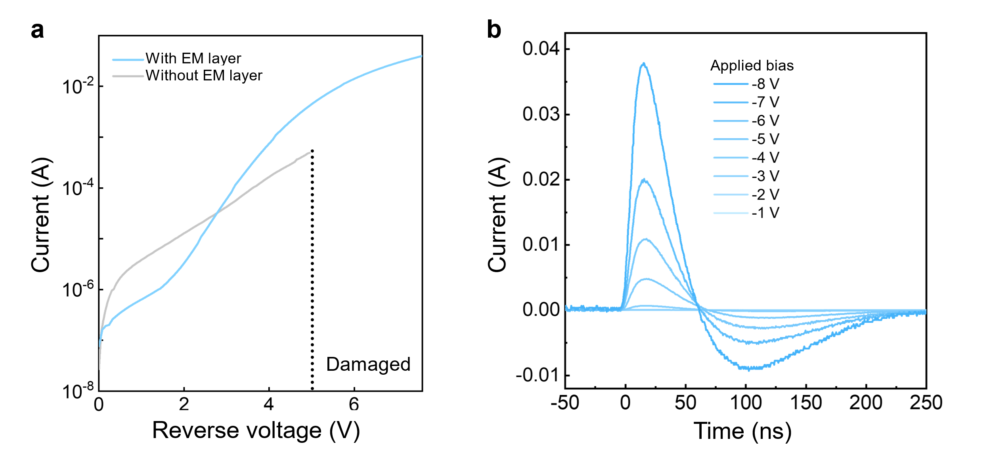
Supplementary Fig. 1 | Device performance under illuminated conditions a Photocurrent–reverse voltage plots of CQD photodiodes (PDs) with (blue) and without (grey) an EM layer under 1550 nm illumination. b Transient photoresponse of the device with the CQD EM layer at various applied reverse bias conditions under 1550-nm pulsed light illumination to confirm the gain enhancement as the reverse bias increases.

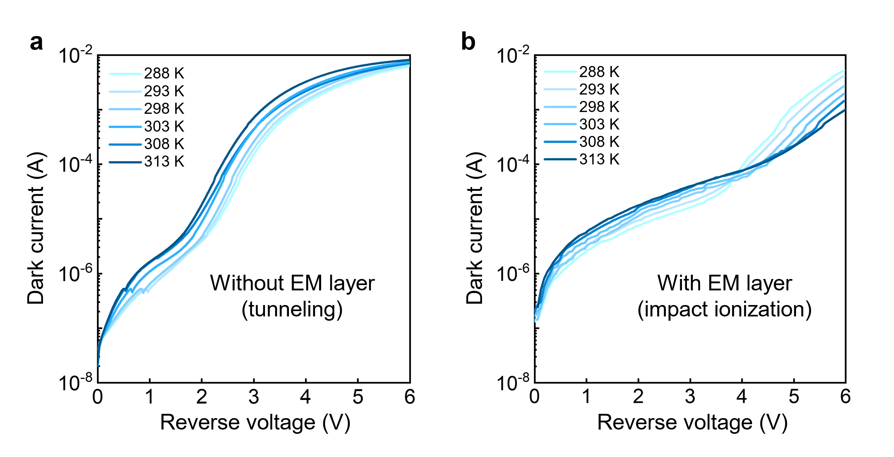
Supplementary Fig. 2 | Dark current–reverse voltage plots of devices without and with a CQD EM layer at different temperatures. Experimental dark current-reverse voltage plots of devices at different temperatures: a without and b with a CQD EM layer.

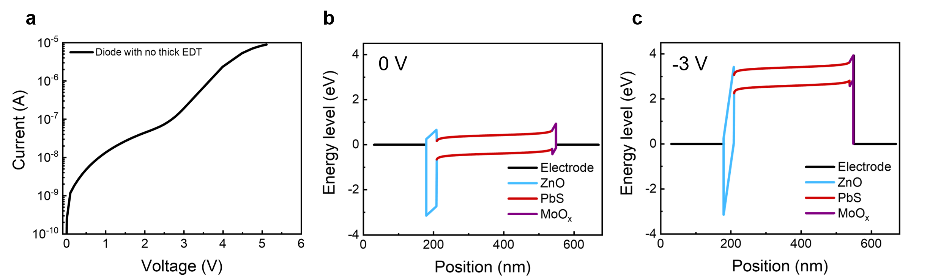
Supplementary Fig. 3 | Simulation results for devices without a CQD EM layer. a Dark current–reverse voltage plot of a device without a CQD EM layer. The band diagram of the device without a CQD EM layer b at 0 V and c at -3 V. Zener tunneling is suppressed in devices with an EDT structure compared to devices without EDT. The concentrated electric field (E-field) in the narrow depletion region of the heavily doped layer enables the Zener tunneling. In devices without the PbS-EDT layer, the E-field is concentrated in the thin and highly doped ZnO layer, resulting in Zener tunneling.

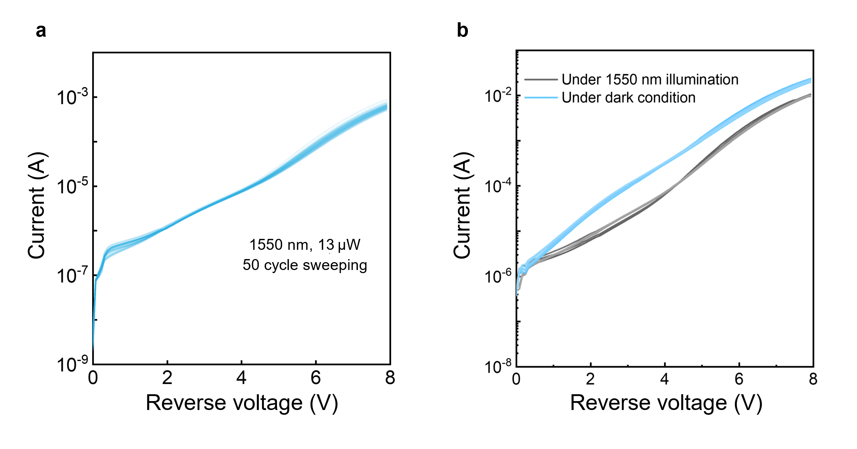
Supplementary Fig. 4 | Stability of the photodetector with CQD EM layer. a I-V curve of the device with the CQD EM layer after 50 cycles of sweeping under continuous 1550-nm illumination. b I-V curves of the device with the CQD EM layer under after 5 voltage sweeps under dark (black) and illuminated (blue) conditions.

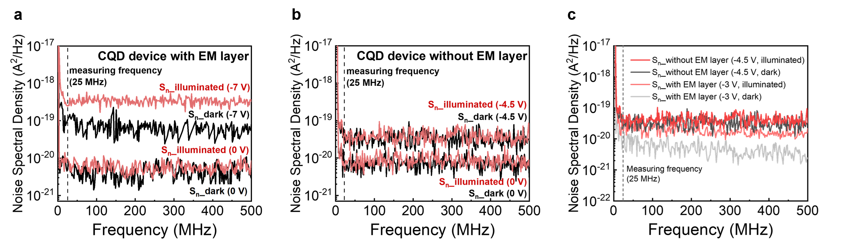
Supplementary Fig. 5 | The noise characterization of CQD device with (left) and without (right) an EM layer under dark and illuminated conditions. a Noise spectral density of CQD devices with an EM layer at 0 V and -7 V (operating voltage) under dark (black) and illuminated (red) conditions. b Noise spectral densities of CQD devices without an EM layer at 0 V and -4.5 V (operating voltage) under dark (black) and illuminated (red) conditions. c Noise spectral densities of CQD devices with (at -3 V) and without (at -4.5 V) EM layer, where the devices exhibit same amount of gain (M = 11). The difference between the noise under dark conditions and illuminated conditions was used to calculate the excess noise factor.
The noise power of conventional device without an EM layer measured under both conditions at 0 V is similar to that of CQD devices with an EM layer, as there is insufficient E-field to activate the impact ionization without reverse bias. As the reverse voltage increases, conventional PDs exhibit increased noise spectral densities in both dark and illuminated conditions, but the subtraction of these noises results in an excess noise factor close to 1, as there is no internal multiplication to amplify the illuminated noise. However, CQD devices with the EM layer show a higher increase in excess noise under illuminated conditions due to an increase in shot noise caused by avalanche multiplication at reverse bias.

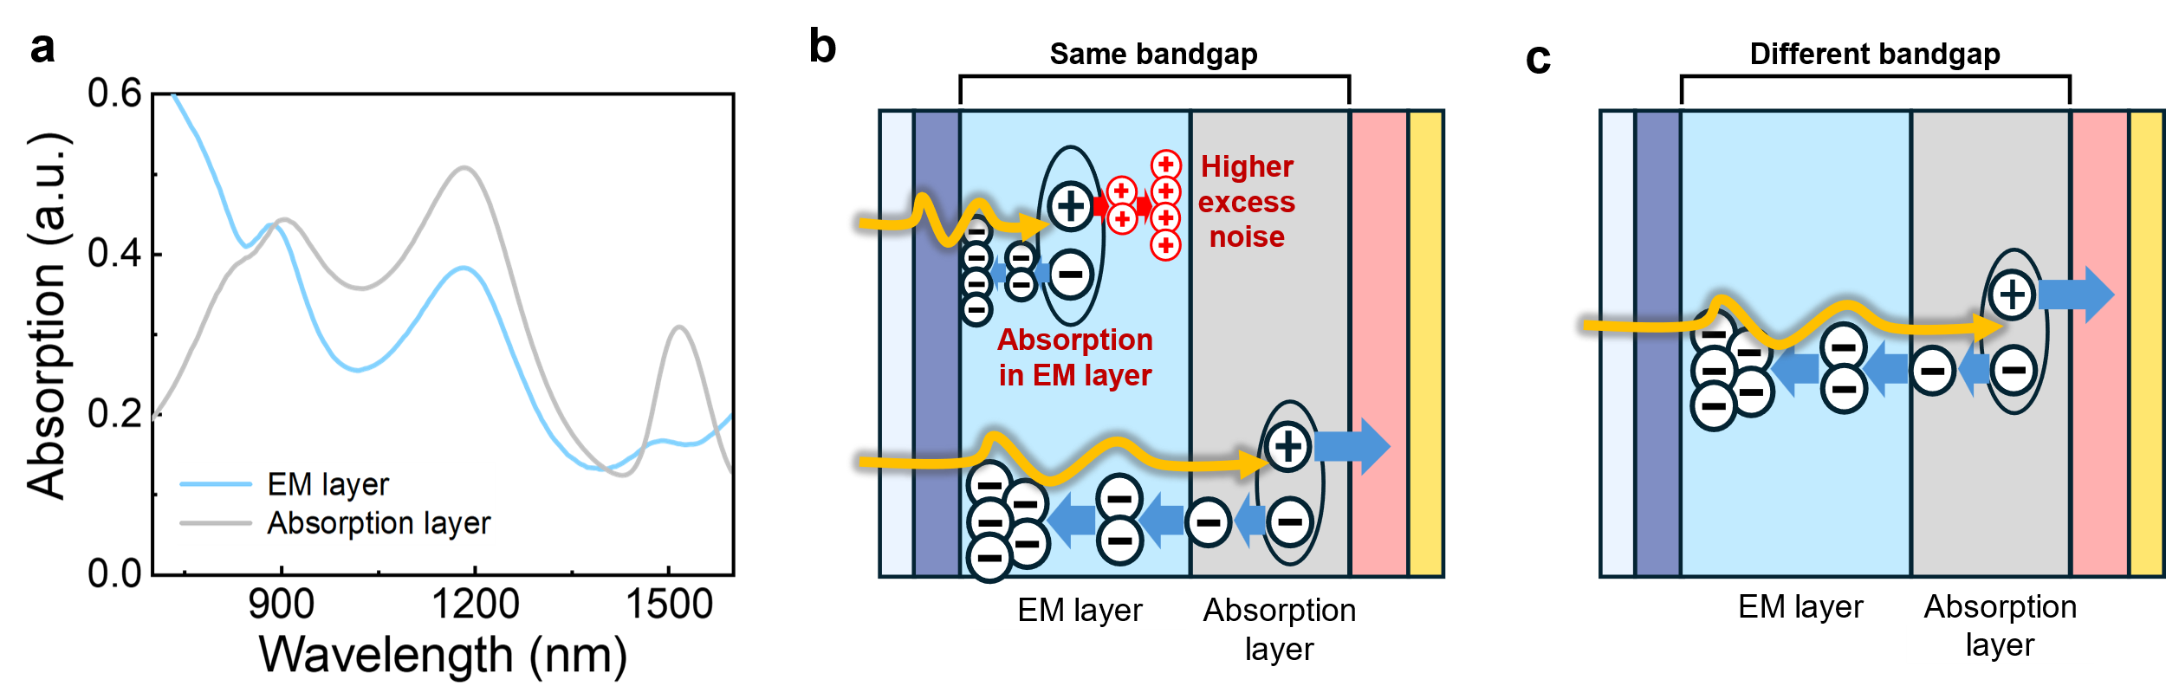
Supplementary Fig. 6 | Impact of using the same bandgap for the absorption and EM layers in a CQD device. a Simulated absorption spectra of the CQD EM layer (0.82 eV) and absorption layer as a function of device depth under irradiation at a wavelength of 1550-nm. Schematic diagrams illustrating the operating mechanism of the device with b the same and c different bandgaps for the absorption and EM layer.

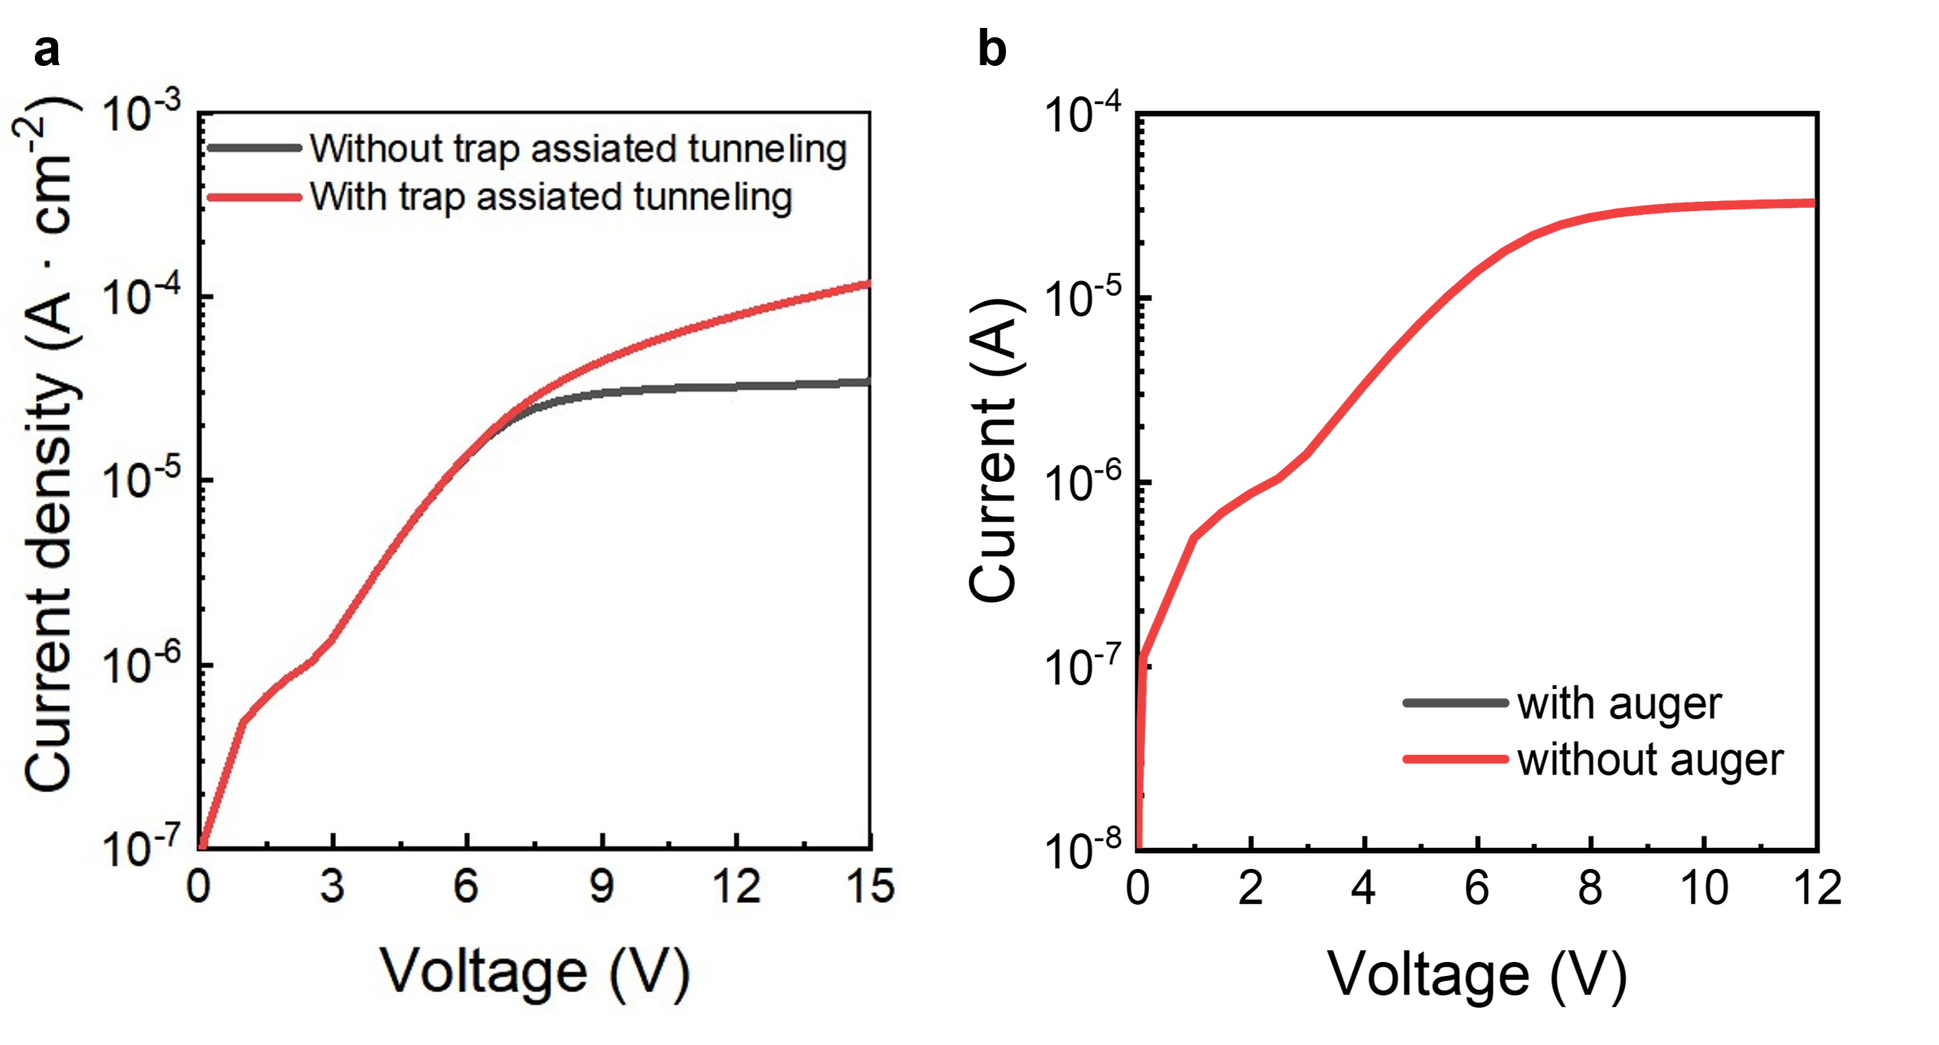
Supplementary Fig. 7 | The simulated dark current versus reverse voltage of the device. a With and without the trap-assisted tunneling model, and b with and without impact of Auger recombination. The negligible change in current with or without the Auger model presumably indicates that the high bandgap of the PbS-EDT EM layer (0.9 eV) results in a small Auger recombination effect.

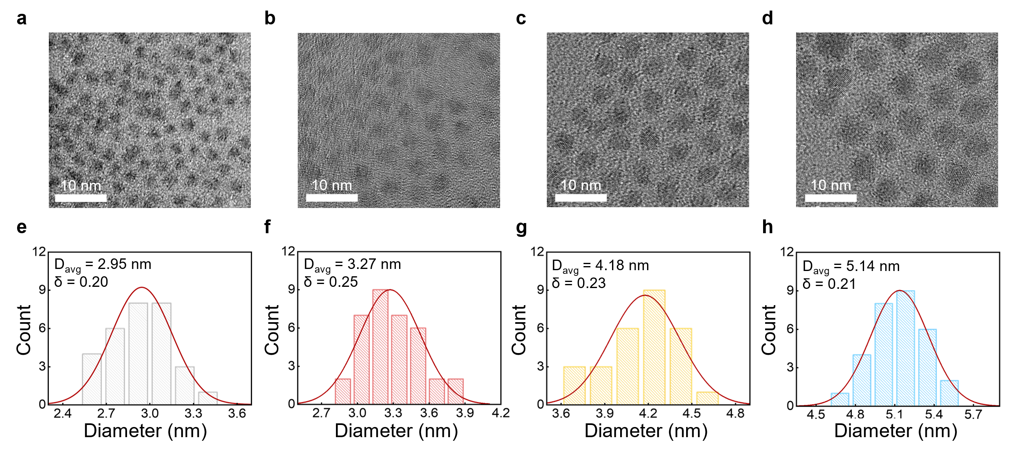
Supplementary Fig. 8 | Properties of PbS CQDs used for the absorption and EM layer of the devices. a-d TEM images and e-h size distributions of PbS CQDs with different sizes and bandgaps: a, e 1.39 eV, b, f 1.13 eV, c, g 0.95 eV, and d, h 0.82 eV. D_{avg} and δ denote the average size and standard deviation of the PbS CQDs, respectively. Scale bars: 10 nm.

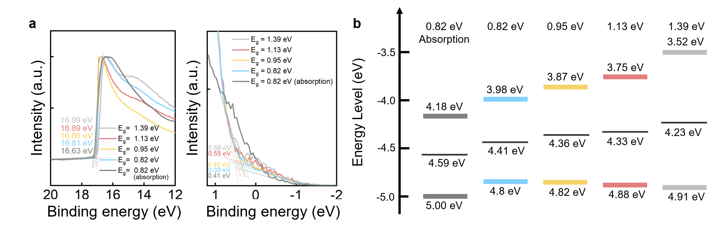
Supplementary Fig. 9 | Energy level characterizations of the PbS CQDs. a UPS spectra of the absorption layer and EM layers with different bandgaps. b Energy band diagrams of the EM layers and the absorption layer.

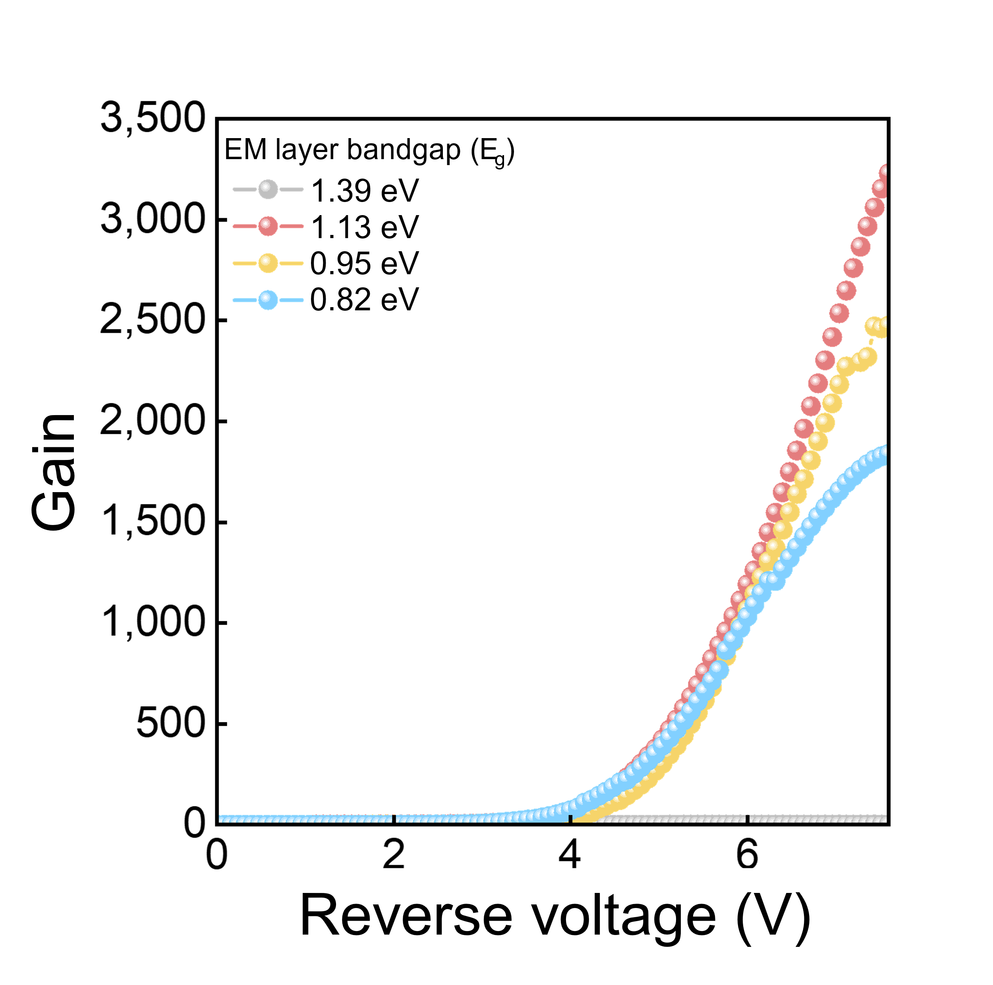
Supplementary Fig. 10 | Gain–reverse voltage plots for devices with different EM layer bandgaps: 1.39 eV (blue), 1.13 eV (red), 0.95 eV (yellow), and 0.82 eV (grey).

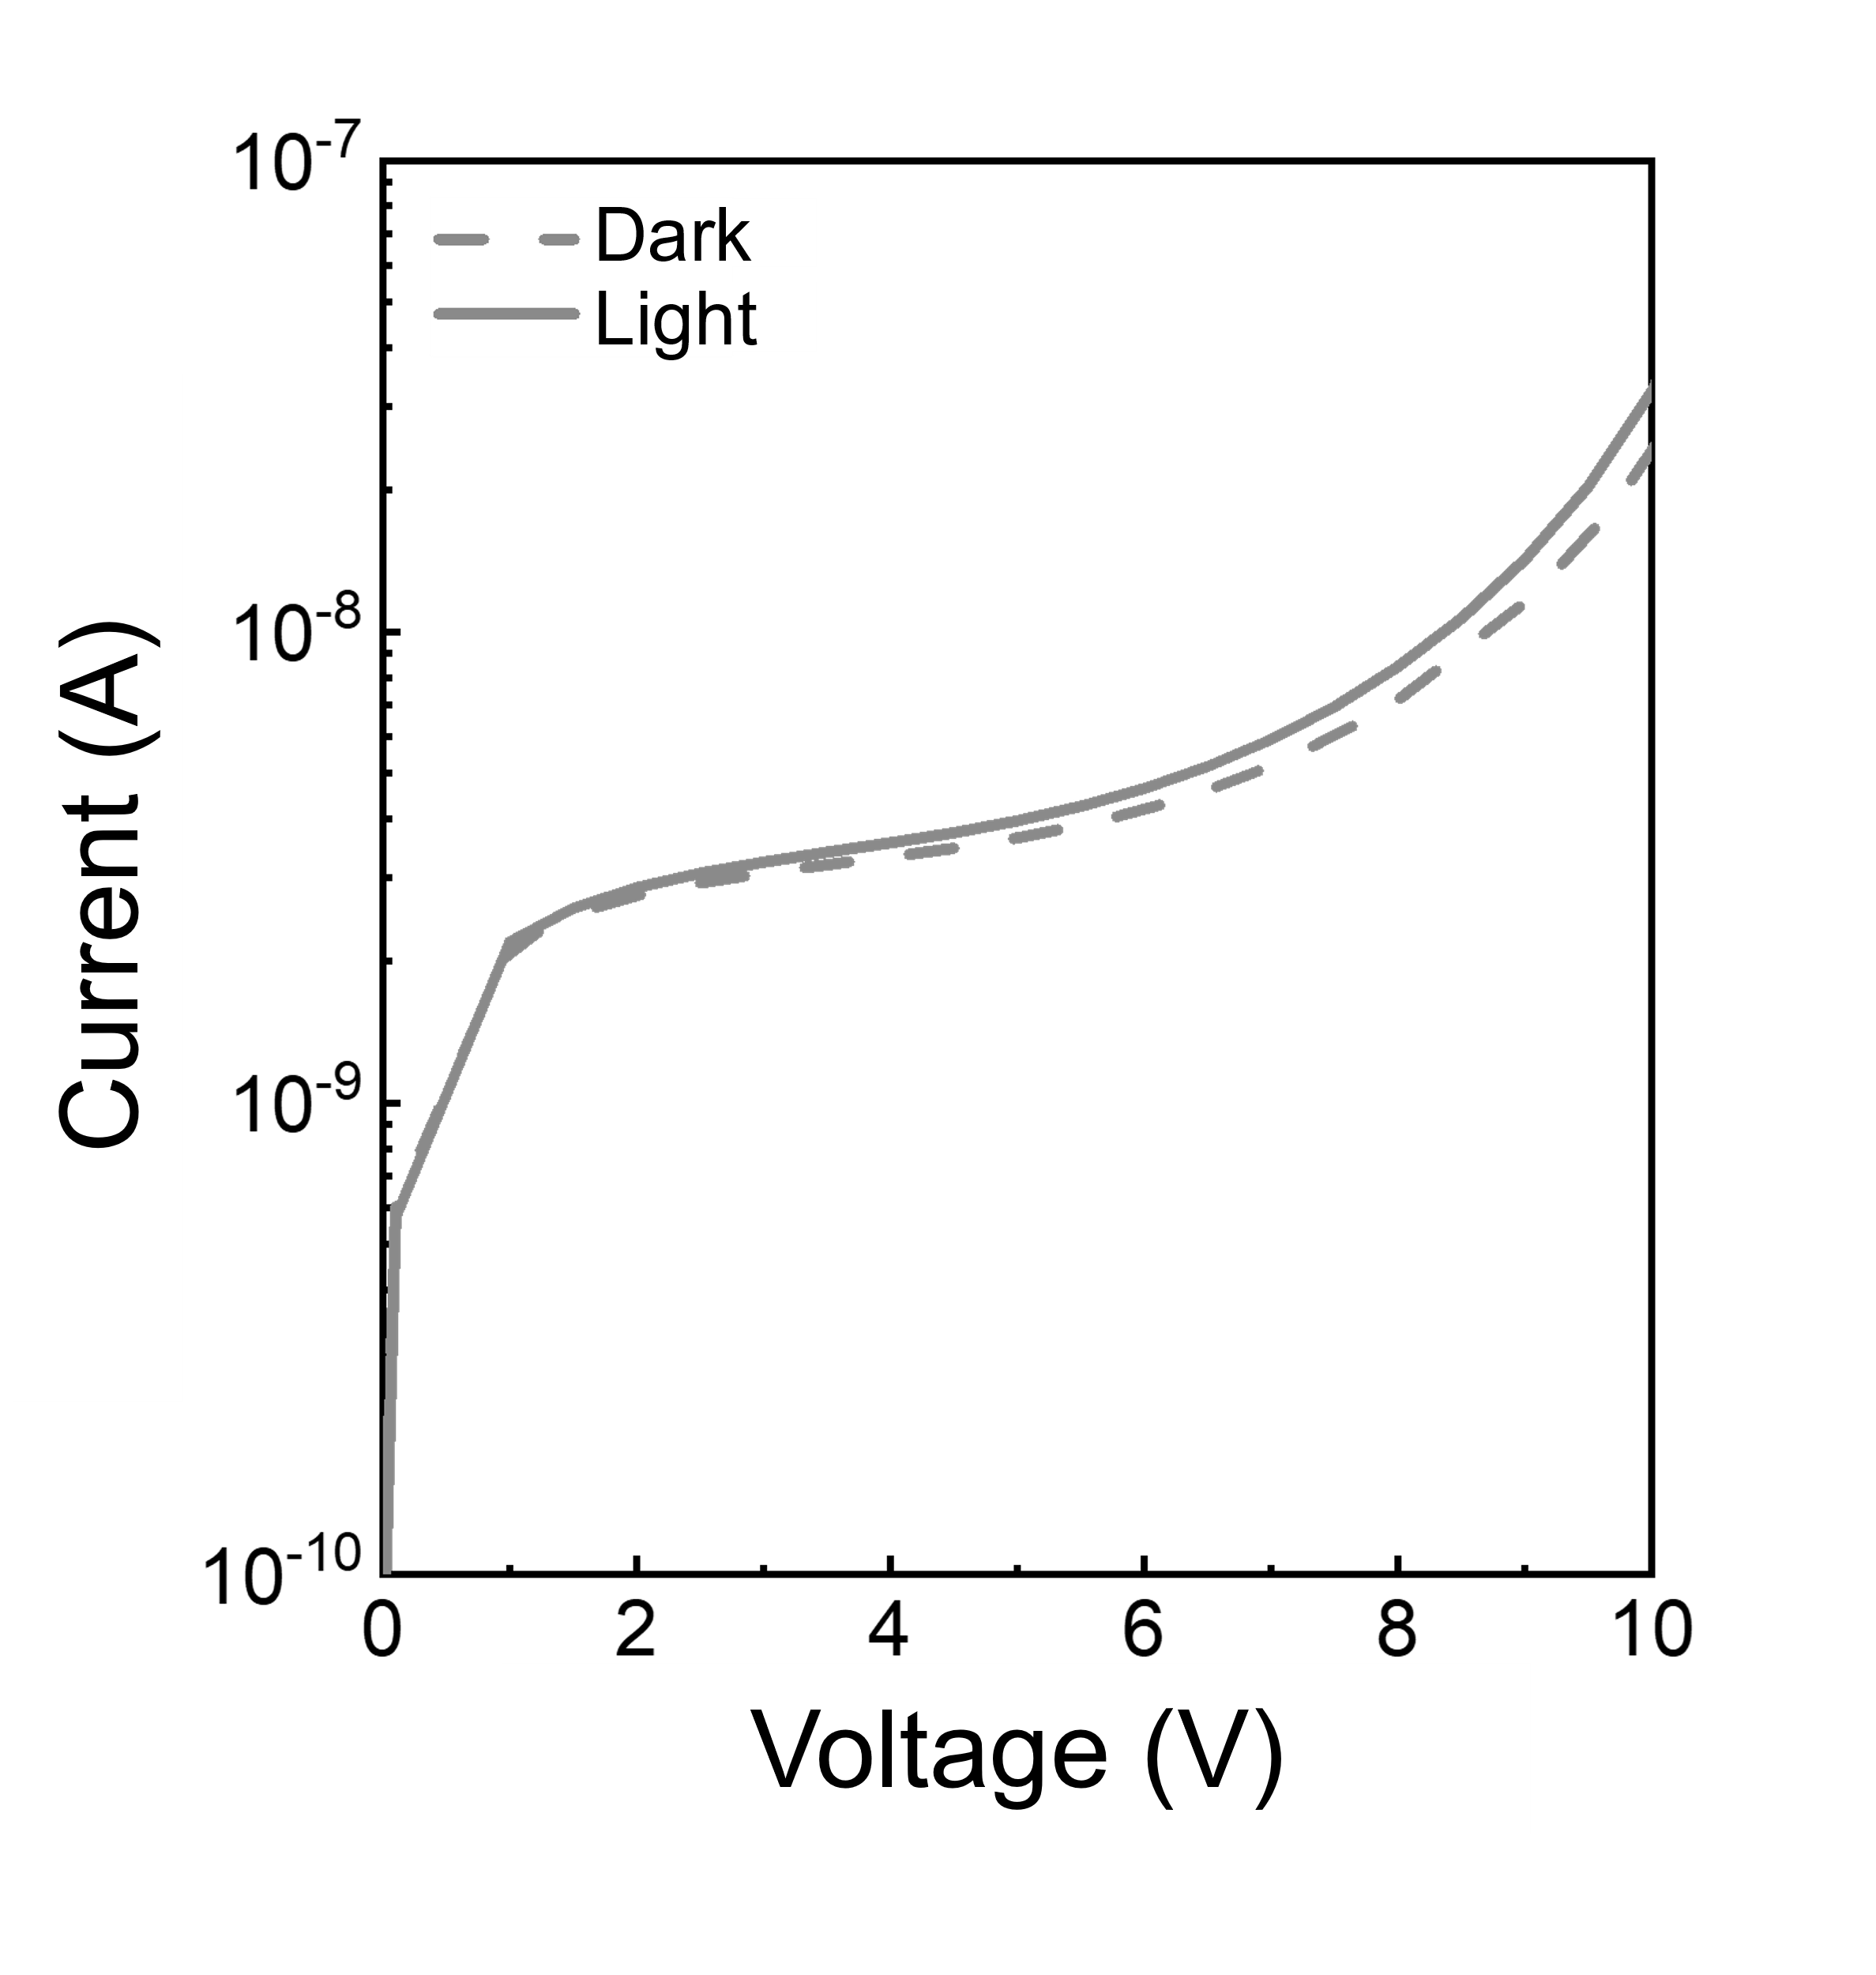
Supplementary Fig. 11 | Simulated current–voltage (I–V) characteristics of the device with a 1.39-eV EM layer under dark and illuminated conditions. The I–V results show that avalanche multiplication was not initiated, consistent with the experimental results (Fig. 3b).

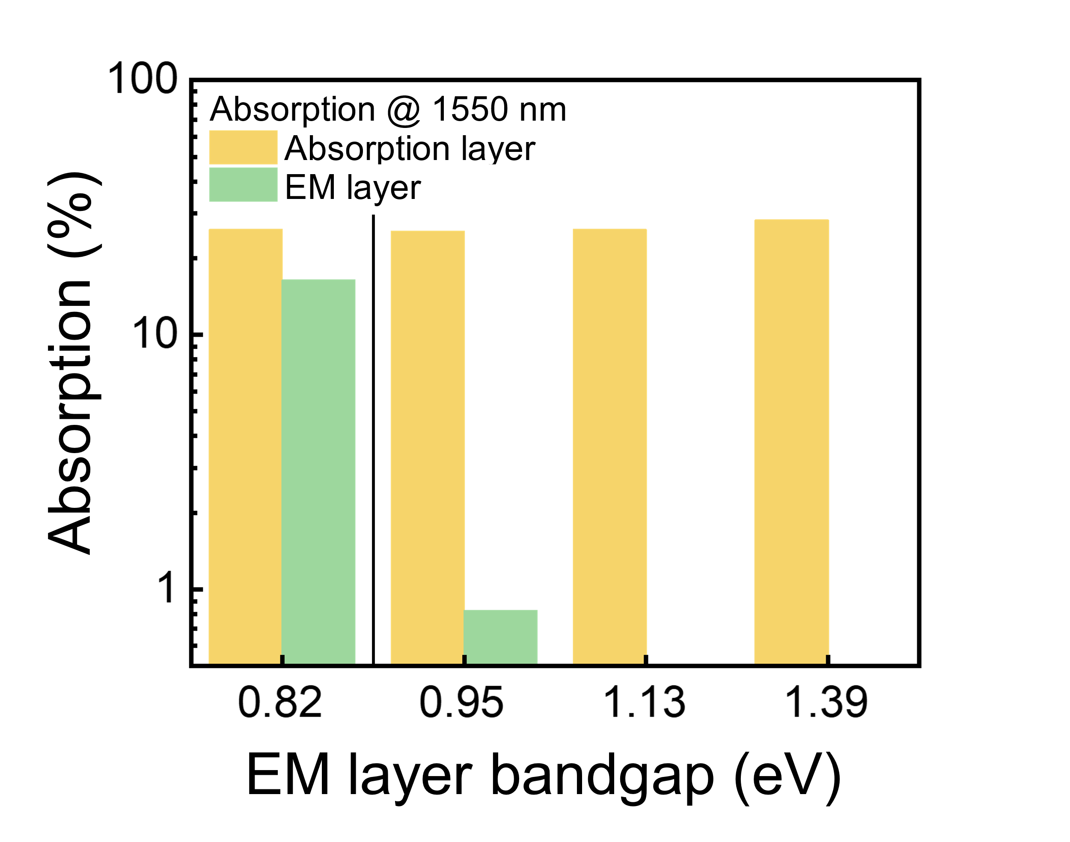
Supplementary Fig. 12 | Absorption at 1550 nm in the absorption layer and EM layer for devices with different EM layer bandgaps. The absorption of each layer was calculated using the transfer matrix method. The simulated device structure consists of ITO/ZnO (30 nm)/EM layer (225 nm)/absorption layer (330 nm)/MoO_{x} (10 nm)/Au.

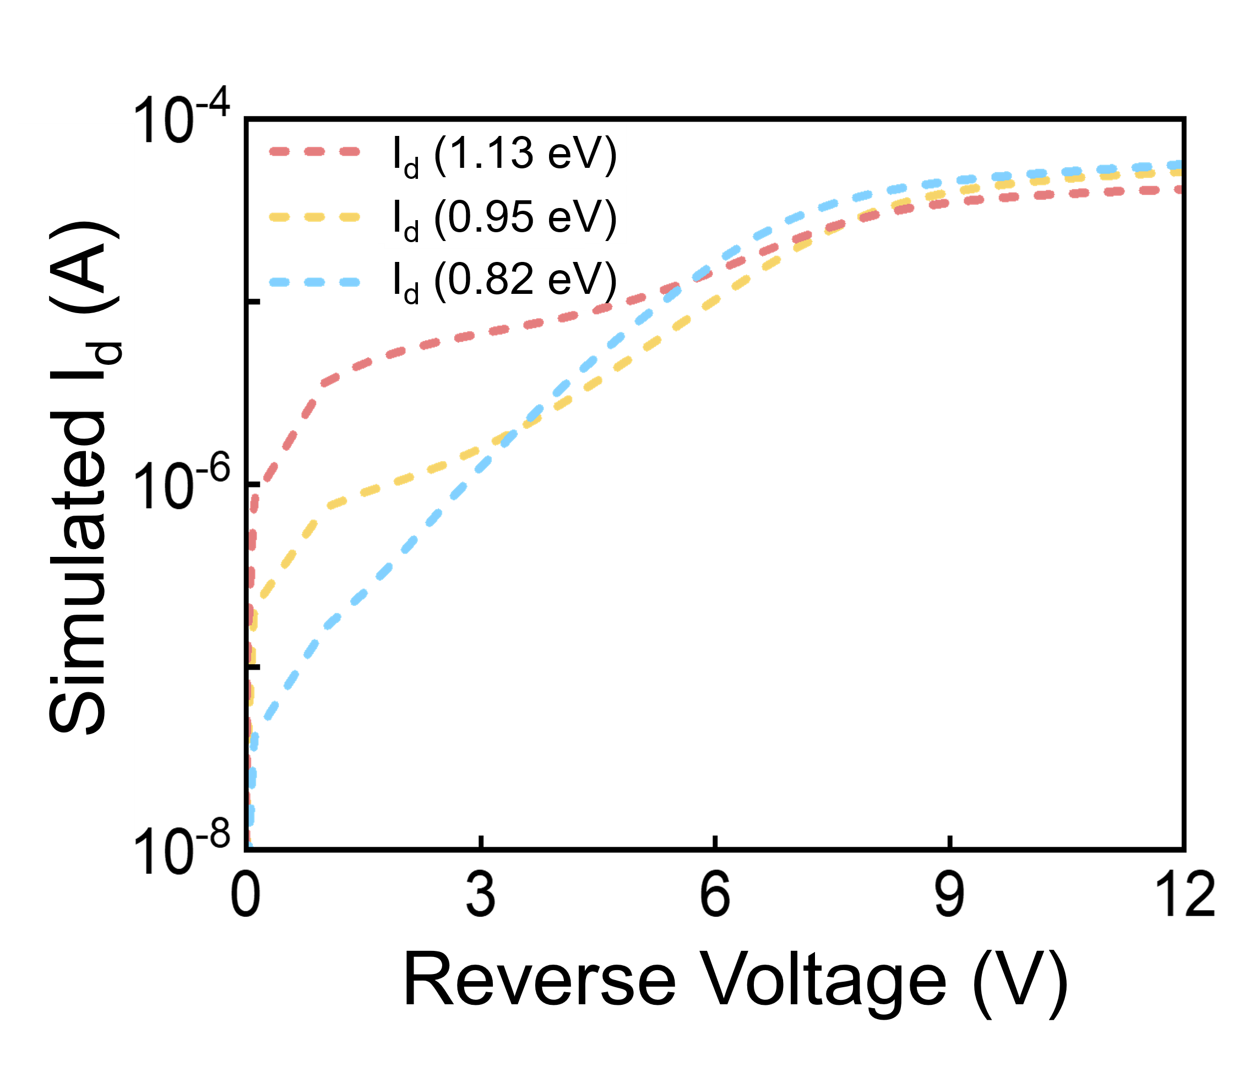
Supplementary Fig. 13 | Simulated I–V characteristics obtained using the TCAD. Simulated dark current–reverse voltage plots of devices with EM layer bandgaps of 1.13 eV (red), 0.95 eV (yellow), and 0.82 eV (grey). I_{d} denotes dark current. Detailed material parameters are provided in Supplementary Table 3. The simulation parameters were derived from our experimental data and previous research^{9,10}. The simulated I–V results are consistent with experimental trends (Fig. 3b).

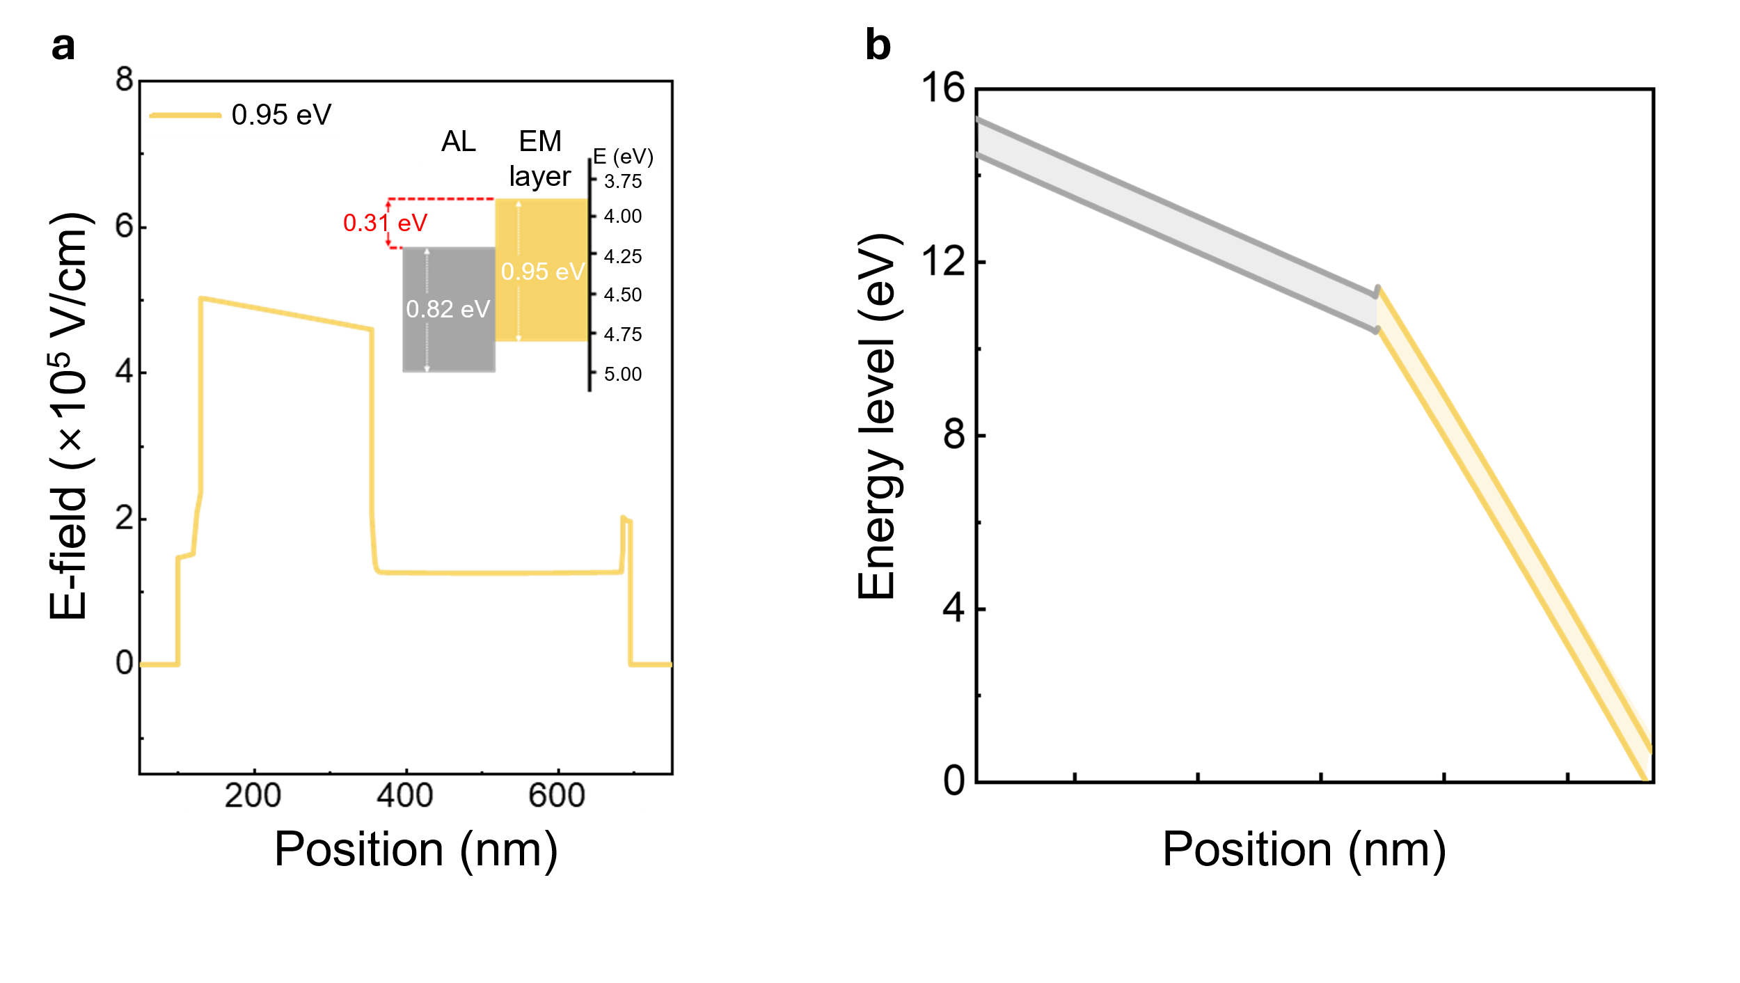
Supplementary Fig. 14 | Electrical properties of the EM layer device with 0.95 eV bandgap under reverse bias. a Electric field (E-field) analysis of the EM layer device under a reverse bias of 0.95 eV. The inset shows flat band diagram of the EM layer device (0.95 eV bandgap). b Simulated energy band diagrams under a reverse bias for the EM layer device (0.95 eV bandgap). For the 0.95 eV EM layer device, the medium conduction band offset (0.31 eV) rendered an E-field of approximately 5×10⁵ V/cm in the EM layer.

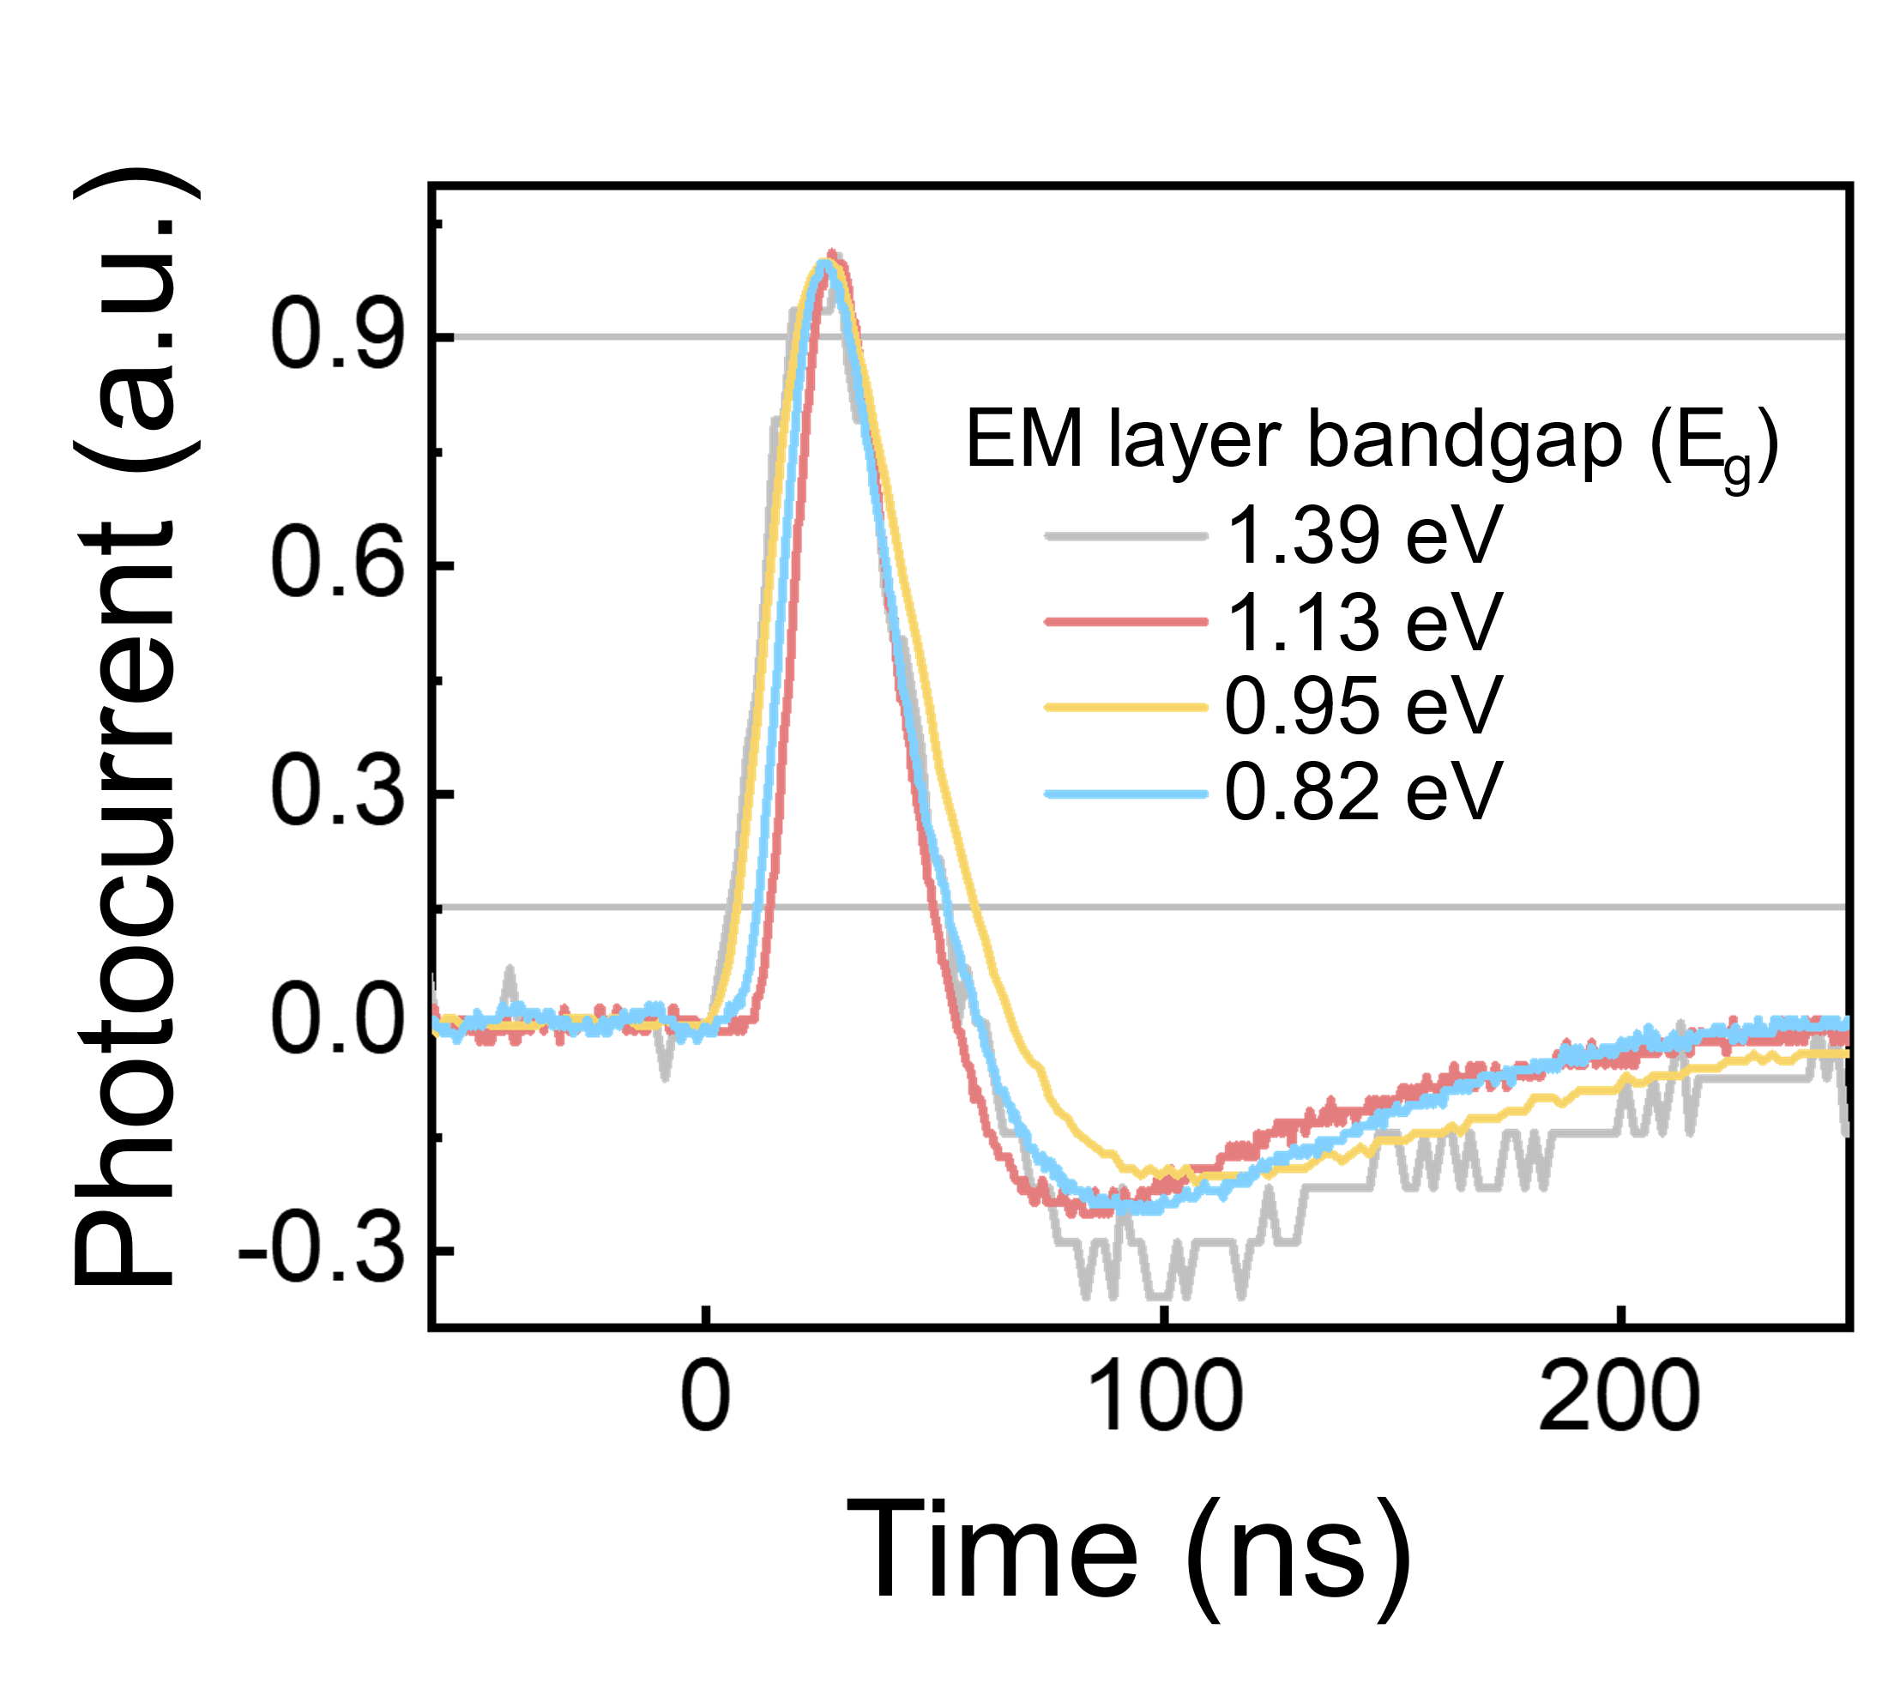
Supplementary Fig. 15 | Transient photoresponses of CQD devices with different EM layer bandgaps at –7 V. Blue: 1.39 eV, red: 1.13 eV, yellow: 0.95 eV and grey: 0.82 eV.

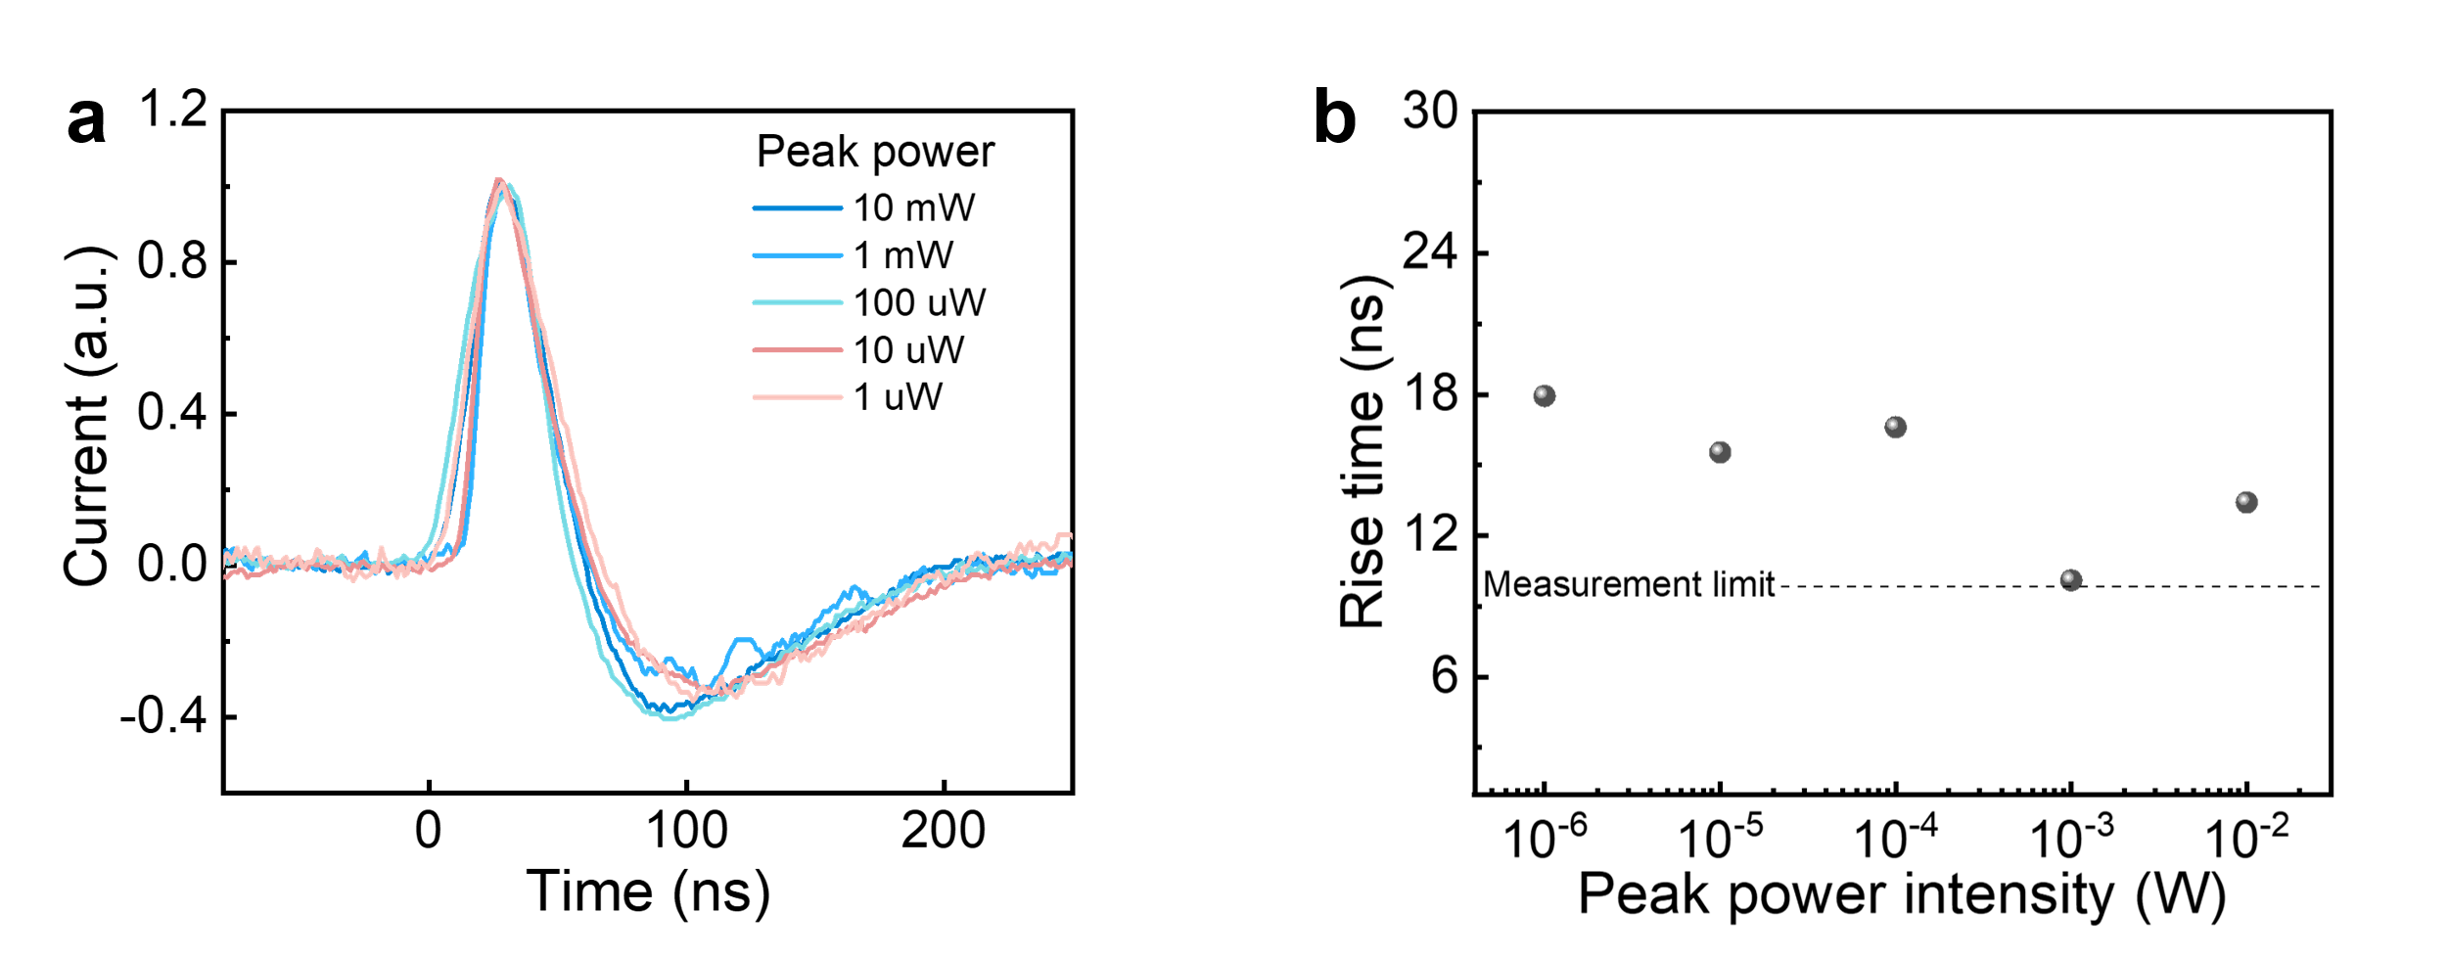
Supplementary Fig. 16 | Response time of devices under different light intensities of illumination. a Transient photoresponse spectra of CQD photodetectors with the EM layer under different peak powers of the laser. b Rise time as a function of peak power. A pulsed laser with a peak power of 10 μW was used to calculate 3-dB bandwidth and GBP, ensuring the light intensity corresponds to the optical power of the light source used for gain determination.

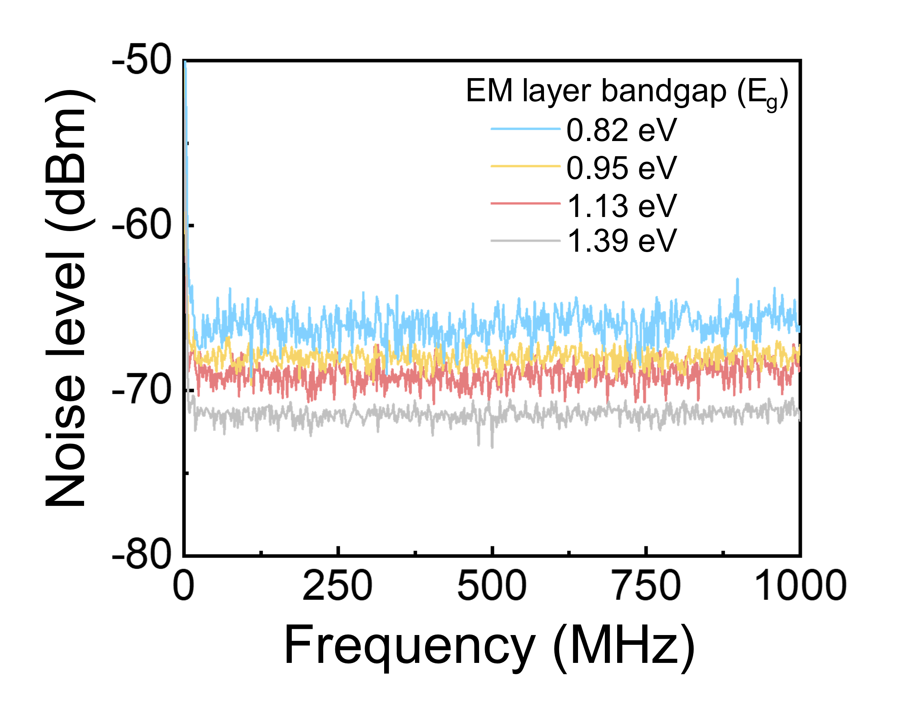
Supplementary Fig. 17 | Calculated excess noise spectra of devices with different EM layer bandgaps used to characterize the excess noise factor at –7 V. The noise levels under dark conditions were subtracted from those under illuminated conditions to determine the excess noise spectra. (Blue: 1.39 eV, red: 1.13 eV, yellow: 0.95 eV and grey: 0.82 eV)

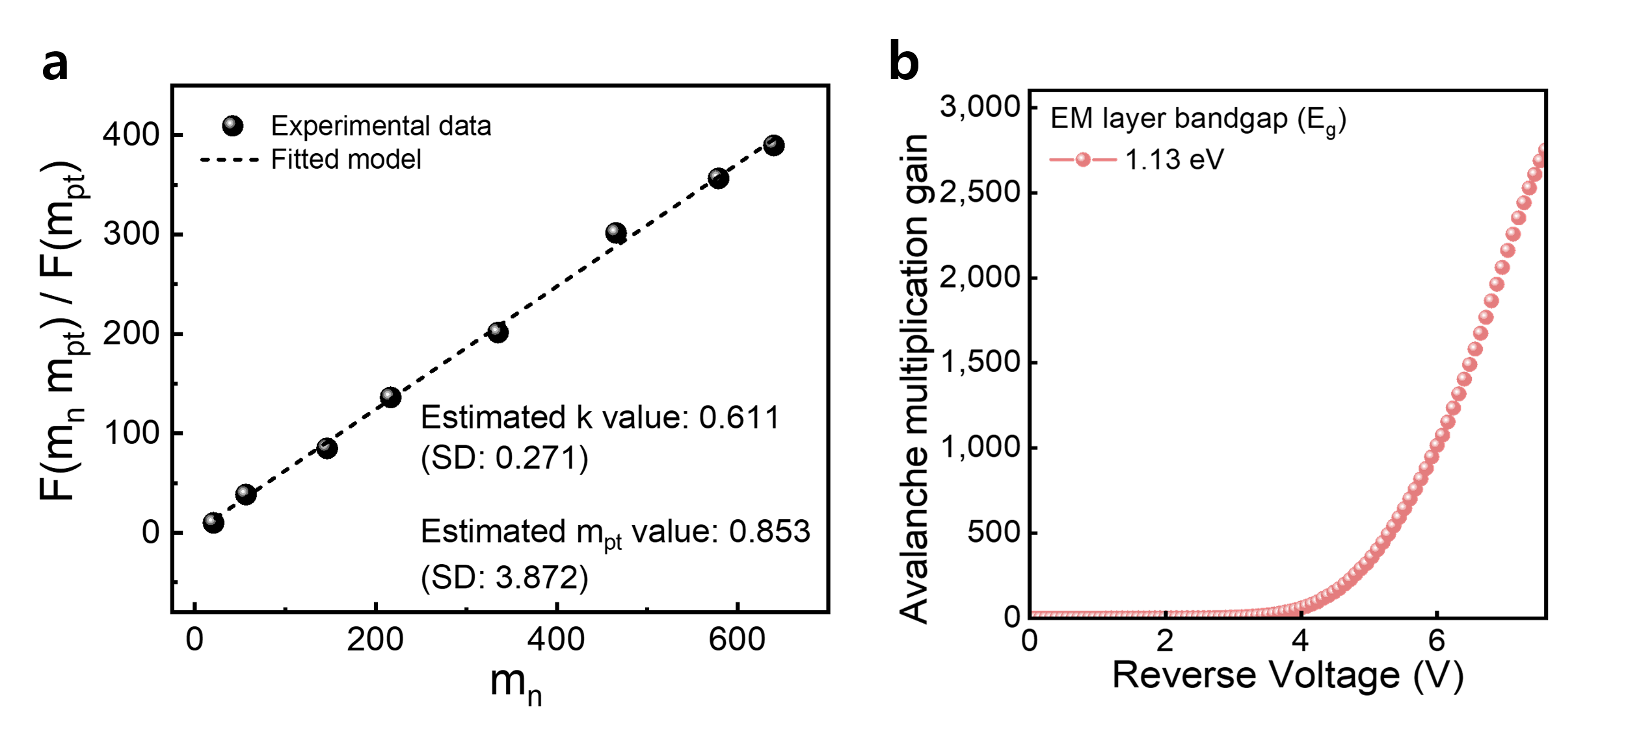
Supplementary Fig. 18 | Estimated punch-through gain through excess noise based on McIntyre’s model. a The ratio of excess noise as a function of relative gain (m_{n}), which was normalized to the gain at the punch-through voltage. b The calculated gain from excess noise as a function of reverse voltage. The fitted model was used to extract the excess noise factor (k) and punch-through gain (m_{pt}) to estimate the actual gain of the CQD devices due to impact ionization.

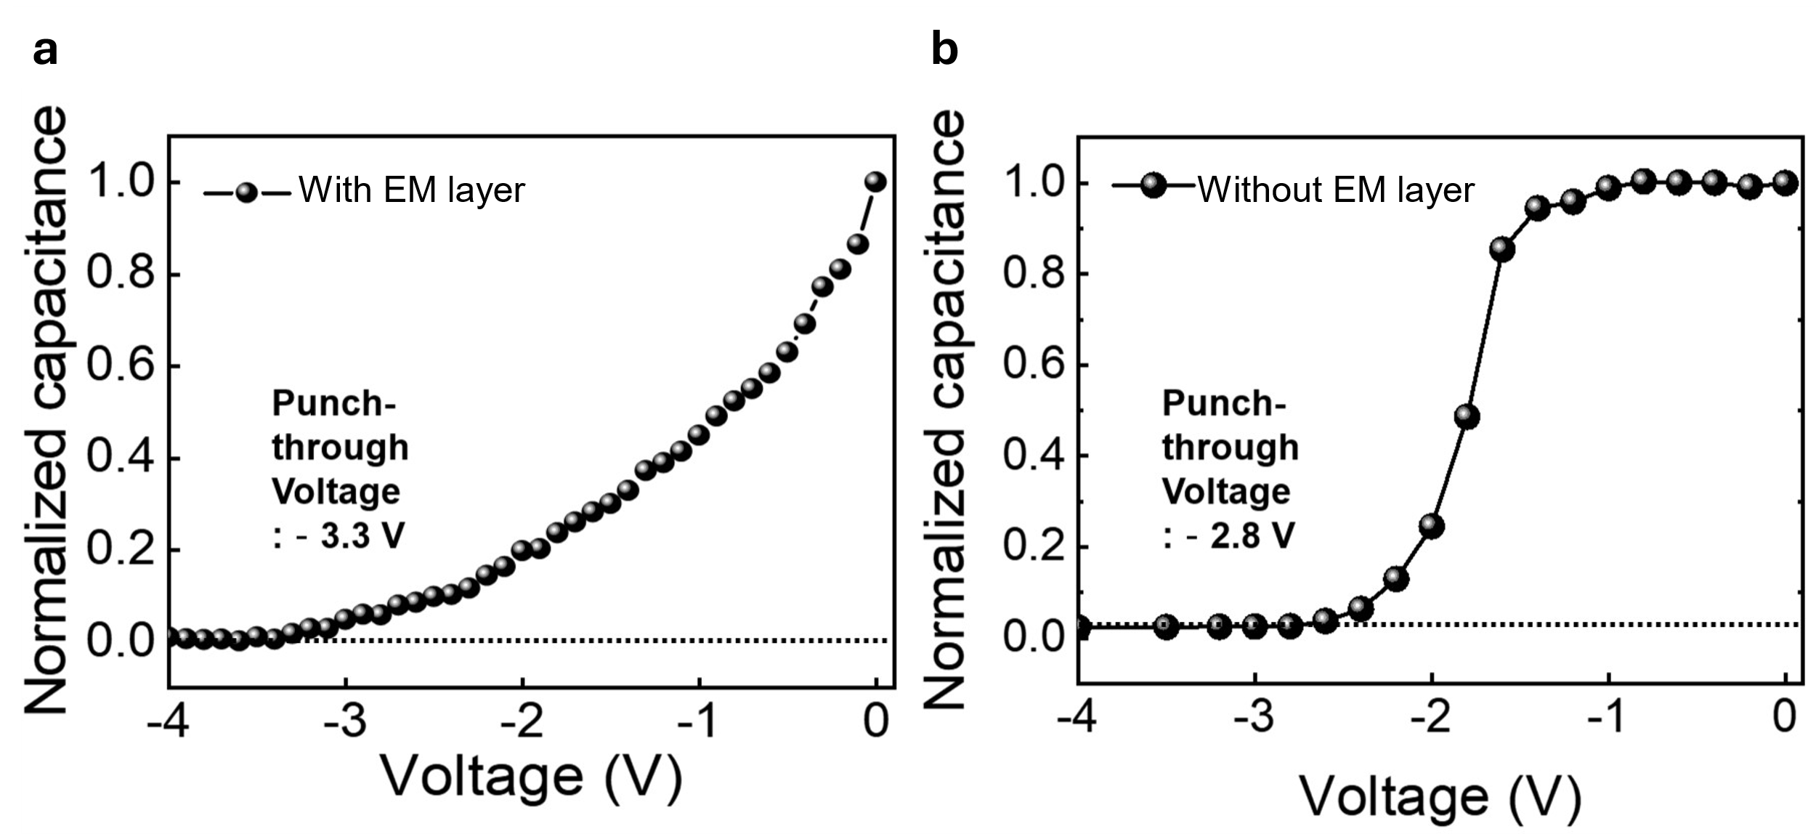
Supplementary Fig. 19 | C-V characterization of CQD devices. a With and b without EM layer. The device without the EM layer showed a lower punch-through voltage (-2.8 V) due to its thinner structure. The depletion is less sharp for device with the CQD EM layer, presumably due to the trap states of additional EM layer.

Supplementary Table 1 | Performance metrics of solution-processed photodetectors, including detectivity, gain, bandwidth, and the GBP product.

Device type | Photoactive  material | λ  (nm) | Detectivity (Jones)ª | Gain | 3-dB Bandwidth  (Hz) | GBP  (Hz) | Ref.
PT | PbS CQD | 632 | 5.0×10¹² | 222 ^{b} | 300 ª | 6.66×10⁴ | ¹¹
PVFET | Si-PbS | 1500 | 1.8×10¹² | 10^{4 a} | 10^{5 a} | 10⁹ | ¹²
PD | PbS CQD | 1550 | 8.0×10¹¹ | 1 ^{c} | 1.4×10^{8 d} | 1.4×10⁸ | ¹³
PT | PbS-Graphene CQD | 1600 | 1.0×10¹³ | 10⁵ ª | 1.5×10^{3 a} | 1.5×10⁸ | ¹⁴
PD | InAs CQD | 940 | 1.0×10¹¹ | 1 ^{c} | 1.17×10^{9 d} | 1.17×10⁹ | ¹⁵
PD | Ag₂Te CQD | 1550 | 3.0×10¹² | 1 ^{c} | 1.1×10^{5 a} | 1.1×10⁵ | ¹⁶
PC | PbS CQD | 1300 | 1.8×10¹³ | 2575 ^{b} | 18 ª | 4.64×10⁴ | ¹⁷
PT | PbS-SnS₂ CQD | 970 | 2.2×10¹² | 1.28 ⅹ 10^{6 b} | 5 ª | 6.41×10⁶ | ¹⁸
PD | PbS CQD | 1450 | 1.0×10¹² | 1 ^{c} | 1.5×10⁴ | 1.5×10⁴ | ¹⁹
PD | HgTe-Se CQD | 2000 | 5.1×10¹¹ | 1 ^{c} | 1.28×10^{5 d} | 1.28×10⁵ | ²⁰
PT | Organic | 450 | 1.1×10¹³ | 1.87ⅹ10^{7 b} | 1.70×10^{-2 d} | 3.18×10⁵ | ²¹
PD | Organic | 600 | 8.0×10¹² | 1 ^{c} | 1.5×10^{4 a} | 1.5×10⁴ | ²²
PD | Organic | 940 | 1.0×10¹² | 1 ^{c} | 2.4×10^{5 a} | 2.4×10⁵ | ²³
PD | Organic | 654 | 9.8×10¹² | 24 ^{b} | - | - | ²⁴
PD | Perovskite | 905 | 1.5×10¹² | 1 ^{c} | 4.0×10^{9 d} | 4.0×10⁹ | ²⁵
PC | Perovskite | 350~740 | - | 489 ^{b} | 3.50×10^{4 d} | 1.71×10⁷ | ²⁶
APD | PbS CQD | 940 | 1.4×10¹⁴ | 85 ª | 2.0×10⁵ | 1.7×10⁷ | ²⁷
APD | PbS CQD | 1550 | 2.8×10¹³ | 3228 | 2.25×10⁷ | 7.27×10¹⁰ | Present study
PT: Phototransistor, PVFET: Photovoltage field effect transistor, PD: Photodiode, PC: Photoconductor, APD: Avalanche photodiode
ª Measured.
^{b} The gain of the device was calculated based on the responsivity assuming a quantum efficiency of 100%.
^{c} If the PD device responsivity was less than 1 A/W, we assumed that the gain was 1.
^{d} The 3-dB bandwidth (ƒ_{3dB}) was calculated based on the rise time (t_{rise}) using following equation:²⁸
$f_{3dB }≅ \frac{0.35}{t_{rise}}$ (8)

Supplementary Table 2 | Parameters for calculating the effective detection range of the sensor system. The values of the transmitted power and aperture area were consistent with those used in the device characterization. The attenuation coefficient used for the calculation was derived based on clear weather conditions, with a visibility of 23 km at a wavelength of 1550 nm²⁹.
Parameter | Value
Efficiency of optical system (η, %) | 90
Diffuse reflectivity (ρ, %) | 30
Transmitted power (P_{t}, W) | 3.0×10^{–3}
Aperture area of a receiver (A, m²) | 1.0×10^{–5}
Attenuation coefficient (γ, m⁻¹) | 4.6×10^{–5}

Supplementary Table 3 | Simulation parameters for the Silvaco ATLAS TCAD simulation^{7,10}. We used different electron affinities for different bandgap EM layers: 3.52 eV for 1.39 eV, 3.75 eV for 1.13 eV, 3.87 eV for 0.95 eV, and 3.95 eV for 0.82 eV.

 | ZnO | EM layer | Absorption layer | MoO_{x}
Thickness (nm) | 30 | 225 | 330 | 10
Bandgap (eV) | 3.4 | Vary | 0.82 | 3.0
Electron affinity (eV) | 3.82 | Vary | 4.18 | 2.0
Permittivity (ε_{r}) | 66 | 20 | 20 | 12.5
Electron mobility (cm/V·s) | 5 | 0.002 | 0.05 | 5
Hole mobility (cm/V·s) | 5 | 0.002 | 0.05 | 5
Acceptor density (cm⁻³) | 1×10¹⁷ | 1×10¹⁶ | 1×10¹⁴ | 6×10¹⁶
Donor density (cm⁻³) | - | - | 1×10¹⁴ | -

Supplementary References

- Weitkamp, C. Range-Resolved Optical Remote Sensing of the Atmosphere (Springer-Verlag New York, 2005).
- Kokhanovsky, A. A Light scattering reviews 4: single light scattering and radiative transfer. (Springer Science & Business Media, 2009).
- Eppeldauer, G. P., Detector-Based Reference Calibrations for Electro-Optical Instruments. (Cambridge Scholars Publishing, 2021).
- Adams, M. D. Coaxial range measurement - current trends for mobile robotic applications. IEEE Sens. J. 2, 2-13 (2002).
- Korb, C. L., & Weng, C. Y. A Theoretical Study of a Two-Wavelength Lidar Technique for the Measurement of Atmospheric Temperature Profiles. J. Appl. Meteorol. 21, 1346-1355 (1982).
- Wang, Z., Liu, L., Qi, P., Chen, J., & Zhao, L. High-breakdown-voltage GaN-based vertical FinFET design. J. Power Electron. 24, 448-455 (2024).
- ATLAS.ti. Atlas.ti Windows User Manual, Version 23. (Atlas ti, 2023).
- Liu, H. D. et al. Avalanche photodiode punch-through gain determination through excess noise analysis. J. Appl. Phys. 106, 064507 (2009).
- Kim, B., Baek, S. W., Kim, C., Kim, J., & Lee, J. Y. Mediating colloidal quantum dot/organic semiconductor interfaces for efficient hybrid solar cells. Adv. Energy Mater. 12, 2102689 (2022).
- Di, Y. et al. Interface engineering to drive high‐performance MXene/PbS quantum dot NIR photodiode. Adv. Sci. 11, 2307169 (2024).
- Konstantatos, G., Clifford, J., Levina, L., & Sargent, E. H. Sensitive solution-processed visible-wavelength photodetectors. Nat. Photon. 1, 531-534 (2007).
- Zhou, W. et al. Silicon: quantum dot photovoltage triodes. Nat. Commun. 12, 6696 (2021).
- Vafaie, M. et al. Colloidal quantum dot photodetectors with 10-ns response time and 80% quantum efficiency at 1,550 nm. Matter 4, 1042-1053 (2021).
- Nikitskiy, I. et al. Integrating an electrically active colloidal quantum dot photodiode with a graphene phototransistor. Nat. Commun. 7, 11954 (2016).
- Sun, B. et al. Fast near-infrared photodetection using III–V colloidal quantum dots. Adv. Mater. 34, 2203039 (2022).
- Wang, Y. et al. Silver telluride colloidal quantum dot infrared photodetectors and image sensors. Nat. Photon. 18, 236-242 (2024).
- Konstantatos, G. et al. Ultrasensitive solution-cast quantum dot photodetectors. Nature 442, 180-183 (2006).
- Gao, L. et al Broadband, sensitive and spectrally distinctive SnS2 nanosheet/PbS colloidal quantum dot hybrid photodetector. Light Sci. Appl. 5, e16126-e16126 (2016).
- Clifford, J. P. et al. Fast, sensitive and spectrally tuneable colloidal-quantum-dot photodetectors. Nat. Nanotechnol. 4, 40-44 (2009).
- Yu, M. et al. In‐Synthesis Se‐Stabilization Enables Defect and Doping Engineering of HgTe Colloidal Quantum Dots. Adv. Mater. 36, 2311830 (2024).
- Zhang, S. et al. Photovoltaic nanocells for high-performance large-scale-integrated organic phototransistors. Nat. Nanotechnol. 19, 1323-1332 (2024)
- Fuentes-Hernandez, C. et al. Large-area low-noise flexible organic photodiodes for detecting faint visible light. Science 370, 698-701 (2020).
- Huang, J. et al. A high‐performance solution‐processed organic photodetector for near‐infrared sensing. Adv. Mater. 32, 1906027 (2020).
- Lan, Z. et al. Near-infrared and visible light dual-mode organic photodetectors. Sci. Adv. 6, eaaw8065 (2020).
- Morteza Najarian, A. et al. Sub-millimetre light detection and ranging using perovskites. Nat. Electron. 5, 511-518 (2022).
- Dong, R. et al. High‐gain and low‐driving‐voltage photodetectors based on organolead triiodide perovskites. Adv. Mater. 27, 1912-1918 (2015).
- Kim, B. et al. Ultrahigh-gain colloidal quantum dot infrared avalanche photodetectors. Nat. Nanotechnol. 20, 237-245 (2025).
- Saran, R. & Curry, R. J. Lead sulphide nanocrystal photodetector technologies. Nat. Photon. 10, 81-92 (2016).
- Wojtanowski, J., Zygmunt, M., Kaszczuk, M., Mierczyk, Z., Muzal, M. Comparison of 905 nm and 1550 nm semiconductor laser rangefinders’ performance deterioration due to adverse environment conditions. Opto-Electron. Rev. 22, 183-190 (2014).

