Table S1. Search strategy

1. MEDLINE VIA PUBMED |  | Results | Date
#1 | "Multidrug resistant tuberculosis"[Mesh] | 1,027 | December 31, 2024
#2 | "Obesity"[Mesh] | 25,905
#3 | “Overweight” [Mesh] | 27,035
#4 | #1 AND #3 | 7
#5 | #2 AND #3 | 4
#6 | #1 AND #2 AND #3 | 2
2. GOOGLE SCHOLAR |  | Results | December 31, 2024
#1 | "Multidrug resistant tuberculosis" | 375,000
#2 | "Obesity" OR “Overweight” | 3’640,000
#3 | #1 AND #2 | 18,400
3. SCOPUS |  | Results |  | December 31, 2024
#1 | TITLE-ABS-KEY ('Multidrug resistant tuberculosis') | 518 |  | December 31, 2024
#2 | TITLE-ABS-KEY ('overweight') | 20,661 |  | December 31, 2024
#3 | #1 AND #2 | 0 |  | December 31, 2024
4. EMBASE |  | Results | December 31, 2024
#1 | 'tuberculosis'/exp | 318,029
#2 | 'Obesity'/exp | 68,575
#3 | 'Overweight'/exp | 1,122
#4 | #1 AND #2 AND #3 | 49
4. Web of Science |  | Results | December 31, 2024
#1 | "Multidrug resistant tuberculosis" | December 31, 2024
#2 | "Obesity" OR “Overweight” | 68,575
#3 | #1 AND #2 | 29

Table S2. Excluded Studies and the reason for their exclusion
Study | Reason for Exclusion
Kandi, Subhakar; K, Tilak Kumar; Kandi, Shravika Reddy; Mathur, Neeta; D, Jalla Devi; Adepu, Rajesham. Study of treatment outcomes of multidrug-resistant tuberculosis under programmatic conditions and factors influencing the outcomes in Hyderabad District. The Indian Journal of Tuberculosis. 2021 Jul 1;68(3): 379-383. DOI: 10.1016/j.ijtb.2020.12.008. | Population and outcome different from our PECO question.
Mukati, Suneel; Julka, Arti; Varudkar, HG; Singapurwala, Mustafa; Agrawat, JC; Bhandari, Deepali; Jainista, Anukool. A study of clinical profile of cases of MDR-TB and evaluation of challenges faced in initiation of second line Anti tuberculosis treatment for MDR-TB cases admitted in drug resistance tuberculosis center. Indian J Tuberc. 2019 Jul 1;63(3): 358-363. DOI: 10.1016/j.ijtb.2016.11.031. | Only the summary is available.
Park, Hyun Oh; Kim, Sung Hwan; Luna, Seong Ho; Byun, Joung Hun; Kim, Jong Woo; Lee, Chung Eun; Kim, Jong Duk; Jang, In Seok; Yang, Jun Ho. Association between Body Mass Index and Sputum Culture Conversion among South Korean Patients with Multidrug Resistant Tuberculosis in a Tuberculosis Referral Hospital. Infect Chemother. 2016 Dic 1; 48 (4): 317-323. DOI: 10.3947/ic.2016.48.4.317 | Population and outcome different from our PECO question.
Gupta, Siddhartha; Bandyopadhyay, Debasis; Gupta, Soma; Sadhukhan, Sanjoy; Banerjees, Surajita. A sociodemographic study of multidrug resistant tuberculosis cases from DOTS clinics of Kolkata. J Indian Med Assoc. 2012 Oct 1; 110 (10): 723-725. PMID: 23738405 | Only the summary is available.
Angrup, Archana; Varma-Basil, Mandira; Kumar, Sujeet; Pathak, Rakesh Kumar; Sharma, Himanshu; Banavaliker, Jayant Nagesh; Bose, Mridula. Drug resistance among Mycobacterium tuberculosis isolates from private clinics and a dots center in Delhi, India. The Southeast Asian Journal of Tropical Medicine and Public Health. 2011 Jan 1; 42 (1): 122-127. PMID: 21323174 | Only the summary is available.
Wang, Kai; Chen, Songhua; Wang, Xiaomeng; Zhong, Jieming; Wang, Xinting; Huai, Pengcheng; Wu, Limin; Wang, Lixia; Jiang, Shiwen; Li, junio; Peng, Ying; Yao, Hongyan; Mamá, Wei. Factors Contributing to the High Prevalence of Multidrug-Resistant Tuberculosis Among Previously Treated Patients: A Case–Control Study from China. Microbial Drug Resistance. 2014 Aug 1; 20 (4): 294-300. DOI: 10.1089/mdr.2013.0145 | Only the summary is available.
Campbell, Jonathon R.; Chan, Edward D.; Falzón, Dennis; Trajmán, Anete; Keshavjee, Salmaan; Leung, Chi C.; Molinero, Ann C.; Monedero-Recuero, Ignacio; Rodrigues, Denise S.; Seo, Haesook; Baghaei, Parvaneh; Udwadia, Zarir; Viiklepp, Piret; Bastos, Mayara; Menzies, Dick. Low Body Mass Index at Treatment Initiation and Rifampicin-Resistant Tuberculosis Treatment Outcomes: An Individual Participant Data Meta-Analysis. Clinical Infectious Diseases. 2022 Dic 15; 75(12): 2201–2210, https://doi.org/10.1093/cid/ciac322 | Population and outcome different from our PECO question.
Migliori, GB; Espinal, M.; Danilova, ID; Punga, VV; Grzemska, M.; Raviglione, MC. Frequency of recurrence among MDR-tB cases 'successfully' treated with standardised short-course chemotherapy. The International Journal of Tuberculosis and Lung Disease: The Official Journal of the International Union Against Tuberculosis and Lung Disease. 2002 Oct 1; 6 (10): 858-864. PMID: 12365571 | Only the summary is available.
Kwak, N.; Kim, recursos humanos; Yoo, CG.; Kim, YW; Han, SK; Yim, JJ. Multidrug-resistant tuberculosis over 20 years at a referral hospital in South Korea: trends and outcomes. The International Journal of Tuberculosis and Lung Disease. 2019 Feb 1; 23 (2): 174-180. DOI: 10.5588/ijtld.18.0295 | Only the summary is available.
Harausz, Elizabeth P.; García-Prats, Anthony J.; Ley, Stephanie; Schaaf, H. Simón; Kredo, Tamara; Seddon, James A.; Menzies, Dick; Turkova, Anna; Achar, Jay; Amanullah, Farhana. Treatment and outcomes in children with multidrug-resistant tuberculosis: A systematic review and individual patient data meta-analysis. 2018 Jul 1; 15(7): 2100-2591. DOI: 10.1371/journal.pmed.1002591 | Population and outcome different from our PECO question.
Diallo, Alhassane; Djelo Diallo, Boubacar; Mady Cámara, Lansana; Nadège Kounoudji, Lucrèce Ahouéfa; Bah, Boubacar; Oumar Barry, Alfa; N'Zabintawali, Fulgence; Carlos-Bolumbu, Miguel; Hassimiou Diallo, Mamadou; Younoussa Sow, Oumou. Different Profiles of Body Mass Index Evolutions Among Patients with Multidrug-Resistant Tuberculosis: A Retrospective Cohort Study. 2019. DOI: 10.2139/ssrn.3468387 | Population and outcome different from our PECO question.
Shah, AR; Agarwal, SK; Shah, KV. Study of drug resistance in previously treated tuberculosis patients in Gujarat, India. The International Journal of Tuberculosis and Lung Disease: The Official Journal of the International Union Against Tuberculosis and Lung Disease. 2002 Dic 1; 6 (12): 1098-1101. PMID: 12546118 | Only the summary is available.
Hayashi, S.; Takeuchi, M.; Hatsuda, K.; Ogata, K.; Kurata, M.; Nakayama, T.; Ohishi, Y.; Nakamura, H. The impact of nutrition and glucose intolerance on the development of tuberculosis in Japan. The International Journal of Tuberculosis and Lung Disease: The Official Journal of the International Union Against Tuberculosis and Lung Disease. 2014 Jan 1; 18 (1): 84-88. DOI: 10.5588/ijtld.13.0495 | Only the summary is available.
Prajapati, Krunal; Mishra, Vishal; Desai, Mira; Solanki, Rajesh; Naik, Purvi. Treatment outcome of patients having extensively drug-resistant tuberculosis in Gujarat, India. International Journal of Mycobacteriology. 2017 Jan 1; 6 (3): 289-295. DOI: 10.4103/ijmy.ijmy_59_17. | Only the summary is available.

Table S3. Meta-regression analysis of the studies included in the metanalysis assessing the effect of overweight and obesity on the risk of developing MDR-TB in all participants.
Variable | Test of moderators (coefficient 2) | Test for residual heterogeneity
Type of study (CSS, RCS, or CCS). | QM (df = 2) = 2.5759, p = 0.2758 | QE (df = 11) = 31.0373, p = 0.0011
Weight category (normal weight, overweight, or obesity). | QM (df = 2) = 0.4272, p = 0.8077 | QE (df = 11) = 37.0597, p = 0.0001
Previous TB treatment (yes or not). | QM (df = 2) = 0.8887, p = 0.6413 | QE (df = 11) = 30.8318, p = 0.0012
Continent of origin (America, Africa, Asia) | QM (df = 2) = 52.0945, p < 0.0001 | QE (df = 11) = 8.9424, p = 0.6272
CCS: Case-control study, RCS: Retrospective cohort study, CSS: Cross-sectional study.

Figure S1. Influence analysis of the studies included in the metanalysis assessing the effect of overweight and obesity on the risk of developing MDR-TB in all participants.
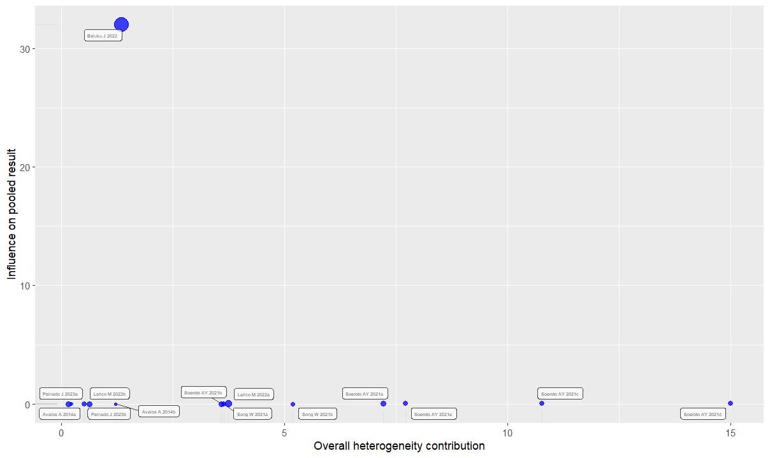

Figure S2. Sensitivity analysis of the studies included in the metanalysis assessing the effect of overweight and obesity on the risk of developing MDR-TB in all participants.

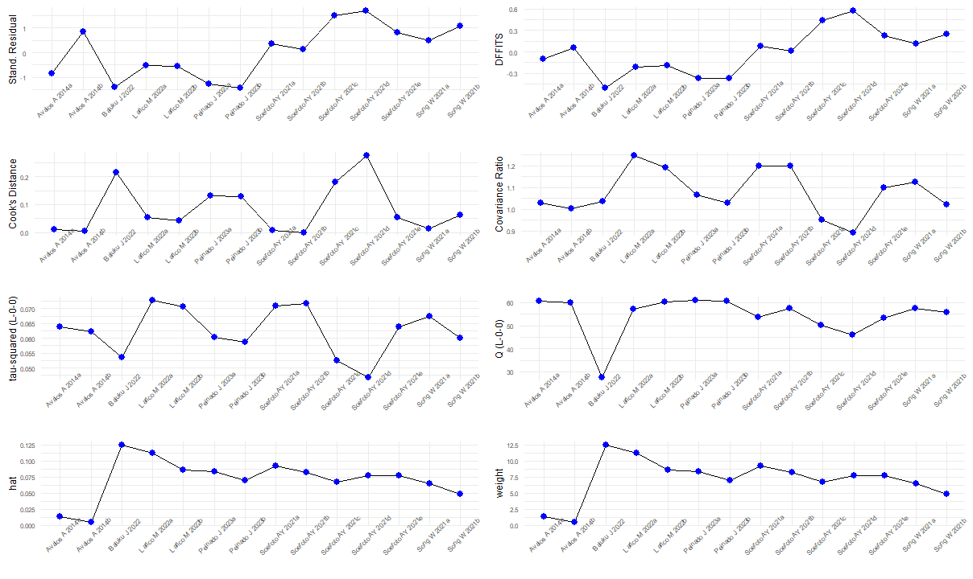

Figure S3. Leave-one-out analysis sorted by effect size of the studies included in the metanalysis assessing the effect of overweight and obesity on the risk of developing MDR-TB in all participants.
Leave-one-out analysis
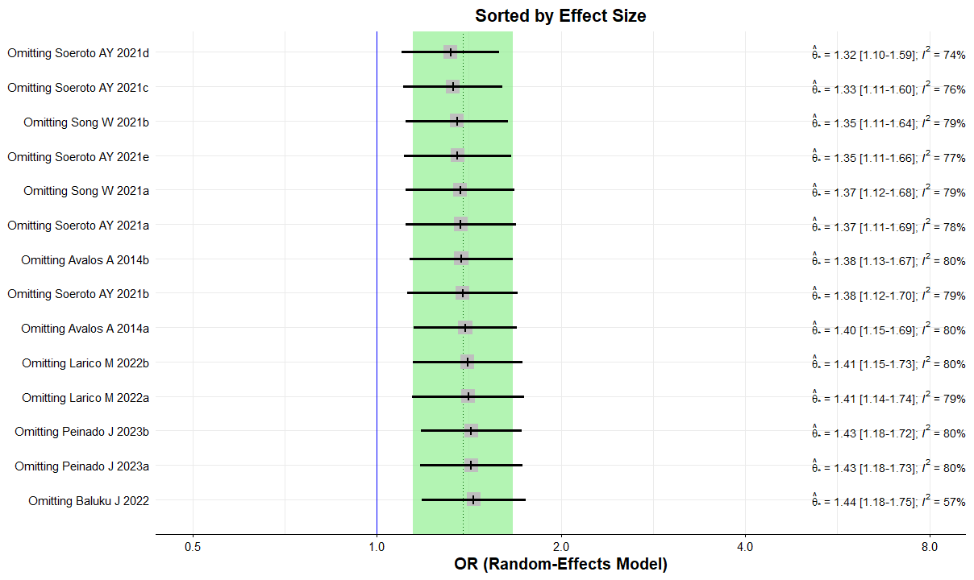

Figure S4. Leave-one-out analysis sorted by I² of the studies included in the metanalysis assessing the effect of overweight and obesity on the risk of developing MDR-TB in all participants.
