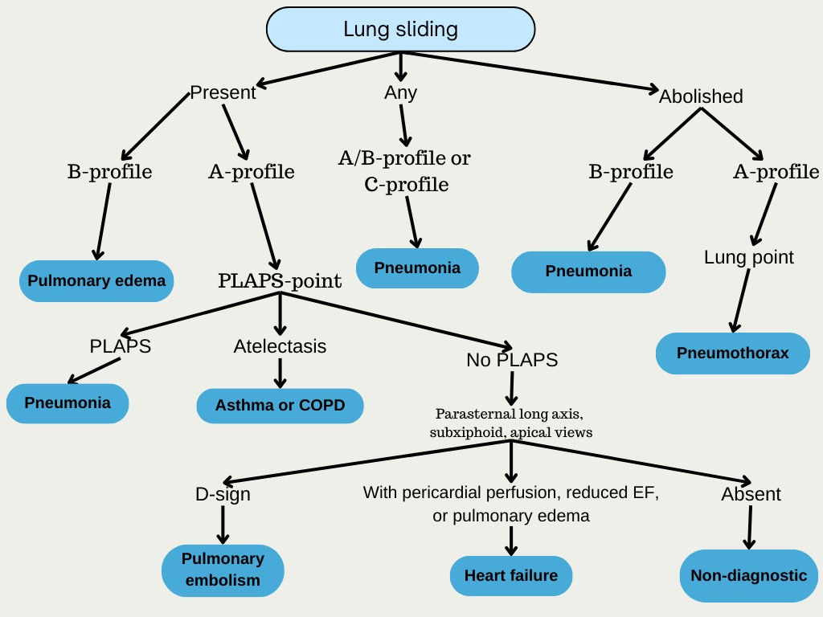
Supplemental Figure 1: Modified BLUE protocol for the diagnosis of dyspnea in the emergency department.

