Supplementary Figures

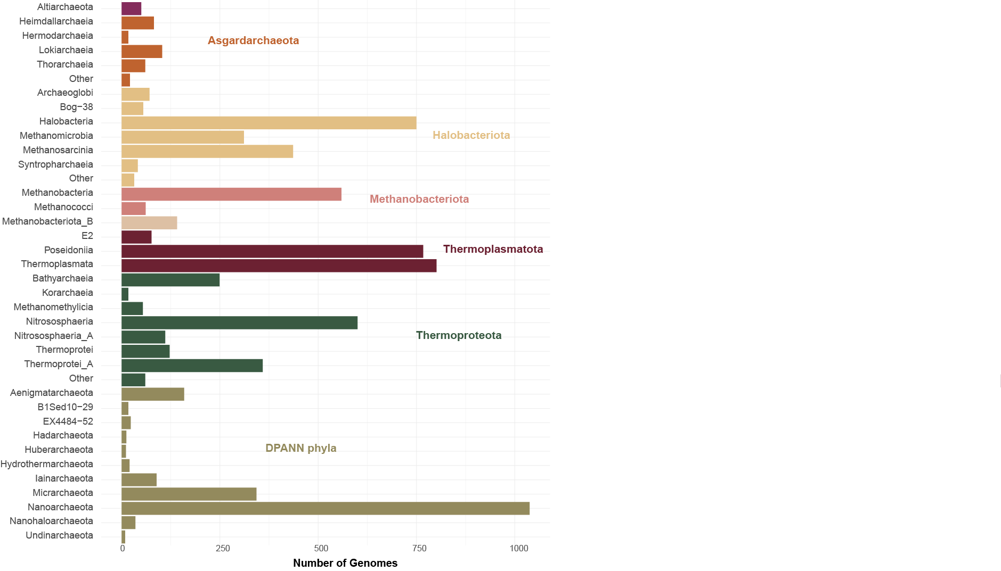
Supplementary Figure 1. Taxonomic diversity of the archaeal database. The taxonomic classification of genomes follows the phylogeny of the Genome Taxonomy Database (Rinke et al. 2021). Bars are colored according to the phylum or superphylum to which they belong.

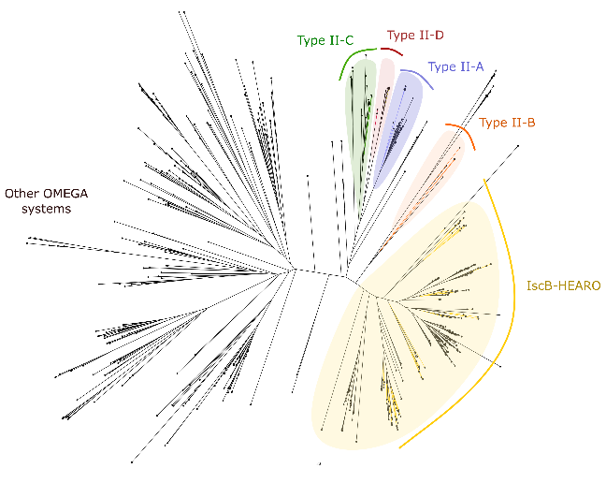
Supplementary Figure 2. Phylogeny of archaeal type-II CRISPR-Cas systems identified by CRISPR-Cas Typer. Proteins from the archaeal database are indicated in black and representative sequences of the previously characterized Cas9 subtypes (II-A to II-D) or IscB elements are shown in color. Sequences belonging to OMEGA clades (Altae-Tran et al. 2021, Aliaga-Goltsman et al. 2022) are shaded in yellow. Proteins identified as type II-D CRISPR-Cas effectors do not cluster with the known Cas9 subtypes and are likely OMEGA systems.

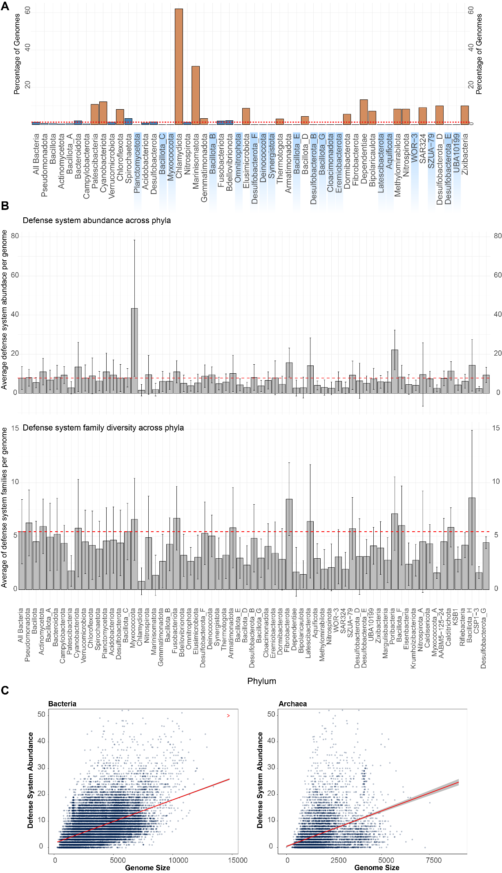
Supplementary Figure 3. Statistical analysis of bacterial defense systems. A) Taxonomic distribution of bacterial genomes lacking defense systems. The dashed red line indicates the average percentage across all bacterial genomes analyzed. Orange bars indicate above-average values. All genomes belonging to the phyla shaded in blue encode one or more defense system. B) Comparison of defense system abundance and diversity across bacterial phyla. The top panel shows the average number of defense systems per genome. The bottom panel presents the average number of defense system families per genome. The dashed red line indicated the average value of all bacterial genomes analyzed. Error bars indicate standard deviation. C) Relationship between genome size and defense system abundance in Bacteria (Left) and Archaea (Right). Each dot represents a genome, with the number of defense systems plotted against genome size. The dotted red line represents the linear regression trendline, while the shaded area indicates the standard error of the regression fit.

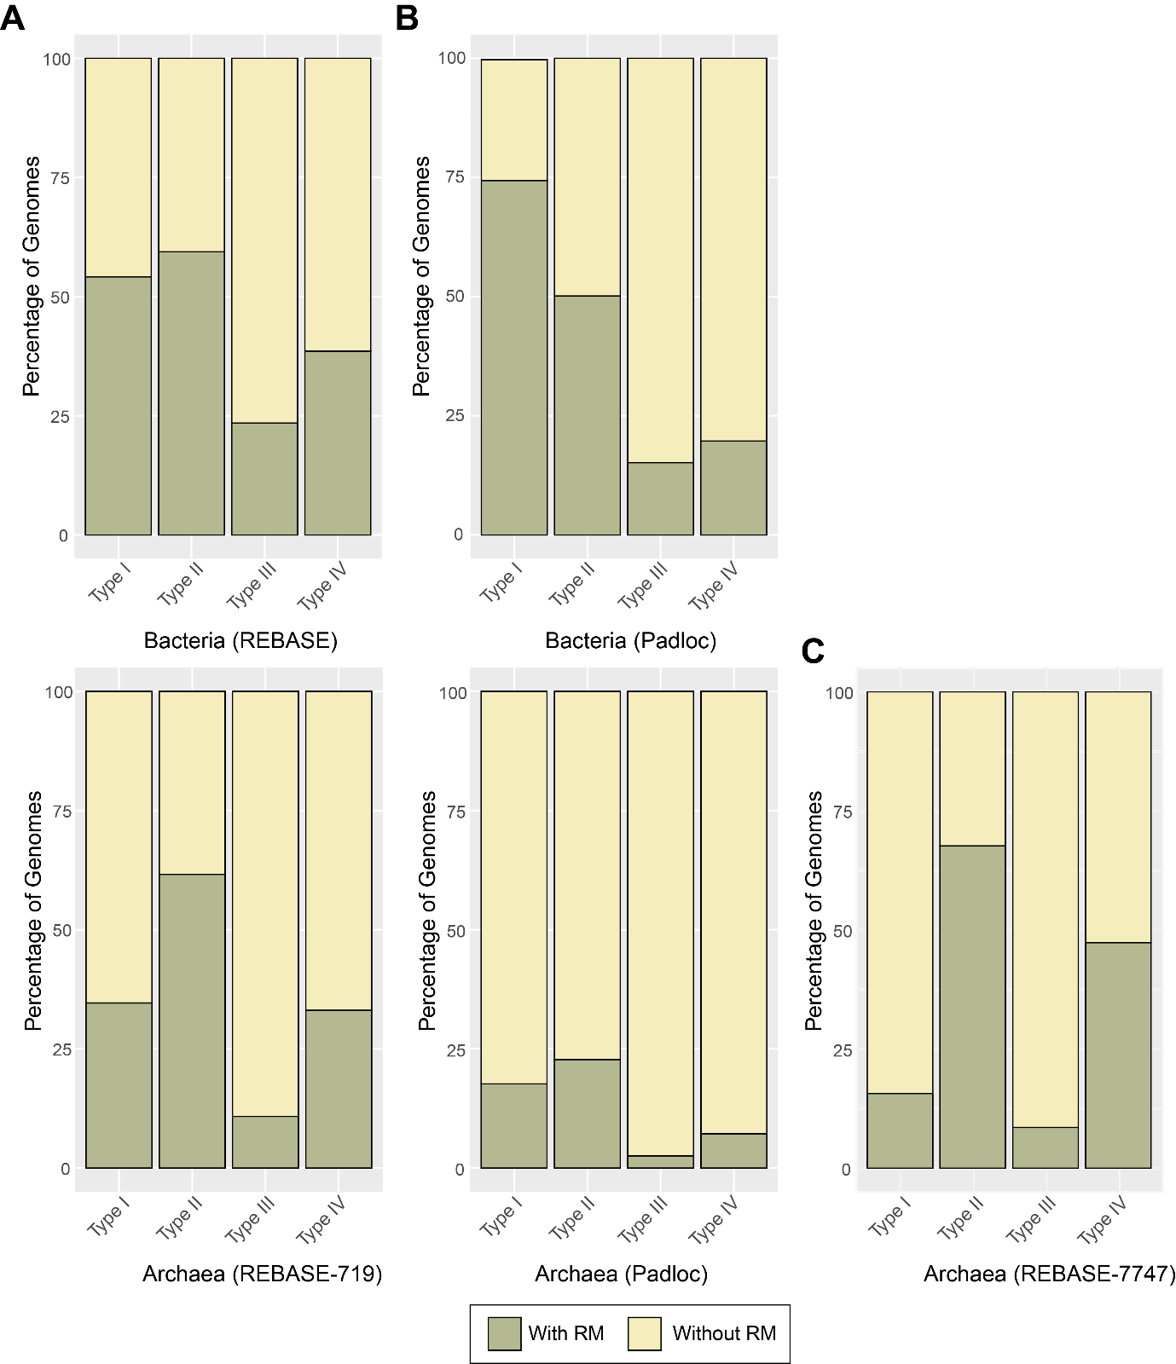
Supplementary Figure 4. Output of the restriction-modification identification approaches. Prevalence of the four types of restriction-modification systems in the genomes deposited in REBASE (Roberts et al. 2023) (A), or in the bacterial and archaeal datasets used in this work as predicted by PADLOC (B) or our homology REBASE-based approach (REBASE-7747) (C).
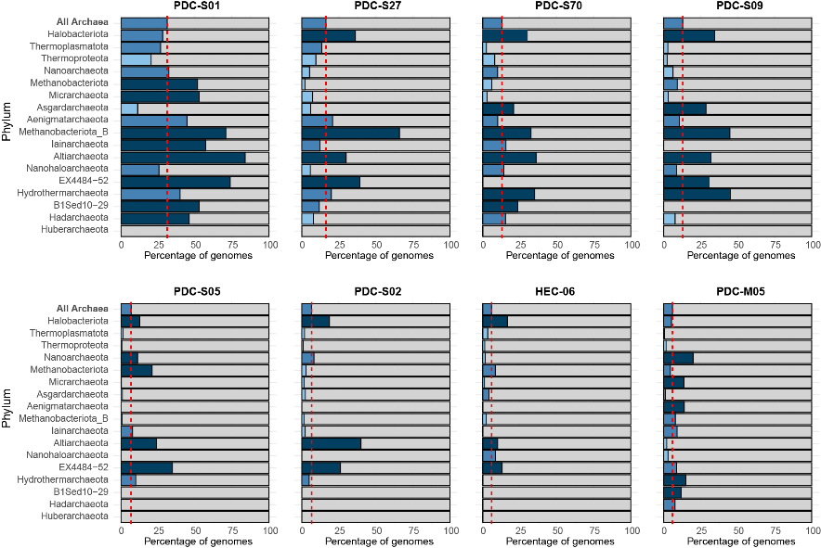
Supplementary Figure 5. Taxonomic distribution of the archaeal PDC-core defensome. PDC systems in the top 20 most prevalent archaeal antiviral systems. The bar charts represent the percentage of genomes in each phylum containing the defense system. The red line indicates the average prevalence of each defense system across all archaeal genomes. Dark blue bars indicate overrepresentation of the defense system in a given lineage, while light blue bars reflect underrepresentation relative to the average.

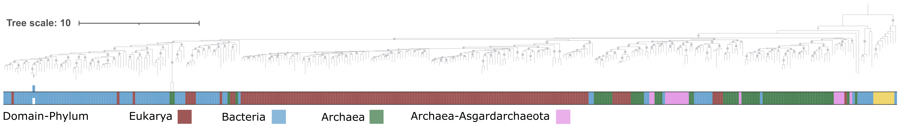
Supplementary Figure 6. Phylogenetic analysis of viperins closely related to eukaryotic viperins. Prokaryotic viperins that clustered near eukaryotic viperins in a preliminary, broad phylogenetic tree (see Methods) were extracted and re-analyzed to investigate the evolutionary origins of eukaryotic viperins. The color strip indicates taxonomic classification: blue for bacteria, red for eukaryotes, green for archaea, and pink for asgard archaea. Bootstrap support values (≥70%) are marked as dots at the corresponding nodes. Tree was rooted using MoaA sequences (yellow).

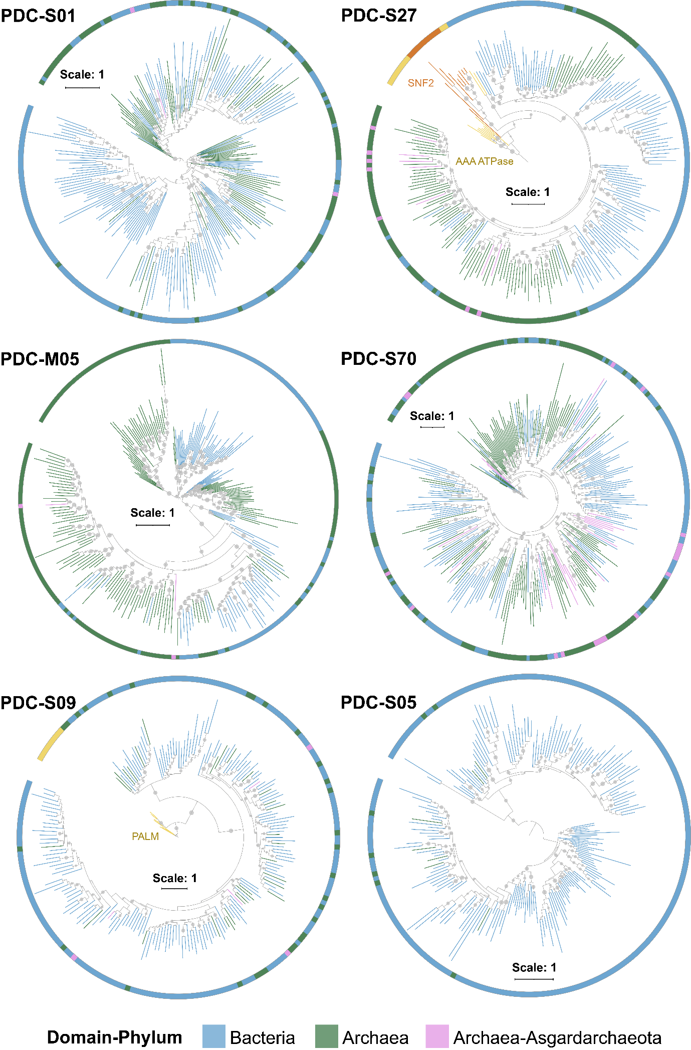

Supplementary Figure 7. Evolutionary origins of the PDC-core defensome. Phylogenetic trees of the most prevalent PDC systems in the prokaryotic core-defensome. Branch and innermost ring colors indicate taxonomic classification: blue for bacteria, red for eukaryotes, green for archaea, and pink for Asgard archaea. Bootstrap support values (≥70%) are marked as dots at the corresponding nodes. Trees were rooted at midpoint, except PDC-S27 and PDC-S09, which were rooted using AAA ATPases (PF00004), and DNA polymerase beta PALM domain (PF14792) sequences, respectively (yellow).

