Supplementary Table
Cryo-EM data acquisition and structure determination.
 | G51D Case1 | H50Q
 | (EMD-70252, PDB 9O9J) | (EMD-70253, PDB 9O9K)
Data acquisition
Electron gun | CFEG | CFEG
Detector | Falcon 4i | Falcon 4i
Energy filter slit (eV) | 10 | 10
Magnification | 165,000 | 165,000
Voltage (kV) | 300 | 300
Electron dose (e–/Å²) | 40 | 40
Defocus range (μm) | 0.6 to 1.4 | 0.6 to 1.8
Pixel size (Å) | 0.744 | 0.724
Map refinement
Symmetry imposed | C1 | C1
Initial particle images (no.) | 362549 | 618647
Final particle images (no.) | 247047 | 200126
Map resolution (Å) | 2.3 | 2.9
FSC threshold | 0.143 | 0.143
Helical twist (°) | 179.93 | 0.89
Helical rise (Å) | 2.44 | 4.73
Model refinement
Model resolution (Å) | 2.3 | 2.9
FSC threshold | 0.5 | 0.5
Map sharpening B factor (Å²) | -43.5 | -40.4
Model composition
Non-hydrogen atoms | 4296 | 2835
Protein residues | 632 | 430
Ligands | 0 | 0
B factors (Å²)
Protein | 62.6 | 49.9
R.m.s. deviations
Bond lengths (Å) | 0.0092 | 0.0100
Bond angles (°) | 1.65 | 1.78
Validation
MolProbity score | 0.99 | 2.26
Clashscore | 1.37 | 7.75
Poor rotamers (%) | 0.98 | 2.00
Ramachandran plot
Favored (%) | 97.33 | 87.50
Allowed (%) | 2.67 | 12.50
Disallowed (%) | 0 | 0

Extended Data Figures
Extended Data Figure 1
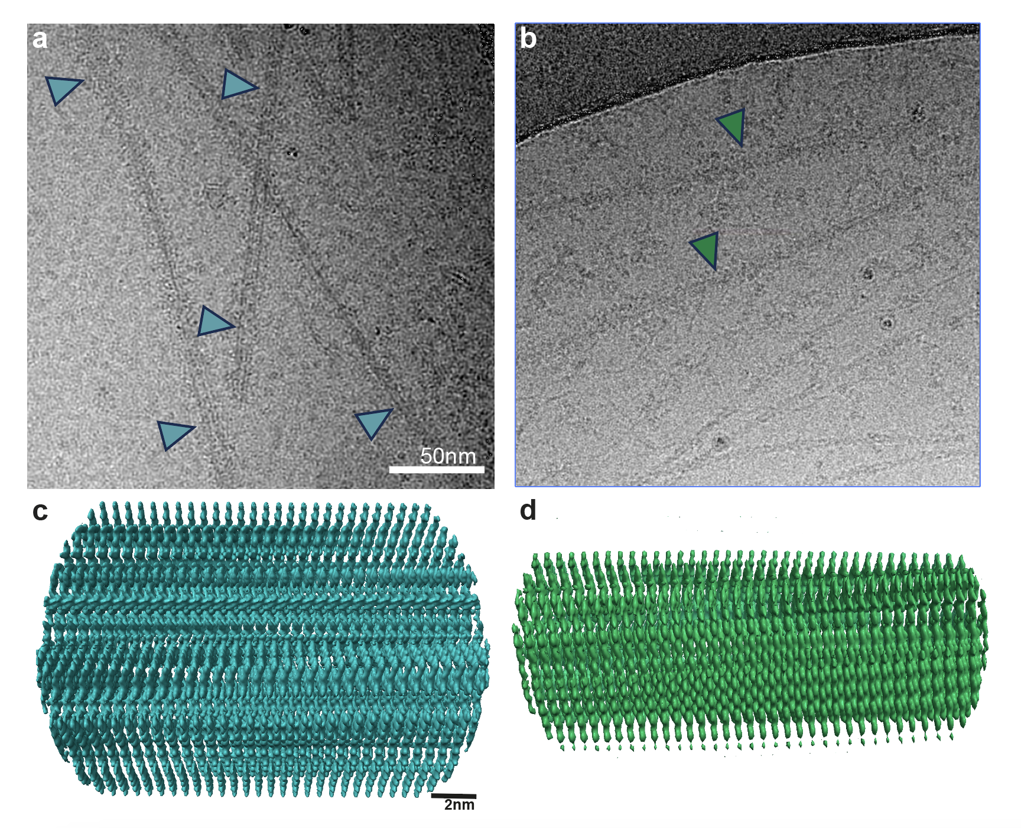
Cryo-EM images and reconstructions of α-synuclein filaments from cases with variants G51D and H50Q
a, Micrograph of α-synuclein filaments from G51D indicated by cyan arrowheads. Scale bar, 50 nm.
b, Micrograph of α-synuclein filaments from H50Q indicated by green arrowheads.
c,d, Side views of the reconstructed G51D (c) and H50Q (d) α-synuclein filaments.

Extended Data Figure 2
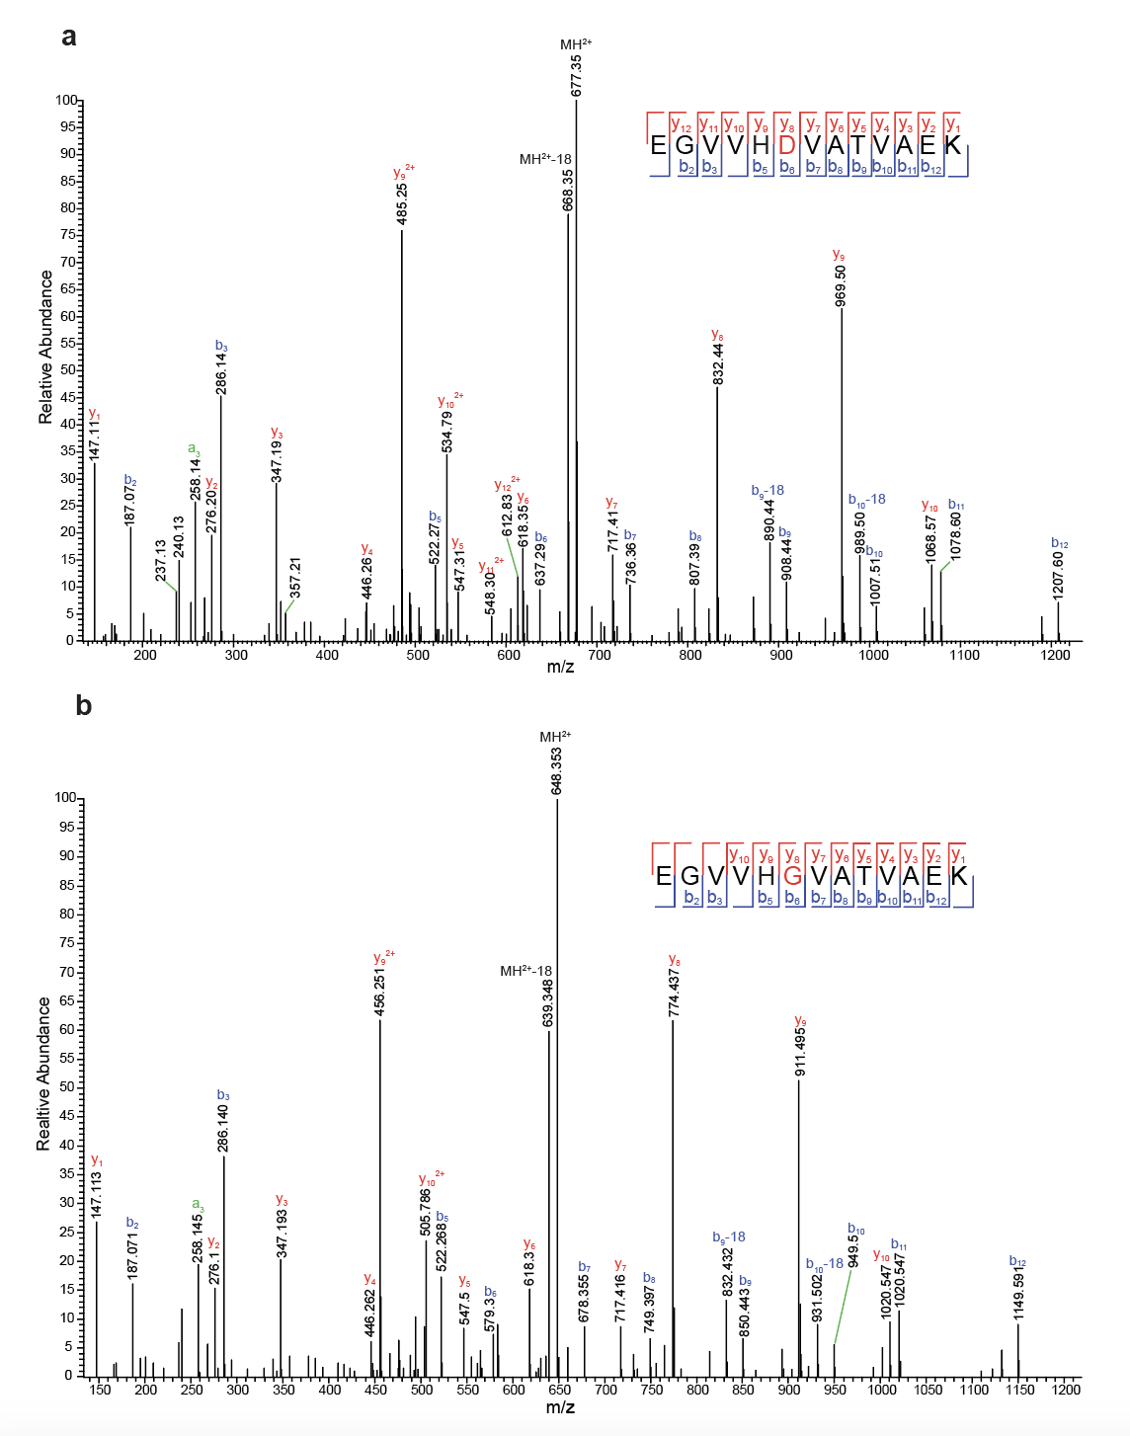
Mass spectrometry of sarkosyl-insoluble extracts from the frontal cortex of case 1 with mutation G51D
Peptide sequences are shown at the top of each panel, together with collision-induced fragmentation patterns; b ions (N-terminal) and y ions (C-terminal) are generated during peptide fragmentation. Doubly charged ions are labelled “2+”. The ions that have a neutral loss are shown in green. Pyroglutamate-modified ions are labelled “-18”.
a, MS/MS spectrum of the mutant α-synuclein sequence: ⁴⁵EGVVHDVATVAEK⁵⁷.
b, MS/MS spectrum of the wild-type α-synuclein sequence:
⁴⁵EGVVHGVATVAEK⁵⁷.

Extended Data Figure 3
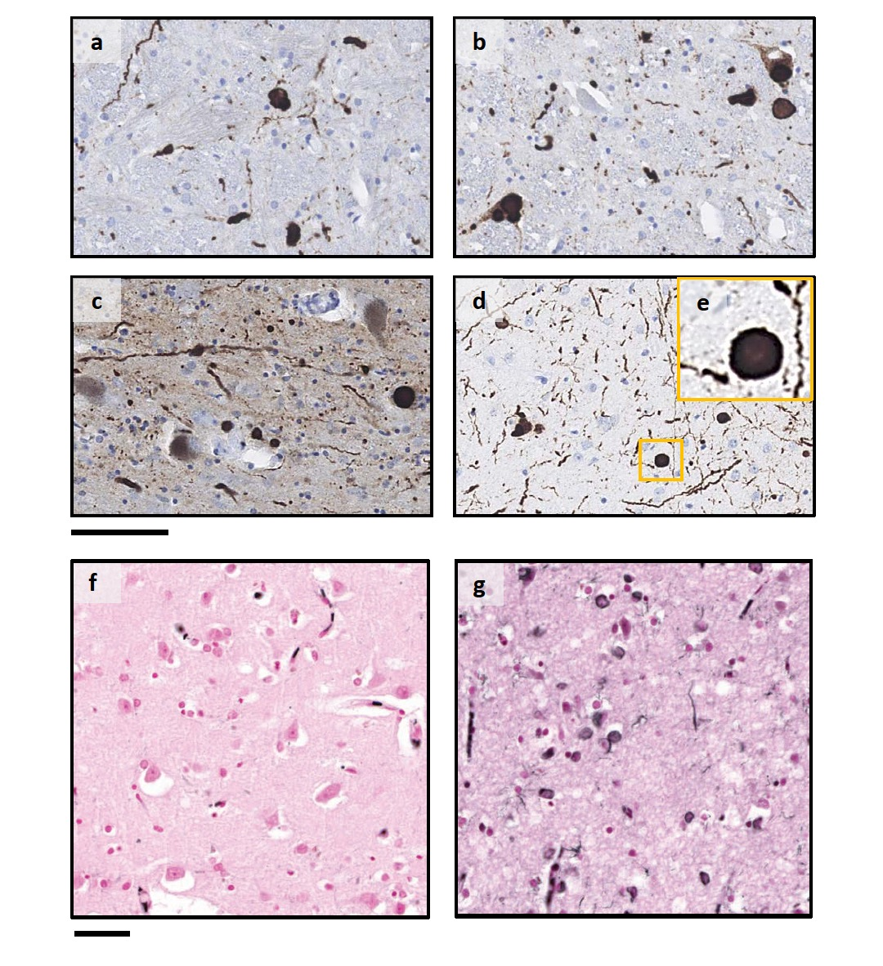
Immunostaining of α-synuclein inclusions in the brain from the H50Q case and Gallyas-Braak silver staining of the insular cortex from H50Q and G51D case 2
Sections from brain regions contralateral to those used for cryo-EM structure determination were stained with anti-α-synuclein antibody MA1-90342 (1:500). There was widespread staining in nerve cells of the dorsal medulla (a), locus coeruleus (b), substantia nigra (c) and CA4 subregion of the hippocampus (d,e). The morphology of inclusions was that of typical Lewy bodies and Lewy neurites. No Gallyas-Braak silver staining of insular cortex from the H50Q case (f), but strong staining of insular cortex from G51D case 2 (g). Scale bars: 80 μm (a-d); 20 μm (e); 50 μm (f,g).

Extended Data Figure 4
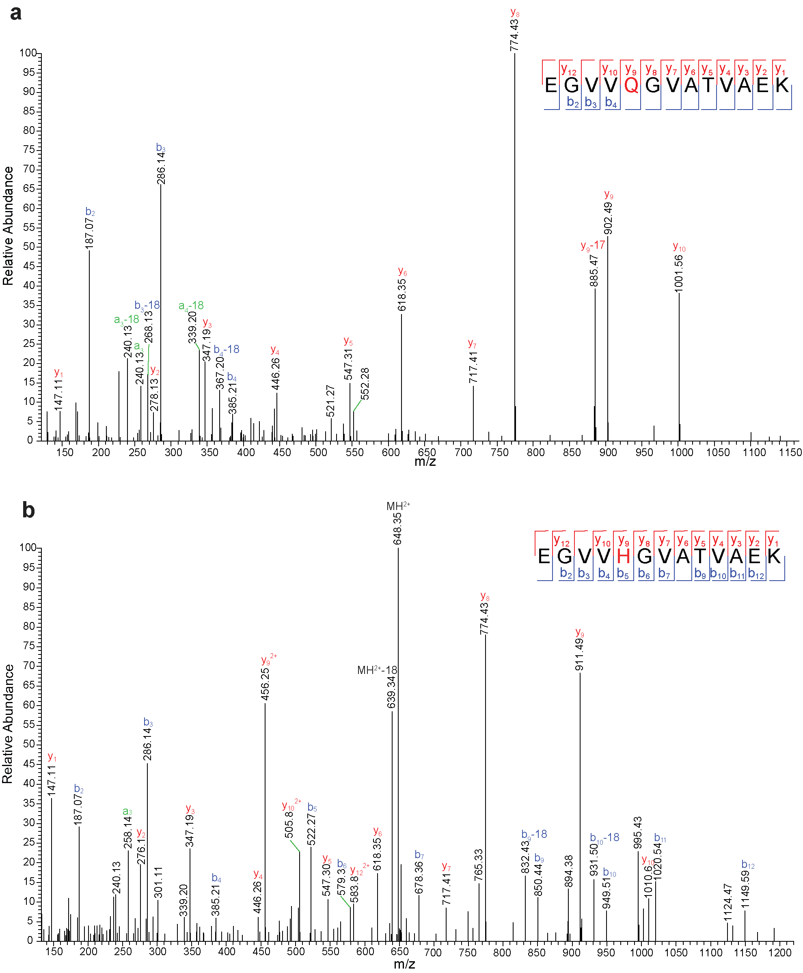
Mass spectrometry of sarkosyl-insoluble extracts from the amygdala of the case with variant H50Q
Peptide sequences are shown at the top of each panel, together with collision-induced fragmentation patterns; b ions (N-terminal) and y ions (C-terminal) are generated during peptide fragmentation. Doubly charged ions are labelled “2+”. The ions that have a neutral loss are shown in green. Pyroglutamate-modified ions are labelled “+18”.
a, MS/MS spectrum of mutant α-synuclein sequence: ⁴⁵EGVVQGVATVAEK⁵⁷.
b, MS/MS spectrum of wild-type α-synuclein sequence:
⁴⁵EGVVHGVATVAEK⁵⁷.

Extended Data Figure 5
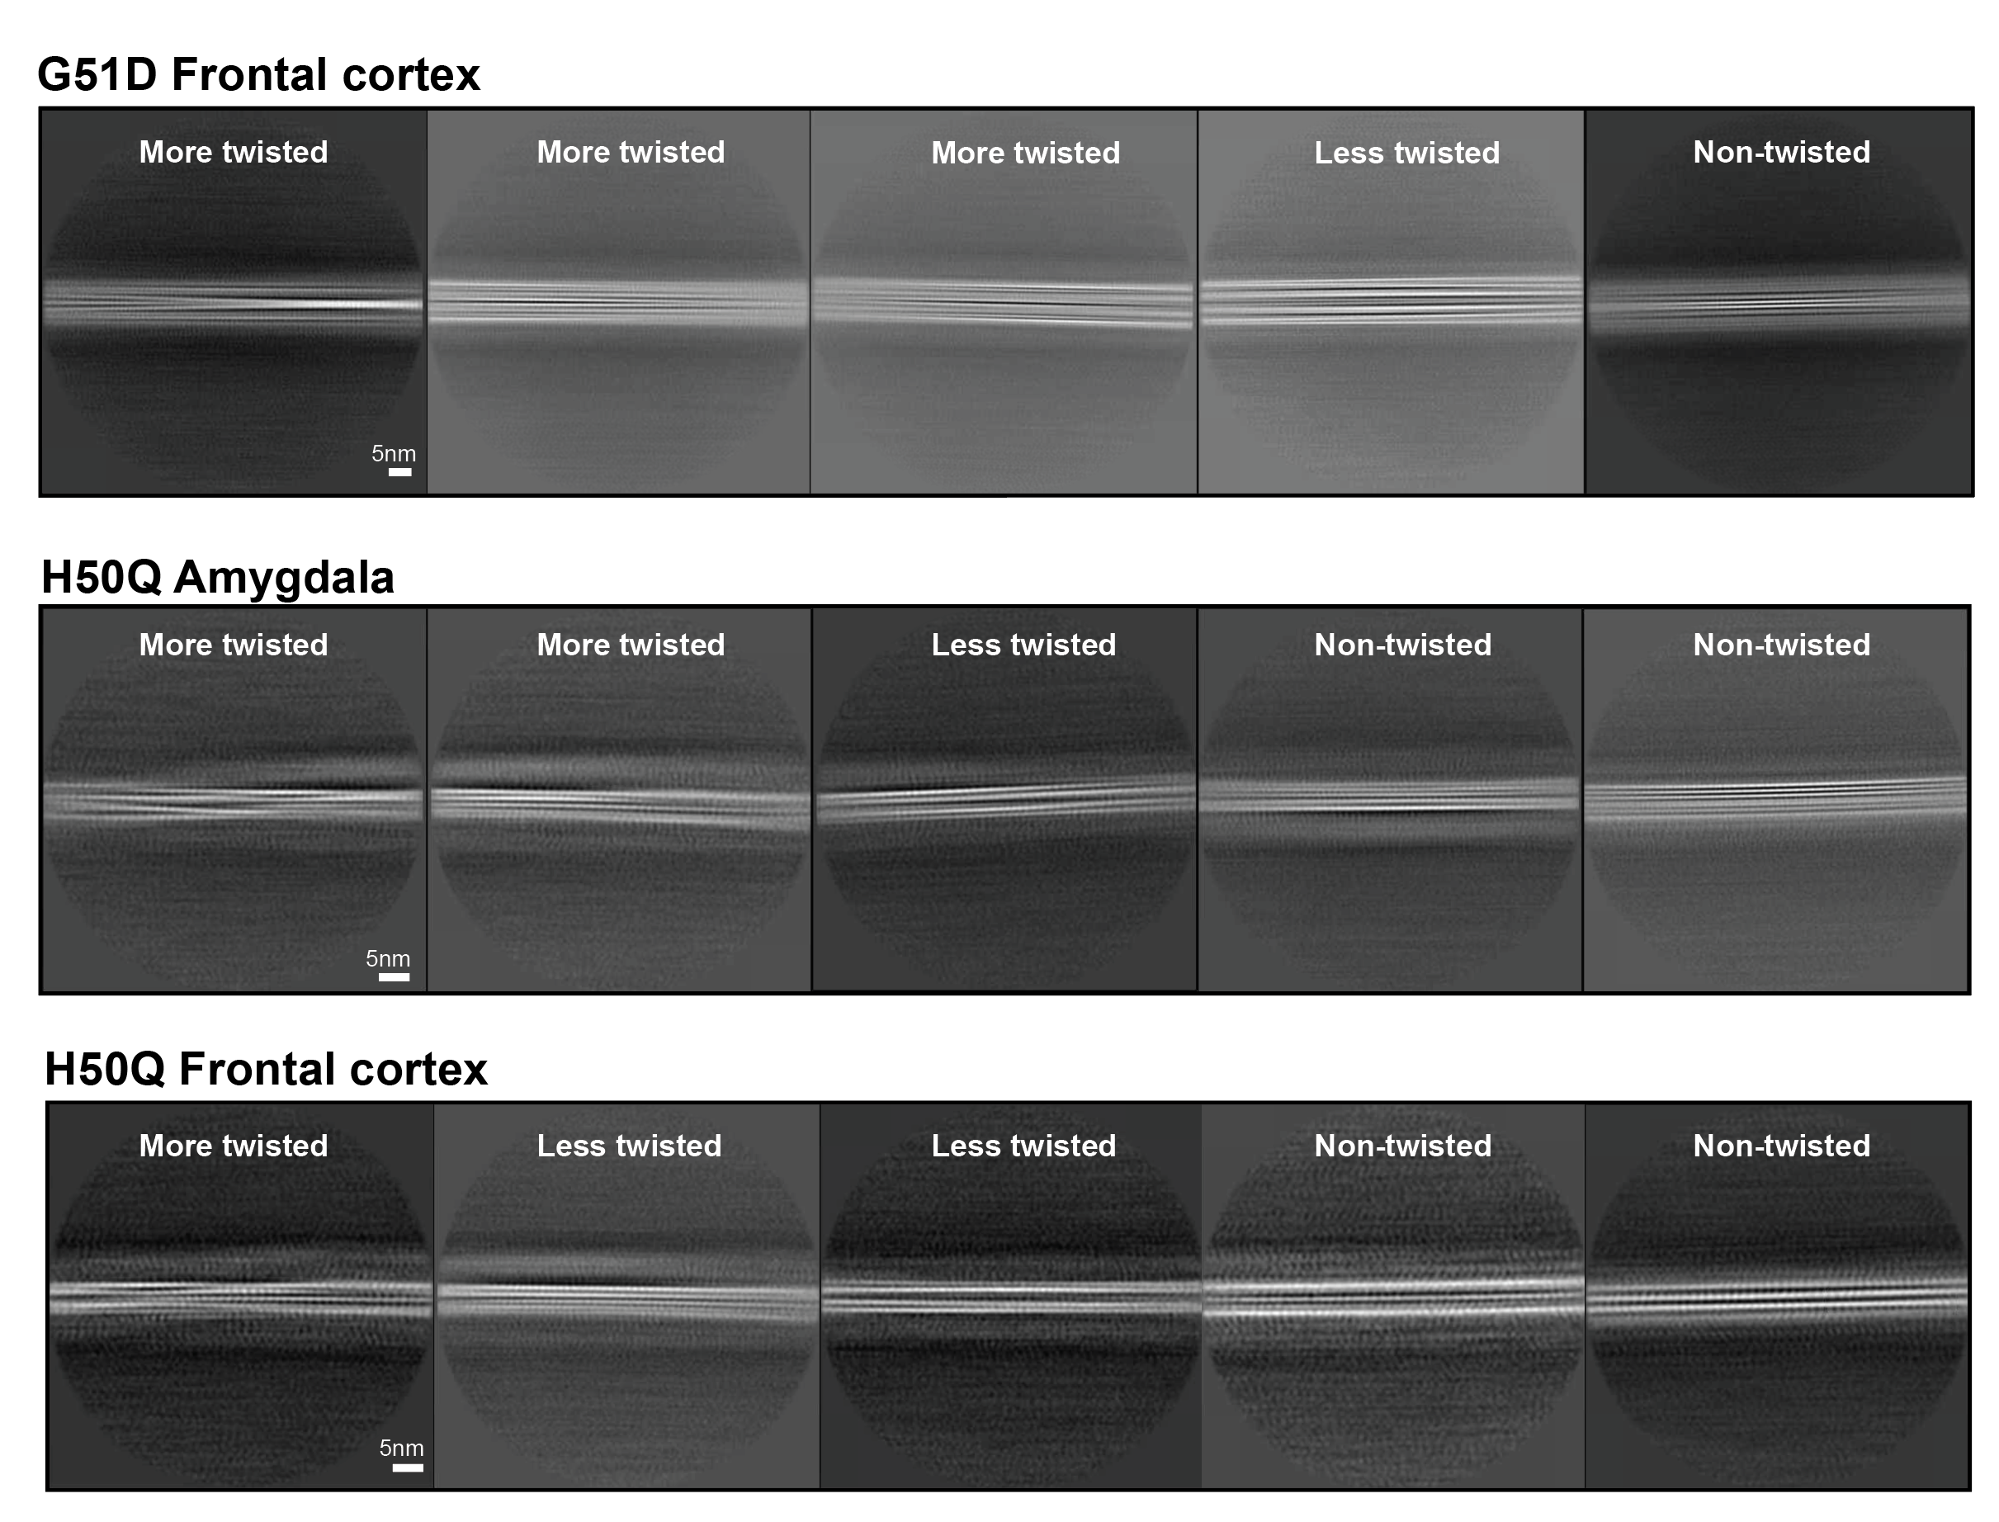
Two-dimensional (2D) class averages of G51D and H50Q α-synuclein filaments
a, Representative 2D class averages of G51D cryo-EM images from the frontal cortex. The box size is 860Å.
b, Representative 2D class averages of H50Q cryo-EM images from the amygdala. The box size is 640Å.
c, Representative 2D class averages of H50Q cryo-EM images from the frontal cortex. The box size is 640Å. Scale bars, 5 nm.

Extended Data Figure 6
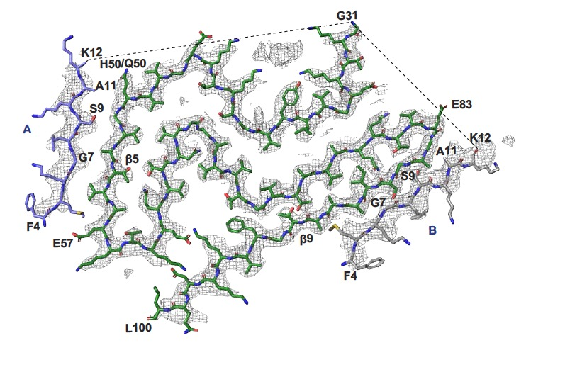
Model of the Lewy fold with both islands assigned N-terminal sequences
Island A (in blue) and island B (in grey) are assigned to the same sequence ⁴FMKGLSKAK¹². Core regions are in green and map densities in transparent grey. The N- and C-terminal residues are labelled.

