Supplementary Materials for
Decreased expression of T-cell-associated immune markers predicts poor prognosis in patients with advanced follicular lymphoma received rituximab plus bendamustine

Shinya Rai¹*, Hiroaki Inoue¹, Kazuko Sakai², Hitoshi Hanamoto³, Mitsuhiro Matsuda⁴, Yasuhiro Maeda⁵, Takahiro Haeno¹, Yosaku Watatani¹, Takahiro Kumode¹, Kentarou Serizawa¹, Yasuhiro Taniguchi¹, Chikara Hirase¹, J. Luis Espinoza¹, Yasuyoshi Morita¹, Hirokazu Tanaka¹, Takashi Ashida¹, Yoichi Tatsumi¹, Kazuto Nishio², and Itaru Matsumura¹

*Corresponding author. Email: rai@med.kindai.ac.jp

The PDF file includes:
Supplemental Fig 1.
Supplemental Fig 2.
Supplemental Fig 3.
Supplemental Fig 4.

Supplementary Table 1.
Supplementary Table 2.
Supplementary Table 3.

Supplementary Fig. 1.
Clinical outcomes in this study.
(a)Kaplan-Meier curves for progression-free survival and (b) overall survival in the cases in this study. (c)Kaplan-Meier curves for progression-free survival and (d) overall survival in OR-group and nOR-group. Log-rank p-values are shown in the graphs.

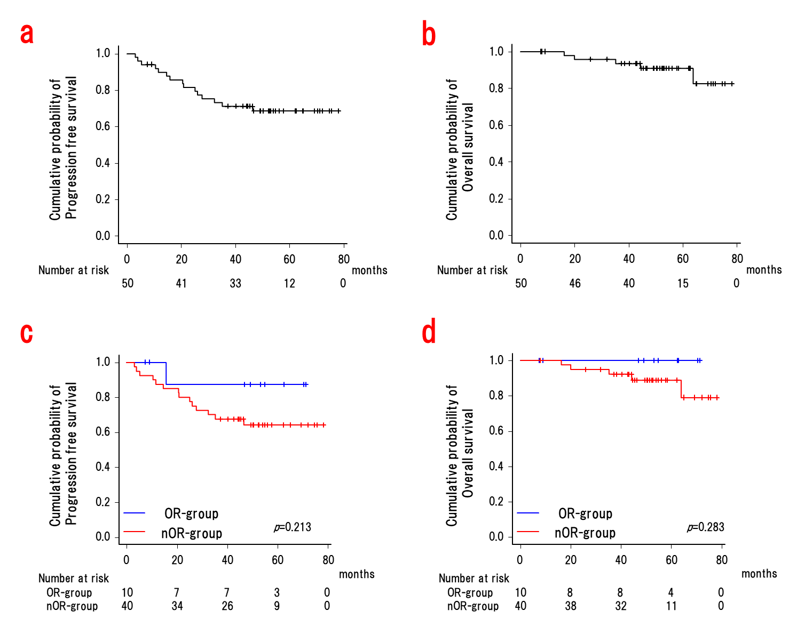

Supplementary Fig. 2.
Positions and types of somatic mutations encoded in each gene.

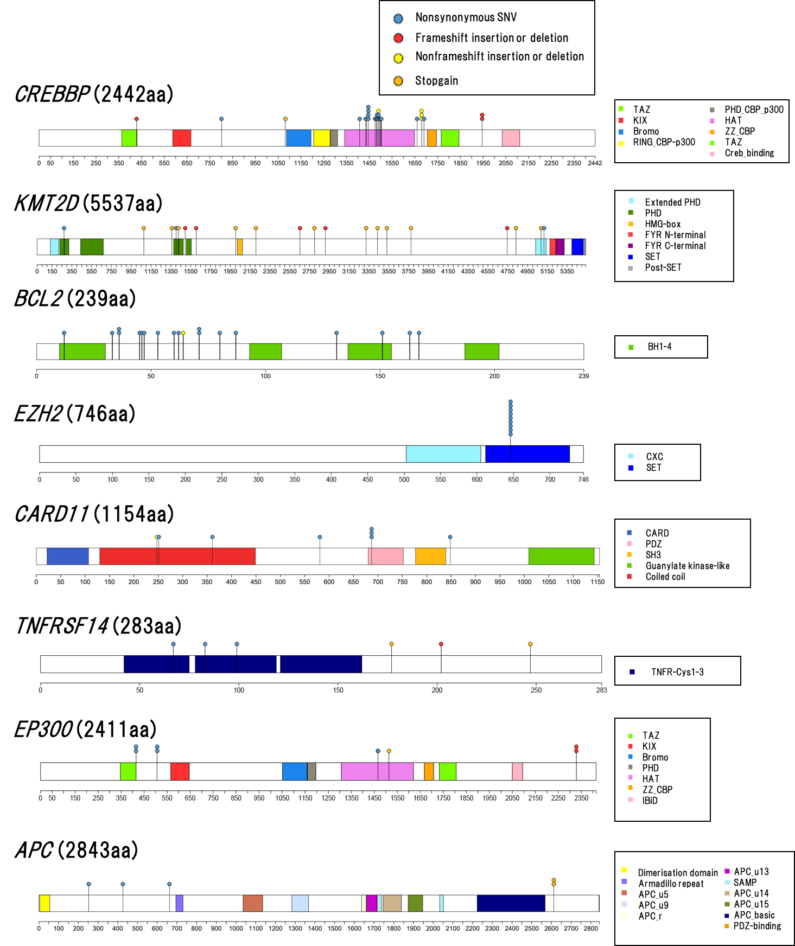

Supplementary Fig. 3.
The gene expression levels of each gene in the 23-gene expression-based predictor in the cases with and without POD24. In box plots, the center line and lower and upper hinges correspond to the median, and the first and third quartiles (25 and 75 percentiles), respectively. The upper and lower whiskers extend from the upper and lower hinges to the largest or smallest values no further than 1.5× inter-quartile range from the hinges.

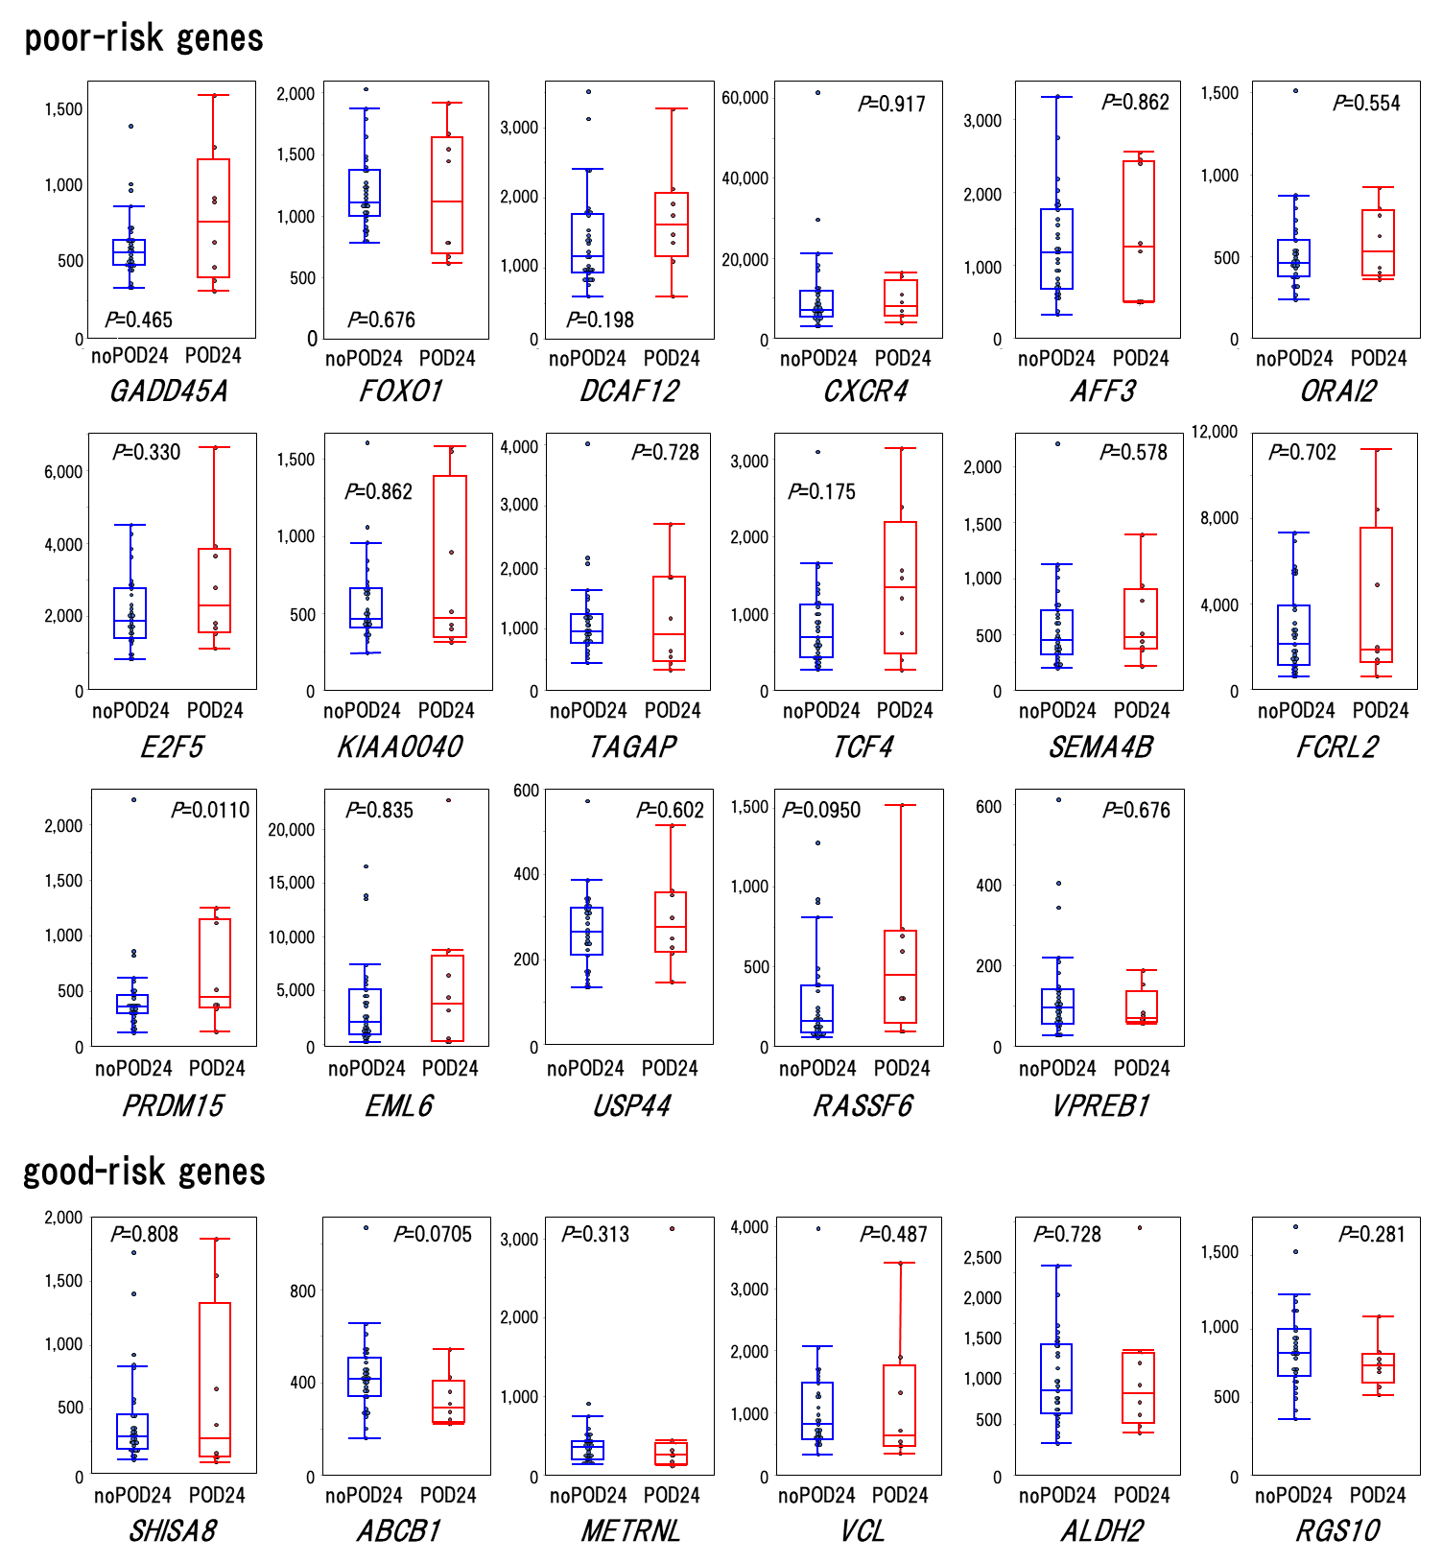

Supplementary Fig. 4.
The gene expression levels of each gene in the T-cells-associated gene in the cases with and without POD24. In box plots, the center line and lower and upper hinges correspond to the median, and the first and third quartiles (25 and 75 percentiles), respectively. The upper and lower whiskers extend from the upper and lower hinges to the largest or smallest values no further than 1.5× inter-quartile range from the hinges.

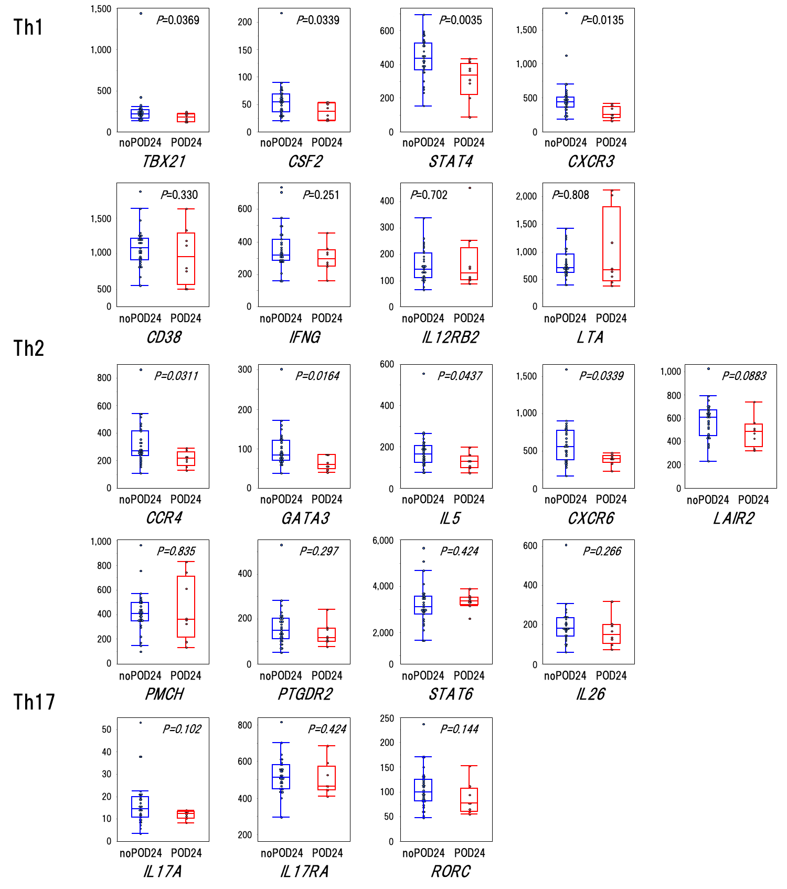

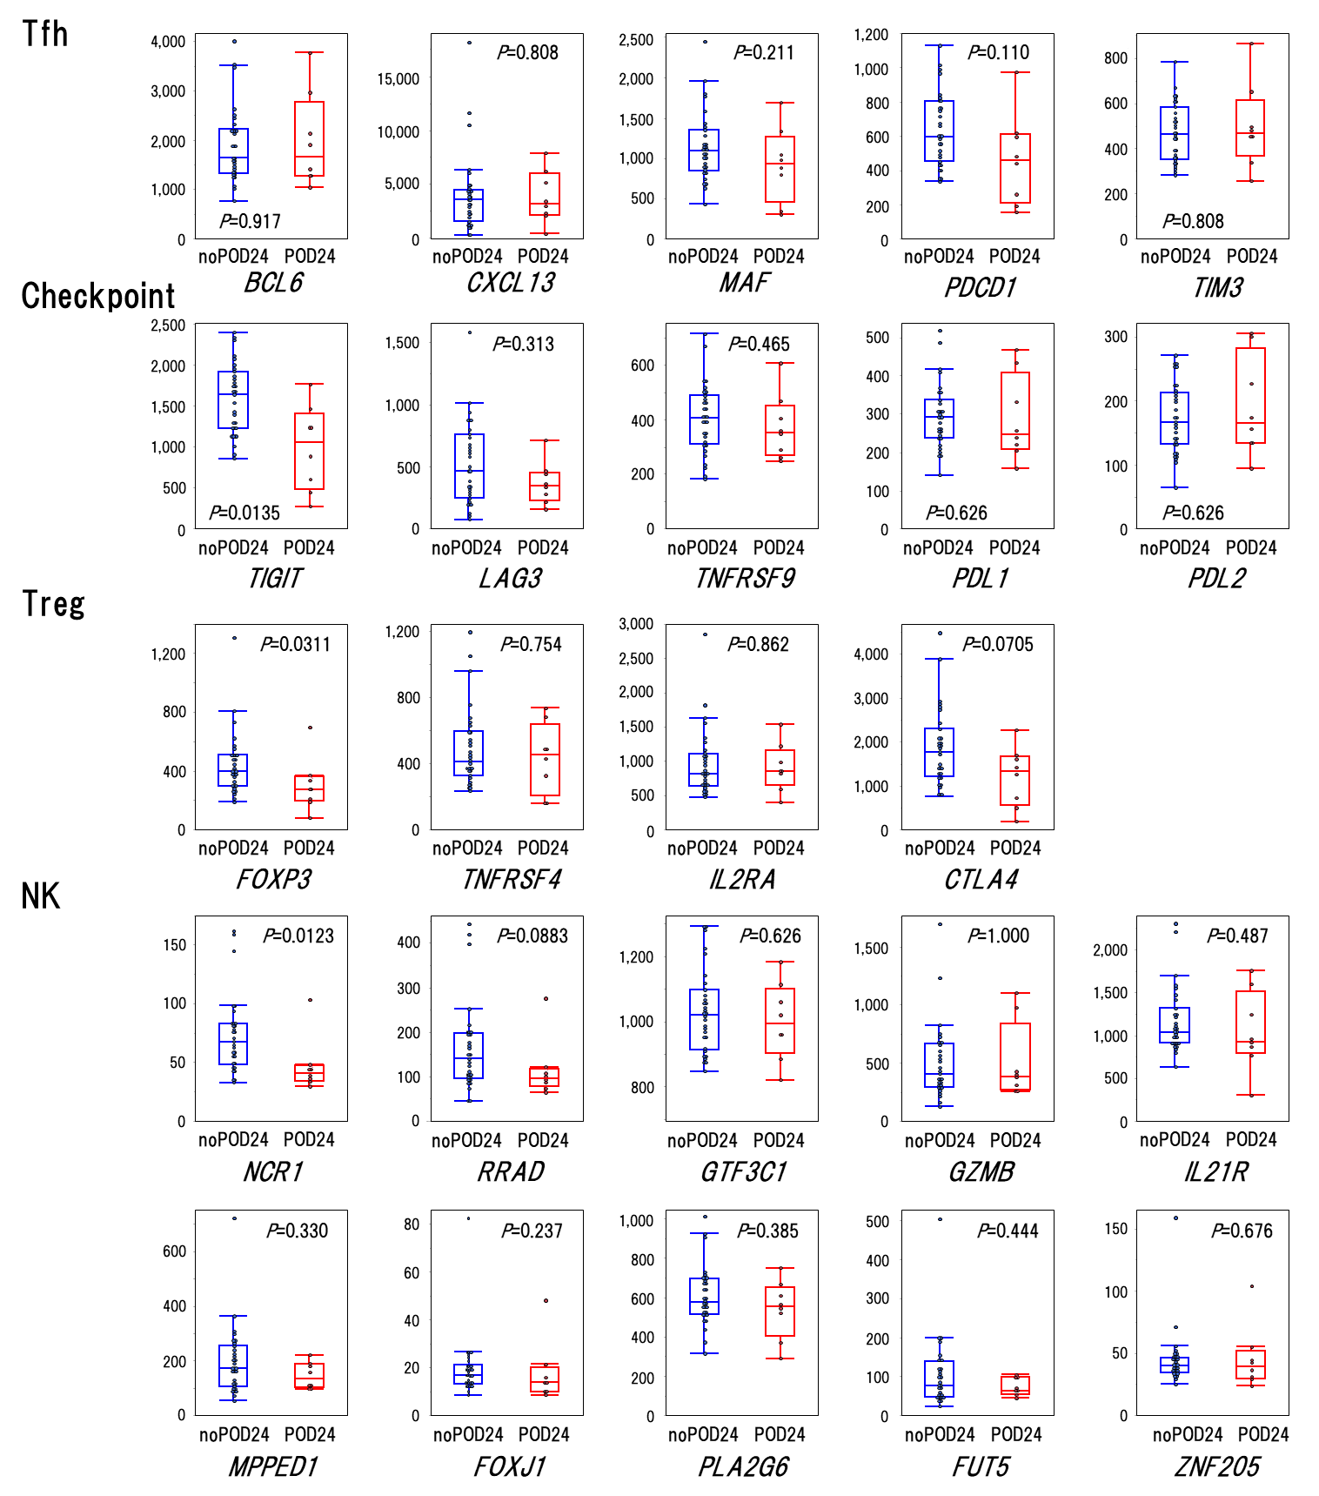

Supplementary Table 1.
Gene contents of Oncomine Tumor Mutation Load Assay
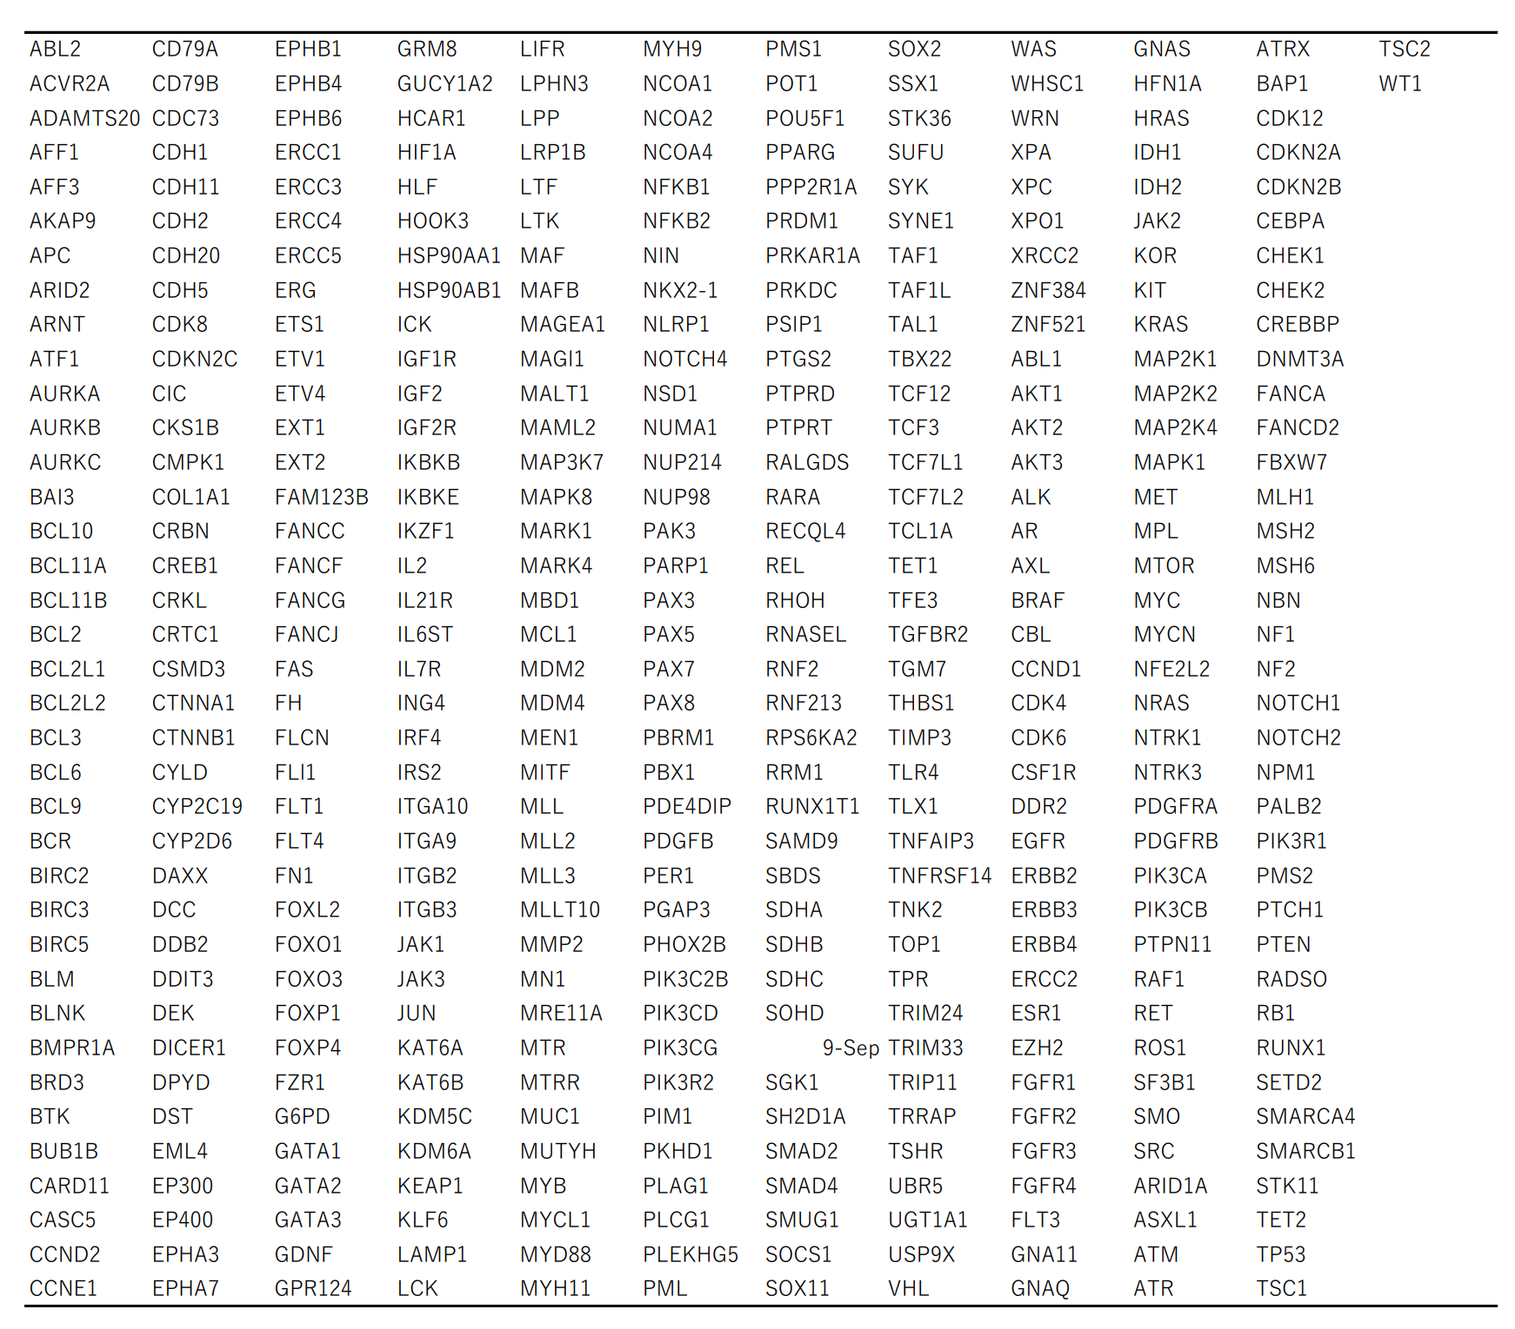

Supplementary Table 2.
The sequences of the PCR primers used in this study.
Exon2 of MEF2B forward: 5’-GACAGAGGAGAGGTGTGAGGC-3
Exon2 of MEF2B freverse: 5’-AAAGGCTGACATGGCATCAG-3
Exon3 of MEF2B forward: 5’-GCATGTTCGAGGAAGGGTTAG-3
Exon3 of MEF2B reverse: 5’-TAAAGCACGTCAGCCACAAAG-3

Supplementary Table 3.
Gene list of the customized PanCancer immune-profiling panel.

