Supplementary Appendix 1
The training was performed on a personal computer equipped with two GeForce GTX1080Ti (NVIDIA) graphics processing units. Python version 3.6.12 and Pytorch framework were used for the training. The networks were trained using the Adam Optimizer method with a binary cross-entropy loss function and the learning rate was set to 10⁻⁴. The batch size was set to 64. Other hyperparameters tuning (such as weight initialization and dropout for regularization) were randomly searched and automatically executed in the validation set. To reduce the likelihood of over-fitting, strategies included L2 regularization (with a weight decay of 0.0005) and early stopping. We trained the model for up to 100 epochs and the model with the lowest validation loss was selected.
The ROI (32×32×32 pixel) of each patient were fed into the ResNet-18 network as inputs. ResNet-18 consists of 17 convolutional layers and one fully connected layer. Through processing by a sequence of convolution and pooling layers, the WHO/ISUP nuclear grade of ccRCC could be obtained from the last full-connection layer of the DL network. The abovementioned DL model was performed on UP, CMP and NP phases, respectively, thus acquiring corresponding three single phase-based predict results.

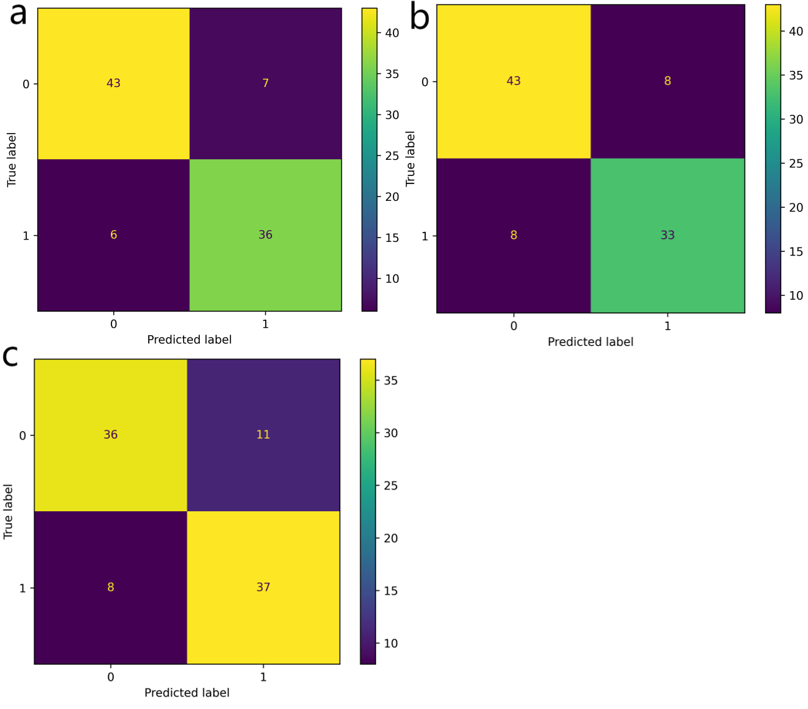
Figure A1. a, b and c are confusion matrices of the 3D ResNet-18 deep learning models based on CMP, NP and UP images in the testing set. A total of 92 patients are included, with 41 patients of high-grade ccRCC (labeled 1) and the remaining 51 patients of low-grade ccRCC (labeled 0).

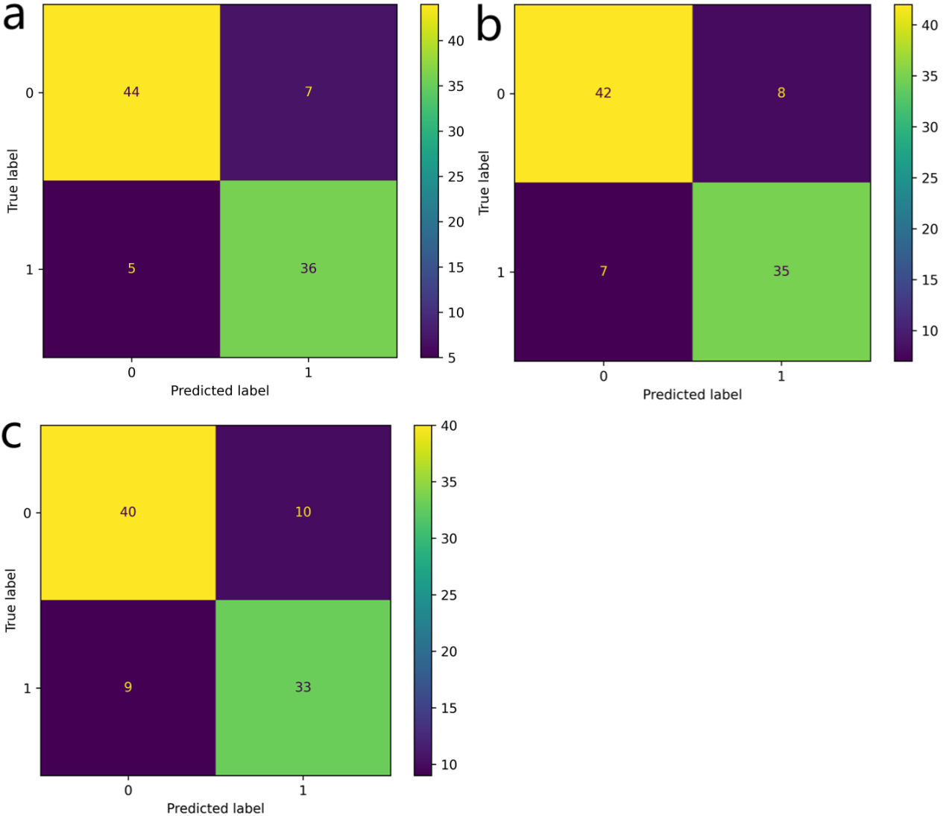
Figure A2. a, b, and c are confusion matrices of the 2D ResNet-18 deep learning models based on CMP, NP and UP images in the testing set. A total of 92 patients are included, with 41 patients of high-grade ccRCC (labeled 1) and the remaining 51 patients of low-grade ccRCC (labeled 0).

Table A1: The Details on three CT scanners.
Product name | Tube voltage | Tube current | Slice thickness | Detector collimation | Image matrix | Gantry rotation time
64-slice spiral CT (General Electric Company, America) | 120 kvp | 180 mAs | 5 mm | 64 * 0.6 mm | 512 * 512 | 0.8 s
64-slice spiral CT (Siemens, Germany) | 100 kvp | 205 mAs | 5 mm | 64 * 0.6 mm | 512 * 512 | 0.5 s
256-slice spiral CT (General Electric Company, America) | 100-110 kvp | 180 mAs | 5 mm | 64 * 0.6 mm | 512 * 512 | 0.8 s

Table A2: Patient demographics and characteristics of ccRCC in training and testing set.
Variable | Training set (n=214) |  |  | Testing set (n=92)
Variable | low-grade ccRCC (n=114) | high-grade ccRCC (n=100) | P-value | low-grade ccRCC  (n=51) | high-grade ccRCC  (n=41) | P-value
Age (year), M (IQR) | 56.0  (49.0, 67.0) | 60.0  (52.3, 66.8) | 0.207 | 55.0  (46.0, 64.0) | 56.0  (49.5, 67.0) | 0.309
Sex (n, %) |  |  | 0.021 |  |  | 0.872
Male | 66 (57.9) | 73 (73) |  | 29 (56.9) | 24 (58.5)
Female | 48 (42.1) | 27 (27) |  | 22 (43.1) | 17 (41.5)
Tumor diameter (cm), M (IQR) | 3.8 (2.9, 5.0) | 6.0 (4.3, 7.9) | 0.000 | 3.9 (2.9, 5.5) | 6.4 (5.0, 8.3) | 0.000
Tumor diameter, (n, %) |  |  | 0.000 |  |  | 0.001
≤4cm | 66 (57.9) | 24 (24) |  | 26 (51.0) | 7 (17.1)
>4cm | 48 (42.1) | 76 (76) |  | 25 (49.0) | 34 (82.9)
Side (n, %) |  |  | 0.841 |  |  | 0.589
Right | 54 (47.4) | 46 (46) |  | 29 (56.9) | 21 (51.2)
Left | 60 (52.6) | 54 (54) |  | 22 (43.1) | 20 (48.8)
Note: ccRCC, clear cell renal cell carcinoma; M, median; IQR, inter-quartile range

