Copyright Transfer Agreement

The Asian Surgical Association (“the Proprietor”) will be pleased to publish your article (“the Work”),tentatively entitled

Dual primary cancers of skin cancer and lung cancer：A case report

in the Asian Journal of Surgery (“the Journal”) if the Work is accepted for publication. The undersigned authors transfer all copyright ownership in and relating to the Work, in all forms and media, to the Proprietor in the event that the Work is pub- lished. However, this agreement will be null and void if the Work is not published in the Journal.
The undersigned authors warrant that the Work is original, is not under consideration by another journal, and has not been previously published.
(This agreement must be signed by all authors. A photocopy of this form may be used if there are more than 10 authors.)

Author’s  Bowei  He | Name | & | Signature  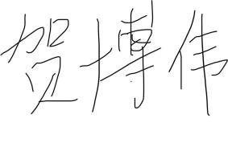 | Date  December 22, 2024
Author’s  Hanbing  Zhang | name | & | Signature  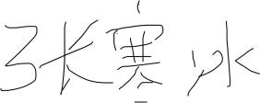 | Date  December 22, 2024
Author’s  Yu Guo | name | & | Signature  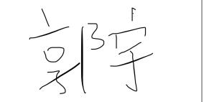 | Date  December 24, 2024
Author’s  Yongbin  Song | name | & | Signature  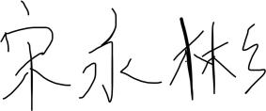 | Date
Author’s name & signature
Date

Author’s | name | & | signature | Date
Author’s | name | & | signature | Date
Author’s | name | & | signature | Date
Author’s | name | & | signature | Date
Author’s name & signature
Date

