Trajectory of thirst level in critically ill oncology patients based on group-based trajectory model

Supplementary Appendix

Appendix1.Thirst assessment tool: Critically Ill Patients’ Thirst Assessment Scale(CIP-TAS)

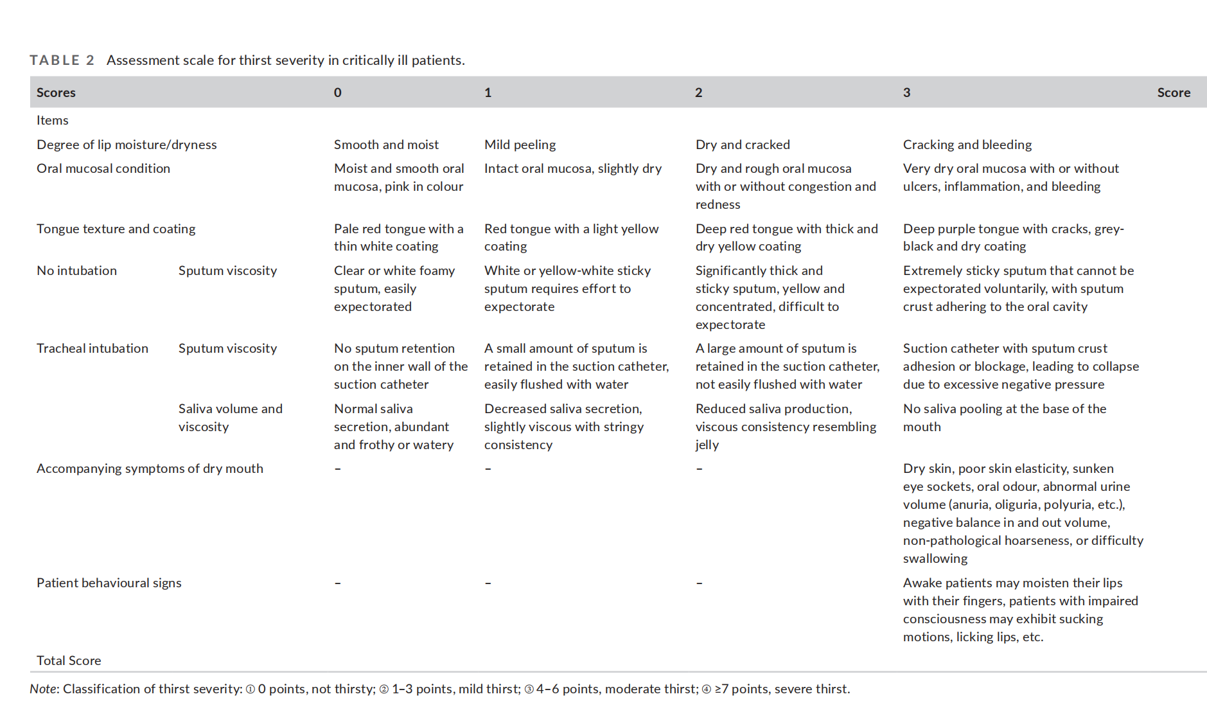

Appendix 2. Multivariate logistic regression model

Table 1 Model fit information
model | model fit condition | likelihood ratio test
model | -2 log-likelihood | chi-square | df | significance
intercept only | 479.877
outcome | 442.884 | 36.994 | 21 | .017
Note: p=0.17<0.05 indicated that the model has applicability.

Table 2 Goodness of fit
 | chi-square | df | significance
Pearson | 527.203 | 534 | .575
Deviance | 442.884 | 534 | .998
Note: p=0.575>0.05 indicated that the regression has a good fit.

Table 3 likelihood ratio test
effect | model fit condition | likelihood ratio test
effect | The -2 log-likelihood of the simplified model | chi-square | df | significance
intercept | 442.884ª | .000 | 0 | .
CRP | 448.744 | 5.860 | 3 | .119
temperature | 451.786 | 8.903 | 3 | .031
dignosis | 468.239 | 25.356 | 15 | .045

Note: The regression model indicated that temperature (p = 0.031) and diagnosis (p = 0.045) had a statistically significant influence.

