SUPPORTING INFORMATION

Large Third-Order Optical Nonlinearity for Dipolar Carbene-Metal-Amide Material with Two-Photon Excited Delayed Fluorescence

Ikechukwu D. Nwosu, Lujo Matasović, Tárcius N. Ramos, Nguyen Le Phuoc, Giacomo Londi, Alexander J. Gillett, Daniel Toolan, Charles T. Smith, George F. S. Whitehead, Mireille Blanchard-Desce, Jonathan Daniel, Mikko Linnolahti, Yoann Olivier, and Alexander S. Romanov

Supporting Information Table of Contents
General Considerations 3
Experimental 4
Thermogravimetric Analysis 16
Single Crystal X-ray Crystallography 17
Cyclic Voltammetry 18
Photophysical Characterisation 19
2-Photon Absorption 23
Theoretical Calculations 27
References 35

GENERAL CONSIDERATIONS
All reactions were performed under a N₂ atmosphere. Solvents were dried as required. 2,3-dichloroquinoxaline, 3,5-dimethylaniline, and triethyl orthoformate were purchased from commercial vendors and used as received. Carbazole was prepared according to the literature procedure. ¹H and ¹³C{¹H} NMR spectra were recorded using a Bruker AVIII HD 400 MHz NMR spectrometer. ¹H NMR spectra (400 MHz) and ¹³C NMR (400 MHz) were referenced to CD₂Cl₂ at δ 5.32 ppm (¹³C, δ 53.84 ppm) or CDCl₃ at δ 7.26 ppm (¹³C, δ 77.16 ppm). Elemental analyses were performed by the Microanalysis Laboratory at the University of Manchester. Mass spectrometry data were obtained by the Mass Spectrometry Laboratory at the University of Manchester. Thermogravimetric analysis was performed with a TA Instruments SDT650 simultaneous thermal analyzer under a stream of nitrogen.
Experimental.
Synthesis and Characterization
Note that reported synthetic routes for CMA complexes require the use of strong bases such as potassium hexamethyldisilazide (KHMDS) to obtain the key precursor – Carbene-Metal-Halide (LMCl, M = Cu, Ag or Au) complex. We developed a facile synthetic route towards LMCl that involves microwave heating (μW) of the ethoxy derivative (LOEt, Scheme 2) for 2 h in the presence of the corresponding metal halides to obtain copper and gold complexes in excellent yields.

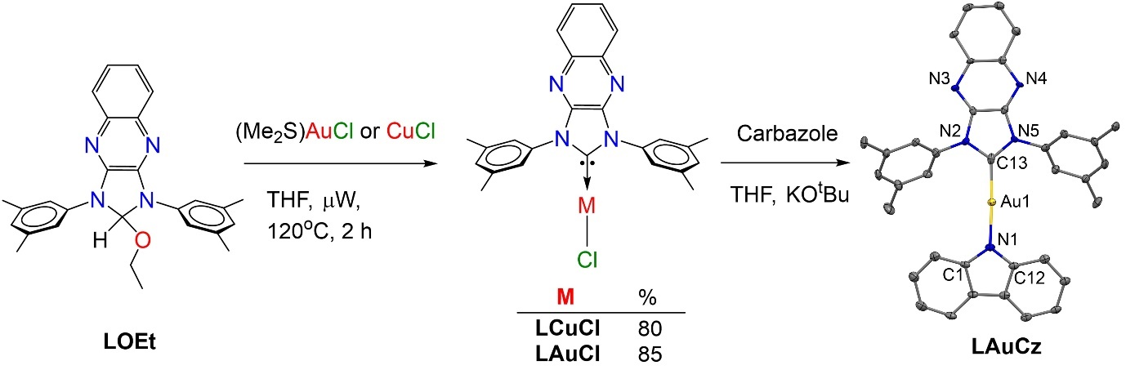
Scheme S1| Synthesis of the new CMA complex LAuCz and its crystal structure (right). Ellipsoids are shown at the 50% probability level. Hydrogen atoms are omitted for clarity.

Synthesis of (QuinIm)OEt:
An oven-dried bomb flask equipped with a stir bar was charged with 2,3-dichloroquinoxaline (6 g, 0.03 mol) and 3,5-dimethylaniline (12 ml, 0.1 mol) under nitrogen. The solution mixture was stirred for 2 hours at 145 ºC, until a yellow solid formed. Triethyl orthoformate (30 ml, 0.18 mol) and concentrated HCl (3 ml) were added, and the solution was stirred overnight at 145ºC. Thereafter, the solution was left to cool slowly to room temperature, at which crystals were formed. The solution was filtered off and the crystals were washed with pentane and dried to give the desired product as off-white crystals. Yield 94% (12 g, 0.03 mol). ¹H NMR (400 MHz, CD₂Cl₂): δ 7.76 – 7.79 (m, 6H), 7.40 – 7.43 (m, 2H), 7.25 – 7.26 (d, 1H), 6.89 (s, 2H), 3.33 – 3.39 (q, 2H), 2.42 (s, 12H), 1.06 – 1.10 (t, 3H). ¹³C{¹H} NMR (400 MHz, CD₂Cl₂): δ 143.7, 138.9, 137.4, 137.3, 126.7, 126.6, 125.6, 117.3, 96, 55.3, 21.8, 14.6.
¹H NMR (400 MHz, CDCl₃)
Figure S1. ¹H NMR (400 MHz, CD₂Cl₂)
Figure S2. ¹³C NMR (100 MHz, CD₂Cl₂)

Synthesis of LCuCl:
Method 1: A solid mixture of (QuinIm)OEt (5 g, 0.01 mol) and CuCl (1.06 g, 10.7 mmol) was added dry THF (100 ml). The solution was stirred in refluxing THF for 5 hours, during which ethanol was completely evacuated via a Dean-Stark apparatus to promote the forward reaction. The reaction mixture was cooled to room temperature and volatiles were removed under vacuum. The crude solid was washed with THF (2 x 10 ml) and pentane (3 x 10 ml) and dried under vacuum to yield the pure product as a yellow solid in 70% yield (3.94 g, 8.25 mmol).

Method 2: A dry THF solution (40 ml) of L-ethoxy (2 g, 4.71 mmol) and CuCl (424 mg, 4.28 mmol) was heated at 120ºC in a microwave synthesizer for 1 hour. The reaction mixture was cooled to room temperature and evaporated under vacuum. The resulting solid was washed with THF (2 x 10 ml) and pentane (3 x 10 ml) and dried under vacuum to yield the pure product as a yellow solid in 80% yield (1.8 g, 3.77 mmol). ¹H NMR (400 MHz, CD₂Cl₂): δ 8.26 - 8.21 (m, 2H), 7.91 – 7.87 (m, 2H), 7.55 (s, 4H), 7.31 (s, 2H), 2.51 (s, 12H). HRMS C₂₅H₂₂ClCuN₄ theoretical [M+H]⁺ = 476.0824, HRMS (APCI(ASAP): = 476.0834
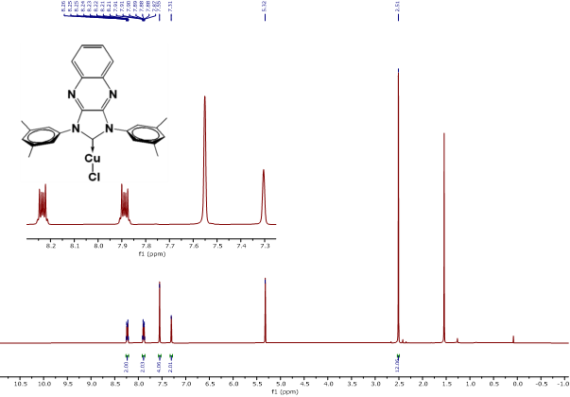
Figure S3. ¹H NMR (400 MHz, CD₂Cl₂)

Synthesis of LAuCl:
Method 1: To a solid mixture of LCuCl (1.08 g, 2.27 mmol) and chlorodimethylsulphide gold (I) (0.67 g, 2.27 mmol, 1 eq.) was added dry CH₂Cl₂ (80 ml). The solution was sonicated for 10 minutes and stirred overnight at room temperature. Volatiles were removed under reduced pressure. The product was extracted with CH₂Cl₂, filtered through silica gel, and concentrated on a rotary evaporator. The product was precipitated with hexane, centrifuged and the supernatant decanted to give a white solid, which was washed with hexane and pentane successively and dried to give the pure product as a white powder in 85% yield (1.18 g, 1.93 mmol).
Method 2: A dry THF (60 ml) solution of (QuinIm)OEt (2.98 g, 7.02 mmol) and chlorodimethylsulphide gold (I) (2.05 g, 6.94 mmol) was heated at 120ºC in a microwave synthesizer for 2 hours. The reaction mixture was cooled to room temperature and evaporated under vacuum. The product was extracted with DCM, filtered through silica gel, and concentrated on a rotary evaporator. The product was precipitated with hexane, centrifuged and the supernatant decanted to give a white solid, which was washed successively with hexane and pentane and dried to give the pure product as a white powder in 80% yield (3.43 g, 5.62 mmol). ¹H NMR (400 MHz, CD₂Cl₂): δ 8.23 - 8.19 (m, 2H), 7.91 – 7.87 (m, 2H), 7.45 (s, 4H), 7.35 (s, 2H), 2.51 (s, 12H).
¹H NMR (400 MHz, CD₂Cl₂)

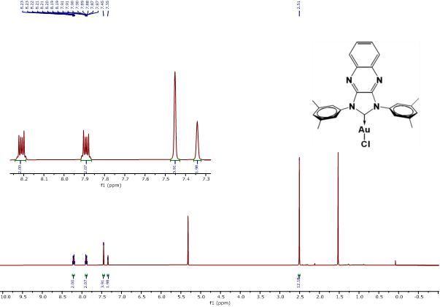
Figure S4. ¹³C NMR (CD₂Cl₂)

Synthesis of LAuCz:
An oven dried Schlenk flask was charged with (QuinoxNHC)AuCl (500 mg, 0.82 mmol), carbazole (150.5 mg, 0.9 mmol) and KO^{t}Bu (121 mg, 1.08 mmol), followed by addition of THF (60 ml) under nitrogen. The solution was stirred overnight at room temperature. Afterwards, all volatiles were removed under reduced pressure. The residue was washed with copious amounts of diethyl ether, re-dissolved in CH₂Cl₂, filtered through a 2 cm celite layer, and evaporated to dryness. The resulting solid residue was washed with small amounts of diethyl ether to give orange solids as product. Yield 75% (455 mg, 0.61 mmol).
¹H NMR (400 MHz, CD₂Cl₂): δ 8.23 – 8.28 (m, 2H,2 x o-CH Quinox), 7.97 – 7.99 (d, 2H, 2 x CH Cz), 7.89 – 7.93 (m, 2H, 2 x m-CH Quinox), 7.69 (s, 4H, 4 x o-CH dimethylPhen), 7.47 (s, 2H, 2 x p-CH dimethylPhen), 7.13 – 7.22 (m, 4H, 4 x CH Cz), 6.96 – 7.00 (m, 2H 2 x CH Cz), 2.60 (s, 12H, 4 x CH₃ dimethylPhen).
¹³C NMR (400 MHz, CD₂Cl₂): δ 193.3 (C:), 149.3 (NCN Quinox-C-Im), 140.4 (CNAu, Cz), 140.2, 139.8, 135.6, 131.9, 130.2, 129.1, 124.9, 124, 123.7, 119.4, 116.5, 113.5, 21.3 (CH₃).
CD₂Cl₂
H₂O
*
Figure S5. ¹H NMR (400 MHz, CD₂Cl₂)
Figure S6. ¹³C NMR (100 MHz, CD₂Cl₂)

Thermogravimetric Analysis.
Figure S7. TGA curve for LAuCz. Decomposition temperature (T_{d}) indicates the temperature at 5% weight loss.

X-Ray Crystallography.
Crystals suitable for X-ray diffraction study were obtained by slow layer diffusion of hexanes/petroleum ether into dichloromethane solution for LAuCz at room temperature. Crystals were mounted in oil on a MiTeGen loop and fixed on the diffractometer in a cold nitrogen stream. Data were collected using dual wavelength Rigaku FR-X rotating anode diffractometer using CuKα (λ = 1.54146 Å) radiation, equipped with an AFC-11 4-circle kappa goniometer, VariMAXTM microfocus optics, a Hypix-6000HE detector and an Oxford Cryosystems 800 plus nitrogen flow gas system, at a temperature of 100K. Data were collected and reduced using CrysAlisPro v42., Absorption correction was performed using empirical methods (SCALE3 ABSPACK) based upon symmetry-equivalent reflections combined with measurements at different azimuthal angles. Molecules of LAuCz experiences a static disorder of the carbazolide ligand with equal occupancies over two positions. Structures were solved by direct method/intrinsic phasing and refined by the full-matrix least-squares against F². All non-hydrogen atoms were refined with anisotropic atomic displacement parameters. All hydrogen atoms were positioned geometrically and constrained to ride on their parent atoms with C-H = 0.95-1.00 Å, and U_{iso} = 1.2−1.5 U_{eq} (parent atom). All calculations were performed using the SHELXL software and Olex2 graphical user interface.^{2,}
Complex LAuCz, CCDC number 2431742, C₃₉H₃₄AuCl₄N₅ (M =911.48 g/mol). Monoclinic, space group P2₁/c (no. 14), a = 7.4874(2) Å, b = 17.5679(7) Å, c = 27.6166(9) Å, β = 96.442(3)°, V = 3609.7(2) Å³, Z = 4, T = 100.00(10) K, μ(Cu Kα) = 10.666 mm⁻¹, Dcalc = 1.677 g/cm³, 11870 reflections measured (5.974° ≤ 2Θ ≤ 158.132°), 11870 unique (R_{int} = 0.0638, R_{sigma} = 0.0760) which were used in all calculations. The final R₁ was 0.0742 (I > 2σ(I)) and wR₂ was 0.2224 (all data).
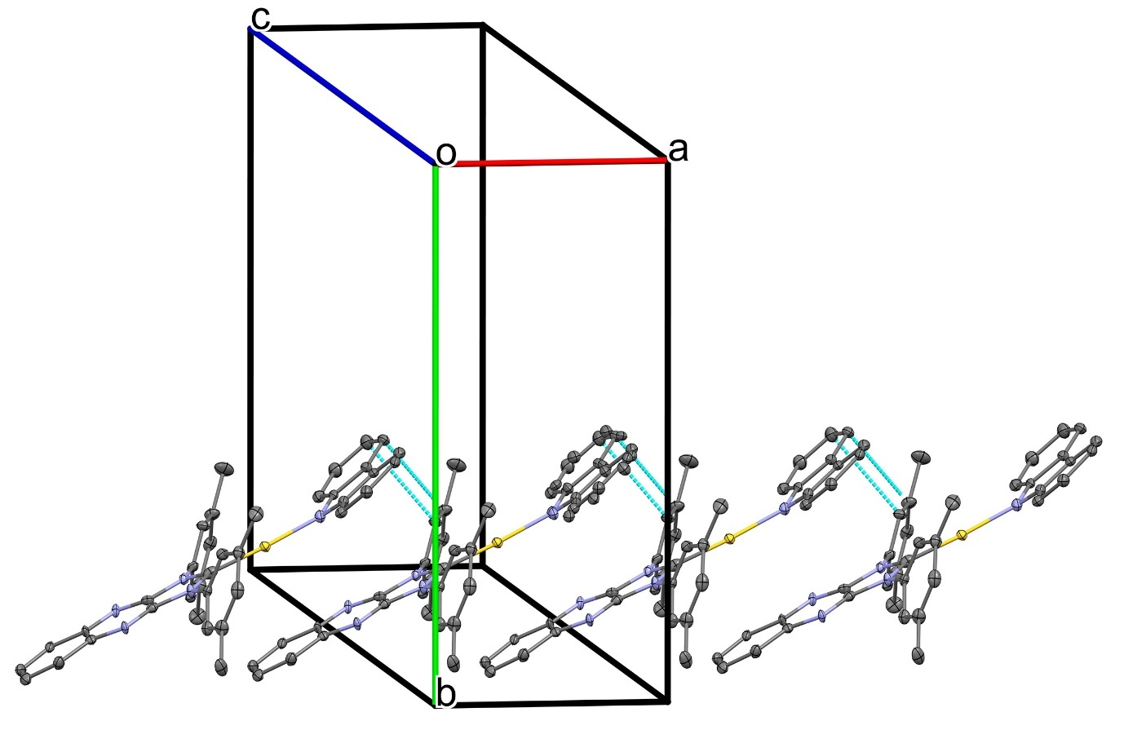
Figure S8. Molecular packing diagram for complex LAuCz along crystallographic axis a. Neighboring molecules of LAuCz are arranged in stacks via weak C–H(carbene)∙∙∙π(amide) head to tail intermolecular interactions along crystallographic axis a.

Electrochemistry.
Cyclic voltammetry (CV) was performed using a three-electrode configuration consisting of a glassy carbon macrodisk working electrode (GCE) (diameter of 3 mm; BASi, Indiana, U.S.A.) combined with a Pt wire counter electrode (99.99%; GoodFellow, Cambridge, U.K.) and an Ag wire pseudoreference electrode (99.99%; GoodFellow, Cambridge, U.K.). The GCE was polished between experiments using alumina slurry (0.3 μm), rinsed in distilled water and subjected to brief sonication to remove any adhering alumina microparticles. The metal electrodes were then dried in an oven at 100 °C to remove residual traces of water, the GCE was left to air dry and residual traces of water were removed under vacuum. The Ag wire pseudoreference electrodes were calibrated to the ferrocene/ferrocenium couple in 1,4-difluorobenzene at the end of each run to allow for any drift in potential, following IUPAC recommendations. All electrochemical measurements were performed at ambient temperatures under an inert N₂ atmosphere in tetrahydrofuran containing the compound under study (0.14 mM) and the supporting electrolyte [n-Bu₄N][PF₆] (0.13 mM). Data were recorded with Autolab NOVA software (v. 1.11).
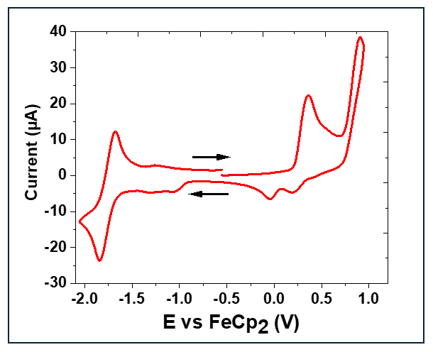
Figure S9. Full range cyclic voltammogram of complex LAuCz. Recorded using a glassy carbon electrode in THF solution (1.4 mM) with [n-Bu₄N]PF₆ as supporting electrolyte (0.13 M), scan rate 0.1 V s^{–1}. The near-unity ratio between cathodic and anodic currents i_{pc}/i_{pa} of 0.71 supports the quasi-reversible character of the reduction process.

Table S1. Selected distances [Å], angles [°],Formal electrode potentials (peak position E_{p} for irreversible and E_{1/2} for quasi-reversible processes (*), V, vs. FeCp₂), onset potentials (E, V, vs. FeCp₂), peak-to-peak separation in parentheses for quasi-reversible processes (ΔE_{p} in mV), E_{HOMO}/E_{LUMO} (eV) and band gap values (ΔE, eV) for the redox changes exhibited by complexes LAuCz and CMA1.ª
 | Au–C, (Å) | Au–N, (Å) | C–Au–N, (°) | Torsion α, (°) | E_{ox} (V) | E_{HOMO}  (eV) | E_{red} (V) | E_{LUMO}  (eV)
CMA1 | 1.994(3) | 2.027(2) | 178.6(1) | 17.1(1) | +0.25 | –5.53 | –2.80 | –2.68
LAuCz | 1.942(12) | 2.022(15) | 175.3(7) | 16.5(3) | +0.36 | –5.62 | –1.76 | –3.72
ª torsion angle (α) N–C_{carbene}···N–C_{amide}.
The torsion angle between the carbene and amide ligands is 16.5(1)°, which differs by less than 1° from that of the CMA1 complex (Table S1) indicating a common two-coordinate linear geometry with co-planar arrangement of the ligands around gold(I) atom.

Experimental Methods for Spectroscopy
Sample Preparation
Samples for photophysical measurements were made from powders stored in a glovebox. Toluene solutions were made and kept in the glovebox until measured. Prior to measuring, solutions were transferred into 1mm path length quartz cuvettes which were sealed with a screw-top cap, parafilm and Teflon tape. Cuvettes were taken out of the glovebox immediately prior to experiments to minimize oxygen ingress.
Films were made from chlorobenzene solutions of polystyrene and Au1-2 at 20mg/ml mixed in the appropriate ratio. Solution was drop-cast onto quartz substrates heated to 80°C or spin coated at 1500 rpm depending on the desired thickness. Films were made and stored in a glovebox. For transient absorption, films were encapsulated inside the glovebox using a coverslip, spacer tape and epoxy.
Time-Correlated Single Photon Counting
A 407nm PicoQuant LDH400 40MHz laser was used to photoexcite the samples. The repetition rate was set to 20-30kHz by a signal generator. A Princeton Instruments SpectraPro2500i spectrograph with a CCD was used to collect emitted photons, and the time taken for the first photon to be emitted after excitation was recorded.
Photoluminescence Quantum Yield
Quantum yields have been measured in air for solid samples and under nitrogen for solutions. Photoluminescence quantum yields were recorded using an Hamamatsu Quantaurus-QY C11347-11. Quantum yields have been measured in air for solid samples and under nitrogen for solutions.
Steady-state Photoluminescence
Steady-state PL spectra were recorded using an Edinburg Instruments FLS1000 spectrofluorimeter. The light source was a monochromated Xenon arc lamp; excitation wavelength varied. Samples were measured in air or under flowing nitrogen, at room temperature.
UV-Vis Absorption
UV-Vis spectra were measured using a Varian Cary 5000 UV-Vis-NIR spectrometer and Shimadzu UV-3600 Plus UV-VIS-NIR spectrophotometer. The spectrometer has a PMT detector for wavelength ranges from UV to visible, as well as InGaAs and PbS detectors for NIR. The light source used was a deuterium lamp for wavelengths less than 280nm and a tungsten halogen lamp for higher wavelengths. The LCuCl complex shows high-energy absorption with a significant input from the 3,5-dimethylbenzene moieties of the carbene for S₀→S₁, whereas the high energy absorption band shows additional localization of the hole NTO on the carbene backbone.
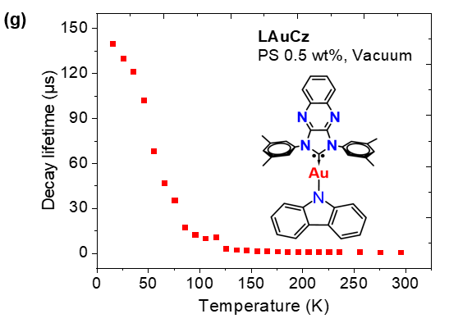
Figure S10. Varied-temperature excited state lifetime measurements for LAuCz in polystyrene matrix at 0.5% doping concentration.

Two-Photon Absorption
2PA measurements were performed at NanoMultiPhot (Institute of Molecular Science, Bordeaux university, Talence, France). The two-photon absorption were measured using the well-established method described by Xu and Webb.^{[6]} An Ultra II (Coherent) femtoseconds pulsed laser (repetition rate: 80 MHz, pulsed width: 150 fs) was focalized on samples or reference solutions using an air Thorlabs objective (LMM15X-P01, 0.3 NA) under magnetic stirring. Excitation wavelength was tuned in the range 680-1050 nm and 1070-1200 nm (polystyrene matrix). Extended NIR-II wavelengths (i.e. 1070-1200 nm) were generated by pumping -with the Ultra II- an optical parametric oscillator (MIRA OPO Coherent) in linear configuration. Visible frequencies were removed using a 800 nm long-pass filter before exciting the sample. The 2PA measurements were conducted on Argon saturated solutions of LAuCz in toluene, THF (12 mM) and dispersed in polystyrene matrix (C= 1.4 mM) by two-photon excited fluorescence (TPEF) method, using fluorescein in aqueous NaOH (C= 0.22 mM, pH= 11.0) as two-photon reference.[,] For 2PA measurements on the range 1070 nm-1200 nm, Nile Red in DMSO (C= 97 µM) was used as two-photon reference.^{[7,8]}
The 1 cm quartz cuvette -containing the solution or the PS matrix- was set in order to have the fluorescence generated on the close vicinity of the wall of the cuvette to limit reabsorption of fluorescence. The solution was stirred using magnetic bar to limit photobleaching during the measurements. The fluorescence is then collected in epifluorescence and filtered from back-scattered laser using a dichroic mirror (650 dcxru or 780 dcxruv, Chroma), filtered to remove residual laser scattering (FF01-650/SP-25, Semrock or E750sp-2p, Chroma) and finally send to a fast spectrophotometer (MayaPro, OceanInsight) by the mean of an optical fiber. The power of the laser is tuned using a polarizer at Brewster’s angle (142013, Layertec) in tandem with a rotating halfwave plate. The power is measured in real time by sending a part of the laser beam on a silicon photodiode (S142CL with power meter interface PM101U, both from Thorlabs) using a beam splitter (UFBS5050, Thorlabs). Quadraticity of the TPEF signals is evaluated checking the quadratic dependence of fluorescence to the laser power. The full programs used for TPEF measurements and analysis are available on github.[] The two-photon brightness σ₂Φ of samples were calculated using equation 1.
$$σ_{2}Φ=σ_{2}Φ_{ref}*{\left(\frac{n}{n_{ref}}\right)}^{2}*\frac{C_{ref}}{C}*\left(\frac{\int{Fluo. int. }}{P^{2}}/\frac{\int{{Fluo. int. }_{ref}}}{P_{ref}^{2}}\right)*\frac{η_{ref}}{η}$$
Equation 1. Calculation of two-photon brightness σ₂Φ.
Where n is the refractive index, C the concentration, P the laser power, $\int{Fluo.} int.$ The fluorescence intensity and η the spectral correction of the sample and reference (ca. ref 7).

Table S2. Two-photon brightness (σ₂Φ) and two-photon cross-section (σ₂) of LAuCz .
λ^{2PA} / nm | σ₂Φ / GM |  |  | σ₂ / GM
λ^{2PA} / nm | Toluene | THF | PS | Toluene | THF | PS
680 | - | 0.059 | 129 | - | 0.310 | 168
690 | - | 0.046 | 54.8 | - | 0.242 | 71.1
700 | - | 0.036 | 23.4 | - | 0.189 | 30.4
710 | - | 0.017 | 13.3 | - | 0.088 | 17.3
720 | - | 0.012 | 9.21 | - | 0.061 | 12
730 | - | 0.007 | 5.8 | - | 0.036 | 7.53
740 | - | 0.003 | 3.07 | - | 0.015 | 3.99
750 | - | 0.002 | 1.48 | - | 0.009 | 1.93
760 | - | 0.002 | 0.712 | - | 0.011 | 0.924
770 | - | 0.002 | 0.427 | - | 0.009 | 0.555
780 | - | 0.018 | 0.308 | - | 0.011 | 0.4
790 | 0.027 | 0.003 | 0.276 | 0.035 | 0.014 | 0.358
800 | 0.041 | 0.014 | 0.296 | 0.053 | 0.072 | 0.384
810 | 0.051 | 0.008 | 0.351 | 0.066 | 0.045 | 0.456
820 | 0.074 | 0.022 | 0.471 | 0.096 | 0.118 | 0.612
830 | 0.082 | 0.017 | 0.493 | 0.107 | 0.087 | 0.64
840 | 0.107 | 0.038 | 0.699 | 0.139 | 0.202 | 0.907
850 | 0.118 | 0.015 | 0.838 | 0.153 | 0.079 | 1.09
860 | 0.120 | 0.013 | 1.06 | 0.155 | 0.069 | 1.37
870 | 0.148 | 0.020 | 1.49 | 0.192 | 0.108 | 1.93
880 | 0.175 | 0.022 | 2.13 | 0.227 | 0.115 | 2.76
890 | 0.225 | 0.027 | 2.89 | 0.293 | 0.143 | 3.75
900 | 0.226 | 0.024 | 4.24 | 0.294 | 0.129 | 5.51
910 | 0.220 | 0.025 | 5.43 | 0.286 | 0.131 | 7.06
920 | 0.205 | 0.028 | 6.3 | 0.266 | 0.148 | 8.18
930 | 0.200 | 0.024 | 7.87 | 0.259 | 0.126 | 10.2
940 | 0.189 | 0.030 | 9.92 | 0.246 | 0.157 | 12.9
950 | 0.204 | 0.026 | 11.4 | 0.266 | 0.138 | 14.8
960 | 0.229 | 0.026 | 14.1 | 0.298 | 0.139 | 18.3
970 | 0.279 | 0.023 | 18.2 | 0.362 | 0.122 | 18.9
980 | 0.259 | 0.024 | 13.2 | 0.337 | 0.125 | 24.8
990 | 0.216 | 0.016 | 18.2 | 0.281 | 0.086 | 23.6
1000 | 0.146 | 0.011 | 13.2 | 0.189 | 0.058 | 17.1
1010 | - | 0.009 | 18.8 | - | 0.050 | 24.5
1020 | - | 0.010 | 21.1 | - | 0.055 | 27.4
1030 | - | 0.011 | 36.2 | - | 0.058 | 47
1040 | - | 0.012 | 46.6 | - | 0.064 | 60.5
1050 | - | 0.010 | 80.9 | - | 0.052 | 105
1070 | - | - | 73 | - | - | 94.8
1080 | - | - | 70 | - | - | 90.9
1090 | - | - | 61.4 | - | - | 79.7
1100 | - | - | 56.9 | - | - | 73.8
1110 | - | - | 49 | - | - | 63.6
1120 | - | - | 41.1 | - | - | 53.4
1130 | - | - | 25.6 | - | - | 33.2
1140 | - | - | 22.8 | - | - | 29.6
1150 | - | - | 22.8 | - | - | 29.6
1160 | - | - | 27.5 | - | - | 35.7
1170 | - | - | 23.9 | - | - | 31
1180 | - | - | 25.2 | - | - | 32.7
1190 | - | - | 12 | - | - | 15.6
1200 | - | - | 16.7 | - | - | 21.6
While the TADF emission exhibits a quadratic dependence on excitation power (confirming a second-order excitation process, i.e., 2PA), the experimental absorption data in solution deviate from the theoretical calculations (Figure S15). Specifically, the 2PA response amplitude decreases by three orders of magnitude during the measurements. This discrepancy suggests the presence of an additional deactivation pathway occurring under 2PA measurements conditions. We hypothesize that, in solution, the high concentration of LAuCz, combined with the prolonged lifetime of the excited states, promotes the formation of non-fluorescent excimers or the occurrence of triplet-triplet annihilation processes. This assumption is support by the observation that restricting the diffusion of LAuCz (i.e. within a PS matrix) substantially restore the 2PEF response. Under these conditions, the allowed 2PA band (CT S₁→S₀) appears distorted compared to one-photon excitation. This distortion may result from the depletion of the S₁ excited state, which is facilitated by long wavelength TADF emission, the use of a high-repetition-rate laser (80 MHz, 12.5 ns between pulses), the significantly longer excited-state lifetime of LAuCz (Table 2), and the viscosity of the host matrix which restricts orientation changes of the transition dipole moment.,
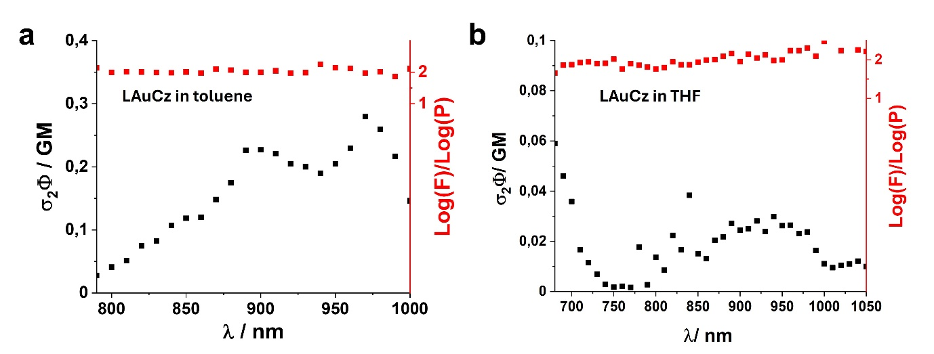
Figure S11. 1PA vs 2PA cross-sections (under Ar) spectra of LAuCz in solution (12mM) in toluene (a) and THF (b).
Quantum chemical calculations
The ground state optimization for the complexes were studied by means of density functional theory (DFT) and the excited-state properties were computed at the time-dependent DFT (TD-DFT) level, using the Tamm-Dancoff approximation., Calculations were carried by using the global hybrid MN15 functional of the Minnesota series by Truhlar and coworkers, which has especially good performance for noncovalent interactions and excitation energies. The def2-TZVP basis set, was employed with relativistic effective core potential of 60 electrons for description of the core electrons of Au. We have previously employed the selected methodology with success for closely related molecules., Copper and gold metal contributions to HOMO and LUMO were calculated by the Mulliken population analysis and HOMO-LUMO overlap integrals were calculated using Multiwfn program. All calculations were carried out with the Gaussian 16 suite package, except the spin-orbit- coupling matrix elements which were calculated with Orca 5.0.4.

Table S3. HOMO and LUMO for copper and gold complexes showing also contributions of the metal atomic orbitals.
 | HOMO | LUMO
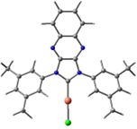  LCuCl  Overlap integral: 0.33 | 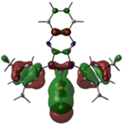  34.3%Cu | 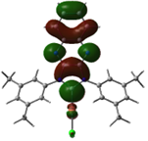  2.4%Cu
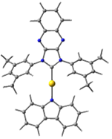  LAuCz  Overlap integral: 0.26 | 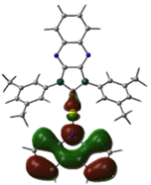  3.1%Au | 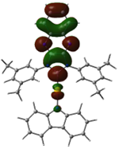  3.7%Au

Table S4. Calculated electric dipole moment (in Debye) of S₀ and S₁ states at the optimized S₀ geometry.
 | S₀ | S₁@S₀
LCuCl | 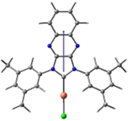  8.5D | 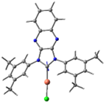  (-)2.4D
LAuCz | 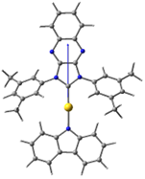  9.9D | 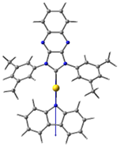  (-)13.0D

Table S5. Calculated vertical excitations, their orbital contributions, and their oscillator strengths (only for singlet excited states) .
 | Excitation Energy | Orbital Contribution | Oscillator Strength
LCuCl | S₁ (mixed ¹CT and ¹LE(Carbene)): 3.31eV = 375nm | HOMO – LUMO (41%)  HOMO-2 – LUMO (39%) | 0.008
 | S₄ (mixed ¹CT and ¹LE(Carbene)): 3.80eV = 327nm | HOMO – LUMO (44%)  HOMO-2 – LUMO (43%) | 0.291
 | T₁ (³LE(Carbene)): 2.97eV = 418nm | HOMO-3 – LUMO (48%)  HOMO-7 – LUMO (31%)
 | T₂ (mixed ³CT and ³LE(Carbene)): 3.04eV = 407nm | HOMO – LUMO (49%)  HOMO-2 – LUMO (17%)
 | T₃ (mixed ³CT and ³LE(Carbene)): 3.15eV = 394nm | HOMO-2 – LUMO (41%)  HOMO-6 – LUMO (19%)  HOMO-8 – LUMO (18%)
LAuCz | S₁ (¹CT): 2.33eV = 532nm | HOMO – LUMO (98%) | 0.260
 | T₁ (³CT): 2.13eV = 582nm | HOMO – LUMO (95%)
 | T₂ (³CT): 2.88eV = 431nm | HOMO-1 – LUMO (97%)
 | T₃ (³LE(Carbene)): 3.01eV = 412nm | HOMO-4 – LUMO (54%)  HOMO-8 – LUMO (23%)

Table S6. Calculated hole-particle natural transition orbitals (NTOs) for the relevant excited states.
 |  | Hole NTO | Particle NTO
LCuCl | S₁ | 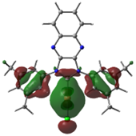 | 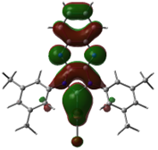
 | S₄ | 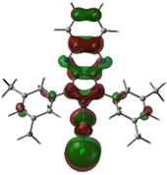 | 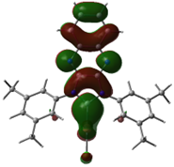
 | T₁ | 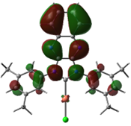 | 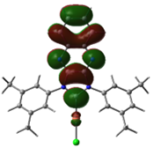
 | T₂ | 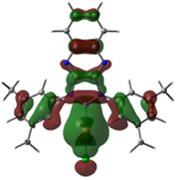 | 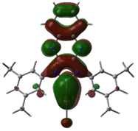
 | T₃ | 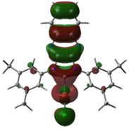 | 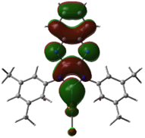
LAuCz | S₁ | 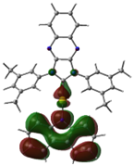 | 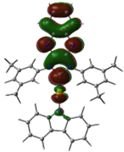
LAuCz | T₁ | 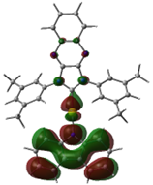 | 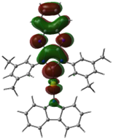
LAuCz | T₂ | 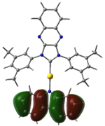 | 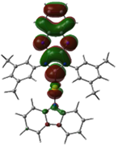
 | T₃ | 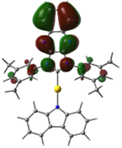 | 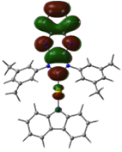

Table S7. Calculated spin-orbit- coupling matrix elements (SOCME, cm⁻¹) for complex LAuCz. (MN15/def2-TZVP).¹⁸
 | State |  | Component |  |  | SOCME
 | T | S | Z | X | Y | cm^{–1}
LAuCz | 1 | 0 | -0.75 | 0.92 | 1.81 | 2.16
LAuCz | 1 | 1 | -0.03 | 0.01 | -6.07 | 6.07
LAuCz | 1 | 2 | -24.58 | 10.79 | -1.53 | 26.88
LAuCz | 1 | 3 | -4.59 | 8.79 | 25.23 | 27.10
LAuCz | 2 | 0 | -30.94 | -1.65 | -4.54 | 31.31
LAuCz | 2 | 1 | -20.37 | 11.76 | -0.81 | 23.53
LAuCz | 2 | 2 | -0.1 | 0.6 | -1.2 | 1.34
LAuCz | 2 | 3 | 9.25 | -5.55 | 0.31 | 10.79
LAuCz | 3 | 0 | -17.46 | -22.89 | 2.27 | 28.87
LAuCz | 3 | 1 | -15.09 | 3.26 | 3.82 | 15.90
LAuCz | 3 | 2 | -0.07 | -0.79 | 1.42 | 1.62
LAuCz | 3 | 3 | 0.76 | 1.07 | -0.85 | 1.56

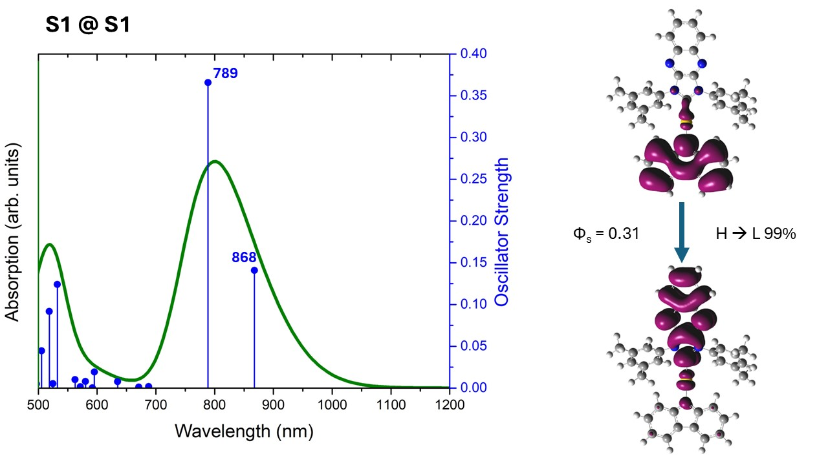
Figure S11: LAuCz excited-state absorption of S1 at its optimized excited-state geometry. The hole-electron densities are reported as well, along with the Φ_{s} metric and the orbital contribution for such transition.

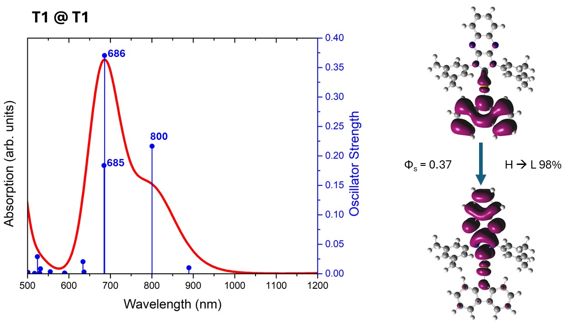
Figure S12: LAuCz excited-state absorption of T1 at its optimized excited-state geometry. The hole-electron densities are reported as well, along with the Φ_{s} metric and the orbital contribution for such transition.

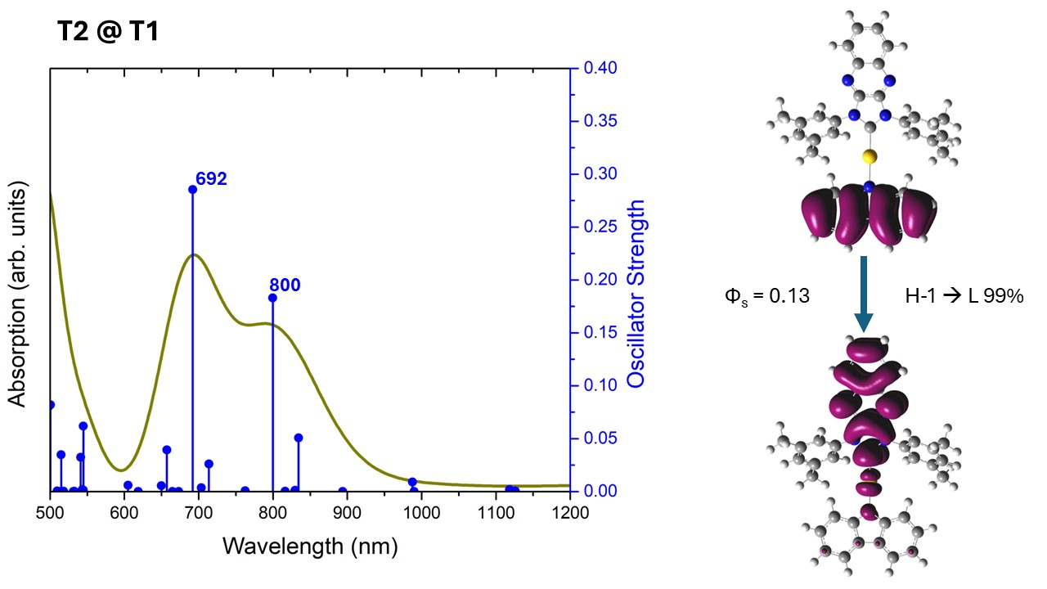
Figure S13: LAuCz excited-state absorption of T2 at the T1 optimized excited-state geometry. The hole-electron densities are reported as well, along with the Φ_{s} metric and the orbital contribution for such transition.

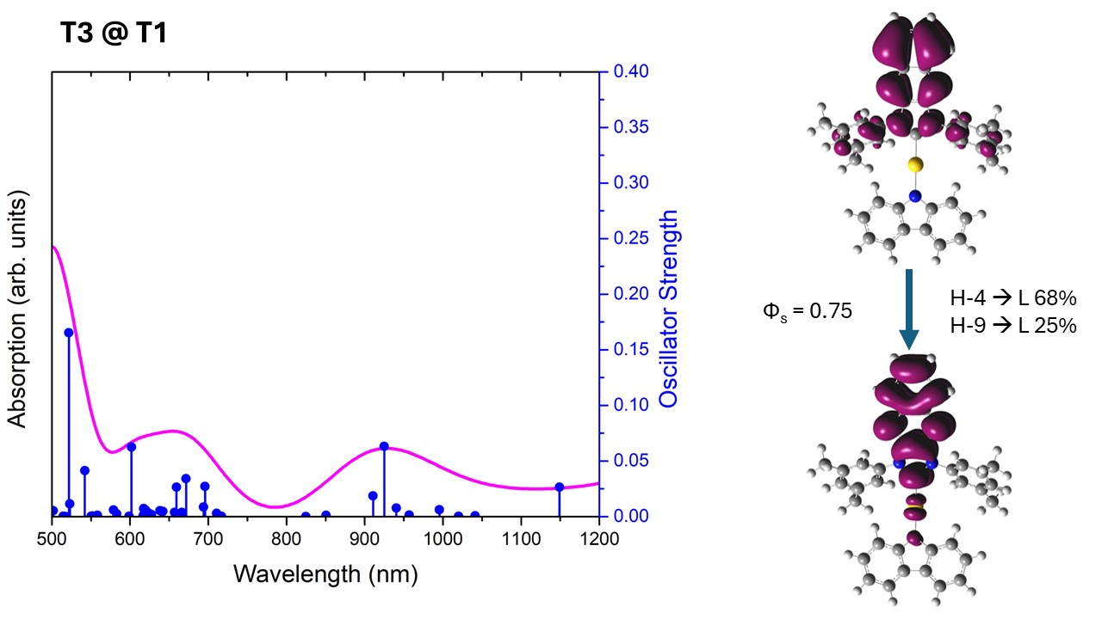
Figure S14: LAuCz excited-state absorption of T2 at the T1 optimized excited-state geometry. The hole-electron densities are reported as well, along with the Φ_{s} metric and the orbital contribution for such transition.

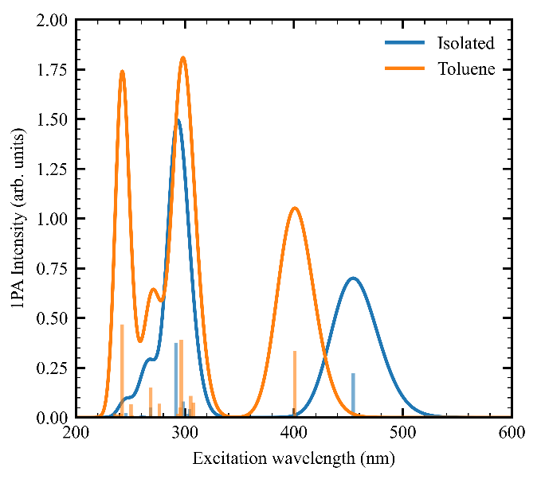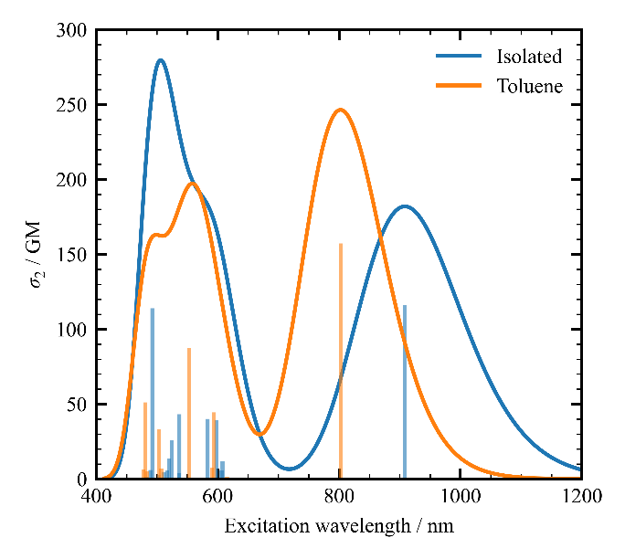
Figure S15: 1PA (left) and 2PA (right) absorption spectra of LAuCz considering the 20 lowest-lying transitions and 0.3 eV FWHM value.

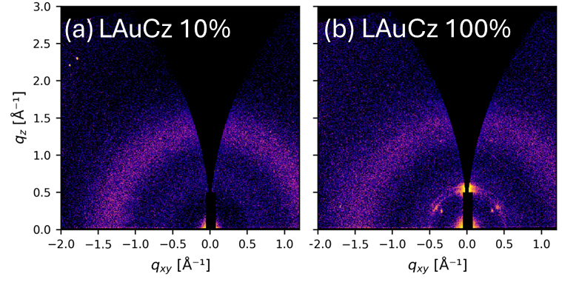
Figure S16. 2D GIWAXS patterns of: (a) LAuCz complex in 10 wt.% PS thin film; (b) LAuCz neat thin film. The intensity of X-ray scattering is presented on a common logarithmic colour scale.
Experimental methods of grazing incidence wide angle X-ray scattering measurements
GIWAXS measurements were performed using a Xeuss 3.0 laboratory beamling (Xenocs) equipped with a liquid gallium MetalJet source (Excillum), producing X-rays with an energy of 9.243keV (λ=1.34Å). A collimated X-ray beam was directed at sample surfaces inclined at a grazing angle of 0.15° and scattered X-rays were detected by a Pilatus3R 1M 2D X-ray detector (Dectris) positioned ~100 mm from the sample centre. The sample to detector distance was calibrated using a silver behenate standard in transmission geometry. GIWAXS data were corrected, reshaped and reduced using code based on pyfai and pygix python libraries. 1D intensity profiles were generated by azimuthally integrating the 2D patterns as a function of q = 4πsinθ/λ where 2θ is the angle between the incident and scattered X-ray of wavelength λ. Integrations were performed across the full q range.

Table S8. 1PA and 2PA absorption as obtained for LAuCz isolated and in toluene.
 | Isolated |  |  |  | Toluene
State | Transition  Energy [eV] | 1PA Intensity (arb. units) | $σ$ [GM] |  | Transition  Energy [eV] | 1PA Intensity (arb. units) | $σ$ [GM]
1 | 2.73 | 1.00 | 183 |  | 3.09 | 1.00 | 247
2 | 3.46 | 0.00 | 0 |  | 3.92 | 0.00 | 0
3 | 4.07 | 0.19 | 2 |  | 4.03 | 0.22 | 2
4 | 4.08 | 0.06 | 19 |  | 4.06 | 0.32 | 0
5 | 4.09 | 0.09 | 9 |  | 4.18 | 1.17 | 70
6 | 4.15 | 0.36 | 62 |  | 4.20 | 0.15 | 12
7 | 4.18 | 0.00 | 0 |  | 4.23 | 0.06 | 1
8 | 4.25 | 1.68 | 63 |  | 4.49 | 0.21 | 138
9 | 4.60 | 0.00 | 1 |  | 4.61 | 0.45 | 0
10 | 4.63 | 0.23 | 7 |  | 4.66 | 0.01 | 0

Table S9. S₀-S₁ 2PA absorption cross-section as obtained using few-state models (equation 4) for LAuCz isolated and in toluene.
 | Isolated | Toluene
States | $σ$ [GM] | $σ$ [GM]
S₀, S₁ | 260 | 426
S₀, S_{1,} S₂ | 260 | 426
S₀, S_{1,} S₃ | 260 | 428
S₀, S_{1,} S₄ | 253 | 422
S₀, S_{1,} S₅ | 265 | 333
S₀₋₅ | 258 | 330

Table S10. Permanent (i = j) and transition dipole moments as obtained for LAuCz isolated and in toluene.
Isolated |  |  |  |  |  | Toluene
i | j | $$μ_{x}$$ | $$μ_{y}$$ | $$μ_{z}$$ |  | i | j | $$μ_{x}$$ | $$μ_{y}$$ | $$μ_{z}$$
0 | 0 | 4.015 | 0.006 | 0.203 |  | 0 | 0 | 4.521 | 0.004 | 0.212
0 | 1 | -1.830 | -0.003 | -0.093 |  | 0 | 1 | -2.106 | -0.006 | -0.114
0 | 2 | 0.000 | -0.008 | 0.002 |  | 0 | 2 | 0.001 | 0.051 | -0.012
0 | 3 | 0.006 | 0.647 | -0.151 |  | 0 | 3 | -0.009 | -0.866 | 0.199
0 | 4 | -0.352 | -0.032 | -0.114 |  | 0 | 4 | 1.045 | 0.026 | 0.157
0 | 5 | -0.437 | 0.045 | 0.153 |  | 0 | 5 | -1.957 | 0.007 | -0.054
1 | 1 | -5.490 | -0.020 | -0.325 |  | 1 | 1 | -6.035 | -0.046 | -0.453
1 | 2 | -0.002 | -0.193 | 0.044 |  | 1 | 2 | 0.004 | 0.217 | -0.049
1 | 3 | -0.025 | -0.152 | 0.035 |  | 1 | 3 | -0.004 | -0.206 | 0.047
1 | 4 | 1.311 | -0.013 | 0.007 |  | 1 | 4 | -0.185 | 0.007 | 0.023
1 | 5 | -0.684 | 0.014 | 0.029 |  | 1 | 5 | 2.263 | 0.012 | 0.147
2 | 2 | -7.195 | -0.035 | -0.464 |  | 2 | 2 | -8.124 | -0.069 | -0.640
2 | 3 | -0.140 | 0.000 | -0.010 |  | 2 | 3 | 1.056 | 0.007 | 0.073
2 | 4 | -0.002 | -0.028 | 0.006 |  | 2 | 4 | 0.005 | -0.023 | 0.006
2 | 5 | 0.002 | 0.066 | -0.015 |  | 2 | 5 | -0.004 | 0.011 | -0.003
3 | 3 | 4.093 | 0.020 | 0.201 |  | 3 | 3 | 5.025 | 0.007 | 0.222
3 | 4 | -0.026 | 0.113 | -0.027 |  | 3 | 4 | 0.001 | 0.061 | -0.014
3 | 5 | 0.048 | -0.559 | 0.130 |  | 3 | 5 | -0.002 | 0.411 | -0.094
4 | 4 | 2.871 | 0.000 | 0.136 |  | 4 | 4 | 5.244 | 0.015 | 0.299
4 | 5 | -1.457 | -0.011 | -0.072 |  | 4 | 5 | 0.027 | 0.002 | 0.012
5 | 5 | -0.068 | 0.020 | 0.122 |  | 5 | 5 | 4.324 | 0.005 | 0.205

References.

[] Programs CrysAlisPro, Oxford Diffraction Ltd. Abingdon, UK, 2010.
[] G. Sheldrick, Crystal structure refinement with SHELXL. Acta Cryst. C 2015, 71 (1), 3-8.
[] O. V. Dolomanov, L. J. Bourhis, R. J. Gildea, J. A. K. Howard, H. Puschmann, OLEX2: a complete structure solution, refinement and analysis program. J. Appl. Cryst. 2009, 42 (2), 339.
[] Gritzner, G.; Kůta, J. Recommendations on reporting electrodepotentials in nonaqueous solvents: IUPC commission on electro-chemistry. Electrochim. Acta, 1984, 29, 869−873.
[] M. A. Albota, C. Xu, W. W. Webb, Appl. Opt., 1998, 37 (31), 7352.
[] C. Xu, W. W. Webb, J. Opt. Soc. Am. B, 1996, 13 (3), 481.
[] J. Daniel, website link: https://github.com/LAGONteam/PyTwoPhotonExcitedFluorescence.
[] R.J. Marsh et al. / Chemical Physics Letters 366 (2002) 398–405
[] Teodora Scheul, Ciro D’Amico, Irène Wang, and Jean-Claude Vial, "Two-photon excitation and stimulated emission depletion by a single wavelength," Opt. Express 19, 18036-18048 (2011)
[] F. Furche and D. Rappoport, Density functional methods for excited states: equilibrium structure and electronic spectra. In Computational Photochemistry; M. Olivuccim, Ed.; Elsevier: Amsterdam, 2005; pp. 93–128.
[] G. M. J. Peach and D. J. Tozer, J. Phys. Chem. A, 2012, 116, 9783–9789.
[] H. S. Yu, X. He, S. L. Li and D. G. Truhlar, Chem. Sci., 2016, 7, 5032–5051.
[] F. Weigend, M. Häser, H. Patzelt and R. Ahlrichs, Chem. Phys. Lett., 1998, 294, 143–152.
[] F. Weigend and R. Ahlrichs, Phys. Chem. Chem. Phys., 2005, 7, 3297–3305.
[] D. Andrae, U. Haeussermann, M. Dolg, H. Stoll and H. Preuss, Theor. Chim. Acta, 1990, 77, 123–141.
[] F. Chotard, A. S. Romanov, D. L. Hughes, M. Linnolahti and M. Bochmann, Eur. J. Inorg. Chem., 2019, 4234–4240.
[] A. S. Romanov, S. T. E. Jones, Q. Gu, P. J. Conaghan, B. H. Drummond, J. Feng, F. Chotard, L. Buizza, M. Foley, M. Linnolahti, D. Credgington and M. Bochmann, Chem. Sci., 2020, 11, 435–446.
[] T. Lu and F. J. Chen, Comput. Chem., 2012, 33, 580–592.
[] Gaussian 16, Revision A.03, M.J. Frisch, G.W. Trucks, H.B. Schlegel, G.E. Scuseria, M.A. Robb, J.R. Cheeseman, G. Scalmani, V. Barone, G.A. Petersson, H. Nakatsuji, X. Li, M. Caricato, A.V. Marenich, J. Bloino, B.G. Janesko, R. Gomperts, B. Mennucci, H.P. Hratchian, J.V. Ortiz, A.F. Izmaylov, J.L. Sonnenberg, D. Williams-Young, F. Ding, F. Lipparini, F. Egidi, J. Goings, B. Peng, A. Petrone, T. Henderson, D. Ranasinghe, V.G. Zakrzewski, J. Gao, N. Rega, G. Zheng, W. Liang, M. Hada, M. Ehara, K. Toyota, R. Fukuda, J. Hasegawa, M. Ishida, T. Nakajima, Y. Honda, O. Kitao, H. Nakai, T. Vreven, K. Throssell, J.A. Montgomery, Jr., J.E. Peralta, F. Ogliaro, M.J. Bearpark, J.J. Heyd, E.N. Brothers, K.N. Kudin, V.N. Staroverov, T.A. Keith, R. Kobayashi, J. Normand, K. Raghavachari, A P. Rendell, J.C. Burant, S.S. Iyengar, J. Tomasi, M. Cossi, J.M. Millam, M. Klene, C. Adamo, R. Cammi, J.W. Ochterski, R.L. Martin, K. Morokuma, O. Farkas, J.B. Foresman and D.J. Fox, Gaussian, Inc., Wallingford CT, 2016.
[] Neese, F. Software update: the ORCA program system -- Version 5.0 Wiley Interdiscip. Rev.: Comput. Mol. Sci., 2022, 12, 1, e1606.

