Electronic Supplementary

Eco-Friendly Synthesis and Enhanced Photocatalytic Performance of CeO₂/Porphyrin Nanocomposites for Organic Pollutant Degradation under Visible Light
Kieu Anh Thi Vo^{1,2+}, Duy Van Lai^{3,+}, Nam Thi Pham^{1,2}, Lam Dai Tran^{1,2}, Thanh Tung Nguyen³, Dinh Ngo Vu⁴, Duong Duc La^{5,*}
¹Institute for Tropical Technology, Vietnam Academy of Science and Technology, Hanoi, Vietnam
²Graduate University of Science and Technology-VAST, Cau Giay, Hanoi, Vietnam
³Institute of Materials Science, Vietnam Academy of Science and Technology, 18 Hoang Quoc Viet Street, Cau Giay District, Hanoi City, Vietnam.
⁴Electric Power University, 235 Hoang Quoc Viet St, Bac Tu Liem Dist, Hanoi, Vietnam
⁵Institute of Chemistry and Materials, 17 Hoang Sam, Nghia Do, Cau Giay, Hanoi, Vietnam
⁺ These authors contributed equally
* Corresponding authors: duc.duong.la@gmail.com

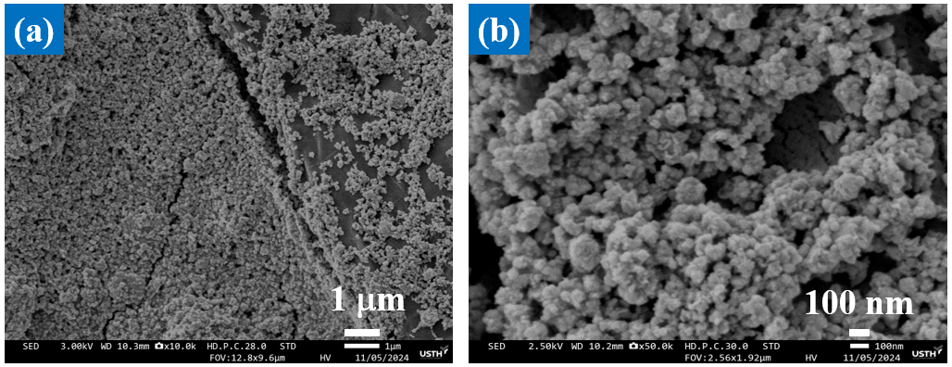

Figure S1. SEM image of pure CeO2 nanoparticles.

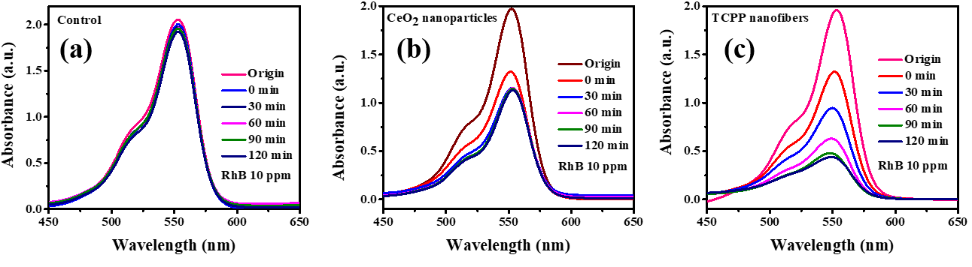
Figure S2. (a) Adsorption kinetics over time, (b) Photocatalytic degradation performance, and (c) First-order kinetic analysis for the control sample, CeO2 nanoparticles, and TCPP nanofibers under simulated sunlight exposure for 120 minutes.

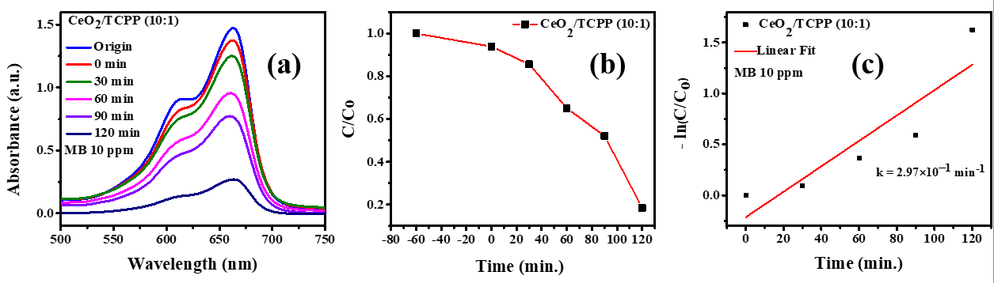
Figure S3. (a) Time-dependent removal of Rhodamine B (RhB) using CeO2/TCPP nanocomposite, (b) Adsorption and photodegradation kinetics of RhB, and (c) Kinetic study under simulated sunlight over a 120-minute period.

