Condition | JP_{HIP} (W·kg⁻¹) | JP_{KNEE} (W·kg⁻¹) | JP_{ANKLE} (W·kg⁻¹)
PP_{free} | -3.06 ± 2.79 | -19.04 ± 8.87 | -8.05 ± 4.69
PP_{trunk} | -3.23 ± 3.31 | -24.51 ± 11.27 | -7.48 ± 4.32
PP_{prep} | -2.62 ± 4.00 | -20.16 ± 8.90 | -7.41 ± 3.96
UP_{free} | -3.66 ± 3.52 | -17.69 ± 8.58 | -6.67 ± 4.00
UP_{trunk} | -3.73 ± 3.29 | -20.01 ± 7.74 | -7.19 ± 5.25
UP_{prep} | -4.04 ± 4.64 | -17.82 ± 9.02 | -5.89 ± 3.53
Online supplement - Table 1. Peak negative joint power
Data are presented as mean ± SD

Condition | JP_{HIP} (W·kg⁻¹) | JP_{KNEE} (W·kg⁻¹) | JP_{ANKLE} (W·kg⁻¹)
PP_{free} | 1.6 | 6.2 | 3.0
PP_{prep} - PP_{free} | 2.3 | 4.3 | 3.0
PP_{trunk} - PP_{free} | 1.8 | 6.3 | 2.8
UP_{free} - PP_{free} | 1.6 | 6.1 | 5.0
UP_{prep} - PP_{free} | 3.8 | 5.8 | 2.9
UP_{trunk} - PP_{free} | 1.5 | 7.4 | 4.2
Residual | 2.7 | 5.6 | 2.3
Online supplement - Table 2. The standard deviation of the random intercepts

Online supplement - Table 3. The correlation coefficient (r) between the random intercepts and slopes
Condition |  |  | JP_{HIP} (W·kg⁻¹) |  | JP_{KNEE} (W·kg⁻¹) |  | JP_{ANKLE} (W·kg⁻¹)
PP_{free} | PP_{prep} | 0.51 |  | 0.05 |  | -0.13
PP_{free} | PP_{trunk} | 0.58 |  | 0.52 |  | 0.05
PP_{free} | UP_{free} | 0.00 |  | -0.12 |  | -0.23
PP_{free} | UP_{prep} | 0.30 |  | -0.09 |  | -0.14
PP_{free} | UP_{trunk} | 0.49 |  | -0.33 |  | 0.14
PP_{prep} | PP_{trunk} | 0.82 |  | 0.51 |  | 0.55
PP_{prep} | UP_{free} | 0.12 |  | 0.67 |  | 0.88
PP_{prep} | UP_{prep} | -0.55 |  | 0.28 |  | 0.93
PP_{prep} | UP_{trunk} | -0.11 |  | 0.33 |  | 0.38
PP_{trunk} | UP_{free} | 0.13 |  | 0.44 |  | 0.71
PP_{trunk} | UP_{prep} | -0.18 |  | 0.08 |  | 0.64
PP_{trunk} | UP_{trunk} | 0.38 |  | 0.51 |  | 0.76
UP_{free} | UP_{prep} | 0.03 |  | 0.60 |  | 0.92
UP_{free} | UP_{trunk} | 0.39 |  | 0.76 |  | 0.71
UP_{prep} | UP_{trunk} | 0.73 |  | 0.52 |  | 0.61

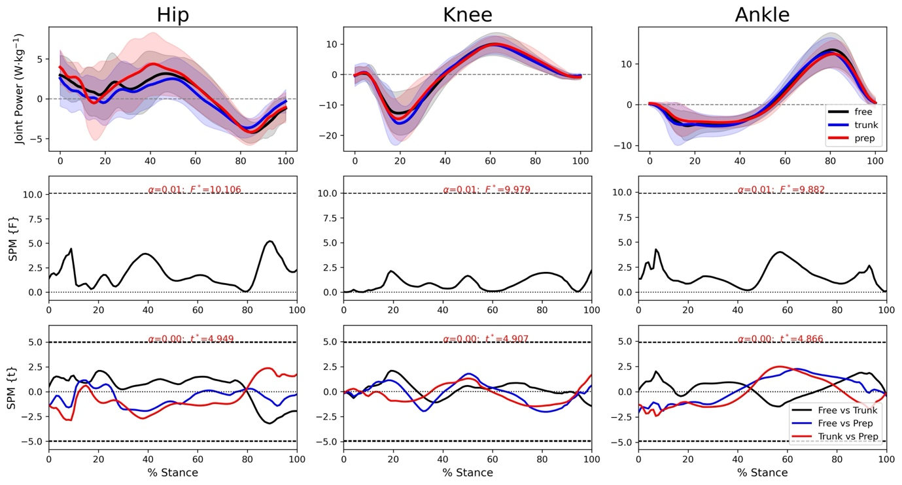
Online Supplement - Fig. 1. Top panel - Mean and SD time series for the hip, knee and ankle joint power normalized to body mass. Middle panel - SPM repeated measures ANOVA results for all pre-planned conditions. Inference curves with suprathreshold clusters (shaded) with the critical threshold (dashed line). Bottom panel - Follow-up SPM T-test with Bonferroni correction between all pre-planned conditions. Inference curves with suprathreshold clusters (shaded) and critical threshold (dashed line). ANOVA = analysis of variance; SPM = statistical parametric mapping.

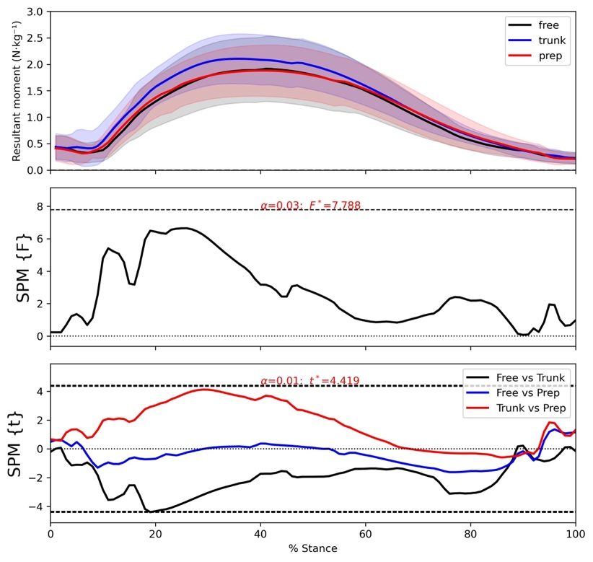
Online Supplement - Fig. 2. Top panel - Mean and SD time series for the resultant knee joint moment normalized to body mass. Middle panel - SPM repeated measures ANOVA results for all pre-planned conditions. Inference curves with suprathreshold clusters (shaded) with the critical threshold (dashed line). Bottom panel - Follow-up SPM T-test with Bonferroni correction between all pre-planned conditions. Inference curves with suprathreshold clusters (shaded) and critical threshold (dashed line). ANOVA = analysis of variance; SPM = statistical parametric mapping.

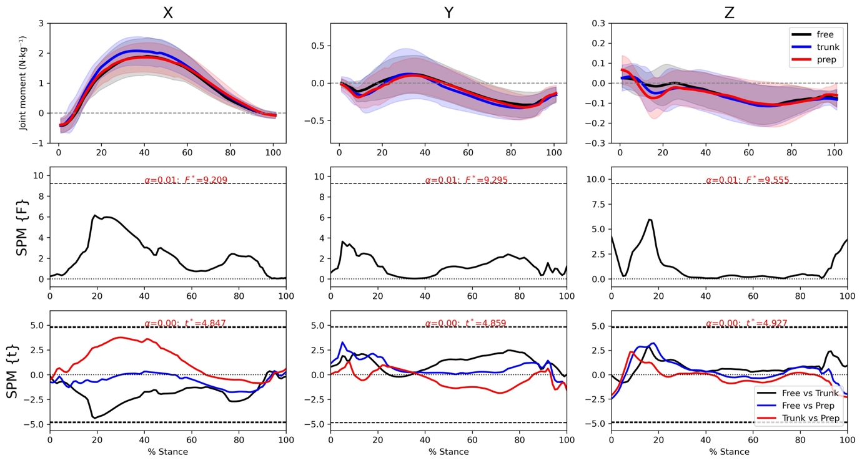
Online Supplement - Fig. 3. Top panel - Mean and SD time series for the decomposed knee joint moment normalized to body mass. Middle panel - SPM repeated measures ANOVA results for all pre-planned conditions. Inference curves with suprathreshold clusters (shaded) with the critical threshold (dashed line). Bottom panel - Follow-up SPM T-test with Bonferroni correction between all pre-planned conditions. Inference curves with suprathreshold clusters (shaded) and critical threshold (dashed line). ANOVA = analysis of variance; SPM = statistical parametric mapping.

