Table S1. Demographics and clinical characteristics by cohort.
Variables | Total cohort  (n = 5601) |  | Train cohort  (n = 5037) |  | Holdout cohort  (n = 564)
Variables | M (SD)  / n (%) | Missing (%) | M (SD)  / n (%) | Missing (%) | M (SD)  / n (%) | Missing (%) | P
Age |  | 0.0% |  | 0.0% |  | 0.0% | 0.407
0 - 9 | 66 (1.2%) |  | 61 (1.2%) |  | 5 (0.9%)
10 - 19 | 205 (3.7%) |  | 185 (3.7%) |  | 20 (3.6%)
20 - 29 | 1110 (19.8%) |  | 988 (19.6%) |  | 122 (21.6%)
30 - 39 | 564 (10.1%) |  | 513 (10.2%) |  | 51 (9.0%)
40 - 49 | 739 (13.2%) |  | 652 (12.9%) |  | 87 (15.4%)
50 - 59 | 1141 (20.4%) |  | 1039 (20.6%) |  | 102 (18.1%)
60 - 69 | 907 (16.2%) |  | 809 (16.1%) |  | 98 (17.4%)
70 - 79 | 545 (9.7%) |  | 495 (9.8%) |  | 50 (8.9%)
≥ 80 | 324 (5.8%) |  | 295 (5.9%) |  | 29 (5.1%)
Sex (male) | 2310 (41.2%) | 0.0% | 2073 (41.2%) | 0.0% | 237 (42.0%) | 0.0% | 0.726
Pregnancy | 19 (0.3%) | 0.4% | 17 (0.3%) | 0.3% | 2 (0.4%) | 0.5% | 1.000
Pregnancy weeks | 0.05 (1.1) | 0.4% | 0.06 (1.1) | 0.4% | 0.03 (0.5) | 0.5% | 0.399
Body mass index |  | 21.4% |  | 21.5% |  | 20.9% | 0.653
< 18.5 | 259 (4.6%) |  | 236 (4.7%) |  | 23 (4.1%)
18.5 - 22.9 | 1854 (33.1%) |  | 1666 (33.1%) |  | 188 (33.3%)
23.0 - 24.9 | 1035 (18.5%) |  | 929 (18.4%) |  | 106 (18.8%)
25.0 - 29.9 | 1045 (18.7%) |  | 938 (18.6%) |  | 107 (19.0%)
≥ 30 | 207 (3.7%) |  | 185 (3.7%) |  | 22 (3.9%)
SBP |  | 2.5% |  | 2.5% |  | 2.7% | 0.600
< 120 | 1306 (23.3%) |  | 1177 (23.4%) |  | 129 (22.9%)
120 - 129 | 1138 (20.3%) |  | 1012 (20.1%) |  | 126 (22.3%)
130 - 139 | 1084 (19.4%) |  | 977 (19.4%) |  | 107 (19.0%)
140 - 159 | 1418 (25.3%) |  | 1281 (25.4%) |  | 137 (24.3%)
≥ 160 | 513 (9.2%) |  | 463 (9.2%) |  | 50 (8.9%)
DBP |  | 2.5% |  | 2.5% |  | 2.7% | 0.036
< 80 | 2102 (37.5%) |  | 1878 (37.3%) |  | 224 (39.7%)
80 - 89 | 1797 (32.1%) |  | 1601 (31.8%) |  | 196 (34.8%)
90 - 99 | 1056 (18.9%) |  | 971 (19.3%) |  | 85 (15.1%)
≥ 100 | 504 (9.0%) |  | 460 (9.1%) |  | 44 (7.8%)
Heart rate | 85.8 (15.1) | 2.3% | 85.8 (15.0) | 2.3% | 86.3 (15.4) | 2.5% | 0.474
Body temperature | 36.9 (0.6) | 0.7% | 36.9 (0.6) | 0.8% | 37.0 (0.6) | 0.7% | 0.861
Fever | 1302 (23.3%) | 0.1% | 1168 (23.2%) | 0.1% | 134 (23.8%) | 0.0% | 0.801
Cough | 2331 (41.6%) | 0.1% | 2103 (41.8%) | 0.1% | 228 (40.4%) | 0.0% | 0.575
Sputum | 1611 (28.8%) | 0.1% | 1460 (29.0%) | 0.1% | 151 (26.8%) | 0.0% | 0.293
Sore throat | 872 (15.6%) | 0.1% | 779 (15.5%) | 0.1% | 93 (16.5%) | 0.0% | 0.565
Rhinorrhea | 617 (11%) | 0.1% | 560 (11.1%) | 0.1% | 57 (10.1%) | 0.0% | 0.511
Myalgia | 920 (16.4%) | 0.1% | 820 (16.3%) | 0.1% | 100 (17.7%) | 0.0% | 0.411
Fatigue | 233 (4.2%) | 0.1% | 207 (4.1%) | 0.1% | 26 (4.6%) | 0.0% | 0.650
Shortness of breath | 665 (11.9%) | 0.1% | 608 (12.1%) | 0.1% | 57 (10.1%) | 0.0% | 0.194
Headache | 963 (17.2%) | 0.1% | 873 (17.3%) | 0.1% | 90 (16.0%) | 0.0% | 0.446
Altered consciousness | 35 (0.6%) | 0.1% | 31 (0.6%) | 0.1% | 4 (0.7%) | 0.0% | 0.776
Vomiting | 244 (4.4%) | 0.1% | 210 (4.2%) | 0.1% | 34 (6.0%) | 0.0% | 0.052
Diarrhea | 516 (9.2%) | 0.1% | 457 (9.1%) | 0.1% | 59 (10.5%) | 0.0% | 0.315
Diabetes mellitus | 688 (12.3%) | 0.1% | 620 (12.3%) | 0.1% | 68 (12.1%) | 0.0% | 0.916
Hypertension | 1198 (21.4%) | 0.1% | 1087 (21.6%) | 0.1% | 111 (19.7%) | 0.0% | 0.323
Heart failure | 59 (1.1%) | 0.1% | 52 (1.0%) | 0.1% | 7 (1.2%) | 0.0% | 0.808
Cardiovascular disease | 179 (3.2%) | 0.3% | 156 (3.1%) | 0.3% | 23 (4.1%) | 0.4% | 0.259
Asthma | 128 (2.3%) | 0.1% | 118 (2.3%) | 0.1% | 10 (1.8%) | 0.0% | 0.478
COPD | 40 (0.7%) | 0.1% | 38 (0.8%) | 0.1% | 2 (0.4%) | 0.0% | 0.428
Chronic kidney disease | 55 (1.0%) | 0.1% | 48 (1.0%) | 0.1% | 7 (1.2%) | 0.0% | 0.665
Malignancy | 145 (2.6%) | 0.1% | 134 (2.7%) | 0.1% | 11 (2.0%) | 0.0% | 0.386
Chronic liver disease | 83 (1.6%) | 5.8% | 75 (1.6%) | 5.7% | 8 (1.5%) | 6.7% | 1.000
Autoimmune disease | 38 (0.7%) | 5.9% | 32 (0.7%) | 5.8% | 6 (1.1%) | 6.9% | 0.365
Dementia | 224 (4.2%) | 5.9% | 203 (4.3%) | 5.8% | 21 (3.7%) | 6.7% | 0.811
Hemoglobin | 13.3 (1.8) | 27.2% | 13.29 (1.8) | 26.7% | 13.2 (1.8) | 31.6% | 0.412
Hematocrit | 39.2 (5.0) | 27.2% | 39.3 (4.9) | 26.7% | 39.1 (5.2) | 31.7% | 0.558
Lymphocyte | 29.2 (11.7) | 27.6% | 29.3 (11.7) | 27.1% | 28.2 (11.0) | 32.1% | 0.088
Platelet | 236697 (82897) | 27.1% | 236776 (82534) | 26.7% | 235943 (86395) | 31.4% | 0.856
White blood cell | 6126 (2824) | 27.1% | 6121 (2841) | 26.7% | 6167 (2666) | 31.4% | 0.748
WHO OSCI ≥6 | 271 (4.8%) | 0.0% | 242 (4.8%) | 0.0% | 29 (5.1%) | 0.0% | 0.802
Data are presented as mean (standard deviation) or number (%). Differences between groups were analyzed using Welch’s t-test for continuous variables, Mann-Whitney U test for ordinal variables, Chi-square test for categorical variables with frequencies above 5, and Fisher’s exact test for categorical variables with frequencies below 5. Two-sided p-values are reported.
COPD = chronic obstructive pulmonary disease, DBP = diastolic blood pressure, M = mean, SBP = systolic blood pressure, SD = standard deviation, WHO OSCI = World Health Organization Ordinal Scale for Clinical Improvement

Table S2. Performance of the models according to the World Health Organization Ordinal Scale for Clinical Improvement.
WHO OSCI | Model | AUROC | Specificity | Sensitivity | Accuracy | PPV | NPV | P
≥ 5 | LR | 0.915  (0.882 - 0.941) | 0.901  (0.891 - 0.908) | 0.766  (0.695 - 0.830) | 0.893  (0.882 - 0.905) | 0.300  (0.270 - 0.330) | 0.986  (0.982 - 0.990) | 0.030
≥ 5 | XGB | 0.950  (0.936 - 0.961) | 0.900  (0.891 - 0.908) | 0.882  (0.838 - 0.919) | 0.899  (0.890 - 0.907) | 0.333  (0.312 - 0.356) | 0.993  (0.990 - 0.995) | 0.030
≥ 6 | LR | 0.938  (0.911 - 0.959) | 0.900  (0.888 - 0.912) | 0.814  (0.737 - 0.881) | 0.896  (0.885 - 0.907) | 0.273  (0.246 - 0.302) | 0.991  (0.987 - 0.994) | 0.039
≥ 6 | XGB | 0.965  (0.958 - 0.972) | 0.900  (0.892 - 0.908) | 0.905  (0.868 - 0.942) | 0.901  (0.892 - 0.909) | 0.314  (0.295 - 0.335) | 0.995  (0.993 - 0.997) | 0.039
≥ 7 | LR | 0.938  (0.903 - 0.963) | 0.900  (0.888 - 0.912) | 0.857  (0.790 - 0.924) | 0.898  (0.887 - 0.910) | 0.259  (0.234 - 0.289) | 0.994  (0.993 - 0.997) | 0.060
≥ 7 | XGB | 0.966  (0.959 - 0.973) | 0.900  (0.892 - 0.909) | 0.902  (0.862 - 0.938) | 0.900  (0.892 - 0.909) | 0.297  (0.278 - 0.318) | 0.995  (0.993 - 0.997) | 0.060
≥ 8 | LR | 0.940  (0.907 - 0.964) | 0.900  (0.889 - 0.911) | 0.867  (0.796 - 0.929) | 0.899  (0.887 - 0.909) | 0.248  (0.223 - 0.273) | 0.994  (0.991 - 0.997) | 0.062
≥ 8 | XGB | 0.968  (0.961 - 0.975) | 0.900  (0.892 - 0.908) | 0.903  (0.861 - 0.940) | 0.900  (0.892 - 0.908) | 0.288  (0.270 - 0.307) | 0.995  (0.993 - 0.997) | 0.062
Data are value (95% confidence interval)
AUROC = area under the receiver operating characteristic, LR = logistic regression, NPV = negative predictive value, PPV = positive predictive value, WHO OSCI = World Health Organization Ordinal Scale for Clinical Improvement, XGB = extreme gradient boosting

Table S3. AUROCs at each step of the RFE and P values of the difference in AUROC compared with the F+L+ and F+L- models.
Number of variables | F+L+ model |  | F+L- model
Number of variables | AUROC | P | AUROC | P
1 | 0.889 | 0.000 | 0.889 | 0.000
2 | 0.931 | 0.000 | 0.917 | 0.000
3 | 0.934 | 0.000 | 0.921 | 0.000
4 | 0.946 | 0.000 | 0.932 | 0.001
5 | 0.948 | 0.000 | 0.936 | 0.008
6 | 0.951 | 0.000 | 0.937 | 0.009
7 | 0.953 | 0.000 | 0.934 | 0.001
8 | 0.959 | 0.003 | 0.936 | 0.007
9 | 0.956 | 0.000 | 0.935 | 0.000
10 | 0.957 | 0.000 | 0.938 | 0.007
11 | 0.958 | 0.000 | 0.942 | 0.137
12 | 0.957 | 0.000 | 0.941 | 0.043
13 | 0.961 | 0.018 | 0.939 | 0.014
14 | 0.962 | 0.018 | 0.942 | 0.087
15 | 0.962 | 0.015 | 0.942 | 0.063
16 | 0.962 | 0.021 | 0.941 | 0.015
17 | 0.963 | 0.080 | 0.942 | 0.108
18 | 0.964 | 0.252 | 0.943 | 0.051
19 | 0.964 | 0.379 | 0.945 | 0.435
20 | 0.965 | 0.392 | 0.943 | 0.024
21 | 0.963 | 0.016 | 0.946 | 0.556
22 | 0.964 | 0.352 | 0.946 | 0.640
23 | 0.964 | 0.510 | 0.948 | 0.551
24 | 0.963 | 0.107 | 0.947 | 0.988
25 | 0.963 | 0.077 | 0.945 | 0.517
26 | 0.961 | 0.002 | 0.946 | 0.693
27 | 0.964 | 0.141 | 0.946 | 0.305
28 | 0.962 | 0.014 | 0.945 | 0.437
29 | 0.963 | 0.027 | 0.947 | 0.672
30 | 0.963 | 0.043 | 0.942 | 0.004
31 | 0.963 | 0.116 | 0.946 | 0.686
32 | 0.963 | 0.054 | 0.946 | -
33 | 0.963 | 0.173 | - | -
34 | 0.964 | 0.378 | - | -
35 | 0.962 | 0.009 | - | -
37 | 0.965 | - | - | -
For the F+L+ model, pregnancy and pregnancy week variables showed zero SHAP values. Hence, the two variables were eliminated.
AUROC = area under the receiver operating characteristic, F+L+ = full models with laboratory data, F+L- = full models without laboratory data, RFE = recursive feature elimination

Table S4. Performance of the models with the hold-out set.
Model | Number of variables | AUROC | Specificity | Sensitivity | Accuracy | PPV | NPV | P
F+L+ | 37 | 0.958  (0.924-0.991) | 0.882  (0.854-0.908) | 0.966  (0.897-1.000) | 0.887  (0.860-0.911) | 0.309  (0.262-0.367) | 0.998  (0.994-1.000) | 0.663
F-L+ | 17 | 0.949  (0.906-0.99) | 0.888  (0.862-0.914) | 0.966  (0.897-1.000) | 0.892  (0.867-0.917) | 0.319  (0.270-0.378) | 0.998  (0.994-1.000) | 0.541
F+L- | 32 | 0.943  (0.901-0.985) | 0.907  (0.882-0.931) | 0.828  (0.690-0.966) | 0.902  (0.878-0.926) | 0.325  (0.265-0.400) | 0.990  (0.982-0.998) | 0.889
F-L- | 11 | 0.941  (0.903-0.978) | 0.912  (0.890-0.935) | 0.828  (0.690-0.931) | 0.908  (0.885-0.931) | 0.338  (0.274-0.415) | 0.990  (0.982-0.996) | 0.950
Data are value (95% confidence interval)
AUROC = area under the receiver operating characteristic, F+L+ = full model with laboratory data, F-L+ = reduced model with laboratory data, F+L- = full model without laboratory data, F-L- = reduced model without laboratory data, NPV = negative predictive value, PPV = positive predictive value

Table S5. Order of feature importance for each variable set.
Order | With laboratory variable | Without laboratory variable
1 | Age | Age
2 | Lymphocyte | Shortness of breath
3 | Platelet | Body mass index
4 | Body mass index | Sex
5 | Hematocrit | Body temperature
6 | Shortness of breath | Heart rate
7 | Sex | Hypertension
8 | Body temperature | Systolic blood pressure
9 | Heart rate | Diabetes mellitus
10 | White blood cell | Dementia
11 | Hemoglobin | Diastolic blood pressure
12 | Hypertension | Rhinorrhea
13 | Dementia | Fever
14 | Diabetes mellitus | Cough
15 | Systolic blood pressure | Headache
16 | Diastolic blood pressure | Sore throat
17 | Altered consciousness | Altered consciousness
18 | Rhinorrhea | Malignancy
19 | Headache | Sputum
20 | Cough | Myalgia
21 | Fatigue | Cardiovascular disease
22 | Cardiovascular disease | Chronic kidney disease
23 | Malignancy | Diarrhea
24 | Myalgia | Vomiting
25 | Sputum | Chronic liver disease
26 | Fever | Fatigue
27 | Chronic kidney disease | Asthma
28 | Chronic liver disease | Heart failure
29 | Heart failure | Chronic obstructive pulmonary disease
30 | Diarrhea | Autoimmune disease
31 | Autoimmune disease | Pregnancy
32 | Vomiting | Pregnancy Weeks
33 | Asthma | N/A
34 | Sore throat | N/A
35 | Chronic obstructive pulmonary disease | N/A
37 | Pregnancy | N/A
37 | Pregnancy Weeks | N/A

Fig. S1a
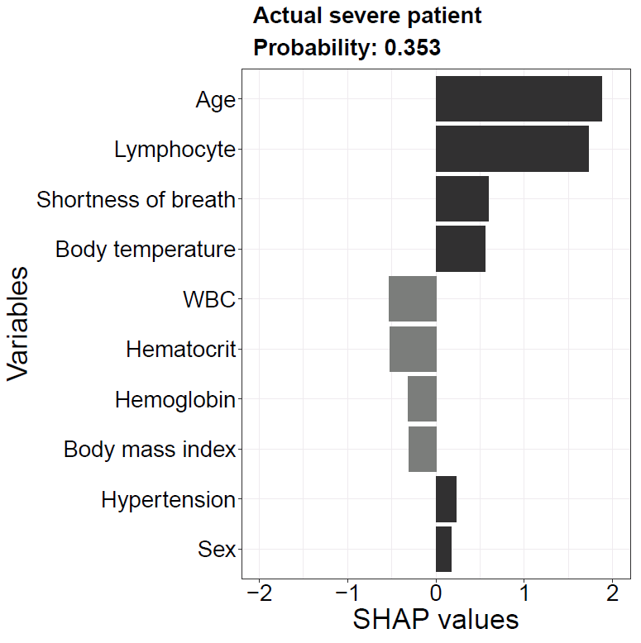
Fig. S1b
