Supporting information for:
Carbocation scavengers for soft- and hardwood pretreatment: Impact on enzymatic cellulose saccharification and microbial fermentation
B. Nikqi, J. Salzmann, M. Eckl, D. Di Francesco and Thomas Pielhop

Table of contents
Table of contents ………………………………………………..…………………………. …………………………………………………………………….. ...……………….………………………………………………… | 1
Experimental details: Raw biomass …..………...………..………....................................... | 2
Experimental details: Autohydrolysis pretreatment ..……………....................................... | 2
Experimental details: Compositional analysis of pretreated biomass .................................. | 3
Experimental details: Analysis of scavenger consumption in pretreatment ......................... | 3
Experimental details: Enzymatic saccharification ………………………............................ | 4
Experimental details: FT-IR analysis of lignin residues …………....................................... | 5
Experimental details: S. Cerevisiae and E. coli cultivation .....………................................. | 5
Table S1 ………………………………………...………..………....................................... | 7
Table S2………………………………………………...………………………………….. | 7
Figure S1..……………………………….…………………..…........................................... | 8
Figure S2..……………………………….…………………..…........................................... | 9
Figure S3..……………………………….…………………..…........................................... | 10
Figure S4..……………………………….…………………..…........................................... | 10
Figure S5..……………………………….…………………..…........................................... | 10
Figure S6..……………………………….…………………..…........................................... | 11
References………………………………………………………..……................................ | 11

Experimental details

Raw biomass
The raw biomass was analyzed for dry matter, ethanol extractives and the contents of glucan, mannan, acid-soluble lignin (ASL) and acid-insoluble lignin (AIL) according to standard National Renewable Energy Laboratory (NREL) methods [1-3]. All biomass analyses were done in triplicate, and single standard deviations are reported with the mean in this work.
Spruce was cut at the end of August 2016 in Lohn-Ammansegg (canton of Solothurn, Switzerland) from a roughly 50 year old tree, chopped through a 30 mm sieve (G30 standard) and dried at 40°C. Pieces of bark were removed and the chips were knife milled (SM200 cutting mill; Retsch) using a 1 mm screen size. The spruce had a dry matter content of 92.21 ± 0.89%, and the composition was determined to be: cellulose 37.21 ± 0.16%, hemicellulose 19.52 ± 0.51%, acid-soluble lignin 4.42 ± 0.08%, acid-insoluble lignin 28.93 ± 0.27%, whole ash 0.08 ± 0.04%, and ethanol extractives 5.46 ± 0.05% (total 95.60%).
Beech (Fagus sylvatica) was cut in the winter of 2017/18 in Mühledorf (canton of Solothurn, Switzerland) and chopped and dried as described for spruce. The chips (including pieces of bark) were knife milled (SM200 cutting mill; Retsch) using a 1.5 mm screen size. The beech had a dry matter content of 92.88 ± 0.30%, and the composition was determined to be: cellulose 37.74 ± 0.37%, hemicellulose 19.69 ± 0.84%, acid-soluble lignin 5.85 ± 0.13%, acid-insoluble lignin 22.03 ± 0.27%, whole ash 0.60 ± 0.01%, and ethanol extractives 3.31 ± 0.07% (total 89.22%).

Autohydrolysis pretreatment:
Pretreatment experiments were carried out in a customized multi-reactor system (Parr instruments MRS 5000, further details provided elsewhere [4]). Each reactor was loaded with 2.5 g of wood and 39.2 g of water. As additives, either 2-naphthol (TCI, >99%), 2-naphthol-7-sulfonate (TCI, >98%), mannitol (Riedel-de Haën, ≥98%) or syringic acid (Sigma-Aldrich, >95%) were added at a concentration of 0.2 mol/mol lignin C₉ unit, assuming a C₉ unit molecular weight of 185 g mol⁻¹ for spruce and 210 g mol⁻¹ for beech wood. In pretreatment experiments with spruce, this corresponded to 119, 210, 150 and 163 mg for 2-naphthol, 2-naphthol-7-sulfonate, mannitol and syringic acid, respectively. In pretreatment experiments with beech, this corresponded to 87, 150, 110 and 120 mg for 2-naphthol, 2-naphthol-7-sulfonate, mannitol and syringic acid, respectively. The stirring speed of the reactors was set to 400 min⁻¹. Spruce was pretreated at 210°C for 60 min, while beech was pretreated at 185°C for 120 min. The heat-up interval from 100°C (estimated onset of pretreatment effects) to the pretreatment temperatures of 185 and 210°C took about 10 and 12 min, respectively. At the end of the pretreatment time, the reactors were immersed in a water bath (0.5 L water in 1 L glass beaker), which allowed to cool down the reactor contents rapidly below 100°C in less than 1 min. The recovered slurry was vacuum filtered with a Büchner funnel, recording volume and pH of the filtrate. The solids were washed directly in the funnel with 300 mL of boiling water, and the weight and moisture of the recovered biomass were recorded.

Compositional analysis of pretreated biomass
The analyses of biomass dry matter content and biomass composition were carried out according to NREL protocols [1, 3]. The analyses of the biomass composition was downscaled as described elsewhere [4]. A Shimadzu LC-20AD XR separation module equipped with a Bio-Rad Aminex HPX-87P column with precolumn, and a Shimadzu RID-20A differential refractometer were used for high-performance liquid chromatography (HPLC) sugar analysis. All biomass analyses were performed in triplicate, and single standard deviations are reported with the mean in this work.

Analysis of scavenger consumption in pretreatment
For the analysis of mannitol in the recovered pretreatment slurry, 2 mL of the slurry were filtered with a hydrophilic PTFE syringe filter (0.45 µm pore size, 25 mm diameter). and analyzed by high-performance liquid chromatography (HPLC, System: Thermo Fisher Vanquish; column: Bio-Rad Aminex HPX-87P, column temperature: 85°C, mobile phase: deionized water, flow rate: 0.6 mL·min⁻¹; detector: refractive index).
For the analysis of syringic acid, 10 mL of methanol were added to the complete recovered pretreatment slurry, in order to enhance the solubility of syringic acid [5]. 2 mL of the obtained mixture were filtered as described for mannitol and analyzed by HPLC (System: Shimadzu Nextera, column: Luna 5 µm C18(2), column temperature: 35°C, flow rate: 0.7 mL·min⁻¹, detector: diode array measuring at 270 nm). Methanol (A) and 0.1% H₃PO₄ in water (B) were used as mobile phase with an elution gradient, in order to separate syringic acid from other pretreatment byproducts: 0-10 min: 60-40% B, 10-12 min: 40-25% B, 12-15 min: 25% B.
For the analysis of 2-naphthol-7-sulfonate, 2 mL of the pretreatment slurry were filtered and analyzed by HPLC as described for syringic acid, but using fluorescence detection (excitation at 275 nm, emission at 350 nm) as described previously for naphthalene sulfonates [6].
Due to its low water-solubility, 2-naphthol was analyzed by gas chromatography-mass spectrometry (GC-MS). Therefore, the complete pretreatment slurry was first extracted with 40 mL of chloroform. 2 mL of the extract were then filtered with a hydrophilic PTFE syringe filter (0.45 µm pore size, 25 mm diameter) and analyzed by GC-MS (System: Agilent 7890A GC; 5975 Series mass selective detector; column: HP-1, 60 m length, 0.32 mm inner diameter, 5 µm film thickness, stationary phase 100% dimethylpolysiloxane). The injector temperature was 240°C and an injection volume of 1 µL (splitless) was used with helium as carrier gas (flow rate: 1.3 mL·min⁻¹). The GC-oven program (start 50°C, heating to 300°C @ 8°C min⁻¹, 300°C for 2 min) resulted in a total runtime of 33.25 min.
The analyses for all compounds were done in duplicate, and mean values along with single standard deviations are reported in this work. Quantification was based on external calibration using standard solutions.

Enzymatic saccharification
Enzymatic saccharification of the pretreated biomass was conducted according to the NREL standard procedure, preparing 10 g of slurry with a cellulose concentration of 1% w/w in 20 mL scintillations vials [7]. The following adaptions were made: sodium azide with a final concentration of 0.2 g L⁻¹ was used instead of antibiotics, and the pH of the 0.05 M sodium citrate buffer was adjusted to 5.0. Accellerase 1500 (Genencor) with an activity of 26 FPU mL⁻¹, determined according to the NREL standard procedure [8], was used with a starting concentration of 15 FPU g⁻¹ cellulose for pretreated spruce and 2.5 FPU g⁻¹ cellulose for pretreated beech wood. The samples were incubated in a shaker (Multitron Standard; Infors HT) with a shaking throw of 25 mm, at 180 rpm and 50°C for 14 days. After 3, 7 and 9 days, a second, third and fourth enzyme dose was added. For pretreated spruce wood, the additional enzyme doses corresponded to concentrations of 30, 60 and 120 FPU g⁻¹ cellulose, respectively, in the biomass slurry. For pretreated beech wood, the additional enzyme doses corresponded to concentrations of 5, 10 and 20 FPU g⁻¹ cellulose, respectively, in the biomass slurry. The detailed sample compositions and enzyme dosing are shown in Table S1. During the enzymatic conversion, 0.3 mL samples of the biomass slurry were taken at different time intervals and analyzed for sugars in the supernatant. Sugars were analyzed by HPLC as described above for the compositional analysis of the pretreated biomass. All saccharification experiments were carried out in triplicate, and single standard deviations are reported with the mean.

FT-IR analysis of lignin residues
The lignin residues from the enzymatic saccharification experiments were dried and analyzed by Fourier transform infrared (FT-IR) spectrometry. Spectra were recorded (scan range: 4000-600 cm⁻¹, number of scans: 4, resolution: 4.0 cm⁻¹) with a PerkinElmer Frontier FT-IR spectrometer, equipped with a PerkinElmer universal attenuated total reflection (UATR) accessory (Diamond/ZnSe). Neat samples were analyzed by placing them directly onto the ATR crystal.

S. Cerevisiae and E. coli cultivation
In cultivations with S. Cerevisiae, a growth medium with a glucose content of 1% w/w was prepared, using 25 g micro-granulated yeast extract (Roth), 50 g peptone (enzymatic digest of casein; Roth) and 25 g glucose (≥ 98%; Fluka). Distilled water was added to achieve a total volume of 2.5 L, the pH was adjusted to 6 with 0.1M HCl, and the medium was sterilized in an autoclave. The medium was used for preparing 50 mL samples in 100 mL Erlenmeyer flasks. This included the control experiments and the experiments with different additives at different concentrations, which were sterilized again by autoclavation after the additives had been added. Control experiments were prepared in triplicate, while the samples with additives were prepared as single experiments. For preparing the inoculum, 7 g of dry yeast (Naturaplan, Coop, Switzerland) together with 250 mL of sterile medium were cultivated in an 0.5 L Erlenmeyer flask overnight at 37°C (110 RPM). 0.5 mL of the inoculum were then added to each of the control and additive experiments under sterile conditions. The cultivation was performed in a shaker (Multitron Standard; Infors HT) with a shaking throw of 25 mm, at 170 rpm and 37°C for 28 h. 1 mL samples of the broth were taken at different time intervals under sterile conditions for analysis. The optical density of the samples was measured at a wavelength of 600 nm (OD₆₀₀), to monitor the biomass growth. In addition, the glucose and ethanol concentrations of the samples were analyzed by HPLC (System: Shimadzu LC-20AD XR, column: Bio-Rad Aminex HPX-87H with precolumn, column temperature: 60°C, mobile phase: 0.0025 M H₂SO₄, flow rate: 0.6 mL·min⁻¹, detector: Shimadzu RID-20A differential refractometer). For the control experiments, single standard deviations are reported with the mean in this work.
For cultivations with E. coli, a growth medium was prepared using 25 g Nutrient Broth No. 2 (Dehydrated, Thermo Scientific), 25 g peptone (enzymatic digest of casein; Roth) and 12.5 g NaCl (≥ 99.5%; Roth). Distilled water was added to achieve a total volume of 2.5 L, resulting in a neutral pH of 7, and the medium was sterilized in an autoclave. Control experiments and samples with different additives at different concentrations were prepared as described for S. Cerevisiae. For preparing the inoculum, 50 µL of an E. Coli strain culture of BL21(DE3), together with 250 mL of sterile medium, were cultivated in an 0.5 L Erlenmeyer flask overnight at 37°C (110 RPM). Inoculation, cultivation, sampling and OD₆₀₀ measurements were carried out as described for S. Cerevisiae. In addition, the concentrations of glucose, ethanol, acetic acid, formic acid and lactic acid in the samples were analyzed by HPLC, using the same HPLC setup as described above for the S. Cerevisiae experiments. For the control experiments, single standard deviations are reported with the mean in this work.

Supplementary tables

Table S1: Overview of sample compositions in the enzymatic conversion experiments. Cellulase enzyme (Accellerase 1500) was added at the start and after 3, 7 and 9 days.
Wood | Pretreatment additive | Pretreated biomass (wet) [g] | H₂O  [mL] | Citric acid buffer,  1 mol L⁻¹ [mL] | Sodium azide,  20 g L⁻¹ [mL] | Accellerase 1500 [mL]
 |  |  |  |  |  | Start | Day 3 | Day 7 | Day 9
Spruce | - (control) | 0.6517 | 8.915 | 0.5 | 0.1 | 0.058 | 0.056 | 0.101 | 0.182
Spruce | 2-Naphthol | 0.6841 | 8.899 | 0.5 | 0.1 | 0.058 | 0.056 | 0.101 | 0.182
Spruce | 2-Naphthol-7-sulfonate | 0.6195 | 8.940 | 0.5 | 0.1 | 0.058 | 0.056 | 0.101 | 0.182
Spruce | Mannitol | 0.6430 | 8.923 | 0.5 | 0.1 | 0.058 | 0.056 | 0.101 | 0.182
Spruce | Syringic acid | 0.6288 | 8.945 | 0.5 | 0.1 | 0.058 | 0.056 | 0.101 | 0.182
Beech | - (control) | 0.4581 | 9.120 | 0.5 | 0.1 | 0.010 | 0.009 | 0.017 | 0.030
Beech | 2-Naphthol | 0.4791 | 9.107 | 0.5 | 0.1 | 0.010 | 0.009 | 0.017 | 0.030
Beech | 2-Naphthol-7-sulfonate | 0.4135 | 9.150 | 0.5 | 0.1 | 0.010 | 0.009 | 0.017 | 0.030
Beech | Mannitol | 0.4708 | 9.112 | 0.5 | 0.1 | 0.010 | 0.009 | 0.017 | 0.030
Beech | Syringic acid | 0.4449 | 9.142 | 0.5 | 0.1 | 0.010 | 0.009 | 0.017 | 0.030

Table S2: Relative change in enzymatic cellulose conversion by the pretreatment additives, compared to the control as reference value. Enzyme dosages are indicated in FPU g⁻¹ cellulose.
Wood | Pretreatment additive | Conversion change [%]
Wood | Pretreatment additive | 15 FPU | 30 FPU | 60 FPU | 120 FPU
Spruce | 2-Naphthol | +20 ± 2 | +30 ± 0.5 | +19 ± 2 | +8 ± 4
Spruce | 2-Naphthol-7-sulfonate | +110 ± 6 | +66 ± 3 | +30 ± 2 | +10 ± 1
Spruce | Mannitol | +8 ± 2 | +2 ± 2 | -2 ± 2 | -5 ± 1
Spruce | Syringic acid | -4 ± 2 | +2 ± 1 | -1 ± 1 | -2 ± 2
 |  | 2.5 FPU | 5 FPU | 10 FPU | 20 FPU
Beech | 2-Naphthol | -10 ± 0.5 | +4 ± 3 | +4 ± 3 | +2 ± 2
Beech | 2-Naphthol-7-sulfonate | +19 ± 2 | +20 ± 3 | +9 ± 3 | +4 ± 0.5
Beech | Mannitol | +9 ± 2 | +12 ± 4 | +4 ± 5 | +2 ± 5
Beech | Syringic acid | +1 ± 1 | +18 ± 3 | +11 ± 3 | +6 ± 3

Supplementary figures

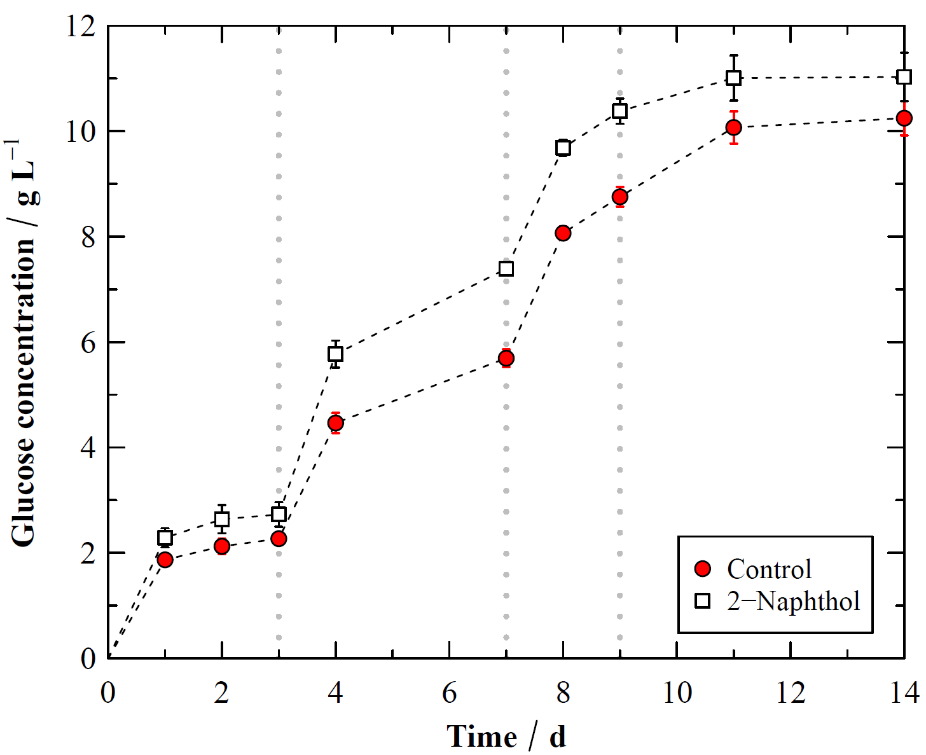 | 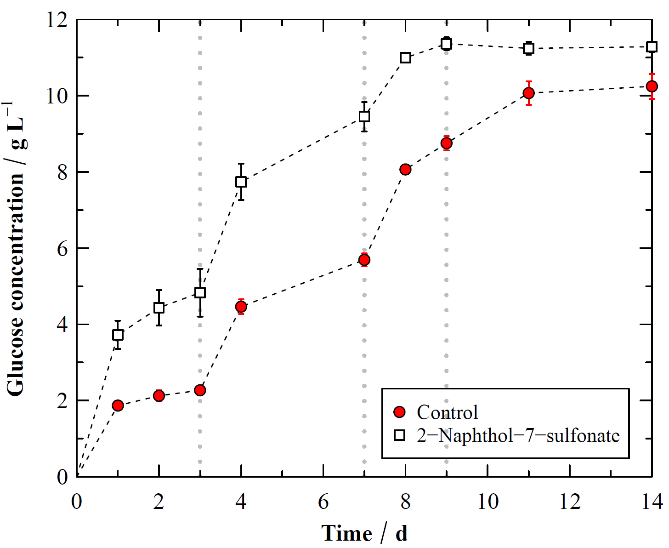
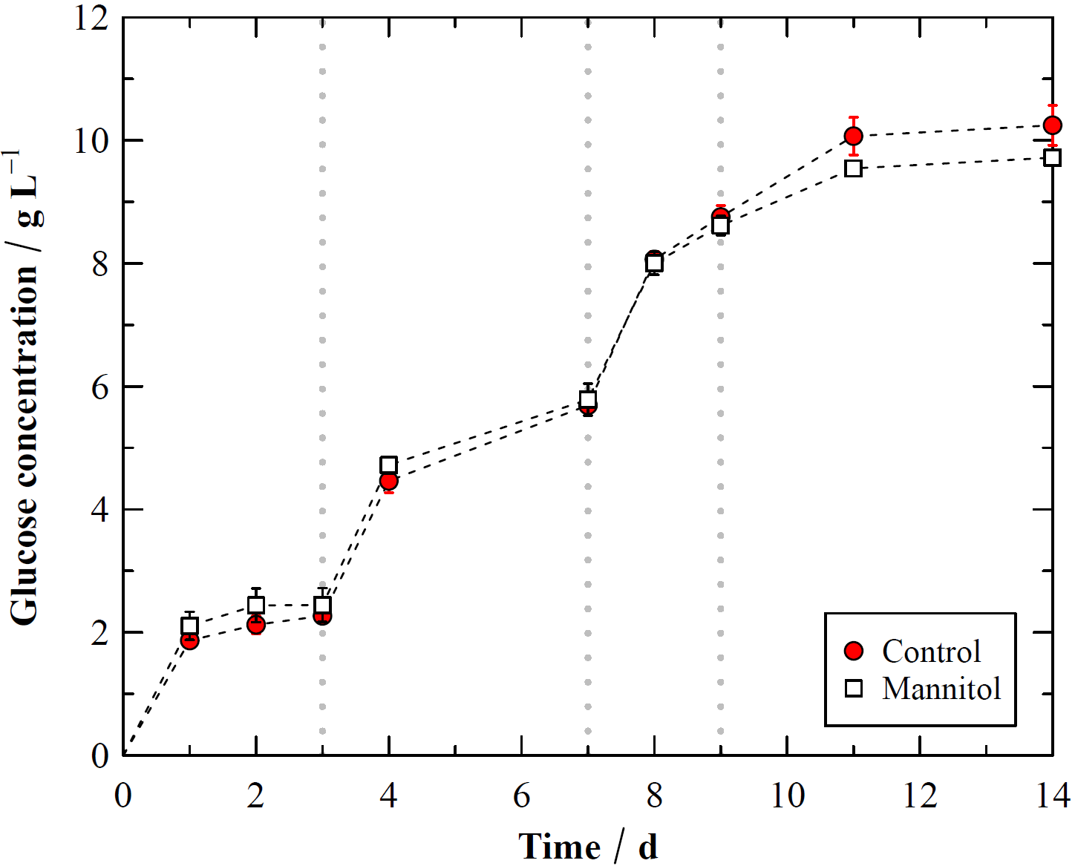 | 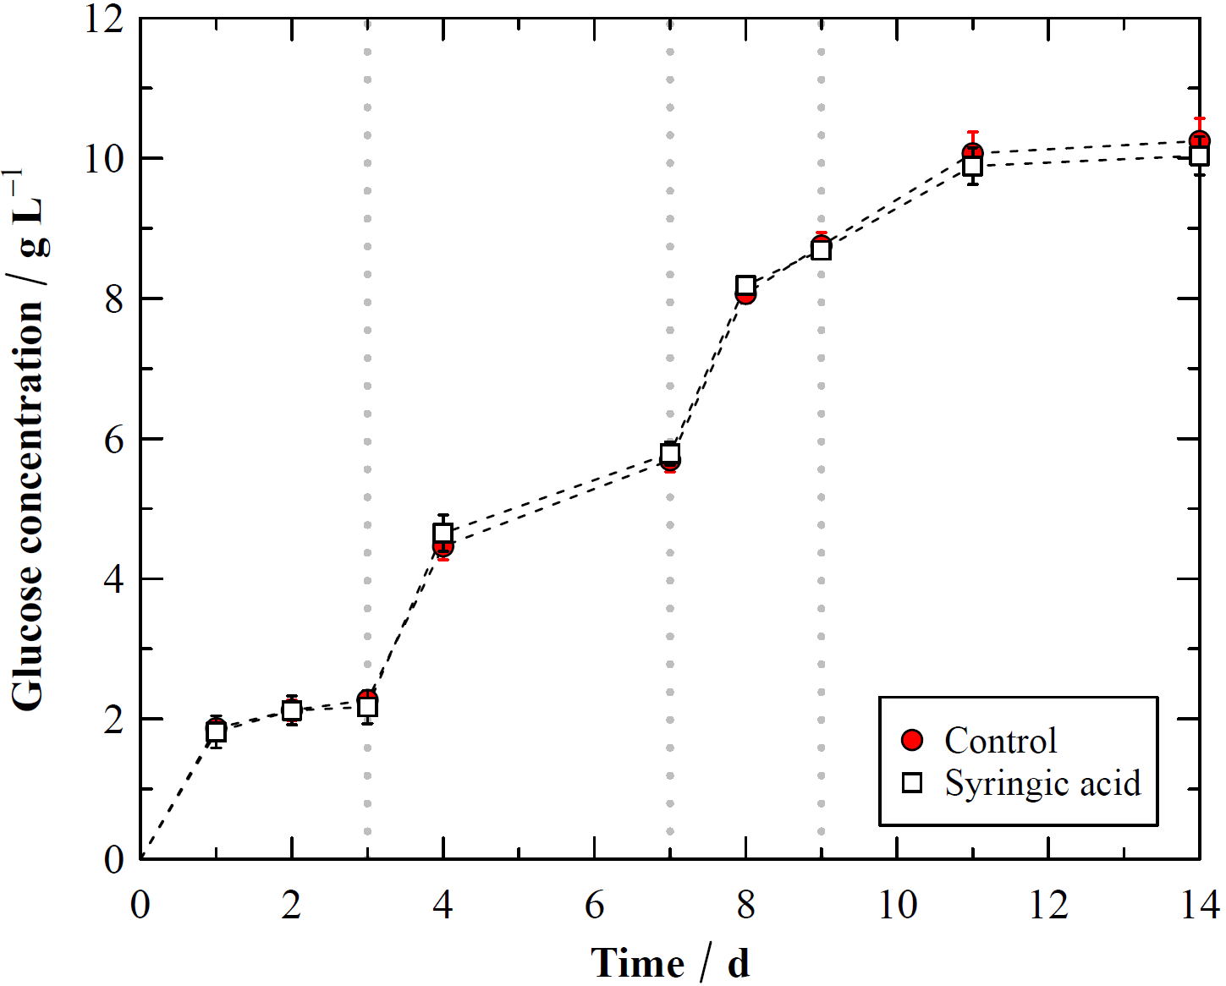
Figure S1: Progress in the enzymatic cellulose conversion of spruce after autohydrolysis pretreatment. Shown are experiments with the pretreatment additives 2-naphthol, 2-naphthol-sulfonate, mannitol and syringic acid (0.2 mol/mol lignin C₉ unit), each compared to the control without additive. Saccharification conditions: 1%w/w cellulose, initial enzyme dose 15 FPU g⁻¹ cellulose. Further 15, 30 and 60 FPU g⁻¹ cellulose were added after 3, 7 and 9 days, respectively (dashed vertical lines).

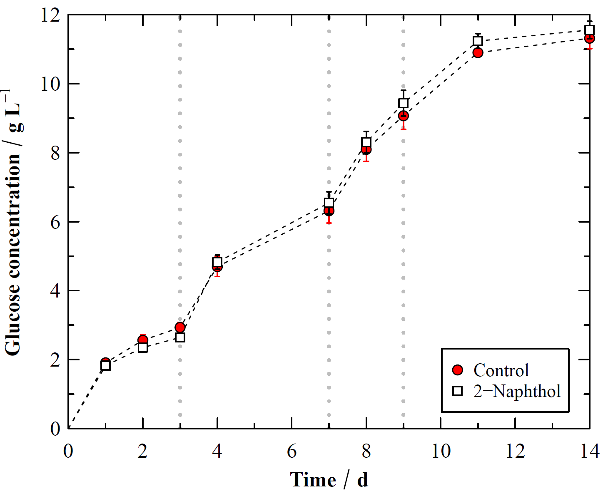 | 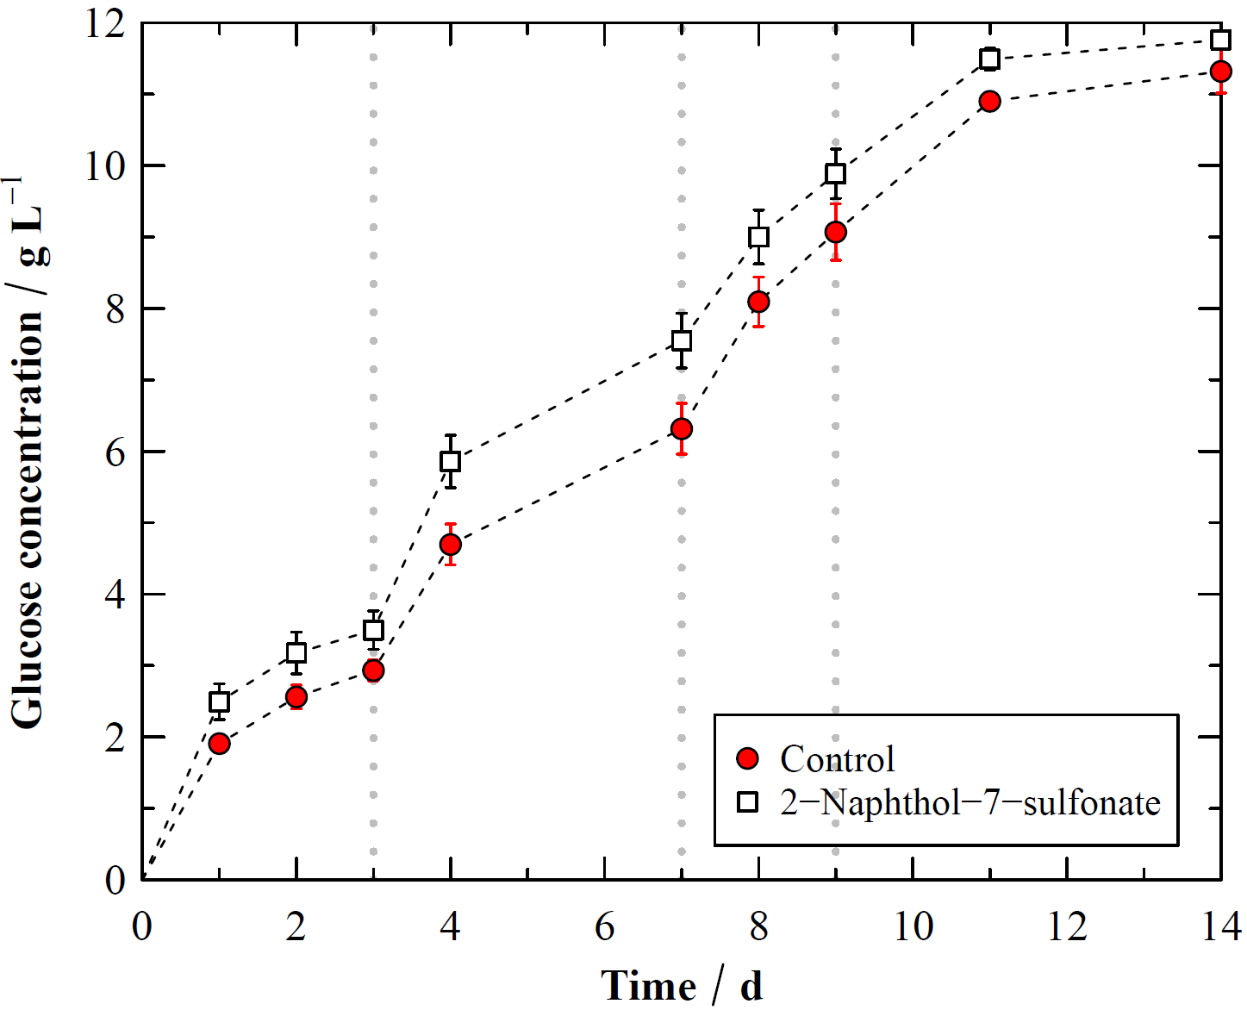
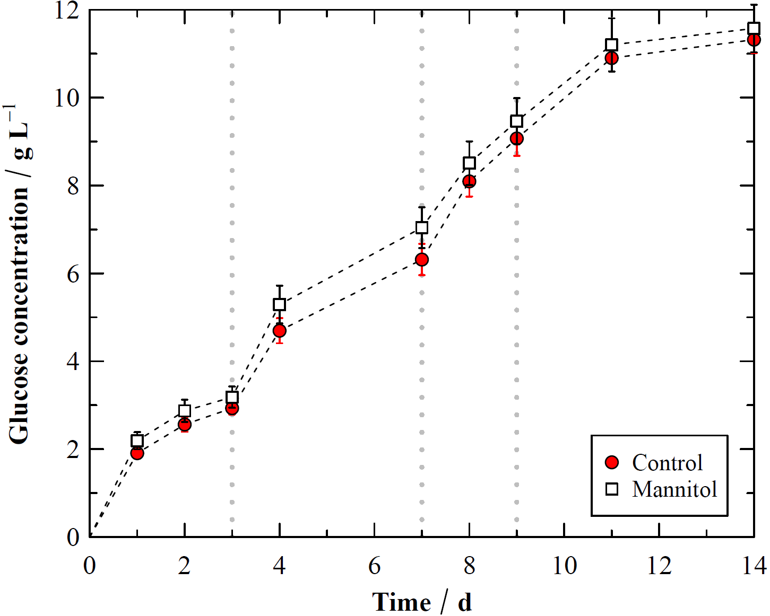 | 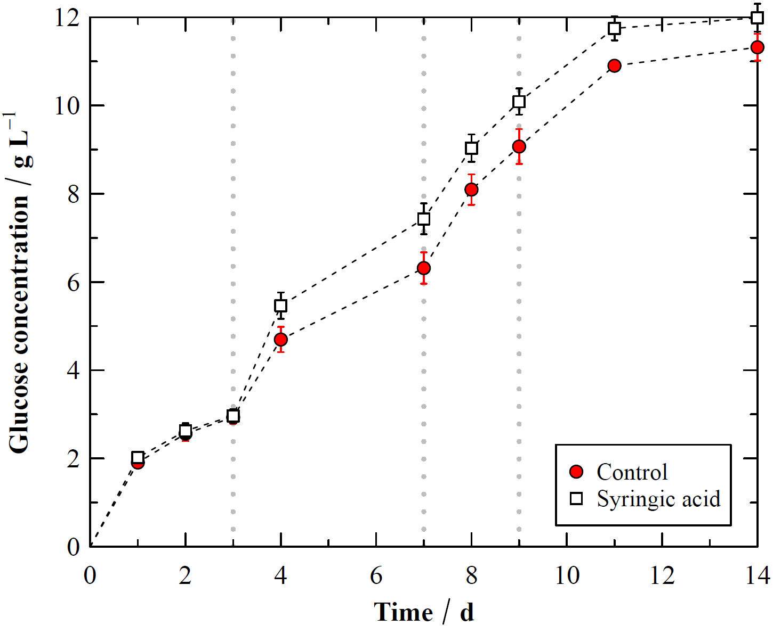
Figure S2: Progress in the enzymatic cellulose conversion of beech after autohydrolysis pretreatment. Shown are experiments with the pretreatment additives 2-naphthol, 2-naphthol-sulfonate, mannitol and syringic acid (0.2 mol/mol lignin C₉ unit), each compared to the control without additive. Saccharification conditions: 1%w/w cellulose, initial enzyme dose 2.5 FPU g⁻¹ cellulose. Further 2.5, 5 and 10 FPU g⁻¹ cellulose were added after 3, 7 and 9 days, respectively (dashed vertical lines).

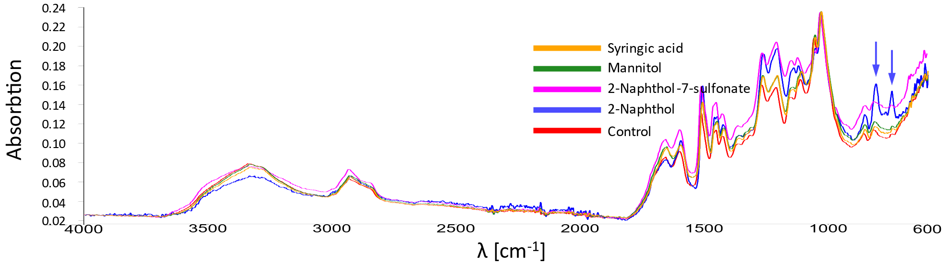
Figure S3: FT-IR spectra of lignin residues from the enzymatic saccharification of spruce. The spruce had been pretreated without additive (control) and with 2-naphthol, 2-naphthol-7-sulfonate, mannitol and syringic acid. Signals at 815 and 750 cm⁻¹ (highlighted) are characteristic of 1,2-disubstituted naphthalenes [9, 10].

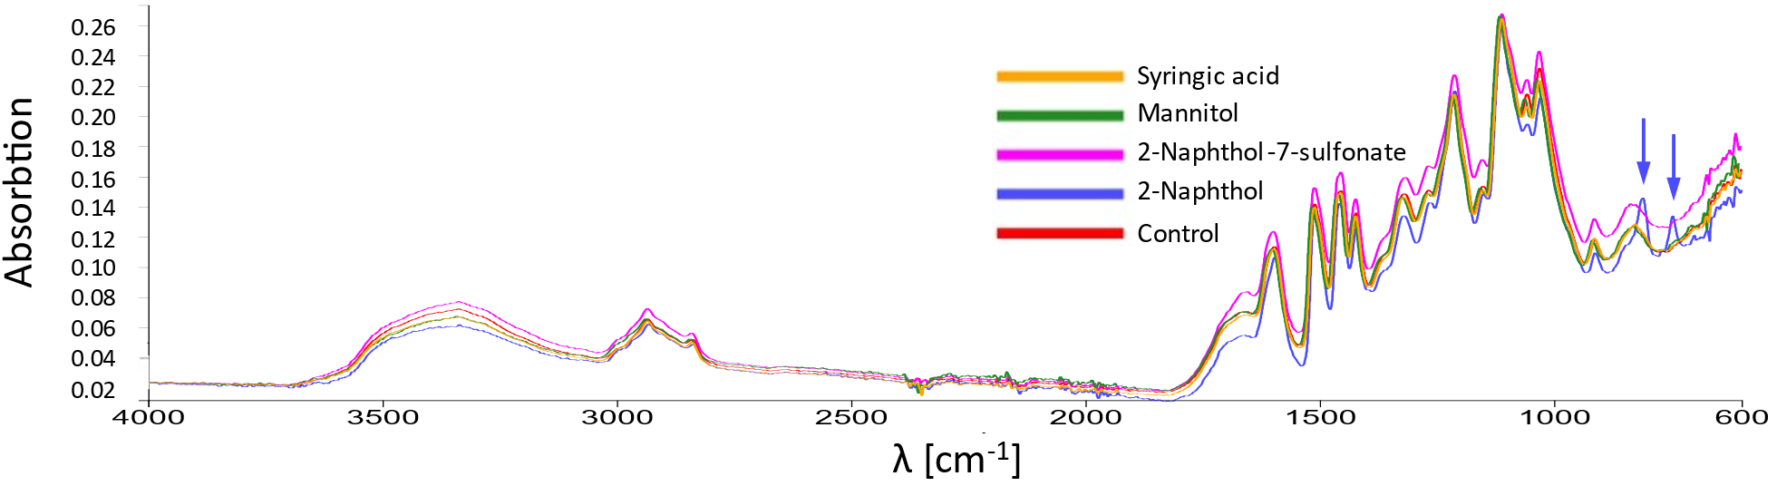
Figure S4: FT-IR spectra of lignin residues from the enzymatic saccharification of beech. The beech had been pretreated without additive (control) and with 2-naphthol, 2-naphthol-7-sulfonate, mannitol and syringic acid. Signals at 815 and 750 cm⁻¹ (highlighted) are characteristic of 1,2-disubstituted naphthalenes [9, 10].

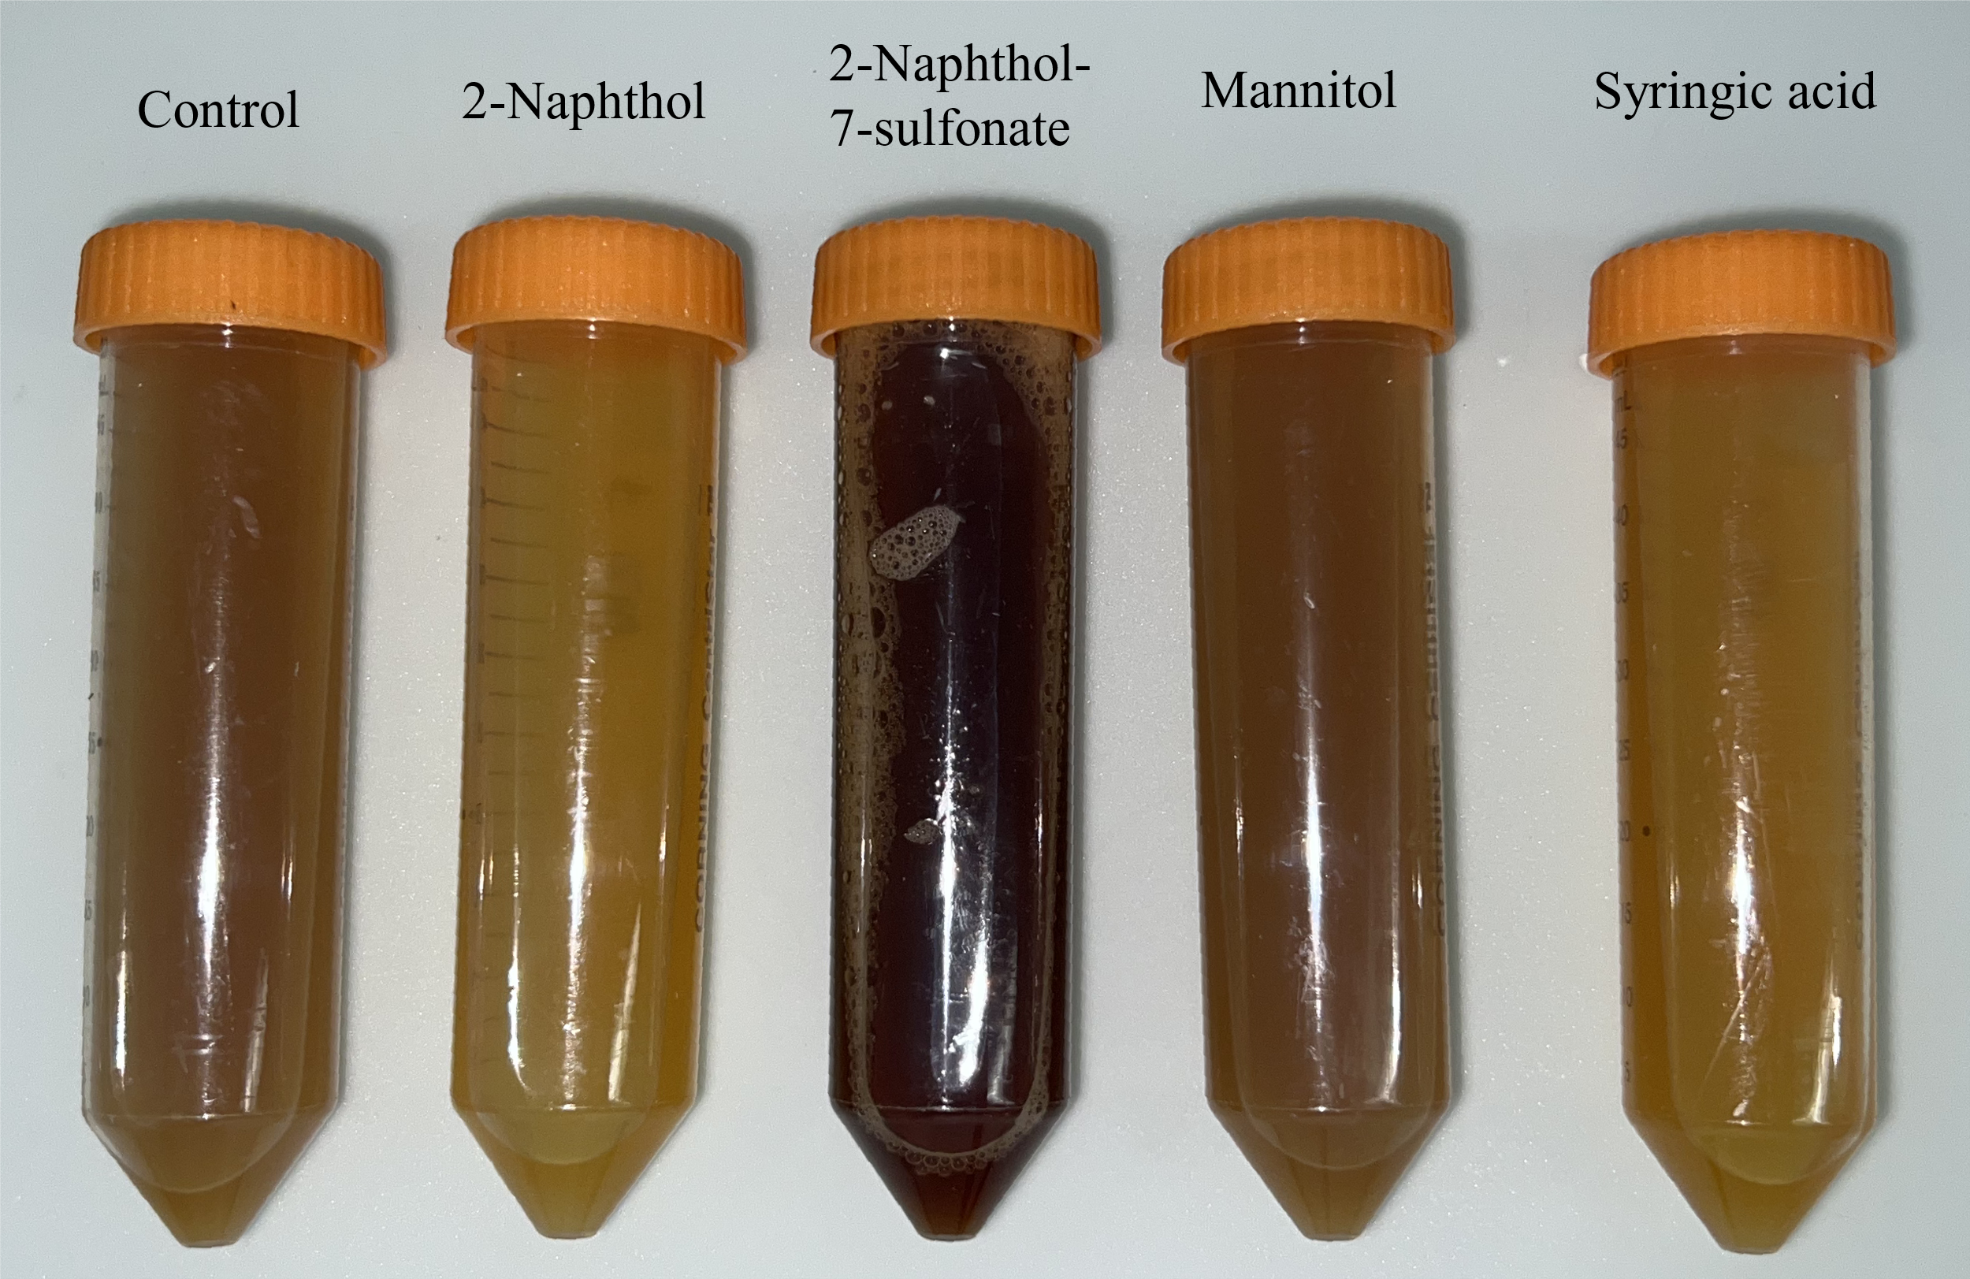 |  | 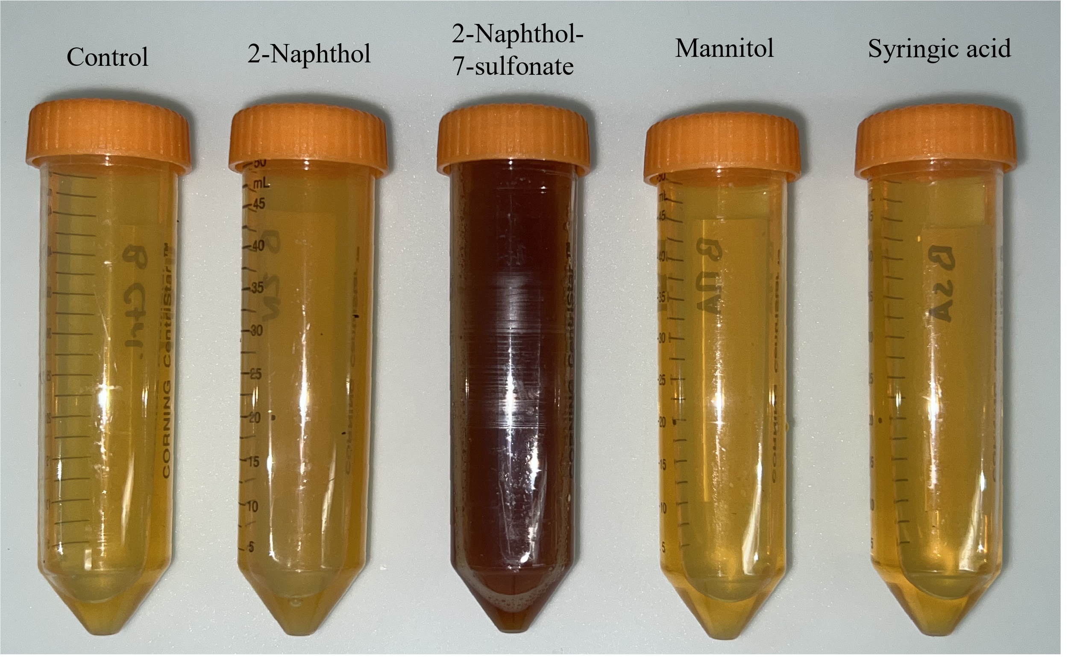
(a) | (b)
Figure S5: Liquors obtained after the pretreatments without additive (control) and with 2-naphthol, 2-naphthol-7-sulfonate, mannitol and syringic acid. Shown are both the samples obtained from spruce (a) and beech (b) wood.

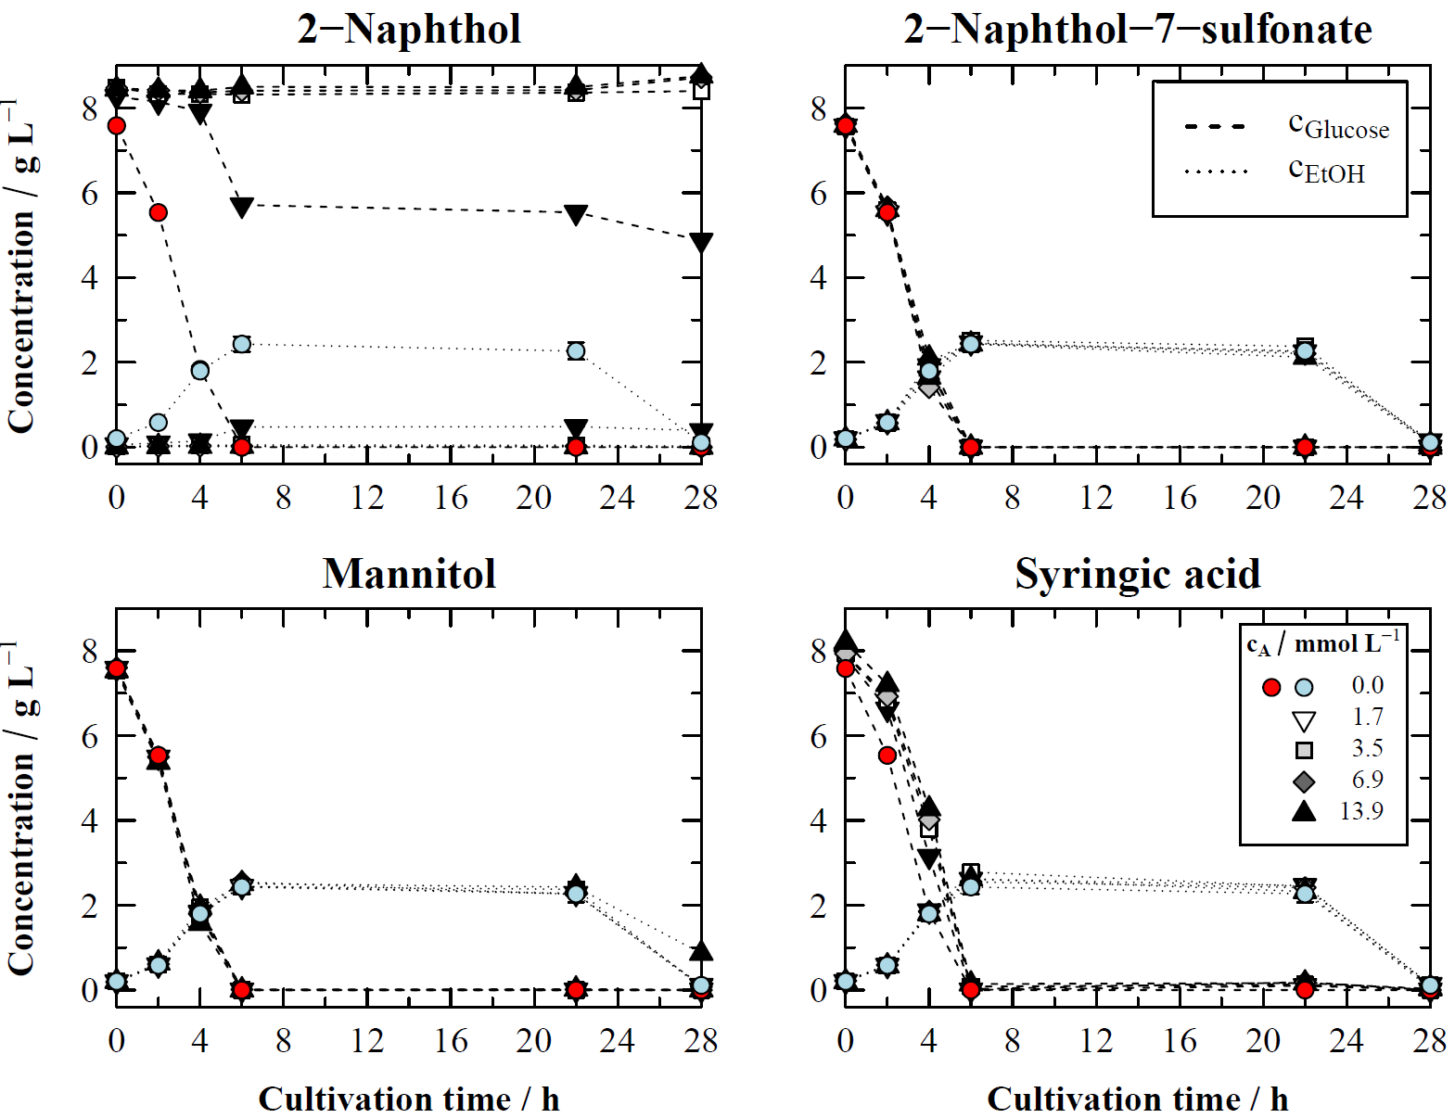
Figure S6: Glucose and ethanol concentrations in the cultivation of S. cerevisiae without additive (control) and with 2-naphthol, 2-naphthol-7-sulfonate, mannitol and syringic acid added at different concentrations (c_{A}). All additives added in equimolar amounts.

References
1. Sluiter, A., et al., Determination of Structural Carbohydrates and Lignin in Biomass. NREL/TP-510-42618, 2008, National Renewable Energy Laboratory: Golden, CO.
2. Sluiter, A., et al., Determination of Extractives in Biomass. NREL/TP-510-42619, 2005, National Renewable Energy Laboratory: Golden, CO.
3. Sluiter, A., et al., Determination of Total Solids in Biomass and Total Dissolved Solids in Liquid Process Samples. NREL/TP-510-42621, 2008, National Renewable Energy Laboratory: Golden, CO.
4. Pielhop, T., et al., Lignin repolymerisation in spruce autohydrolysis pretreatment increases cellulase deactivation. Green Chemistry, 2015. 17(6): p. 3521 - 3532.
5. Vilas-Boas, S.M., et al., Solvent and temperature effects on the solubility of syringic, vanillic or veratric acids: Experimental, modeling and solid phase studies. Journal of Molecular Liquids, 2019. 289: p. 111089.
6. Nottebohm, M. and T. Licha, Detection of naphthalene sulfonates from highly saline brines with high-performance liquid chromatography in conjunction with fluorescence detection and solid-phase extraction. Journal of chromatographic science, 2012. 50(6): p. 477-481.
7. Selig, M., N. Weiss, and Y. Ji, Enzymatic Saccharification of Lignocellulosic Biomass. NREL/TP-510-42629, 2008, National Renewable Energy Laboratory: Golden, CO.
8. Adney, B. and J. Baker, Measurement of Cellulase Activities. NREL/TP-510-42628, 1996, National Renewable Energy Laboratory: Golden, CO.
9. Wayman, M. and J.H. Lora, Simulated autohydrolysis of aspen milled wood lignin in the presence of aromatic additives: Structural modifications. Journal of Applied Polymer Science, 1980. 25(10): p. 2187-2194.
10. Hawkins, J.G., E.R. Ward, and D.H. Whiffen, Characteristic infra-red absorption frequencies of substituted naphthalenes. Spectrochimica Acta, 1957. 10(1): p. 105-109.

