Too hot for my bugs: Mediterranean heatwaves disrupt associated microbiomes in the sponge Petrosia ficiformis

Luigi Maria Cusano^{1,2}, Valerio Mazzella^{2,3*}, Antonia Chiarore³, Alice Mirasole³, Núria Teixidó³, Jana Efremova¹, Laura Núñez-Pons^{1,2*}

Supplementary Material

Table S1. Temperature statistics for the period July, August, and September (JAS). Means were calculated from hourly measurements taken by in situ hobo sensors from 2012 to 2023 at 5 m depth. Summer periods include July 1 through September 30. Values are mean, sd, minimum, 25th and 75th percentiles, maximum, and n. Threshold T> 27°C represents the % of measurements registered above 27°C.

year | mean | sd | min | max | per25 | per75 | Threshold | n
 |  |  |  |  |  |  | T> 27°C
2012 | 23.573 | 0.92151 | 20.841 | 26.207 | 22.92 | 24.002 | 0 | 1408
2013 | 24.7232 | 1.84301 | 20.531 | 27.974 | 22.992 | 26.524 | 14.1837 | 2940
2014 | 24.5783 | 1.20883 | 18.723 | 27.161 | 23.809 | 25.404 | 0.30738 | 2928
2015 | 25.1732 | 2.19391 | 20.412 | 28.99 | 23.256 | 26.867 | 21.0041 | 2928
2016 | 24.5936 | 1.5714 | 20.889 | 28.122 | 23.617 | 25.793 | 2.50678 | 2952
2017 | 24.4458 | 2.0943 | 19.674 | 29.015 | 22.705 | 25.987 | 7.30874 | 2928
2018 | 25.3151 | 2.22126 | 20.77 | 29.14 | 22.848 | 26.793 | 21.9679 | 2927
2019 | 25.568 | 1.67986 | 19.722 | 28.072 | 24.406 | 27.02 | 25.6812 | 2936
2020 | 24.8809 | 2.14446 | 18.699 | 28.642 | 22.25 | 26.402 | 16.3101 | 2851
2021 | 26.0219 | 1.4238 | 20.269 | 28.394 | 25.453 | 26.989 | 24.888 | 2455
2022 | 25.5748 | 2.17304 | 20.412 | 28.965 | 22.776 | 27.382 | 35.5691 | 2952

Table S2. Pre-processing of sequencing raw reads. Filtering outcomes after DADA2 denoising, showing the number of reads per sample and by sample grouping (Unhealthy, Healthy), and the percentage of sequences passing through after each step.

Sample | Raw | Filtered | Filtered (%) | Denoised | Merged | Merged (%) | Non- chimeric | Non-chimeric (%)
VcPf1N | 184232 | 129458 | 70.27 % | 116223 | 96414 | 52.33 % | 67555 | 36.67 %
VcPf2N | 282116 | 203397 | 72.10 % | 183043 | 151542 | 53.70 % | 102590 | 36.30 %
VcPf3N | 200605 | 143874 | 71.72 % | 133450 | 116675 | 58.10 % | 85962 | 42.80 %
VcPf4N | 138215 | 97595 | 70.61 % | 86450 | 70245 | 50.80 % | 48591 | 35.10 %
VcPf5N | 230166 | 162874 | 70.70 % | 145231 | 117137 | 50.80 % | 77353 | 33.60 %
VcPfA | 272394 | 176589 | 64.80 % | 161603 | 126888 | 46.50 % | 74508 | 27.30 %
VcPfB | 160409 | 108772 | 67.80 % | 97780 | 77380 | 48.20 % | 47631 | 29.60 %
VcPfC | 150209 | 97920 | 65.10 % | 86211 | 64963 | 43.20 % | 41458 | 27.60 %
VcPfD | 169800 | 109751 | 64.60 % | 101053 | 84633 | 49.80 % | 61416 | 36.10 %
VcPfE | 145292 | 97219 | 66.90 % | 86480 | 67652 | 46.50 % | 41567 | 28.60 %
Total | 1933438 | 1327449 | 68.66 % | 1197524 | 973529 | 50.35 % | 648631 | 33.55 %
Unhealthy | 1035334 | 737198 | 71.20 % | 664397 | 552013 | 53.30 % | 382051 | 36.90 %
Healthy | 898104 | 590251 | 66.00 % | 533127 | 421516 | 46.90 % | 266580 | 29.60 %

Table S3. Sequencing overview. Number of reads and frequency distribution of rarefied and non-rarefied feature filtered tables for the whole dataset.

 | n | Rarefaction depth | Number ASVs | Total frequency | Median frequency per sample | Min. frequency per feature | Max. frequency per feature
Unrarefied | 10 |  | 1137 | 638147 | 65946 | 10 | 55167
Rarefied | 10 |  | 1136 | 390099 | 39010 | 2 | 26884

Table S4. Number of MHW events, duration (number of days), and maximum intensity (°C) from 2012 to 2023. Data were collected using in situ data loggers at 5 m with hourly measurements (HOBO TidbiT v2, Onset).

Year | N. events | Duration (days) | Max. Intensity (°C)
2013 | 1 | 17 | 1.3
2014 | 6 | 96 | 1.7
2015 | 1 | 5 | 1.8
2016 | 1 | 5 | 1.2
2017 | 1 | 9 | 1.2
2018 | 4 | 42 | 2.2
2019 | 3 | 26 | 2.1
2020 | 1 | 6 | 0.9
2021 | 1 | 6 | 1.8
2022 | 6 | 71 | 2.7

Tables S5-S18 are reported in the excel file Supplementary_Data2.xslx

Table S5. Feature ASV table with counts abundance, metadata information, taxonomy.

Table S6. Shared ASVs across Healthy and Unhealthy sponges, reporting their relative abundance contribution within each sample and their taxonomy.

Table S7. Statistical output tables for alpha and beta diversity analyses, beta dispersion and dysbiosys index.

Table S8. Taxonomy of the core taxa in Healthy core microbiomes, calculated at 100 % prevalence across samples and 0.01 % detection.

Table S9. Taxonomy of core taxa in Unhealthy core microbiomes, calculated at 100 % prevalence across samples and 0.01 % detection.

Table S10. Relative abundance values of core taxa within Healthy and Unhealthy core microbiomes, calculated at 100 % prevalence across samples and 0.01 % detection. sd: standard deviation.

Table S11. Core size (CA) of the core microbiome of Healthy and Unhealthy sponge groups, calculated at 100 % prevalence across samples and 0.01 % detection. sd: standard deviation.

Table S12. Differentially abundant taxa markers at the genus level between Healthy and Unhealthy sponge microbiomes obtained from Aldex2 with method Welch' T-tests statistic at the genus level. ef aldex2: effect size value (log fold change); p adj: FDR adjusted p-value for repeated measures.

Table S13. Differentially abundant taxa markers at the ASV level between Healthy and Unhealthy sponge microbiomes obtained from Aldex2 with method Welch' T-tests statistic at the genus level. ef aldex2: effect size value (log fold change); p adj: FDR adjusted p-value for repeated measures.

Table S14. Topological properties of prokaryotic community compositional co-occurrence networks for the Healthy and the Unhealthy sponge groups constructed with R > 0.35 and R > 0.98.

Table S15. Modules table of Healthy co-occurrence network built at correlation threshold R > 0.35.

Table S16. Modules table of Healthy co-occurrence network built at correlation threshold R > 0.98.

Table S17. Modules table of Unhealthy co-occurrence network built at correlation threshold R > 0.35.

Table S18. Modules table of Unhealthy co-occurrence network built at correlation threshold R > 0.98.

SUPPLEMENTARY FIGURES

Fig. S1. Prokaryotic phylum composition. Relative abundance of prokaryotic community composition at the phylum level associated with Healthy and Unhealthy P. ficiformis sponges, with the best annotated taxonomy. In blue writing samples refer to the Healthy sponges, whereas is red are the Unhealthy specimens after the heatwave.

Fig. S2. Prokaryotic class composition. Relative abundance of prokaryotic community composition at the class level associated with Healthy and Unhealthy P. ficiformis sponges, with the best annotated taxonomy. In blue writing samples refer to the Healthy sponges, whereas is red are the Unhealthy specimens after the heatwave. Top 40 abundant taxa overall the dataset were considered, while all the taxa present whose relative abundance was < 1% detection (sum of the frequencies) were grouped in “Other”.
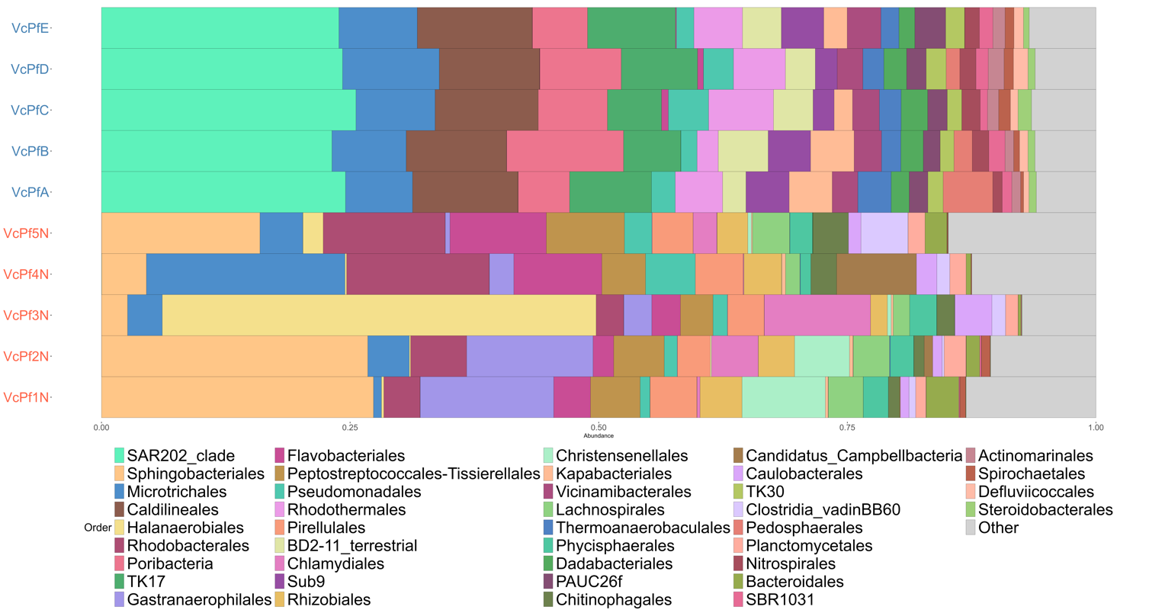
Fig. S3. Prokaryotic order composition. Relative abundance of prokaryotic community composition the order level associated with Healthy and Unhealthy P. ficiformis sponges, with the best annotated taxonomy. In blue writing samples refer to the Healthy sponges, whereas is red are the Unhealthy specimens after the heatwave. Top 40 abundant taxa overall the dataset were considered, while all the taxa present whose relative abundance was < 1% detection (sum of the frequences) were grouped in “Other”.

Fig. S4. Prokaryotic genus composition. Relative abundance of prokaryotic community composition the genus level associated with Healthy and Unhealthy P. ficiformis sponges, with the best annotated taxonomy. In blue writing samples refer to the Healthy sponges, whereas is red are the Unhealthy specimens after the heatwave. Top 40 abundant taxa overall the dataset were considered, while all the taxa present whose relative abundance was < 1% detection (sum of the frequences) were grouped in “Other”.
Fig. S5. Venn’s diagram. Unique and shared prokaryotic ASVs between healthy and affected specimens.
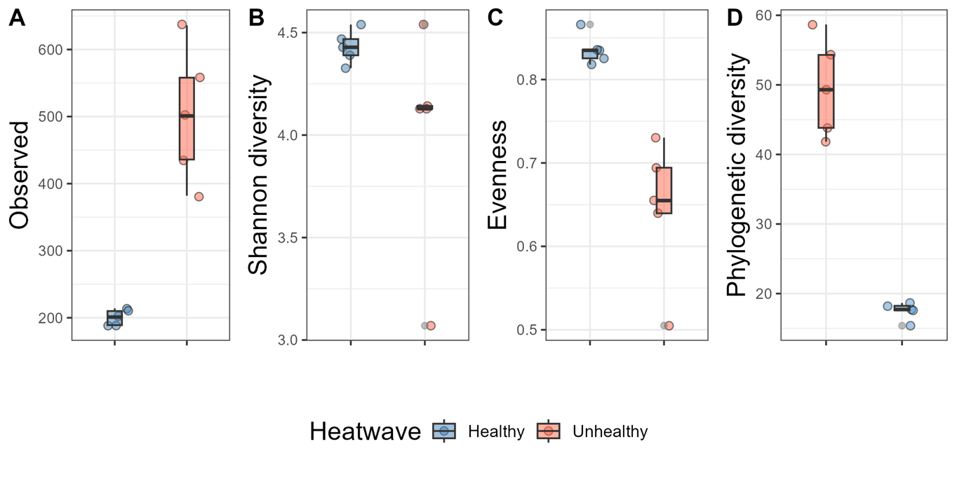
Fig. S6. Alpha diversity. Box plots reporting alpha diversity values of sponge microbial communities according to: A) Observed ASV richness; B) Shannon-Weaner diversity; C) Pielou Evenness and D) Phylogenetic diversity. Unhealthy sponges revealed higher richness and phylogenetic diversity, and lower evenness with respect to Healthy specimens (Welch’s T-tests, p-value < 0.05).

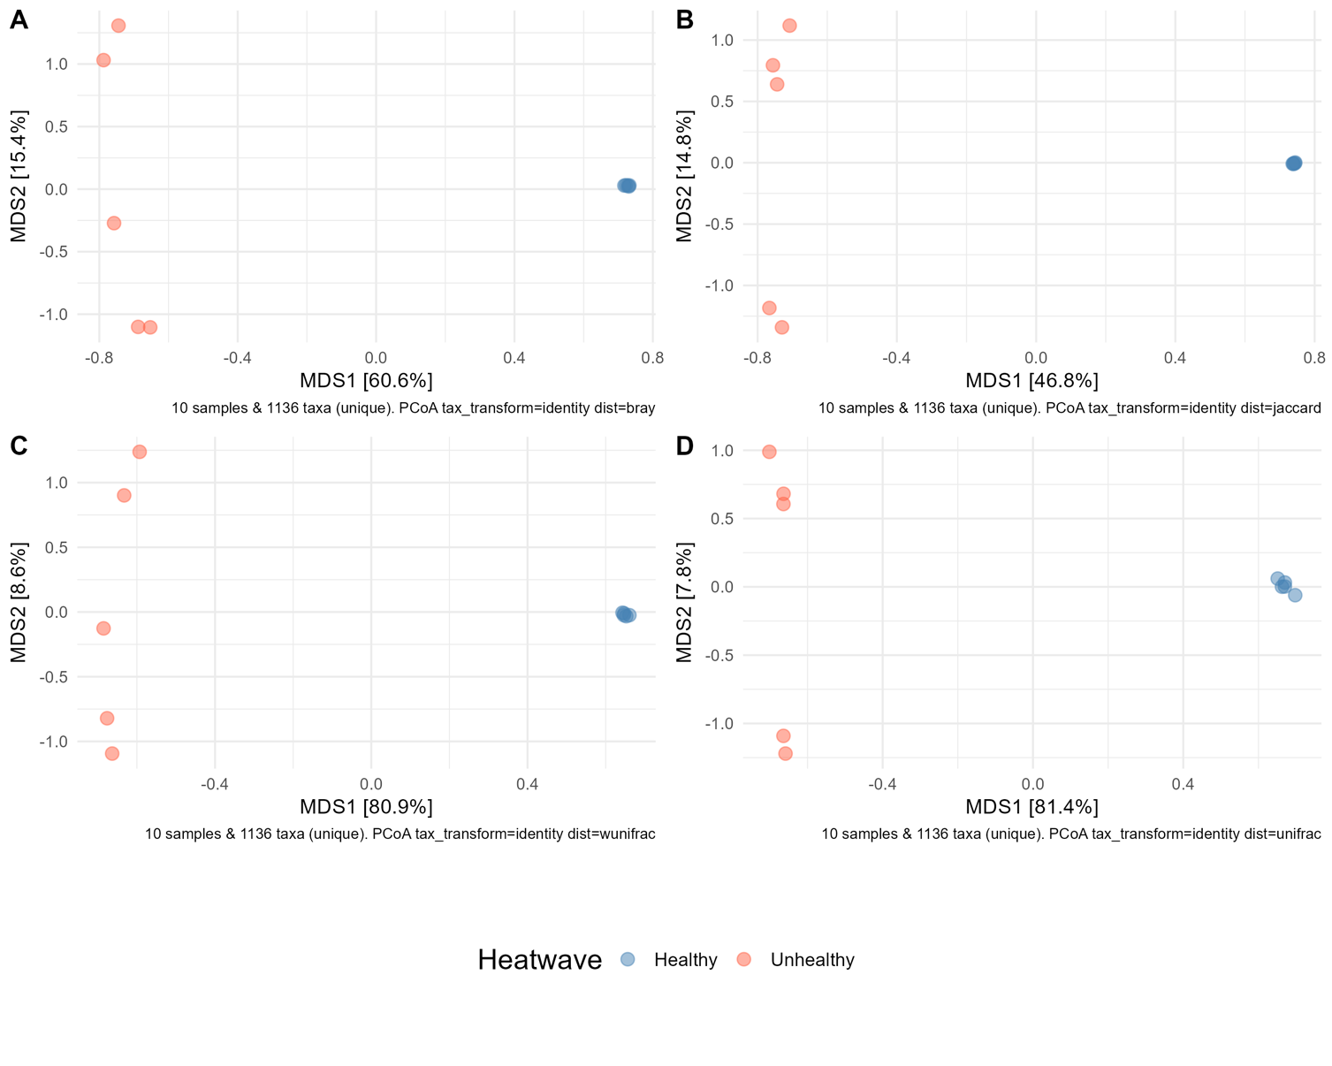
Fig. S7. Beta diversity. PCoA based on different distance matrices: A) Bray-Curtis distance matrix;
B) Jaccard distance matrix; C) Weighted UniFrac distance matrix; D) Unweighted UniFrac distance matrix. All methods clearly clustered healthy and Unhealthy sponges in two defined groups (PERMANOVA; p-value < 0.05). Unhealthy samples were more dispersed with respect to their intra group centroid, than Healthy samples (Beta dispersion, ANOVA; p-value < 0.01).

Fig. S8. Beta dispersion with relative abundance based indexes. Average distance from centroids in Healthy and Unhealthy sponge microbiomes according to: A) Bray-Curtis; B) Jaccard; C) Weighted Unifrac and D) Unweighted Unifrac dissimilarity matrices. Microbial communities in Healthy sponges reveal lower beta dispersion and lower distance to centroid with respect to those in Unhealthy specimens for all indexes (Beta dispersion, q-value < 0.05; ANOVA, p-value < 0.05).

Fig. S9. Aitchison beta dispersion. Average distance from centroids in Healthy and Unhealthy sponge microbiomes based on Aitchison dissimilarity, with ASVs grouped at the family level. Microbial communities in Healthy sponges reveal lower beta dispersion and lower distance to centroid with respect to those in Unhealthy specimens (Beta dispersion, q-value < 0.05; ANOVA, p-value < 0.05).
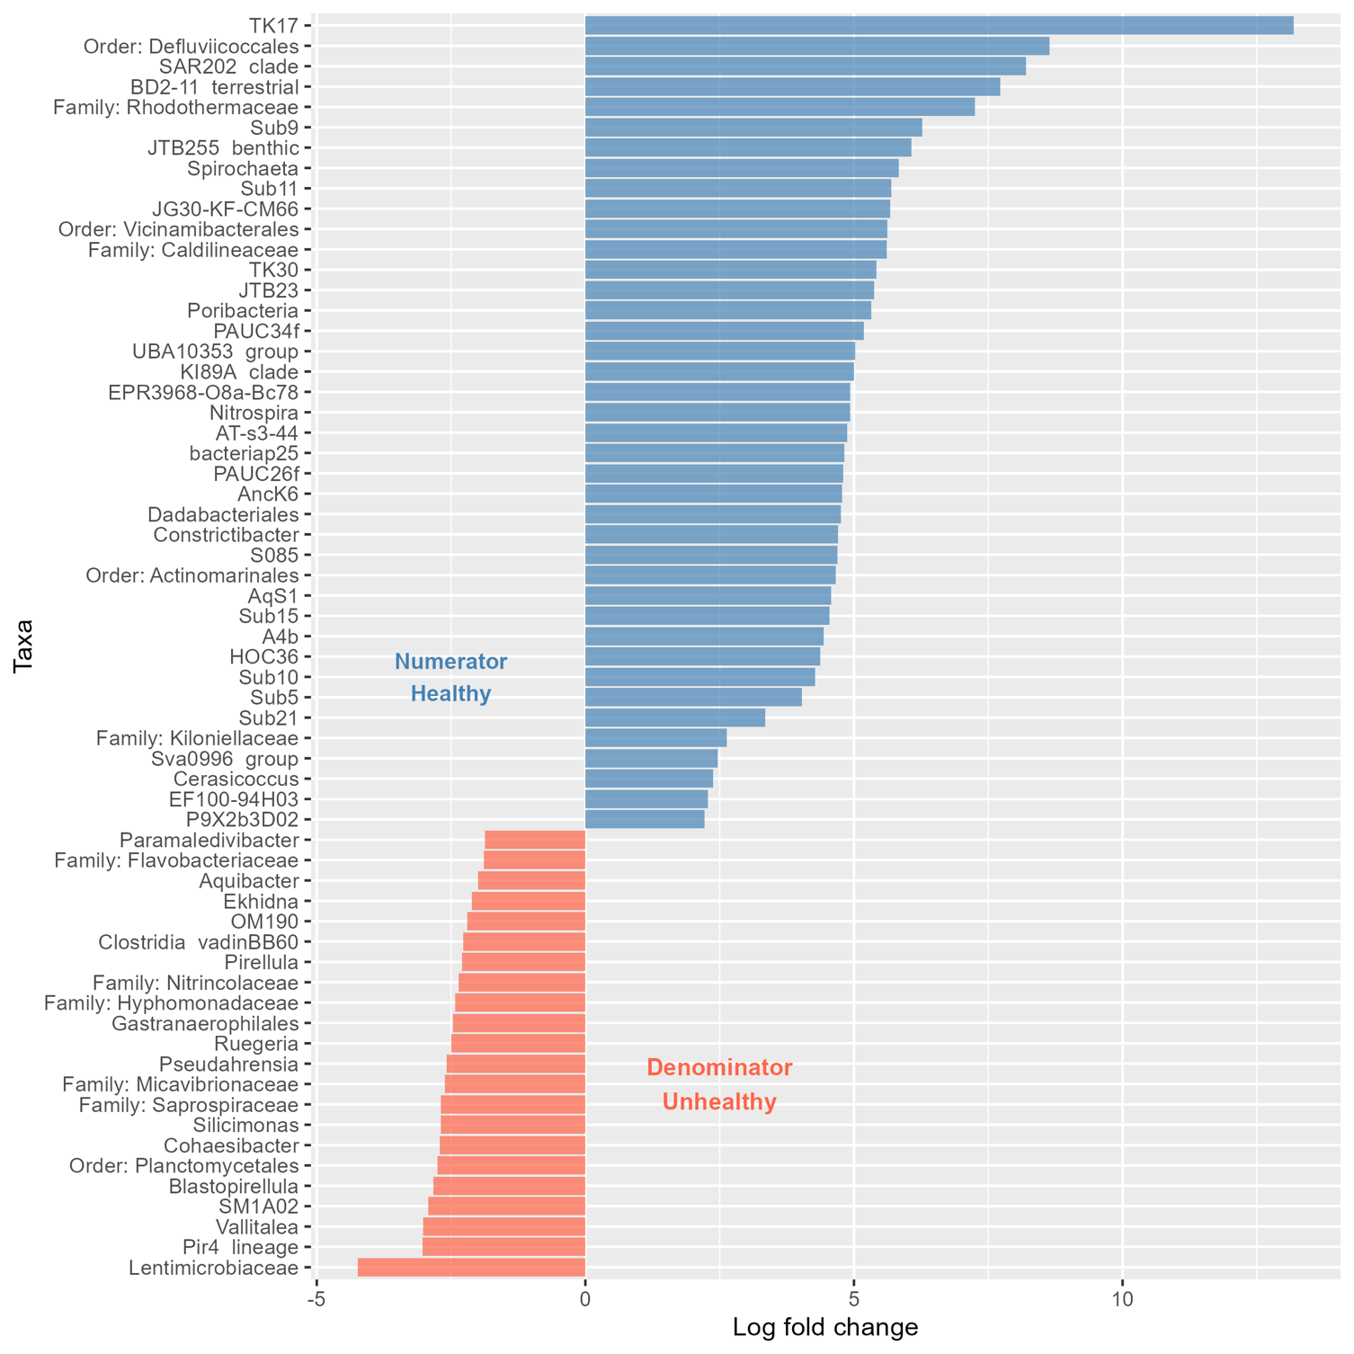
Fig. S10. Differential abundance analysis at the genus level. Divergent plots depicting differentially abundant genera ranked to either Healthy (blue bars) or Unhealthy (red bars) sponges according to log fold change (CLR) values (Aldex2, Welch’s T-tests, q–value < 0.05).
Fig. S11. Differential abundance analysis at the ASV level. Divergent plots depicting differentially abundant ASVs ranked to either Healthy (blue bars) or Unhealthy (red bars) sponges according to log fold change (CLR) values (Aldex2, Welch’s T-tests, q–value < 0.05). In genus Sva0996 group six AVS were associated with Healthy specimens and one was enriched in Unhealthy (in light green highlighted)

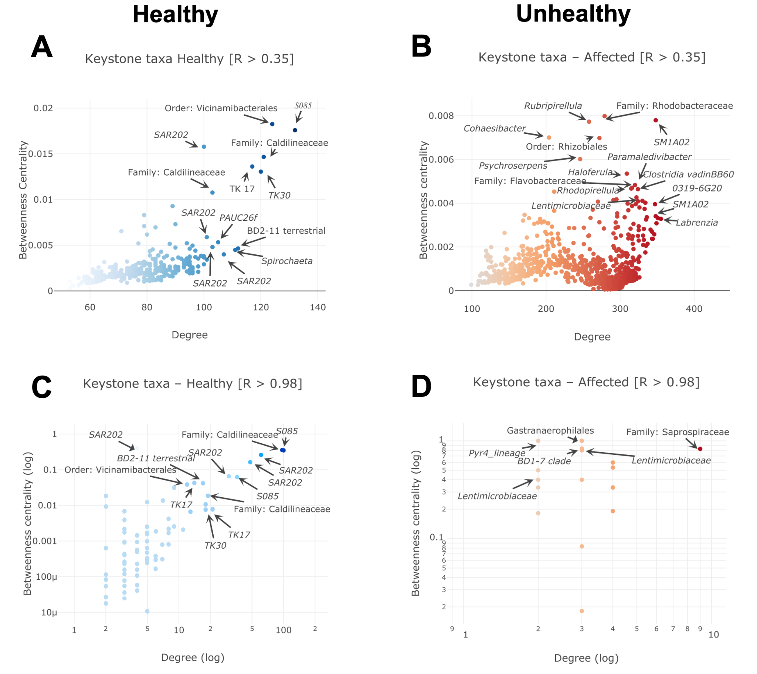
Fig. S12. Keystone taxa. Node Degree vs Betweenness centrality in the bacterial compositional co-occurrence prokaryotic community networks constructed with R threshold > 0.35 for A) Healthy and B) Unhealthy sponge microbiomes; and networks constructed with R threshold > 0.98 for C) Healthy and C) Unhealthy sponge microbiomes. Potential keystone taxa (ASV) displaying maximum properties of Degree and Betweenness centrality are highlighted in the plot with arrows at the best taxonomy annotation.

