Appendix A Search strategy
Database | Search strategy | amount
A1:Search Strategy in PubMed
#1 | Search: Exercise[MeSH Terms] Sort by: Most Recent | 247,243
#2 | Search: ((((((((((Exercise) OR (Physical Activity)) OR (physical exercise)) OR (sport)) OR (Training)) OR (Exercise Training)) OR (Acute Exercise)) OR (Isometric Exercise)) OR (Aerobic Exercise)) OR (Activities, Physical)) OR (Activity, Physical) Sort by: Most Recent | 3,254,873
#3 | #1 OR #2 | 3,254,873
#4 | Search: Autistic Disorder[MeSH Terms] Sort by: Most Recent | 25,367
#5 | Search: (((((((((((Autistic Disorder) OR (Disorder, Autistic)) OR (Kanner Syndrome)) OR (Autism, Infantile)) OR (Infantile Autism)) OR (Autism)) OR (Autism, Early Infantile)) OR (Early Infantile Autism)) OR (Infantile Autism, Early)) OR (Autism Spectrum Disorder)) OR (Autistic Spectrum Disorder)) OR (Disorder, Autistic Spectrum) Sort by: Most Recent | 74,011
#6 | #4 OR #5 | 74,011
#7 | Search: child[MeSH Terms] Sort by: Most Recent | 2,156,788
#8 | Search: ((child) OR (children)) Sort by: Most Recent | 3,141,341
#9 | #7 OR #8 | 3,141,341
#10 | Search: ((((Randomized controlled trial) OR (controlled clinical trial)) OR (randomized)) OR (placebo)) OR (randomly) Sort by: Most Recent | 1,831,028
#11 | #3 AND #6 AND #9 AND #10 | 1,177

A2:Search Strategy in Embase
#1 | 'exercise'/exp OR 'Exercise' OR 'Physical Activity' OR 'physical exercise' OR 'sport' OR 'Training' OR 'Exercise Training' OR 'Acute Exercise' OR 'Isometric Exercise' OR 'Aerobic Exercise' OR 'Activities, Physical' OR 'Activity, Physical' | 1,869,515
#2 | 'autism'/exp OR 'autistic disorder' OR 'disorder, autistic' OR 'kanner syndrome' OR 'autism, infantile' OR 'infantile autism' OR 'autism' OR 'autism, early infantile' OR 'early infantile autism' OR 'infantile autism, early' OR 'autism spectrum disorder' OR 'autistic spectrum disorder' OR 'disorder, autistic spectrum' | 111,357
#3 | 'child'/exp OR 'child' OR 'children' | 4,682,327
#4 | 'randomized controlled trial'/exp OR 'randomized controlled trial' OR 'controlled clinical trial' OR 'randomized' OR 'placebo' OR 'randomly' | 2,164,973
#3 | #1 AND #2 AND #3 | 810

A3:Search Strategy in Web of Science
#1 | ((((((((((TS=(Exercise)) OR TS=(Physical Activity)) OR TS=(physical exercise)) OR TS=(sport)) OR TS=(Training)) OR TS=(Exercise Training)) OR TS=(Acute Exercise)) OR TS=(Isometric Exercise)) OR TS=(Aerobic Exercise)) OR TS=(Activities, Physical)) OR TS=(Activity, Physical) | 3,848,927
#2 | (((((((((((TS=(Autistic Disorder)) OR TS=(Disorder, Autistic)) OR TS=(Kanner Syndrome)) OR TS=(Autism, Infantile)) OR TS=(Infantile Autism)) OR TS=(Autism)) OR TS=(Autism, Early Infantile)) OR TS=(Early Infantile Autism)) OR TS=(Infantile Autism, Early)) OR TS=(Autism Spectrum Disorder)) OR TS=(Autistic Spectrum Disorder)) OR TS=(Disorder, Autistic Spectrum) | 133,310
#3 | ((TS=(child )) OR TS=(children)) | 4,122,994
#4 | (((((TS=(Randomized controlled trial )) OR TS=(controlled clinical trial )) OR TS=( randomized ))) OR TS=(placebo )) OR TS=( randomly) | 2,041,780
#5 | #1 AND #2 AND #3 AND #4 | 1,086

A4:Search Strategy in Cochrane
#1 | MeSH descriptor: [Exercise] explode all trees | 38402
#2 | (Exercise):ti,ab,kw OR (Physical Activity):ti,ab,kw OR (physical exercise):ti,ab,kw OR (sport):ti,ab,kw OR (Training):ti,ab,kw | 230456
#3 | (Exercise Training):ti,ab,kw OR (Acute Exercise):ti,ab,kw OR (Isometric Exercise):ti,ab,kw OR (Aerobic Exercise):ti,ab,kw OR (Activities, Physical):ti,ab,kw | 69190
#4 | #1 OR #2 OR #3 | 236010
#5 | MeSH descriptor: [Autistic Disorder] explode all trees | 1394
#6 | (Autistic Disorder) OR (Disorder, Autistic) OR (Kanner Syndrome) OR (Autism, Infantile) OR (Infantile Autism) | 2275
#7 | (Autism) OR (Autism, Early Infantile) OR (Early Infantile Autism) OR (Infantile Autism, Early) OR (Autism Spectrum Disorder) | 5001
#8 | (Autistic Spectrum Disorder) OR (Disorder, Autistic Spectrum) | 1380
#9 | #5 OR #6 OR #7 OR #8 | 5223
#10 | MeSH descriptor: [Child] explode all trees | 78301
#11 | ("Child") OR (children) | 199914
#12 | #10 OR #11 | 199914
#13 | MeSH descriptor: [Randomized Controlled Trial] explode all trees | 25734
#14 | (Randomized controlled trial) OR (controlled clinical trial) OR (randomized) OR (placebo) OR (randomly) | 1546008
#15 | #13 OR #14 | 1546008
#16 | #4 AND #9 AND #12 AND 15 | 208

Appendix B
B1 Arim and Fill Analysis on motor ability

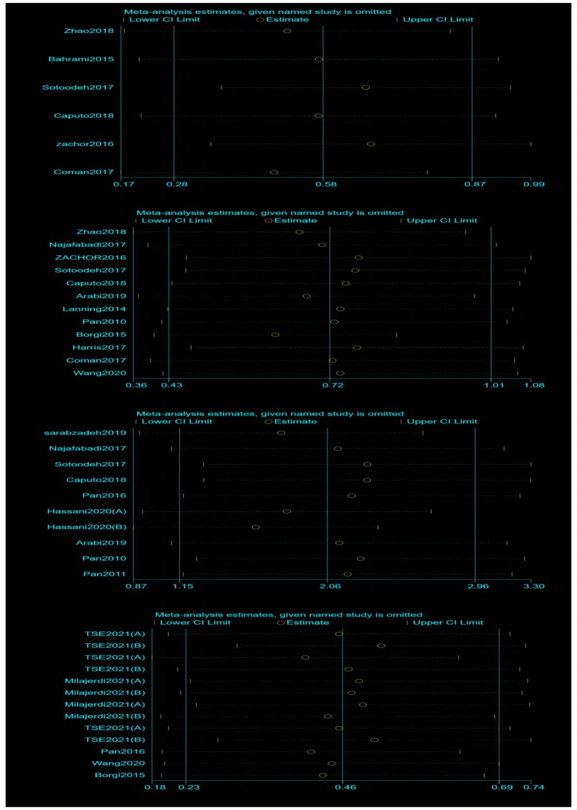
B2 Sensitivity analysis.

