Supplementary Figures
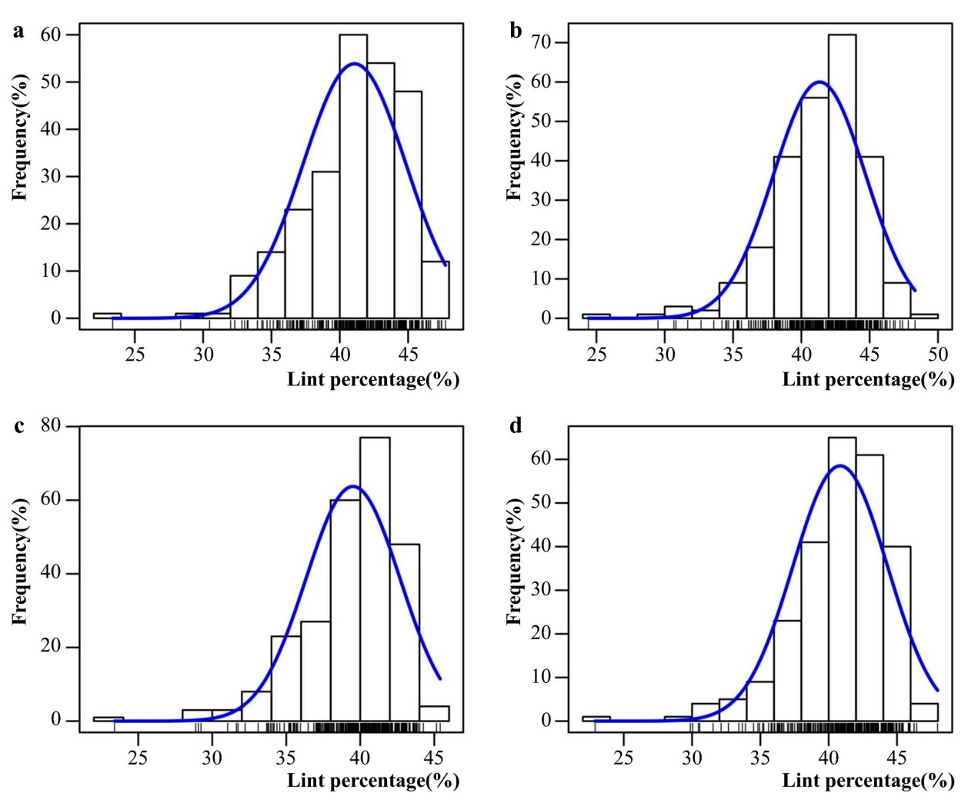
Supplementary Fig. S1. Frequency distribution of the lint percentage (LP, %) in four environments (16AY, 16LQ, 17AY, 17LQ) among the 254 upland cotton (G. hirsutum) accessions. (a) 16AY, (b) 16LQ, (c) 17AY, and (d) 17LQ.

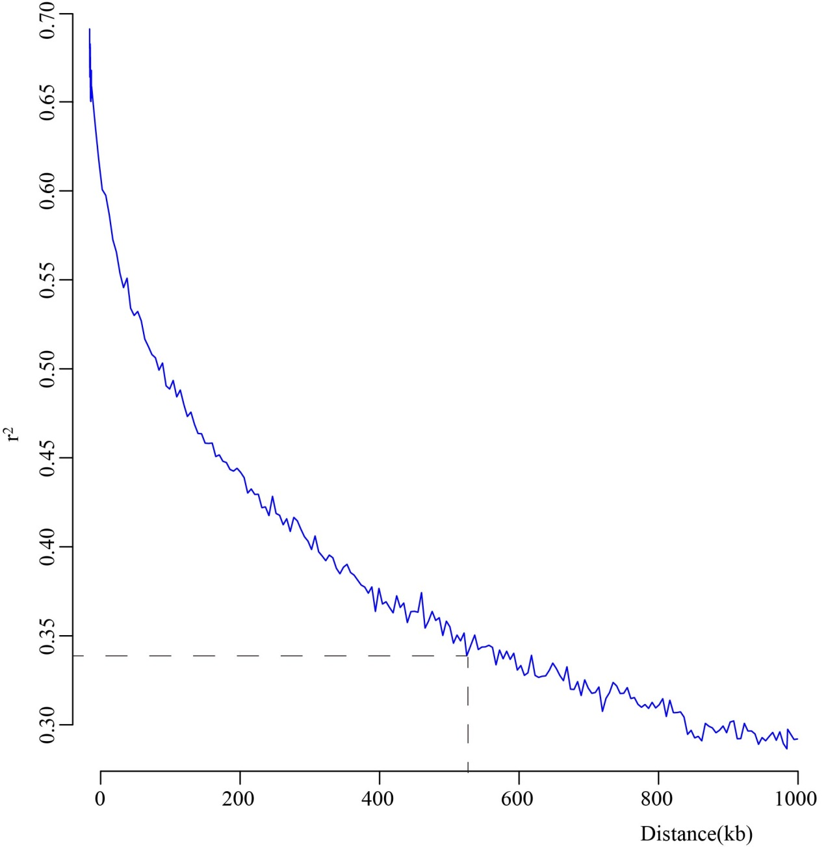
Supplementary Fig. S2. Genome-wide average LD decay estimates of the 254 upland cotton (G. hirsutum) accessions.

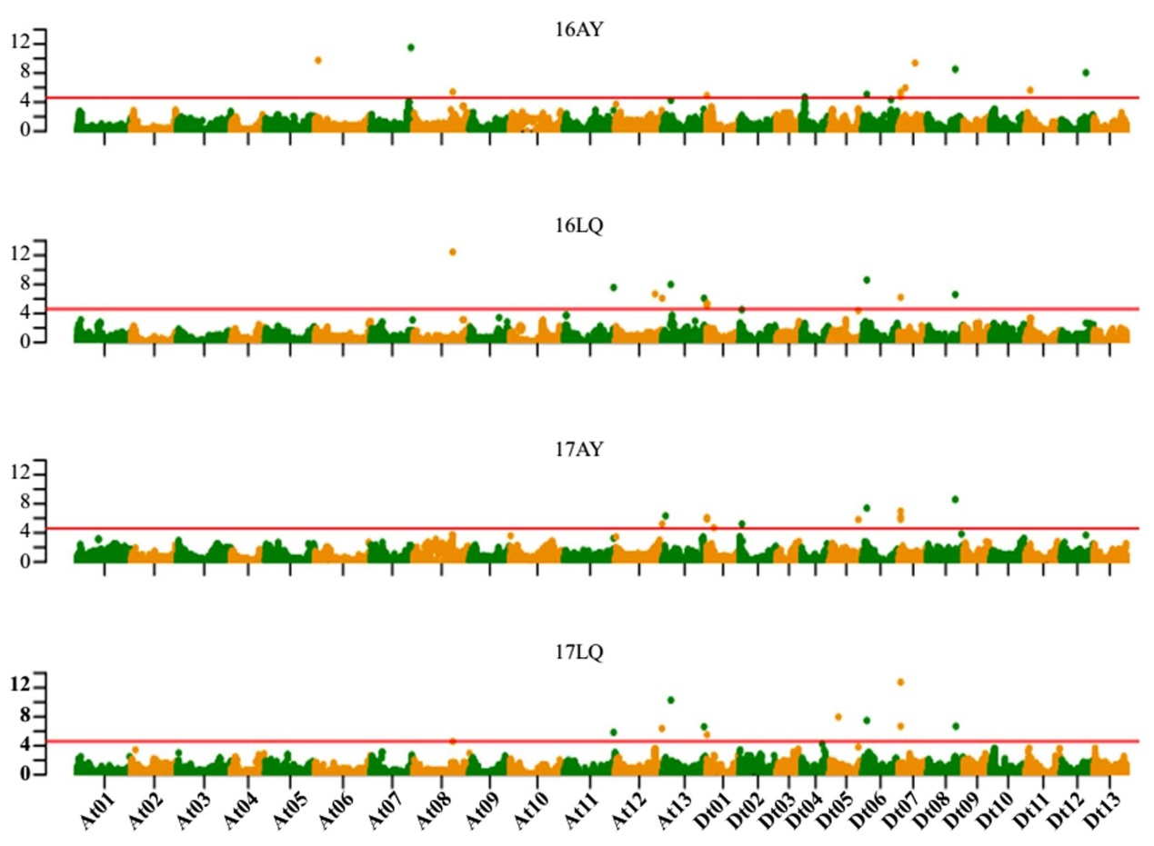
Supplementary Fig. S3. Manhattan plots showing the GWAS results for lint percentage (LP, %) in four environments (16AY, 16LQ, 17AY, 17LQ) using the FarmCPU model. The red horizontal line represents the significance threshold (−log₁₀ P = 4.61).

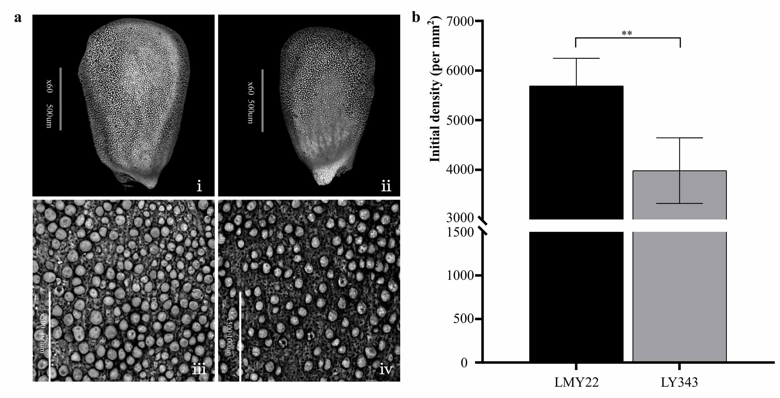
Supplementary Fig. S4. The number of fiber protrusions of cotton accessions with different lint percentage detected by Scan Electronic Microscope (SEM). (a) Detection of fiber initiation at 0 DPA; i) and ii) present the whole ovule of LMY22 (left) and LY343 (right), respectively, scale bar, 500 μm; iii) and iv) present close-up views of LMY22 (left) and LY343 (right), respectively, scale bar, 100 μm. (b) Counts of fiber initiations, mean ± s.d., n=20, **Significant at P = 0.01 level.

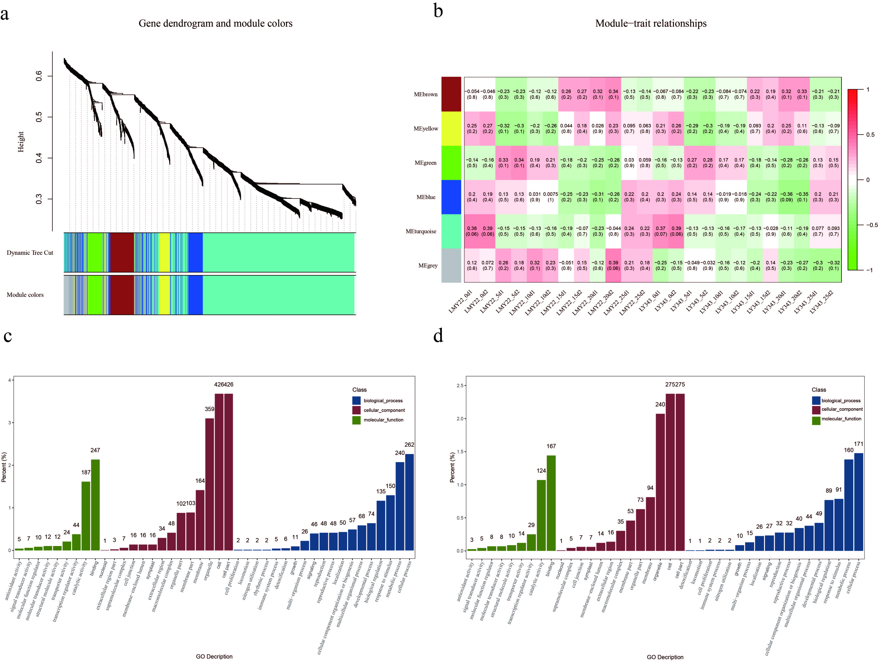
Supplementary Fig. S5. Gene clustering, module correlation and GO enrichment analyses in WGCNA. (a) Gene cluster dendrograms and module detecting. (b) Heat map of the correlation between modules and traits. Each row corresponds to a module, and each column corresponds to a trait, and each material has 2 repetitions in each period. The correlation coefficient (up) and the corresponding p-value (down) are shown in each cell. (c) Go enrichment of 1291 candidate gene which were filtered. (d) Go enrichment of candidate gene for the turquoise module.
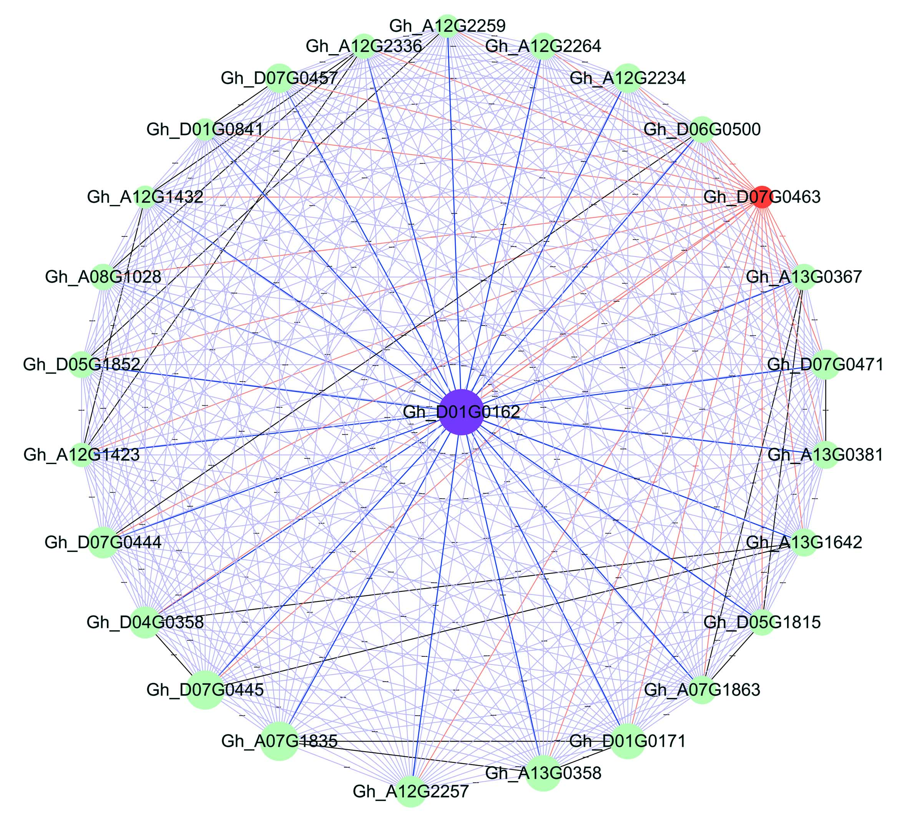
Supplementary Fig. S6. Co-expression network diagram of the causal candidate gene Gh_D01G0162. The blue dot in the center of the circle represents the causal candidate gene Gh_D01G0162, the 25 genes distributed around include the causal gene Gh_D01G0162 which was marked by a red dot was obtained through co-expression network analysis and interact with causal genes.

