Appendices: Global variation in the costs and ecological benefits of tropical natural regeneration
Table of contents
Appendix 1. Table of the potential for natural tropical forest regeneration cost-benefits categories across all studied countries 3
Appendix 2. Input datasets for potential for natural tropical forest regeneration categorisation analysis 7
Appendix 2.1 Carbon accumulation dataset 7
Appendix 2.2 Threatened species richness distribution dataset 8
Appendix 2.3 Opportunity cost of regeneration (US$ per ha) 9
Appendix 2.4 Implementation cost of assisted natural regeneration (US$ per ha) 10
Appendix 2.5 Potential for natural tropical forest regeneration 11
Appendix 3. Sensitivity analysis of opportunity cost on natural regeneration costs 12
Appendix 3.1 Global distribution of 12 potential for natural tropical forest regeneration cost-benefit categories based solely on implementation costs (excluding opportunity costs) 12
Appendix 3.2 Table of the potential for natural tropical forest regeneration cost-benefits categories based solely on implementation costs (excluding opportunity costs) 14
Appendix 4. Sensitivity analysis of benefits classification thresholds 18
Appendix 4.1 Global distribution of 12 potential for natural tropical forest regeneration cost-benefit categories using median number as classification thresholds 19
Appendix 4.2 Table of the potential for natural tropical forest regeneration cost-benefits categories using median number as classification thresholds 21
Appendix 4.3 Total potential for natural tropical forest regeneration area plotted against holistic hotspot area (bubble positions are on log10 scale for visualisation) 25
Appendix 4.4 Summary of potential for natural tropical forest regeneration area with holistic hotspots (in log10 (x/1000 +1) scale). 26
Appendix 5. Spatial distribution of countries with holistic hotspots versus other potential for natural tropical forest regeneration cost-benefit categories (using natural breaks as classification method) 27
Appendix 6. Summary of potential for natural tropical forest regeneration area with holistic hotspots (in log10 (x/1000 +1) scale) (using natural breaks as classification method) 28
References 29

Appendix 1. Table of the potential for natural tropical forest regeneration cost-benefits categories across all studied countries
This table presents data for 80 countries with potential for natural tropical forest regeneration across 12 cost-benefit categories. Countries with zero potential for natural regeneration area across all categories in the study area (n=203) have been excluded from this table for clarity. Area values are calculated in square kilometres (km²). The 12 categories represent different combinations of regeneration costs and potential benefits, as follows:
Category 1: low-cost-low-carbon-low-biodiversity
Category 2: low-cost-high-carbon-low-biodiversity
Category 3: low-cost-low-carbon-high-biodiversity
Category 4: low-cost-high-carbon-high-biodiversity
Category 5: medium-cost-low-carbon-low-biodiversity
Category 6: medium-cost-high-carbon-low-biodiversity
Category 7: medium-cost-low-carbon-high-biodiversity
Category 8: medium-cost-high-carbon-high-biodiversity
Category 9: high-cost-low-carbon-low-biodiversity
Category 10: high-cost-high-carbon-low-biodiversity
Category 11: high-cost-low-carbon-high-biodiversity
Category 12: high-cost-high-carbon-high-biodiversity
Note: For space efficiency, category labels are abbreviated as "Cat 1" through "Cat 12” in the following table:

Country | Realm | Cat 1 |  | Cat 2 | Cat 3 | Cat 4 | Cat 5 | Cat 6 | Cat 7 | Cat 8 | Cat 9 | Cat 10 | Cat 11 | Cat 12
Angola | Afrotropics |  | 1324.43 | 371.25 | 0.00 | 0.00 | 4982.88 | 432.34 | 0.00 | 0.00 | 43396.93 | 12929.48 | 0.00 | 0.00
Argentina | Neotropics |  | 997.83 | 0.00 | 0.00 | 0.00 | 11135.11 | 0.00 | 0.00 | 0.00 | 33818.87 | 0.00 | 0.00 | 0.00
Burundi | Afrotropics |  | 1386.31 | 4205.14 | 0.00 | 0.00 | 3.13 | 59.53 | 0.00 | 0.00 | 0.00 | 0.00 | 0.00 | 0.00
Benin | Afrotropics |  | 242.80 | 61.87 | 0.00 | 0.00 | 1087.90 | 196.59 | 0.00 | 0.00 | 0.00 | 0.00 | 0.00 | 0.00
Bangladesh | Indomalayan tropics |  | 596.03 | 9.40 | 7567.52 | 321.12 | 2190.68 | 12.53 | 8671.87 | 1096.52 | 104.17 | 0.00 | 119.83 | 0.00
Belize | Neotropics |  | 11.75 | 524.76 | 0.00 | 0.00 | 137.85 | 1029.94 | 0.00 | 0.00 | 626.58 | 1586.81 | 0.00 | 0.00
Bolivia | Neotropics |  | 7005.95 | 13134.68 | 0.00 | 0.00 | 63862.60 | 77715.50 | 0.00 | 0.00 | 54377.75 | 26988.37 | 0.00 | 0.00
Brazil | Neotropics |  | 177766.23 | 244662.26 | 182.49 | 5065.90 | 87636.61 | 404974.32 | 5.48 | 74.41 | 345135.93 | 598785.69 | 2066.15 | 5850.69
Botswana | Afrotropics |  | 466.02 | 0.00 | 0.00 | 0.00 | 231.05 | 0.00 | 0.00 | 0.00 | 390.83 | 0.00 | 0.00 | 0.00
Central African Republic | Afrotropics |  | 64440.62 | 53368.95 | 0.00 | 0.00 | 134.71 | 263.95 | 0.00 | 0.00 | 28.20 | 54.83 | 0.00 | 0.00
China | Indomalayan tropics |  | 283688.79 | 1887.57 | 63261.87 | 10232.83 | 159900.08 | 645.38 | 18701.85 | 6501.55 | 4220.80 | 0.00 | 1053.44 | 53.26
Côte d'Ivoire | Afrotropics |  | 122.97 | 46219.67 | 0.00 | 2190.68 | 3148.56 | 60615.35 | 0.00 | 2258.04 | 0.00 | 0.00 | 0.00 | 0.00
Cameroon | Afrotropics |  | 209.90 | 10729.40 | 54.04 | 1037.77 | 1447.40 | 109208.19 | 52.48 | 7956.00 | 0.00 | 1427.82 | 0.00 | 52.48
Democratic Republic of the Congo | Afrotropics |  | 73091.34 | 501846.72 | 1102.00 | 4914.74 | 1054.22 | 1383.96 | 9.40 | 74.41 | 408.06 | 455.05 | 0.00 | 0.00
Republic of the Congo | Afrotropics |  | 13.31 | 1886.01 | 0.00 | 0.00 | 413.54 | 18490.38 | 0.00 | 0.00 | 1299.37 | 40083.89 | 0.00 | 0.00
Colombia | Neotropics |  | 11753.07 | 25517.47 | 271.78 | 765.21 | 18844.39 | 115285.24 | 910.11 | 5867.92 | 30535.59 | 234087.16 | 1457.58 | 12661.62
Costa Rica | Neotropics |  | 935.17 | 1540.60 | 0.00 | 3.92 | 7059.99 | 4145.61 | 14.88 | 49.34 | 18318.07 | 8551.25 | 69.71 | 200.51
Cuba | Neotropics |  | 37735.78 | 837.27 | 10.97 | 28.20 | 13505.93 | 1152.12 | 21.15 | 41.51 | 25602.84 | 6419.31 | 38.38 | 69.71
Dominican Republic | Neotropics |  | 8400.09 | 556.09 | 588.99 | 13.31 | 12026.42 | 1656.52 | 790.27 | 15.66 | 13269.40 | 2324.61 | 1549.22 | 6.27
Ecuador | Neotropics |  | 3781.41 | 2565.85 | 531.03 | 586.64 | 8855.14 | 14104.32 | 1433.30 | 6138.13 | 16217.46 | 14654.92 | 5825.63 | 17276.38
Eritrea | Afrotropics |  | 358.72 | 0.00 | 0.00 | 0.00 | 0.00 | 0.00 | 0.00 | 0.00 | 0.00 | 0.00 | 0.00 | 0.00
Ethiopia | Afrotropics |  | 67114.55 | 11048.17 | 292.93 | 0.00 | 1145.07 | 279.61 | 0.00 | 0.00 | 7.05 | 0.00 | 0.00 | 0.00
Gabon | Afrotropics |  | 0.00 | 106.52 | 0.00 | 0.00 | 0.00 | 1530.42 | 0.00 | 0.00 | 75.19 | 80070.66 | 0.00 | 0.00
Ghana | Afrotropics |  | 72.06 | 9921.89 | 0.00 | 0.00 | 104.95 | 55643.44 | 0.00 | 0.00 | 0.00 | 14.88 | 0.00 | 0.00
Guinea | Afrotropics |  | 20860.41 | 19853.97 | 0.00 | 4017.16 | 218.52 | 85.37 | 0.00 | 18.01 | 0.00 | 0.00 | 0.00 | 0.00
Gambia | Afrotropics |  | 116.70 | 0.00 | 0.00 | 0.00 | 0.00 | 0.00 | 0.00 | 0.00 | 0.00 | 0.00 | 0.00 | 0.00
Guinea-Bissau | Afrotropics |  | 2583.08 | 0.00 | 0.00 | 0.00 | 378.30 | 0.00 | 0.00 | 0.00 | 0.00 | 0.00 | 0.00 | 0.00
Equatorial Guinea | Afrotropics |  | 0.00 | 20.36 | 0.00 | 0.00 | 0.00 | 191.89 | 0.00 | 0.00 | 0.00 | 16269.93 | 0.00 | 0.00
Guatemala | Neotropics |  | 10176.44 | 25177.55 | 61.09 | 29.76 | 25411.74 | 14171.67 | 190.32 | 152.73 | 8735.31 | 2611.27 | 138.63 | 77.54
French Guiana | Neotropics |  | 18.80 | 332.87 | 0.00 | 0.00 | 57.96 | 1085.55 | 0.00 | 0.00 | 24.28 | 730.75 | 0.00 | 0.00
Guyana | Neotropics |  | 55.61 | 1582.11 | 0.00 | 0.00 | 361.85 | 10542.21 | 0.00 | 0.00 | 796.54 | 18323.55 | 0.00 | 0.00
Honduras | Neotropics |  | 24737.38 | 1741.89 | 6.27 | 44.64 | 46753.83 | 5563.25 | 56.39 | 413.54 | 5215.50 | 852.15 | 17.23 | 28.20
Haiti | Neotropics |  | 7812.67 | 1280.57 | 2810.99 | 2109.22 | 1915.77 | 113.57 | 473.07 | 192.67 | 45.43 | 0.00 | 36.03 | 0.78
Indonesia | Indomalayan tropics |  | 21205.03 | 38778.25 | 1441.13 | 165135.16 | 26436.19 | 98882.94 | 4037.52 | 295222.57 | 13281.93 | 172506.09 | 5518.60 | 318062.97
India | Indomalayan tropics |  | 7899.61 | 223.22 | 10025.28 | 988.43 | 41301.80 | 1170.14 | 39772.17 | 8866.89 | 19311.98 | 1302.50 | 16651.36 | 7620.00
Jamaica | Neotropics |  | 546.69 | 150.38 | 547.47 | 35.25 | 1175.62 | 874.08 | 1021.33 | 204.42 | 1164.66 | 1237.50 | 1036.21 | 809.85
Kenya | Afrotropics |  | 21763.47 | 10089.50 | 0.00 | 0.00 | 11334.05 | 2230.62 | 0.00 | 0.00 | 728.40 | 122.18 | 0.00 | 0.00
Cambodia | Indomalayan tropics |  | 116.70 | 75.97 | 20586.29 | 5862.44 | 180.92 | 207.55 | 37594.80 | 10944.00 | 3.92 | 42.29 | 1300.94 | 173.09
Laos | Indomalayan tropics |  | 4140.13 | 332.87 | 21869.21 | 14715.23 | 5351.78 | 672.79 | 62980.69 | 26320.28 | 928.90 | 151.16 | 9711.21 | 3782.98
Liberia | Afrotropics |  | 0.00 | 65345.24 | 0.00 | 6400.51 | 0.00 | 539.64 | 0.00 | 45.43 | 0.00 | 0.00 | 0.00 | 0.00
Sri Lanka | Indomalayan tropics |  | 3457.94 | 126.88 | 1000.18 | 262.38 | 11007.44 | 580.37 | 3715.62 | 4815.27 | 14128.60 | 364.20 | 4114.28 | 6306.53
Madagascar | Afrotropics |  | 52777.62 | 15097.45 | 71776.31 | 8563.78 | 15351.21 | 2070.06 | 11724.10 | 270.21 | 0.00 | 0.00 | 0.00 | 0.00
México | Neotropics |  | 47624.00 | 33715.49 | 0.78 | 0.00 | 71498.26 | 53169.23 | 3.92 | 0.00 | 164554.79 | 63900.19 | 44.64 | 14.10
Mali | Afrotropics |  | 775.39 | 0.00 | 0.00 | 0.00 | 127.67 | 0.00 | 0.00 | 0.00 | 0.00 | 0.00 | 0.00 | 0.00
Myanmar | Indomalayan tropics |  | 32485.04 | 22.71 | 39135.40 | 5813.88 | 38988.94 | 24.28 | 139724.99 | 18943.86 | 39.94 | 0.00 | 1527.29 | 1336.97
Mozambique | Afrotropics |  | 96022.60 | 1879.74 | 0.00 | 0.00 | 453.49 | 7.83 | 0.00 | 0.00 | 0.00 | 0.00 | 0.00 | 0.00
Malawi | Afrotropics |  | 4007.76 | 0.00 | 0.00 | 0.00 | 242.80 | 0.00 | 0.00 | 0.00 | 0.00 | 0.00 | 0.00 | 0.00
Malaysia | Indomalayan tropics |  | 0.00 | 0.00 | 3.92 | 30001.43 | 0.00 | 0.00 | 16.45 | 51580.85 | 0.00 | 0.00 | 133.93 | 168274.32
Namibia | Afrotropics |  | 643.03 | 0.00 | 0.00 | 0.00 | 443.31 | 0.00 | 0.00 | 0.00 | 470.72 | 0.00 | 0.00 | 0.00
Niger | Afrotropics |  | 85.37 | 0.00 | 0.00 | 0.00 | 0.00 | 0.00 | 0.00 | 0.00 | 0.00 | 0.00 | 0.00 | 0.00
Nigeria | Afrotropics |  | 609.35 | 5046.32 | 0.00 | 0.00 | 545.12 | 32278.27 | 0.00 | 0.00 | 56.39 | 41209.38 | 0.00 | 0.00
Nicaragua | Neotropics |  | 54702.00 | 6042.58 | 0.00 | 0.00 | 26869.32 | 1635.37 | 0.00 | 0.00 | 1285.27 | 102.60 | 0.00 | 0.00
Oman | Indomalayan tropics |  | 5.48 | 0.00 | 0.00 | 0.00 | 3.92 | 0.00 | 0.00 | 0.00 | 122.97 | 0.00 | 0.00 | 0.00
Panama | Neotropics |  | 463.67 | 5498.24 | 75.19 | 108.09 | 1439.57 | 13539.61 | 416.68 | 513.01 | 2628.50 | 13990.75 | 1757.56 | 1439.57
Peru | Neotropics |  | 3924.74 | 16676.43 | 0.00 | 0.00 | 18733.96 | 62453.58 | 0.00 | 6.27 | 17507.43 | 58412.14 | 0.00 | 31.33
Philippines | Indomalayan tropics |  | 2224.36 | 39872.42 | 7.83 | 9444.13 | 10857.85 | 104064.76 | 61.09 | 20254.98 | 2635.55 | 11909.72 | 16.45 | 5369.01
Papua New Guinea | Indomalayan tropics |  | 5298.52 | 11707.65 | 0.00 | 0.00 | 27163.81 | 67781.07 | 0.00 | 0.00 | 4341.42 | 8694.58 | 0.00 | 0.00
Paraguay | Neotropics |  | 189.54 | 1.57 | 0.00 | 0.00 | 7214.29 | 138.63 | 0.00 | 0.00 | 68381.03 | 332.09 | 0.00 | 0.00
Rwanda | Afrotropics |  | 161.34 | 7145.36 | 34.46 | 505.18 | 23.50 | 261.60 | 13.31 | 63.44 | 0.00 | 0.00 | 0.00 | 0.00
Saudi Arabia | Indomalayan tropics |  | 2.35 | 0.00 | 0.00 | 0.00 | 15.66 | 0.00 | 0.00 | 0.00 | 13.31 | 0.00 | 0.00 | 0.00
Sudan | Afrotropics |  | 84.59 | 0.00 | 0.00 | 0.00 | 32.11 | 0.00 | 0.00 | 0.00 | 0.00 | 0.00 | 0.00 | 0.00
Senegal | Afrotropics |  | 43.08 | 0.00 | 0.00 | 0.00 | 23.50 | 0.00 | 0.00 | 0.00 | 0.00 | 0.00 | 0.00 | 0.00
Sierra Leone | Afrotropics |  | 6686.39 | 39120.52 | 0.00 | 0.00 | 190.32 | 624.23 | 0.00 | 0.00 | 0.00 | 0.00 | 0.00 | 0.00
El Salvador | Neotropics |  | 3078.86 | 0.00 | 0.00 | 0.00 | 7269.11 | 0.00 | 0.00 | 0.00 | 5179.47 | 0.00 | 0.00 | 0.00
Somalia | Afrotropics |  | 556.09 | 0.00 | 0.00 | 0.00 | 0.00 | 0.00 | 0.00 | 0.00 | 0.00 | 0.00 | 0.00 | 0.00
South Sudan | Afrotropics |  | 1098.86 | 0.00 | 0.00 | 0.00 | 2960.59 | 153.51 | 0.00 | 0.00 | 11956.71 | 3.92 | 0.00 | 0.00
Suriname | Neotropics |  | 0.00 | 94.77 | 0.00 | 0.00 | 0.78 | 853.72 | 0.00 | 0.00 | 13.31 | 4447.93 | 0.00 | 0.00
Chad | Afrotropics |  | 365.77 | 0.00 | 0.00 | 0.00 | 79.89 | 0.00 | 0.00 | 0.00 | 0.00 | 0.00 | 0.00 | 0.00
Togo | Afrotropics |  | 518.49 | 3224.54 | 0.00 | 0.00 | 27.41 | 305.46 | 0.00 | 0.00 | 0.00 | 0.00 | 0.00 | 0.00
Thailand | Indomalayan tropics |  | 17213.72 | 325.04 | 17577.92 | 17912.36 | 29127.35 | 802.81 | 56921.66 | 34853.51 | 7713.20 | 235.75 | 53405.76 | 29332.56
Timor-Leste | Indomalayan tropics |  | 10568.05 | 26.63 | 0.00 | 0.00 | 2420.17 | 7.05 | 0.00 | 0.00 | 0.00 | 0.00 | 0.00 | 0.00
Trinidad and Tobago | Neotropics |  | 14.88 | 8.62 | 0.00 | 0.00 | 104.17 | 137.85 | 0.00 | 0.00 | 1336.18 | 1151.34 | 0.00 | 0.00
Tanzania | Afrotropics |  | 46998.20 | 6355.87 | 2429.56 | 887.39 | 37887.73 | 3256.65 | 2847.02 | 849.80 | 17.23 | 8.62 | 0.00 | 0.00
Uganda | Afrotropics |  | 17614.73 | 16948.21 | 137.06 | 1812.38 | 12411.77 | 4804.30 | 94.77 | 993.13 | 0.78 | 0.00 | 0.00 | 0.00
Venezuela | Neotropics |  | 11285.49 | 3389.01 | 3.13 | 0.00 | 13937.49 | 11777.35 | 17.23 | 0.00 | 81738.14 | 105714.23 | 348.54 | 341.49
Vietnam | Indomalayan tropics |  | 12582.51 | 475.42 | 82732.84 | 16311.44 | 4984.44 | 1837.45 | 75692.43 | 24371.61 | 509.10 | 1261.78 | 7001.25 | 4316.35
Yemen | Indomalayan tropics |  | 1090.25 | 0.00 | 0.00 | 0.00 | 1789.67 | 0.00 | 0.00 | 0.00 | 32.90 | 0.00 | 0.00 | 0.00
South Africa | Afrotropics |  | 286.66 | 0.00 | 0.00 | 0.00 | 555.31 | 0.00 | 0.00 | 0.00 | 5513.90 | 0.00 | 0.00 | 0.00
Zambia | Afrotropics |  | 10331.52 | 0.00 | 0.00 | 0.00 | 15033.22 | 0.00 | 0.00 | 0.00 | 327.39 | 0.00 | 0.00 | 0.00
Zimbabwe | Afrotropics |  | 3890.28 | 0.00 | 0.00 | 0.00 | 707.25 | 0.00 | 0.00 | 0.00 | 0.78 | 0.00 | 0.00 | 0.00

Appendix 2. Input datasets for potential for natural tropical forest regeneration categorisation analysis

Appendix 2.1 Carbon accumulation dataset
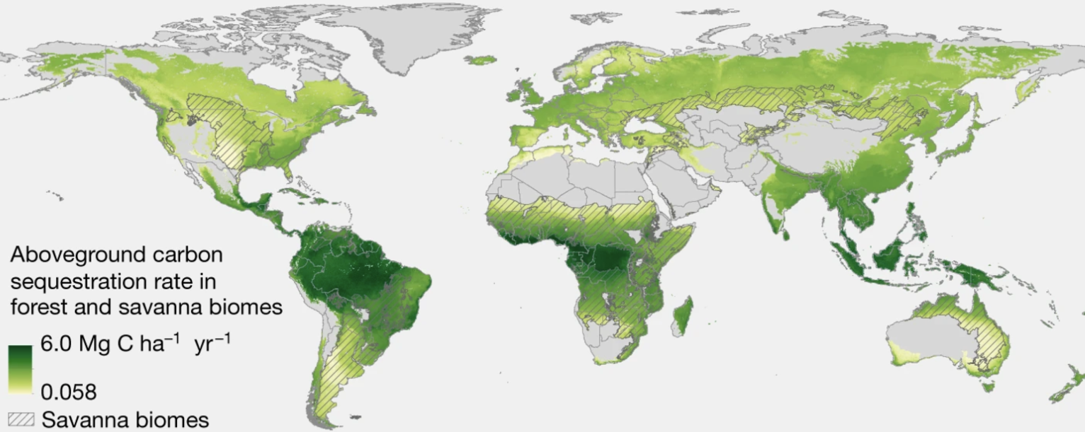
This dataset represents predicted aboveground carbon accumulation rates (Mg C per ha per year) in naturally regrowing forests across both forest and savanna biomes. The model predicts potential carbon accumulation rates for areas if natural forest regrowth occurred over a 30-year period¹.

Appendix 2.2 Threatened species richness distribution dataset
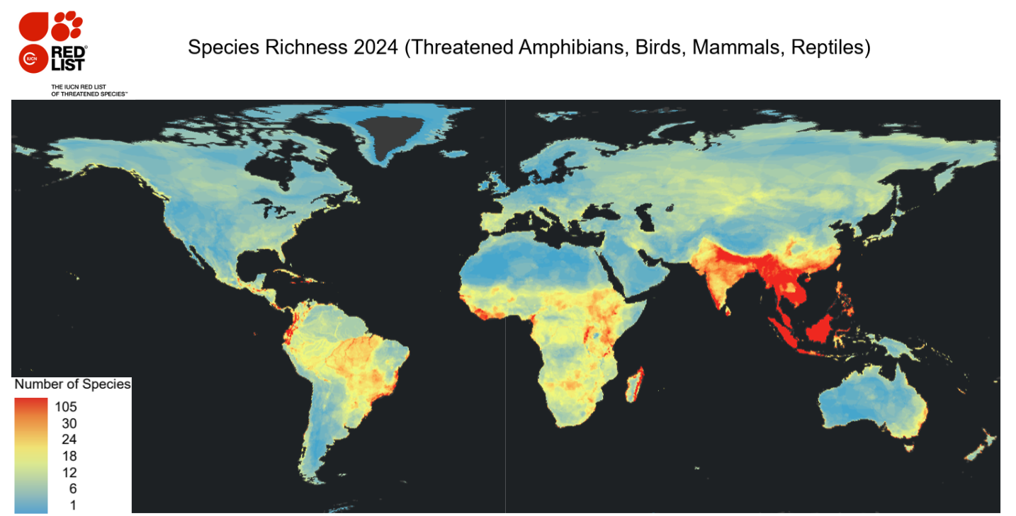
This dataset represents the spatial distribution of threatened species richness based on IUCN Red List². Threatened species richness is measured as potential ranges of endangered, critically endangered, and vulnerable species.

Appendix 2.3 Opportunity cost of regeneration (US$ per ha)
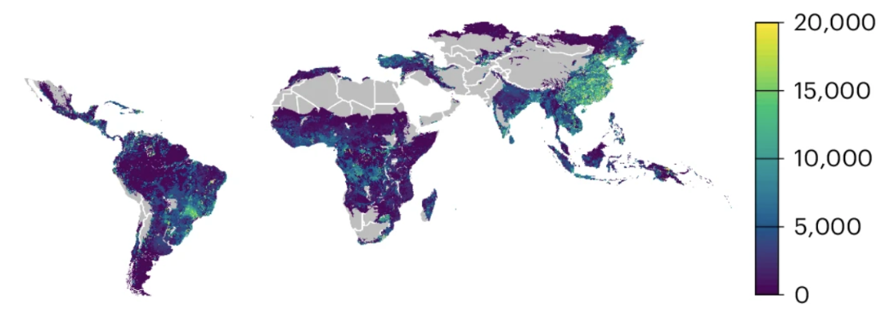
This dataset represents the portion of annual agricultural profits attributed to land used for crop or livestock production, which reflects the short-term economic value of keeping the land in its current agricultural use³.

Appendix 2.4 Implementation cost of assisted natural regeneration (US$ per ha)
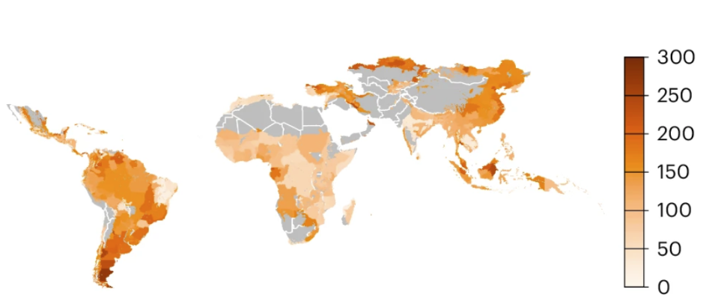
This dataset represents the direct expenses for site evaluation and protection measures such as fencing and guards to prevent human encroachment³.

Appendix 2.5 Potential for natural tropical forest regeneration
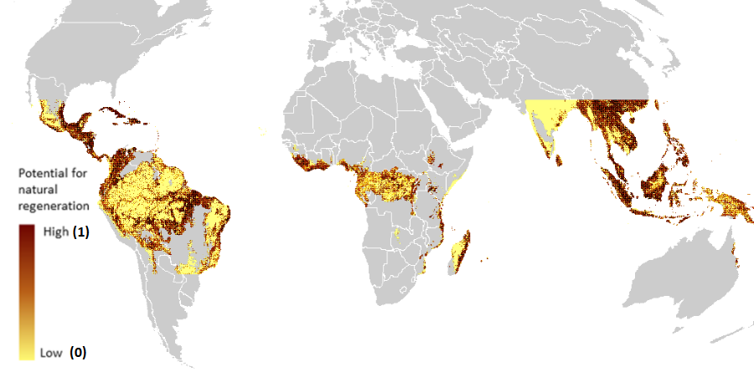
This dataset provides a continuous metric ranging from 0 to 1, where higher values indicate greater potential or likelihood of successful natural regeneration⁴.

Appendix 3. Sensitivity analysis of opportunity cost on natural regeneration costs

Appendix 3.1 Global distribution of 12 potential for natural tropical forest regeneration cost-benefit categories based solely on implementation costs (excluding opportunity costs)
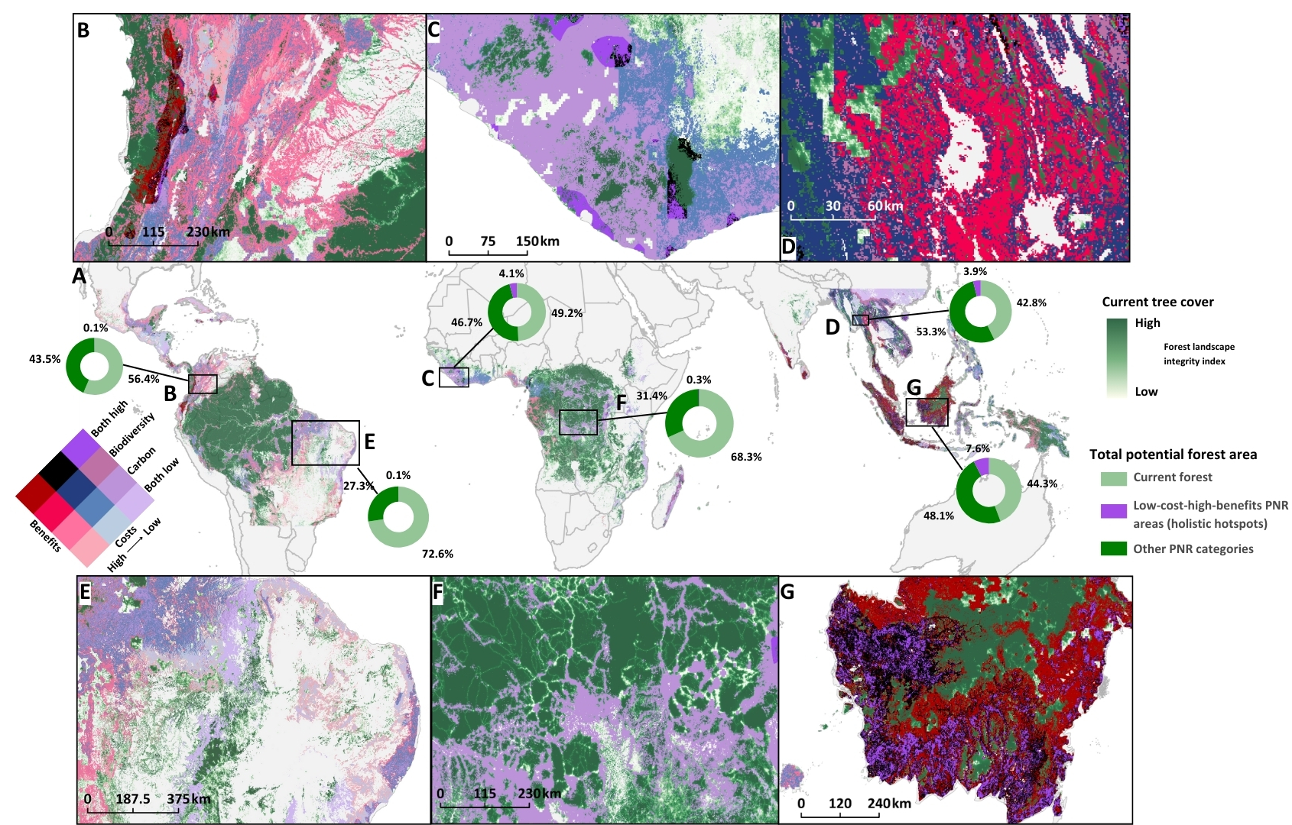
This map shows 12 cost-benefit categories using only implementation cost, with examples across the pantropics (A), as well as insets showing B) Colombia, C) Liberia, D) Thailand, E) Brazil, F) the Democratic Republic of Congo, and G) Indonesia. Costs are represented on a gradient from high (in red) to low (in purple), while benefit levels increase with darker shades within each colour scheme. The holistic hotspot category represents areas characterised by low restoration costs and high climate accumulation and biodiversity conservation benefits, highlighted in neon purple (3.12% of the spatial area of potential for natural tropical forest regeneration). Currently forested areas are shown in the light to dark green gradient reflecting the forest landscape integrity index⁵, with darker green indicating higher forest landscape integrity. The doughnut charts illustrate the total potential forest area, with current forest cover⁶ represented in light green, the holistic hotspot category in purple, and all other potential for natural tropical forest regeneration cost-benefit categories in dark green.
This sensitivity analysis reveals that while opportunity costs do not significantly alter the total cost-benefit category distribution across most regions compared to Fig. 2 in the main manuscript Results section, the statistics show that they can play an important role in certain locations.

Appendix 3.2 Table of the potential for natural tropical forest regeneration cost-benefits categories based solely on implementation costs (excluding opportunity costs)
Country | Realm | Cat 1 | Cat 2 | Cat 3 | Cat 4 | Cat 5 | Cat 6 | Cat 7 | Cat 8 | Cat 9 | Cat 10 | Cat 11 | Cat 12
Angola | Afrotropics | 1282.14 | 372.03 | 0.00 | 0.00 | 5023.61 | 755.81 | 0.00 | 0.00 | 43398.50 | 12605.22 | 0.00 | 0.00
Argentina | Neotropics | 897.58 | 0.00 | 0.00 | 0.00 | 12679.63 | 0.00 | 0.00 | 0.00 | 32374.61 | 0.00 | 0.00 | 0.00
Burundi | Afrotropics | 1376.91 | 4135.43 | 0.00 | 0.00 | 12.53 | 129.23 | 0.00 | 0.00 | 0.00 | 0.00 | 0.00 | 0.00
Benin | Afrotropics | 222.44 | 57.96 | 0.00 | 0.00 | 1108.26 | 200.51 | 0.00 | 0.00 | 0.00 | 0.00 | 0.00 | 0.00
Bangladesh | Indomalayan tropics | 697.07 | 10.18 | 7901.17 | 421.38 | 2167.18 | 11.75 | 8458.05 | 996.26 | 26.63 | 0.00 | 0.00 | 0.00
Belize | Neotropics | 18.01 | 606.22 | 0.00 | 0.00 | 204.42 | 1159.17 | 0.00 | 0.00 | 553.74 | 1376.13 | 0.00 | 0.00
Bolivia | Neotropics | 5163.80 | 11123.36 | 0.00 | 0.00 | 54414.56 | 69208.89 | 0.00 | 0.00 | 65667.93 | 37506.30 | 0.00 | 0.00
Brazil | Neotropics | 179289.60 | 243150.63 | 182.49 | 5117.59 | 77209.54 | 398154.78 | 10.97 | 28.20 | 354039.63 | 607116.86 | 2060.66 | 5845.21
Botswana | Afrotropics | 438.61 | 0.00 | 0.00 | 0.00 | 226.35 | 0.00 | 0.00 | 0.00 | 422.94 | 0.00 | 0.00 | 0.00
Central African Republic | Afrotropics | 64506.41 | 53396.36 | 0.00 | 0.00 | 97.12 | 231.83 | 0.00 | 0.00 | 0.00 | 59.53 | 0.00 | 0.00
China | Indomalayan tropics | 378780.92 | 2292.50 | 74054.71 | 12718.01 | 69018.57 | 240.45 | 8726.69 | 4059.46 | 10.18 | 0.00 | 235.75 | 10.18
Côte d'Ivoire | Afrotropics | 43.86 | 36812.36 | 0.00 | 1912.64 | 3227.67 | 70022.66 | 0.00 | 2536.08 | 0.00 | 0.00 | 0.00 | 0.00
Cameroon | Afrotropics | 172.31 | 10327.60 | 47.78 | 852.93 | 1484.99 | 110578.06 | 58.74 | 8193.32 | 0.00 | 459.75 | 0.00 | 0.00
Democratic Republic of the Congo | Afrotropics | 73472.77 | 502754.48 | 1102.78 | 4901.42 | 971.20 | 442.52 | 8.62 | 87.72 | 109.65 | 488.73 | 0.00 | 0.00
Republic of the Congo | Afrotropics | 13.31 | 1880.52 | 0.00 | 0.00 | 331.30 | 18690.10 | 0.00 | 0.00 | 1381.61 | 39889.65 | 0.00 | 0.00
Colombia | Neotropics | 12869.17 | 27662.72 | 384.56 | 1203.82 | 20294.93 | 113967.85 | 870.16 | 5165.37 | 27968.96 | 233259.29 | 1384.74 | 12925.56
Costa Rica | Neotropics | 1276.66 | 1470.90 | 0.00 | 6.27 | 8359.36 | 4634.34 | 20.36 | 46.21 | 16677.21 | 8132.23 | 64.22 | 201.29
Cuba | Neotropics | 38483.76 | 822.39 | 10.97 | 25.85 | 13470.69 | 1166.22 | 18.01 | 41.51 | 24890.11 | 6420.10 | 41.51 | 72.06
Dominican Republic | Neotropics | 8740.79 | 609.35 | 557.66 | 12.53 | 11886.22 | 1693.33 | 763.64 | 16.45 | 13068.89 | 2234.54 | 1607.18 | 6.27
Ecuador | Neotropics | 3833.10 | 2630.07 | 493.43 | 466.02 | 8857.49 | 13470.69 | 1391.01 | 4812.92 | 16163.41 | 15224.33 | 5905.52 | 18722.21
Eritrea | Afrotropics | 333.65 | 0.00 | 0.00 | 0.00 | 25.06 | 0.00 | 0.00 | 0.00 | 0.00 | 0.00 | 0.00 | 0.00
Ethiopia | Afrotropics | 59512.57 | 8619.39 | 245.15 | 0.00 | 8754.11 | 2708.39 | 47.78 | 0.00 | 0.00 | 0.00 | 0.00 | 0.00
Gabon | Afrotropics | 0.00 | 103.39 | 0.00 | 0.00 | 0.78 | 1550.00 | 0.00 | 0.00 | 74.41 | 80054.21 | 0.00 | 0.00
Ghana | Afrotropics | 68.92 | 6658.20 | 0.00 | 0.00 | 108.09 | 58922.02 | 0.00 | 0.00 | 0.00 | 0.00 | 0.00 | 0.00
Guinea | Afrotropics | 14600.88 | 18324.33 | 0.00 | 3696.04 | 6478.05 | 1615.01 | 0.00 | 339.14 | 0.00 | 0.00 | 0.00 | 0.00
Gambia | Afrotropics | 96.34 | 0.00 | 0.00 | 0.00 | 20.36 | 0.00 | 0.00 | 0.00 | 0.00 | 0.00 | 0.00 | 0.00
Guinea-Bissau | Afrotropics | 1532.77 | 0.00 | 0.00 | 0.00 | 1428.60 | 0.00 | 0.00 | 0.00 | 0.00 | 0.00 | 0.00 | 0.00
Equatorial Guinea | Afrotropics | 0.00 | 15.66 | 0.00 | 0.00 | 0.00 | 180.92 | 0.00 | 0.00 | 0.00 | 16285.60 | 0.00 | 0.00
Guatemala | Neotropics | 10309.59 | 24841.55 | 81.46 | 34.46 | 27511.56 | 15246.26 | 220.09 | 177.01 | 6502.33 | 1872.69 | 88.50 | 48.56
French Guiana | Neotropics | 14.88 | 267.08 | 0.00 | 0.00 | 50.91 | 918.72 | 0.00 | 0.00 | 35.25 | 963.37 | 0.00 | 0.00
Guyana | Neotropics | 56.39 | 1509.27 | 0.00 | 0.00 | 343.05 | 10101.25 | 0.00 | 0.00 | 814.55 | 18837.34 | 0.00 | 0.00
Honduras | Neotropics | 23654.18 | 1775.57 | 8.62 | 36.03 | 49473.19 | 5814.66 | 50.91 | 390.05 | 3579.34 | 567.05 | 20.36 | 60.31
Haiti | Neotropics | 7262.06 | 1143.51 | 2572.11 | 1978.43 | 2469.51 | 250.63 | 706.47 | 322.69 | 42.29 | 0.00 | 41.51 | 1.57
Indonesia | Indomalayan tropics | 18445.73 | 35614.02 | 1716.05 | 158845.86 | 29942.69 | 98174.90 | 4314.79 | 295874.21 | 12534.73 | 176378.35 | 4966.43 | 323700.63
India | Indomalayan tropics | 7791.52 | 233.40 | 10661.26 | 1017.41 | 43622.50 | 1242.19 | 40149.68 | 8586.50 | 17099.37 | 1220.26 | 15637.87 | 7871.41
Jamaica | Neotropics | 570.97 | 170.74 | 540.43 | 35.25 | 1191.29 | 904.62 | 1031.51 | 201.29 | 1124.71 | 1186.59 | 1033.07 | 812.99
Kenya | Afrotropics | 16906.69 | 9470.76 | 0.00 | 0.00 | 16764.15 | 2971.56 | 0.00 | 0.00 | 155.08 | 0.00 | 0.00 | 0.00
Cambodia | Indomalayan tropics | 125.32 | 88.50 | 24204.00 | 6361.35 | 173.88 | 204.42 | 35209.88 | 10576.67 | 2.35 | 32.90 | 68.14 | 41.51
Laos | Indomalayan tropics | 4553.67 | 402.58 | 24232.98 | 16464.17 | 5858.52 | 733.88 | 70213.77 | 28248.58 | 8.62 | 20.36 | 114.35 | 105.74
Liberia | Afrotropics | 0.00 | 65173.72 | 0.00 | 6384.07 | 0.00 | 711.17 | 0.00 | 61.87 | 0.00 | 0.00 | 0.00 | 0.00
Sri Lanka | Indomalayan tropics | 3273.88 | 112.00 | 974.33 | 253.76 | 10661.26 | 577.24 | 3728.15 | 4595.96 | 14658.84 | 382.21 | 4127.60 | 6534.45
Madagascar | Afrotropics | 46641.83 | 15620.64 | 66650.10 | 7966.18 | 21486.99 | 1546.87 | 16850.30 | 867.81 | 0.00 | 0.00 | 0.00 | 0.00
México | Neotropics | 44410.42 | 29408.53 | 0.78 | 0.00 | 65098.53 | 52880.22 | 3.92 | 0.00 | 174168.09 | 68496.16 | 44.64 | 14.10
Mali | Afrotropics | 697.07 | 0.00 | 0.00 | 0.00 | 205.99 | 0.00 | 0.00 | 0.00 | 0.00 | 0.00 | 0.00 | 0.00
Myanmar | Indomalayan tropics | 26940.59 | 18.01 | 32955.76 | 5424.62 | 44573.33 | 28.98 | 146587.61 | 19697.33 | 0.00 | 0.00 | 844.32 | 972.77
Mozambique | Afrotropics | 89300.18 | 1794.37 | 0.00 | 0.00 | 7175.91 | 93.20 | 0.00 | 0.00 | 0.00 | 0.00 | 0.00 | 0.00
Malawi | Afrotropics | 4241.95 | 0.00 | 0.00 | 0.00 | 8.62 | 0.00 | 0.00 | 0.00 | 0.00 | 0.00 | 0.00 | 0.00
Malaysia | Indomalayan tropics | 0.00 | 0.00 | 3.92 | 24420.96 | 0.00 | 0.00 | 14.10 | 48239.61 | 0.00 | 0.00 | 136.28 | 177196.04
Namibia | Afrotropics | 643.03 | 0.00 | 0.00 | 0.00 | 429.99 | 0.00 | 0.00 | 0.00 | 484.03 | 0.00 | 0.00 | 0.00
Niger | Afrotropics | 85.37 | 0.00 | 0.00 | 0.00 | 0.00 | 0.00 | 0.00 | 0.00 | 0.00 | 0.00 | 0.00 | 0.00
Nigeria | Afrotropics | 547.47 | 4342.98 | 0.00 | 0.00 | 603.08 | 31252.24 | 0.00 | 0.00 | 60.31 | 42938.74 | 0.00 | 0.00
Nicaragua | Neotropics | 51420.29 | 5750.44 | 0.00 | 0.00 | 30224.65 | 1923.60 | 0.00 | 0.00 | 1211.65 | 106.52 | 0.00 | 0.00
Oman | Indomalayan tropics | 6.27 | 0.00 | 0.00 | 0.00 | 4.70 | 0.00 | 0.00 | 0.00 | 121.40 | 0.00 | 0.00 | 0.00
Panama | Neotropics | 469.94 | 5396.42 | 73.62 | 142.55 | 1423.12 | 13256.87 | 432.34 | 557.66 | 2638.69 | 14375.31 | 1743.46 | 1360.46
Peru | Neotropics | 3725.02 | 17697.75 | 0.00 | 0.00 | 16488.45 | 57975.88 | 0.00 | 0.00 | 19952.66 | 61868.51 | 0.00 | 37.59
Philippines | Indomalayan tropics | 2263.52 | 41247.76 | 17.23 | 9170.00 | 11926.95 | 104356.90 | 59.53 | 19919.76 | 1527.29 | 10242.23 | 8.62 | 5978.36
Papua New Guinea | Indomalayan tropics | 8323.33 | 23165.45 | 0.00 | 0.00 | 28480.41 | 64981.05 | 0.00 | 0.00 | 0.00 | 36.81 | 0.00 | 0.00
Paraguay | Neotropics | 206.77 | 1.57 | 0.00 | 0.00 | 8315.50 | 93.99 | 0.00 | 0.00 | 67262.58 | 376.73 | 0.00 | 0.00
Rwanda | Afrotropics | 47.78 | 4832.50 | 36.81 | 496.56 | 137.06 | 2574.46 | 10.97 | 72.06 | 0.00 | 0.00 | 0.00 | 0.00
Saudi Arabia | Indomalayan tropics | 2.35 | 0.00 | 0.00 | 0.00 | 14.88 | 0.00 | 0.00 | 0.00 | 14.10 | 0.00 | 0.00 | 0.00
Sudan | Afrotropics | 76.76 | 0.00 | 0.00 | 0.00 | 39.94 | 0.00 | 0.00 | 0.00 | 0.00 | 0.00 | 0.00 | 0.00
Senegal | Afrotropics | 31.33 | 0.00 | 0.00 | 0.00 | 35.25 | 0.00 | 0.00 | 0.00 | 0.00 | 0.00 | 0.00 | 0.00
Sierra Leone | Afrotropics | 2930.04 | 32268.09 | 0.00 | 0.00 | 3946.67 | 7476.67 | 0.00 | 0.00 | 0.00 | 0.00 | 0.00 | 0.00
El Salvador | Neotropics | 2662.18 | 0.00 | 0.00 | 0.00 | 7163.38 | 0.00 | 0.00 | 0.00 | 5701.88 | 0.00 | 0.00 | 0.00
Somalia | Afrotropics | 556.09 | 0.00 | 0.00 | 0.00 | 0.00 | 0.00 | 0.00 | 0.00 | 0.00 | 0.00 | 0.00 | 0.00
South Sudan | Afrotropics | 1510.06 | 0.78 | 0.00 | 0.00 | 14506.11 | 156.65 | 0.00 | 0.00 | 0.00 | 0.00 | 0.00 | 0.00
Suriname | Neotropics | 0.00 | 169.96 | 0.00 | 0.00 | 0.78 | 906.19 | 0.00 | 0.00 | 13.31 | 4320.27 | 0.00 | 0.00
Chad | Afrotropics | 322.69 | 0.00 | 0.00 | 0.00 | 122.97 | 0.00 | 0.00 | 0.00 | 0.00 | 0.00 | 0.00 | 0.00
Togo | Afrotropics | 215.39 | 2021.50 | 0.00 | 0.00 | 330.52 | 1508.49 | 0.00 | 0.00 | 0.00 | 0.00 | 0.00 | 0.00
Thailand | Indomalayan tropics | 16584.01 | 346.97 | 17024.18 | 18180.22 | 29148.50 | 820.04 | 57760.49 | 34447.02 | 8321.77 | 196.59 | 53120.67 | 29471.19
Timor-Leste | Indomalayan tropics | 9653.25 | 19.58 | 0.00 | 0.00 | 3334.97 | 14.10 | 0.00 | 0.00 | 0.00 | 0.00 | 0.00 | 0.00
Trinidad and Tobago | Neotropics | 13.31 | 6.27 | 0.00 | 0.00 | 101.82 | 128.45 | 0.00 | 0.00 | 1340.10 | 1163.09 | 0.00 | 0.00
Tanzania | Afrotropics | 33130.42 | 5385.46 | 1774.00 | 653.21 | 51748.46 | 4206.70 | 3502.58 | 1083.98 | 24.28 | 28.98 | 0.00 | 0.00
Uganda | Afrotropics | 10956.53 | 12833.14 | 115.13 | 1345.58 | 19070.75 | 8919.37 | 116.70 | 1459.93 | 0.00 | 0.00 | 0.00 | 0.00
Venezuela | Neotropics | 14127.81 | 6375.45 | 7.05 | 0.00 | 15612.81 | 14011.11 | 25.85 | 5.48 | 77220.50 | 100494.03 | 336.00 | 336.00
Vietnam | Indomalayan tropics | 12470.51 | 569.40 | 84964.25 | 17030.44 | 5205.31 | 2081.81 | 75143.39 | 25750.87 | 400.23 | 923.42 | 5318.88 | 2218.09
Yemen | Indomalayan tropics | 1098.08 | 0.00 | 0.00 | 0.00 | 1798.28 | 0.00 | 0.00 | 0.00 | 16.45 | 0.00 | 0.00 | 0.00
South Africa | Afrotropics | 316.42 | 0.00 | 0.00 | 0.00 | 726.05 | 0.00 | 0.00 | 0.00 | 5313.40 | 0.00 | 0.00 | 0.00
Zambia | Afrotropics | 8992.99 | 0.00 | 0.00 | 0.00 | 16664.68 | 0.00 | 0.00 | 0.00 | 34.46 | 0.00 | 0.00 | 0.00
Zimbabwe | Afrotropics | 2834.49 | 0.00 | 0.00 | 0.00 | 1763.04 | 0.00 | 0.00 | 0.00 | 0.78 | 0.00 | 0.00 | 0.00

Appendix 4. Sensitivity analysis of benefits classification thresholds
This appendix presents an alternative classification approach using median values as thresholds, compared to the natural breaks method used in the main analysis. Here, we demonstrate how classification methods influence the distribution of potential for natural tropical forest regeneration cost-benefit categories. Using the calculated costs of natural regeneration, we first stratified areas into three cost categories based on quantile thresholds (low, medium, and high). Within each cost category, we further classified areas into four benefit subgroups based on the median values (values below the median were considered low, and values above the median were considered high): (1) both high, (2) high-carbon-low-biodiversity, (3) low-carbon-high-biodiversity, and (4) both low. The result in the following appendices shows that while the top countries in each category remained consistent across both classification methods (natural breaks and median thresholds), the proportion of holistic hotspots varied dramatically. These results indicate the importance of threshold selection when making local restoration decisions.

Appendix 4.1 Global distribution of 12 potential for natural tropical forest regeneration cost-benefit categories using median number as classification thresholds
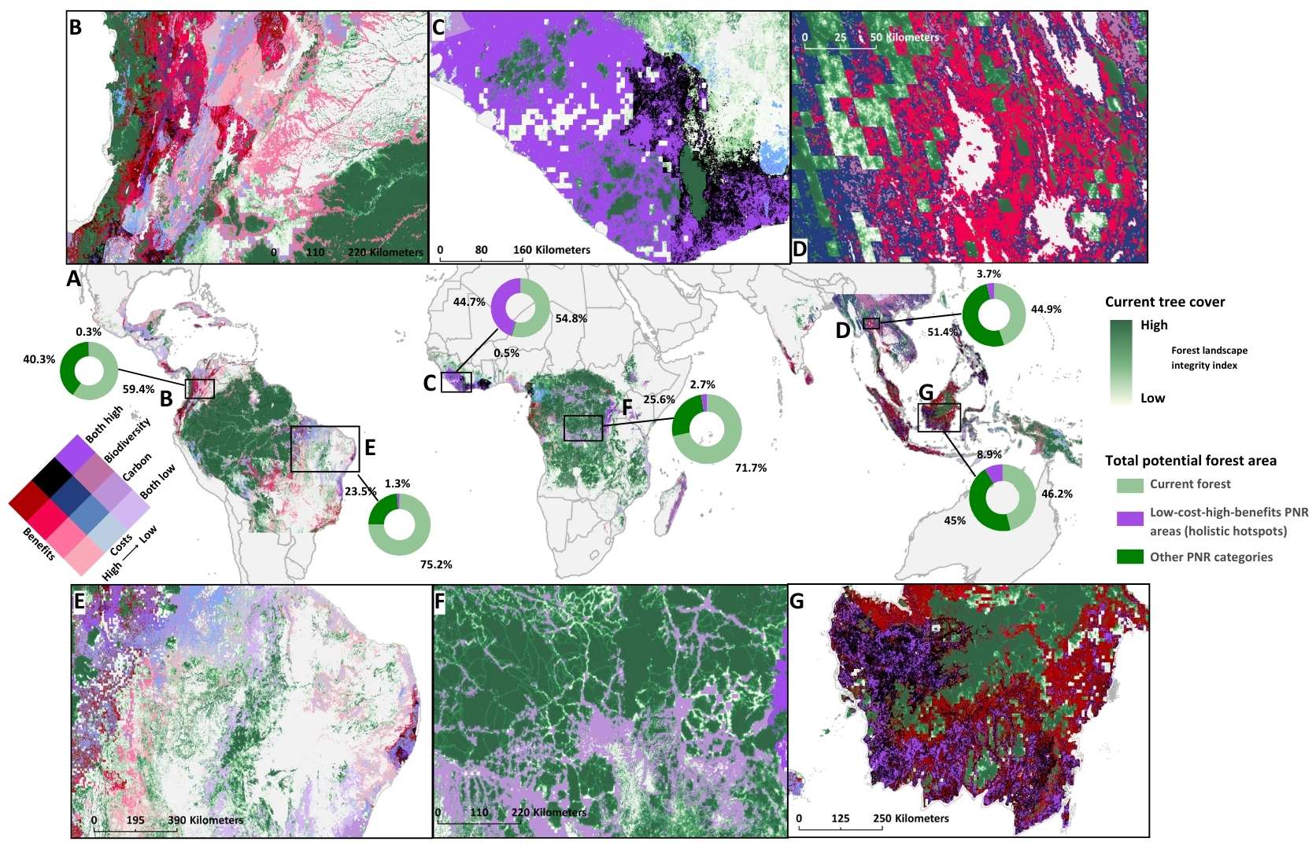

This map shows the 12 cost-benefit categories using median number as classification threshold, with examples across the pantropics (A), as well as insets showing B) Colombia, C) Liberia, D) Thailand, E) Brazil, F) the Democratic Republic of Congo, and G) Indonesia. Costs are represented on a gradient from high (in red) to low (in purple), while benefit levels increase with darker shades within each colour scheme. The holistic hotspot category represents areas characterised by low restoration costs and high climate accumulation and biodiversity conservation benefits, highlighted in neon purple (8.25% of the spatial area of potential for natural tropical forest regeneration). Currently forested areas are shown in the light to dark green gradient reflecting the forest landscape integrity index⁵, with darker green indicating higher forest landscape integrity. The doughnut charts illustrate the total potential forest area, with current forest cover⁶ represented in light green, the holistic hotspot category in purple, and all other potential for natural tropical forest regeneration cost-benefit categories in dark green.

Appendix 4.2 Table of the potential for natural tropical forest regeneration cost-benefits categories using median number as classification thresholds
Country | Realm | Cat 1 | Cat 2 | Cat 3 | Cat 4 | Cat 5 | Cat 6 | Cat 7 | Cat 8 | Cat 9 | Cat 10 | Cat 11 | Cat 12
Angola | Afrotropics | 483.84 | 321.77 | 0.78 | 0.00 | 3230.27 | 207.47 | 0.00 | 0.00 | 43712.74 | 2751.13 | 836.93 | 0.00
Argentina | Neotropics | 800.13 | 0.00 | 0.00 | 0.00 | 7748.41 | 0.00 | 0.00 | 0.00 | 26984.40 | 0.00 | 0.00 | 0.00
Bangladesh | Indomalayan  tropics | 0.00 | 0.00 | 6141.11 | 293.59 | 0.00 | 0.00 | 9278.21 | 0.00 | 0.00 | 0.00 | 244.27 | 0.00
Belize | Neotropics | 5.48 | 216.08 | 0.00 | 0.00 | 191.03 | 501.84 | 0.00 | 0.00 | 931.66 | 819.70 | 0.00 | 0.00
Benin | Afrotropics | 220.00 | 68.90 | 0.00 | 0.00 | 1283.18 | 14.09 | 0.00 | 0.00 | 0.00 | 4.70 | 0.00 | 0.00
Bolivia | Neotropics | 5324.54 | 11265.23 | 16.44 | 138.57 | 73449.05 | 41532.35 | 0.00 | 0.00 | 58401.61 | 14598.05 | 1992.49 | 1414.71
Botswana | Afrotropics | 0.00 | 0.00 | 0.00 | 0.00 | 3.91 | 0.00 | 0.00 | 0.00 | 23.49 | 0.00 | 21.92 | 0.00
Brazil | Neotropics | 149321.19 | 129750.91 | 5847.52 | 86922.85 | 104399.65 | 307702.17 | 482.27 | 12574.24 | 242901.87 | 148012.17 | 196754.30 | 256681.79
Burundi | Afrotropics | 1046.74 | 1879.76 | 173.02 | 2413.70 | 0.78 | 0.00 | 25.84 | 70.46 | 0.00 | 0.00 | 0.00 | 0.00
Cambodia | Indomalayan  tropics | 0.00 | 0.00 | 17151.89 | 5277.57 | 0.00 | 0.00 | 34471.32 | 7053.19 | 0.00 | 0.00 | 1095.28 | 117.44
Cameroon | Afrotropics | 41.49 | 3992.03 | 63.42 | 5515.57 | 2577.32 | 80898.39 | 746.89 | 21775.73 | 0.00 | 328.04 | 0.78 | 1099.98
Central African Republic | Afrotropics | 54182.53 | 48339.71 | 0.00 | 0.00 | 53.24 | 179.29 | 0.00 | 0.00 | 57.15 | 15.66 | 0.00 | 0.00
Chad | Afrotropics | 10.96 | 0.00 | 0.00 | 0.00 | 14.88 | 0.00 | 0.00 | 0.00 | 0.00 | 0.00 | 0.00 | 0.00
China | Indomalayan tropics | 19088.02 | 0.00 | 218794.65 | 11839.10 | 20334.40 | 0.00 | 111076.27 | 4612.88 | 15.66 | 0.00 | 4029.61 | 3.13
Colombia | Neotropics | 7007.00 | 18782.68 | 2049.65 | 3258.45 | 25731.75 | 72557.32 | 11714.61 | 10234.14 | 44435.36 | 115516.12 | 55736.60 | 36892.07
Costa Rica | Neotropics | 513.59 | 1261.26 | 285.76 | 301.42 | 7056.33 | 1234.64 | 2221.10 | 11.74 | 8377.87 | 167.54 | 16954.60 | 357.00
Côte d'Ivoire | Afrotropics | 66.55 | 325.69 | 38.36 | 43759.71 | 4897.07 | 20123.02 | 27.40 | 42600.23 | 0.00 | 0.00 | 0.00 | 0.00
Cuba | Neotropics | 27656.13 | 167.54 | 3901.22 | 468.96 | 10894.13 | 270.89 | 569.96 | 173.80 | 13024.41 | 5.48 | 11821.09 | 1298.06
Dominican Republic | Neotropics | 6273.42 | 603.62 | 1598.69 | 41.49 | 10407.16 | 60.28 | 1092.15 | 0.00 | 7836.10 | 11.74 | 5164.04 | 0.78
Democratic Republic of the Congo | Afrotropics | 53563.25 | 388490.95 | 6087.87 | 47774.45 | 709.31 | 1162.61 | 104.13 | 56.37 | 490.10 | 232.52 | 187.11 | 43.84
Ecuador | Neotropics | 1424.89 | 1350.51 | 1556.42 | 1361.47 | 6714.98 | 6624.16 | 4959.71 | 7796.95 | 4062.50 | 2073.13 | 28631.63 | 14332.65
El Salvador | Neotropics | 2573.41 | 0.00 | 0.00 | 0.00 | 4392.10 | 0.00 | 0.00 | 0.00 | 1113.29 | 0.00 | 0.00 | 0.00
Equatorial Guinea | Afrotropics | 0.00 | 7.83 | 0.00 | 4.70 | 0.00 | 215.30 | 0.00 | 0.00 | 0.00 | 5856.13 | 34.45 | 9441.84
Eritrea | Afrotropics | 26.62 | 0.00 | 0.00 | 0.00 | 0.00 | 0.00 | 0.00 | 0.00 | 0.00 | 0.00 | 0.00 | 0.00
Ethiopia | Afrotropics | 29688.55 | 4394.45 | 15800.60 | 5985.31 | 1345.03 | 331.95 | 0.78 | 0.00 | 0.00 | 0.00 | 0.00 | 0.00
French Guiana | Neotropics | 7.83 | 253.66 | 0.00 | 0.00 | 351.52 | 495.58 | 0.00 | 0.00 | 277.15 | 315.51 | 0.00 | 0.00
Gabon | Afrotropics | 0.00 | 57.15 | 0.00 | 10.18 | 6.26 | 1210.37 | 0.00 | 98.65 | 3097.96 | 44871.44 | 367.18 | 20227.93
Gambia | Afrotropics | 0.00 | 0.00 | 16.44 | 0.00 | 0.00 | 0.00 | 0.78 | 0.00 | 0.00 | 0.00 | 0.00 | 0.00
Ghana | Afrotropics | 0.00 | 532.38 | 0.00 | 8564.20 | 304.55 | 9337.71 | 79.07 | 46170.28 | 0.00 | 0.00 | 0.00 | 9.39
Guatemala | Neotropics | 2644.65 | 22459.99 | 1636.27 | 1622.18 | 10583.31 | 10130.80 | 4514.23 | 391.45 | 3342.22 | 677.21 | 2595.33 | 589.53
Guinea | Afrotropics | 18849.23 | 3022.01 | 1271.44 | 20801.80 | 540.20 | 41.49 | 0.00 | 70.46 | 0.00 | 0.00 | 0.00 | 0.00
Guinea-Bissau | Afrotropics | 305.33 | 0.00 | 1428.02 | 0.00 | 183.20 | 0.00 | 357.79 | 0.00 | 0.00 | 0.00 | 0.00 | 0.00
Guyana | Neotropics | 19.57 | 1370.87 | 0.00 | 0.00 | 1259.69 | 7957.45 | 0.00 | 0.00 | 4551.81 | 11516.54 | 0.00 | 0.00
Haiti | Neotropics | 5116.29 | 1251.87 | 3683.57 | 2311.92 | 1588.51 | 48.54 | 614.58 | 62.63 | 10.96 | 0.00 | 34.45 | 0.00
Honduras | Neotropics | 15803.73 | 1053.79 | 1952.57 | 634.15 | 19927.29 | 1182.19 | 1432.72 | 668.60 | 1526.67 | 1.57 | 1514.14 | 75.94
India | Indomalayan tropics | 25.05 | 0.00 | 9881.05 | 984.11 | 4510.32 | 0.00 | 61245.90 | 3074.47 | 442.34 | 0.00 | 41118.19 | 2364.37
Indonesia | Indomalayan tropics | 15834.26 | 13869.95 | 4600.35 | 176900.60 | 33465.29 | 51191.83 | 31387.46 | 283826.68 | 28972.20 | 84787.09 | 74411.24 | 275384.62
Jamaica | Neotropics | 0.00 | 0.00 | 919.91 | 168.32 | 0.00 | 0.00 | 2807.50 | 124.48 | 0.00 | 0.00 | 3780.65 | 33.66
Kenya | Afrotropics | 3516.03 | 3841.72 | 15158.61 | 5872.57 | 6881.74 | 301.42 | 6658.61 | 124.48 | 0.00 | 0.00 | 786.82 | 7.83
Laos | Indomalayan tropics | 0.00 | 0.00 | 21265.28 | 13256.94 | 0.00 | 0.00 | 74132.53 | 3833.10 | 0.00 | 0.00 | 13436.22 | 65.76
Liberia | Afrotropics | 0.00 | 0.00 | 0.00 | 62129.80 | 0.00 | 0.00 | 0.00 | 732.02 | 0.00 | 0.00 | 0.00 | 0.00
Madagascar | Afrotropics | 14392.15 | 7504.93 | 98476.19 | 17270.11 | 12901.50 | 218.43 | 20270.99 | 31.32 | 0.00 | 0.00 | 0.00 | 0.00
Malawi | Afrotropics | 2208.58 | 0.00 | 2.35 | 0.00 | 151.88 | 0.00 | 0.00 | 0.00 | 0.00 | 0.00 | 0.00 | 0.00
Malaysia | Indomalayan tropics | 0.00 | 0.00 | 3.91 | 28710.71 | 0.00 | 0.00 | 473.66 | 49044.32 | 0.00 | 0.00 | 11027.22 | 140796.92
Mali | Afrotropics | 40.71 | 0.00 | 1.57 | 0.00 | 32.88 | 0.00 | 0.00 | 0.00 | 0.00 | 0.00 | 0.00 | 0.00
México | Neotropics | 36890.50 | 30747.04 | 209.04 | 891.73 | 51916.02 | 43874.80 | 497.93 | 361.70 | 107176.61 | 35622.19 | 6055.77 | 4133.74
Mozambique | Afrotropics | 82710.82 | 1527.45 | 685.83 | 6.26 | 966.11 | 0.00 | 0.00 | 0.00 | 0.00 | 0.00 | 0.00 | 0.00
Myanmar | Indomalayan tropics | 0.00 | 0.00 | 51416.53 | 5110.81 | 0.00 | 0.00 | 147316.17 | 3212.26 | 0.00 | 0.00 | 2505.30 | 256.79
Namibia | Afrotropics | 0.78 | 0.00 | 0.78 | 0.00 | 69.68 | 0.00 | 0.00 | 0.00 | 8.61 | 0.00 | 145.62 | 0.00
Nicaragua | Neotropics | 50534.98 | 5787.24 | 0.00 | 0.00 | 19833.34 | 227.04 | 0.00 | 0.00 | 1344.25 | 0.78 | 0.00 | 0.00
Niger | Afrotropics | 6.26 | 0.00 | 0.00 | 0.00 | 0.00 | 0.00 | 0.00 | 0.00 | 0.00 | 0.00 | 0.00 | 0.00
Nigeria | Afrotropics | 19.57 | 4338.86 | 1.57 | 230.96 | 1334.07 | 29376.96 | 0.00 | 126.05 | 102.56 | 35832.80 | 1.57 | 5940.69
Oman | Indomalayan tropics | 0.00 | 0.00 | 0.00 | 0.00 | 0.00 | 0.00 | 0.00 | 0.00 | 14.88 | 0.00 | 0.00 | 0.00
Panama | Neotropics | 310.81 | 4475.09 | 133.88 | 768.03 | 5028.60 | 7923.79 | 1550.94 | 170.67 | 4772.59 | 4909.60 | 6497.33 | 1377.91
Papua New Guinea | Indomalayan tropics | 4330.25 | 9387.04 | 41.49 | 856.50 | 42322.30 | 32168.02 | 0.00 | 0.00 | 6588.93 | 5178.14 | 115.09 | 0.00
Paraguay | Neotropics | 148.75 | 0.00 | 0.00 | 0.00 | 5378.56 | 0.00 | 0.00 | 0.00 | 57219.42 | 0.00 | 188.68 | 0.00
Peru | Neotropics | 1803.03 | 13006.41 | 269.32 | 1545.46 | 16877.87 | 50630.49 | 162.84 | 122.13 | 15636.19 | 34451.75 | 5732.43 | 6583.45
Philippines | Indomalayan tropics | 0.00 | 1613.57 | 1305.89 | 45216.70 | 201.99 | 5560.19 | 21157.23 | 99714.74 | 0.00 | 1.57 | 7351.48 | 13477.72
Republic of the Congo | Afrotropics | 11.74 | 1334.85 | 0.00 | 14.09 | 1137.56 | 14602.75 | 3.91 | 0.00 | 4996.50 | 28302.81 | 1193.15 | 924.61
Rwanda | Afrotropics | 32.10 | 185.55 | 92.38 | 6897.40 | 14.09 | 7.05 | 382.06 | 165.19 | 0.00 | 0.00 | 0.00 | 0.00
Saudi Arabia | Indomalayan tropics | 0.00 | 0.00 | 0.00 | 0.00 | 0.78 | 0.00 | 0.00 | 0.00 | 0.00 | 0.00 | 0.00 | 0.00
Senegal | Afrotropics | 2.35 | 0.00 | 1.57 | 0.00 | 2.35 | 0.00 | 5.48 | 0.00 | 0.00 | 0.00 | 0.00 | 0.00
Sierra Leone | Afrotropics | 3401.72 | 8821.78 | 2326.01 | 28778.04 | 1105.46 | 1283.18 | 38.36 | 153.45 | 0.00 | 0.00 | 0.00 | 0.00
Somalia | Afrotropics | 64.98 | 0.00 | 0.00 | 0.00 | 0.00 | 0.00 | 0.00 | 0.00 | 0.00 | 0.00 | 0.00 | 0.00
South Africa | Afrotropics | 0.00 | 0.00 | 3.13 | 0.00 | 194.16 | 0.00 | 19.57 | 0.00 | 2179.61 | 0.00 | 2072.35 | 0.00
South Sudan | Afrotropics | 104.91 | 0.00 | 140.14 | 0.00 | 2359.68 | 0.00 | 19.57 | 0.00 | 7901.86 | 0.00 | 3646.77 | 0.00
Sri Lanka | Indomalayan tropics | 1795.20 | 21.92 | 2288.43 | 353.87 | 8554.02 | 0.00 | 9133.37 | 1406.10 | 5679.20 | 0.00 | 18439.77 | 1095.28
Sudan | Afrotropics | 0.78 | 0.00 | 0.00 | 0.00 | 48.54 | 0.00 | 0.00 | 0.00 | 0.00 | 0.00 | 0.00 | 0.00
Suriname | Neotropics | 0.00 | 61.85 | 0.00 | 0.00 | 14.09 | 678.78 | 0.00 | 0.00 | 172.24 | 3316.39 | 0.00 | 0.00
Tanzania | Afrotropics | 26239.07 | 4926.82 | 12668.97 | 2017.55 | 29294.75 | 570.74 | 10451.00 | 613.80 | 7.83 | 0.00 | 33.66 | 0.00
Thailand | Indomalayan tropics | 118.22 | 0.00 | 32272.14 | 16499.73 | 17186.34 | 0.00 | 65194.88 | 27646.74 | 0.00 | 0.00 | 65619.21 | 19564.02
Timor-Leste | Indomalayan tropics | 9630.52 | 46.97 | 0.00 | 0.00 | 2459.89 | 0.00 | 0.00 | 0.00 | 0.00 | 0.00 | 0.00 | 0.00
Togo | Afrotropics | 491.66 | 3262.37 | 0.00 | 0.00 | 47.76 | 311.60 | 0.00 | 0.00 | 0.00 | 0.00 | 0.00 | 0.00
Trinidad and Tobago | Neotropics | 12.53 | 8.61 | 0.00 | 0.00 | 192.59 | 10.18 | 0.00 | 0.00 | 2200.75 | 23.49 | 0.00 | 0.00
Uganda | Afrotropics | 3472.19 | 1074.93 | 11821.87 | 16664.92 | 12448.98 | 1246.39 | 2639.17 | 3321.08 | 0.00 | 0.00 | 1.57 | 0.00
Venezuela | Neotropics | 9239.85 | 2414.48 | 114.30 | 438.43 | 13948.24 | 7576.96 | 227.04 | 75.94 | 87842.77 | 49535.99 | 10623.24 | 10981.03
Vietnam | Indomalayan tropics | 0.00 | 0.00 | 87218.79 | 16228.06 | 0.00 | 0.00 | 85368.00 | 12258.73 | 0.00 | 0.00 | 11554.90 | 1724.74
Yemen | Indomalayan tropics | 10.18 | 0.00 | 0.00 | 0.00 | 284.19 | 0.00 | 0.00 | 0.00 | 4.70 | 0.00 | 0.00 | 0.00
Zambia | Afrotropics | 997.42 | 0.00 | 15.66 | 0.00 | 9806.67 | 0.00 | 0.00 | 0.00 | 349.96 | 0.00 | 2.35 | 0.00
Zimbabwe | Afrotropics | 1970.57 | 0.00 | 1056.92 | 0.00 | 859.63 | 0.00 | 0.00 | 0.00 | 0.00 | 0.00 | 0.00 | 0.00

Appendix 4.3 Total potential for natural tropical forest regeneration area plotted against holistic hotspot area (bubble positions are on log10 scale for visualisation)
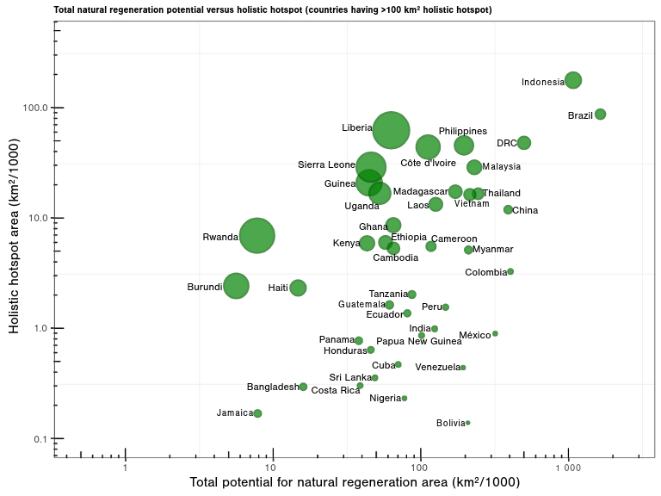
Bubble size is the proportion of holistic hotspots in total potential for natural tropical forest regeneration, in which Liberia (99%), Rwanda (89%), Sierra Leone (63%), Guinea (47%) and Burundi (43%) are the 5 countries with the largest proportion of holistic hotspot areas when using median number as classification threshold.

Appendix 4.4 Summary of potential for natural tropical forest regeneration area with holistic hotspots (in log10 (x/1000 +1) scale).
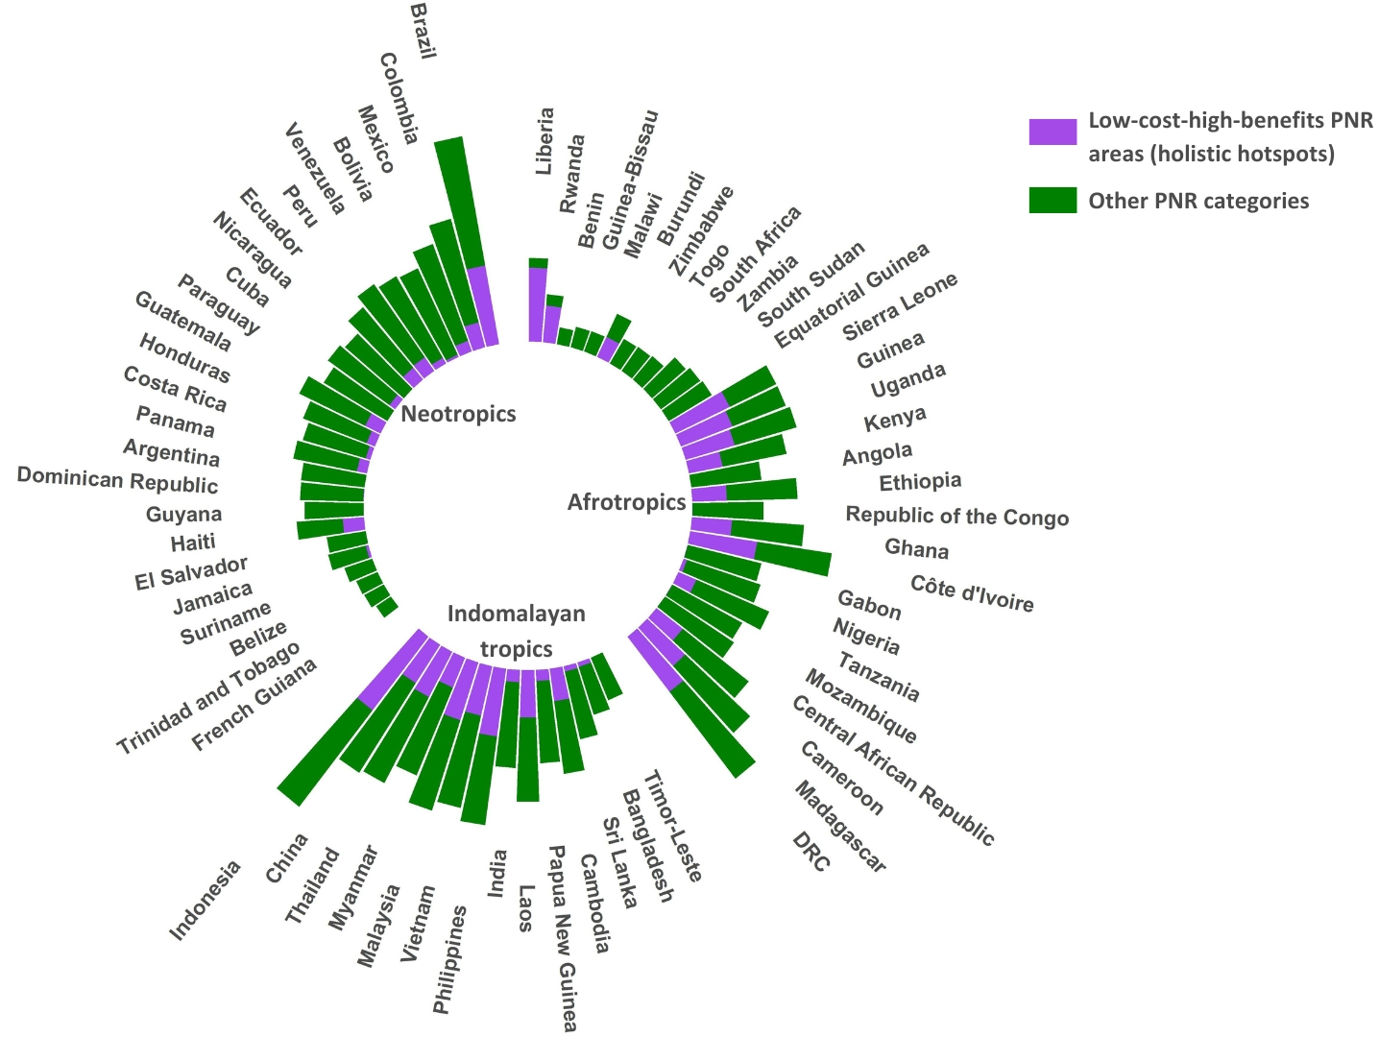
Distribution of holistic hotspots (purple) and other 11 cost-benefit categories (green) in countries with over 1000 km² of total potential for natural tropical forest regeneration area. Bar lengths indicate the relative extent of total potential for natural tropical forest regeneration area per country.

Appendix 5. Spatial distribution of countries with holistic hotspots versus other potential for natural tropical forest regeneration cost-benefit categories (using natural breaks as classification method)
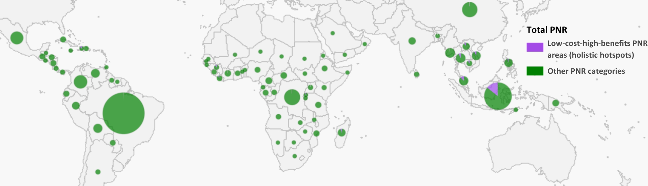
Size of pie chart indicate the total potential for natural tropical forest regeneration area for each country (larger pies - greater total potential for natural tropical forest regeneration area). Each pie chart shows the proportion of holistic hotspots (purple) versus other potential for natural tropical forest regeneration categories (green).

Appendix 6. Summary of potential for natural tropical forest regeneration area with holistic hotspots (in log10 (x/1000 +1) scale) (using natural breaks as classification method)
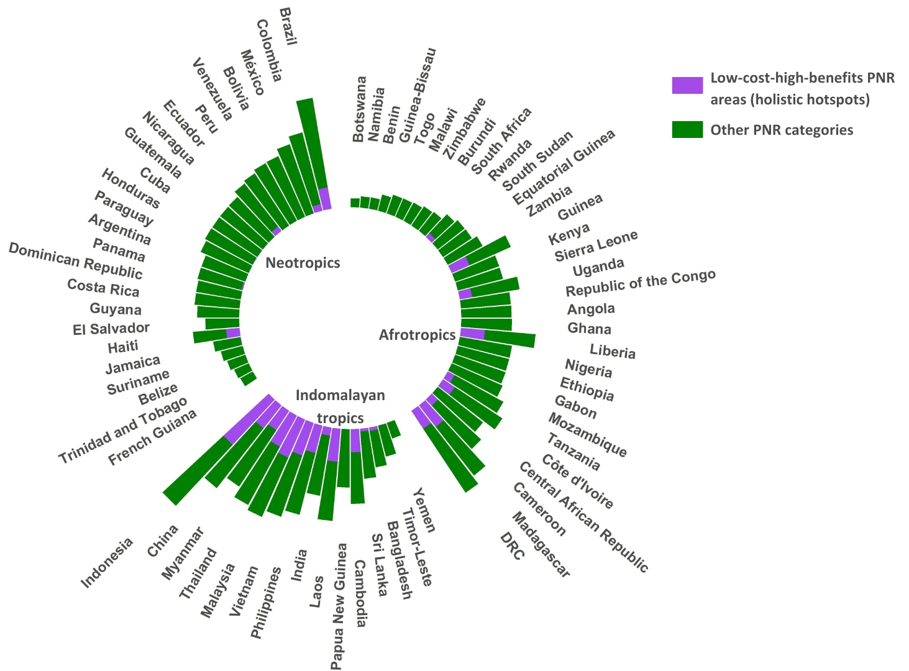

References
- Cook-Patton, S. C. et al. Mapping carbon accumulation potential from global natural forest regrowth. Nature 585, 545–550 (2020).
- IUCN. Species Richness and Rarity-Weighted Richness Data Version 2024-2. IUCN Red List of Threatened Species (2024).
- Busch, J. et al. Cost-effectiveness of natural forest regeneration and plantations for climate mitigation. Nat. Clim. Chang. 1–7 (2024).
- Williams, B. A. et al. Global potential for natural regeneration in deforested tropical regions. Nature 1–7 (2024).
- Grantham, H. S. et al. Anthropogenic modification of forests means only 40% of remaining forests have high ecosystem integrity. Nat. Commun. 11, 5978 (2020).
- FAO. Forest Resources Assessment. UN Food and Agriculture Organization (2020).

