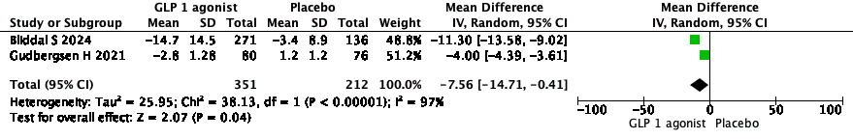
Forest plot for change in weight.

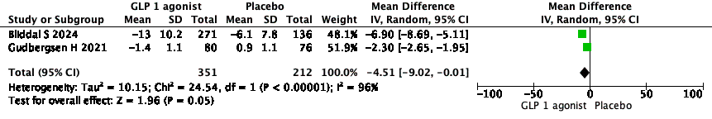
Forest plot for change in BMI

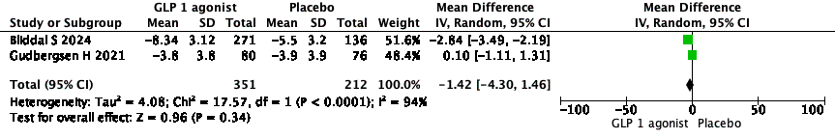
Forest plot for change in pain severity

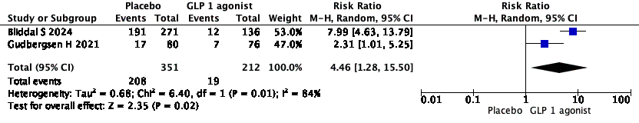
Forest plot for proportion of patients 10% reduction in weight

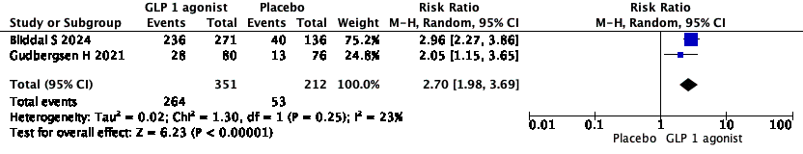
Forest plot for proportion of patients 5% reduction in weight
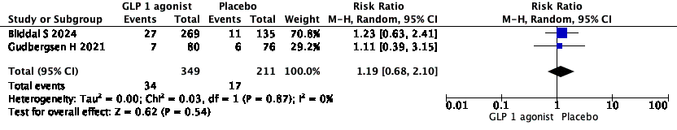
Forest plot for Serious adverse events

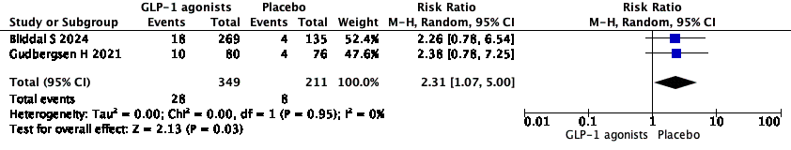
Forest plot for proportion of patients discontinuing the drug

.

