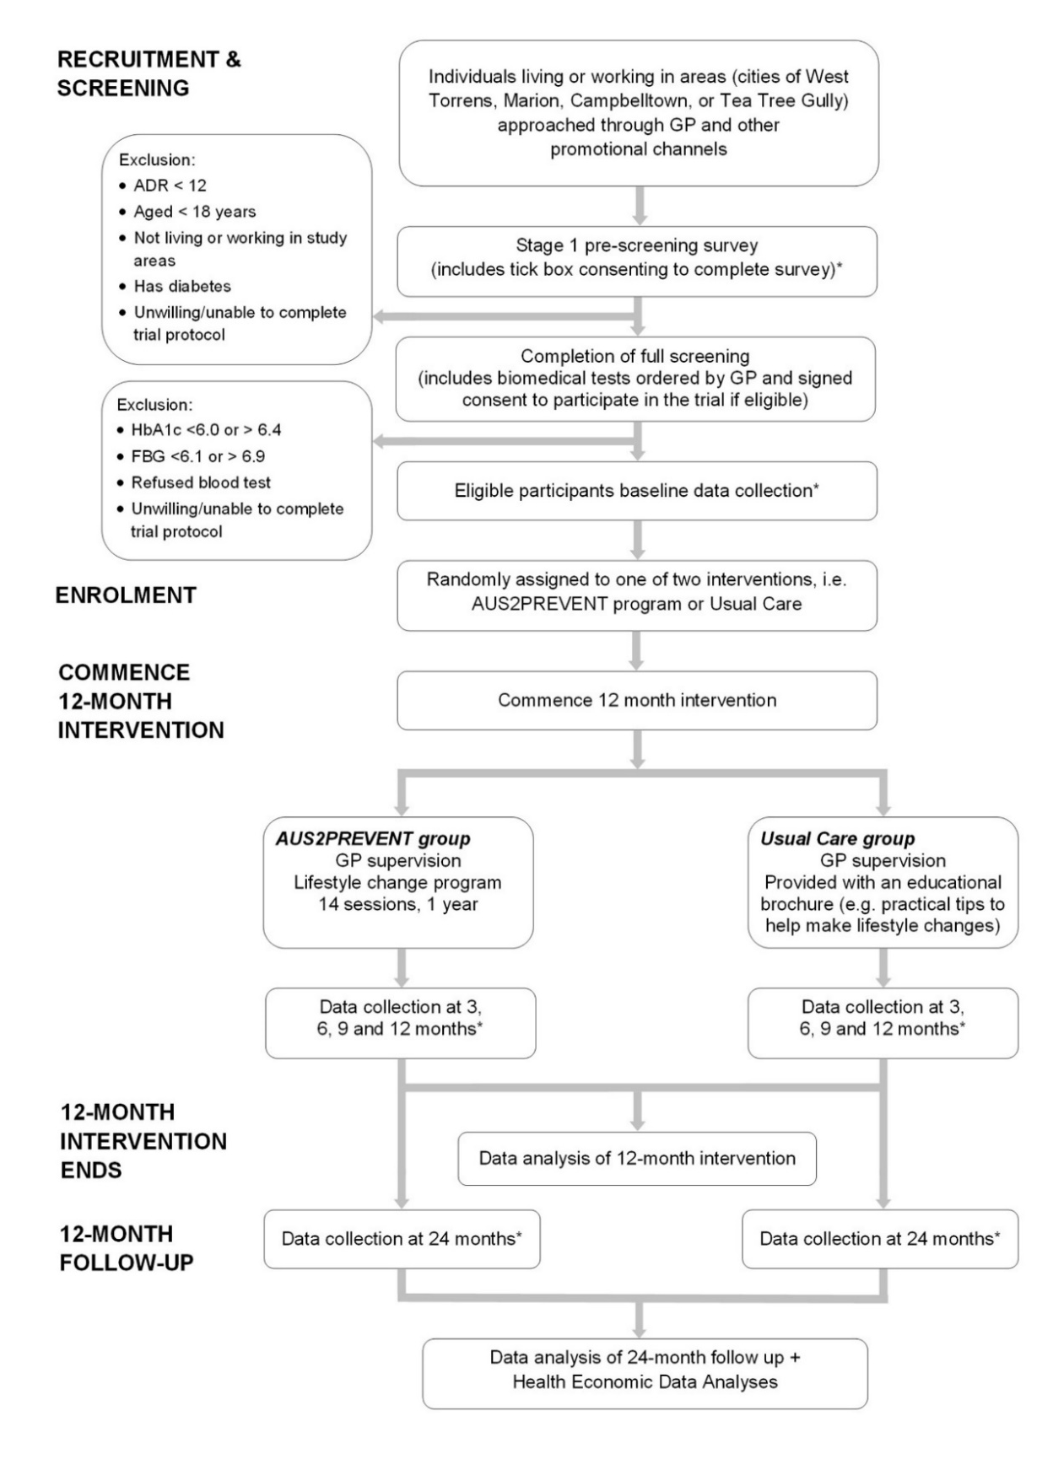
Additional File 1 Overview of the AUS2PREVENT trial design.

