Extended Data Figure Titles and Legends and Supplementary Table Titles

Spatially Resolved Panoramic in vivo CRISPR Screen via Perturb-DBiT
Alev Baysoy^{1,†}, Xiaolong Tian^{1,2, †}, Feifei Zhang^{2, †}, Paul Renauer^{2, †}, Zhiliang Bai¹, Hao Shi³, Dingyao Zhang², Haikuo Li¹, Bo Tao¹, Mingyu Yang¹, Archibald Enninful¹, Fu Gao¹, Guangchuan Wang², Wanqiu Zhang⁴, Thao Tran⁴, Nathan Heath Patterson⁴, Jie Sheng⁵, Shuozhen Bao¹, Chuanpeng Dong², Shan Xin², Binfan Chen², Mei Zhong^{1,6}, Sherri Rankin³, Cliff Guy³, Yan Wang³, Jon P. Connelly⁷, Shondra M. Pruett-Miller⁷, Daifeng Wang⁵, Mina Xu⁸, Mark B. Gerstein^{2,10}, Hongbo Chi³, Sidi Chen^{2,10,11}*, Rong Fan^{1,8,10,11,12} *

¹ Department of Biomedical Engineering, Yale University; New Haven, CT, USA.
² Department of Genetics, Yale University School of Medicine; New Haven, CT, USA.
³ Department of Immunology, St. Jude Children’s Research Hospital; Memphis, TN, USA.
⁴Aspect Analytics NV; Genk, Belgium.
⁵ Department of Biostatistics and Medical Informatics, University of Wisconsin; Madison, WI 53705, USA.
⁶ Department of Cell Biology, Yale Stem Cell Center, Yale School of Medicine; New Haven, CT, 06520, USA.
⁷ Center for Advanced Genome Engineering, St. Jude Children’s Research Hospital; Memphis, TN, USA.
⁸ Department of Pathology, Yale University School of Medicine; New Haven, CT, USA.
⁹ Department of Molecular Biophysics and Biochemistry, Yale University; New Haven, CT, USA.
¹⁰ Systems Biology Institute, Integrated Science & Technology Center; West Haven, CT, USA.
¹¹ Yale Stem Cell Center and Yale Cancer Center, Yale University School of Medicine; New Haven, CT 06520, USA.
¹² Human and Translational Immunology, Yale University School of Medicine; New Haven, CT 06520, USA.
†These authors contributed equally
* Correspondence: sidi.chen@yale.edu (S.C), and rong.fan@yale.edu (R.F.)

Extended Data Figure Legends
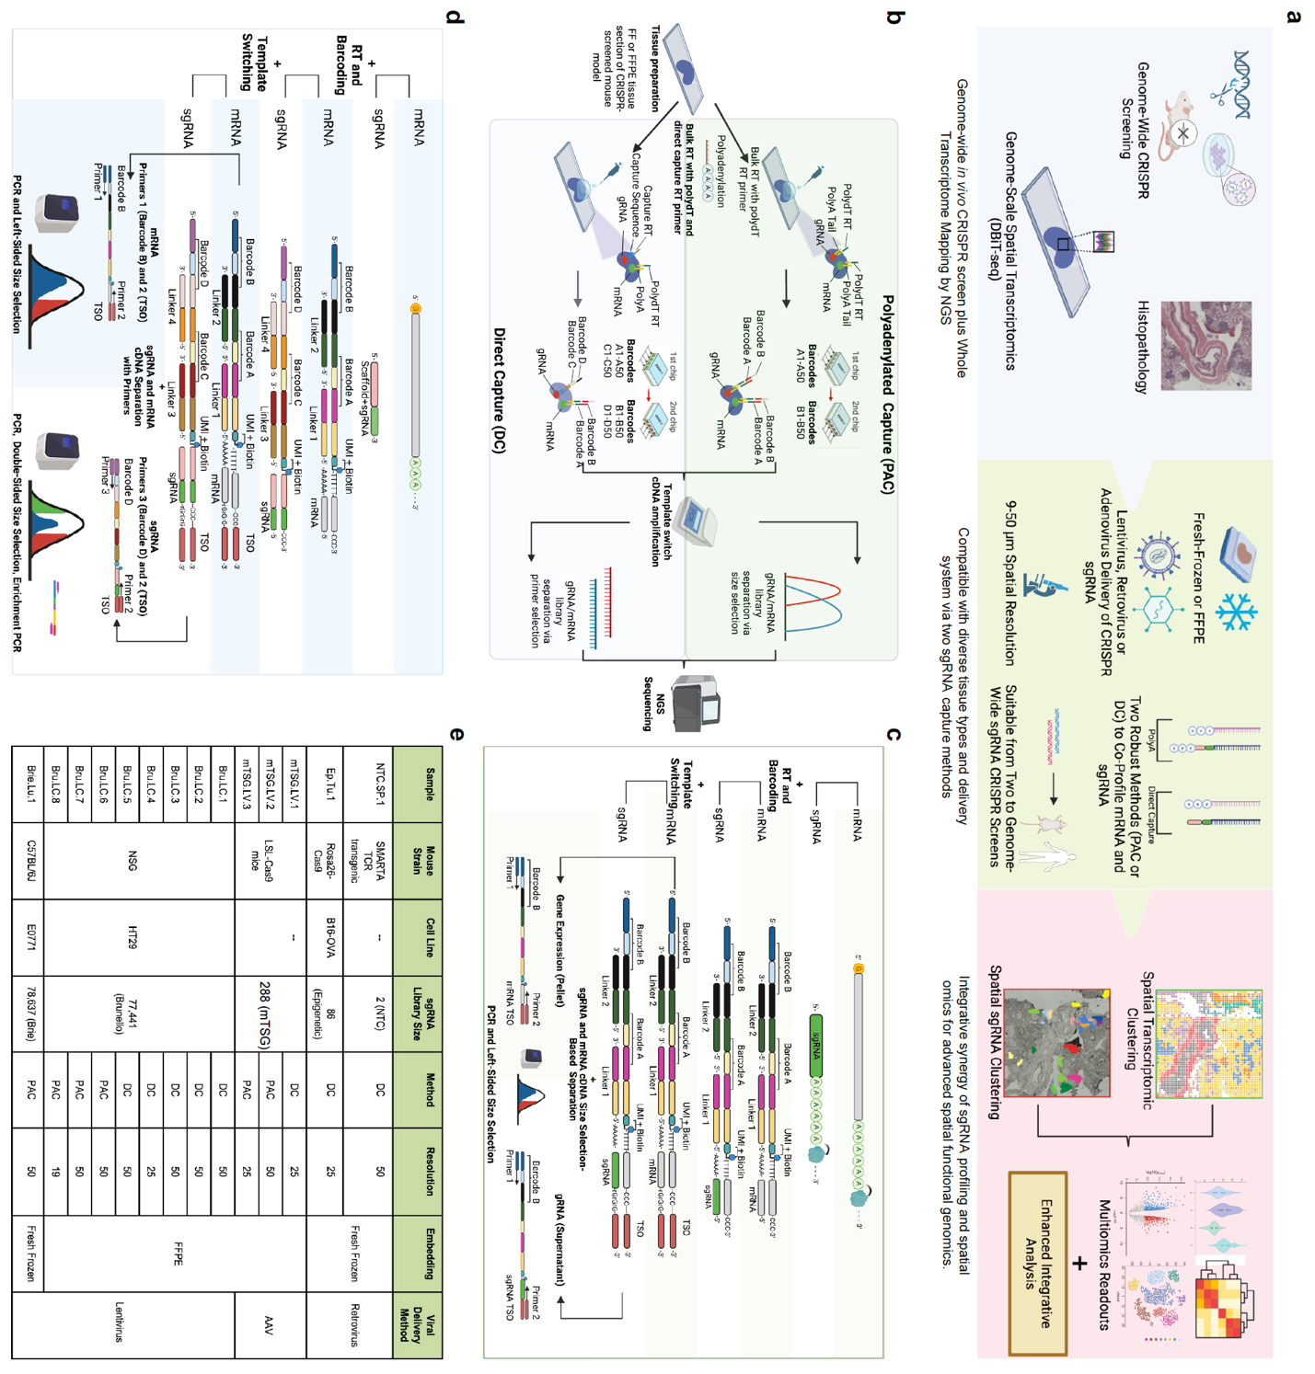
Extended Data Fig. 1. Perturb-DBiT workflow, chemistry design, and optimization, Related to Figure 1
(a) Schematic of Perturb-DBiT and its diverse applications. (b) Perturb-DBiT workflow for both PAC and DC methods. (c) Chemistry design of Perturb-DBiT PAC. (d) Chemistry design of Perturb-DBiT DC. (e) Overview of samples, sgRNA libraries, methods, and conditions used in the study.
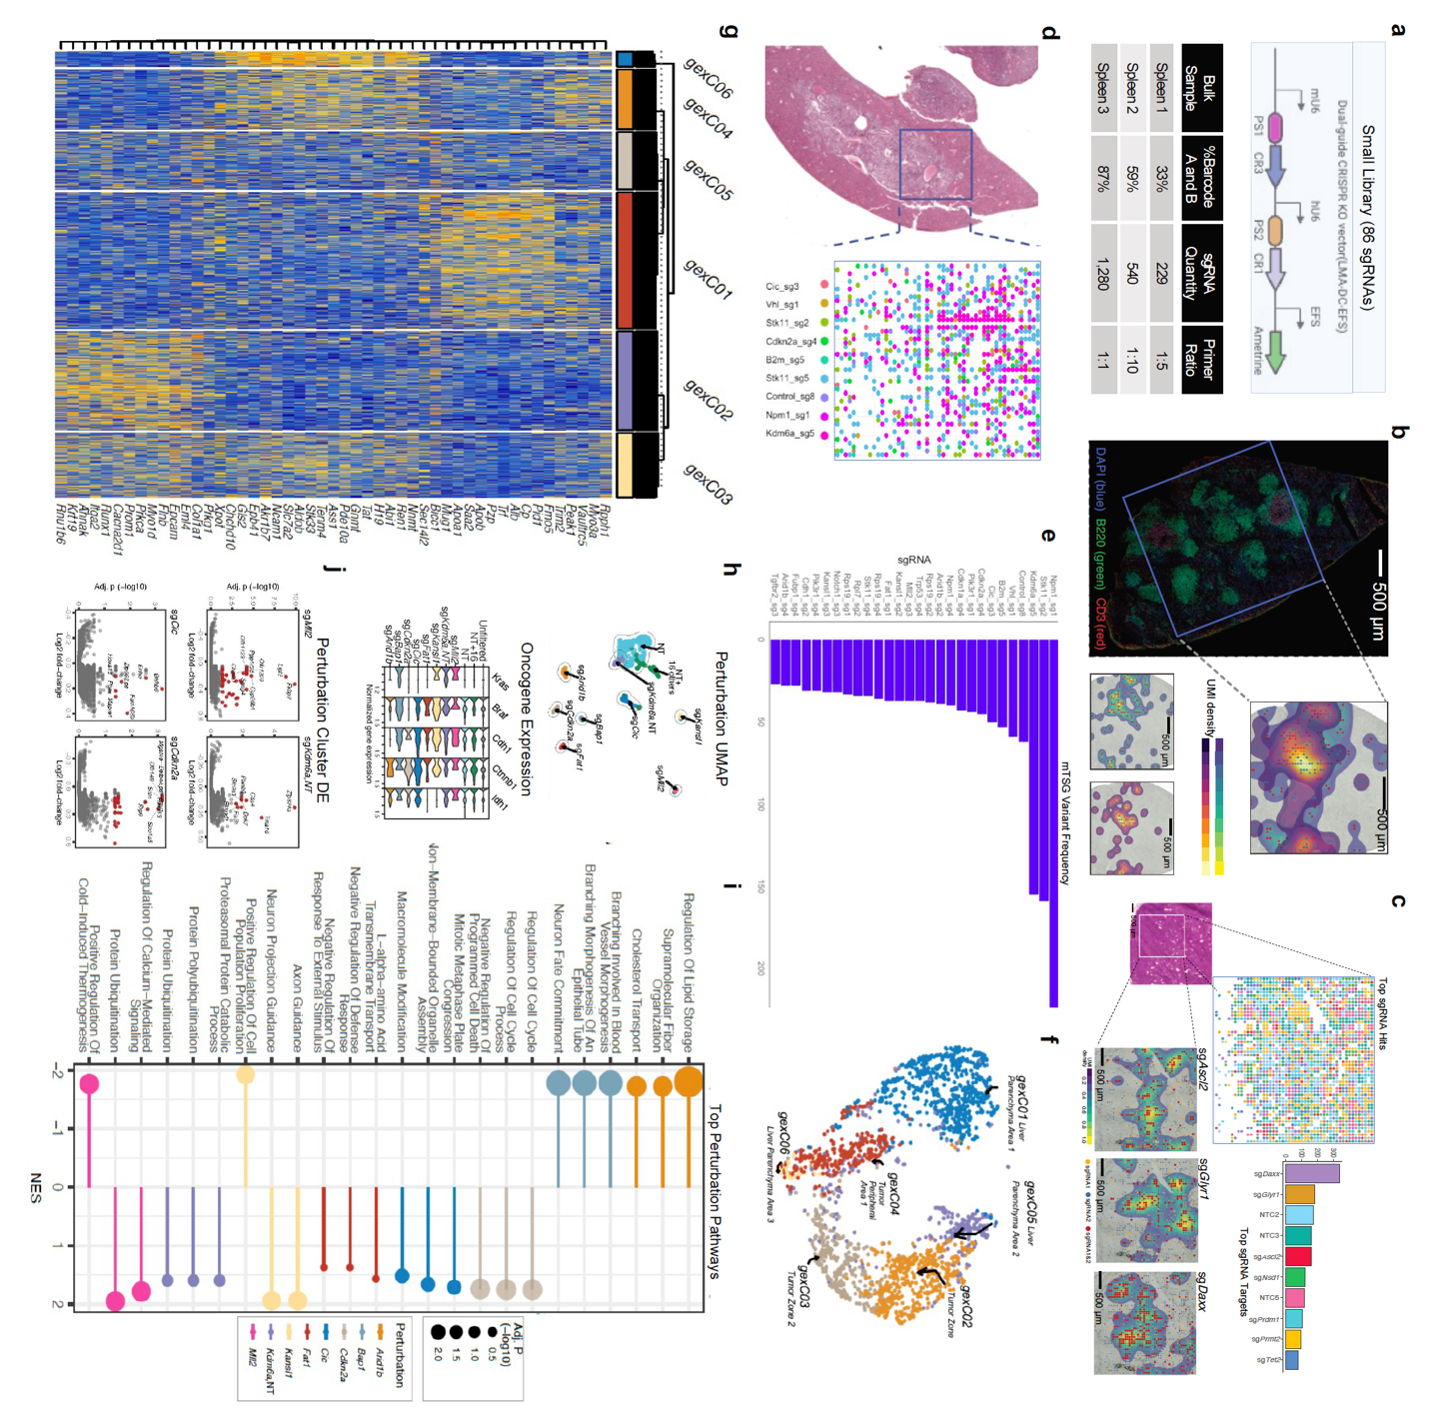
Extended Data Fig. 2. Spatial mapping of sgRNAs in small and medium CRISPR-screening libraries, related to Figure 1
(a) Top: Schematic of the dual sgRNA CRISPR KO retroviral vector used for Perturb-DBiT with
the small (86 sgRNA) library. Bottom: table depicting sgRNA capture validation experiments done in bulk on three spleen sections with two non-targeting controls. (b) Small library guide detection (2 sgRNAs) in Cas9-expressing SMARTA cells in a mouse host spleen using a non-targeting control (NTC) dual-guide. Left, Immunofluorescence imaging of the host tissue (sample NTC.Sp.1) is presented with host CD3+ T cells in red, and a blue box marks the ROI used for Perturb-DBiT. Right, The UMI detection of each of the dual guides are shown relative to the ROI. NTC sgRNAs are presented with points (sgRNA1 = red, sgRNA2 = blue) atop a 2D density map (sgRNA1 = blue-to-gold, sgRNA2 = purple-to-yellow). (c) Small library guide detection (86 sgRNAs) in Cas9-expressing tumor cells in a tumor tissue (sample Ep.Tu.1) using a library of 38 epigenetic regulators and 10 non-targeting controls (NTC). Top left: Top sgRNA hit spatial plot and adjacent H&E image corresponding to the region of interest. Top right: top sgRNA hits bar plot. Bottom: Top sgRNAs are presented with points atop a 2D density map (sgRNA1 and sgRNA2 overlap = blue-to-gold). (d) Visualization of top sgRNA hits from 25-micron Perturb-DBiT detection of a medium-sized guide library (288 sgRNAs) in a murine model of autochthonous liver cancer. (e) Bar plot of top sgRNA hits from 25-micron Perturb-DBiT applied to a murine model of autochthonous liver cancer (f) UMAP visualization of Fig. 1f. (g) Heatmap of top differentially expressed genes for clusters in Fig 1f. (h) Top: UMAP visualization of spots based on the dimensional reduction of Mixscape perturbation scores (pUMAP). Non-perturbed (NP) spots were included in the analysis to serve as a control/reference point. Additionally, spots were clustered (shown by color and outline) then named by the major perturbations of the cluster (>= 20% of clustered spots). One cluster with NP and 16 minor perturbations (< 20% of cluster) was named “NP+16”. Bottom: violin plot of the expression of 5 selected oncogenes, compared between pUMAP clusters. (i) Bubble plot of the top 3 pathways identified from DE genes of each pUMAP cluster (point color). Pathways were detected from gene set enrichment analyses using biological process gene ontologies, and the results are presented by significance (point size) and normalized enrichment score (NES), which provided the enrichment direction and magnitude. (j) Volcano plots of the DE analysis between selected pUMAP clusters using pseudo-replicate Wilcox tests. DE genes were those with an adjusted p < 0.05 and an absolute fold-change > 0.1 (up-regulation = red, down-regulation = blue), and the top 8 most significant DE genes were labeled for each analysis.
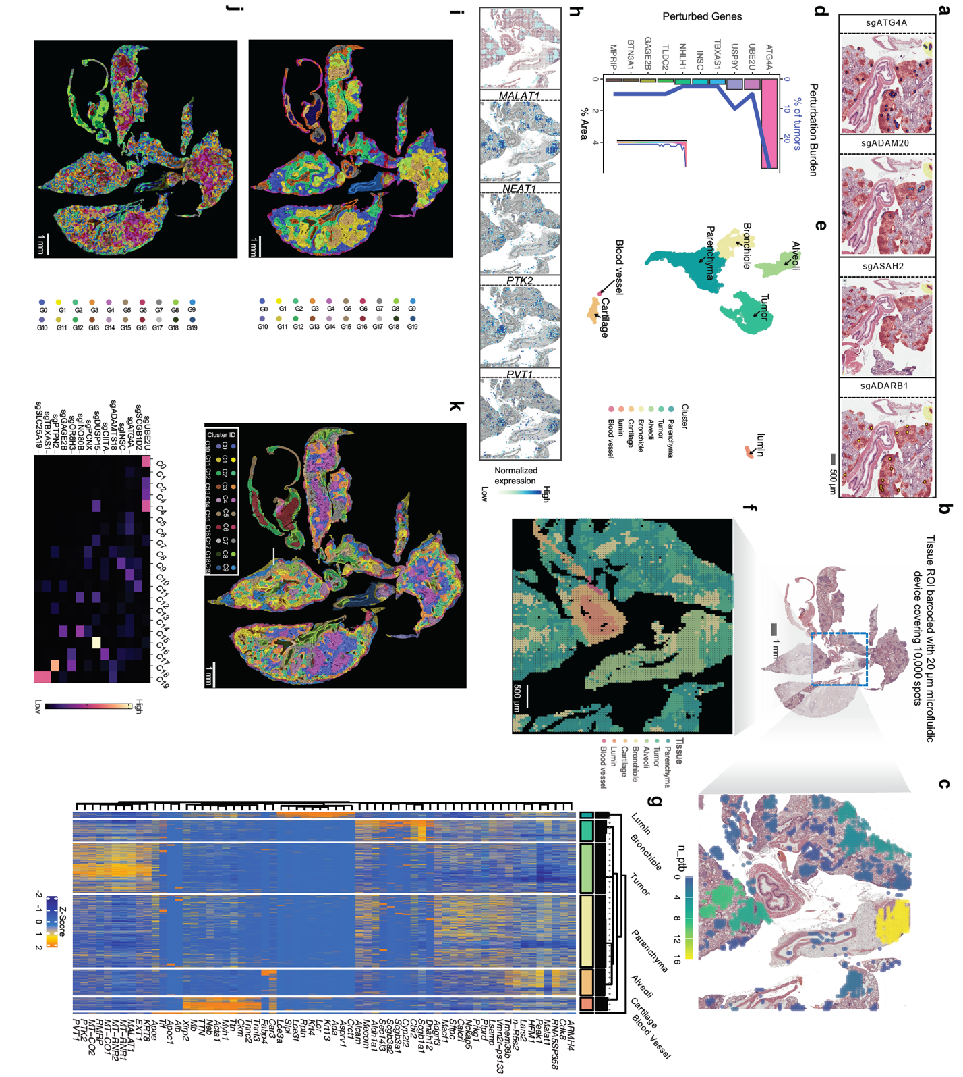
Extended Data Fig. 3. Genome-wide high-resolution mapping of HT29 lung metastatic colonization model tissue sections, related to Figure 2
(a) Spatial distribution of select sgRNAs. (b) Spatial mapping of the lung section using 20-μm device covering 100,000 spots: H&E of an adjacent section. (c) Spatial distribution of perturbation burden calculated as the area of spots with a detected sgRNA within a specified tumor region. (d) Bar plot of the top 10 gene perturbations detected by 20-μm Perturb-DBiT. The area and total counts of the gene perturbations are presented by bars and blue line, respectively. (e) Spatial UMAP analysis revealed seven clusters in the 100,000-spot sample. (f) Spatial mapping of the seven clusters in S3E. (g)Top ranked DEGs defining each cluster in Extended Data Fig. 3f. (h) Spatial distribution of the top genes defining the tumor cluster overlaid on the H&E brightfield image. (i,j) Super-resolved spatial clustering of the top 3,000 gene profile (i) or all sgRNAs (j) imputed with iStar. (k) Super-resolved spatial clustering of the top 16 sgRNA profile and representative sgRNA expression (bottom) enhanced with iStar. These sgRNAs exhibit cluster-specific imputed expression.
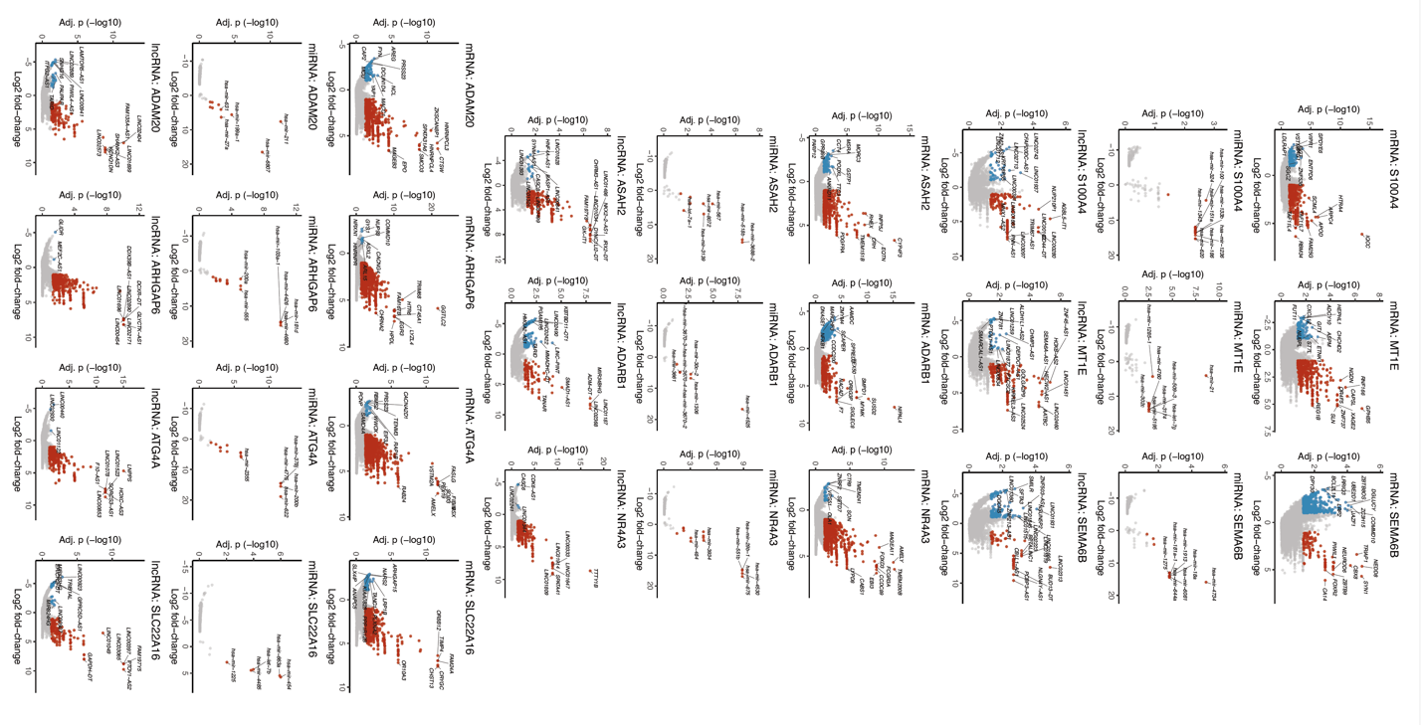
Extended Data Fig. 4. Differential non-coding RNA analysis of HT29 lung metastatic colonization model, related to Figure 3
Volcano plots depicting top ten sgRNA hits and their impact on differential expression of tRNA, microRNA and lncRNAs.
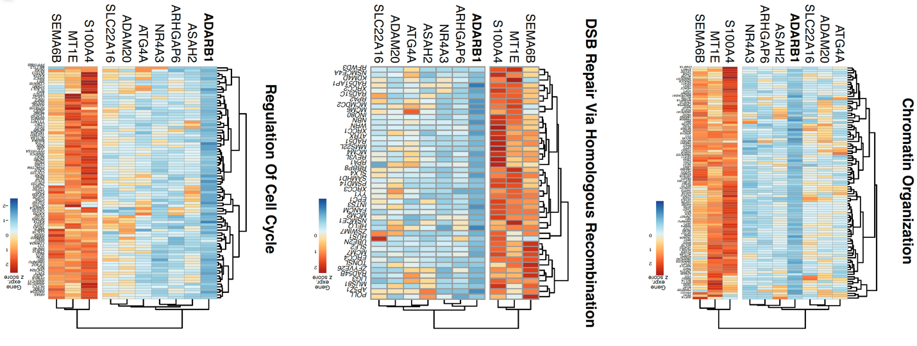
Extended Data Fig. 5. Pathway-level analysis of differentially expressed genes for top sgRNAs hits in HT29 lung metastatic colonization model, related to Figure 3
Pathway-level clustering of DEGs related to regulation of cell cycle, DSB repair via homologous recombination, and chromatin organization for top ten sgRNA hits.
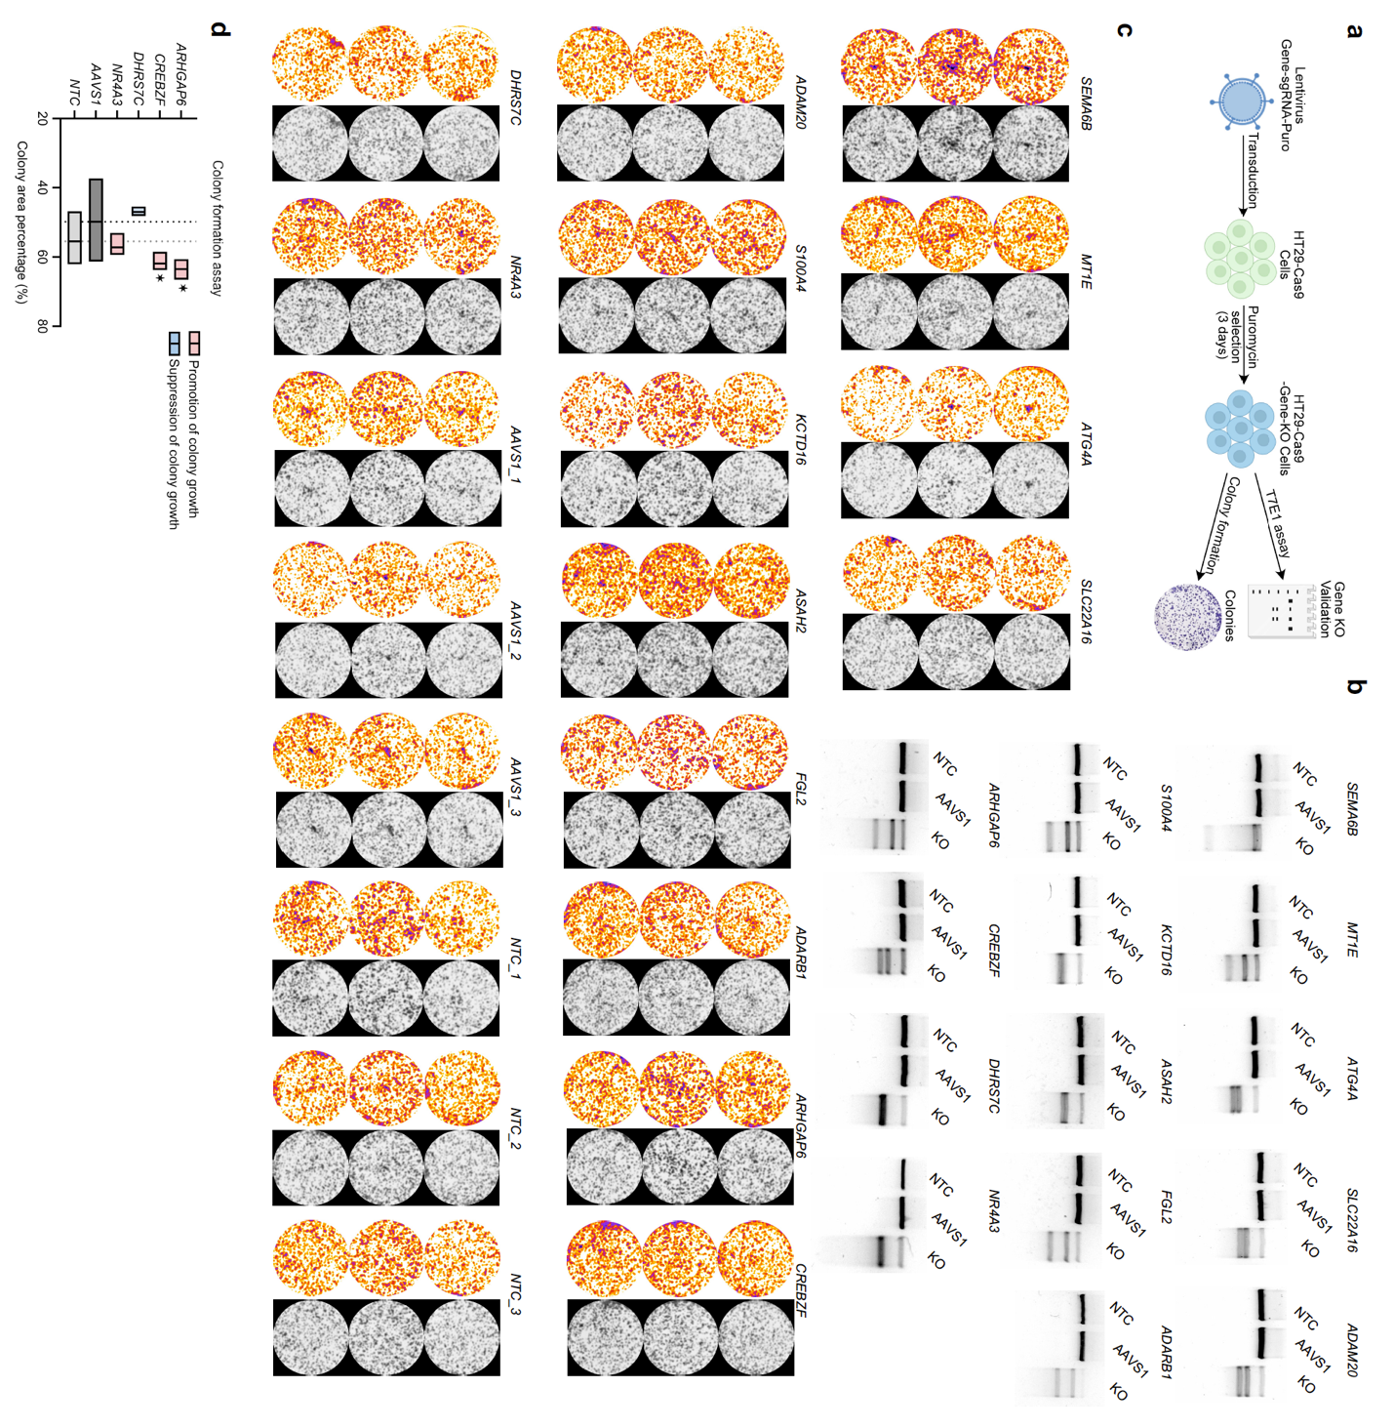
Extended Data Fig. 6. Colony formation assays and spatial pseudotime analysis of HT29 lung metastatic colonization model, related to Figure 4
(a) Schematic showing the colony formation assay. (b) T7E1 assays determined genomic DNA editing and cutting efficiency of each sgRNA. (c) Colony formation assay analysis utilizing Colony Area plugin in ImageJ of both top enriched sgRNA hits from Perturb-DBiT and validated tumor suppressor/promoter genes for the HT29 lung metastatic colonization model. (d) Colony formation assay results of validated tumor suppressor/promoter genes for the HT29 lung metastatic colonization model.
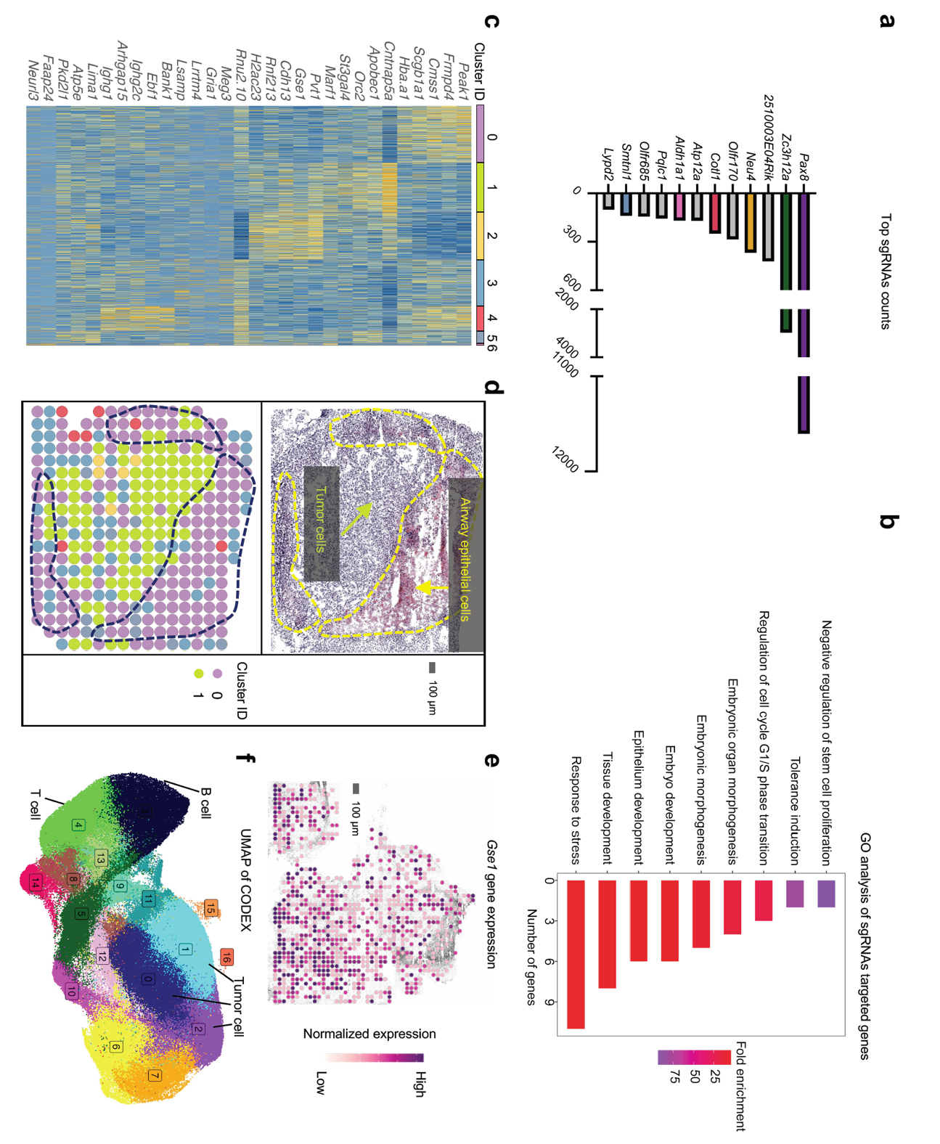
Extended Data Fig. 7. E0771 syngeneic lung model schematic, sgRNA mapping and GO analysis, and tumor architecture insights, related to Figure 5
(a) Top sgRNA hits and their respective counts detected by Perturb-DBiT. (b) GO analysis of top sgRNA hits based on annotation from Ensembl and STRING-db. (c) Heatmap of 6 distinct clusters revealed by unsupervised clustering of spatial transcriptomics data. (d) Top: Pathology annotation differentiating airway epithelial cells and tumor cells within one of the three tumor regions covered by the ROI for Perturb-DBiT. (e) Gene expression spatial plot of Gse1 overlain on brightfield image of tissue section. (f) CODEX UMAP revealing 16 unique clusters. Cluster 3: B cells, Cluster 4: T cells, Cluster 0,1,2: Tumor cells.

Supplementary Table 1-6 Titles

Table 1. Summary of samples and sgRNA data quality.
Table 2. Lists of CODEX antibody list, cycle design, and reporter plate composition. Related to Methods.
Table 3. List of primers and barcodes.
Table 4. List of sgRNAs and spacer sequences pertaining to Brie, Brunello, mTSG and Epigenetic libraries.
Table 5. List of Primers used in T7E1 assay.
Table 6. List of parameters used for preprocessing spatial screen data

