Supplementary information.
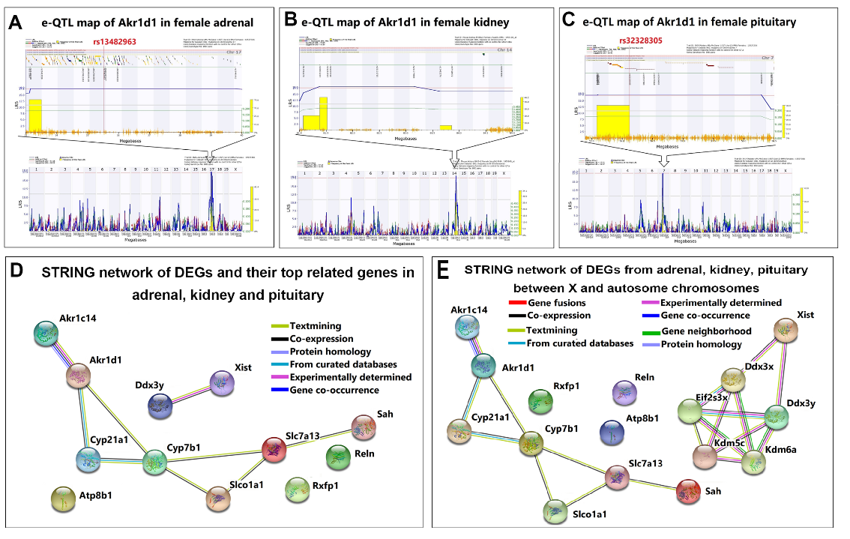
Fig. S A-C. eQTL maps of Akr1d1 in female mouse tissues. Significant eQTLs for Akr1d1 were detected on chromosome 17 in the adrenal gland (A), chromosome 14 in the kidney (B), and chromosome 7 in the pituitary gland (C), all surpassing the significance threshold (dashed line). The adrenal region (A) harbored 9 SNPs, the kidney (B) 5 SNPs, and the pituitary (C) 6 SNPs. Two SNPs (marked in red) were located within genes. D–E. STRING networks of EDEGs and their top interactors in adrenal, kidney, and pituitary tissues. PPI networks of EDEGs located on autosomal chromosomes(D). Colored nodes represent query proteins (EDEGs) and their first-shell interactors; edges indicate functional associations. EDEGs were linked to diverse biological processes. PPI networks of DEGs on autosomal and X chromosomes (E), highlighting Ddx3y and Xist as key interactors. These genes were top-ranked for autosomal DEGs and showed strong connectivity with X-chromosome DEGs.

