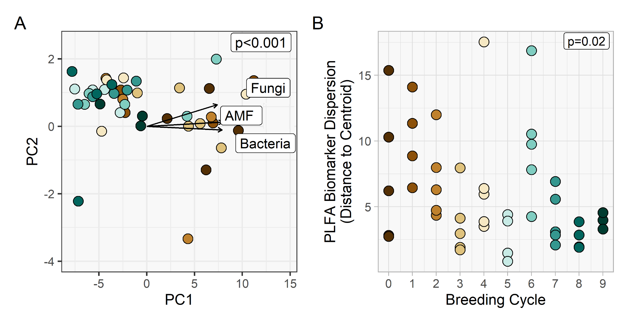
Figure S1. Effect of breeding cycle on phospholipid fatty acid (PLFA) biomarker composition (A) and dispersion (B). Fungi, bacteria, and arbuscular mycorrhizal fungi (AMF) represent the total sums of PLFAs assigned to those groups, and are correlated to the underlying ordination, with arrow length and direction indicating the strength and direction of the correlation. P-values are from permutational multivariate analysis of variance. Different colors in A indicate breeding cycle as indicated in B

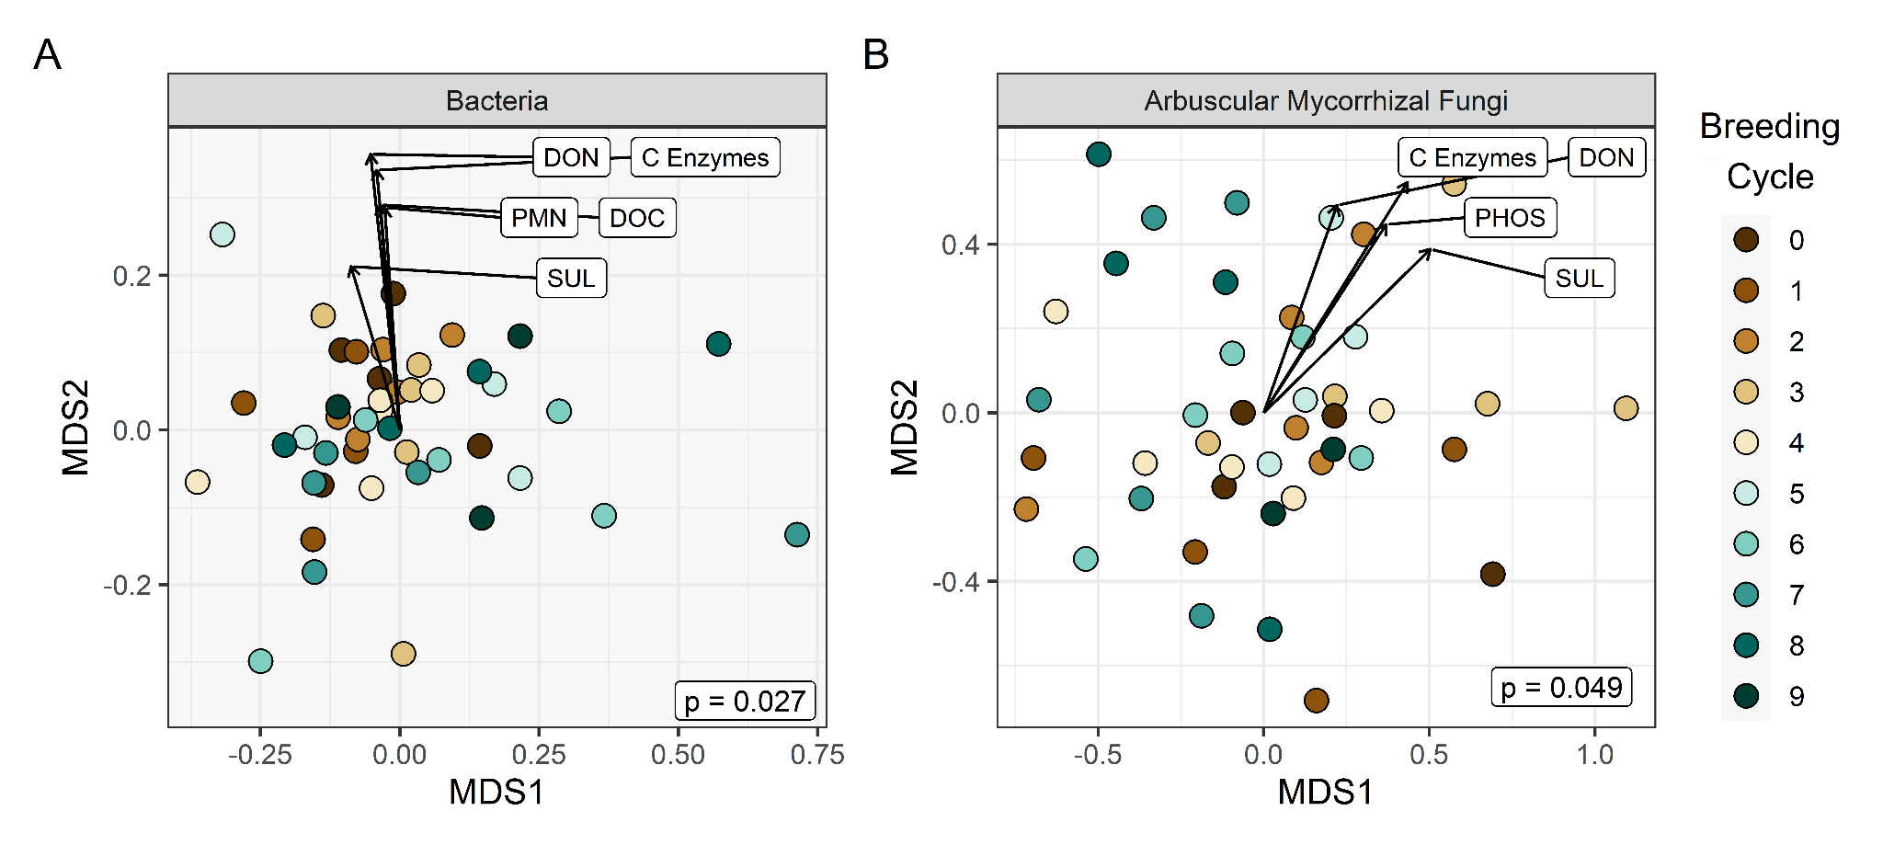

Figure S2. Effect of breeding cycle on bacterial (A) and arbuscular mycorrhizal fungal (AMF) (B) community composition. Environmental variables are correlated to the underlying ordination, with arrow length and direction indicating the strength and direction of the correlation. Only environmental variables that significantly correlate to the underlying ordination (p < 0.05) are shown. DON is dissolved organic nitrogen, DOC is dissolved organic carbon, PMN is potentially mineralizable nitrogen, SUL is arylsulfatase, PHOS is phosphatase, and C enzymes is the scaled mean of 𝛼- and β-glucosidase, β-xylosidase, and cellobiohydrolase. P-values are from permutational analysis of variance.

Supplementary Table 1. Impact of breeding cycle on all measured soil variables. P-values and predicted maximum and minimum values (reported along with the breeding cycle they are predicted in) are from generalized additive models (GAMs) with breeding cycle as a smoothed term. NS indicates p > 0.1, while p-values between 0.05 and 0.1 indicate marginal effects. C is carbon and N is nitrogen. Mean carbon enzymes represents the scaled mean of 𝛼- and β-glucosidase, β-xylosidase, and cellobiohydrolase.
Soil Measurement | GAM p-value | Predicted Max (cycle, mean) | Predicted Min  (cycle, mean)
Soil Chemistry
Gravimetric Moisture (%) | NS | C5, 21.2 | C0, 20.1
pH | NS | C9, 7.98 | C3, 7.96
Electrical Conductivity (uS/cm) | NS | C0, 406 | C9, 361
Nitrate (mg/kg soil) | NS | C0, 27.5 | C9, 19.2
Organic Matter Pools
Soil protein (mg/kg soil) | NS | C3, 4060 | C7, 3560
Potentially Mineralizable N (mg/kg soil) | 0.035 | C0, 17.2 | C9, 10.1
Permanganate oxidizable C (mg/kg soil) | NS | C2, 632 | C8, 564
Dissolved organic C (mg/kg soil) | 0.012 | C0, 110 | C6, 61.2
Dissolved organic N (mg/kg soil) | 0.047 | C0, 10.5 | C9, 6.7
Total N (%) | NS | C2, 0.228 | C8, 0.204
Soil organic C (%) | NS | C3, 2.34 | C7, 2.02
Enzyme Activities (nmol/h/g soil)
Mean carbon enzymes | 0.026 | C0, 5.25 | C9, 4.54
Leucine aminopeptidase (LAP) | 0.067 | C0, 549 | C6, 450
Phosphatase (PHOS) | <0.001 | C0, 115 | C9, 73
Arylsulfatase (SUL) | <0.001 | C4, 21 | C7, 9
Enzyme Activity per unit biomass (nmol substrate/h/nmol PLFA)
Mean carbon enzymes | 0.008 | C9, 0.075 | C0, 0.051
Leucine aminopeptidase (LAP) | 0.015 | C9, 7.48 | C0, 4.83
Phosphatase (PHOS) | NS | C9, 1.26 | C0, 1.04
Arylsulfatase (SUL) | 0.007 | C4, 0.262 | C0, 0.123
PLFA Functional Groups (nmol/g soil)
Firmicutes | <0.001 | C0, 23.0 | C0, 11.8
Actinobacteria | <0.001 | C0, 14.1 | C9, 7.8
Arbuscular mycorrhizal fungi | <0.001 | C0, 5.4 | C9, 2.6
Saprotrophic fungi | 0.003 | C0, 19.0 | C9, 10.5
Total fungi | 0.001 | C0, 24.4 | C9, 13.1
Total bacteria | <0.001 | C0, 68.4 | C9, 35.6
Total PLFAs | <0.001 | C0, 119.5 | C9, 63.2
Fungi:Bacteria ratio | NS | C0, 0.37 | C9, 0.37
Arbuscular mycorrhizal fungi: Saprotrophic fungi ratio | NS | C2, 0.280 | C9, 0.251
Supplementary Table 2. Impact of breeding cycle on bacteria and arbuscular mycorrhizal fungi alpha diversity indices. P-values and predicted maximum and minimum values (reported along with the breeding cycle they are predicted in) are from generalized additive models (GAMs) with breeding cycle as a smoothed term. NS indicates p > 0.1, while p-values between 0.05 and 0.1 indicate marginal effects.
Alpha Diversity Index | GAM p-value | Predicted Max  (cycle, mean) | Predicted Min  (cycle, mean)
Bacteria
ESV richness | 0.073 | C0, 4784 | C9, 4620
Shannon | NS | C0, 7.56 | C9, 7.54
Simpson | NS | C0, 0.998 | C9, 0.998
Fisher | 0.075 | C0, 1926 | C9, 1826
Chao1 | 0.034 | C0, 6980 | C9, 6431
ACE | 0.037 | C0, 7296 | C9, 6732
Faith’s phylogenetic diversity | 0.060 | C0, 186 | C9, 175
Arbuscular Mycorrhizal Fungi
ESV richness | NS | C0, 807 | C9, 778
Shannon | NS | C4, 5.28 | C7, 4.73
Simpson | 0.056 | C4, 0.984 | C7, 0.932
Fisher | NS | C0, 239 | C9, 228
Chao1 | NS | C0, 1099 | C9, 1060
ACE | NS | C0, 7.02 | C9, 6.99
Faith’s phylogenetic diversity | NS | C9, 129 | C3, 137

