Online Methods

BraDiPho currently includes eight human brain specimens: four right (01, 04, 16, and 18) and four left hemispheres (02, 10, 17, and 19), each dissected over 7 to 13 progressive epochs (Supplementary Figure S1 and Table 1). All specimens were processed through the same methodological pipeline detailed below.
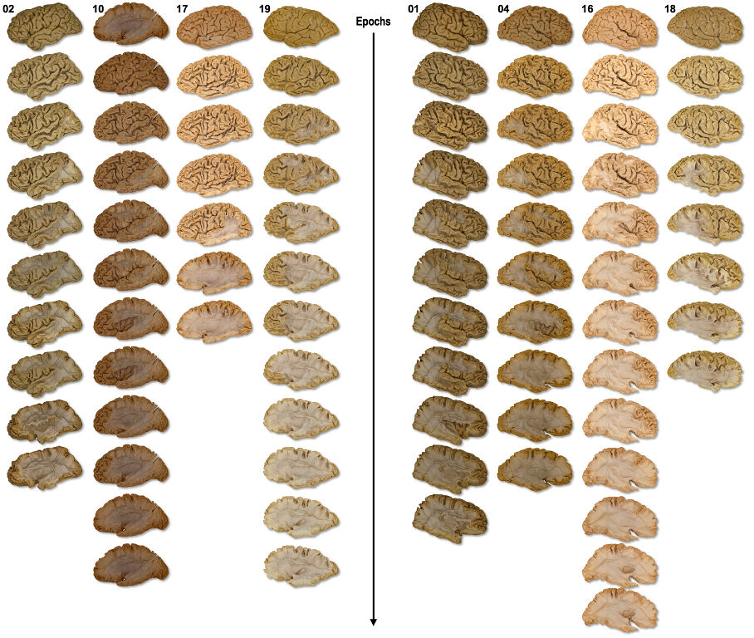
Supplementary Figure S1. All dissection epochs of the eight human specimens currently provided in BraDiPho.

Specimen preparation protocol
The postmortem human brain hemispheres included in BraDiPho originate from the Brain Anatomy Data Bank (BADaBank) of the Structural and Functional Connectivity Lab Project, Department of Neurosurgery of Santa Chiara Hospital (Azienda Provinciale per i Servizi Sanitari (APSS), Trento, Italy). The study was approved by the Ethical Committee of APSS (N° 06/2018). Each hemisphere was prepared following an adapted version of Klingler's original protocol ³¹. Specimens were fixed in a 10% formalin solution for 40 days, then frozen at –80 °C for 30 days before being thawed. The arachnoid, pia mater, and vessels were meticulously removed during this process. The soaking, freezing, and subsequent defrosting of specimens allow water molecules to permeate tissues, expanding their volume and forming ice crystals, separating white matter (WM) fibers and facilitating their isolation during dissection ²⁸. Specimens were stored in formalin-filled jars until MRI acquisition and dissection.

T1 MRI acquisition and processing
MRI scans were acquired using a 1.5 Tesla GE scanner (GE Healthcare, Boston, Massachusetts, USA) with a T1-weighted volumetric sequence (1 mm slice thickness, 24 mm field of view, no gap acquisition). The jar containing the specimen was removed from the images through brain extraction. T1 images were aligned to the anterior commissure–posterior commissure (AC–PC) plane of the Montreal Neurological Institute (MNI) template. A mesh model of each hemisphere was then generated from the multislice volumetric ex-vivo MR-T1 using Monte Carlo methods and smoothing algorithms.

Layer-by-layer Klingler Dissection
Dissections were performed using a refined, cortex-sparing version of the Klingler technique, proceeding layer by layer with wooden spatulas and following a latero-medial approach (Figure S1). The dissection of four hemispheres (left: 02, 10; right: 01, 04) focused on the posterior transverse (PTS) and superior longitudinal systems (SLS), whereas the other four hemispheres (left: 17, 19; right: 16, 18) were dedicated to delineating the inferior longitudinal system (ILS) ³². Given the methodical nature of layer-by-layer dissection, involving the gradual removal of superficial layers to access deeper ones, in addition to isolating ILS fibers in the last four specimens, we successfully extracted the superficial layers of the SLS and PTS in two hemispheres (sub-16, sub-19), and the basal longitudinal system (BLS) in the remaining two (sub-17, sub-18). In all eight hemispheres, dissection commenced from the intact convexity, progressing with systematic decortication of the sulci while preserving the gray matter at the summit of the gyri.
The extraction of the PTS entails two distinct layers of dissection, henceforth referred to as epochs. The initial epoch encompasses superficial fibers connecting the posterior sector of the middle temporal gyrus (MTG) to the inferior parietal lobule, alongside intralobar occipital fibers running parallel and just posterior to them. The second epoch includes longer and deeper fibers connecting the inferior temporal and superior parietal cortices.
The dissection of the SLS starts with the extraction of fronto-parietal fibers. A superficial epoch reveals connections between the angular gyrus (AG) and the posterior frontal cortices, while a deeper epoch comprises longer fibers extending to the anterior frontal cortices. Deep fronto-temporal fibers are exposed after the removal of the AG.
The first step in dissecting the inferior longitudinal system (ILS) involves the identification of its stem, i.e., the bottleneck region of the external/extreme capsule through which all ventral interlobar association fibers pass. This requires the removal of the opercula and the excision of the underlying insula. From the stem, the dissectionist follows the trajectory of WM fibers both anteriorly and posteriorly. Shorter fibers linking the inferior frontal to the anterior temporal cortices are located more lateral and closer to the cortical surface, while longer fibers extending to the temporal, occipital, and parietal cortices run more medially. Characterizing the entire wiring of the ILS typically requires 3 to 4 epochs.
Dissection of the BLS starts from the basal surface of the hemisphere. Analogous to previously described systems, the BLS features a superficial layer of short fibers and a deeper one of longer fibers.
These dissection guidelines were adapted on a case-by-case basis, as individual anatomy and preparation quality influences tract accessibility. Details of dissected layers are summarized in Supplementary Table 1 and on the BraDiPho website (https://bradipho.eu/dev/).

Photogrammetry acquisition & processing
The photogrammetric setup includes two Sony A7RIII cameras equipped with Voigtlander 65mm F2 APO-Lanthar lenses, supported by two tripods and macro sledges, a lightbox, a Vivat Turn Table D-26, and a round plate featuring markers and three rulers. The turntable, housed within the lightbox, securely holds the plate. The cameras, positioned at 40 and 60-degree angles, are mounted on the tripods via the macro sledges. A motorized turntable, set to rotate 3 degrees clockwise, connects to both cameras through a splitter. The acquisition process is automated, with the turntable capturing 120 photos per orientation during each full 360-degree rotation. This rotation sequence is repeated twice, with adjustments made to the macro sledges, ensuring an extended depth of field. Each dissection epoch yields 480 photos, all captured at full 42-megapixel resolution, with a shutter speed of 1/60 and aperture of f/11.
The photogrammetric reconstruction of the dissection scene into 3D digital models was carried out iteratively and independently for each epoch using Metashape Pro v1.8. The initial processing involves photo alignment, leveraging markers coded on the rotating plate to compute the orientation and position of each camera during image capture. The three rulers positioned on the plate define the scale of the photogrammetric model. A 3D dense point cloud is generated, achieving an average linear resolution of approximately 0.05 mm. This point cloud serves as the basis for generating a surface mesh model, while high-resolution images are employed to produce photographic texture.

Iterative registration of dissection epochs
The photogrammetric models of each epoch were registered to the radiological space of the specimen using the Iterative Closest Point (ICP) method, integrated into the open-source software CloudCompare (https://www.cloudcompare.org/). The first epoch (i.e., the intact convexity) is registered to the surface model derived from the ex-vivo MR-T1. Each subsequent epoch is aligned with the preceding one, namely the one with the closest geometric resemblance. The affine transformation from the previous registration is then applied to maintain consistency. This iterative approach is implemented for each epoch, effectively mitigating the effects of gradual tissue removal and the related tissue relaxation on alignment accuracy. The signed distance between mesh models of consecutive epochs is calculated to verify the accuracy of the registration process.

Integration of tractography datasets in each BraDiPho specimen space
The MR-T1 volume of each specimen acquired before dissection provides a reference space for the photogrammetric dissection models of the different epochs. It further introduces the possibility of integrating data from any other radiological space. To integrate the tractography dataset with the layered 3D digital dissection models of each hemisphere, three main transformations are applied:
1. A rigid transformation aligns the photogrammetric model of the first dissection epoch with the ex-vivo MR-T1 space. This is achieved using the Iterative Closest Point (ICP) method as detailed in the paragraph above.
2. A non-linear transformation maps the MNI ICBM152 2009a T1 template to the ex-vivo MR-T1 space.
3. The tractography data from the subject's in-vivo space is mapped to the MNI T1 template space.
These last two transformations are performed with Advanced Normalization Tools (ANTS), specifically the SyN (Symmetric Normalization) technique, ³³, which combines rigid, affine, and diffeomorphic registrations.
The BraDiPho website offers an interactive online service (https://bradipho.eu/dev/5-tool-convert.html) that supports the integration of tractography bundles into the dissection models of each specimen. To use this feature users must upload two files: a tractography file in either TRK or TCK format and the corresponding MR-T1 nifti file. Any personal information must be removed from these files before uploading, although data will be automatically deleted post-processing for privacy reasons. Once the files are uploaded, the system processes the registration of the user’s tractography bundle into the space of the dissection models. The process takes few minutes, after which results are made available for download. The output is provided in two formats: .ply, which can be used for visualization in the software CloudCompare, and .vtk, which represents the streamlines as polylines for further analysis or visualization.
Tutorial 3 (https://youtu.be/d-LbJyGmQAQ) explains how users can explore their own tractography data conjointly with the dissection models. Sample in-vivo tractography data used in this tutorial represent the structural connectivity of the human angular gyrus ¹¹ and were sourced from diffusion-weighted (DW) and T1-weighted images of a single participant of the BIL&GIN database ³⁴. To prepare these data, probabilistic particle filtering tractography was used to generate a whole-brain tractogram ³⁵. ExTractor_flow was used to extract streamlines of the different short- and long-range bundles, revealing the angular gyrus's structural connectivity (AG) ¹¹.

Derivative data made available for each BraDiPho specimen
All surfaces or point cloud manipulations applied to the dissection models and the derivative datasets included in BraDiPho (i.e., tractography data, manual annotations and cortical parcellation atlases contextualised in the space of the dissection models) were made with a series of Python scripts included in bradiphopy (https://github.com/minilabus/bradiphopy). Volumes (.nii) and tractograms (.trk) manipulation were made with scilpy (https://github.com/scilus/scilpy), the Sherbrooke Connectivity Imaging Lab (SCIL) Python dMRI processing toolbox.

Cortical surface annotations along all the dissection epochs
To facilitate users of BraDiPho in exploring the anatomical features of each specimen, the cortical surface of the intact convexity has been annotated manually following a thorough sulcal/gyral subdivision in all the eight specimens currently available (Supplementary Figure S2). Nineteen cortical annotations delineating the gyri of the lateral and basal surfaces are provided. This process constitutes a long and meticulous step in data preparation. Annotations were generated in CloudCompare following the methodology outlined in Tutorial 2 (https://youtu.be/wC0_sbSukMY). In brief, a point cloud made of 100 million points is generated from each mesh model representing the intact convexity of each specimen. Annotations are done by manually outlining the region of interest through successive point picking using the "Segment" tool in CloudCompare. This process is repeated for each "ex-novo" annotation.
Annotations are then transferred from the first epoch of each specimen to all the subsequent epochs by matching neighboring points. This process entails generating a dense point cloud of 10 million points for each epoch in CloudCompare. The bdp_match_neighbors.py script matches the manually drawn annotations of the first epoch with the sampled points in subsequent epochs. The script is run iteratively for each epoch. Finally, the bdp_colorize_vtk_formats.py script creates a colorized version of each cortical annotation, useful for illustrative purposes (Supplementary Figure S2).

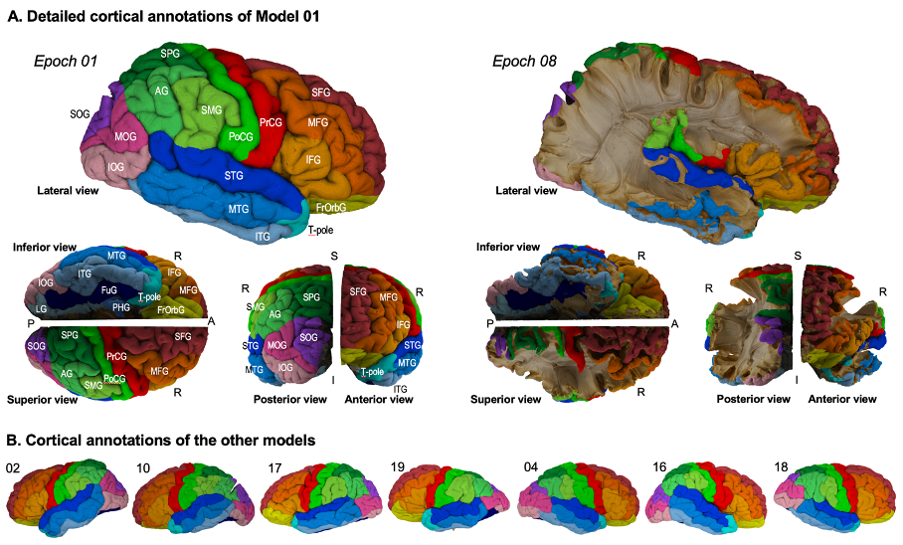
Supplementary Figure S2. Cortical surface annotations of each BraDiPho specimen. Gyral abbreviations and their colored-code description are listed in the supplementary Table 2.

Additional brain parcellation
BraDiPho also includes 12 referenced cortical parcellation atlases registered into the MR-T1 space of each specimen and projected onto the cortical surface of the intact convexity. It comprises the seminal myelo- and cytoarchitectonic microstructural cortical atlases of Campbell (1905), Smith (1907), Brodmann (1909), Flechsig (1920), Von Economo (1925) and Kleist (1934), recently made available as digital reconstruction ³⁶. We also included the cortical parcellation of the Desikan, Destrieux, Glasser, and Brainnetome atlases ^{13,19–21}. A multi-step process is required to map each atlas on the BraDiPho specimens. To ensure accurate registration, the MNI template hosting the original atlases is masked to exclude the cerebellum, matching the MR-T1 of the specimens included in BraDiPho. To improve the accuracy of the cortical surface reconstruction from Freesurfer, we use mri_synthsr to generate a (fake) T1w contrast image from the ex-vivo image. This helps to enhance the contrast between gray matter and WM, which is crucial for accurate surface reconstruction via recon-all. The Freesurfer surface reconstruction is a direct mapping of the specimens’ cortical surface. Registered and parcellated surfaces are saved in the appropriate frame of reference using standard formats for CloudCompare (.ply) and MI-Brain (.nii.gz).
The cortical labels of each atlas parcellation are then transferred along the subsequent dissection epochs as above mentioned for the manual cortical annotations (Supplementary Figure S3).

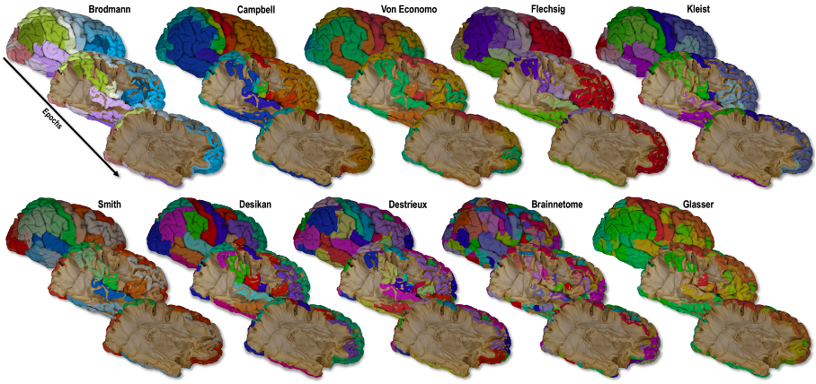
Supplementary Figure S3. Cortical surface labels of each BraDiPho specimen. Cortical annotation names and their colored-code description are listed in the supplementary Table 2.

Relevant tractography data registered in the radiological space of each BraDiPho specimen
BraDiPho also includes a selection of representative association bundles of two population-averaged tractography atlases, the HCP842 ²⁴ and SCIL (St-Onge et al. 2023) atlases (Supplementary Figure S4). This selection includes the arcuate fasciculus, the acoustic radiation, the cingulum, the frontal aslant tract, the inferior fronto-occipital fasciculus, the inferior longitudinal fasciculus, the middle longitudinal fasciculus, the optic radiation, the pyramidal tract, the superior longitudinal fasciculus, the uncinate fasciculus and the vertical occipital fasciculus. These bundles, originally available in the MNI space, are registered to each BraDiPho specimen using both linear and non-linear transformation computed between the MNI-ICBM152-2009a T1 template and the ex-vivo MR-T1 of each specimen.
We are providing tools to co-register files based on their file formats (images, labels, streamlines, etc.) from native space to MNI space and then to the specimen MR-T1 space.
- Precomputed registrations: The script uses precomputed registrations from MNI space to each BraDiPho specimen. These registrations are available at https://zenodo.org/records/11192915. This avoids the need to perform time-consuming registration steps for each specimen individually.
- Code and docker availability:
The code for launching the registration process is available at https://github.com/minilabus/bdp_registration_utils. This code can be used to reproduce the registration steps and apply the precomputed registrations to other BraDiPho specimens.

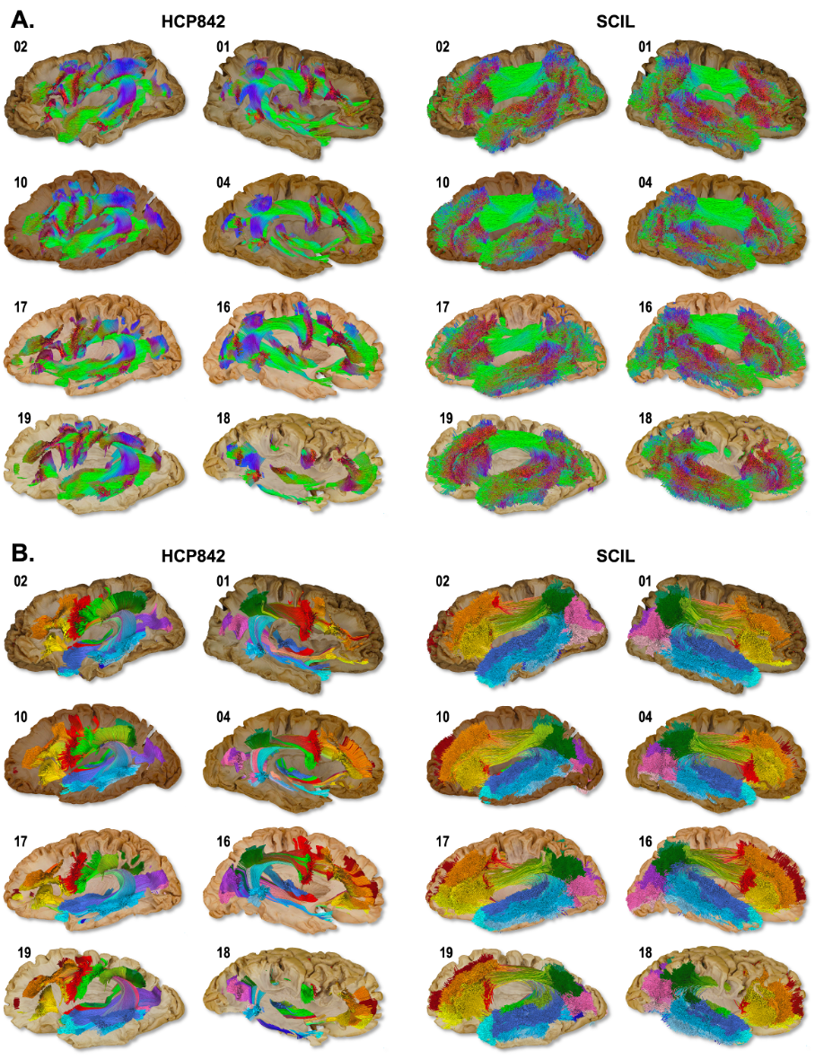
Supplementary Figure S4. Association bundles (AF, SLF, IFOF, UF, ILF, MdLF) of the HCP842 and SCIL atlases integrated on each BraDiPho Specimen. A. Orientation-based coloring ; B. Cortical termination-based coloring. Each streamline is color-coded by the cortical annotation its termination belongs to. Colors details in supplementary Table 2.

