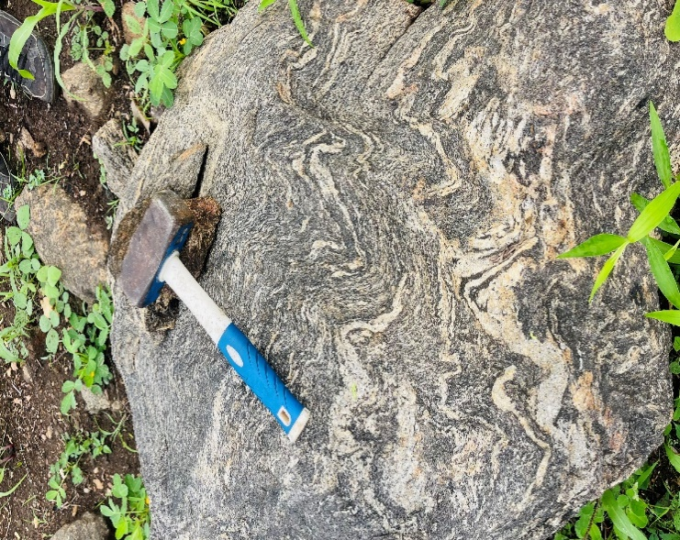
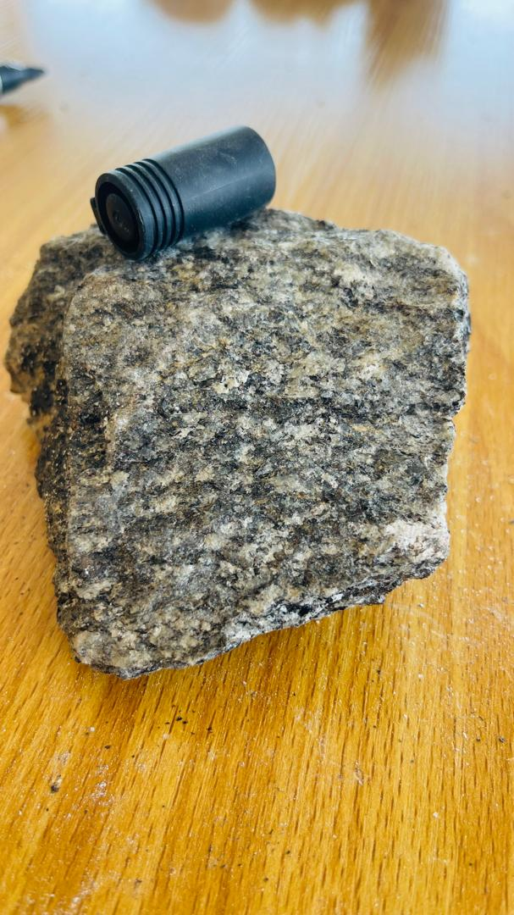

Plate I: Insitu Exposure of Migmatite-Gneiss. Plate II: Hand Specimen of Migmatite

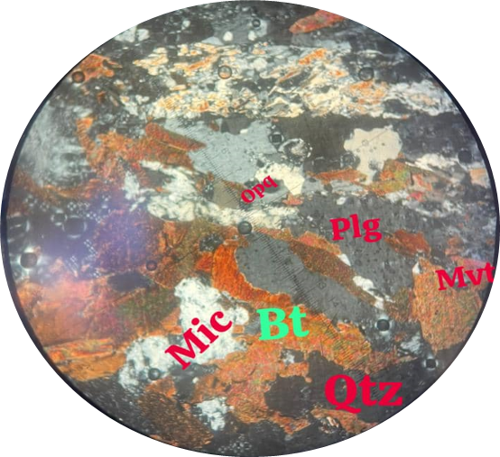
PPL
XPL

Plate III: Photomicrograph of Migmatite Gneiss in both PPL and XPL
(Magnification = 100x).
Qtz = Quartz, Bt = Biotite, Mic = Microcline, Plg = Plagioclase
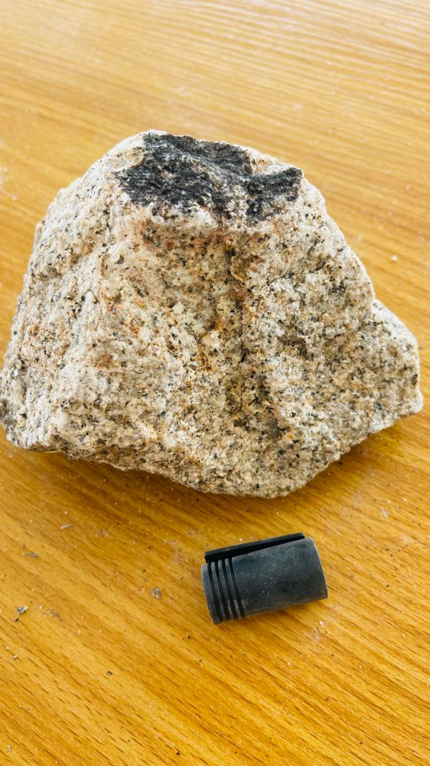
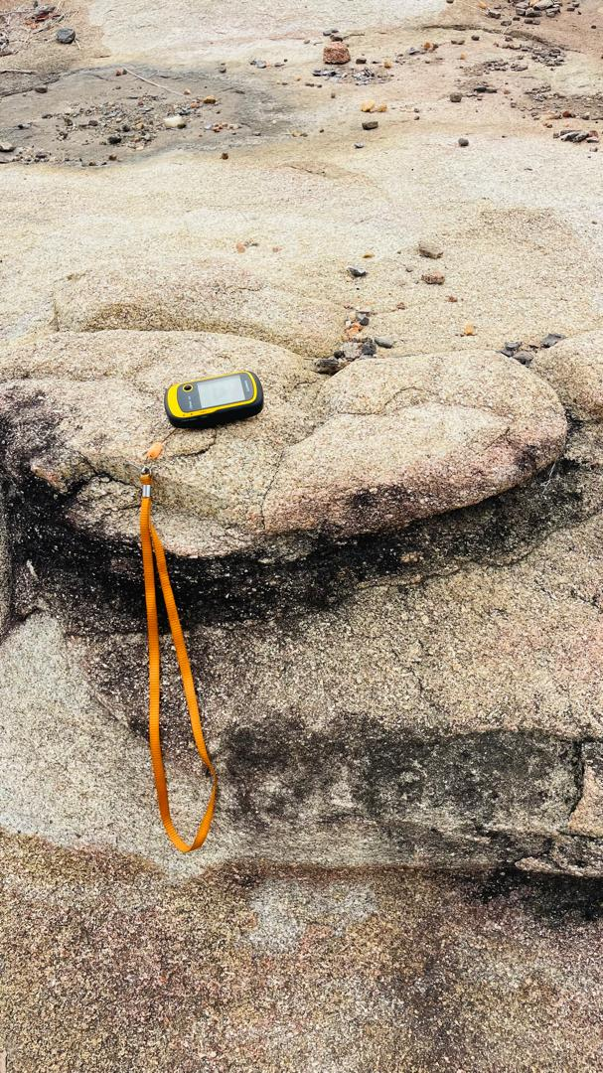

Plate IV: Insitu Exposure of Granite Plate V: Hand Specimen of Granite

PPL
XPL

Plate VI: Photomicrograph of Granitic Rock (SD02) in both PPL and XPL
(Magnification = 100x).
Qtz = Quartz, Bt = Biotite, Mvt = Muscovite, Plg = Plagioclase
XPLL
PPL

Plate VII: Photomicrograph of Granitic Rock (SD03) in both PPL and XPL
(Magnification = 100x).
Qtz = Quartz, Bt = Biotite, Mic = Microcline, Mvt = Muscovite, Plg = Plagioclase

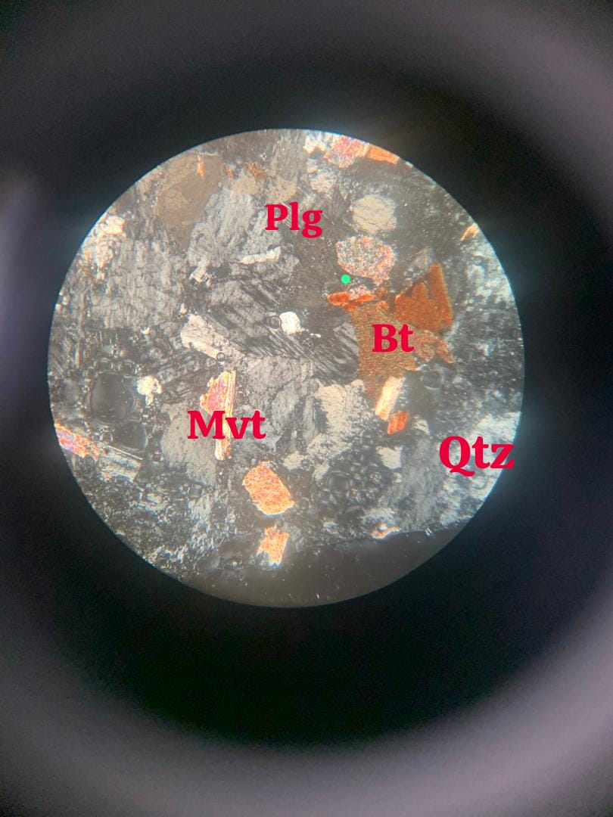
PPL
XPL

Plate VIII: Photomicrograph of Granitic Rock (SD04) in both PPL and XPL
(Magnification = 100x). Qtz = Quartz, Btt = Biotite, Mvt = Muscovite, Plg = Plagioclase
XPL
PPL

Plate IX: Photomicrograph of Granitic Rock (SD05) in both PPL and XPL
(Magnification = 100x).
Qtz = Quartz, Bt = Biotite, Mic = Microcline, Mvt = Muscovite, Plg = Plagioclase
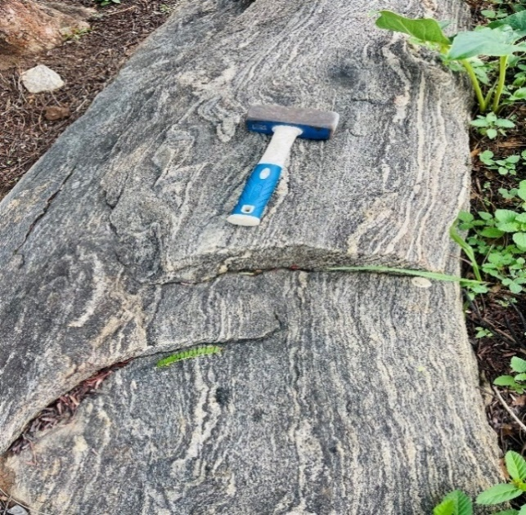

Plate X: Foliation on Gneiss

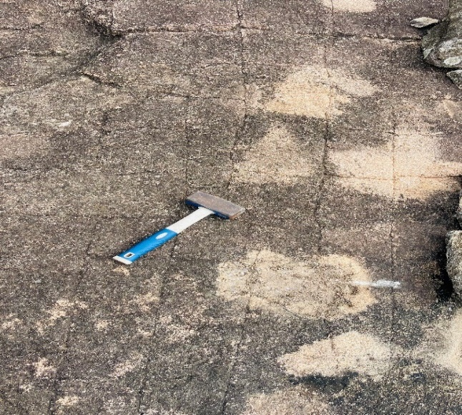
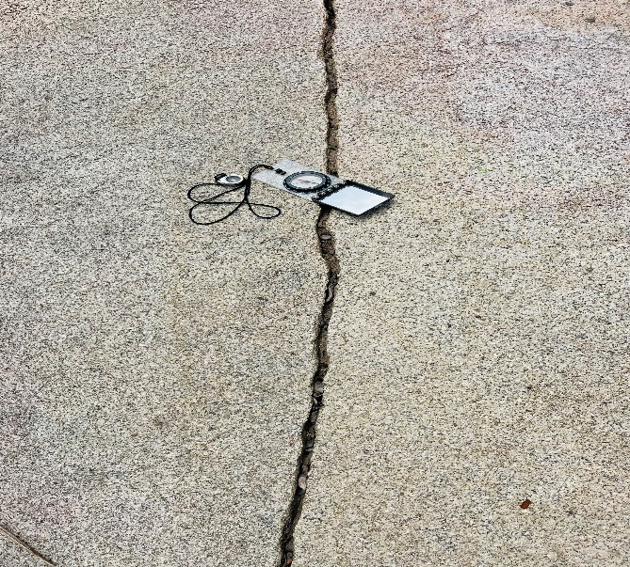

Plate XI: Open Joint on Granite Plate XII: Orthogonal Joint System

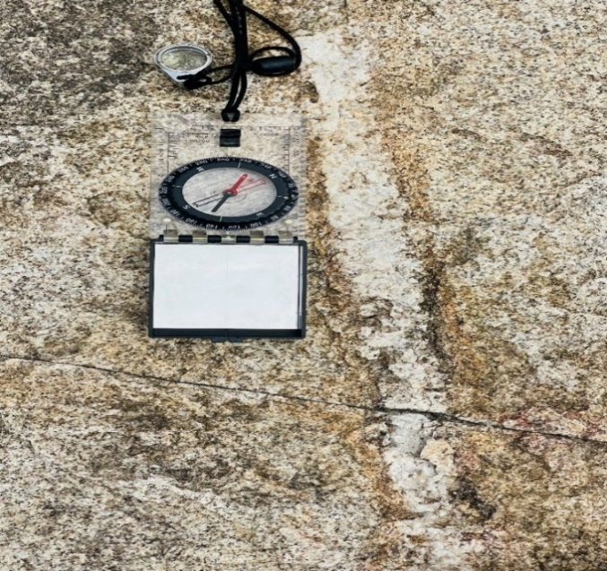

Plate XIV: Quartz vein

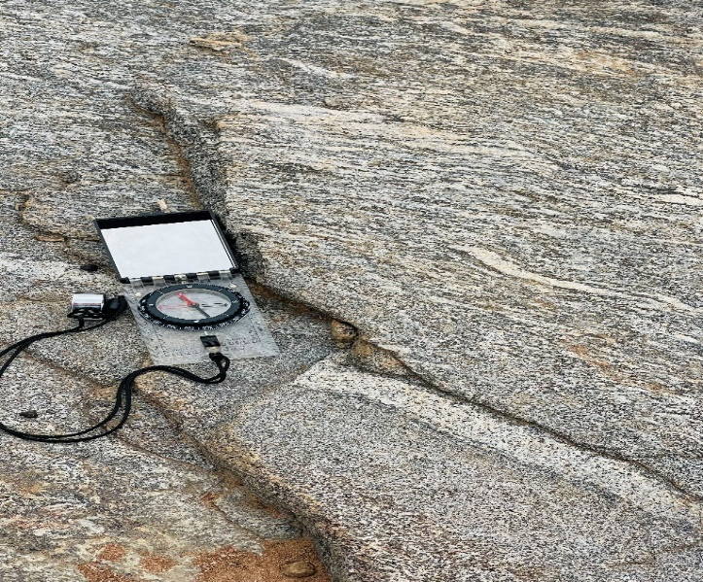

Plate XV: Dextral Fault

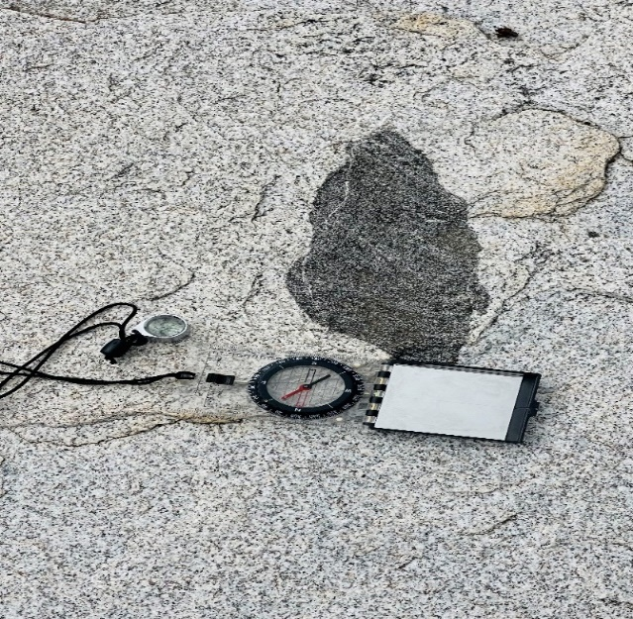
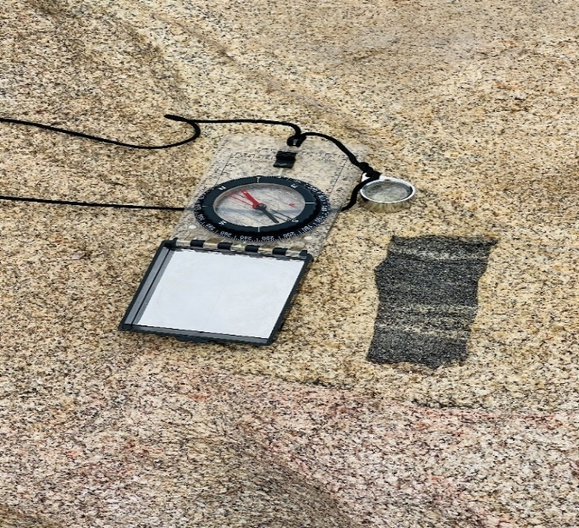

Plate XVI: Xenolith on Granitic rocks

